Lab 3

The sensor tag was connected to the android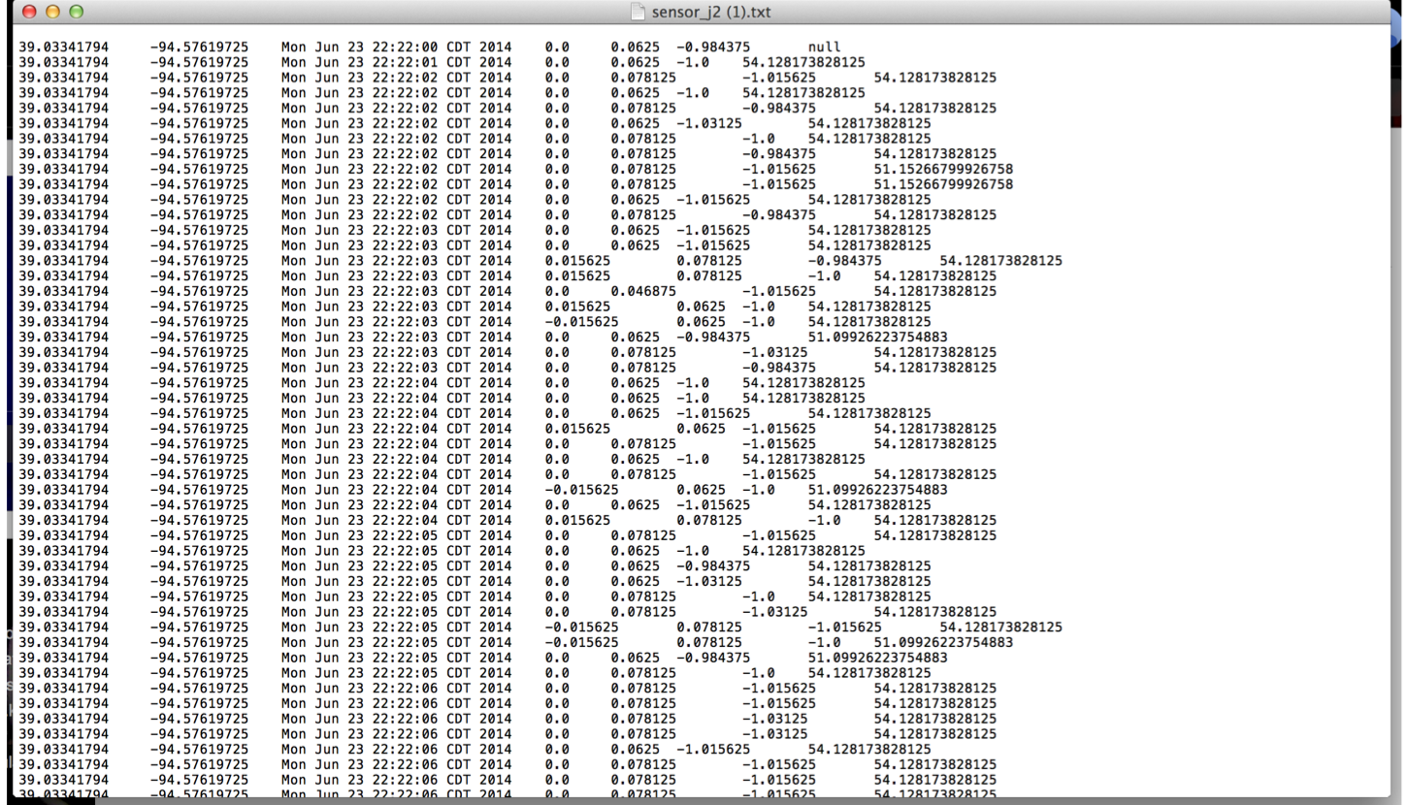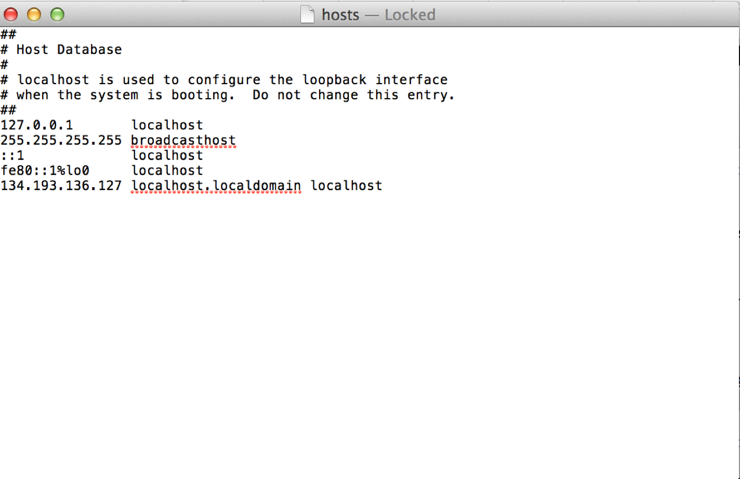 device to generate the data file in text format.

To add new column ,edit HbaseWS file .Then RESTful web services for uploading a file,creation of HBase table,insertion of data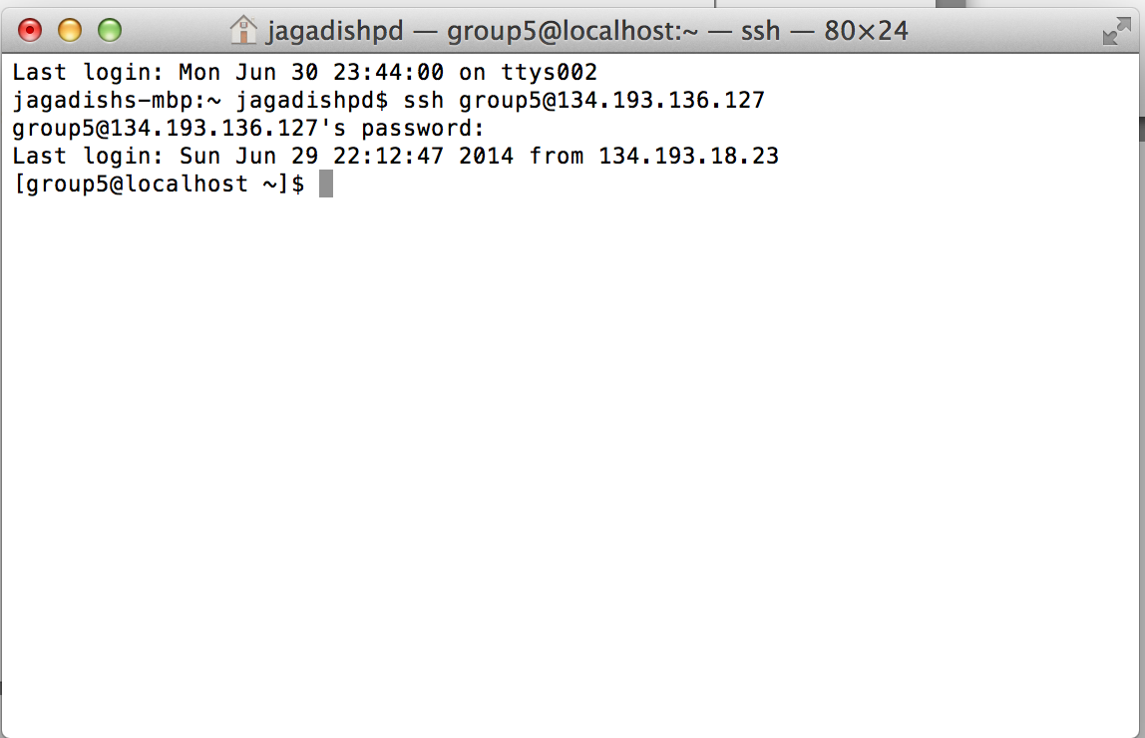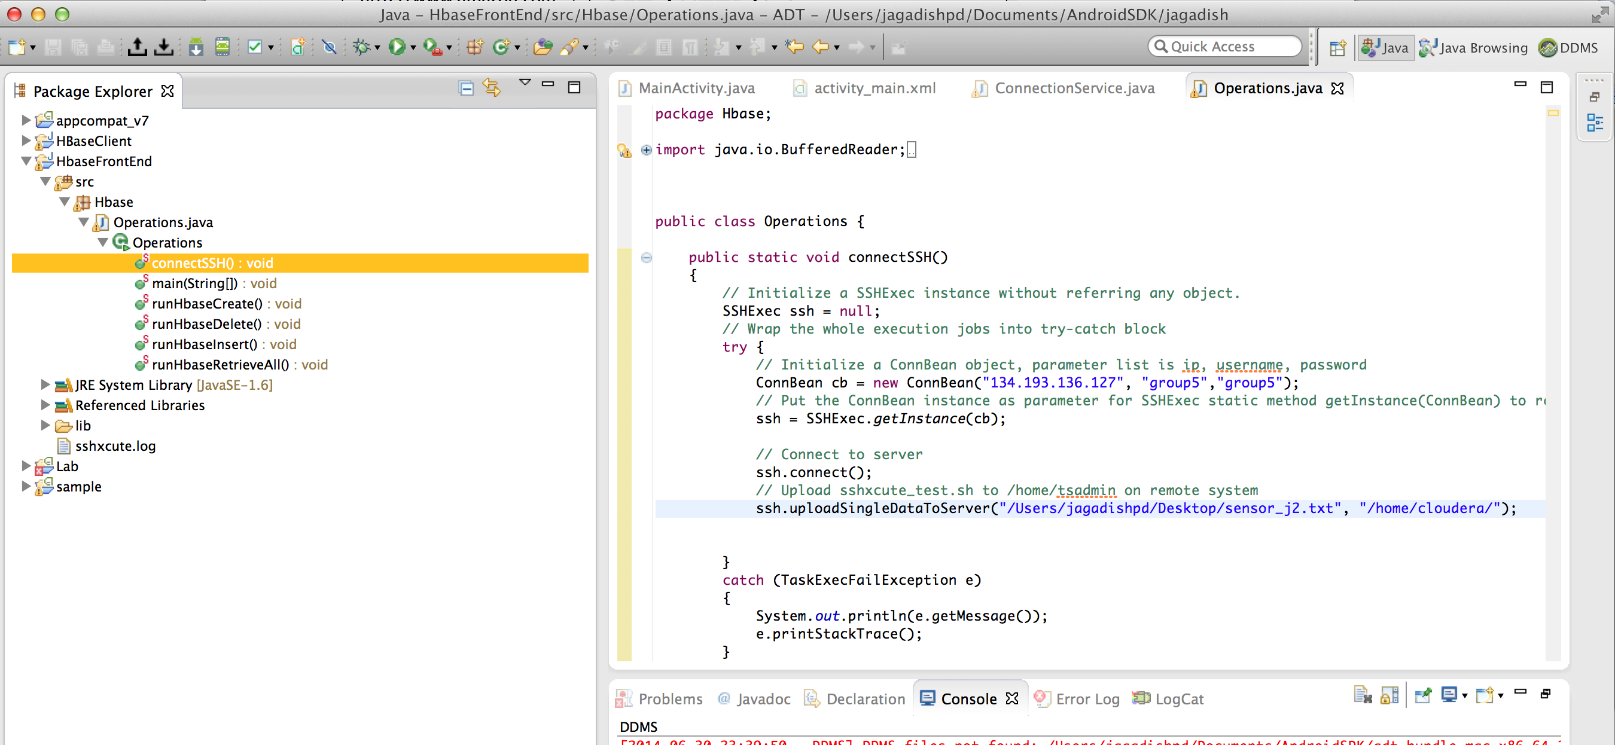 into table,retrieving data,deletion of table

The HbaseWS file is then exported as WAR file and deployed on Glassfish server



