**Assignment 2**

This assignment has been done by SPSS.

**Question 1:**

|  |  |  |  |  |  |  |  |  |
| --- | --- | --- | --- | --- | --- | --- | --- | --- |
| **Descriptive Statistics** | | | | | | | | |
|  | N | Range | Minimum | Maximum | Mean | | Std. Deviation | Variance |
| Statistic | Statistic | Statistic | Statistic | Statistic | Std. Error | Statistic | Statistic |
| apret | 170 | 76.500 | 18.750 | 95.250 | 56.72108 | 1.386450 | 18.077097 | 326.781 |
| tstsc | 170 | 39.375 | 48.125 | 87.500 | 66.16416 | .534982 | 6.975306 | 48.655 |
| salar | 170 | 49260 | 38640 | 87900 | 61357.65 | 751.839 | 9802.786 | 96094622.313 |
| Valid N (listwise) | 170 |  |  |  |  |  |  |  |

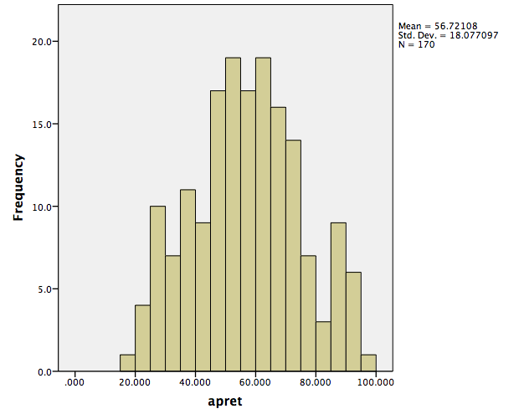

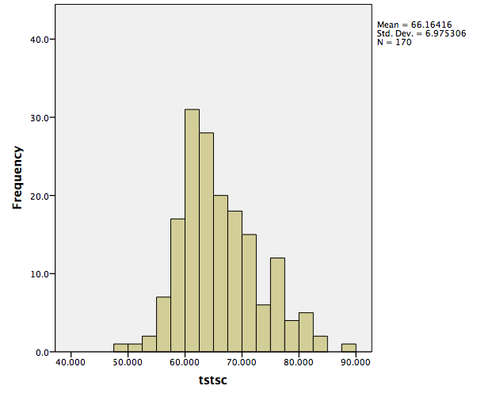

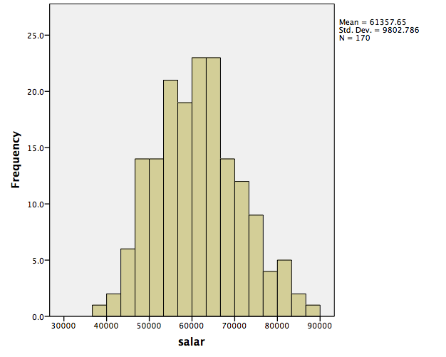

**Question 2:**

**apret on tstsc**

|  |  |  |  |  |
| --- | --- | --- | --- | --- |
| **Model Summaryb** | | | | |
| Model | R | R Square | Adjusted R Square | Std. Error of the Estimate |
| 1 | .782a | .612 | .609 | 11.296381 |

|  |
| --- |
| a. Predictors: (Constant), tstsc |
| b. Dependent Variable: apret |

This table provides the *R* and *R*2 values. The *R* value represents the simple correlation and is 0.782 (the "**R**" Column), which indicates a high degree of correlation. The *R*2 value (the "**R Square**" column) indicates how much of the total variation in the dependent variable, apret, can be explained by the independent variable, tstsc. In this case, 61.2% can be explained, which is very large.

**apret on salar**

|  |  |  |  |  |
| --- | --- | --- | --- | --- |
| **Model Summaryb** | | | | |
| Model | R | R Square | Adjusted R Square | Std. Error of the Estimate |
| 1 | .636a | .404 | .401 | 13.993569 |

|  |
| --- |
| a. Predictors: (Constant), salar |
| b. Dependent Variable: apret |

This table provides the *R* and *R*2 values. The *R* value represents the simple correlation and is 0.636 (the "**R**" Column), which indicates a some degree of correlation. The *R*2 value (the "**R Square**" column) indicates how much of the total variation in the dependent variable, apret, can be explained by the independent variable, salar. In this case, 40.4% can be explained, which is not very large.

**apret on tstsc & salar**

|  |  |  |  |  |
| --- | --- | --- | --- | --- |
| **Model Summaryb** | | | | |
| Model | R | R Square | Adjusted R Square | Std. Error of the Estimate |
| 1 | .790a | .624 | .619 | 11.155094 |
| a. Predictors: (Constant), tstsc, salar | | | | |
| b. Dependent Variable: apret | | | | |

This table provides the *R* and *R*2 values. The *R* value represents the simple correlation and is 0.790 (the "**R**" Column), which indicates a high degree of correlation. The *R*2 value (the "**R Square**" column) indicates how much of the total variation in the dependent variable, apret, can be explained by the independent variable, tstsc and salar. In this case, 62.4% can be explained, which is very large.