# Assignment 3: Validation and Testing

## 1. Overall classification accuracy

Manual Network

Accuracy for all 4 nodes = 0.592529 (1031/1740)

Party = 0.96092 (418/435)

democrat = 0.966292 (258/267)

republican = 0.952381 (160/168)

Naïve Network

Accuracy for all 17 nodes = 0.546586 (4042/7395)

Party = 0.903448 (393/435)

democrat = 0.895131 (239/267)

republican = 0.916667 (154/168)

PC Network

Accuracy for all 17 nodes = 0.546586 (4042/7395)

Party = 0.967816 (421/435)

democrat = 0.966292 (258/267)

republican = 0.970238 (163/168)

## 2. & 3. Sensitivity and specificity for each of the two parties Positive and negative predictive value for each of the two parties

Manual Network

**Democrat**

Sensitivity: 258/267 = 96.62%

Specificity: 160/168 = 95.23%

Positive predictive value: 258/(258+8) = 96.99%

Negative predictive value: 160/ (160 + 9) = 94.67%

**Republic**

Sensitivity: 160/(160 + 8) = 95.23%

Specificity: 258/(9 + 258) = 96.66%

Positive predictive value: 160/(160+9) = 94.67%

Negative predictive value: 258/ (258 + 8) = 96.99%

Naïve Network

**Democrat**

Sensitivity: 238/(238+29) = 89.13%

Specificity: 154/(154+14) = 91.66%

Positive predictive value: 238/(238+14) = 94.44%

Negative predictive value: 154/ (28+ 154) = 84.15%

**Republic**

Sensitivity: 154/(154+14) = 91.66%

Specificity: 238/(238+29) = 89.13%

Positive predictive value: 154/ (28+ 154) = 84.15%

Negative predictive value: 238/(238+14) = 94.44%

PC Network

**Democrat**

Sensitivity: 256/(256+11) = 95.88%

Specificity: 161/(161 + 7) = 95.83%

Positive predictive value: 256/(256+7) = 97.33%

Negative predictive value: 161/ (11+ 161) = 93.60%

**Republic**

Sensitivity: 161/(161+7) = 95.83%

Specificity: 256/ (11 + 256) = 95.88%

Positive predictive value: 161/(161 + 11) = 93.60%

Negative predictive value: 256/(256+7) = 97.33%

## (4 Extra Point!) Calibration curve for a selected bin count or window size

Manual Network

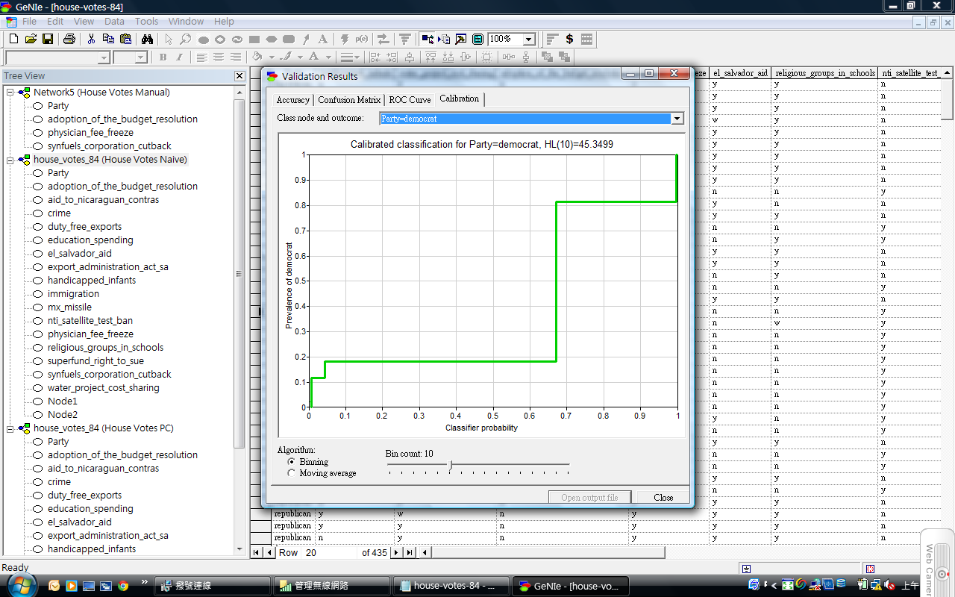

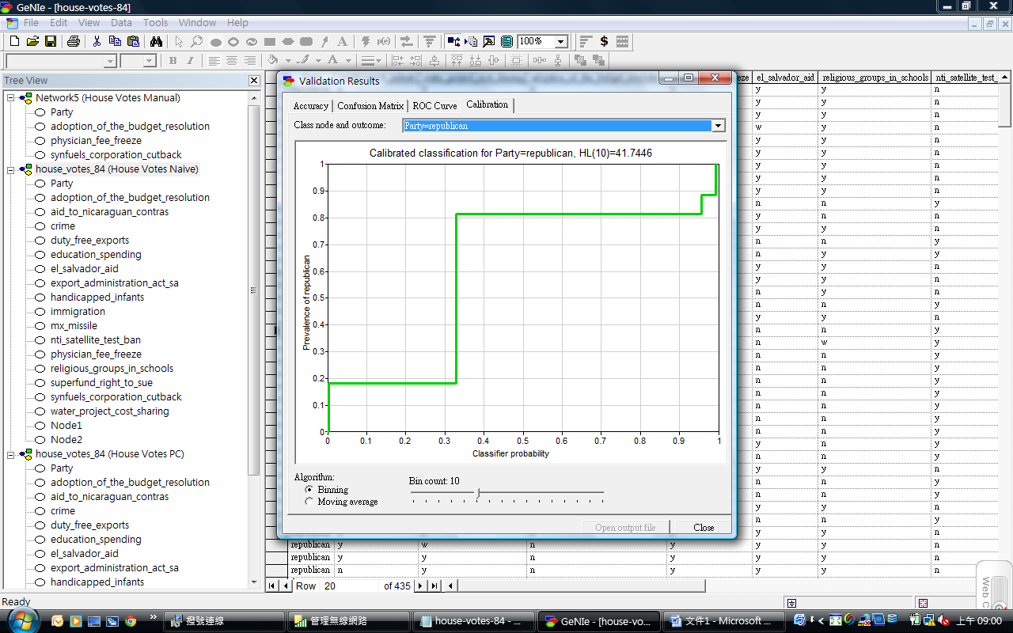

Naïve Network

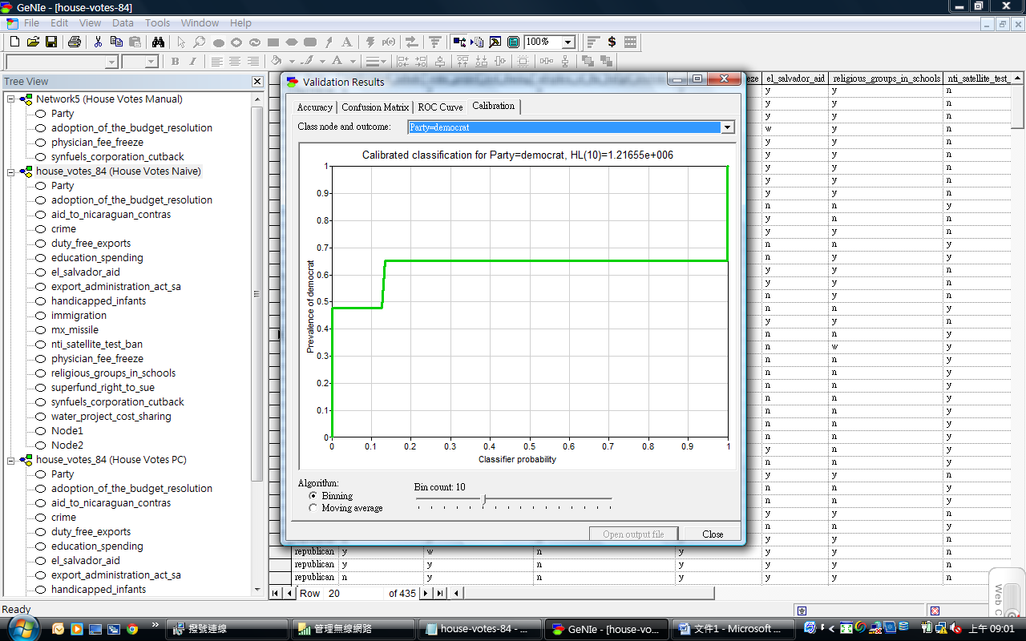

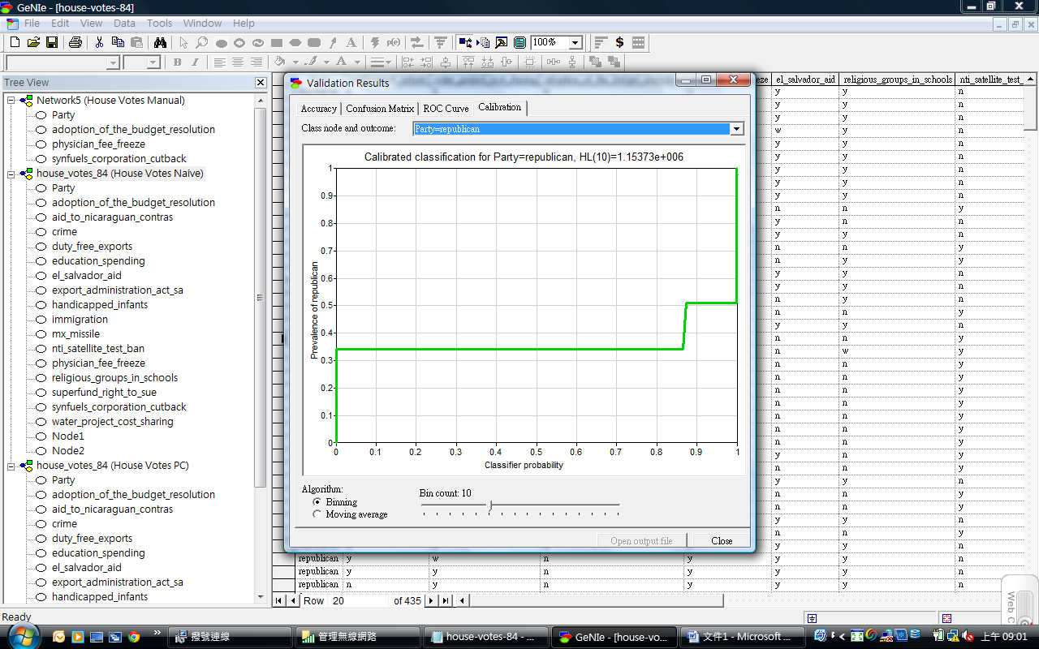

PC Network

