Notice : if copy DIR need/possible set Settings > Project Interpreter add venv DIR

-- 1

--create in repository

--config gitignore

--install env in terminal -->

python -m venv venv

venv\Scripts\activate

pip install django

pip freeze

{

asgiref==3.9.1

Django==5.2.5

sqlparse==0.5.3

tzdata==2025.2

}

--upgrade pip

python -m pip install --upgrade pip

create new project

in venv activate

django-admin startproject mysite1 .

if create project with PyCharm up step not need

only gitignore need to set

--struchter

mange.py mange all commad

in projet folder in case mysite1

__init__.py all files in folder init on run server

asgi.py chanel control

setting.py all config and relted its and manged addres files

urls.py save urls

wsgi.py related by apache and we server

- example create new test url

-create new vw file side manage.py

from django.http import HttpResponse

def test_http(request):

return HttpResponse("Hello, world. ")

add in url.py

from django.contrib import admin

from django.urls import path

from d1.vw_t1 import test_http

urlpatterns = [

path('admin/', admin.site.urls),

path('test_http',test_http),

]

MVC in other structure

MVT in Django

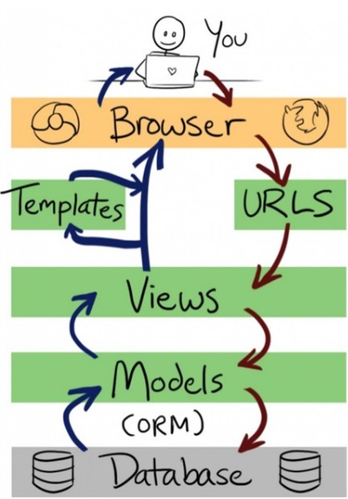

url parameter

base url

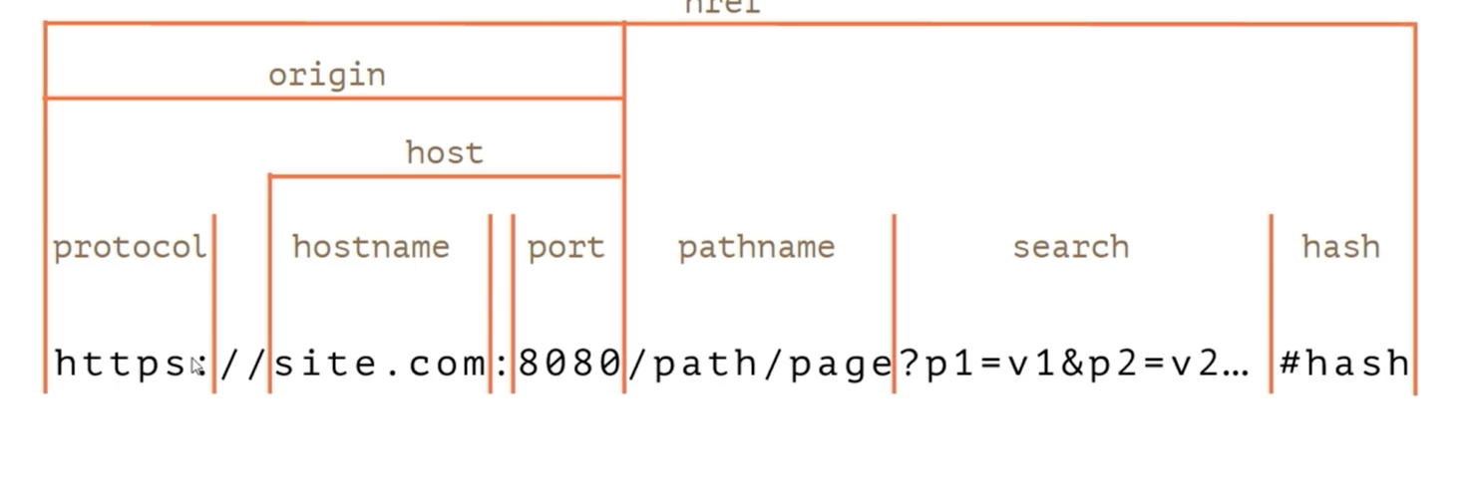

Start app

python manage.py startapp website1

add to setting

example for app urls

can be call view path in based project url file

in view file app

from django.http import HttpResponse,JsonResponse  
  
  
  
def test_http2(request):  
 return HttpResponse('<h1>test_h2 http</h1>')

from website1.views import test_http2

and in based project url file

urlpatterns = [

path('test_http2',test_http2),

]

Or

add view path in app url

and call in based project url file

in view file

from django.http import HttpResponse,JsonResponse  
  
  
  
   
  
def test_http3(request):  
 return HttpResponse('<h1>test_h3 http</h1>')

and create/add url.py in app

from django.urls import path  
from website1.views import test_http3  
urlpatterns = [  
 #jahantetst1  
 path('test_http3',test_http3),  
]

and in based project url file

from django.urls import path  
from django.urls import include

urlpatterns = [  
 path('admin/', admin.site.urls),  
  
 #jahantetst1  
   
 path('website1/',include('website1.urls')),  
]

and ruserver

<http://127.0.0.1:8000/website1/test_http3>

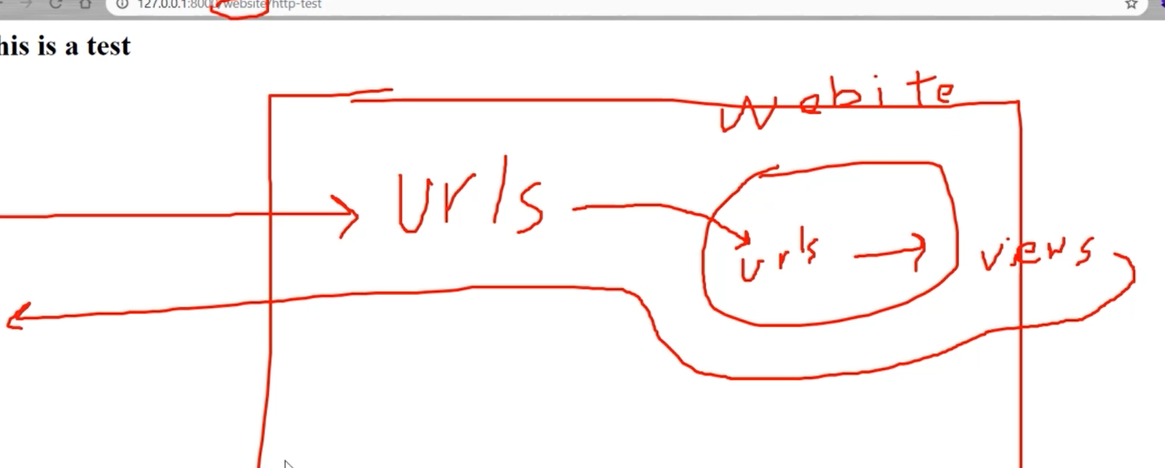

Example

In view website

from django.http import HttpResponse,JsonResponse  
def home(request):  
 return HttpResponse('<h1>Home page </h1>')  
def about(request):  
 return HttpResponse('<h1>About page </h1>')  
def contact(request):  
 return HttpResponse('<h1>contact page </h1>')

in url website

from django.urls import path  
from website1.views import *  
urlpatterns = [  
 #jahantetst1  
 path('home',home),  
 path('about', about),  
 path('contact', contact),  
]

notice: if path('home',home), 🡪 path('',home),

🡪http://127.0.0.1:8000/website1/ show home values

in url project

from django.contrib import admin  
from django.urls import path  
from django.urls import include  
  
urlpatterns = [  
 path('admin/', admin.site.urls),  
  
 path('website1/',include('website1.urls')),  
]

runserver

default page

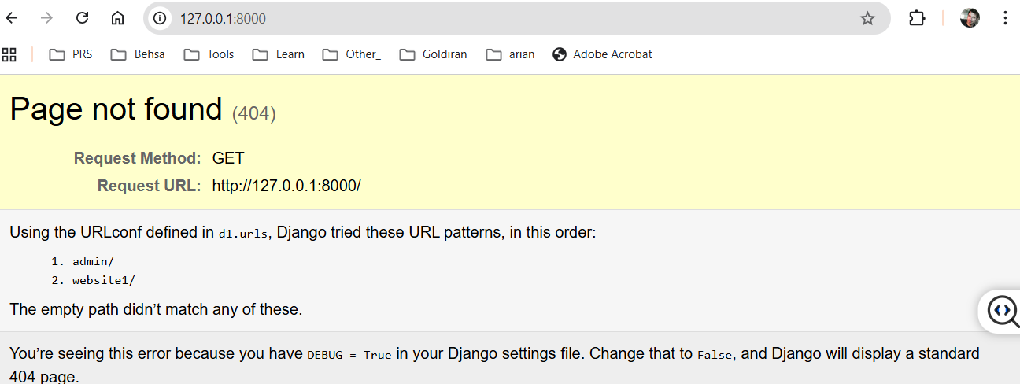

Website page

