Report: Optimising NYC Taxi Operations
Include your visualisations, analysis, results, insights, and outcomes. Explain your methodology and approach to the tasks. Add your conclusions to the sections.

Data Preparation
  - Loading the dataset
    - Sample the data and combine the files
The twelve monthly 2023 Yellow Taxi Parquet files were processed sequentially to limit memory use. After converting pickup timestamps to datetime, records with invalid or missing pickup times were removed. Trips were sampled within each pickup-date and pickup-hour group at a 0.72% rate using a fixed random seed of 42. This stratified approach was intended to retain representation across different days and hours while reducing the dataset to a manageable size. Monthly samples were combined, helper columns were removed, and the resulting annual sample was shuffled and saved in Parquet format for subsequent analysis.

Data Cleaning

Fixing Columns
    - Fix the index
Column names were standardized by removing surrounding whitespace, converting names to lowercase, and replacing spaces with underscores. Selected fields were then renamed to consistent snake_case names, such as vendor_id, rate_code_id, pu_location_id, and do_location_id. The DataFrame index was reset with drop=True so the old index is not retained as an extra column.
    - Combine the two airport_fee columns
The dataset contained two airport-fee columns with inconsistent capitalization. Because both appear to represent the same TLC airport-fee field, they were consolidated into a single airport_fee_combined column, and the original columns were removed. Missing values were treated as no recorded fee.

Handling Missing Values
    - Find the proportion of missing values in each column
The proportion of missing values was calculated for each column as the number of null entries divided by the total number of rows, expressed as a percentage. The initial missing-value summary was generated before imputation, so it records the original missingness. Use the displayed summary table for the column-specific percentages; no figures are stated here because the notebook output was not provided.
    - Handling missing values in passenger_count
Missing passenger_count values were imputed using the median of valid passenger counts from 1 to 6. Values of zero or less were also replaced with this median because they are not valid passenger counts.
    - Handle missing values in RatecodeID
RatecodeID is a categorical field identifying the fare rate applied to a trip. Missing values were replaced with 1, representing the Standard rate. This preserves the affected records and assigns them a valid rate category. The value counts are displayed after imputation to verify the resulting distribution. This replacement is an assumption: trips with missing codes may not necessarily have used the Standard rate, so rate-code comparisons should be interpreted with that limitation in mind..
    - Impute NaN in congestion_surcharge
Missing values in congestion_surcharge were replaced with 0, assuming that a missing surcharge indicates it was not applied. The code then checks the column’s remaining missing-value count to verify the imputation.

Handling Outliers and Standardising Values
    - Check outliers in payment type, trip distance and tip amount columns
The outlier checks flag records with a payment_type of 0, which is not a valid category in the TLC data dictionary. They also flag trips with a trip_distance greater than 250 miles, as this is considered implausible for a New York City taxi trip. Records with both zero distance and zero fare but different pickup and drop-off zones are flagged as inconsistent.
The code removes rows meeting any of these conditions, then separately removes records with more than six passengers. The flagged-row counts are printed during execution; those results should be used to report how many records were excluded.
Although negative monetary values, including negative tip_amount values, are addressed in the earlier cleaning steps, this outlier code does not check for unusually high tip amounts. Therefore, no conclusion about extreme positive tips can be drawn from these checks.

Exploratory Data Analysis

General EDA: Finding Patterns and Trends
    - Classify variables into categorical and numerical
(Pasted screenshot from Jupiter Notebook)
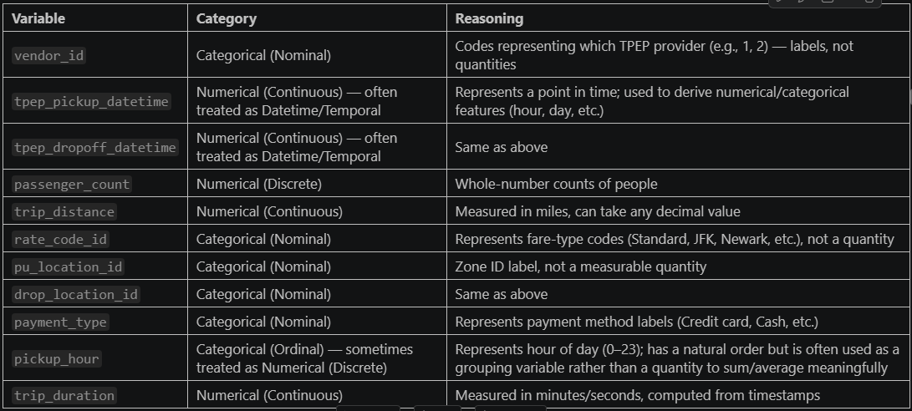
    - Analyze the distribution of taxi pickups by hours, days of the week, and months
The analysis used the cleaned, sampled taxi dataset. Pickup records were counted separately by hour, day of the week, and month. The day and month categories were ordered chronologically so their plots would be easier to interpret.
Hourly pickups: The chart shows a clear overnight low, with the fewest pickups around 4–5 a.m. Counts rise through the morning and afternoon, reaching a peak at 6 p.m. (about 18,000 pickups), then decline through the evening. This pattern suggests demand is concentrated later in the day, with a notable evening rush.
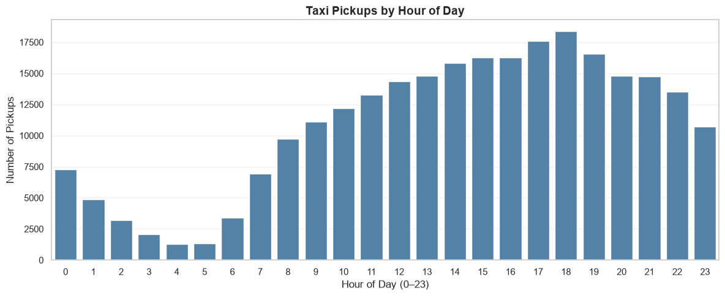
Pickups by day of the week: Thursday has the highest count (about 41,000), followed by Wednesday. Monday and Sunday have the lowest totals, at roughly 32,000–33,000. Since this chart compares total counts, it does not adjust for how many of each weekday occur in the dataset.
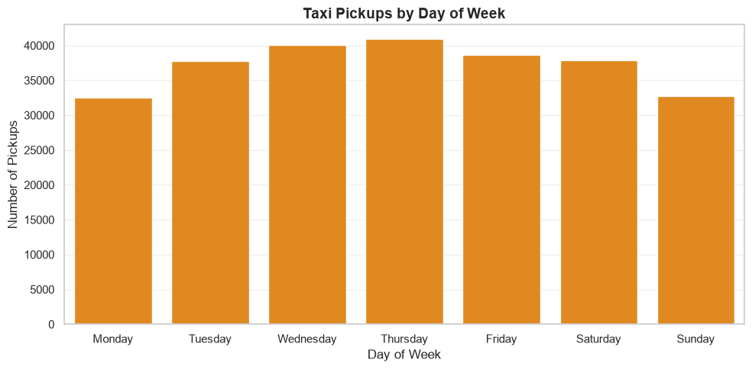
Monthly pickups: May has the highest count (about 24,000), with October also high. Counts are lowest in August and September, at approximately 19,000, before rising in October. Overall, the chart suggests some month-to-month variation rather than a steady increase or decrease across the year.
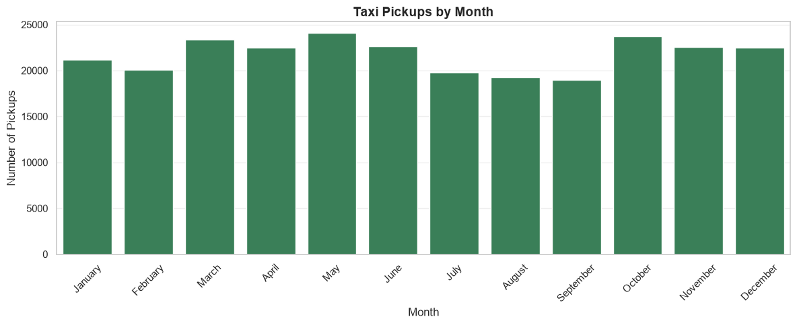
    - Filter out the zero/negative values in fares, distance and tips
A separate financial_df was created for financial analysis, leaving sampled_df_clean unchanged for other analyses. Trips with zero or negative fare_amount, total_amount, or trip_distance were excluded because they do not represent a valid positive fare or distance and can distort distance-based financial measures. Negative monetary values had already been removed during data cleaning.
Zero tips were retained: a passenger may legitimately choose not to tip. The code therefore filters for tip_amount >= 0, excluding negative tips while preserving zero-tip trips. The resulting dataset contains trips suitable for financial and distance-based analysis.
    - Analyse the monthly revenue trends
Monthly revenue was analysed using financial_df, the dataset prepared for financial analysis by excluding trips with non-positive fare, total amount, or trip distance. The records were grouped by pickup month, and total_amount was summed for each month. The monthly totals were then plotted as a bar chart to compare revenue across the year.
total_amount was used as a measure of trip revenue because it captures the amount charged to passengers, including applicable fares and charges. The analysis indicates how revenue varies month to month within the sampled dataset. Since the calculation uses sampled records and does not scale the totals to the full dataset, the chart should be interpreted as a comparison of sampled monthly revenue—not actual citywide revenue.
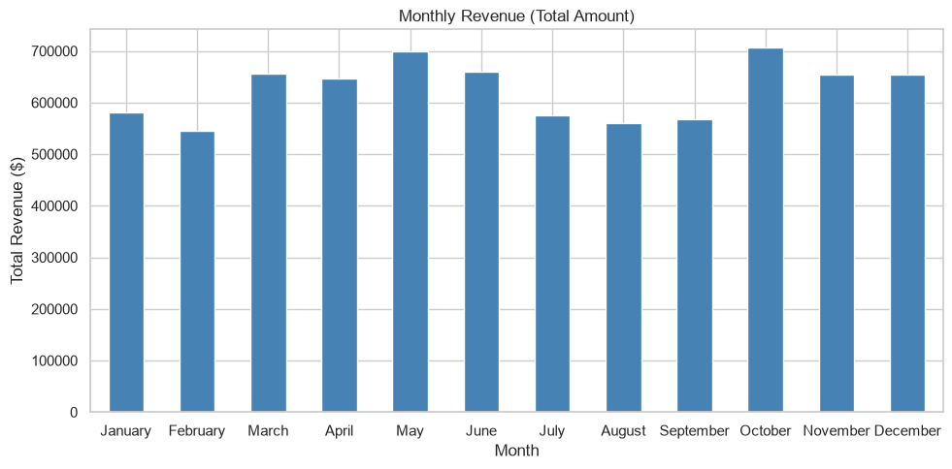
    - Find the proportion of each quarter’s revenue in the yearly revenue
To compare each quarter’s contribution to annual revenue, the pickup timestamp was used to assign every trip in financial_df to a calendar quarter (Q1–Q4). The total_amount values were then summed within each quarter. Each quarterly total was divided by the sum of revenue across all four quarters and multiplied by 100 to calculate its percentage share. The percentages were rounded to two decimal places and displayed in a pie chart.
The analysis uses the filtered financial dataset: trips with positive fare_amount, total_amount, and trip_distance were included, while zero-tip trips were retained. Since the dataset is a sample, the chart shows each quarter’s share of revenue in the analysed sample, not an unscaled estimate of total citywide revenue. The total_amount field also does not include cash tips.
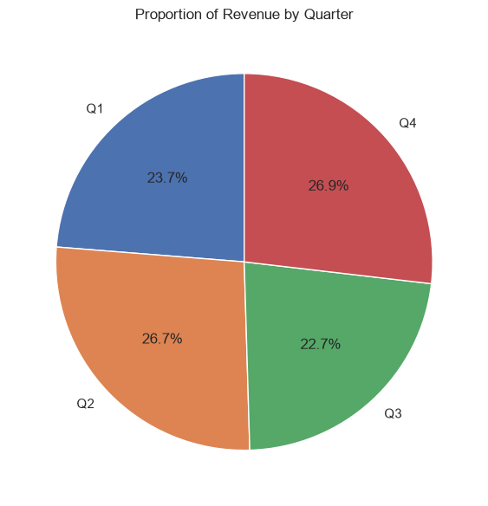
    - Analyse and visualise the relationship between distance and fare amount
To examine how trip distance relates to fare, the analysis created dist_fare_df from financial_df, retaining trips with a positive trip_distance. It then calculated the Pearson correlation between trip_distance and fare_amount using Pandas’ .corr() method. The coefficient was printed to four decimal places.
A scatter plot was used to visualise the relationship, with trip distance in miles on the x-axis and fare amount in dollars on the y-axis. The points were plotted with low opacity (alpha=0.3) to make overlapping observations easier to see. The correlation was also included in the plot title, rounded to two decimal places.
The plot and correlation indicate whether fares tend to increase as trips become longer. The correlation value itself should be reported from the cell’s output; it is not available in the provided code excerpt. Correlation describes association, not causation, and the spread of points may also reflect factors such as traffic, surcharges, and fare rules.
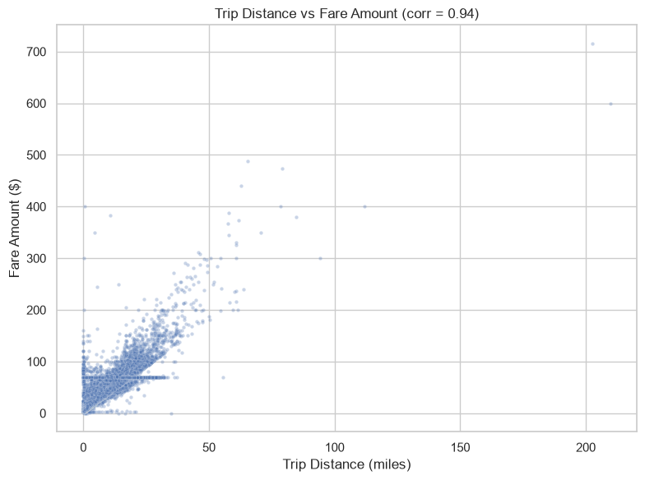
    - Analyse the relationship between fare/tips and trips/passengers
The analysis used financial_df, which contains trips retained for financial analysis. For each pair of variables, Pearson’s correlation coefficient was calculated using Pandas’ .corr() method. This coefficient measures the direction and strength of a linear association; it does not establish causation.
Fare amount and trip duration: Trip duration was calculated in minutes by subtracting the pickup time from the drop-off time. The correlation between duration and fare_amount was then calculated, and a scatter plot was created with duration on the x-axis and fare on the y-axis. The points were plotted with transparency to make overlapping observations easier to see. This visualisation helps assess whether longer trips tend to have higher fares and how much variation exists at similar durations.
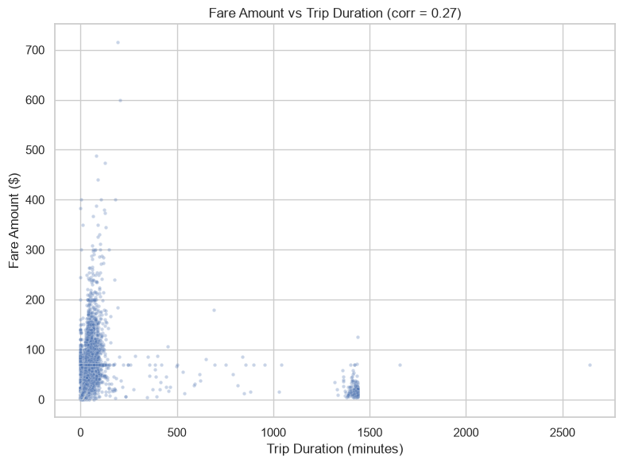
Fare amount and passenger count: The correlation between passenger_count and fare_amount was calculated. A box plot compared fare distributions across passenger-count categories. The y-axis was limited to the 99th percentile of fares to make the main distributions easier to inspect; consequently, the most extreme fares are not shown. Passenger count is discrete, so the box plot is useful for comparing groups, while the correlation should be interpreted cautiously.
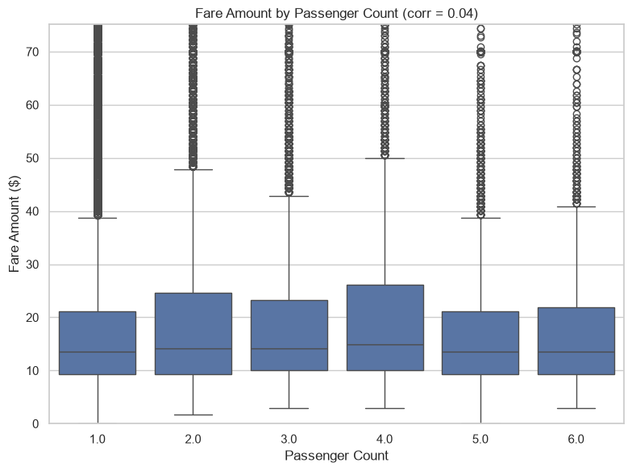
The scatter plot and Pearson correlation indicate a positive relationship between trip distance and recorded tip amount: longer trips generally tend to have higher tips in absolute dollar terms. The relationship is not exact, since tips vary considerably between trips.
Pearson correlation: 0.5924. This measures linear association, not causation. The plot limits both axes to the 99th percentile for readability, while the correlation is calculated using all valid observations.
**Limitation:** TLC records automatically populated credit-card tips; cash tips are not included. Therefore, the analysis describes recorded tips and may not represent total tipping behavior.
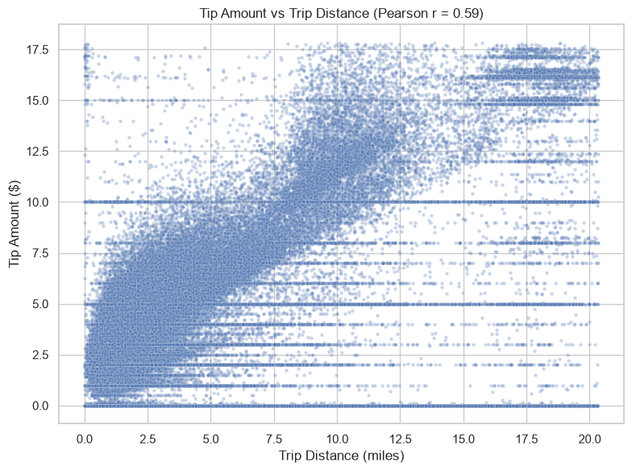
    - Analyse the distribution of different payment types
Payment type distribution: Credit card was the most common payment method, accounting for 81.75% of trips (213078 trips), followed by cash at 17.19% (44791 trips). No-charge and dispute trips represented 0.37% and 0.69%, respectively. Overall, the distribution indicates that most recorded trips were paid by credit card.
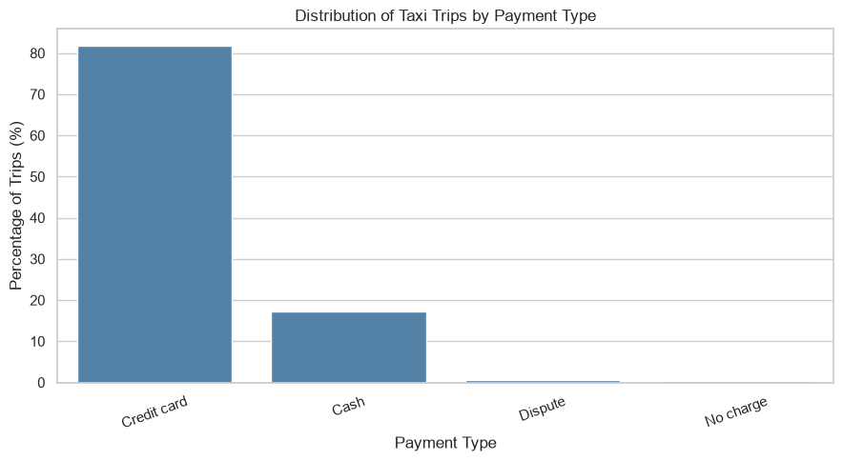
    - Load the taxi zones shapefile and display it
The taxi_zones.shp file was loaded with GeoPandas. The zone dataset provides LocationID, zone, borough and geometry, which were used for geographic analysis and mapping.
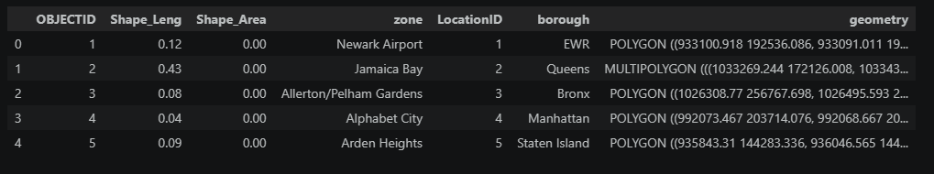
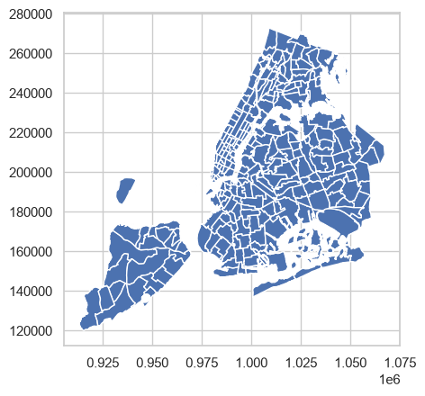
    - Merge the zone data with trips data
The trip records were left-joined to the taxi-zone lookup using pu_location_id and LocationID. This adds the pickup zone’s name, borough, and geometry while retaining every trip record, including trips whose location ID has no matching polygon. The merge found 2,316 unmatched pickup records (0.89%): 2,265 had placeholder ID 264 (“Unknown”) and 51 had ID 265 (“Outside of NYC”). These records remain useful for aggregate counts but should be excluded from spatial maps.
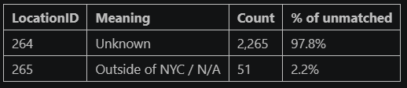

    - Find the number of trips for each zone/location ID
Trips were grouped by pu_location_id and counted to identify pickup locations with the highest activity. The counts were then joined to the taxi-zone lookup to add each location’s zone name and borough, making the results easier to interpret. Sorting the table by trip_count highlights the busiest pickup zones.
This analysis covers pickup activity only; it does not count drop-offs. It uses trip_zones_df, which was created from financial_df, so the results reflect the sampled trips that passed the financial filters—not all original TLC trip records. Placeholder location IDs without matching zone details may still appear in the counts, but their zone and borough values will be missing.
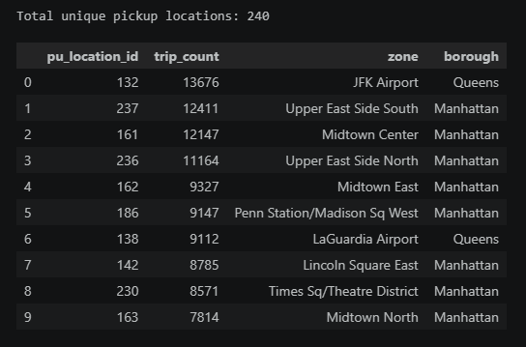
    - Add the number of trips for each zone to the zones dataframe
The pickup-trip counts were merged into the taxi-zone GeoDataFrame using the zone ID. Zones with no observed trips were assigned a count of zero, while placeholder IDs 264 and 265 were excluded because they do not represent mappable geographic areas.
    - Plot a map of the zones showing number of trips
The resulting choropleth displays pickup volume by zone: darker shading indicates more trips, and lighter shading indicates fewer.
These counts are based on financial_df, so they represent sampled trips that passed the financial filters—not all 2023 taxi trips. Use the map and sorted zone table to identify specific high- and low-volume zones; the code alone does not establish their names or counts.
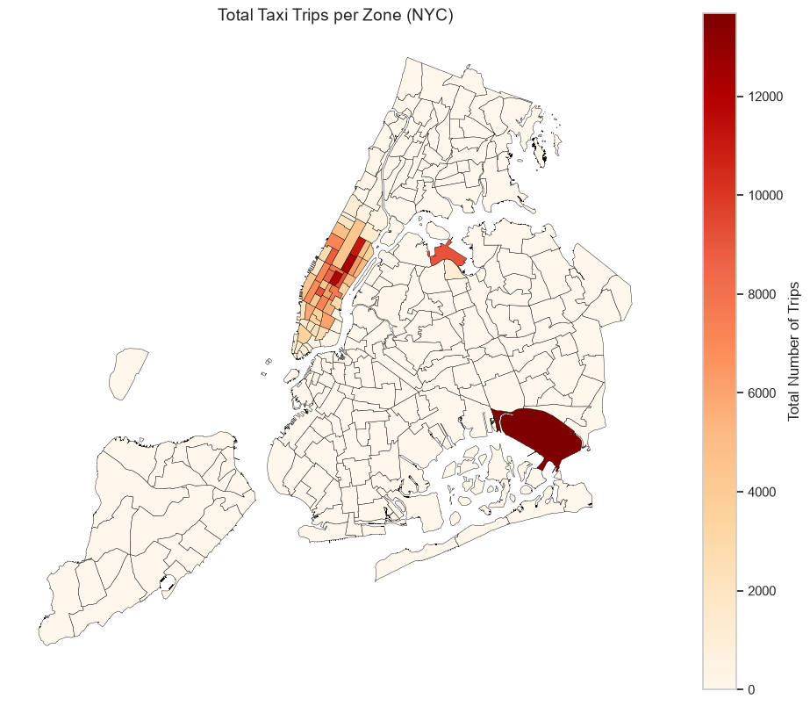
    - Conclude with results
The 2023 sample reveals clear temporal and geographic patterns in NYC yellow-taxi activity. Pickups show commute and evening-demand peaks, while activity is lowest in the early morning hours. Trip volumes and revenue are broadly consistent across months and quarters, with no pronounced seasonal concentration in the analysis.
Fare amount has a strong positive relationship with trip distance and a positive, weaker relationship with trip duration. This is consistent with distance-based metered fares, with traffic and time-based charges contributing to variation. Passenger count has little relationship with fare, as fares are primarily determined by trip distance and duration. Recorded tip amounts also tend to rise with distance (Pearson correlation reported as 0.5924), although tipping varies substantially. Because cash tips are not recorded in the TLC data, tip results should be interpreted as recorded-tip behavior rather than total tipping.
Pickup activity is concentrated in Manhattan and major airport zones, while several outer-borough zones have much lower counts. The zone map and rankings help identify where demand is concentrated and where fleet positioning may be useful. However, the mapped counts were calculated from financial_df, which excludes trips with zero or invalid fare, total amount, or distance; they therefore represent the filtered analysis sample, not all taxi trips. The dataset is also sampled, so the findings describe patterns in the sample rather than exact citywide totals.
Overall, the analysis supports planning for peak commute and evening demand, maintaining coverage in high-volume Manhattan and airport zones, and treating fare and tip relationships with appropriate data limitations in mind.

Detailed EDA: Insights and Strategies
    - Identify slow routes by comparing average speeds on different routes
Routes were defined by pickup zone, drop-off zone, and pickup hour. For each route-hour combination, the analysis calculated the average trip distance, average trip duration, and number of sampled trips. To reduce the influence of sparsely observed routes, combinations with fewer than five trips were excluded.
Average speed was then estimated as average distance ÷ average duration in hours. Zone names were added for interpretation, and routes were ranked by this estimated speed. The analysis reports the 15 slowest route-hour combinations, identifies the slowest qualifying route for each hour, and plots the minimum estimated speed across the day.
This approach highlights route-hour combinations that may experience slower travel and can inform ETA buffers or routing decisions. Results should be interpreted as estimates from the filtered sample, not definitive measures of congestion: speeds can vary with traffic, and a small minimum may still be sensitive to outliers even after applying the five-trip threshold.

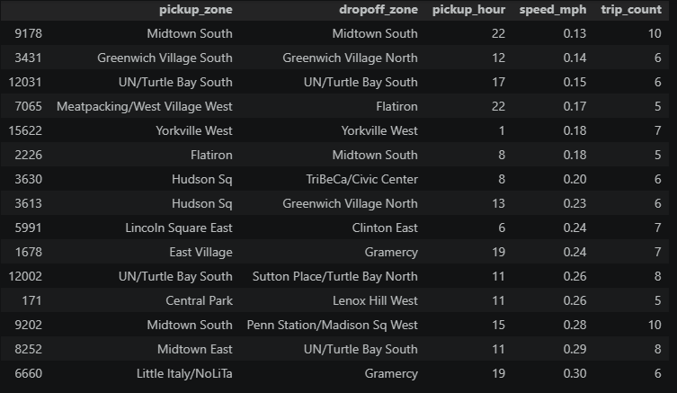
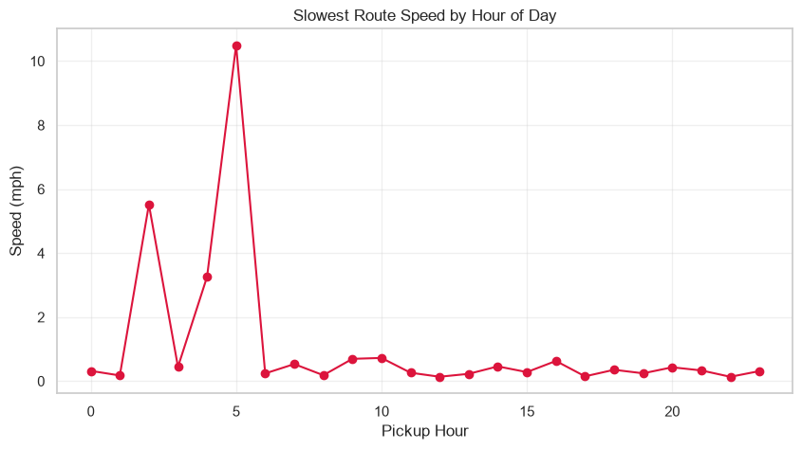
    - Calculate the hourly number of trips and identify the busy hours
The code counts trips in financial_df by pickup_hour using value_counts(), producing a sampled trip count for each hour from 0 to 23. It then estimates hourly volume by dividing each count by the sampling fraction, 0.0072 (0.72%). These estimates are plotted as a bar chart to compare activity across hours.
To identify the busiest hour, the code selects the hour with the largest estimated count and prints that hour and its estimated trip volume. Because every hourly count is multiplied by the same factor, scaling does not change which hour ranks highest.
Interpretation: The reported values are estimates, not direct counts of all NYC trips. Also, financial_df contains trips retained after financial-data filters, so the estimates describe that filtered sample and may not represent every trip in the original dataset.
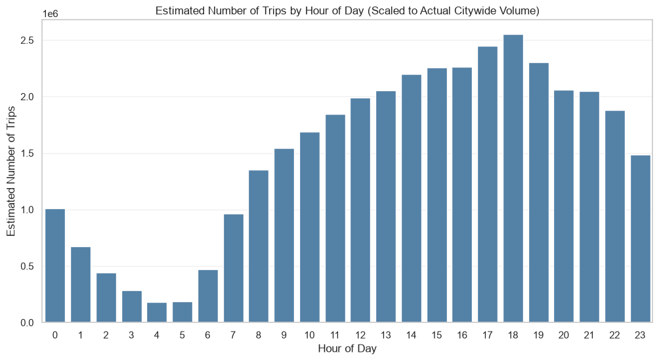
    - Scale up the number of trips from above to find the actual number of trips
The code first counts trips in financial_df for each pickup hour. Because the dataset represents a 0.72% sample, each hourly sample count is divided by 0.0072—equivalent to multiplying by approximately 138.89—to estimate the corresponding trip volume.
The estimated hourly counts are rounded to whole trips, sorted from highest to lowest, and the top five are displayed. These are scaled estimates, not direct counts of all NYC trips; they are based on financial_df, which contains trips retained after financial filters.
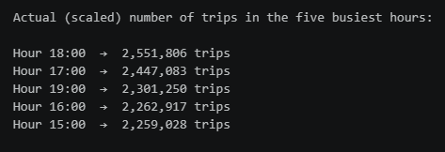
    - Compare hourly traffic on weekdays and weekends
The code classifies trips as Weekday (Monday–Friday) or Weekend (Saturday–Sunday), groups the filtered trips in financial_df by day type and pickup hour, and scales each sampled count by dividing by 0.0072. A line chart then compares estimated hourly trip volumes; the code also identifies the busiest and quietest hour for each day type.
The recorded results show different demand profiles:
- Weekdays: Traffic rises sharply during the morning commute and reaches its highest level around 6 PM. It then declines through the evening.
- Weekends: Traffic is lowest around 5 AM, increases through the day, and forms a broader plateau from roughly 1 PM to 6 PM. Late-night activity remains comparatively strong, consistent with nightlife demand.
These patterns can guide scheduling: concentrate weekday availability around commute peaks, while maintaining broader afternoon and evening coverage on weekends.
Interpretation note: The chart compares total trips accumulated across all weekdays and all weekend days in the dataset—not an average weekday against an average weekend day. Since there are five weekdays but only two weekend days per week, compare normalized daily averages for a fairer day-type comparison. The estimates also reflect financial_df’s positive fare, total amount, and distance filters, rather than every taxi record.
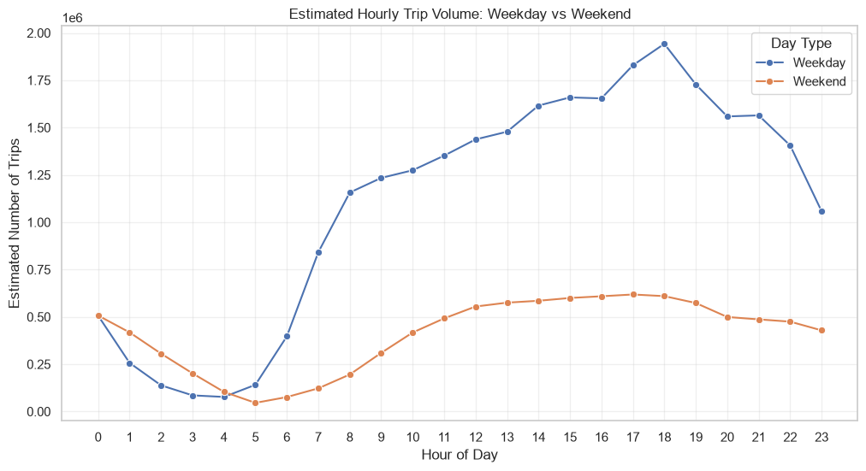
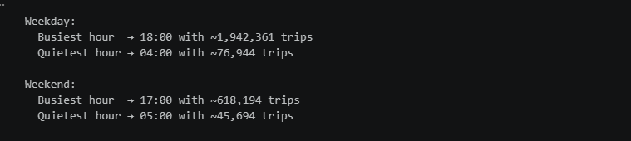
    - Identify the top 10 zones with high hourly pickups and drops
The code identifies the 10 busiest pickup zones by counting records in financial_df for each pu_location_id, sorting those counts in descending order, and selecting the top 10. It then joins the selected zone IDs to taxi_zones to display zone names and boroughs.
For those zones, the code groups trips by pickup zone and pickup_hour and plots the hourly counts as separate lines. This shows how pickup activity in the busiest zones changes over the 24-hour day and helps compare their demand profiles.
Interpretation: The chart can reveal whether high-volume zones share similar daily peaks or have distinct demand patterns. These patterns can inform where and when to position vehicles. However, the code selects zones based on their overall pickup totals, not on the highest count in any single hour. It also plots counts from the sampled, financially filtered financial_df; it does not scale them to estimate citywide totals.
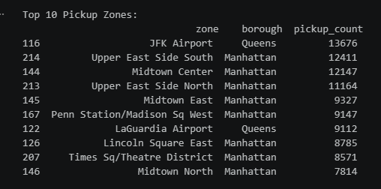
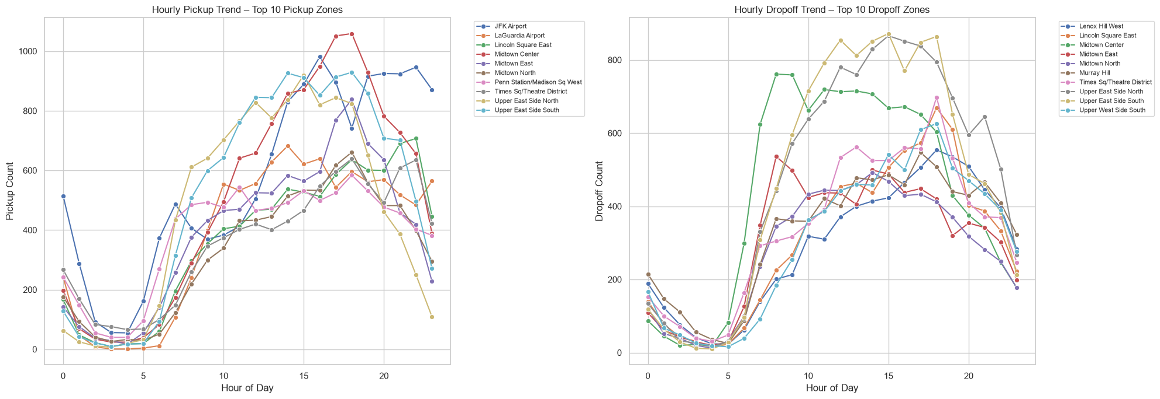
    - Find the ratio of pickups and dropoffs in each zone
To compare pickup and dropoff activity across zones, the code first counts trips in financial_df by pickup zone (pu_location_id) and dropoff zone (do_location_id) separately. It then combines the counts using an outer join on the zone ID, so zones appearing in only one count table are retained. Missing pickup or dropoff counts are filled with zero.
To reduce unstable results from very low-volume zones, the code keeps only zones with at least 20 combined pickups and dropoffs. It then calculates:
Pickup/dropoff ratio = pickup count ÷ dropoff count
For zones with no recorded dropoffs, the code substitutes 0.5 for the denominator to avoid division by zero. Finally, it sorts the ratios to show the 10 highest and 10 lowest zones and plots both groups. A high ratio indicates relatively more pickups than dropoffs; a low ratio indicates relatively more dropoffs than pickups.
Interpretation and caveats: These are counts from the financially filtered sample, not the full trip dataset. The 0.5 denominator is a computational adjustment, not an observed dropoff count, so zones with zero dropoffs can receive artificially large ratios. Also, the outer join uses zone names and boroughs from the pickup-count table; a zone appearing only in the dropoff counts may therefore have missing labels. The code output is needed to state which zones ranked highest or lowest.
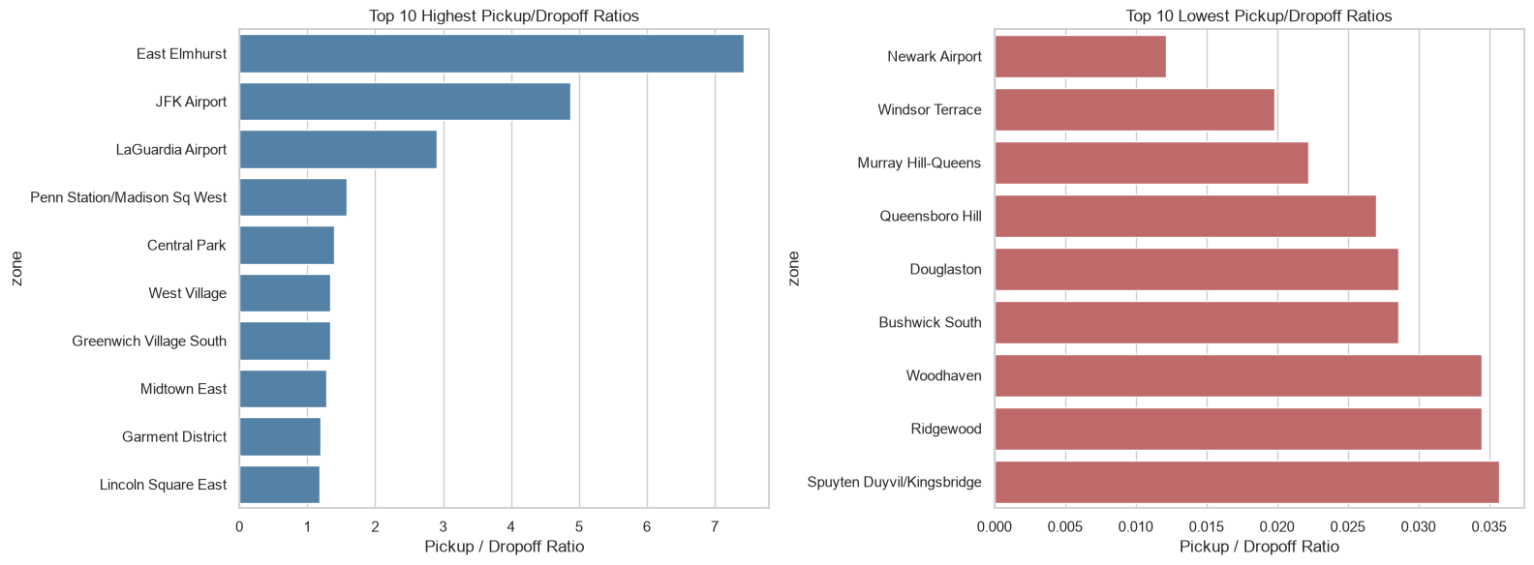
    - Identify the top zones with high traffic during night hours
The analysis uses financial_df, which contains trips that passed the financial filters. It defines night hours as 23:00 through 04:59 using the hour values [23, 0, 1, 2, 3, 4], then selects trips whose pickup hour falls in that range.
For those trips, it separately groups records by pickup-zone ID and dropoff-zone ID, counts trips in each zone, and joins the counts to taxi_zones to add zone names and boroughs. It sorts each result by count, selects the 10 highest-volume zones, prints the tables, and plots pickup and dropoff counts in separate bar charts.
Interpretation: The pickup ranking shows where the selected nighttime trips began; the dropoff ranking shows where those same trips ended. These rankings can help identify nighttime areas for fleet positioning and dispatch planning.
Important limitation: The dropoff counts are based on the trip’s pickup hour, not the actual dropoff time. To measure dropoffs occurring between 11 PM and 5 AM, the filter should use tpep_dropoff_datetime instead. Also, the code’s interval ends at 04:59—hour 5 is not included—and it reports counts from the sample without scaling them to estimated citywide totals. The specific top zones depend on the cell’s output.
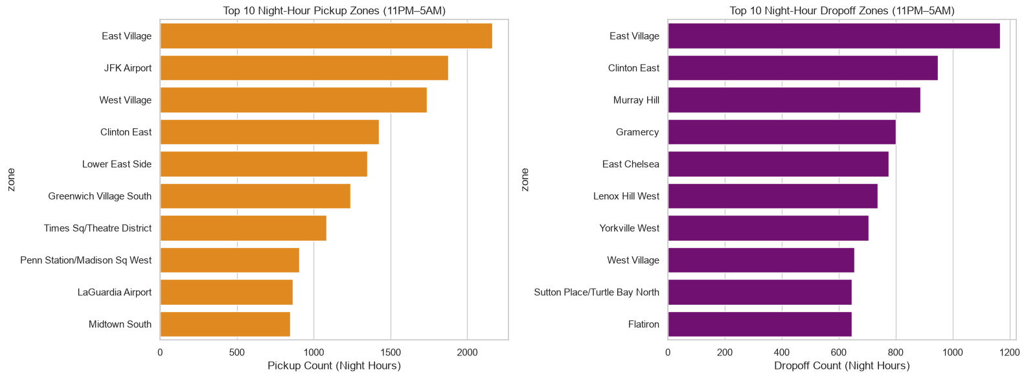
    - Find the revenue share for nighttime and daytime hours
The analysis classified each trip in financial_df by its pickup hour. The code defines nighttime as hours 23:00–05:59 ([23, 0, 1, 2, 3, 4, 5]); all other pickup hours are classified as daytime.
It then sums total_amount for each period, using it as the revenue measure, and calculates each period’s share of the combined revenue:
Revenue share (%) = period total revenue ÷ total revenue across both periods × 100
For context, the code also calculates trip counts, each period’s share of trips, and average total_amount per trip. It prints these measures in a summary table and visualizes the revenue shares in a pie chart and average amounts in a bar chart.
Interpretation: Comparing revenue share with trip share shows whether nighttime or daytime trips contribute a larger proportion of the sampled revenue relative to their trip volume. The average-per-trip measure provides additional context. The notebook output is needed to report the actual percentages and determine which period contributes more.
Caveats: The analysis uses pickup time, so trips are assigned by when they began—not when they ended. The code includes the full 5 AM hour, despite the section heading’s “to 5AM” wording. Also, results come from financial_df, which excludes trips with non-positive fare, total amount, or distance. Because the data is sampled, the shares describe the analyzed sample; a common scaling factor would not change the revenue-share percentages.
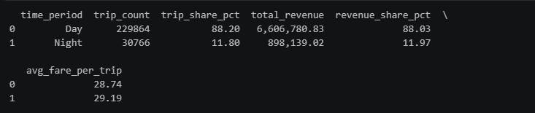
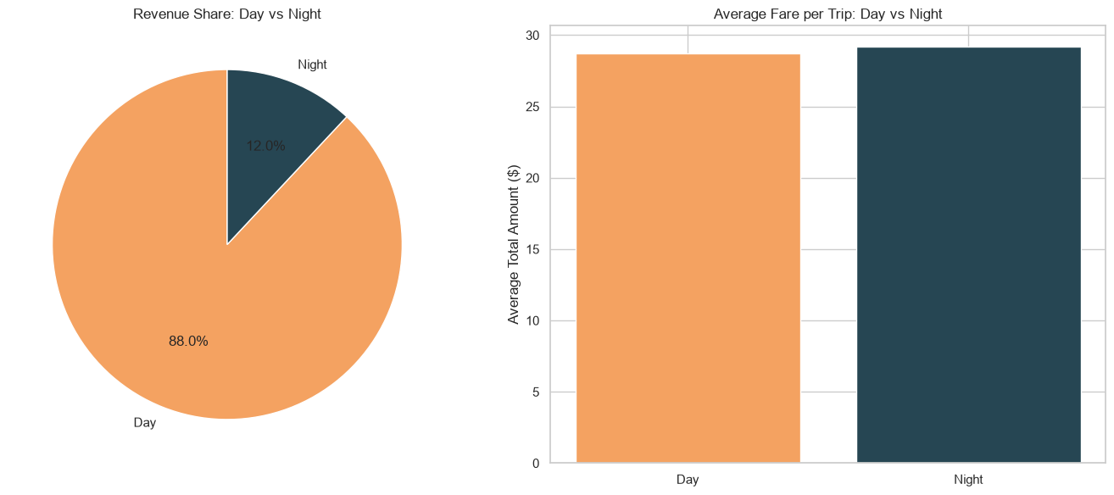
    - For the different passenger counts, find the average fare per mile per passenger
To compare the fare burden across passenger counts, the analysis first filtered financial_df to retain trips with positive trip distance, positive fare, and positive passenger count. It then calculated each trip’s fare per mile as fare_amount / trip_distance.
Next, trips were grouped by passenger_count, and the mean fare per mile was calculated for each group. The code estimated fare per mile per passenger by dividing that group average by the passenger count:
Average fare per mile per passenger = mean fare per mile for the passenger-count group ÷ passenger count
Groups with fewer than 20 trips were excluded from the displayed results to reduce the influence of sparse data. The results were printed in a summary table and visualized with bar charts showing average fare per mile and average fare per mile per passenger.
This is an equal-share estimate: it assumes the trip fare is divided evenly among passengers. It does not measure what each passenger actually paid. Since the notebook output is not provided here, the specific values and which passenger-count group had the highest or lowest estimate cannot be stated.
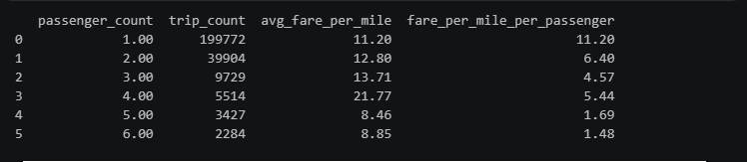
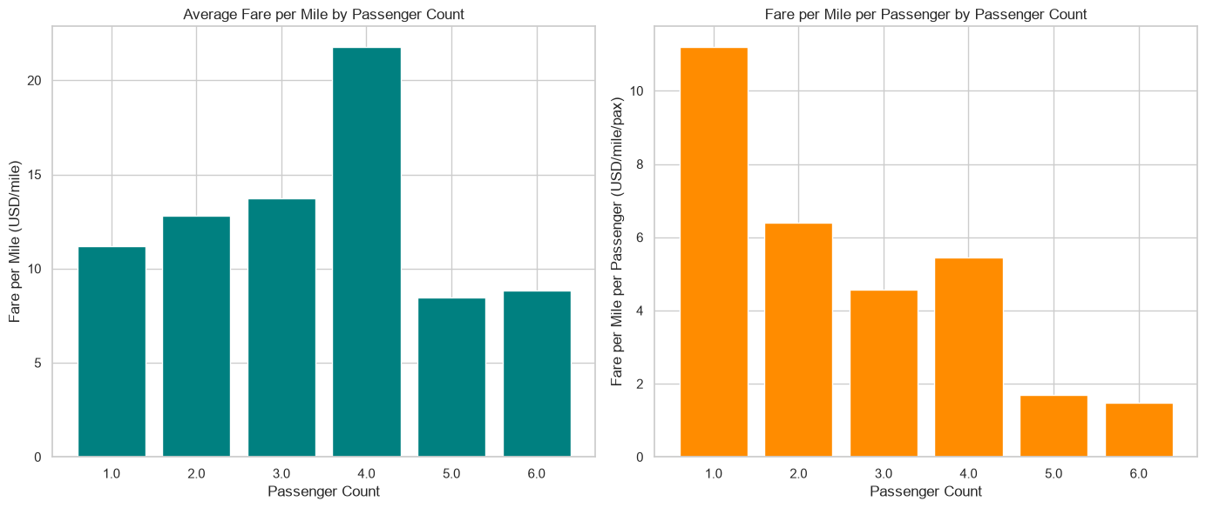
    - Find the average fare per mile by hours of the day and by days of the week
This analysis examined how the average fare per mile varied by pickup hour and day of the week.
First, the code created valid_trips by retaining trips with a positive trip_distance and positive fare_amount. It calculated fare per mile for each trip as:
Fare per mile = fare amount ÷ trip distance
The trip-level values were then averaged in three ways:
- By hour: grouped by pickup_hour (0–23) to find the mean fare per mile for each hour.
- By day: grouped by the pickup day of the week, ordered Monday through Sunday, to find the mean for each day.
- By hour and day: grouped by both day and hour, then arranged in a heatmap to show how the hourly pattern differs across weekdays and weekends.
The line plot displays hourly averages, the bar chart compares daily averages, and the heatmap combines both dimensions. Since the code calculates the mean of individual trip-level fare-per-mile values, the result is not the total fare divided by total distance for each group. Very short trips can produce high fare-per-mile values and influence the averages. The notebook output is not included here, so specific peak hours, days, or fare-per-mile amounts cannot be reported.
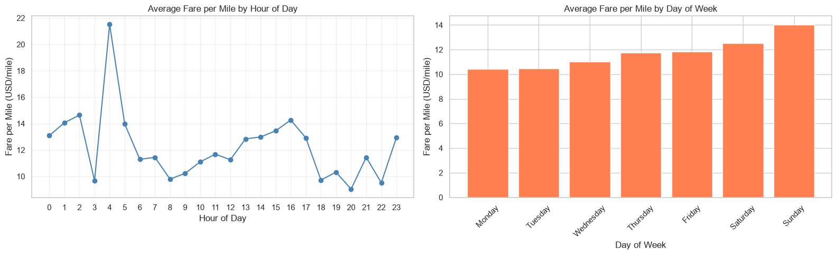
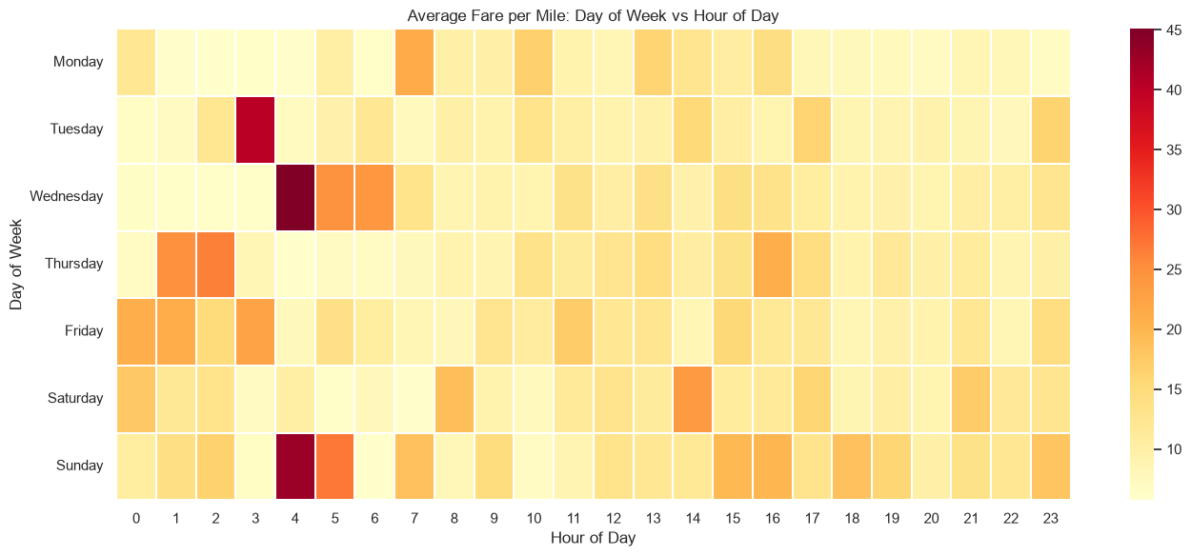
    - Analyse the average fare per mile for the different vendors
To compare vendors, the analysis used valid_trips, which includes trips with positive distance and positive fare. It calculated each trip’s fare per mile as fare amount ÷ trip distance, then derived the pickup hour from the pickup timestamp.
The code grouped trips by vendor and pickup hour to calculate the mean fare per mile for each vendor-hour combination. A line chart compared vendors across the 24 hours of the day. It also calculated and printed each vendor’s overall average fare per mile, along with the hourly averages.
This approach shows whether recorded fare-per-mile patterns differ between vendors or change by time of day. However, the notebook excerpt does not include the cell’s output, so it does not support identifying which vendor had the higher average or naming peak hours. These are averages of trip-level ratios, so short trips or unusually high fare-per-mile trips may affect the results. The comparison also does not apply a minimum trip-count threshold for each vendor-hour group.
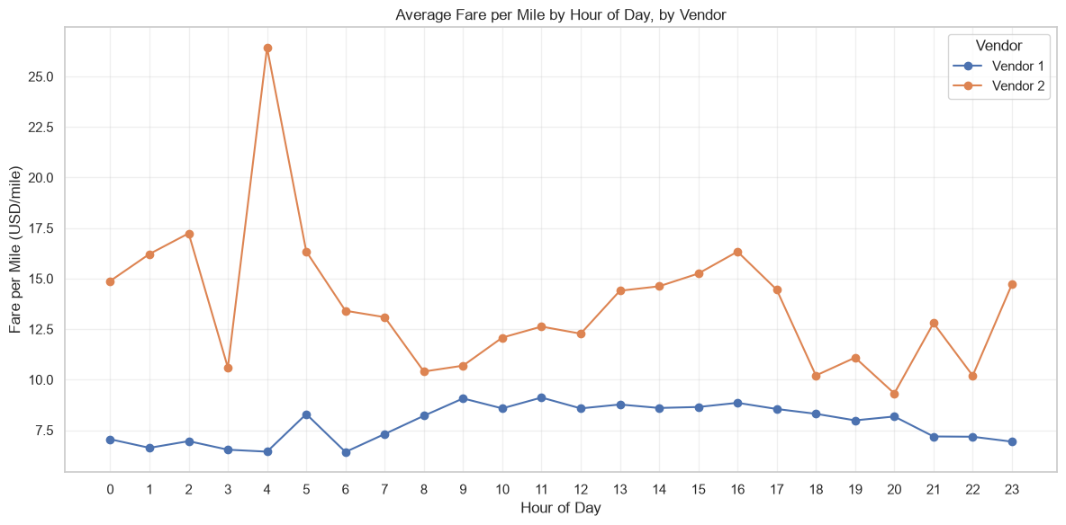

    - Compare the fare rates of different vendors in a distance-tiered fashion
To compare vendor fare rates fairly across trip lengths, trips with a positive distance were divided into three tiers: short (≤2 miles), medium (>2 to 5 miles, despite the label “2–5 mi”), and long (>5 miles). For each trip, fare per mile was calculated as fare_amount ÷ trip_distance.
The analysis grouped trips by distance tier and vendor, then calculated the mean fare per mile, median fare per mile, and trip count for each group. A pivot table and grouped bar chart compared the average rates across tiers and vendors. Boxplots showed the distributions within each tier; showfliers=False hides extreme points from the visual only, not from the summary statistics.
Segmenting by distance helps make vendor comparisons less affected by differences in trip-length mix. The mean reflects the average trip-level fare-per-mile ratio, while the median provides a less outlier-sensitive comparison. Because the dataset is sampled, the reported trip counts describe the sample; the mean and median rates themselves are not scaled.
The code shown does not include the resulting table or plots, so it does not establish which vendor had the higher rate in any tier. Also, trips with zero fares may remain in the data and affect the averages.
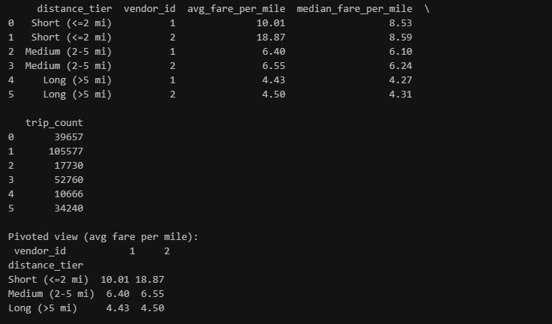
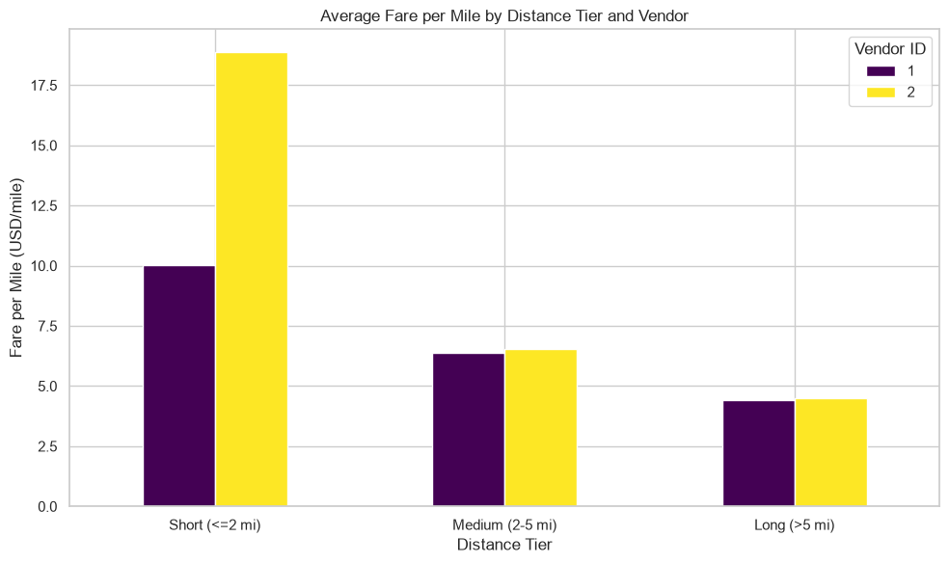
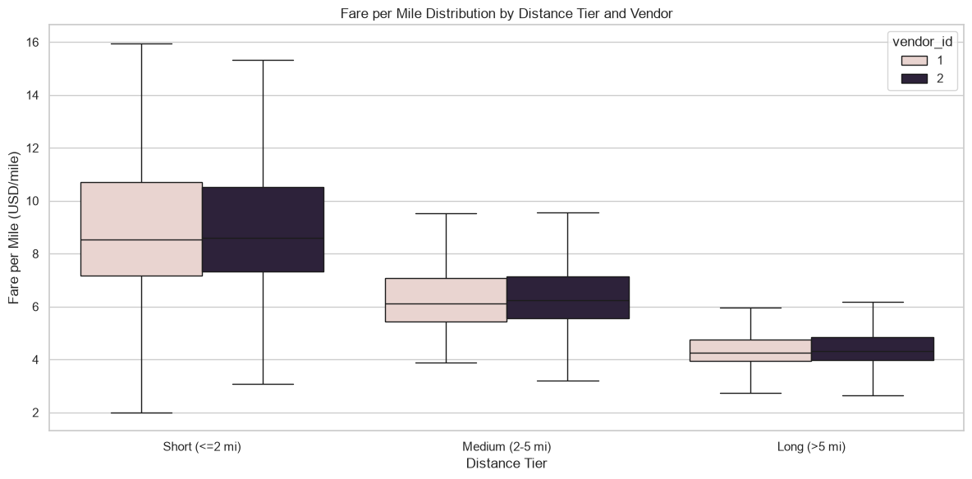
    - Analyse the tip percentages
Tip percentage was calculated for trips with positive fare and distance as:
tip_amount ÷ fare_amount × 100
Records with percentages below 0% or above 100% were excluded to limit the effect of invalid or extreme values. The remaining trips were grouped in three ways: by distance tier (up to 2 miles, over 2 to 5 miles, and over 5 miles), passenger count, and pickup hour. The mean tip percentage was calculated for each group and visualized with bar and line charts. Passenger-count groups with fewer than 20 trips were excluded from that comparison to reduce the influence of small samples.
The code also compared average tip percentage by payment type. This provides context for interpreting low observed tips: TLC records automatically populated credit-card tips, while cash tips are not recorded. Consequently, cash trips can appear to have low or zero tip percentages even when a cash tip was given. Tip-percentage differences—particularly by pickup hour—should therefore be interpreted as recorded-tip patterns, not necessarily differences in actual tipping behavior.
The code produces the summary tables and plots needed to identify which groups have lower averages, but their results are not shown here; specific group comparisons cannot be stated without those outputs.
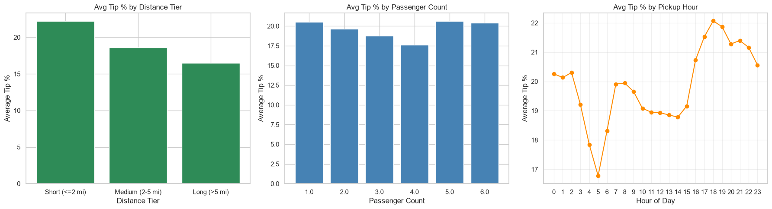
    - Analyse the trends in passenger count
Passenger-count trends were analyzed using the cleaned taxi-trip sample. The pickup day was represented by its weekday name and ordered from Monday to Sunday. The analysis then calculated the average recorded passenger count for each pickup hour, for each day of the week, and for every hour–day combination.
A line chart shows average passenger count across the 24 hours, a bar chart compares daily averages, and a heatmap displays the combined hour-and-day pattern. The heatmap helps identify times when trips tend to have higher or lower recorded occupancy.
These charts describe average occupancy per trip, not the number of trips or total passengers carried. Passenger counts are driver-entered and may include imputed values from the cleaning stage, so small differences should be interpreted cautiously. Specific peak or low-occupancy periods should be reported from the cell’s printed tables and visualizations; those results were not included in the provided excerpt.
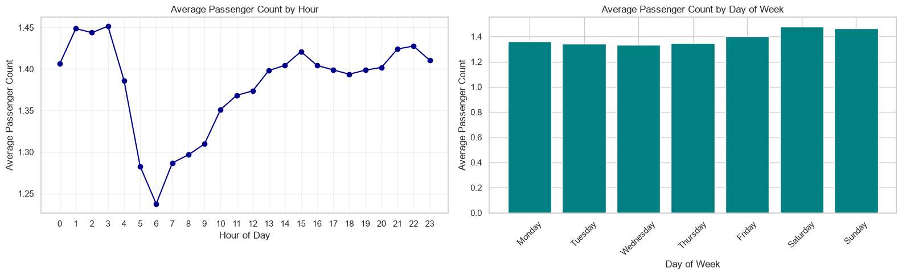
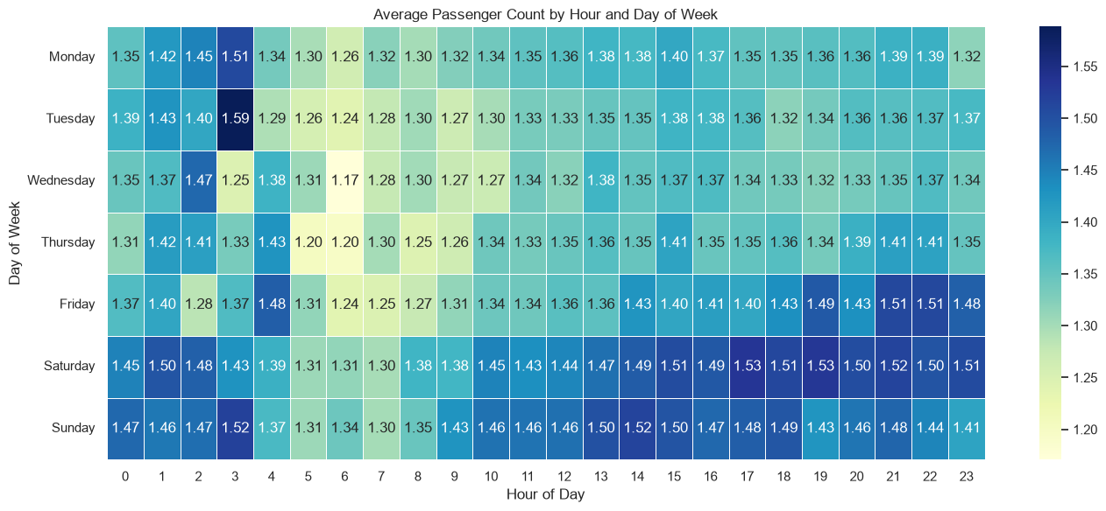
    - Analyse the variation of passenger counts across zones
Passenger-count variation was analyzed by pickup zone using the cleaned taxi-trip sample. For each pickup location ID, the code calculated the mean passenger count and the number of trips. It then retained zones with at least 20 trips to reduce the influence of averages based on very small samples. Zone IDs were matched to zone names and boroughs, and the highest and lowest average passenger-count zones were listed for comparison.
A choropleth map was also created by joining each zone’s average passenger count to the taxi-zone GeoDataFrame. Zones 264 and 265 were excluded from the map because they are placeholder locations without valid geographic areas; zones without usable data were shown in grey.
The analysis compares average passengers per trip, not the total passenger volume or number of trips in each zone. Passenger counts are driver-entered, and missing or zero values were replaced with the median during cleaning, so averages should be interpreted with that limitation in mind. The code identifies the zones with the highest and lowest averages, but their names and values should be taken from the cell’s output rather than inferred from the method alone.
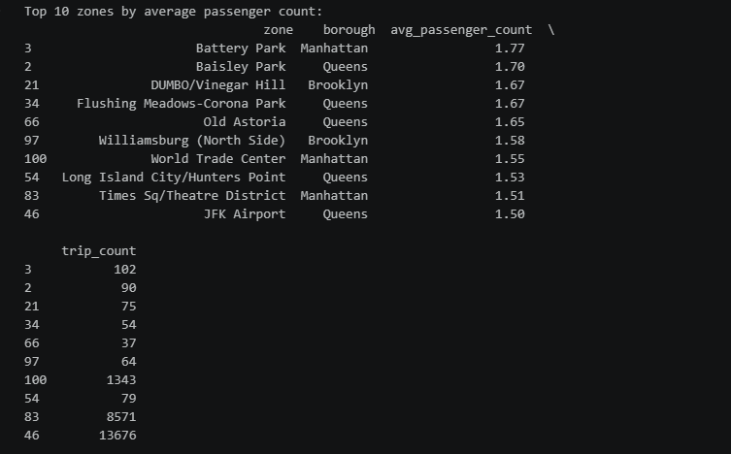
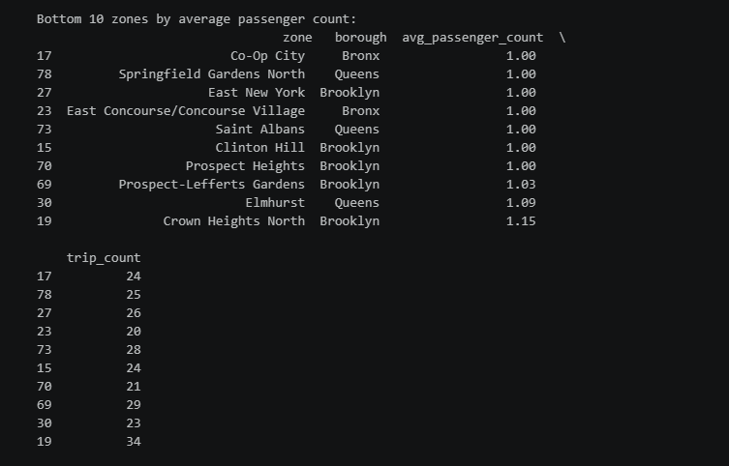
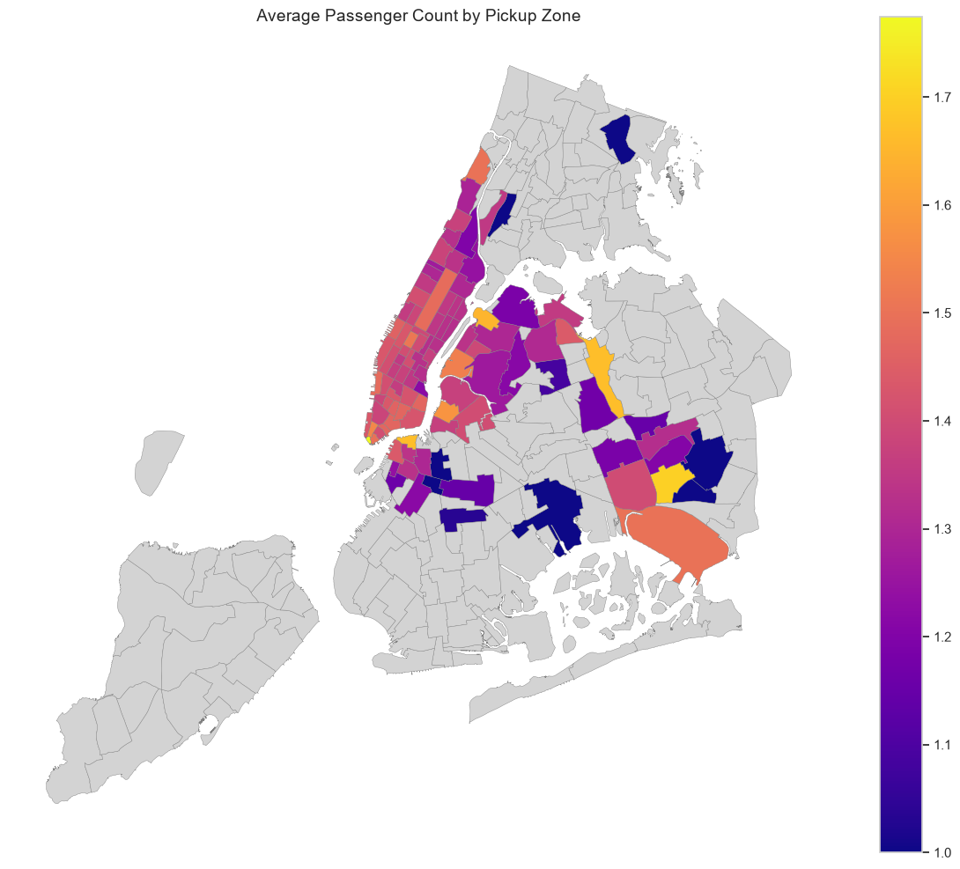

    - Analyse the pickup/dropoff zones or times when extra charges are applied more frequently.
The analysis examined how often surcharge fields were non-zero and how their application varied by time and location. It used a copy of the cleaned trip data so the surcharge analysis would not alter the main dataset.
Overall prevalence (cell 148): The code selected whichever of extra, mta_tax, improvement_surcharge, congestion_surcharge, and airport_fee were present. For each field, it calculated the percentage of trips where the value was non-zero and plotted the results. This provided an overall comparison of how frequently each listed charge appeared.
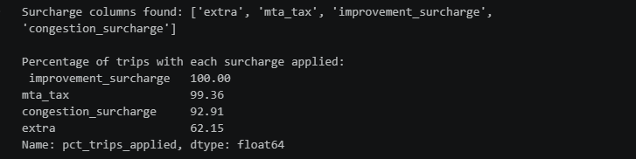
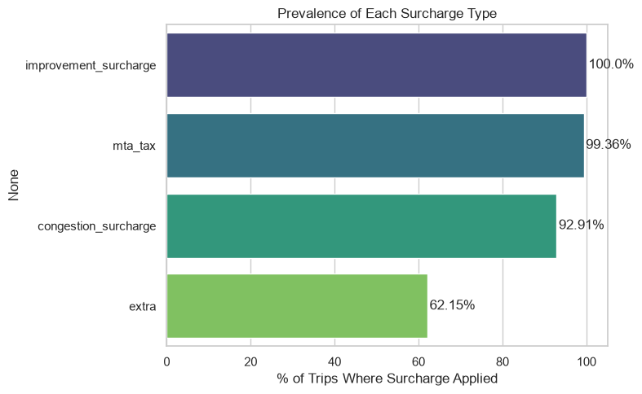
Variation by time (cells 150 and 151): The code created an any_surcharge flag for trips with at least one non-zero value among the selected fields. It then calculated the percentage of trips with each charge—and with any charge—by pickup hour and by day of the week. Line and bar charts were used to compare these application rates across time periods.
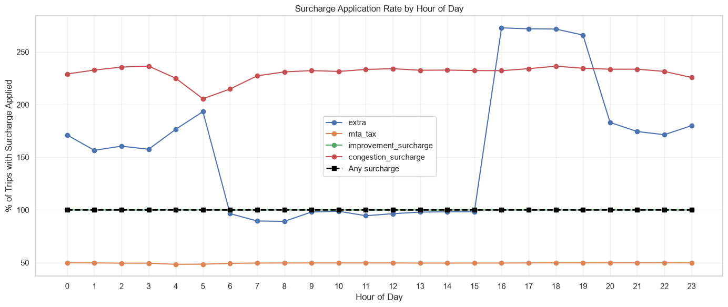
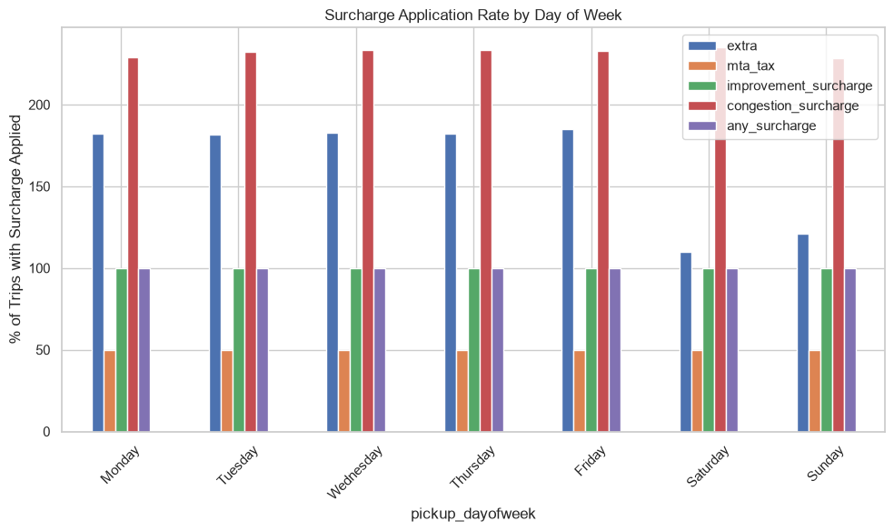
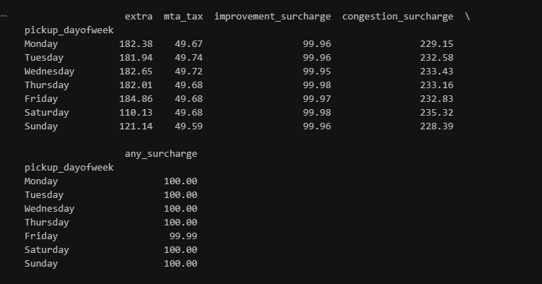
Variation by zone (cell 154): Separately for pickup and drop-off zones, the code calculated the share of trips with any surcharge. It excluded zones with fewer than 20 trips, joined the results to the taxi-zone lookup for names and boroughs, and printed the ten zones with the highest application rates. A bar chart was generated for the top pickup zones; the code prints the top drop-off zones but does not plot them.
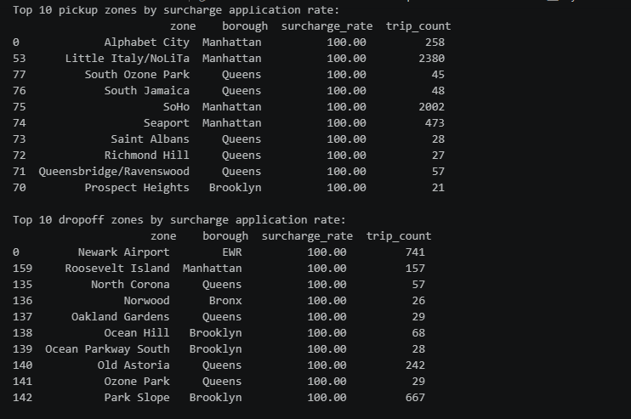
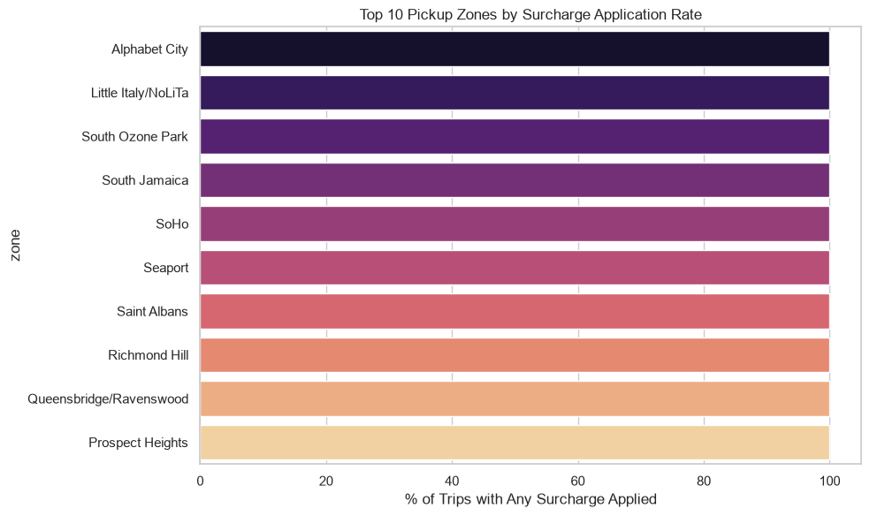
The analysis therefore compares surcharge application rates, not surcharge amounts or total surcharge revenue. The code’s outputs are needed to name the specific leading zones, hours, or days; those values are not included in the provided excerpt. Interpret the results with two caveats: they are based on a sample, and the code includes airport_fee only if that column exists—if airport fees were stored under a different name, they would not be included in these comparisons.

Conclusions

Final Insights and Recommendations
    - Recommendations to optimize routing and dispatching based on demand patterns and operational inefficiencies.
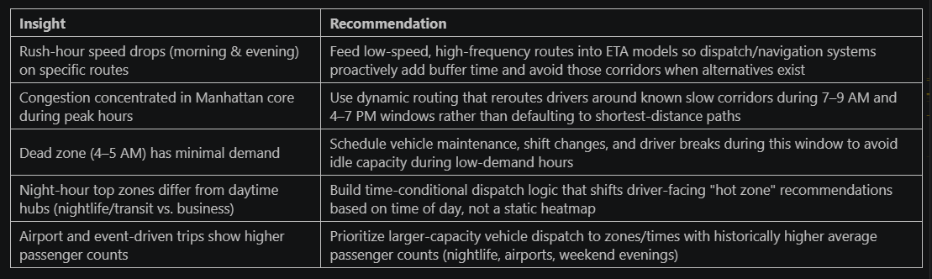

    - Suggestions on strategically positioning cabs across different zones to make best use of insights uncovered by analysing trip trends across time, days and months.

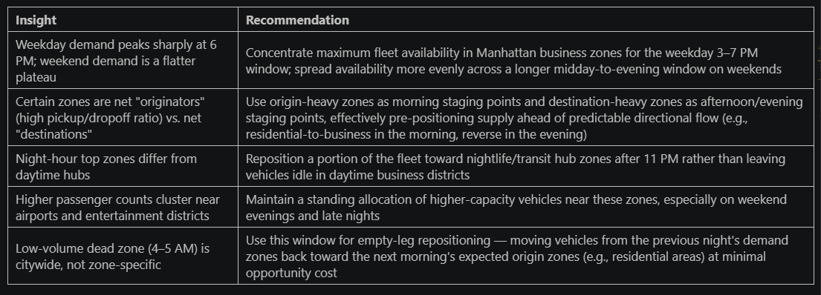

    - Propose data-driven adjustments to the pricing strategy to maximize revenue while maintaining competitive rates with other vendors.

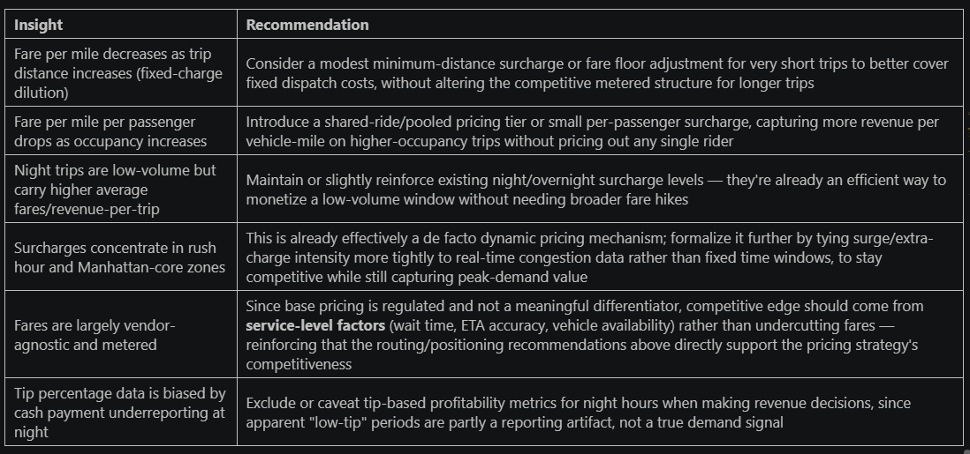

End of the Report

-Author
Jahangir Pasha
Email – Jahangir.Pasha.2006@gmail.com

