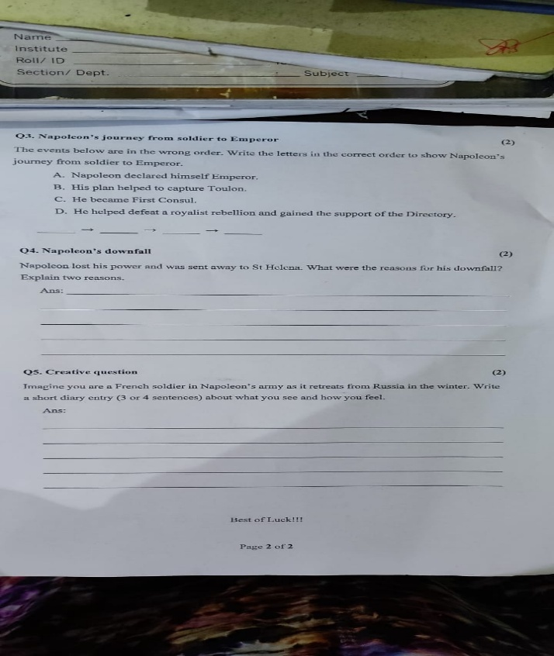
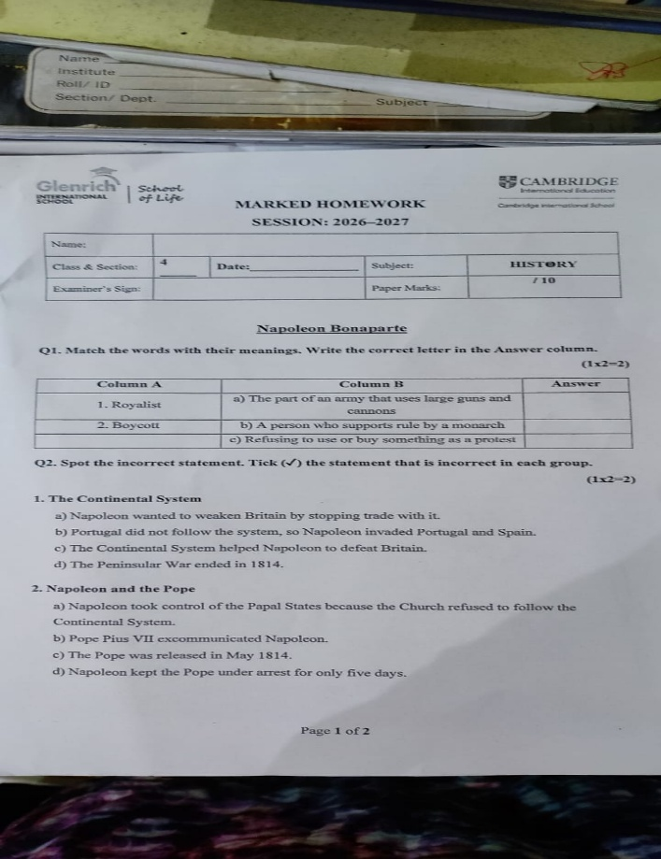
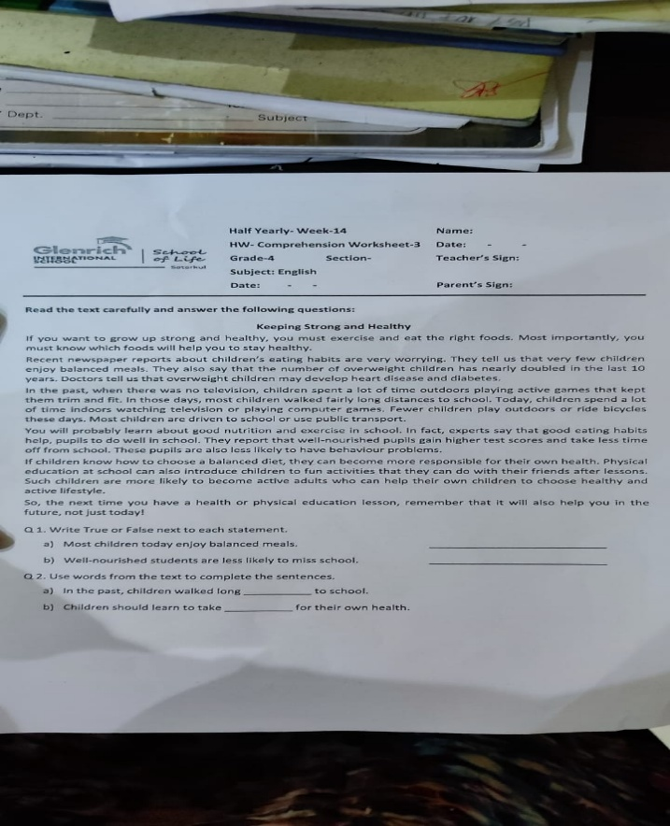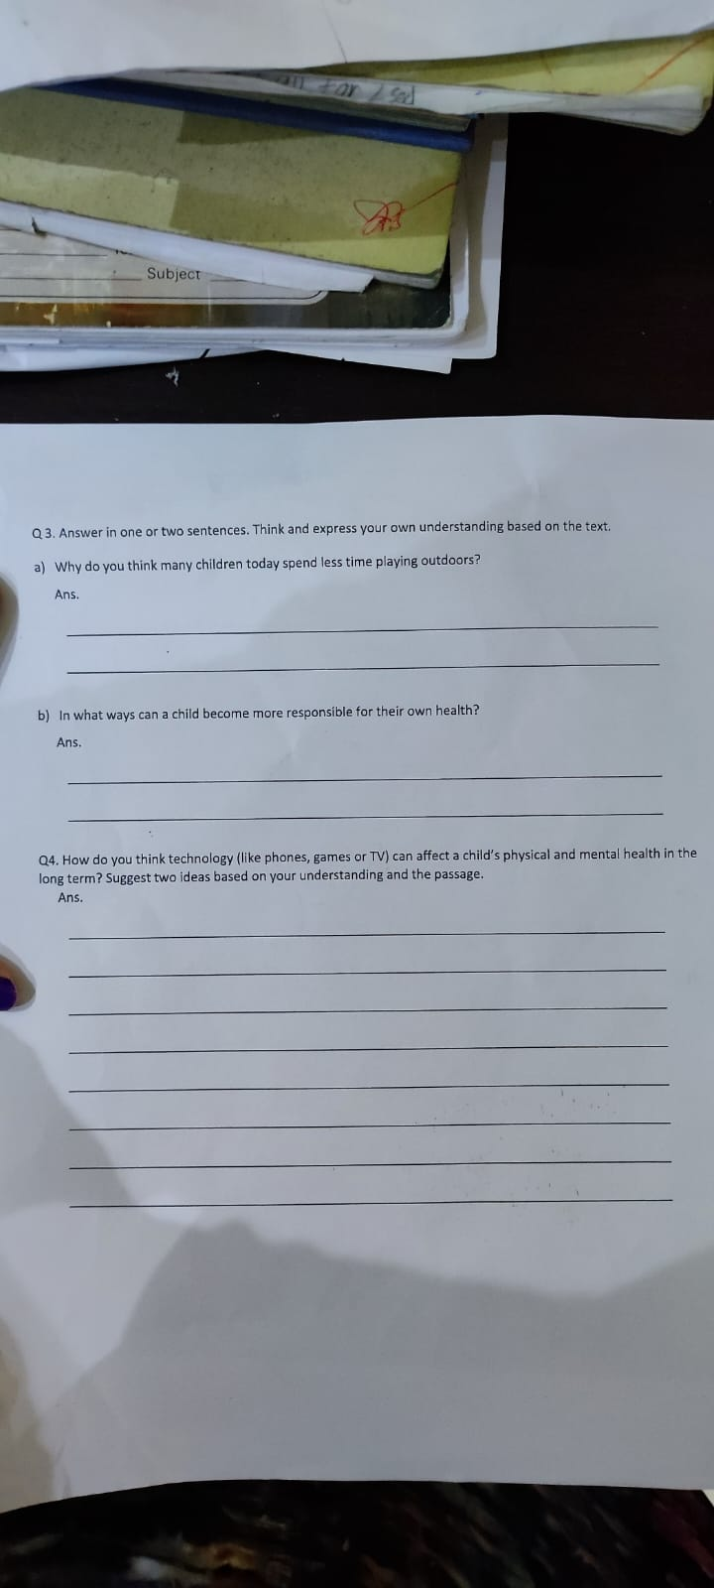

Q1. Match the words
- Royalist — b
- Boycott — c
Q2. Tick the incorrect statement
- The Continental System — c
- Napoleon and the Pope — d
Q3. Correct order: B → D → C → A
Q4. Napoleon’s downfall
- His invasion of Russia failed because of the severe winter and lack of supplies.
- His enemies united and defeated him at the Battle of Waterloo.
Q5. Diary entry
Dear Diary, The snow is freezing, and we have very little food. Many soldiers are tired and sick, and some are dying. I feel frightened and hope to return home safely.
- English – Keeping Strong and Healthy
Q1. True or False
  - a) False
  - b) True
Q2. Fill in the blanks
  - a) distances
  - b) responsibility
Q3. Answer in one or two sentences
a) Many children spend less time outdoors because they watch television and play computer games. They also use transport instead of walking.
b) A child can become responsible by eating balanced meals and exercising regularly. They should choose healthy habits.
Q4. Technology and health
Too much screen time can cause weight gain and reduce physical activity. It can also affect sleep and concentration. Children should play outdoors and limit screen time.

