**Pre-req of before open a defect:**

**1. Defect summary 2. Defect description 3. Screenshot 4. Test data 5. Timestamp**

**Post Request**

**1** Make post request with valid data (Bug)

Defect Description:

**Step:** Enter valid uri , valid payload , valid access token and select POST method and send the request.

**Expected**: User should see status code as **201 created**

**Actual**: User see wrong status code **200 OK** for POST request

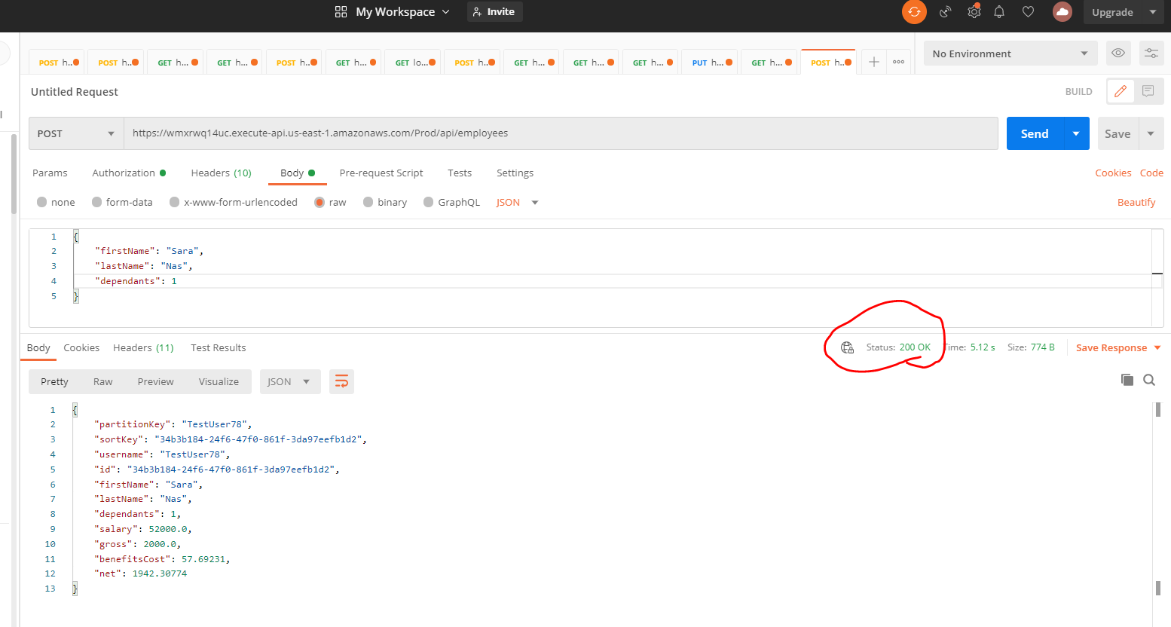

2. Verify response body and check if details are correct bug same issue for put and get

**Step**: Make POST request and verify response

**Expected**: Response body should be correct

**Actual**: Dependents spelling is incorrect (**dependants**)in response body

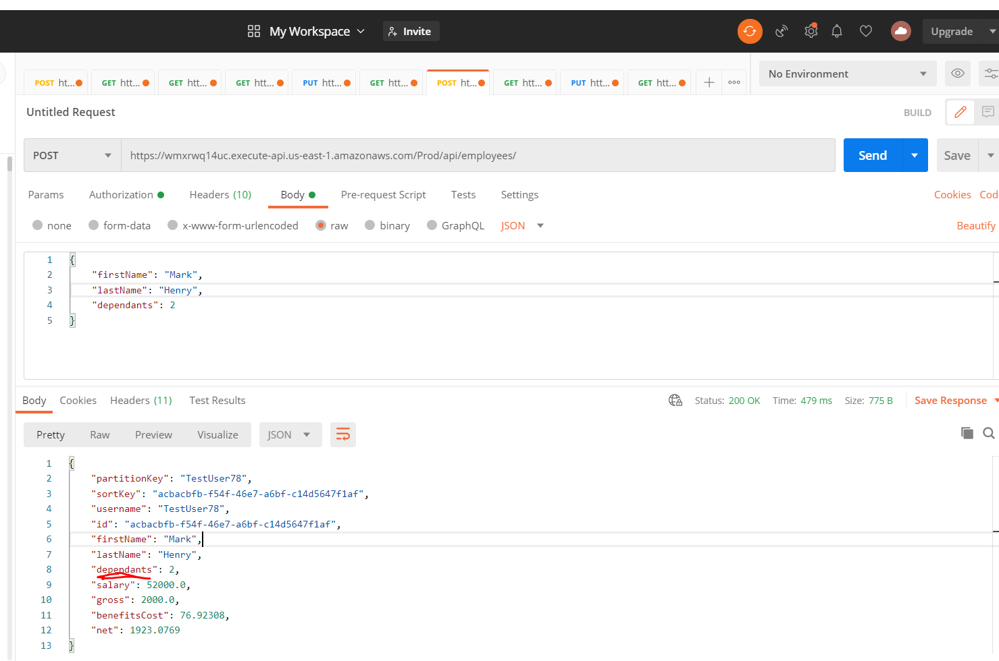

3. Post request with invalid access token (Bug) same issue observed for (Get, Put and Delete)

Description:

**Step:** Enter valid uri , valid payload , invalid access token(invalid user = TestUser7) and select POST method and send the request.

**Expected**: User should see status code **401 Unauthorized**

**Actual:** After making post request with invalid access token user can see wrong status code **500 internal server error.**

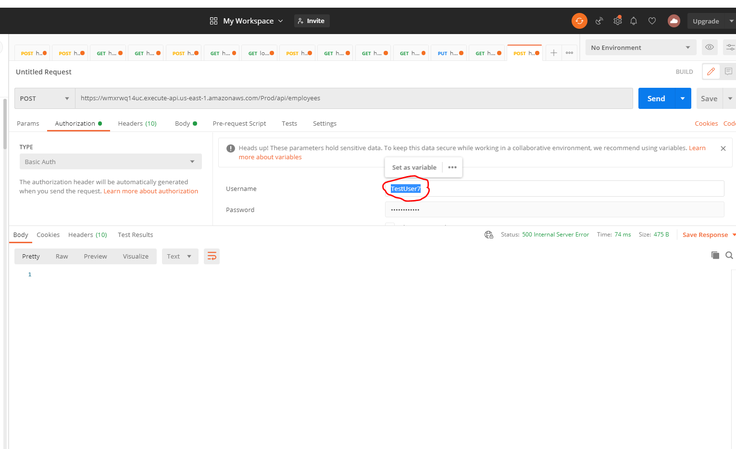

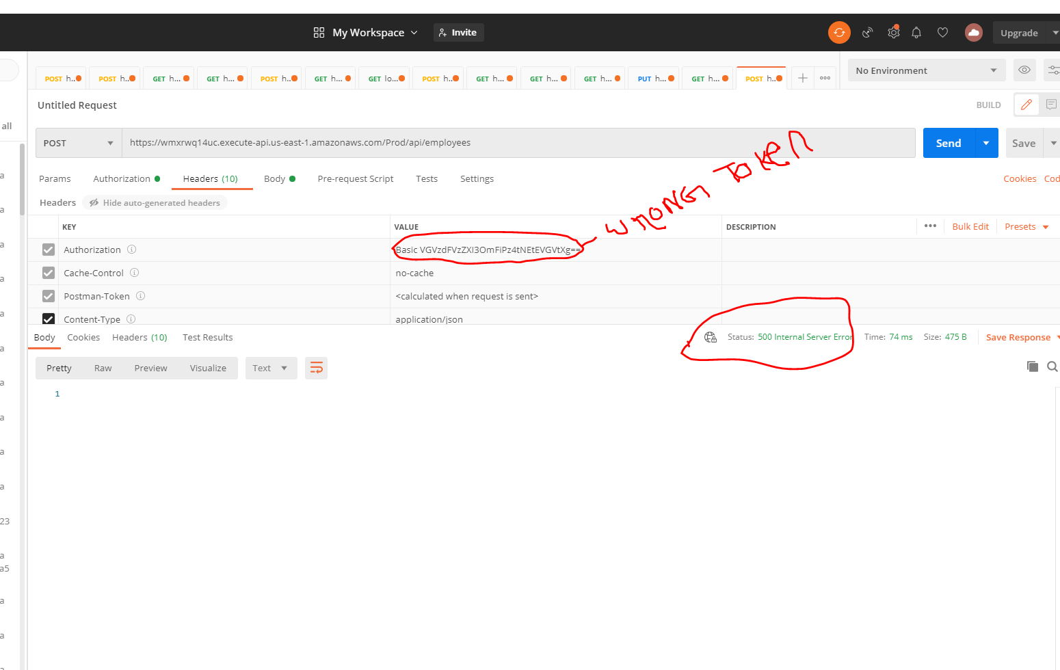

**4. Validating Post request with invalid payload**

**Step:** Enter valid uri , invalid payload **["firstName": ")(*&^%$",and "lastName": ")(*&^%",]** , valid access token and select POST method and send the request.

**Expected**: After making post request with invalid first name and last name user should see some error message.

**Actual**: after making post request with invalid first name and last name user **is not** observing any error message

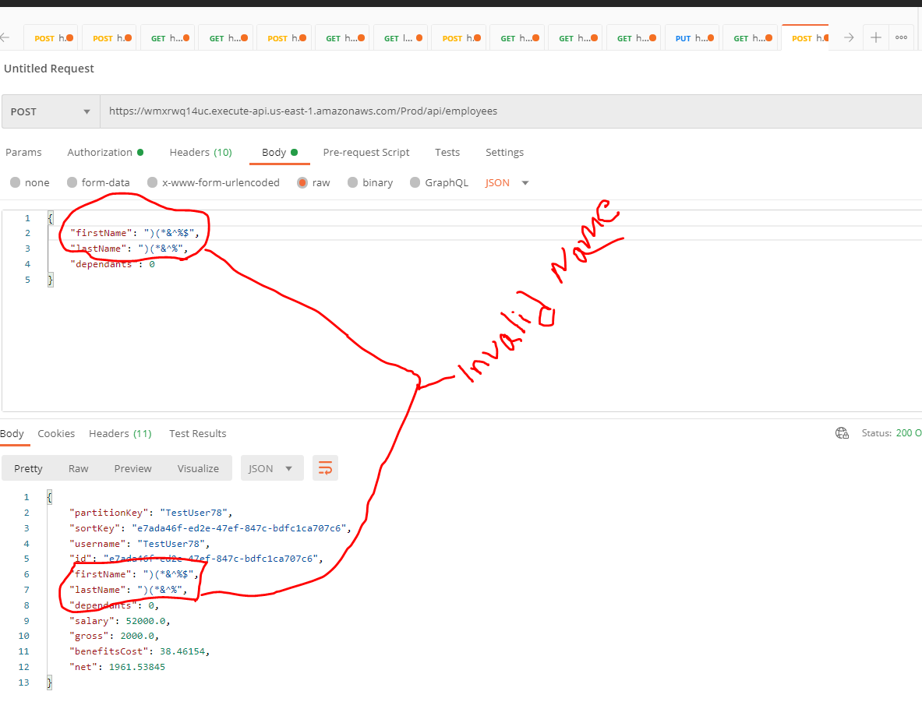

**Delete Request**

5. Make deleted request on already deleted employee details (Bug)

**Steps**:

1. Make a get request on available employee. It will show the correct response body
2. Delete the employee and it gets deleted as expected
3. Then delete the same employee again and user should expect some message since it is deleted before

**Expected**: User should see some error message for delete in response body.

**Actual**: User **does not** see any error message in response body

Make a get request

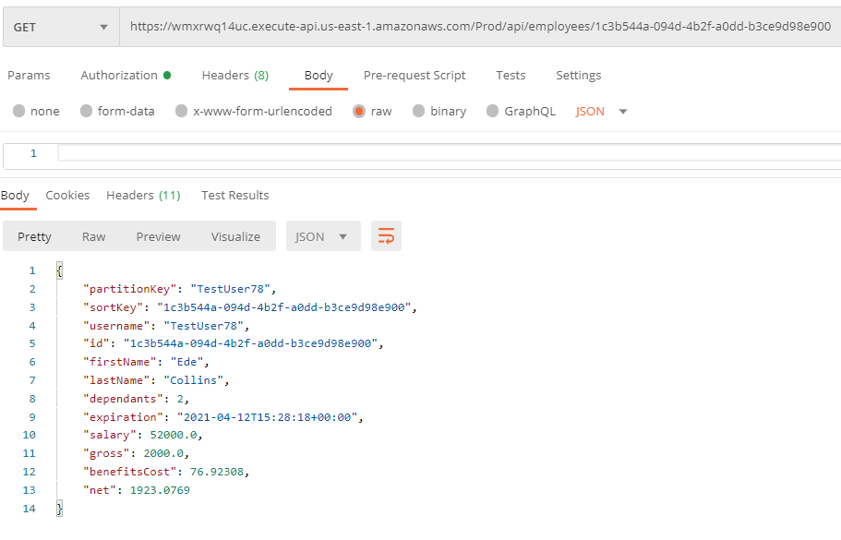

Delete the employee

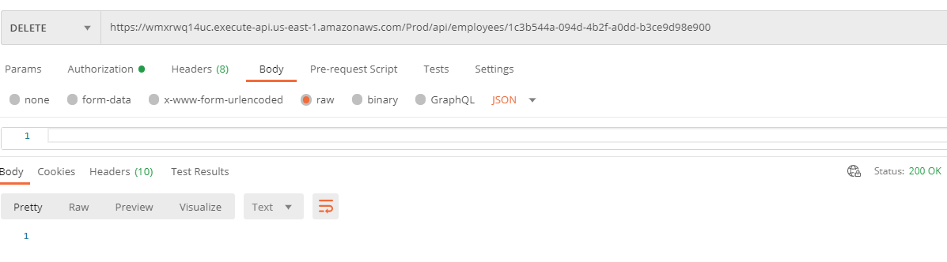

Delete request has been made on already deleted employee but no error message has shown, which is not expected

[1]

**Get Request**

**6.** Makinggetrequest by adding multiple forward slash at end of END POINT “ [https://wmxrwq14uc.execute-api.us-east-1.amazonaws.com/Prod/api/employees**///**](https://wmxrwq14uc.execute-api.us-east-1.amazonaws.com/Prod/api/employees///)” (Bug).

Same issue observed for (Put, Post and delete)

**Description**: Adding multiple forward slash at end of END POINT should throw error message.

**Step**: User add multiple forward slash at end of END POINT.

**Expected**: User should see an error message in response body.

**Actual**: User **did not** see an error message in response body.

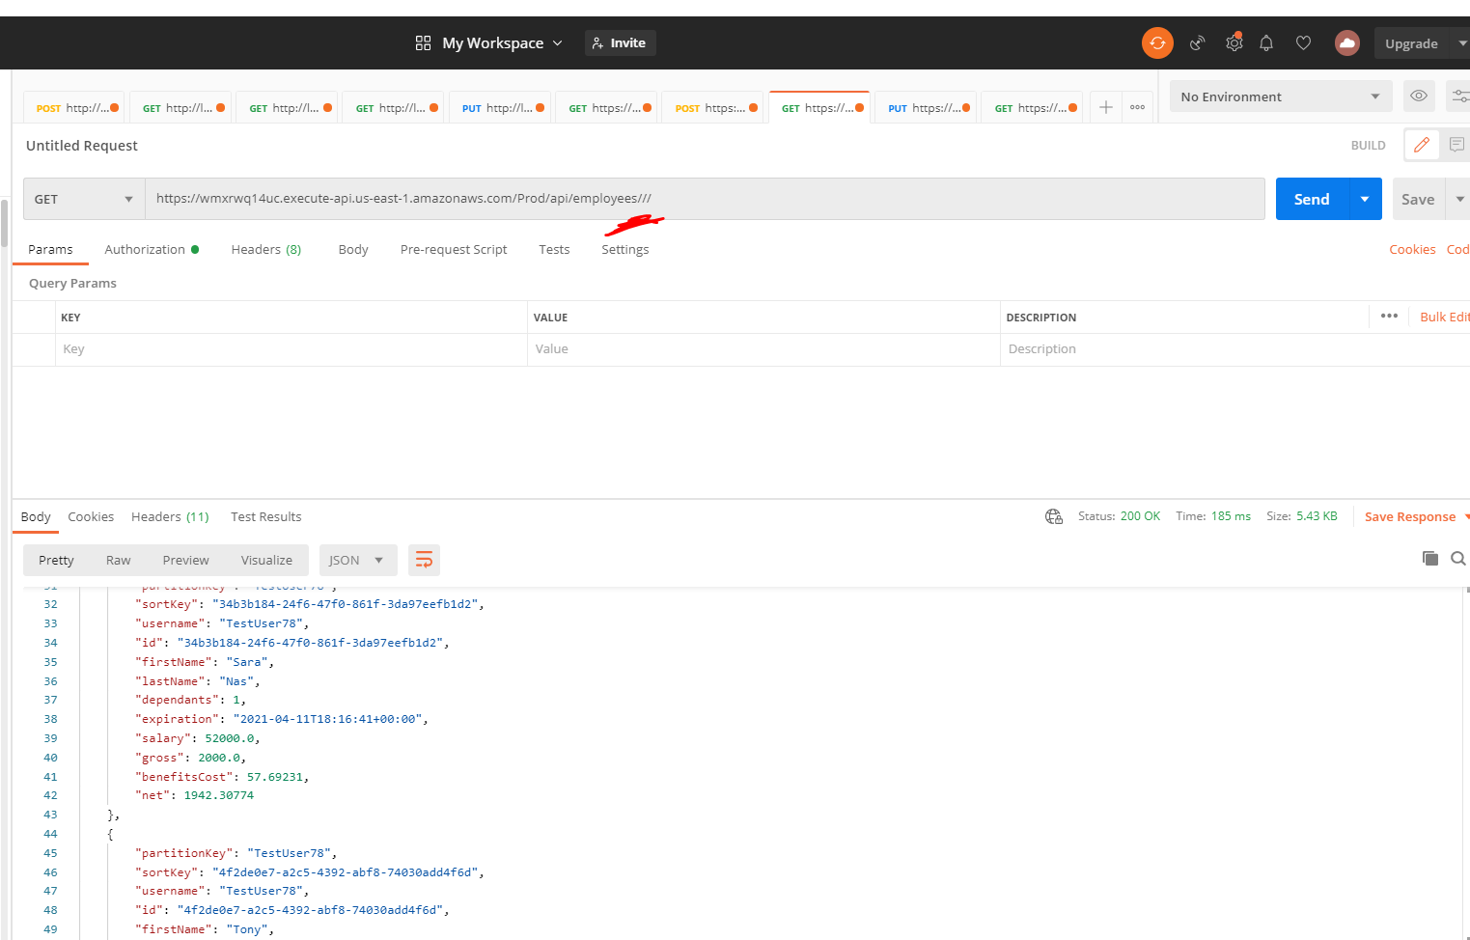

7. According to documentation

* GET request Header is (**Authorization** Basic = {{token}})

* POST request header are [**Content-Type =** application/json] **and [Authorization =** Basic {{token}}]

* PUT request header are [**Content-Type =** application/json] **and [Authorization =** Basic {{token}}]

None of the request work if I disable the **host** header which is not mention in documentation but I am not sure if it issue or not.

1.