Scenario 1: Add Employee

GIVEN an Employer

AND I am on the Benefits Dashboard page

WHEN I select Add Employee

THEN I should be able to enter employee details

AND the employee should save

AND I should see the employee in the table

AND the benefit cost calculations are correct

**Pre-req of before open a defect:**

**1. Defect summary 2. Defect description 3. Screenshot 4. Test data 5. Timestamp**

1. **Verify if Add employee form label name are correct bug**

**Step**: Veify if First name, Last name and Dependents label are correct

**Expected**: First name, Last name and Dependents label should be correct

**Actual**: Dependents spelling is incorrcect “**dependants**”

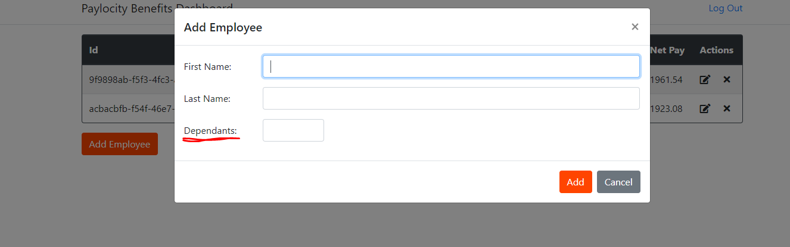

1. **Validated table header after adding an employee bug**

**Description**: After adding an employee make sure if table column and rows details are correct.

**Step**: Add valid first name, last name and dependents

**Expected**: Make sure all inputs are displaying correctly in the table

**Actual**: After adding an employee first name (Jahangir) and Last name (Khan).

**Under First name column Last name “Khan” is displaying**

**Under Last name column First name “Jahangir” is displaying**

Which is column mismatch error.

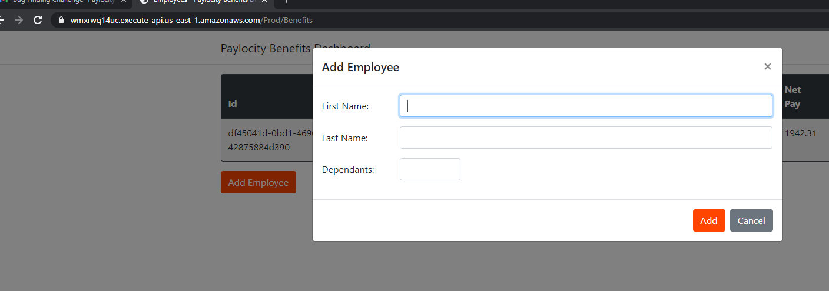

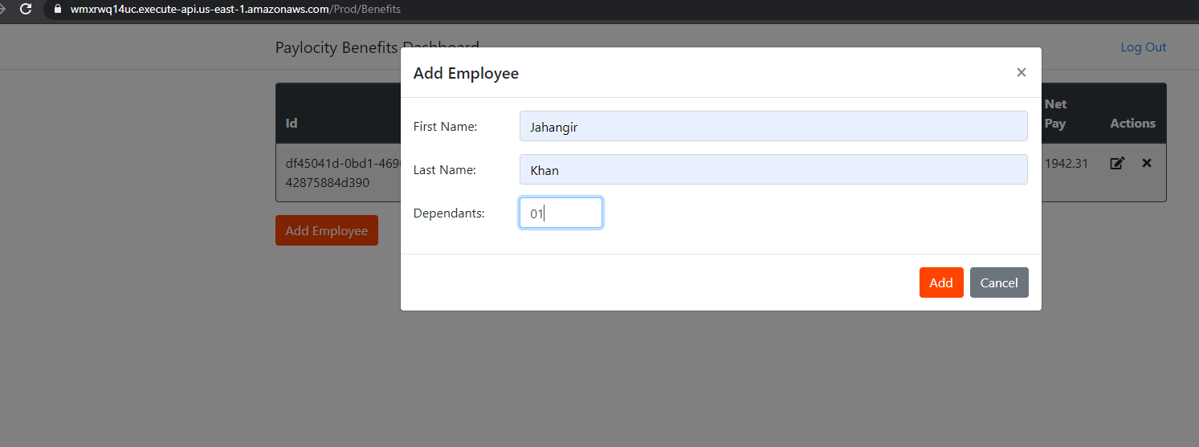

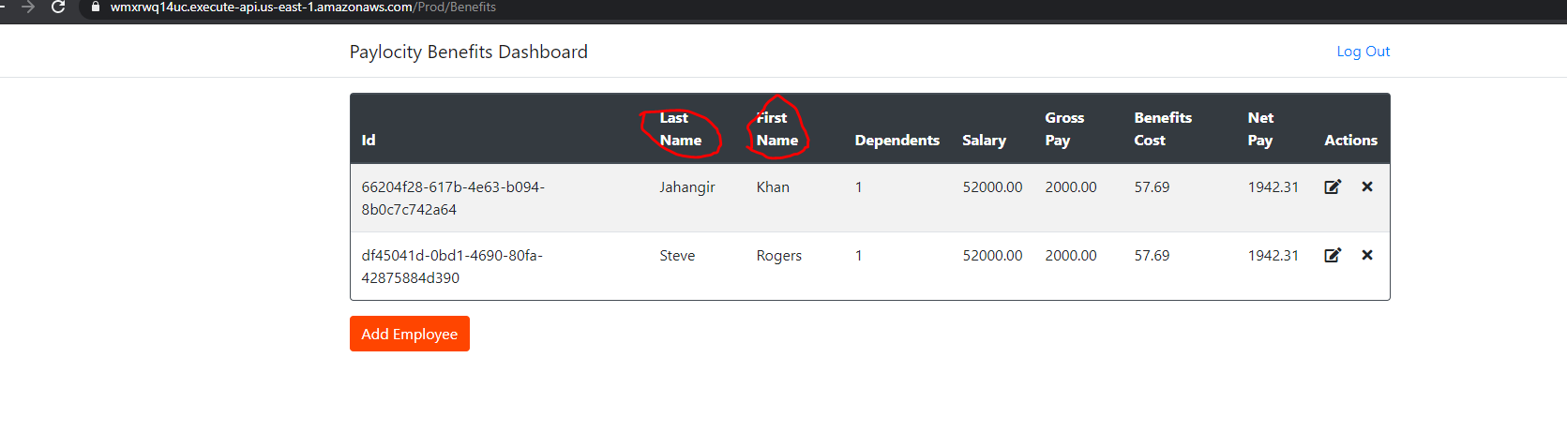

1. **Adding invalid name with only number and only special character bug**

**Description**: In my opinion name should not be only numbers and only special character

**Steps**: Enter (First name: 123456 Last Name: 123456) and (First name: !@#$%^ Last name: !@#$%^)

**Expected**: Application should not allow to add an employee with invalid first and last name.

**Actual**: User is not getting any error message after adding invalid first and last name

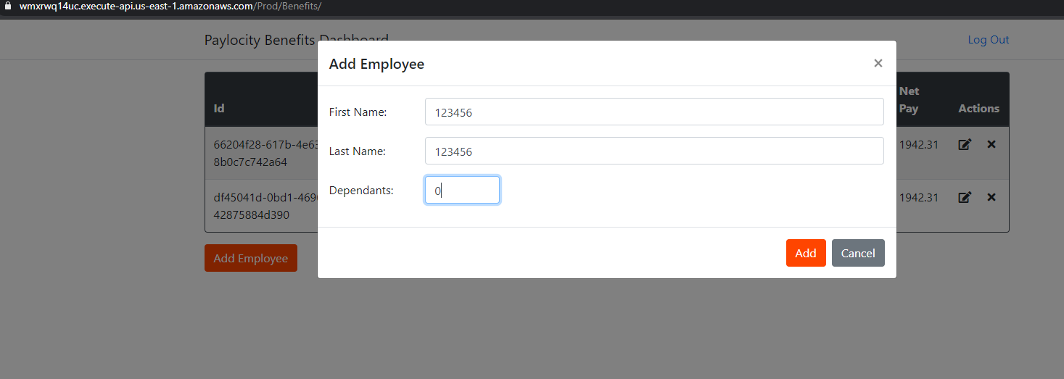

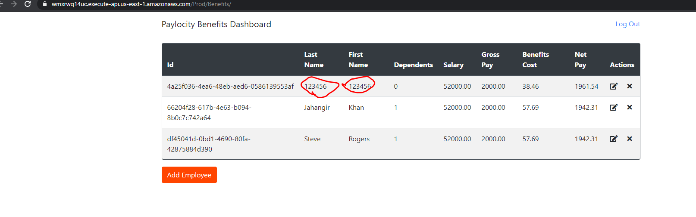

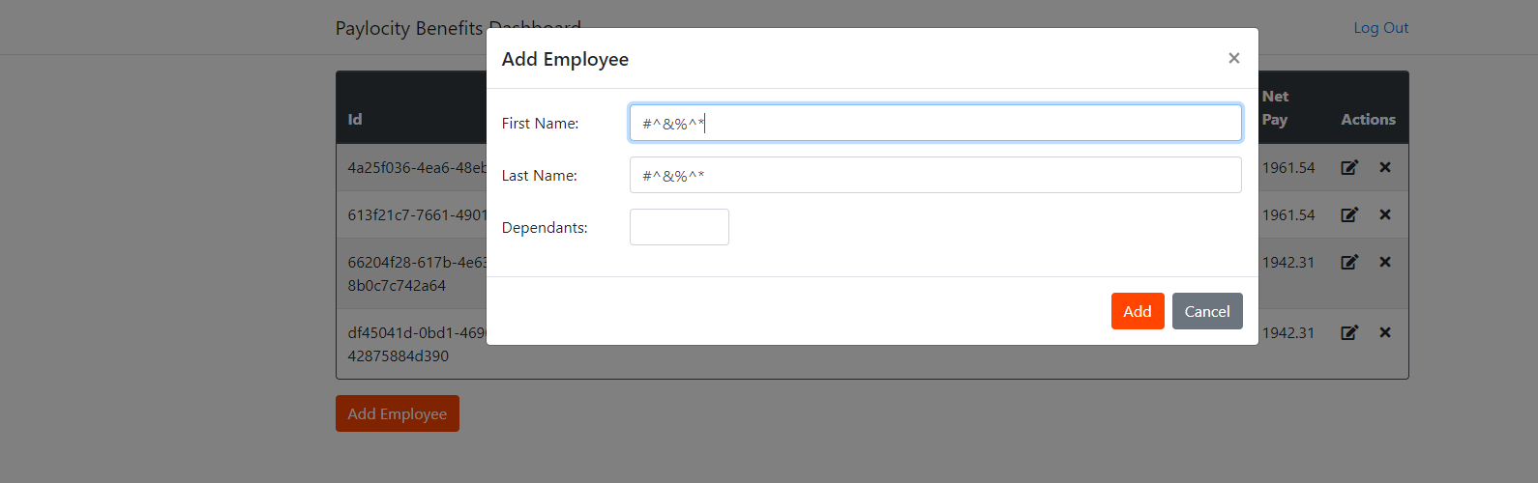

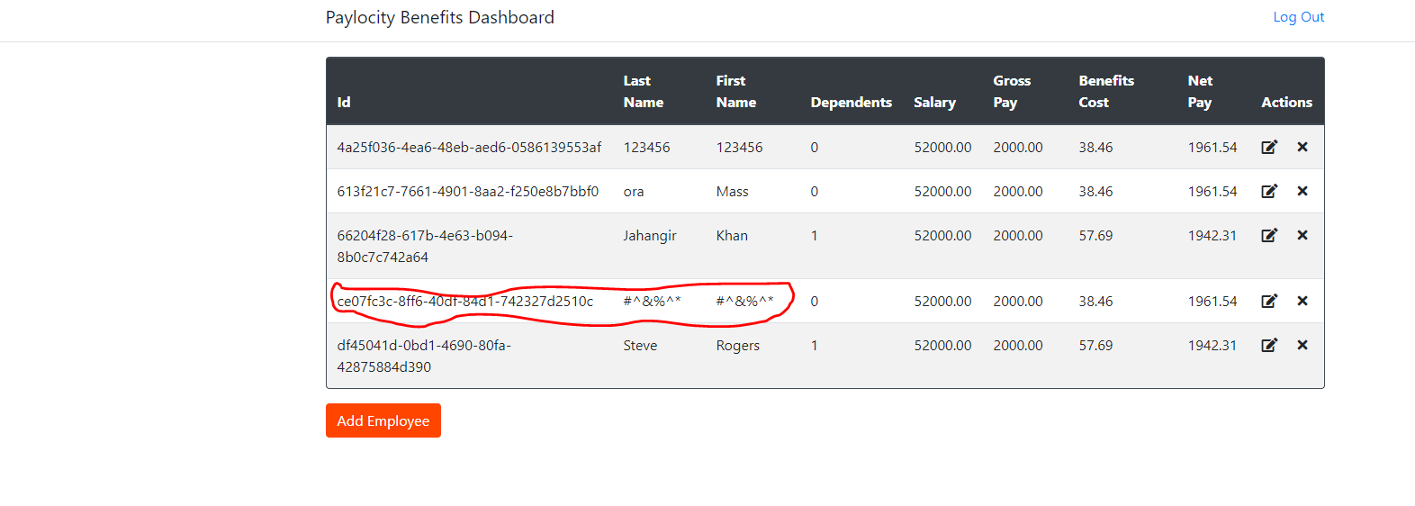

1. **Validating Add employee with only first name. bug**

**Step:** Leave mandatory field empty and clcik on add button

**Expected**: User should see some message for mandatory field

**Actual**: User does not see any message when try to add value without providing value to mandatory field.

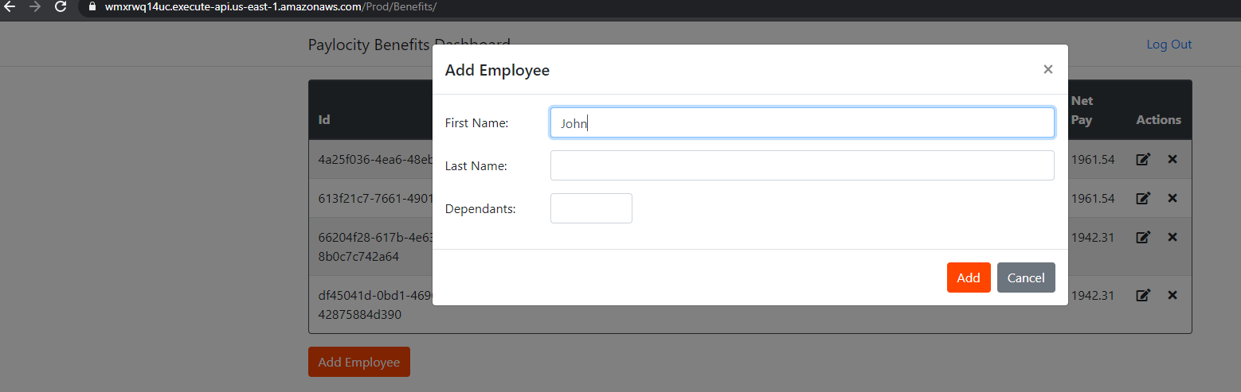

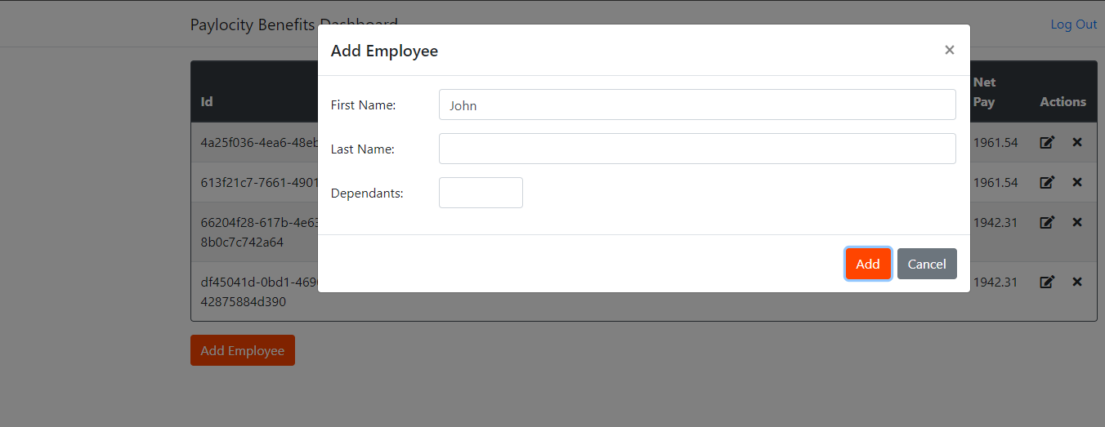

**Boundary Value analysis : First name/ Last name can contain 50 Character and less.**

**Dependents is not more than 32.**

Scenario 2: Edit Employee

GIVEN an Employer

AND I am on the Benefits Dashboard page

WHEN I select the Action Edit

THEN I can edit employee details

AND the data should change in the table

1. **Update employee (bug)**

**Description**: When user click on update icon user should see update employee form to update the data.

**Step**: User click on update icon

**Expected**: Update employee form should be displayed.

**Actual**: After clicking on update icon user can see wrong title name for update employee form

**“Add Employee”**. Form title name should be “Update Employee”

Click on update

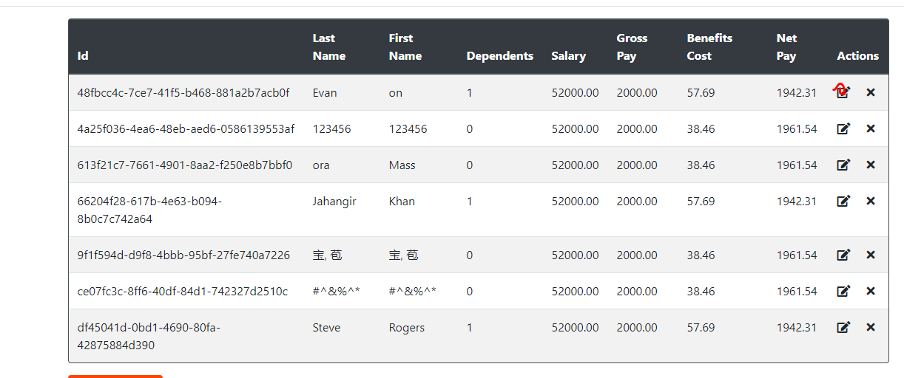

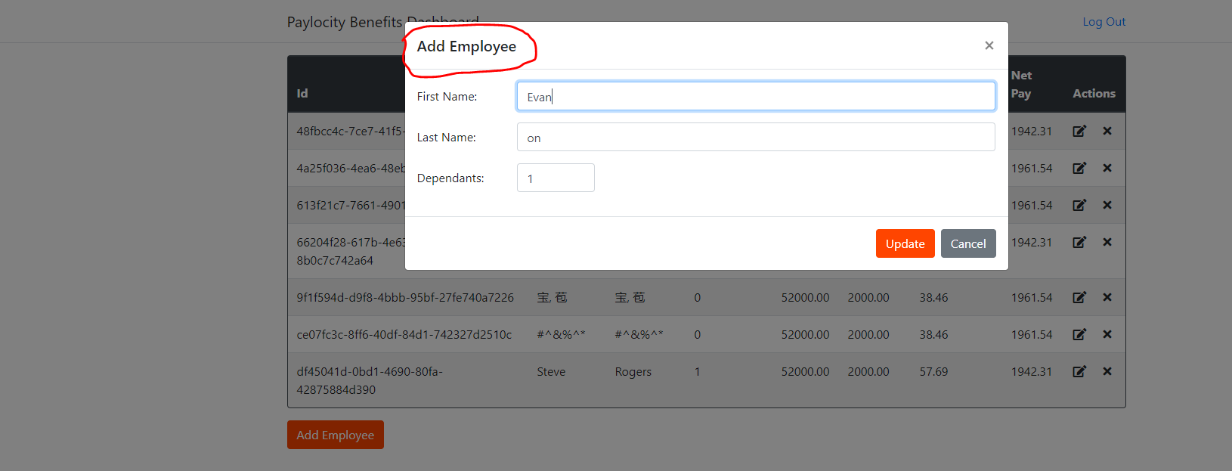

1. **Adding multiple forward slash at the end of the url bug**

**Description**: Adding multiple forward slash at the end of the url application should not allow.

**Step**: add multiple forward slash at the end of the url and press enter

**Expected** : Application should not allow multiple forward slash at the end of the url

**Actual**: Application is allowing multiple forward slash at the end of the url

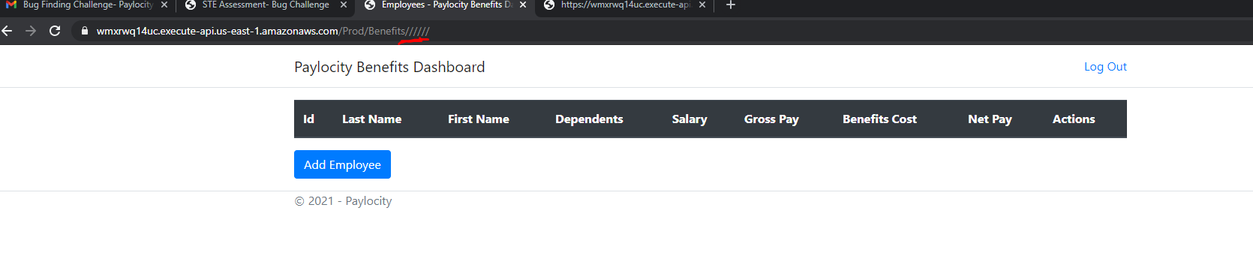

**Suggestions**:

1. After adding, updating and deleting user should see some successful message based on action performed
2. When user mouse hover on any icon it should show the icon description