Signal processing of ECG data to determine cardiovascular pathology

Problem statement
Signal processing (Fast Fourier transforms (FFT), Power spectral density (PSD)) has emerged as an important tool to provide an improved diagnosis of cardiovascular pathologies. Cardiovascular disorders are the leading causes of death in the United States, requiring an enhanced diagnosis to facilitate treatment at an early stage. An ECG (Electrocardiogram), which is a measure of the electrical conductivity of the heart, provides clinical information about the health of the heart. Parameter extraction from the ECG requires its preprocessing and analysis to obtain features that have prognostic value and provide a heart disease pattern. In the current problem, we will use FFT and PSD to differentiate ECG signals of normal subjects from those with having ventricular arrhythmias who eventually had sudden cardiac arrest. The ECG signals are obtained from the database collection provided by http://www.physionet.org/physiobank.

The FFT of a signal x(n) is given by
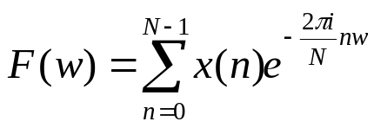; w=0,1,2 …N-1

If the signal is not exactly periodic, which means that the start and end points of the signal do not lie at the same point of the cycle, the FFT can have non-zero values even at non-resonant frequencies. In such a case, sometimes the peaks of the FFT can become smeared. This is known as leakage and is a very common situation in any measurement. To improve the FFT resolution, the signal is multiplied by a window which forces the signal to become perfectly periodic.
The power spectral density (PSD) of a signal indicates how the power of a signal is distributed in the frequency domain, i.e., it gives the energy spectrum of the signal. It is defined as the squared modulus of the FFT, scaled by the length of the signal.
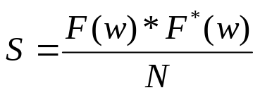
The power of the signal is given by the area of the PSD vs. frequency curve.

It has been shown that heart rate variability (HRV), which is a measure of beat to beat variations, exists in the ECG signal of a normal healthy subject and these variations are also cyclic in nature. The HRV can be used a measure of cardiac activities and how the cardiovascular system responds to various pathologies [1, 2]. Thus, it is an important non-invasive marker which can be computed either by time domain or frequency domain analysis of instantaneous heart rate (IHR). In the clinical setting, the IHR is measured using the heart rate in beats/min and is obtained by the extrapolation of the ECG signal. Specifically, it is obtained using the reciprocal of the RR time interval, which denotes the time between two beats. In this work, the IHR was obtained from the ECG data using the WFDB software package [3] and sampled at a rate of 4 Hz. In the frequency domain, HRV is computed using the PSD of the IHR. It has been shown that HRV decreases in cardiovascular disorders such as congestive heart failure (CHF) and ventricular tachycardia [4, 5]. The power spectrum of the heart rate variability can be divided into three parts: the very low frequency (VLF) component (0.001-0.04 Hz), the low frequency (LF) component [0.04-0.15 Hz] and high frequency (HF) component (0.15-0.4 Hz) [6]. The HF is associated with the respiratory cycle and the LF component has been shown to be associated with parasympathetic and sympathetic activity. Both of these components can be affected during cardiovascular pathologies.

The ECG signals for a normal subject and for a patient who eventually encountered sudden cardiac death following ventricular tachyarrhythmia (VT) were obtained from the physionet database [7] and were processed to get the instantaneous heart rate, using the WFDB software package [3]. The IHR signal was multiplied by a Hanning window to reduce leakage effects and FFT was computed using Matlab®. The PSD and the power in the LF, HF regions were computed as described above.

The IHR and PSD of the healthy subject and a subject who eventually encountered sudden cardiac arrest following ventricular tachyarrhythmia (VT), are depicted in Figures 1(a, b) and 2(a, b), respectively. These data are obtained after processing the ECG data from the MIT-BIH Normal Sinus Rhythm Database and Sudden Cardiac Death Holter Database available at http://www.physionet.org/physiobank.

A comparison of Figs. 1(b) and 2(b) shows that following VT, the amplitude of the PSD of IHR (or HRV) is reduced, thereby indicating a smaller amount of energy associated with the same. Further, in the case of VT, the PSD is a little flatter compared to a healthy subject. Thus, visual differences can be seen in the HRV of the two subjects. Further quantification of this difference is done by computing the power in the HF and LF regions.
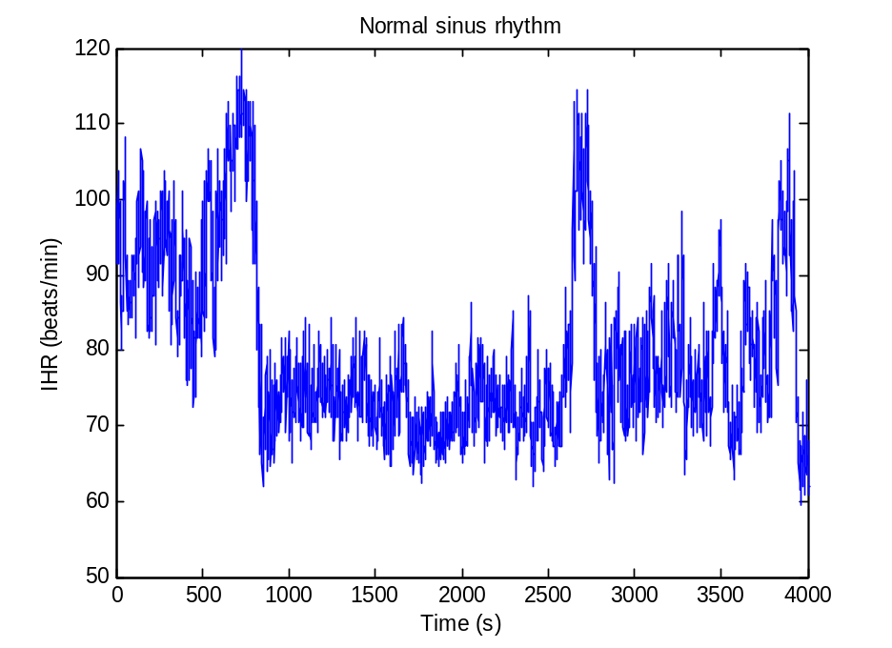

(a)

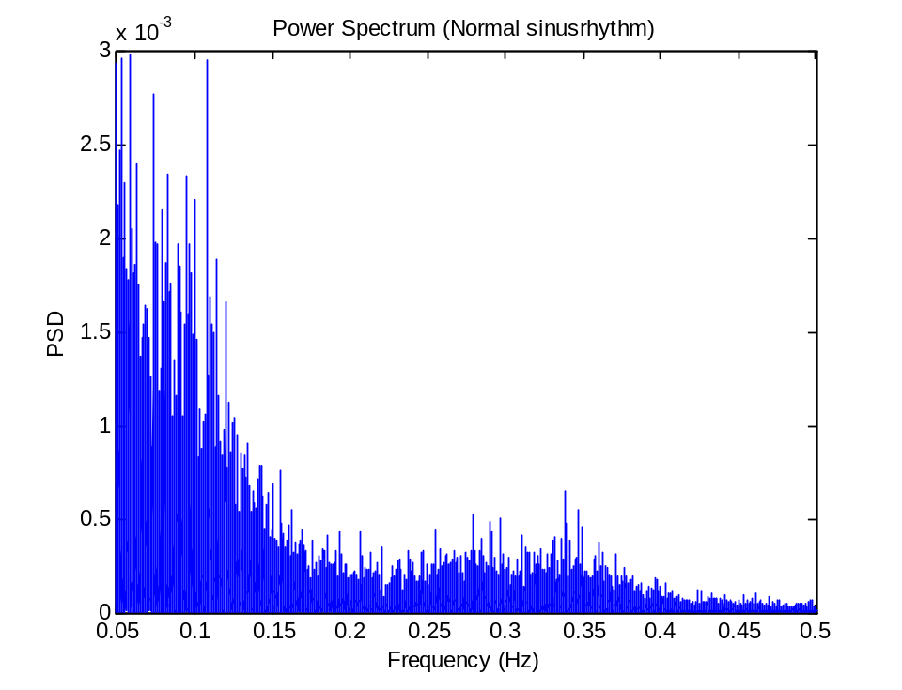

(b)
Figure 1: (a) Instantaneous heart rate (b) PSD of IHR for normal sinus rhythm

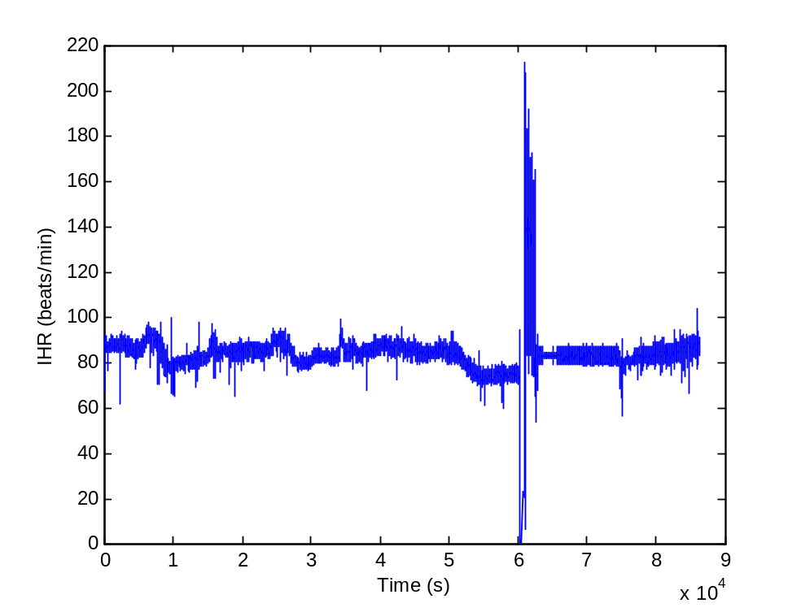

(a)

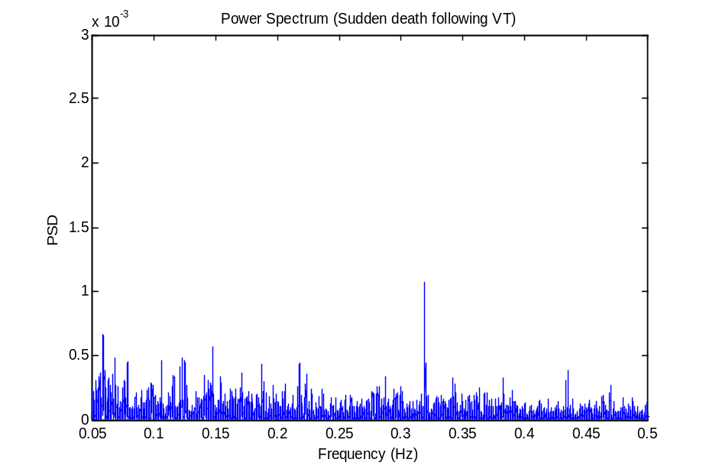
(b)

Figure 2: (a) Instantaneous heart rate (b) PSD of IHR for a patient who had a sudden cardiac arrest following ventricular tachyarrhythmia
Figure 3 compares the power in the HF and LF for the two cases. It can be seen that the normal subject is found to have a significantly higher power in the LF and HF as compared to the patient with VT. This indicates that for VT, the HRV is significantly reduced compared to a normal healthy subject, thereby suggesting that HRV obtained using the frequency domain approach can be an important indicator of cardiovascular pathologies.

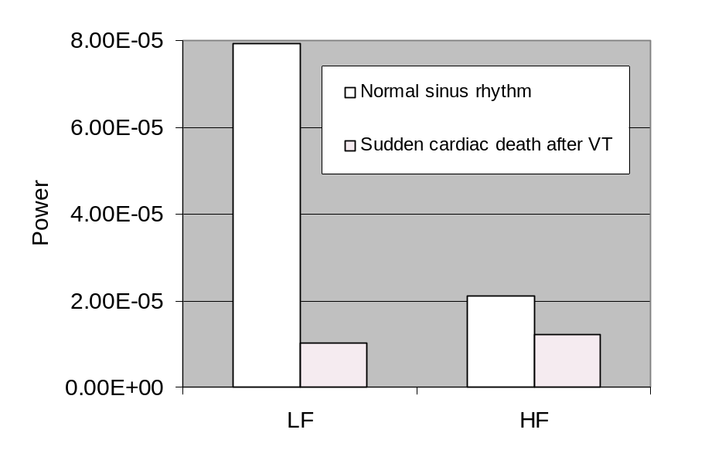
Figure 3: Comparison of power for a healthy subject (normal sinus rhythm) and sudden cardiac arrest following ventricular tachyarrhythmia.

References
- Solange Akselrod, David Gordon, F. Andrew Ubel, Daniel C. Shannon, A. Clifford Barger, Richard J. Cohen. Power Spectrum Analysis of Heart Rate Fluctuation: A Quantitative Probe of Beat-To-Beat Cardiovascular Control. Science, New Series, 1981, 213: 220-222.

- Task Force of the European Society of Cardiology and the North American Society of Pacing and Electrophysiology. Heart Rate Variability: Standards of Measurement, Physiological Interpretation, and Clinical Use Task Force. Circulation, 1996, 93: 1043-1065.

- http://www.physionet.org/physiotools/wfdb.shtml
- Casolo G, Balli E, Taddei T, Amuhasi J, Gori C. Decreased spontaneous heart rate variability in congestive heart failure. American Journal of Cardiology, 1989, 64: 1162-1167.

- Huikuri HV, Valkama JO, Airaksinen KE, Seppänen T, Kessler KM, Takkunen JT, Myerburg RJ. Frequency domain measures of heart rate variability before the onset of nonsustained and sustained ventricular tachycardia in patients with coronary artery disease. Circulation, 1993: 1220-8.

- Zhong, Yuru, Bai, Yan, Yang, Bufa, Ju, Kihwan, Shin, Kunsoo, Lee, Myoungho, Jan, Kung-Ming, Chon, Ki H. Autonomic nervous nonlinear interactions lead to frequency modulation between low- and high- frequency bands of the heart rate variability spectrum. American Journal of Physiology, 2007, 293: R1961-R1968.

- http://www.physionet.org/physiobank/database/#ecg

