Q. Design an SRS (Software Required Specification) document for implementing UMS (University Management System) in LPU for Teachers as well as for students.

Input specification:
Software should able to help the students to view their marks, attendance, online fee payment facility etc.
Software should able to help the teachers to view their attendance, to upload marks, daily activities etc.

Output specification:
Design an SRS

Contents

1. Introduction 2
1.1. Purpose 2
1.2. Document Conventions 3
1.3. Scope 3
2. Overall Description 4
2.1 Product Perspective 4
2.2 Product Features 5
2.3 User Classes and Characteristics 6
2.4 Operating Environment 6
2.5 Design and Implementation Constraints 6
2.6 User Documentation 6
2.7 Assumptions and Dependencies 7
3. System Features 8
3.1. Database – Storage 8
3.2. Functional Requirements 8
3.2.1 Interface Requirements 8
3.2.1.1 User Interfaces 9
4. Non Functional Requirements 10
4.1. User Interfaces 10
4.2. Hardware Interfaces 10
4.3. Software Interfaces 11
4.4. Communications Interfaces 11
5. Other Nonfunctional Requirements 11
5.1. Performance Requirements 11
5.2. Safety Requirements 11
5.3. Security Requirements 12
5.4. Software Quality Attributes 12
5.5 Hardware Constraints 12
5.6 Software Constraints 12
5.7 Design Constraints 12

This document has been prepared in accordance with the IEEE Std 830-1998, IEEE Recommended Practice for Software Requirements Specifications [IEEE 1998].

SRS table of content:

Introduction

1.1. Purpose

The main objective of this document is to illustrate the requirements of the project University Management system. This document describes the design decisions, architectural design and the detailed design needed to implement the system. It provides the visibility in the design and provides information needed for software support. The document gives the detailed description of the both functional and non functional requirements proposed by the client. The document is developed after a number of consultations with the client and considering the complete requirement specifications of the given Project. The final product of the team will be meeting the requirements of this document.

1.2. Document Conventions

The following are the list of conventions and acronyms used in this document and the project as well:
Administrator: A login id representing a user with user administration privileges to the software
User: A general login id assigned to users
Client: Intended users for the software
SQL: Structured Query Language; used to retrieve information from a database
SQL Server: A server used to store data in an organized format
ASP: Active Server Pages: A Web Page formatted on the server and delivered to the browser.
Layer: Represents a section of the project
User Interface Layer: The section of the assignment referring to what the user interacts with directly.
Application Logic Layer: The section of the assignment referring to the Web Server. This is where all computations are completed.
Data Storage Layer: The section of the assignment referring to where all data is recorded
Data flow diagram: It shows the dataflow between the entities.
Use Case: A broad level diagram of the project showing a basic overview
Boolean: A true/false notation
Interface: Something used to communicate across different mediums
Unique Key: Used to differentiate entries in a database
1.3 Scope
Online Project Marking System is developing for School of Computing, University of Portsmouth and used to replace old paper work system and PUMS. OPMS is to build upon the existing web-based project marking system PUMS in order to implement the project marking process and allocating supervisor/ideas to students. This increase in efficiency of project marking, audit trails of marking process, give feedback to student, finally, publication and email student result. It provides a mechanism to edit the online marking form which makes the system is flexible.
2. Overall Description

2.1 Product Perspective

The proposed University Management System is an on-line University Management System. This System will provide a view, submit, online payment, uploading various documents and other mislenious resources. This view will be based on the categories like attendance view and daily activities. Further the University management staff personnel(faculty) can add/update/remove the resources or an automatic removal of accessing features when the time limit completes.
The System will also have an ADMIN who has full-fledged rights with regards to managing resources across branches – such as transferring books across these branches. The users can view, submit, online payment, uploading various documents and information about their account etc. there are basic two types of users one is the students and other are faculty members. Each user facilitates with a different account number having a profile along with a password for private use. The two types of users differ from each other due to the accessing limits to online University management system.

2.2 Product Features

There are three different users who will be using this product:
University chancellor who will be acting as the administrator.
Faculty members who are second level users accessing UMS.
Student of the University who will be accessing the UMS online.

The features that are available to the Administrator are:

The administrator has the full-fledged rights over the UMS.
Can create/delete an account.
Can view the accounts.
Can change the password.
Can hide any kind of features from the both of users.
Insert/delete/edit the information of available on UMS.
Can access all the accounts of the faculty members/students.
The features available to the Faculty members are:
Can mark the attendance of students online.
Can view the attendance online.
Can upload marks, assignments, reading materials for students.
The features available to the Students are:
Can view the different categories of assignments available in their account.
Can view their marks.
Can view the various reading material.
Can view attendance.
Can view and modify its profile but can modify it to some limited range.
Can pay their fee online.

2.3 User Classes and Characteristics:
There are various kinds of users for the product. Usually web products are visited by various users for different reasons.

The users include:
Chancellor who will be acting as the controller and he will have all the privileges of administrator.
Faculty members who will be using the above features by accessing the UMS online.
Students who will be using the above features by accessing the UMS online.

2.4 Operating Environment

The product will be operating in windows environment. Also, it will be compatible with the IE 6.0. Most of the features will be compatible with the Mozilla Firefox & Opera 7.0 or higher version. The only requirement to use this online product would be the internet connection.

2.5 Design and Implementation Constraints
The Product is developed using ASP. The backend database for this SQL Server. The product is accomplished with login facility so that specific function is available to specific student.

2.6 User Documentation
The product will include user manual. The user manual will include product overview, complete configuration of the used software (such as SQL server), technical details, backup procedure and contact information which will include email address. The product will be compatible with the Internet Explorer 6.0 or higher. The databases will be created in the Microsoft SQL server 2000.

2.7 Assumptions and Dependencies
The product needs following third party product.

Microsoft SQL server to store the database.
ASP to develop the Product

3. System Features

3.1. Database – Storage

3.1.1. Description and Priority
Proposed Database is intended to store, retrieve, update, and manipulate information related to university which include
Profile of both users
Staff information
Student details
My account
Online payment
View attendance/marks/uploading of marks and assignments
3.1.2. Stimulus / Response Sequences
Responses for Administrator: The administrator can Login and Logout. When the Administrator Logs into the University management system. The system will check for validity of login .If the Login and password are valid, the response to this action is the administrator will be able to modify, view, add, deleting and all other functions that can be performed on the database.

3.2. Functional Requirements

This section gives the list of Functional and non functional requirements which are applicable to the University Management System.
3.2.1 Interface Requirements
This section describes how the software interfaces with other software products or users for input or output.
3.2.1.1UserInterfaces
Describes how this product interfaces with the user.
GUI
Describes the graphical user interface if present. This section should include a set of screen dumps or mockups to illustrate user interface features.
Description
The user interface must be customizable by the administrator
Criticality
This issue is essential to the overall system. All the modules provided with the software must fit into this graphical user interface and accomplish to the standard defined.
Technical issues
In order to satisfy this requirement the design should be simple and all the different interfaces should follow a standard template. There will be the possibility of changing colors and images, plus switching between interfaces with the minimum impact for the users.
Risks
To reduce the circumstances under which this requirement might not able to be satisfied, all the designers must have been developed web sites previously and they must be aware of html restriction and cross browsers implementations before starting the designing. In order to reduce the probability of this occurrence the entire design team will be trained in basic html development and macromedia fireworks; this tool will be used instead of Photoshop.
Dependencies with other requirements
All user interfaces should be able to interact with the user management module and a part of the interface must be dedicated to the login/logout module
Input Requirements
User access

Each faculty member and student are assigned a unique identifier upon admission to the university. Both of them must know this. This identifying key maps to all his/her registration record information in the main registration system. Admitted and current students have their online registration accounts also enabled. Such account maybe disabled during his/her stay as a matriculated student and/or after graduation or separation from the university.

Uploading of data

Each faculty member should facilitate with uploading of data such assignments, their marks and other kind of reading material. Similarly, such of option must be present they’re for students to upload their assignments.
Online payment

The students should have the facility to pay their payment online any kind of university fee charges so as there should be facility to check whether the entered code for payment is a valid code or not or in simple word a proper validation is required.

4. Non-Functional Requirements
4.1. User Interfaces
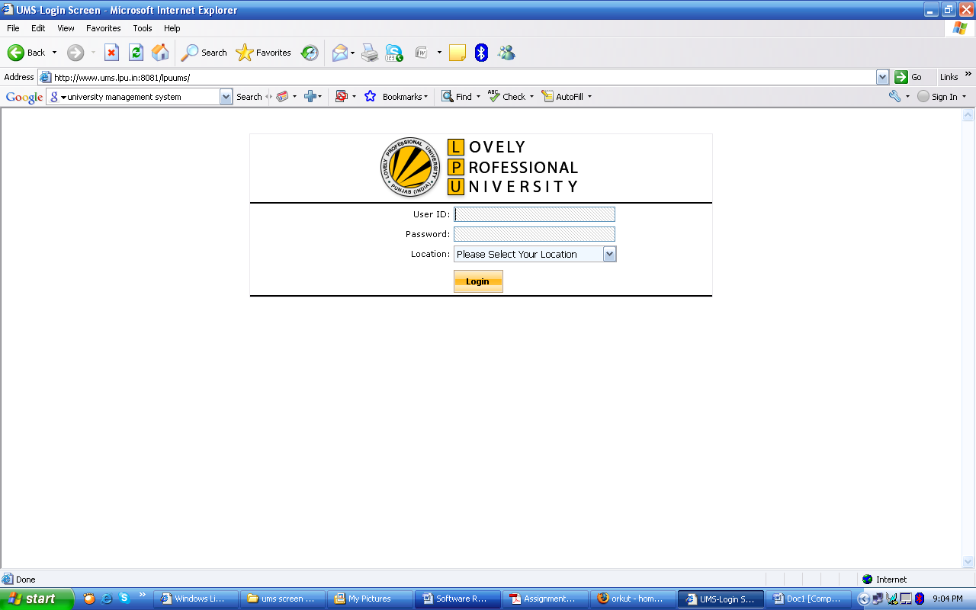

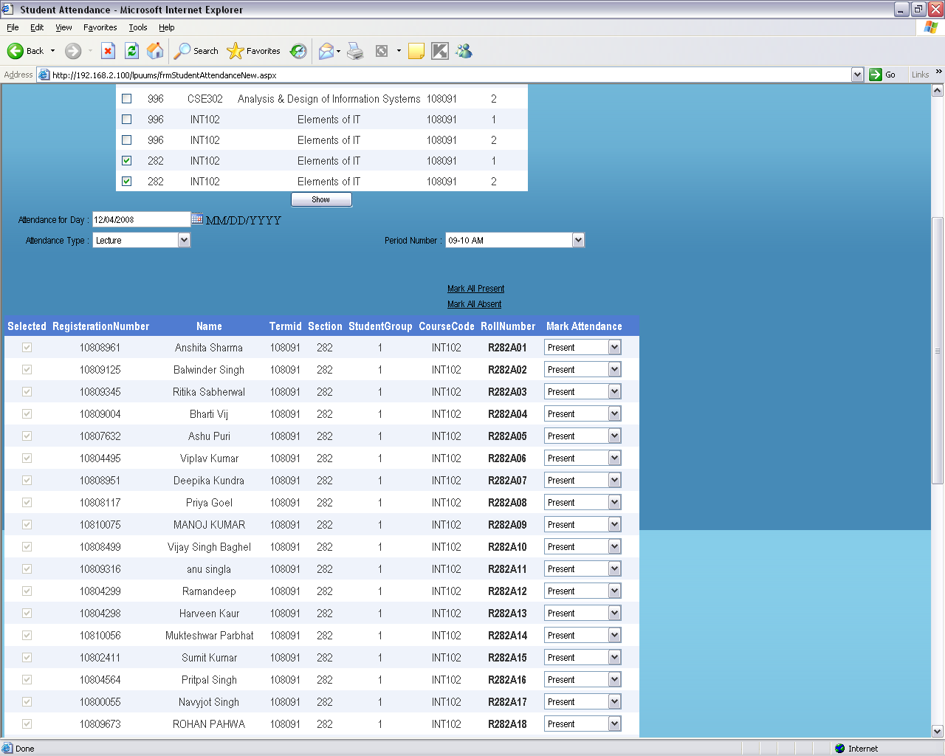

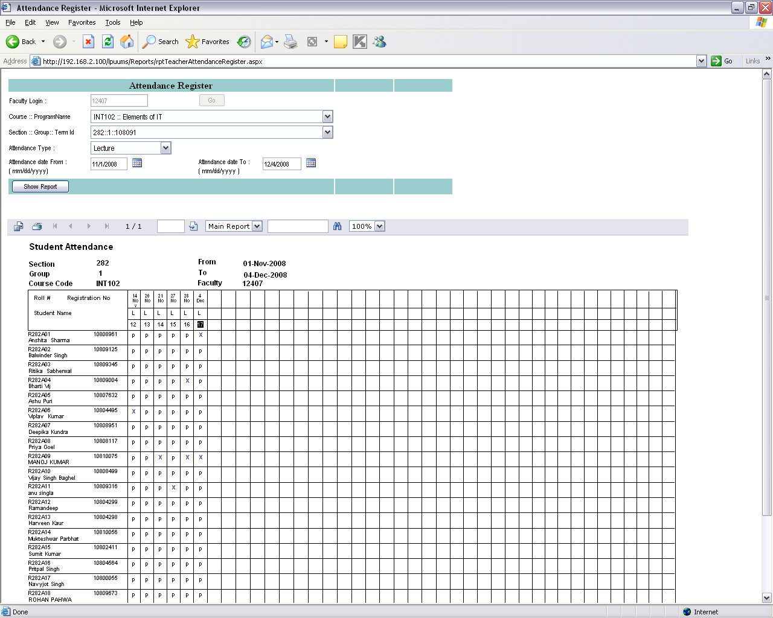

4.2. Hardware Interfaces

Server Side:
Operating System: Windows 9x/xp, Windows ME
Processor: Pentium 3.0 GHz or higher
RAM: 256 Mb or more
Hard Drive: 10 GB or more

Client side:
Operating System: Windows 9x or above, MAC or UNIX.
Processor: Pentium III or 2.0 GHz or higher.
RAM: 256 Mb or more

4.3. Software Interfaces

Database: SQL Server.
Application: ASP (Active Server Pages)
Web Server: IIS (Internet Information Services (IIS) is a powerful Web server that provides a highly reliable, manageable, and scalable Web application infrastructure)

4.4. Communications Interfaces

The Customer must connect to the Internet to access the Website:
Dialup Modem of 52 kbps
Broadband Internet
Dialup or Broadband Connection with a Internet Provider.

6.Other Nonfunctional Requirements

5.1. Performance Requirements

The proposed system that we are going to develop will be used as the Chief performance system within the different campuses of the university which interact with the university staff and students. Therefore, it is expected that the database would perform functionally all the requirements that are specified by the university.
5.2. Safety Requirements

The database may get crashed at any certain time due to virus or operating system failure. Therefore, it is required to take the database backup.

5.3. Security Requirements

We are going to develop a secured database for the university. There are different categories of users namely teaching Administrator, Staff members and students etc. Depending upon the category of user the access rights are decided. It means if the user is an administrator then he can be able to modify the data, delete, append etc. All other users other than University Staff only have the rights to retrieve the information about database.
5.4. Software Quality Attributes

The Quality of the database is maintained in such a way so that it can be very user friendly to all the users of the database.
5.5 Hardware Constraints
The system requires a database in order to store persistent data. The database should have backup capabilities.
5.6 Software Constraints
The development of the system will be constrained by the availability of required software such as web servers, database and development tools.
The availability of these tools will be governed by the Lovely Professional University.
5.7 Design Constraints
The system must be designed to allow web usability. That is, the system must
be designed in such a way that will be easy to use and visible on most of the browsers.

