This is the title: it contains a colon

Author One

Author Two

This is the abstract.

It consists of two paragraphs.

# Introduction

This is my introduction. In the next sentence we will reference tbl. 1.

# Another Section

We progress to another section, where we want to get people to see (1). We then reiterate a claim made in the paper (1). Then we reference tbl. 2.

# A Section for Figures

This is a great and solid section. For example, we have these figures fig. 1. Then we can incorporate some math like $λx=Ax$.

## A subheading for the sake of it

We continue writing for no reason. We display a set of figues in fig. 2. Note we can subreference fig. 2 (a) and fig. 2 (b).

# Conclusions

We make some concluding remarks.

# Tables

Table 1: Table example

| Syntax | Description |
| --- | --- |
| Header | Title |
| Paragraph | Text |

Table 2: This is a table

|  |  | top level 1 | | top level 2 | |
| --- | --- | --- | --- | --- | --- |
|  |  | bottom level 1 | bottom level 2 | bottom level 3 | bottom level 4 |
| idx lvl 1.1 | idx lvl 2.1 | 1 | 2 | 3 | 5 |
| idx lvl 2.2 | 2 | 2 | 4 | 6 |
| idx lvl 1.2 | idx lvl 2.3 | 3 | 3 | 5 | 2 |
| idx lvl 1.3 | idx lvl 2.4 | 4 | 4 | 6 | 1 |

# Figures

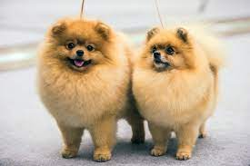

Figure 1: An example figure



a

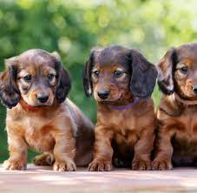

b

Figure 2: Overarching subfigure caption. a — 2 dogs, b — 3 dogs

# References

1. Bhatt AG. Linear filtering with Ornstein-Ulhenbeck process as noise. Sadhana [Internet]. 2006 Apr;31(2):141–53. Available from: <https://doi.org/10.1007/BF02719778>