**Today Lecture Task:-**

**Create SignIn and Signup Page layout using Handlebars**

**Public/login.html**

<html>

    <head>

        <title>Login Here</title>

        <link rel="stylesheet" href="https://maxcdn.bootstrapcdn.com/bootstrap/3.3.7/css/bootstrap.min.css" integrity="sha384-BVYiiSIFeK1dGmJRAkycuHAHRg32OmUcww7on3RYdg4Va+PmSTsz/K68vbdEjh4u" crossorigin="anonymous">

    </head>

    <body class="container">

        <div class="page-header">

            <h1>Create SignIn and Signup Page layout using Handlebars</h1>

        </div>

        <nav class="navbar navbar-default">

            <div class="container-fluid">

                <!-- Collect the nav links, forms, and other content for toggling -->

                <div class="collapse navbar-collapse" id="bs-example-navbar-collapse-1">

                    <ul class="nav navbar-nav">

                        <li><a href="/">Home</a></li>

                        <li><a href="/signup">Sign Up</a></li>

                        <li><a href="/dashboard">Dashboard</a></li>

                    </ul>

                    <ul class="nav navbar-nav navbar-right">

                        <li><a href="/login">Log In</a></li>

                        <li><a href="/logout">Log Out</a></li>

                    </ul>

                </div><!-- /.navbar-collapse -->

            </div><!-- /.container-fluid -->

        </nav>

        <div class="container row">

            <div class="jumbotron col-sm-4 pull-center">

                <form action="/login" method="post">

                    <div>

                        <label>Username:</label>

                        <input type="text" name="username"/>

                    </div>

                    <div>

                        <label>Password:</label>

                        <input type="password" name="password"/>

                    </div>

                    <div>

                        <input class="btn btn-primary" type="submit" value="Log In"/>

                    </div>

                </form>

            </div>

        </div>

    </body>

</html>

**Public/signup.html**

<html>

    <head>

        <title>Login Here</title>

        <link rel="stylesheet" href="https://maxcdn.bootstrapcdn.com/bootstrap/3.3.7/css/bootstrap.min.css" integrity="sha384-BVYiiSIFeK1dGmJRAkycuHAHRg32OmUcww7on3RYdg4Va+PmSTsz/K68vbdEjh4u" crossorigin="anonymous">

    </head>

    <body class="container">

        <div class="page-header">

            <h1>Create SignIn and Signup Page layout using Handlebars</h1>

        </div>

        <nav class="navbar navbar-default">

            <div class="container-fluid">

                <!-- Collect the nav links, forms, and other content for toggling -->

                <div class="collapse navbar-collapse" id="bs-example-navbar-collapse-1">

                    <ul class="nav navbar-nav">

                        <li><a href="/">Home</a></li>

                        <li><a href="/signup">Sign Up</a></li>

                        <li><a href="/dashboard">Dashboard</a></li>

                    </ul>

                    <ul class="nav navbar-nav navbar-right">

                        <li><a href="/login">Log In</a></li>

                        <li><a href="/logout">Log Out</a></li>

                    </ul>

                </div><!-- /.navbar-collapse -->

            </div><!-- /.container-fluid -->

        </nav>

        <div class="container row">

            <div class="jumbotron col-sm-4 pull-center">

                <form action="/signup" method="post">

                    <div>

                        <label>Username:</label>

                        <input type="text" name="username"/>

                    </div>

                    <div>

                        <label>Email:</label>

                        <input type="text" name="email"/>

                    </div>

                    <div>

                        <label>Password:</label>

                        <input type="password" name="password"/>

                    </div>

                    <div>

                        <input class="btn btn-primary" type="submit" value="Sign Up"/>

                    </div>

                </form>

            </div>

        </div>

    </body>

</html>

**Public/dashboard.html**

<html>

    <head>

        <title>Login Here</title>

        <link rel="stylesheet" href="https://maxcdn.bootstrapcdn.com/bootstrap/3.3.7/css/bootstrap.min.css" integrity="sha384-BVYiiSIFeK1dGmJRAkycuHAHRg32OmUcww7on3RYdg4Va+PmSTsz/K68vbdEjh4u" crossorigin="anonymous">

    </head>

    <body class="container">

        <div class="page-header">

            <h1>Create SignIn and Signup Page layout using Handlebars</h1>

        </div>

        <nav class="navbar navbar-default">

            <div class="container-fluid">

                <!-- Collect the nav links, forms, and other content for toggling -->

                <div class="collapse navbar-collapse" id="bs-example-navbar-collapse-1">

                    <ul class="nav navbar-nav">

                        <li><a href="/">Home</a></li>

                        <li><a href="/signup">Sign Up</a></li>

                        <li><a href="/dashboard">Dashboard</a></li>

                    </ul>

                    <ul class="nav navbar-nav navbar-right">

                        <li><a href="/login">Log In</a></li>

                        <li><a href="/logout">Log Out</a></li>

                    </ul>

                </div><!-- /.navbar-collapse -->

            </div><!-- /.container-fluid -->

        </nav>

        <div class="container row">

           <h1>Hi, Welcome to your Dashboard</h1>

        </div>

    </body>

</html>

**Views/layout/layout.hbs**

<html>

    <head>

        <title>

        {{# if loggedin}}

            Welcome {{userName}}

        {{else }}

            NodeJS

        {{/if}}

        </title>

        <link rel="stylesheet" href="https://maxcdn.bootstrapcdn.com/bootstrap/3.3.7/css/bootstrap.min.css" integrity="sha384-BVYiiSIFeK1dGmJRAkycuHAHRg32OmUcww7on3RYdg4Va+PmSTsz/K68vbdEjh4u" crossorigin="anonymous">

    </head>

    <body class="container">

        <div class="page-header">

            <h1>Simple Auth-System</h1>

        </div>

        <nav class="navbar navbar-default">

            <div class="container-fluid">

                <!-- Collect the nav links, forms, and other content for toggling -->

                <div class="collapse navbar-collapse" id="bs-example-navbar-collapse-1">

                    <ul class="nav navbar-nav">

                        <li><a href="/">Home</a></li>

                        <li><a href="/signup">Sign Up</a></li>

                        <li><a href="/dashboard">Dashboard</a></li>

                    </ul>

                    <ul class="nav navbar-nav navbar-right">

                    {{# if loggedin}}

                        <li><a href="/logout">Log Out</a></li>

                    {{else }}

                        <li><a href="/login">Log In</a></li>

                    {{/if}}

                    </ul>

                </div><!-- /.navbar-collapse -->

            </div><!-- /.container-fluid -->

        </nav>

       {{{body}}}

    </body>

</html>

**Views/login.hbs**

<div class="container row">

            <div class="jumbotron col-sm-4 pull-center">

                <form action="/login" method="post">

                    <div>

                        <label>Username:</label>

                        <input type="text" name="username"/>

                    </div>

                    <div>

                        <label>Password:</label>

                        <input type="password" name="password"/>

                    </div>

                    <div>

                        <input class="btn btn-primary" type="submit" value="Log In"/>

                    </div>

                </form>

            </div>

        </div>

**Views/signup.hbs**

<div class="container row">

            <div class="jumbotron col-sm-4 pull-center">

                <form action="/signup" method="post">

                    <div>

                        <label>Username:</label>

                        <input type="text" name="username"/>

                    </div>

                    <div>

                        <label>Email:</label>

                        <input type="text" name="email"/>

                    </div>

                    <div>

                        <label>Password:</label>

                        <input type="password" name="password"/>

                    </div>

                    <div>

                        <input class="btn btn-primary" type="submit" value="Sign Up"/>

                    </div>

                </form>

            </div>

        </div>

**Views/dashboard.hbs**

 <div class="container row">

           <h1>Hi, Welcome to your Dashboard</h1>

    </div>

**File structure:**

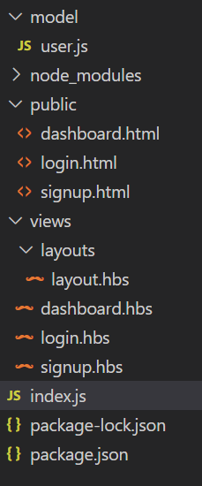

**Output:**

**Table created in mysql**

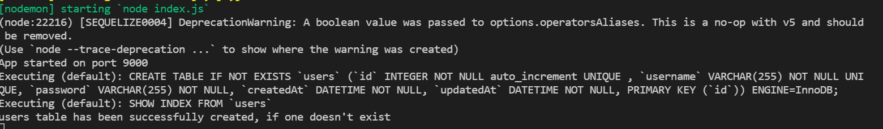

**Login page:**

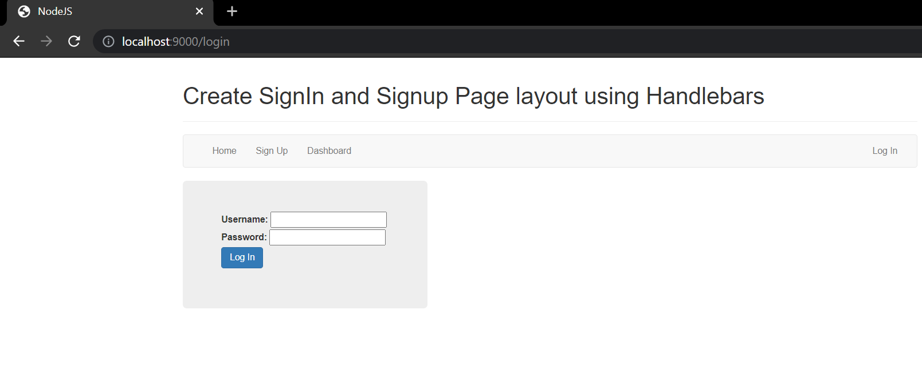

**Signup page:**

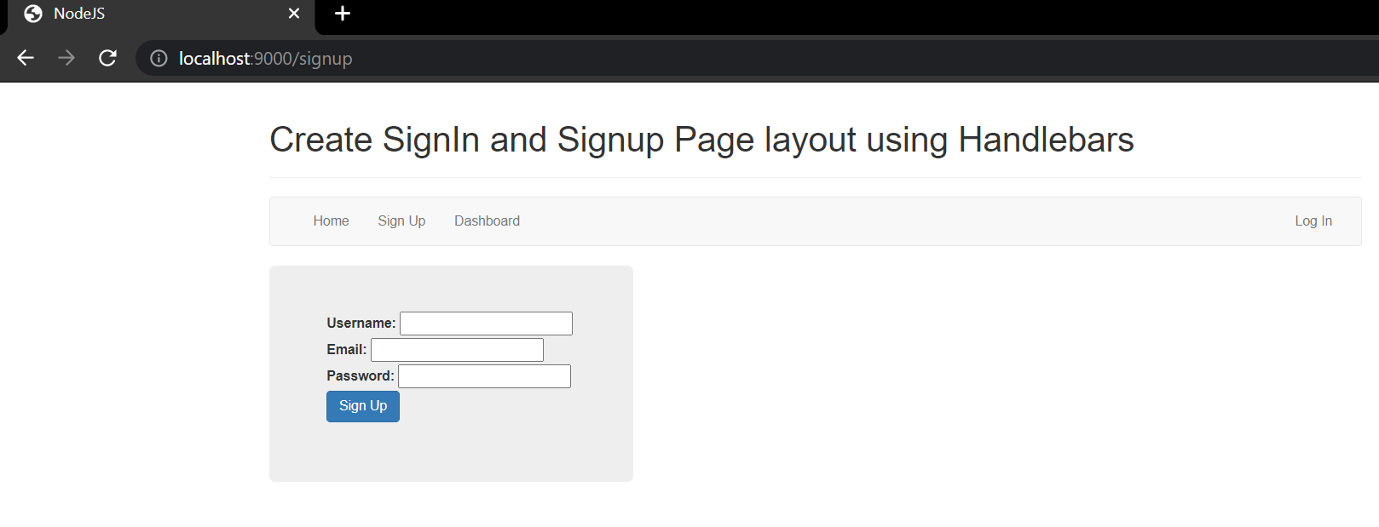

**Signup is completed after go to the dashboard:-**

