@ModelAttribute: This is used for mapping the fields in the form to the object/ model class

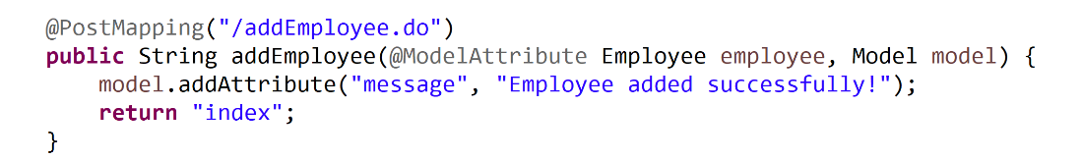

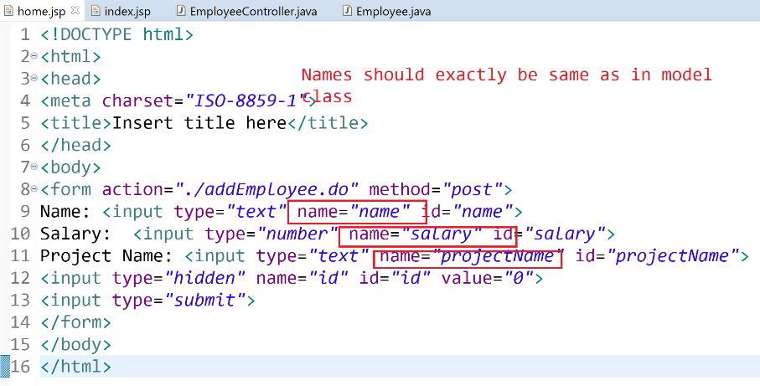

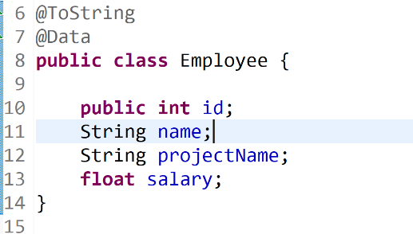

Request : /addEmployee.do -> controller -> index -> viewresolver -> index.jsp: response

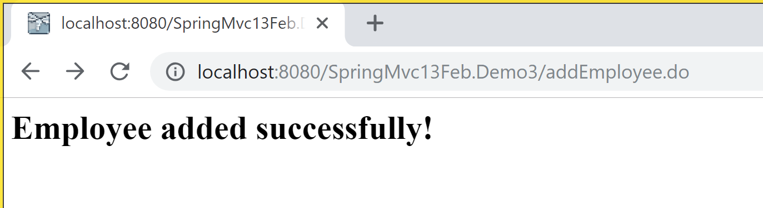

So it is the same request, response object

Url does not change to index.jsp

Q) If we don’t want to map all fields or we want it to be mapped in a different format:

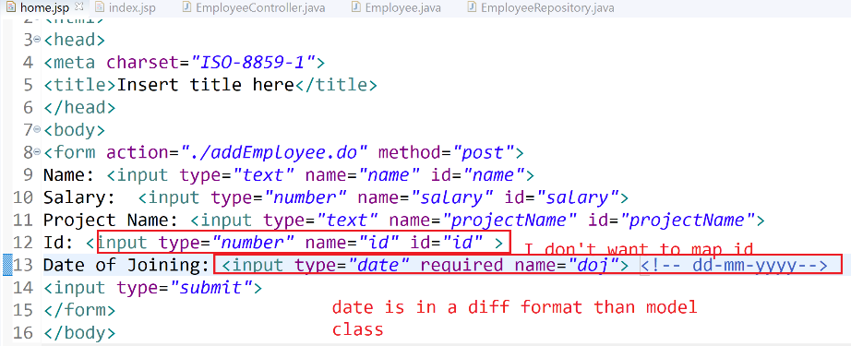

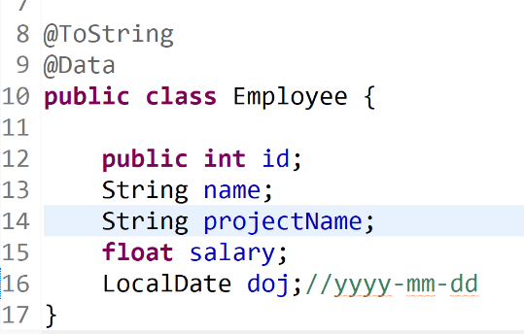

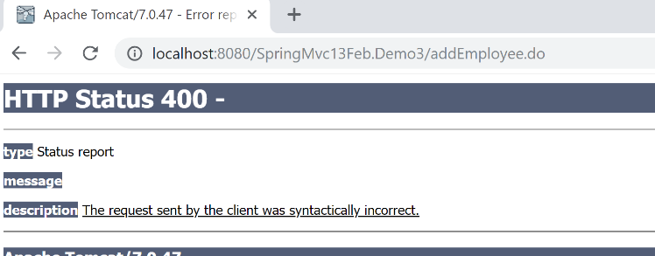

So we will use @**InitBinder**

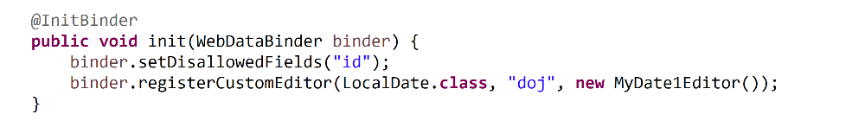

Jsp:

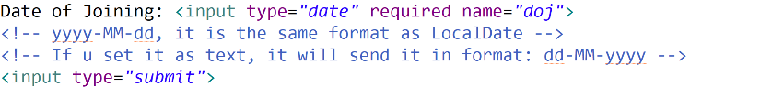

Your custom editor:

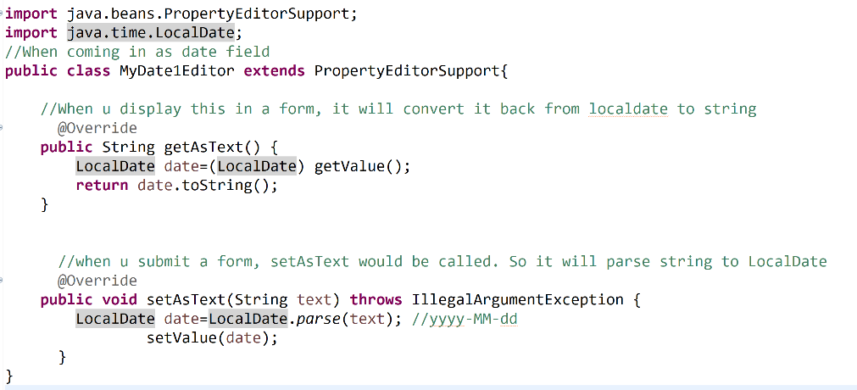

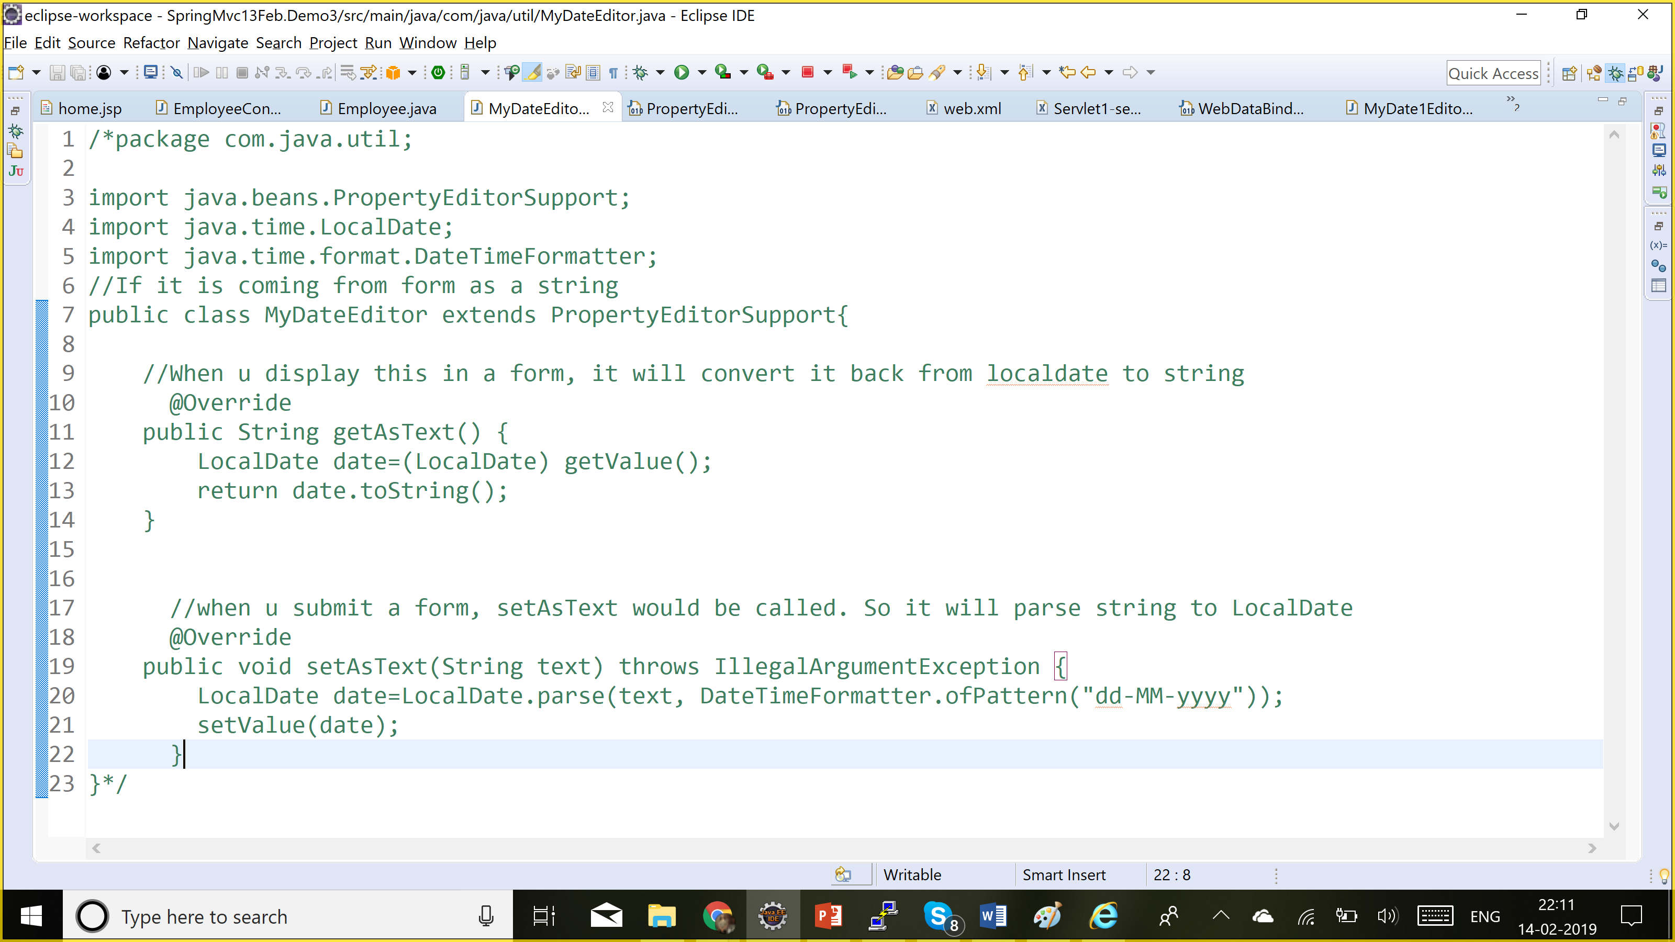

But if we enter a wrong format in the form, we get 400 client error

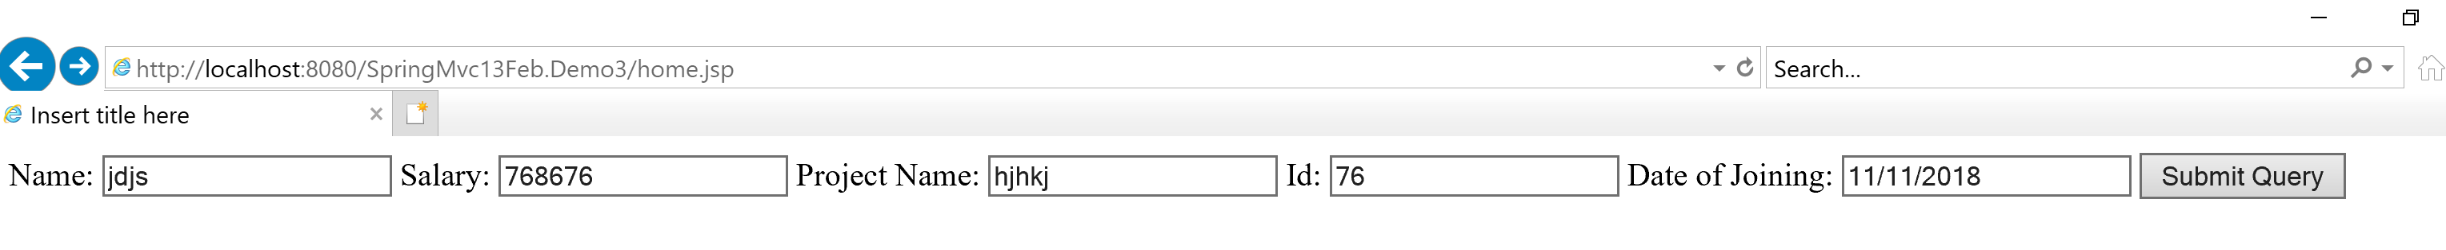

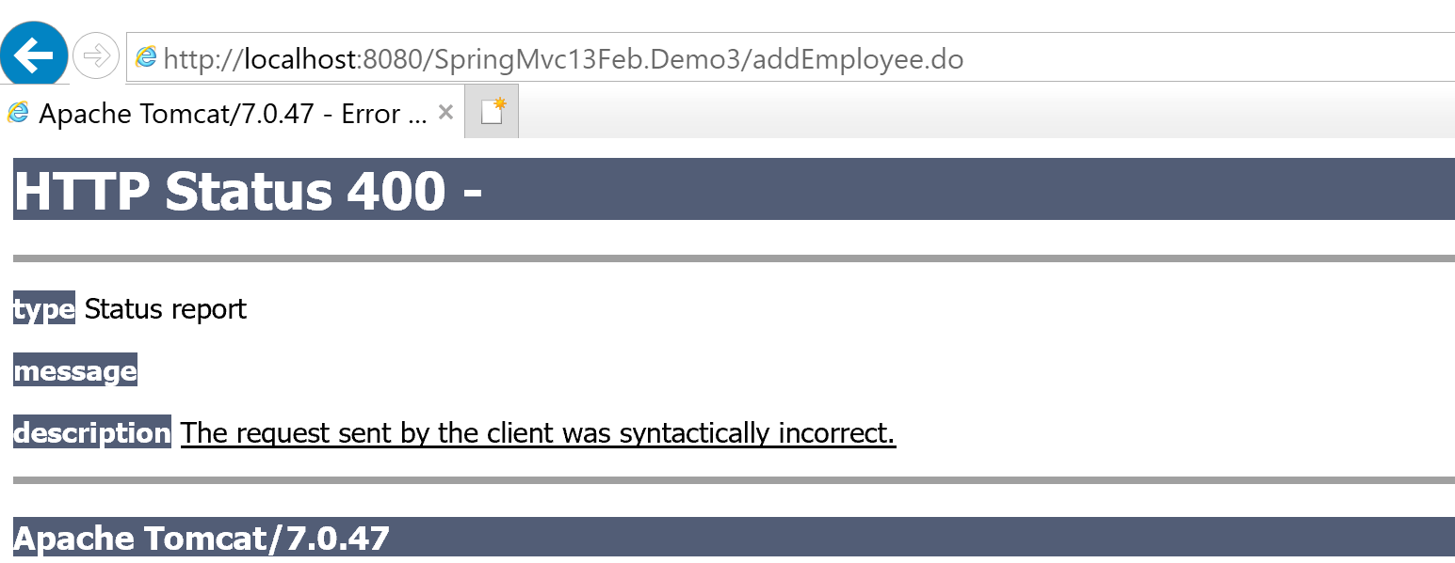

So we will use BindingResult, it will capture all the errors which will happen during binding ur model class with form field.

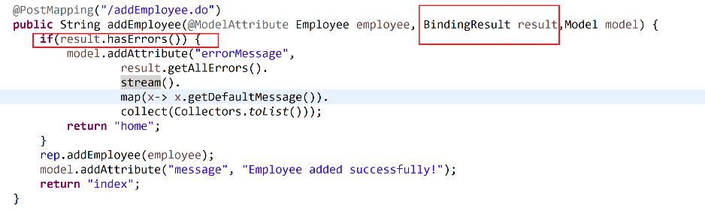

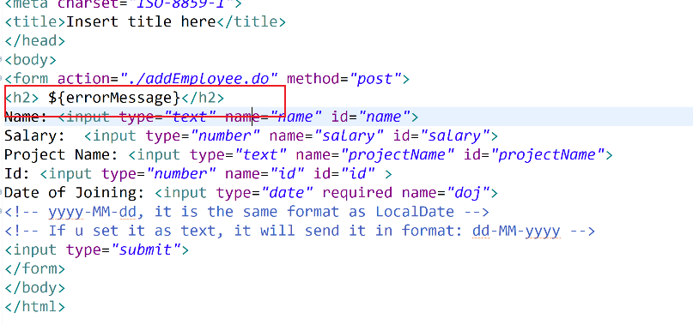

**More Validations:**

1. Date should be in the future
2. {Java Training ,Android training, IOS training }
3. Salary >100000
4. Name should be only alphabets.

We have a library which we can use for validation.

1. Javax.validation
2. Hibernate-validator

<dependency>

<groupId>javax.validation</groupId>

<artifactId>validation-api</artifactId>

<version>2.0.1.Final</version>

</dependency>

<dependency>

<groupId>org.hibernate.validator</groupId>

<artifactId>hibernate-validator</artifactId>

<version>6.0.14.Final</version>

</dependency>

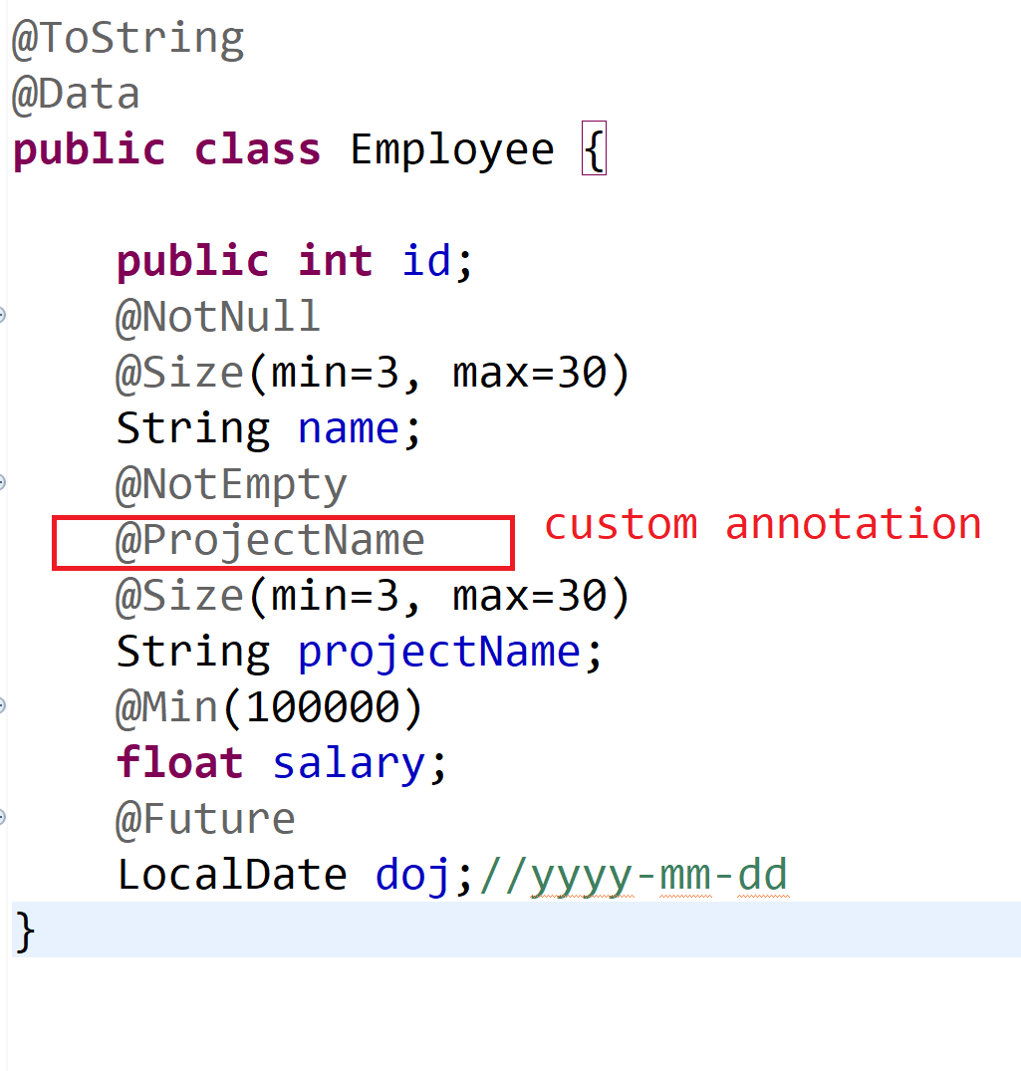

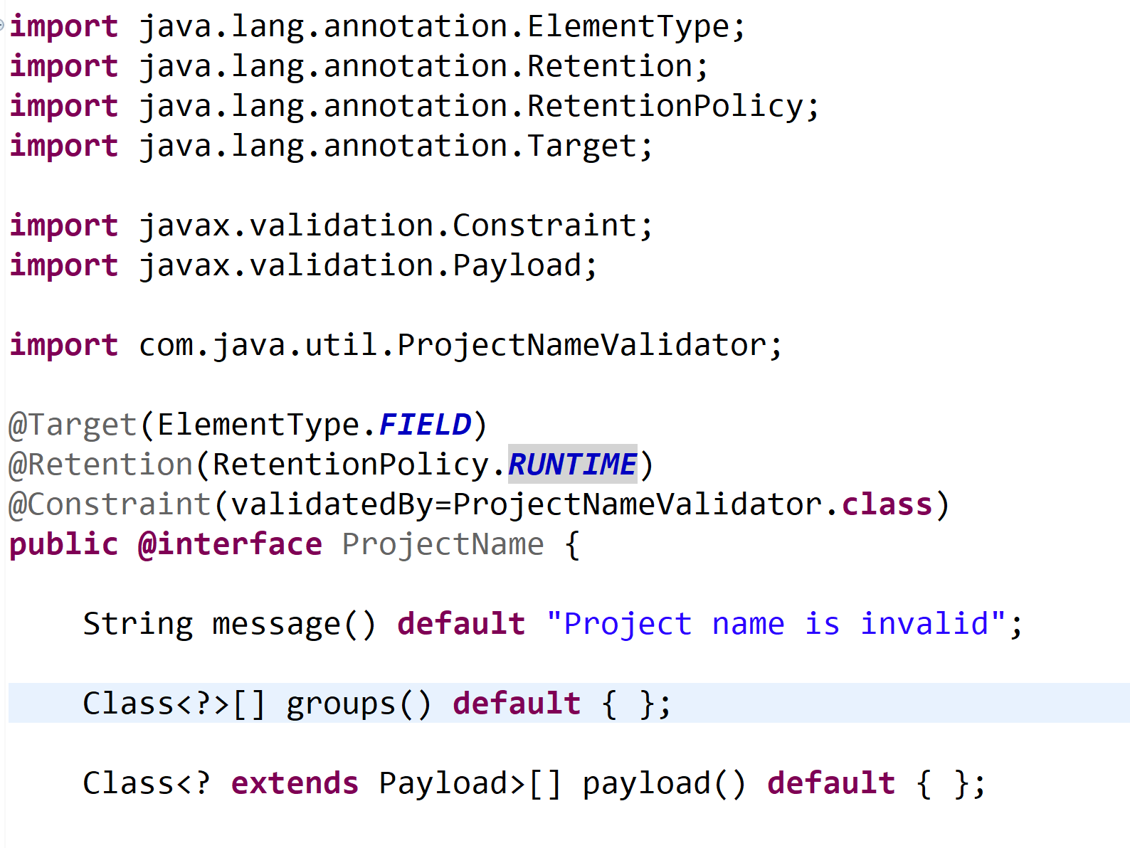

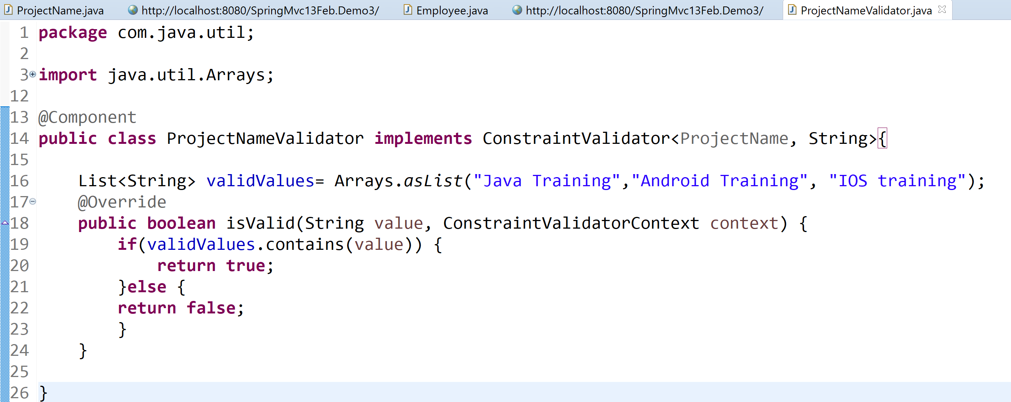

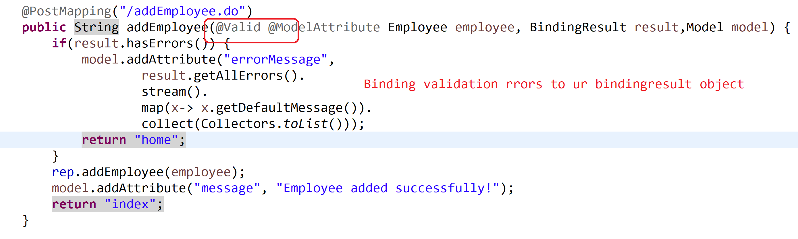

Messages being displayed are not much meaningful during validation

**Customize the messages:**

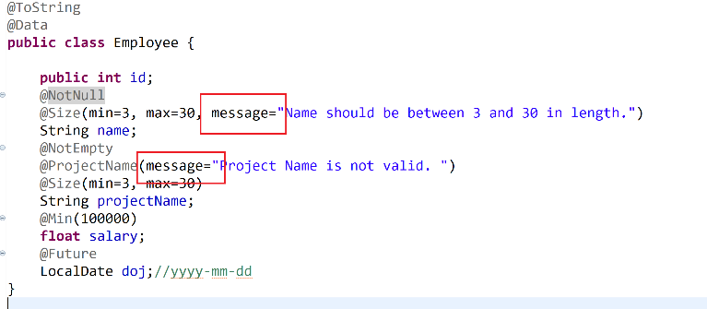

**Adding custom attributes to custom validator annotations**

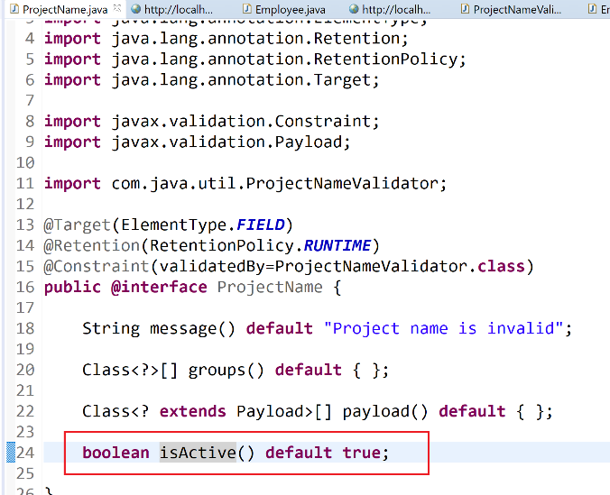

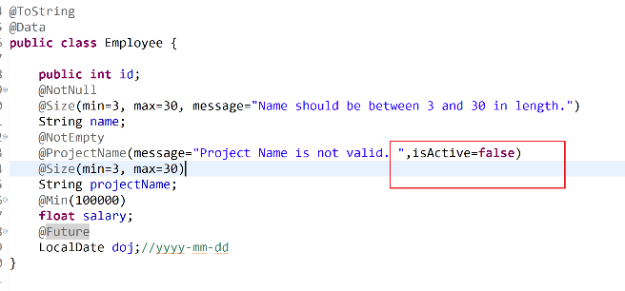

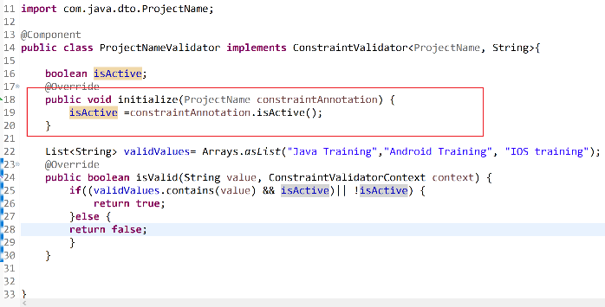

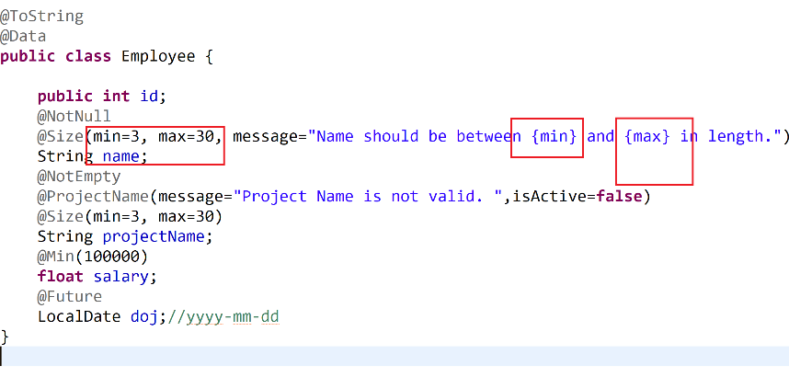

**Reading a property file in spring**