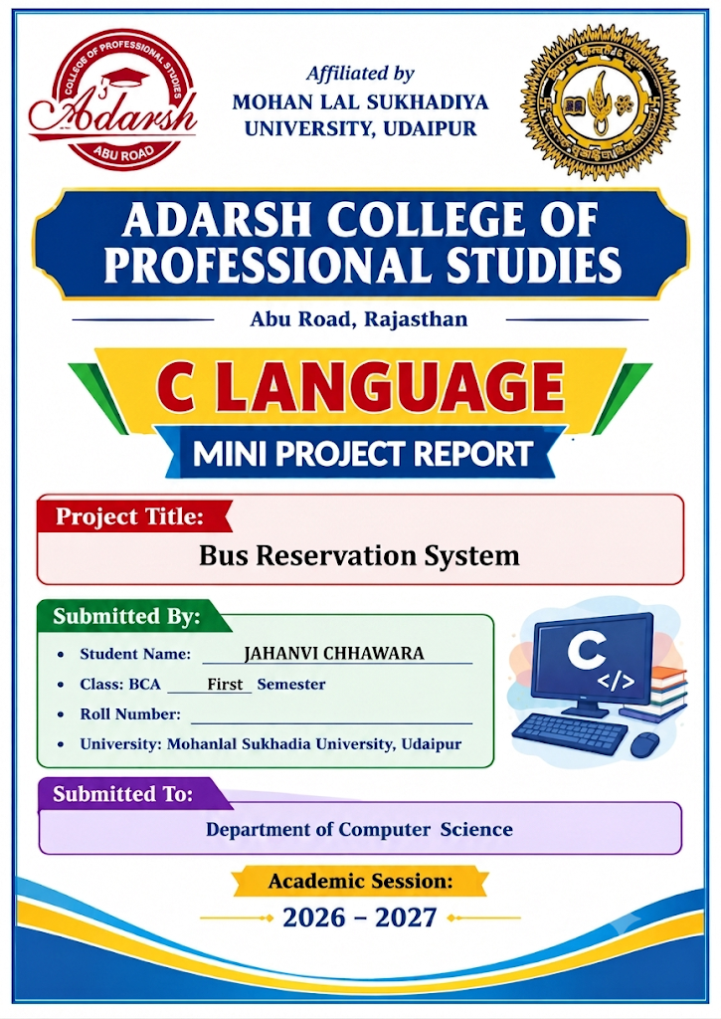

CERTIFICATE
This is to certify that Mr./Ms. Jahanvi Chhawara, a student of BCA First Semester at Adarsh College of Professional Studies, Abu Road, Rajasthan, has successfully completed the C Language Project titled “Bus reservation system” under the guidance of Mr. Narendra Agarwal, Faculty, Department of Computer Science.
This project has been completed as part of the academic requirements for the respective semester. The student has made sincere efforts to complete the project successfully.
We wish the student success in all future endeavors.
________________________ | ________________________
Teacher's Signature | Principal's Signature
Date: ____________________
Place: Abu Road, Rajasthan
ACKNOWLEDGEMENT
I would like to express my sincere gratitude to the Principal and the faculty members of Adarsh College of Professional Studies, Abu Road, for providing me with the opportunity and guidance to complete this C Language Project.
I am especially thankful to my subject teacher, Mr. Narendra Agarwal, for his valuable guidance, support, and encouragement throughout the project.
I would also like to thank my parents and friends for their continuous motivation and support.
Finally, I am grateful to everyone who directly or indirectly helped me complete this project successfully.
THANK YOU!
Submitted By:
JAHANVI CHHAWARA
TABLE OF CONTENTS

1. Introduction 5
2. Objectives 5
3. Scope of the Project 5
4. System Requirements 5
5. Features / Modules 6
6. Data Structure Used 6
7. Concepts of C Used 6
8. Algorithm 6
9. Flowchart 8
10. Source Code 8
11. Output Screenshots 14
12. Testing 16
13. Limitations 17
14. Future Scope 17
15. Conclusion 17
16. Bibliography 17

1. Introduction
A bus service provider handles multiple buses, routes, schedules, and passenger bookings. Managing these records manually in physical registers is slow, tiring and prone to mistakes.
The Bus Reservation System is a console-based application written in C language that helps an administrator store, search, book, and view booking records easily. The project uses structures to hold bus data and text file handling (fopen, fprintf, fgets, fclose) to save passenger bookings permanently in a bus_bookings.txt file, so records are not lost when the program is closed.

2. Objectives
- To reduce manual paperwork in managing bus ticket reservations.
- To store booking records permanently using text file handling.
- To make searching buses by destination and viewing booking history quick and accurate.
- To apply C concepts such as structures, loops, switch-case, strings and files to a real-life problem.

3. Scope of the Project
This project is suitable for a small bus operator, travel agency, or ticket counter. It manages bus schedules and booking records through a simple menu-driven interface on the console.

4. System Requirements

Hardware Requirements
- Processor: Intel Pentium or higher
- RAM: 2 GB or more
- Hard disk: 100 MB free space

Software Requirements
- Operating System: Windows / Linux / macOS
- Language: C
- Compiler / IDE: Cxxdroid (Clang), VS Code, Code::Blocks, Dev-C++, or GCC Compiler

5. Features / Modules
No. | Module | Description
1 | Search Buses by Destination | Searches and displays available buses matching a given city (e.g. Delhi, Jaipur).
2 | Book Ticket | Takes passenger details (Name, Phone, Bus No, Seats) and appends the booking to bus_bookings.txt.
3 | Cancel Ticket | Cancels requested number of booked seats for a specified bus.
4 | View Booking History | Opens bus_bookings.txt in read mode (‘r’) and prints all saved bookings using fgets.
5 | Exit | Closes the program.

6. Data Structure Used
The bus details are stored in memory using an array of structures:

struct Bus {
int bus_no, total_seats, available_seats;
char destination[50];
char timing[10];
};

Booking history records are stored permanently in a text file named bus_bookings.txt.

7. Concepts of C Used
Concept | Use in the Project
Structure | To store bus details (bus number, destination, timing, seats).
File handling (fopen, fprintf, fgets, fclose) | To save passenger records permanently (‘a’ mode) and read history (‘r’ mode).
Switch-case and Do-While | To build the main menu-driven loop.
Strings & Functions (strcasecmp) | To search destinations in a case-insensitive manner.
Loops and Conditions | To traverse bus records and validate inputs.

8. Algorithm

Main Program
- Start.
- Initialize array of 10 bus records.
- Display the menu: 1. Search, 2. Book, 3. Cancel, 4. View History, 5. Exit.
- Read the user’s choice.
- Call the case related to the choice.
- Repeat steps 3 to 5 until choice = 5.
- Stop.

Book Ticket (Append Mode)
- Read Bus Number, Passenger Name, Phone Number, and Seats.
- Search bus in the array.
- Open file bus_bookings.txt in append mode (‘a’).
- Write details using fprintf().
- Close the file using fclose().
- Display success message.

View Booking History (Read Mode)
- Open file bus_bookings.txt in read mode (‘r’).
- If file == NULL, display ‘No booking history found’.
- Otherwise, use loop with fgets(ch, sizeof(ch), file) to read line-by-line.
- Print each line on terminal.
- Close file using fclose().

Cancel Ticket
- Read Bus Number and the number of seats to cancel.
- Search the bus in the array.
- If bus is not found, display ‘Bus Number not found’.
- Check that seats > 0 and booked seats (total – available) >= seats to cancel.
- If valid, add the seats back to available_seats.
- Display success message, otherwise display ‘Invalid seat cancellation count’.

9. Flowchart
START
↓
Display Main Menu
↓
Enter Choice (1 - 5)
↓
Which option? (switch-case)
↓
Choice | Module/Function | Action
1 | Case 1: | Search Buses by Destination using strcasecmp
2 | Case 2: | Book Ticket and append record to bus_bookings.txt
3 | Case 3: | Cancel Ticket for a given bus number
4 | Case 4: | View Booking History by reading bus_bookings.txt using fgets
5 | Main() | Shows menu in a do-while loop and executes switch-case
↓
After every function, control returns to the Main Menu until choice 5
↓
STOP

10. Source Code

How to Compile and Run
Cxxdroid (Android): Open main.c in the app and tap the Run button.
GCC (Laptop): gcc main.c -o main, then ./main (Windows: main.exe)

Functions / Cases Used in the Program:
Case 1: | Search Buses by Destination using strcasecmp
Case 2: | Book Ticket and append record to bus_bookings.txt
Case 3: | Cancel Ticket for a given bus number
Case 4: | View Booking History by reading bus_bookings.txt using fgets
Main() | Shows menu in a do-while loop and executes switch-case

Complete Source Code (main.c)
/*
* Bus Reservation System Mini Project in C
* Features: Search, Book Ticket (Text File Save), Cancel Ticket, View History (Text File Read)
*/
#include <stdio.h>
#include <string.h>
#include <strings.h> // For strcasecmp

// Structure to store Bus details
struct Bus {
int bus_no, total_seats, available_seats;
char destination[50];
char timing[10];
};

int main() {
int choice;

// Inserting information of buses
struct Bus buses[10] = {
{101, 40, 40, "Delhi", "08:00 AM"},
{102, 50, 50, "Jaipur", "10:30 AM"},
{103, 30, 30, "Agra", "01:00 PM"},
{104, 45, 45, "Delhi", "04:15 PM"},
{105, 60, 60, "Chandigarh", "09:00 PM"},
{106, 40, 40, "Mumbai", "07:00 AM"},
{107, 50, 50, "Jaipur", "11:00 AM"},
{108, 35, 35, "Pune", "06:30 PM"},
{109, 55, 55, "Delhi", "10:00 PM"},
{110, 50, 50, "Agra", "03:30 PM"}
};

do {
printf("\n=========================================\n");
printf(" BUS RESERVATION SYSTEM \n");
printf("=========================================\n");
printf("1. Search Buses by Destination\n");
printf("2. Book Ticket\n");
printf("3. Cancel Ticket\n");
printf("4. View Booking History\n");
printf("5. Exit\n");
printf("Enter your choice (1-5): ");
scanf("%d", &choice);

switch (choice) {
case 1: {
char dest[50];
int found = 0;
printf("Enter destination city to search: ");
scanf("%s", dest);

printf("\n--- Available Buses to %s ---\n", dest);
printf("%-10s %-15s %-15s %-15s\n", "Bus No", "Destination", "Timing", "Available Seats");
for (int i = 0; i < 10; i++) {
if (strcasecmp(buses[i].destination, dest) == 0) {
printf("%-10d %-15s %-15s %-15d\n", buses[i].bus_no, buses[i].destination, buses[i].timing, buses[i].available_seats);
found = 1;
}
}
if (!found) {
printf("No buses found for this destination.\n");
}
break;
}
case 2: {
int bno, seats, found = 0;
char name[50], phone[15];

printf("Enter Bus Number: ");
scanf("%d", &bno);

for (int i = 0; i < 10; i++) {
if (buses[i].bus_no == bno) {
found = 1;
printf("Enter Passenger Name: ");
scanf("%s", name);
printf("Enter Phone Number: ");
scanf("%s", phone);
printf("Enter Number of Seats to Book: ");
scanf("%d", &seats);

if (seats <= buses[i].available_seats && seats > 0) {
buses[i].available_seats -= seats;

// Save to file
FILE *file = fopen("bus_bookings.txt", "a");
if (file != NULL) {
fprintf(file, "Bus No: %d | Name: %s | Phone: %s | Seats Booked: %d | Destination: %s\n",
buses[i].bus_no, name, phone, seats, buses[i].destination);
fclose(file);
printf("Ticket(s) booked successfully!\n");
} else {
printf("Error opening file for saving booking.\n");
}
} else {
printf("Not enough seats available or invalid seat count!\n");
}
break;
}
}
if (!found) {
printf("Invalid Bus Number!\n");
}
break;
}
case 3: {
int bno, seats, found = 0;
printf("Enter Bus Number to cancel tickets: ");
scanf("%d", &bno);

for (int i = 0; i < 10; i++) {
if (buses[i].bus_no == bno) {
found = 1;
printf("Enter number of seats to cancel: ");
scanf("%d", &seats);

if (seats > 0 && (buses[i].total_seats - buses[i].available_seats) >= seats) {
buses[i].available_seats += seats;
printf("Successfully cancelled %d seat(s).\n", seats);
} else {
printf("Invalid seat cancellation count!\n");
}
break;
}
}
if (!found) {
printf("Bus Number not found!\n");
}
break;
}
case 4: {
FILE *file = fopen("bus_bookings.txt", "r");
if (file == NULL) {
printf("No booking history found.\n");
} else {
char line[256];
printf("\n--- Booking History ---\n");
while (fgets(line, sizeof(line), file) != NULL) {
printf("%s", line);
}
fclose(file);
}
break;
}
case 5:
printf("Exiting program. Thank you!\n");
break;
default:
printf("Invalid choice! Please enter between 1 and 5.\n");
}
} while (choice != 5);

return 0;
}

11. Output Screenshots
Output 1: Main Menu
BUS RESERVATION SYSTEM
1. Search Buses by Destination
2. Book Ticket
3. Cancel Ticket
4. View Booking History
5. Exit
Enter your choice (1-5): 1

Enter destination city to search: Delhi

--- Available Buses to Delhi ---
Bus No. Destination Timing Available Seats
101 Delhi 08:00 AM 40
104 Delhi 04:15 PM 45
Fig. 1: Main menu and destination search
Output 2: Book Ticket & Save Record to Text File (Append Mode)
Enter your choice (1-5): 2
Enter Bus Number: 101
Enter Passenger Name: Jahanvi
Enter Phone Number: 9876543210
Enter Number of Seats to Book: 2

Ticket(s) booked successfully!
Fig. 2: Booking ticket & records in text file
Output 3: Display All Books
Enter your choice (1-5): 4

--- Booking History ---
Bus No: 101 | Name: Jahanvi | Phone: 9876543210 | Seats Booked: 2 | Destination: Delhi
--------------------------------------------------------------
Fig. 3: display Booking history
Output 4: Exit Program
Exiting program. Thank you!
Fig. 4: exit

12. Testing
Test Case | Input | Expected Output | Result
Search existing route | Destination: Jaipur | Lists all buses to Jaipur | Pass
Search missing route | Destination: Goa | Displays ‘no buses available’ | Pass
Book ticket | Bus 101, Jahanvi, 2 seats | Saves booking to text file | Pass
View history | Choice 4 | Reads bus_bookings.txt with fgets | Pass
Cancel ticket | Bus 101, 1 seat | Displays cancellation confirmation | Pass

13. Limitations
- It is a console application with no graphical user interface (GUI).
- There is no user/admin login system, so anyone running the program can access history.
- Seat availability is managed in memory for the session, while booking history is appended to text file.

14. Future Scope
- Admin and passenger login with password protection.
- Interactive visual seat layout selection.
- Automatic fare calculation and online receipt generation.
- Graphical User Interface (GUI) or web application interface.

15. Conclusion
The Bus Reservation System successfully performs key bus management operations: searching buses, booking tickets with text file persistence, canceling seats, and reading history. The project helped me understand structures, loops, switch-case, and file handling (fopen, fprintf, fgets, fclose) in C language.

16. Bibliography
- Programming in ANSI C by E. Balagurusamy
- Let Us C by Yashavant Kanetkar
- Class notes and lab manual provided by Adarsh College of Professional Studies
- Geeksforgeeks.org and tutorialspoint.com (C File Handling Tutorials)
BUS RESERVATION SYSTEM • C LANGUAGE MINI PROJECT
★ ★ ★
THANK YOU

for your valuable time, guidance and support
I sincerely thank my guide, teachers, friends and family for their
encouragement. I hope this project meets your expectations.
Submitted by | JAHANVI CHHAWARA
Roll No.
Guided by | NARENDRA SIR
Institute | ADARSH COLLEGE OF PROFESSIONAL STUDIES
Project: Bus reservation System in C Language

WITH BEST WISHES

