

**EDUCATION**

*Bachelors in Computer Science Engineering | XYZ University, Gharuan*

Session: 2017-2021 | Score: 7.5 CGPA

*Intermediate (CBSE) |XYZ Public School, Delhi*

Session: 2016-2017 | Percentage: 89%

*Matriculation (CBSE) | XYZ Public School, Delhi*

Session: 2014-2015 | Percentage: 92%

**TRAINING & PROJECTS**

**COMPANY NAME | POSITION**

October 2019-Present

* Designed a program…..
* Performed an analysis on…..

**ONLINE CERTIFICATIONS & ADD-ON COURSES**

* Google Ad Words
* Digital Marketing Certification from Symbiosis

**ACADEMIC ACHIEVEMENTS**

* Awarded Bronze medal for academics by XYZ University
* Presented with the Certificate of Merit in Machine Learning, XYZ University,
* Received the Certificate of Merit in Extra Curricular Activities, XYZ University

**EXTRA CURRICULAR & CO-CURRICULAR ACHIEVEMENTS**

* Won an essay writing competition organized by xyz
* Received the Certificate of Merit in Extra Curricular Activities, XYZ University

**POSITION OF RESPONSILITY**

* Anchored XYZ Seminar at XYZ University
* Assisted as the Student Placement Co-ordinator at XYZ University
* Worked as a Backend Co-ordinator for a Mock Conference on ‘Progressive Punjab’ organized at XYZ, 2019
* Organized Alumni Meet, 2019 at XYZ as a Co-ordinator
* Planned and Co-ordinated Diwali Fest-2018 and 2019 at XYZ University

**ENTER NAME HERE**

Address: #1, ABC CITY, PUNJAB- 140143

E-mail: [*1234abcde@gmail.com*](mailto:1234abcde@gmail.com)

Phone: +91 9999999999

**SUMMARY**

A well-organized, creative and goal-oriented graduate possessing excellent written and oral communication, problem-solving and leadership skills with a flair to explore suitable avenues in Computer Science Engineering

**TECHNICAL COMPETENCIES**

C++ | JAVA | PYTHON | REDHAT

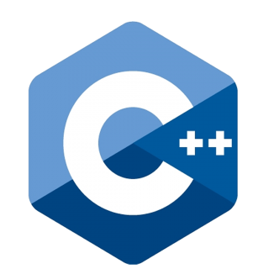 

**INTERPERSONAL SKILLS**

Team Leadership **|** Management & Coordination **|** Decision Making

**VOLUNTARY EXPERIENCE**

Mention, if any.

**INTERESTS & HOBBIES**

Writing **|** Blogging **|** Painting **|** Travelling **|** Reading **|** Gardening

**LANGUAGES KNOWN**

English **|** Hindi **|** Punjabi **|** French

**PERSONAL DETAILS**

Mother’s Name:

Father’ Name:

D.O.B.:

Gender: