Report on
“BB84-QKD BASED SECURE CHAT APPLICATION”

By
Jahanwee Singh (202300408)
Aditya Raj (202300320)
Nityam Sharma (202300193)
In partial fulfillment of the requirements for the award of the degree of
Bachelor of Technology in Computer Science and Engineering
(2027)
Under the guidance of
Mr. Kiran Gautam
Assistant Professor, Department of CSE, SMIT

DEPARTMENT OF COMPUTER SCIENCE AND ENGINEERING
SIKKIM MANIPAL INSTITUTE OF TECHNOLOGY
(A CONSTITUENT COLLEGE OF SIKKIM MANIPAL UNIVERSITY)
MAJITAR, RANGPO, EAST SIKKIM - 737136

LIST OF CONTENTS
Chapter | Title | Page No.
 | Cover | 1
 | List of Contents | 2
 | List of Tables | 3
 | List of Figures | 4
0 | Abstract | 5
1 | Introduction | 6
2 | Literature Survey | 8
3 | Problem Definition | 11
4 | Objectives and Scope | 12
5 | Proposed System Design | 13
6 | Solution Strategy | 16
7 | Expected Outcomes | 18
8 | Work Plan | 19
9 | Gantt Chart | 20
10 | Summary and Conclusion | 21
11 | References | 22

LIST OF TABLES
Table No. | Table Name | Page No.
2.1 | Comparative review of selected literature | 9
3.1 | Problems and proposed solutions | 11
4.1 | Objectives and planned verification | 12
5.1 | Proposed system modules | 13
5.2 | BB84 notation and planned calculations | 14
5.3 | Proposed technology stack | 15
6.1 | Development stages | 16
6.2 | Planned testing and validation | 17
7.1 | Expected project outcomes | 18
8.1 | Project work schedule | 19

LIST OF FIGURES
Figure No. | Figure Name | Page No.
5.1 | Proposed communication and message-protection architecture | 13
5.2 | Planned BB84 simulation and session-decision flow | 14
5.3 | Proposed authenticated message-protection lifecycle | 15

ABSTRACT
Secure digital communication depends on reliable key establishment and authenticated message protection. This project proposes a software framework that will simulate the BB84 Quantum Key Distribution protocol and use the resulting key material in a two-user real-time messaging application.
- The BB84 module will perform random bit and basis generation, state preparation, simulated measurement, basis sifting, and QBER calculation.
- Channel noise and an intercept-resend model will show how errors affect the key-exchange process.
- The accepted key material will pass through key processing and derivation before AES-256-GCM is used for message encryption.
- Python, NumPy, Qiskit, FastAPI, WebSockets, SQLite, and pytest form the proposed technology stack.
- The literature review, problem analysis, BB84 study, and basic Qiskit setup are complete. Simulation, messaging, dashboard development, and testing are planned for the next stages.
The project is an educational software simulation. It is intended to explain the BB84 workflow and its use in a secure communication application without claiming physical quantum transmission.

CHAPTER 1

INTRODUCTION

1.1 Background
Modern communication services depend on cryptographic keys for confidentiality, integrity, and authentication. In many conventional systems, public-key methods establish or protect these keys. Large-scale quantum computers may eventually weaken some widely used public-key techniques, which has increased interest in quantum-safe approaches and in the study of quantum key distribution.
BB84, introduced by Bennett and Brassard, is a foundational QKD protocol. Alice prepares bits using one of two bases, while Bob measures each received state using independently chosen bases. After transmission, the parties reveal only their bases over an authenticated public channel and retain positions where the bases agree. A sample of the sifted bits is then compared to estimate QBER. Unexpected disturbance can cause the session to be rejected.
Physical QKD systems require photon sources, optical channels, detectors, calibration, and specialist equipment. These requirements make direct experimentation difficult in an undergraduate software project. The proposed software simulation provides a practical way to study the BB84 sequence, common error conditions, and the connection between key establishment and encrypted communication. It is intended as an educational model rather than a substitute for a physical QKD installation.

1.2 OVERVIEW OF THE PROPOSED SYSTEM
The proposed system combines two related but separate functions. The first is a BB84 simulation subsystem that produces and evaluates candidate shared key material. The second is a messaging subsystem that uses a standard authenticated-encryption algorithm after the candidate material has passed the defined session checks and key-derivation process.
The project is being developed for academic study and demonstration. It will allow the BB84 exchange to be observed step by step and will show how an accepted key can be used by a separate encryption layer for message exchange.
- Alice and Bob create a controlled session with authenticated identities and agreed parameters.
- The simulation generates random bits and bases, prepares emulated states, and models transmission, measurement, noise, and optional intercept-resend behaviour.
- The parties perform basis sifting and disclose only a selected sample for QBER estimation.
- The session either aborts or proceeds through reconciliation, privacy amplification, key confirmation, and key derivation.
- Only an accepted session may create AES-GCM message envelopes for WebSocket delivery.

CHAPTER 2

LITERATURE SURVEY
Quantum Key Distribution (QKD) has emerged as an important approach for establishing cryptographic keys using the principles of quantum mechanics. Recent research has focused on QKD network architecture, key management, practical security proofs, implementation vulnerabilities, and the difficulties involved in integrating quantum key distribution with conventional communication systems. The following studies provide the technical foundation for the proposed BB84-based secure chat application.
1. Dervisevic et al. (2025) - ACM Computing Surveys
Paper: “Quantum Key Distribution Networks - Key Management: A Survey.”
Inference: Dervisevic et al. present a comprehensive review of key-management approaches used in trusted-relay QKD networks. The study explains how QKD networks generate, store, relay, manage, and supply cryptographic keys to communication services. It emphasizes that effective key management is essential because quantum-generated key resources are limited and must be distributed according to network requirements.
Research Gap: The survey mainly addresses QKD network architecture and key-management mechanisms. It gives less attention to application-level communication systems that directly consume QKD-generated keys, such as a secure messaging or chat application.
Relevance to the Proposed Work: This work supports the proposed project by providing the conceptual basis for secure key establishment and management. The project extends this idea to the application layer by simulating BB84 key generation and using the resulting shared key within a conventional secure chat system.
2. Zhang et al. (2026) - Computer Communications
Paper: “A Survey on Quantum Key Distribution: Foundations and Future Directions.”
Inference: Zhang et al. review the foundations, protocols, security properties, implementation issues, and future directions of QKD. The survey discusses the development of QKD from experimental systems toward larger network deployments and highlights the need for quantum-safe key-establishment mechanisms as conventional public-key techniques face future quantum-computing threats.
Research Gap: Although QKD has advanced significantly, practical deployment and integration with existing communication infrastructure remain challenging. Hardware cost, channel requirements, implementation complexity, and interoperability can limit direct adoption in normal software systems.
Relevance to the Proposed Work: The proposed work addresses this gap through a simulation-oriented approach. Instead of requiring physical quantum hardware, the project models the BB84 protocol and integrates the generated key with a conventional chat application, allowing the overall secure-communication workflow to be demonstrated using standard computing resources.
3. Tupkary et al. (2026) - Reviews of Modern Physics
Paper: “Security Proofs for Practical QKD: Variations, Techniques, Gaps, and Limitations.”
Inference: Tupkary et al. examine the security proofs of practical QKD systems, with particular attention to BB84-based implementations. The review highlights differences between ideal theoretical assumptions and the behavior of real optical devices, protocol variants, detectors, and implementation choices. It also identifies areas where existing security analyses require additional care or stronger justification.
Research Gap: A major research gap is the difference between mathematically secure QKD models and real implementations, where hardware limitations and implementation assumptions can introduce security concerns. Building a complete physical QKD setup is therefore complex for small experimental or educational projects.
Relevance to the Proposed Work: This study justifies the use of simulation in the proposed system. A BB84 simulator can demonstrate key generation, basis comparison, error-rate analysis, and eavesdropping detection without claiming to reproduce every physical-device security property of a real QKD installation.
4. Brazaola-Vicario et al. (2024) - Optics Continuum
Paper: “Quantum Key Distribution: A Survey on Current Vulnerability Trends and Potential Implementation Risks.”
Inference: Brazaola-Vicario et al. analyze security loopholes, attack vectors, side-channel issues, and implementation risks affecting practical and commercial QKD systems. The study shows that theoretical information-theoretic security does not automatically guarantee that every real device is secure, because imperfections in optical components, encoding methods, detectors, and communication pipelines may create exploitable weaknesses.
Research Gap: The main gap identified by this research is that practical QKD systems can remain vulnerable at the implementation level even when the underlying quantum protocol is theoretically secure. Therefore, security evaluation should consider observable errors, abnormal behavior, and possible eavesdropping rather than relying only on theoretical assumptions.
Relevance to the Proposed Work: The proposed project reflects this requirement by incorporating eavesdropping simulation and error analysis into the BB84 process. These functions help demonstrate how interception can disturb quantum states and increase the observed error rate, while clearly positioning the system as a simulation-based prototype rather than a hardware-grade QKD solution.
Overall Research Gap
The reviewed literature shows that substantial research exists on QKD protocols, network-level key management, security proofs, and practical implementation vulnerabilities. However, there is comparatively less emphasis on simple application-level prototypes that connect BB84 key generation with an ordinary end-user communication service. In addition, real QKD hardware introduces cost and implementation complexity that can make experimental development difficult. The proposed work addresses these limitations by developing a simulation-based BB84 secure chat system that demonstrates quantum key establishment, basis reconciliation, eavesdropping detection, error analysis, and the use of the resulting shared key for secure message communication. The system is intended as a practical prototype and educational demonstration rather than a replacement for a physically deployed QKD network.
References
Dervisevic, E., et al. (2025). “Quantum Key Distribution Networks - Key Management: A Survey.” ACM Computing Surveys, 57(10), Article 257. https://doi.org/10.1145/3730575
Zhang, X., Kar, P., Kwong, C. F., Chieng, D., & Guerra-Manzanares, A. (2026). “A Survey on Quantum Key Distribution: Foundations and Future Directions.” Computer Communications, 258, 108652. https://doi.org/10.1016/j.comcom.2026.108652
Tupkary, D., Tan, E. Y.-Z., Nahar, S., Kamin, L., & Lütkenhaus, N. (2026). “Security Proofs for Practical QKD: Variations, Techniques, Gaps, and Limitations.” Reviews of Modern Physics, accepted paper (accepted 10 June 2026).
Brazaola-Vicario, A., Ruiz, A., Lage, O., Jacob, E., & Astorga, J. (2024). “Quantum Key Distribution: A Survey on Current Vulnerability Trends and Potential Implementation Risks.” Optics Continuum, 3(8), 1438-1460. https://doi.org/10.1364/OPTCON.530352

2.3 RESEARCH GAP
Existing literature explains BB84, practical QKD security, and key management in depth. However, these sources do not remove the educational integration challenge faced by this project: students must understand how protocol states, error estimation, key processing, application key derivation, and authenticated message protection connect without confusing a simulation with physical QKD.
Within the selected literature reviewed in Table 2.1, the emphasis is on protocol foundations, security proofs, practical limitations, and key management. This project focuses on bringing those stages together in one educational demonstration.
The planned application will show how sifted bits are processed, how QBER is interpreted when noise and interception are modeled, and how derived key material reaches a real-time messaging system. This is a teaching-focused integration, not a new BB84 algorithm or a physical QKD implementation.
- The reviewed sources treat protocol theory, practical security, and key management as distinct topics.
- Noise and intercept-resend activity can both increase QBER and must be explained correctly.
- Sifted bits require further processing before they can be used for AES encryption.
- The public discussion channel must be authenticated during the key exchange.

CHAPTER 3

PROBLEM DEFINITION
The project problem is to design a software-based framework that explains and evaluates the BB84 protocol while connecting accepted candidate key material to a real-time messaging workflow. The design must remain technically accurate, reproducible, and clear about the limits of a software simulation.

3.1 Problem Statement
A learner should be able to observe how random bases, simulated measurement, sifting, sampled QBER, post-processing, and session acceptance affect the availability of a message-protection key. The system must also prevent message transmission when the session is rejected and must not suggest that a classical simulation supplies physical quantum security.
Table 3.1. Problems and proposed solutions
Problem | Effect | Proposed solution
Classical simulation | False claim of physical QKD security | Persistent simulation notice and explicit limitations.
Authenticated public channel | Man-in-the-middle attack on basis discussion | Pre-established trusted authentication key for the controlled lab scenario.
QBER interpretation | Noise mislabelled as confirmed eavesdropping | Report disturbance probability and decision basis, not certainty.
Key processing | Weak or inconsistent message key | Defined reconciliation, privacy amplification, confirmation, and KDF stages.
Message transport | Replay, tampering, or nonce reuse | AES-GCM tag verification, unique nonces, sequence checks, WSS/TLS, and session binding.
Logging | Exposure of keys or plaintext | Store ciphertext and minimal metadata only; redact secrets from logs.
The design therefore concentrates on correct protocol sequencing, understandable QBER calculation, reliable key processing, and safe use of AES-GCM for message encryption.

CHAPTER 4

OBJECTIVES AND SCOPE
Table 4.1. Objectives and planned verification
No. | Objective | Planned verification
1 | To implement a modular BB84 simulation for random bit and basis generation, state preparation, measurement, and sifting. | Seeded protocol tests and state invariants.
2 | To model channel noise and optional intercept-resend behaviour, then estimate QBER from a disclosed sample. | Repeated scenarios with recorded parameters and expected trends.
3 | To define reconciliation, privacy amplification, confirmation, and KDF stages before application key use. | Alice-Bob key agreement and rejection-path tests.
4 | To develop a two-user real-time messaging prototype using AES-256-GCM and WebSocket delivery. | Round-trip, tag-failure, nonce, replay, and reconnect tests.
5 | To present protocol state, QBER, session decisions, and limitations in a clear dashboard. | Usability, keyboard, focus, contrast, and status-comprehension checks.

4.1 Scope
- Two participants, one active conversation, and controlled local or laboratory deployment.
- Classical emulation of BB84 states and measurements using Python, NumPy, and selected Qiskit checks.
- Configurable noise and intercept-resend scenarios, sampled QBER, and explicit accept or abort states.
- AES-256-GCM message envelopes delivered through authenticated WebSocket sessions.
The present phase is limited to a two-user academic prototype. Physical photon transmission and production deployment are not part of the current work.

CHAPTER 5

PROPOSED SYSTEM DESIGN

5.1 Proposed Architecture and Modules
Figure 5.1 presents the proposed trust boundaries and data flow. The quantum channel is represented by a controlled software model. The authenticated classical exchange, message relay, and storage are separate components so that their assumptions can be tested independently.
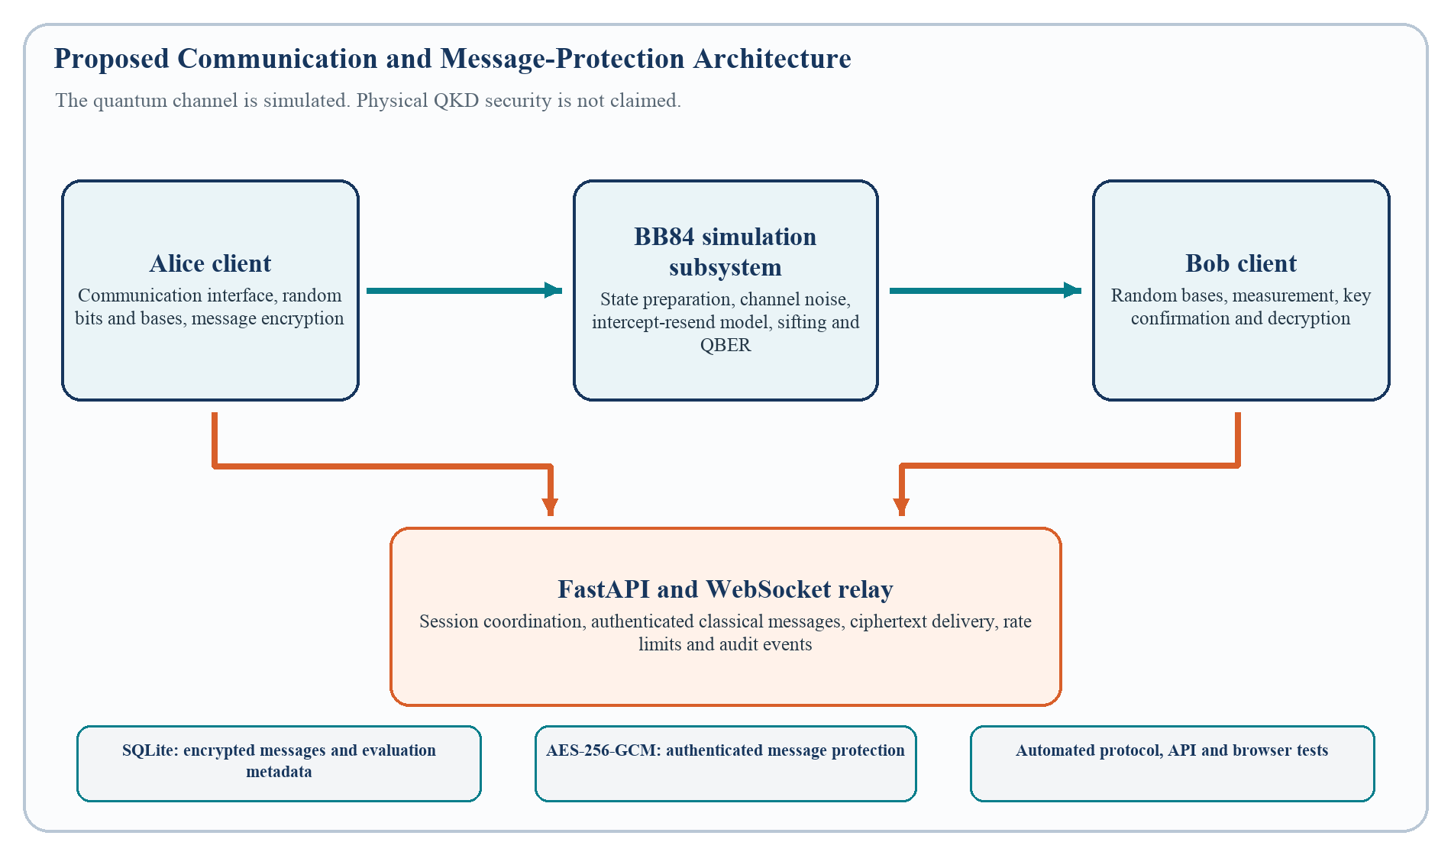
Figure 5.1. Proposed communication and message-protection architecture
Table 5.1. Proposed system modules
Module | Primary responsibility | Current status
Quantum Engine | Emulated state preparation, transmission, measurement, noise, and intercept-resend model. | Design stage
Key Manager | Sifting, QBER sampling, acceptance, reconciliation, privacy amplification, confirmation, and KDF. | Design stage
Messaging Service | User/session handling, WebSocket events, ciphertext delivery, and replay checks. | Planned
Dashboard | Protocol state, QBER, session decisions, and non-secret evaluation records. | Planned
Data Store | Ciphertext and minimal metadata; no active key or plaintext logging. | Planned
In Phase I, the simulator is trusted and may see simulated bits and derived key state, while the relay handles only ciphertext. The prototype therefore does not claim end-to-end security against the simulator. The separation between key handling and application use follows the key-delivery boundary described in ETSI QKD 014 [8] without claiming conformance.

5.2 BB84 PROTOCOL DESIGN
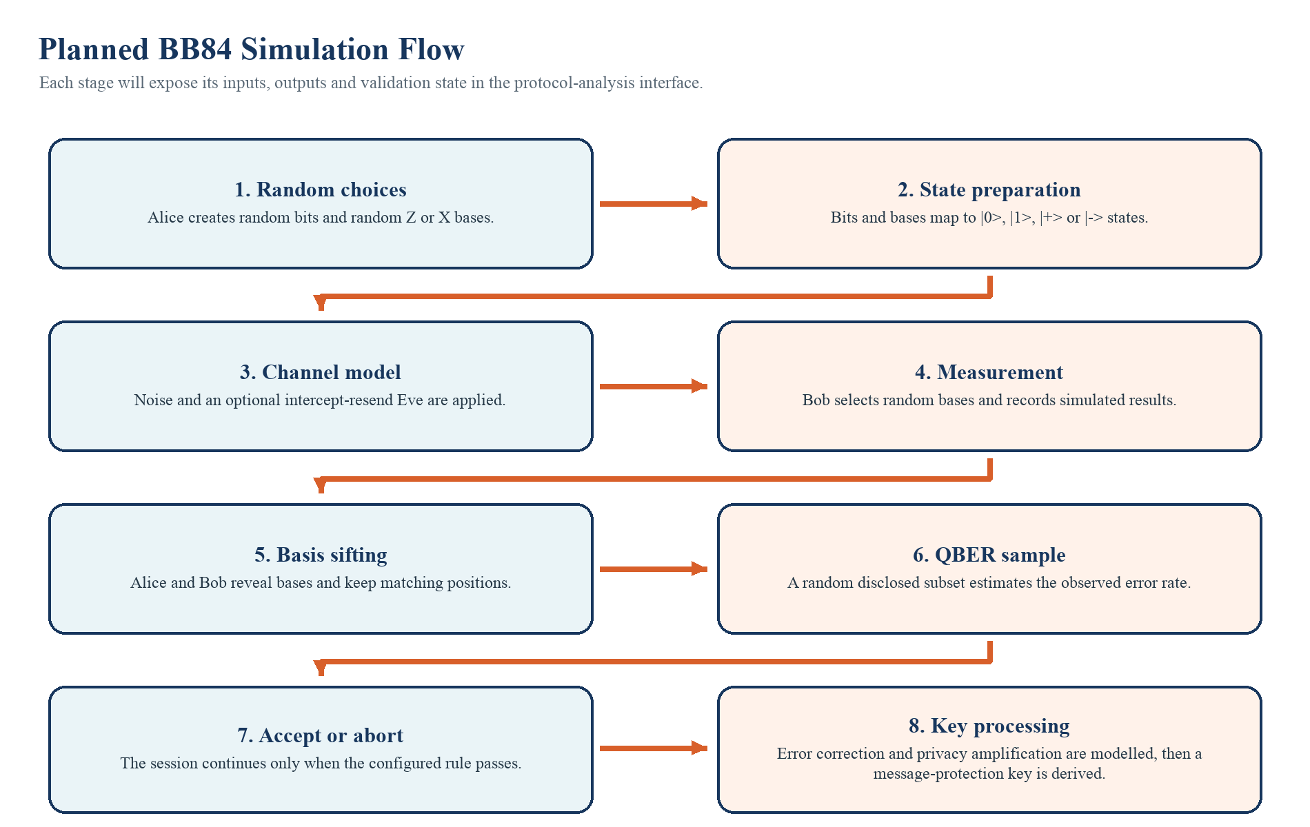
Figure 5.2. Planned BB84 simulation and session-decision flow
Table 5.2. BB84 notation and planned calculations
Item | Definition | Purpose
Basis match | Keep position i only when Alice basis i equals Bob basis i. | Construct the sifted candidate key.
QBER | QBER = mismatches in disclosed sample / disclosed sample size. | Estimate disturbance before acceptance.
Intercept-resend | Ideal full interception approaches 25 percent expected sifted-key QBER; finite runs vary. | Compare simulated distributions with theory.
Post-processing | Reconciliation, leakage verification, privacy amplification, and key confirmation. | Reduce mismatch and information leakage.
Message key | K_msg = KDF(candidate material, salt, session context). | Create correctly sized, context-bound AES key material.
The QBER threshold will be selected for the chosen simulation settings and documented with the test results. The decision will be based on repeated runs rather than a single observation.

5.3 APPLICATION AND DATA FLOW
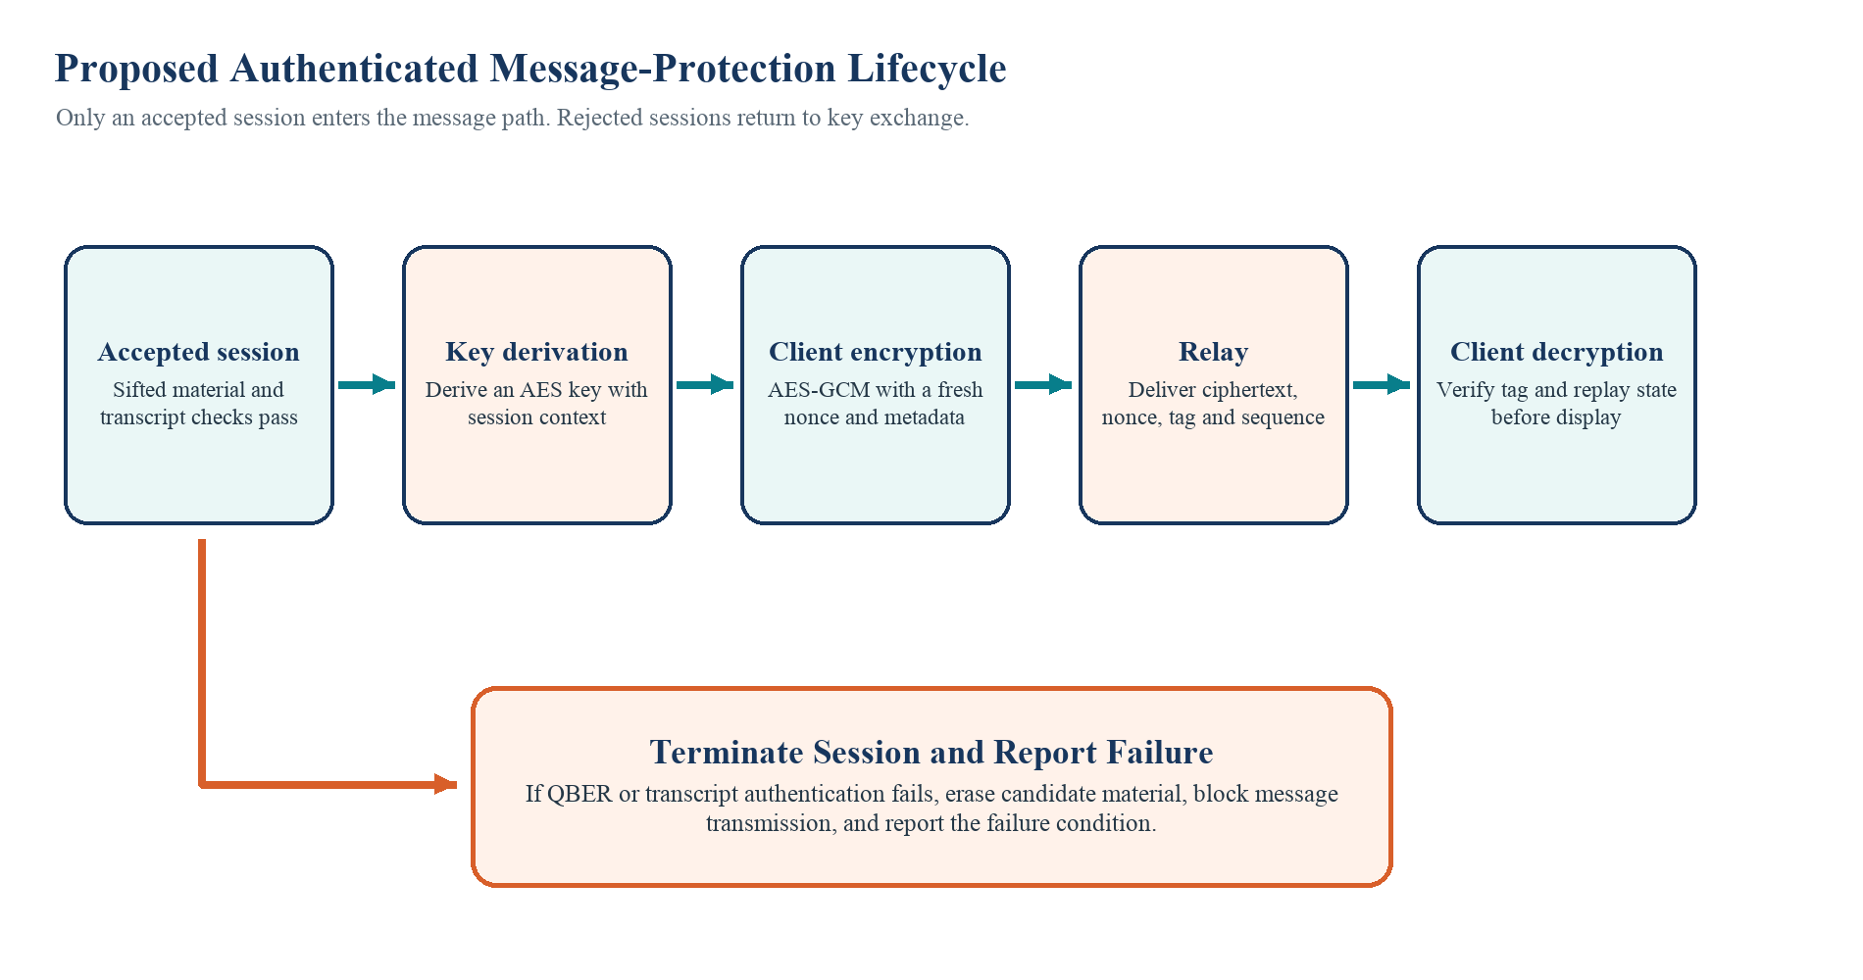
Figure 5.3. Proposed authenticated message-protection lifecycle
Table 5.3. Proposed technology stack
Layer | Selected technology | Planned responsibility
Simulation | Python, NumPy, Qiskit | Protocol logic, repeatable scenarios, and selected circuit cross-checks.
API and events | FastAPI, WebSockets | Session coordination and real-time ciphertext events over WSS/TLS using RFC 6455 [9].
Message protection | AES-256-GCM | Authenticated encryption after KDF, with unique nonce and associated data.
Classical authentication | HMAC | Integrity and authentication using independently trusted bootstrap key material.
Persistence | SQLite | Ciphertext and minimal non-secret evaluation metadata.
Testing | pytest | Protocol, API, cryptographic error-path, and integration tests.
User interface | Web technology to be selected | Two-user messaging controls and protocol-state dashboard.

CHAPTER 6

SOLUTION STRATEGY

6.1 Development Strategy
The project will be developed in stages, beginning with the BB84 simulation and then moving to key processing, messaging, visualisation, and testing.
Table 6.1. Development stages
Stage | Work to be carried out | Main tools
1 | Develop bit generation, basis selection, state preparation, measurement, and sifting. | Python, NumPy, Qiskit
2 | Add channel noise, intercept-resend simulation, QBER calculation, and session rejection. | Python, Qiskit, NumPy
3 | Implement error handling, privacy amplification, key confirmation, and key derivation. | Python cryptography libraries
4 | Develop the server and real-time communication between two users. | FastAPI, WebSockets
5 | Use AES-256-GCM to encrypt and decrypt messages after successful key establishment. | AES-GCM, HMAC, TLS
6 | Build the dashboard, store non-secret records, and complete system testing. | SQLite, pytest, browser interface
The BB84 module will be tested before it is connected to the chat application. This keeps protocol errors separate from networking and user-interface problems.

6.2 TESTING AND VALIDATION
Testing will be carried out at protocol, encryption, communication, and interface levels. The main purpose is to confirm that each stage produces the expected result and that an error stops the session safely.
Table 6.2. Planned testing and validation
Area | Tests to be performed | Expected behaviour
BB84 functions | Known bit and basis inputs, matching and non-matching bases, invalid data. | Correct measurement and sifted-key output.
QBER | No-noise, channel-noise, partial interception, and full intercept-resend scenarios. | Correct calculation and clear accept or reject result.
Key processing | Matching keys, failed correction, confirmation mismatch, and short key material. | Agreement or safe session termination.
AES-GCM | Valid message, modified ciphertext, wrong key, duplicate nonce attempt, and replayed sequence. | Decrypt valid input; reject tag failures; block duplicate key-nonce pairs and replayed sequences.
WebSocket | Login, session joining, message delivery, reconnect, and malformed request. | Correct communication state and error handling.
Interface | Form validation, protocol display, keyboard use, and responsive layout. | Clear operation on desktop and mobile screens.
The final testing report will include the input settings, observed results, and any limitations found during implementation.

CHAPTER 7

EXPECTED OUTCOMES
The project is expected to produce the following outcomes during the remaining development stages.
Table 7.1. Expected project outcomes
Expected outcome | Description
BB84 simulation | A working simulation of bit generation, basis selection, measurement, sifting, and QBER calculation.
Noise and eavesdropping model | Controlled channel-noise and intercept-resend experiments for observing changes in QBER.
Key-processing module | A defined process for correction, privacy amplification, confirmation, and key derivation.
Two-user messaging application | Real-time encrypted message exchange after successful key establishment.
Protocol dashboard | A clear display of BB84 stages, QBER, session status, and eavesdropping simulation.
Testing and documentation | Repeatable tests, setup instructions, design documentation, and final evaluation records.

7.1 Expected Benefits
- A clear demonstration of how BB84 establishes candidate key material rather than encrypting messages directly.
- A controlled comparison of ordinary channel noise and modeled intercept-resend disturbance.
- A practical example of integrating key establishment with standard authenticated encryption.
- A reusable test structure for protocol states, message security, and interface behaviour.

CHAPTER 8

WORK PLAN
The work is divided into study, simulation, key processing, messaging, dashboard development, testing, and documentation. Table 8.1 shows the planned sequence from August to December 2026.
Table 8.1. Project work schedule
Activity | Time window | Status
Literature survey and problem analysis | Aug. 2026 | Completed
BB84 study and basic Qiskit setup | Aug. 2026 | Completed
Core BB84 simulation | Sep.-Oct. 2026 | Planned
Eavesdropping, QBER, and key processing | Oct.-Nov. 2026 | Planned
Messaging and AES integration | Nov.-Dec. 2026 | Planned
Dashboard and system testing | Dec. 2026 | Planned
Documentation and final demonstration | Dec. 2026 | Planned
The core simulation will be completed before the messaging and dashboard modules are integrated. Testing and documentation will continue alongside development so that each result can be checked and explained clearly.

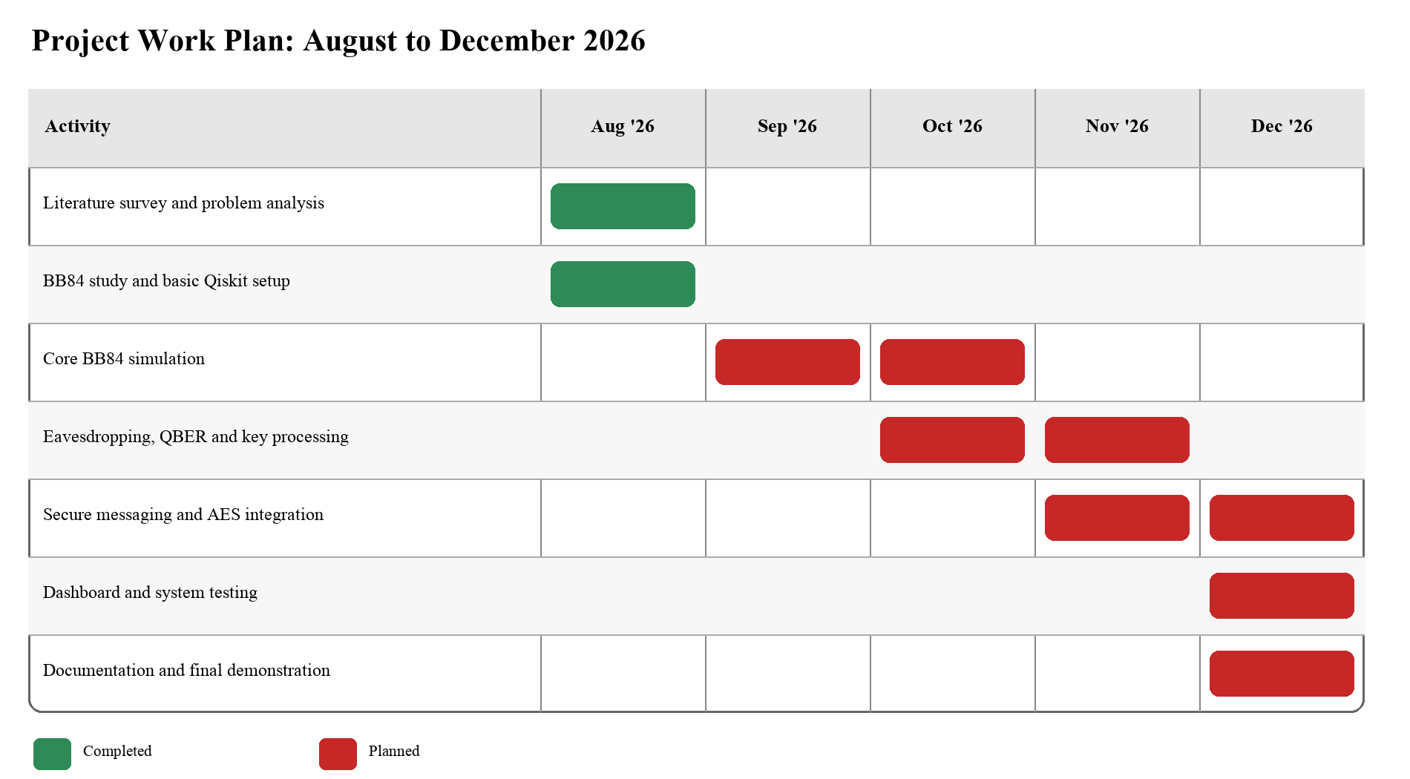

CHAPTER 10

SUMMARY AND CONCLUSION

10.1 Summary of Achievement
Phase-I work has established a clear direction for the proposed BB84-based communication framework. The main work completed so far is listed below:
- Literature survey and study of the BB84 protocol.
- Problem analysis and definition of the project objectives.
- Basic Qiskit environment setup for future simulation work.
- Preparation of the proposed architecture, development method, testing plan, and project schedule.
The application itself is still under development, and no final performance result is presented in this report.

10.2 Main Difficulty Encountered
The main difficulty is connecting a BB84 simulation to standard software components without making incorrect security claims. Noise can raise QBER even when no eavesdropper is present, the sifted key needs processing before AES use, and public basis discussion needs independent authentication. These points must be handled clearly in the protocol logic and interface.

10.3 Conclusion
The proposed project is feasible as an educational software application. The next phase will focus on implementing the BB84 simulation, checking the key-processing stages, and then connecting the accepted key to the messaging system. The final evaluation will compare normal, noisy, and intercept-resend scenarios and will record the behaviour of both the protocol and the encrypted communication. The project provides a useful way to study quantum key-distribution concepts while applying standard software-security practices to message protection.

CHAPTER 11

REFERENCES
- C. H. Bennett and G. Brassard, "Quantum cryptography: Public key distribution and coin tossing," in Proc. IEEE Int. Conf. Computers, Systems and Signal Processing, Bangalore, India, Dec. 1984, pp. 175-179. [Online]. Available: https://arxiv.org/abs/2003.06557
- P. W. Shor and J. Preskill, "Simple proof of security of the BB84 quantum key distribution protocol," Physical Review Letters, vol. 85, no. 2, pp. 441-444, Jul. 2000, doi: 10.1103/PhysRevLett.85.441.
- V. Scarani, H. Bechmann-Pasquinucci, N. J. Cerf, M. Dusek, N. Lutkenhaus, and M. Peev, "The security of practical quantum key distribution," Reviews of Modern Physics, vol. 81, no. 3, pp. 1301-1350, Sep. 2009, doi: 10.1103/RevModPhys.81.1301.
- C. Portmann and R. Renner, "Security in quantum cryptography," Reviews of Modern Physics, vol. 94, no. 2, Art. no. 025008, Jun. 2022, doi: 10.1103/RevModPhys.94.025008.
- E. Dervisevic, A. Tankovic, E. Fazel, R. Kompella, P. Fazio, M. Voznak, and M. Mehic, "Quantum Key Distribution Networks - Key Management: A Survey," ACM Computing Surveys, vol. 57, no. 10, Art. no. 257, pp. 1-36, May 2025, doi: 10.1145/3730575.
- D. Tupkary, E. Y.-Z. Tan, S. Nahar, L. Kamin, and N. Lutkenhaus, "Security proofs for practical QKD: Variations, techniques, gaps, and limitations," Reviews of Modern Physics, accepted Jun. 10, 2026, doi: 10.1103/28rs-frmw.
- M. Dworkin, Recommendation for Block Cipher Modes of Operation: Galois/Counter Mode (GCM) and GMAC, NIST Special Publication 800-38D, Nov. 2007, doi: 10.6028/NIST.SP.800-38D.
- European Telecommunications Standards Institute, "Quantum Key Distribution (QKD); Protocol and data format of REST-based key delivery API," ETSI GS QKD 014 V1.1.1, Feb. 2019. [Online]. Available: https://www.etsi.org/deliver/etsi_gs/QKD/001_099/014/01.01.01_60/gs_qkd014v010101p.pdf. [Accessed: Aug. 27, 2026].
- I. Fette and A. Melnikov, "The WebSocket Protocol," Internet Engineering Task Force, RFC 6455, Dec. 2011, doi: 10.17487/RFC6455.

