

CCP Proposal
TOPIC: Design and Implementation of a Secure Multi-Campus Metropolitan Area Network (MAN) using OSPF and Multilayer Switching
COURSE: Routing & Switching Theory
SUBMITTED TO: Ali Ahmed Siddiqui
GROUP MEMBERS:
NAMES | REG ID
ABDUL SARIM KHAN | 62527
MUHAMMAD JAHANZAIB | 63843
FIZZA BAIG | 63503
KOMAL JALEES | 63614

Motivation
Large educational institutions with geographically distributed campuses face challenges in maintaining secure and efficient connectivity while preserving departmental separation. To ensure scalability and automated convergence, dynamic routing using OSPF is employed instead of static routing. Network performance is enhanced by performing inter-VLAN routing on Cisco 3560 multilayer switches, while asymmetric privileged access policies allow administrative coordination across campuses and restrict student traffic to prevent WAN congestion.

Concept
This project integrates multiple Local Area Networks into a unified Metropolitan Area Network using Layer 3 switching. User traffic is logically segmented through VLANs, with inter-VLAN routing handled internally on multilayer switches via SVIs. OSPF is deployed to provide dynamic routing across a high-speed fiber backbone, while extended ACLs and asymmetric access control policies enforce secure campus isolation by granting full privileges to the administrative network and restricting student and laboratory traffic to local communication only.

Problem Statement
A robust network is designed for four university campuses namely Gulshan, Airport, Main, and North Nazimabad interconnected through a Metro Ethernet ring topology using OSPF for dynamic routing. Each campus is logically segmented into three VLANs including Admin (10), Student (20), and Labs (30). Administrative staff are granted full inter campus connectivity through privileged access policies, while Student and Lab VLANs are strictly restricted to local campus communication only. Extended access control mechanisms prevent these VLANs from accessing the Admin network or traversing the WAN, ensuring secure, isolated, and efficient network operations.

Background / Theory
Layer 3 switching enables multilayer switches to perform packet rewriting and routing at hardware speeds using Switch Virtual Interfaces (SVIs), providing high-performance inter-VLAN communication. A single OSPF backbone configuration using Area 0 is implemented to ensure that all four campuses maintain a synchronized and consistent routing table across the network. Instead of relying on physical router interfaces, SVIs act as virtual default gateways for VLANs, simplifying network design and improving scalability. Additionally, stateful traffic behavior is simulated using access control rules such as TCP established and ICMP echo-reply, allowing return traffic to pass through otherwise stateless ACL filtering while maintaining secure traffic control.

Procedure / Methodology
A structured IP addressing scheme is defined to allocate unique subnets to the North Nazimabad, Main, Airport, and Gulshan campuses, ensuring clear identification and efficient routing of network traffic, such as assigning separate /24 networks for administrative, student, and laboratory VLANs at each campus. The network configuration begins with the Layer 2 setup, where VLANs and trunk ports are created on access switches to enable proper segmentation and VLAN propagation. Layer 3 functionality is then enabled on Cisco 3560 multilayer switches by activating IP routing. Switch Virtual Interfaces for VLANs 10, 20, and 30 are configured to act as default gateways for end devices. Wide area connectivity is established by configuring routed ports on the switches using fiber links between campuses. Dynamic routing is implemented by enabling OSPF and advertising the relevant networks, while network security is enforced by applying inbound extended access control lists to the Student and Lab SVIs to restrict unauthorized traffic.

Block Diagram / Topology Design
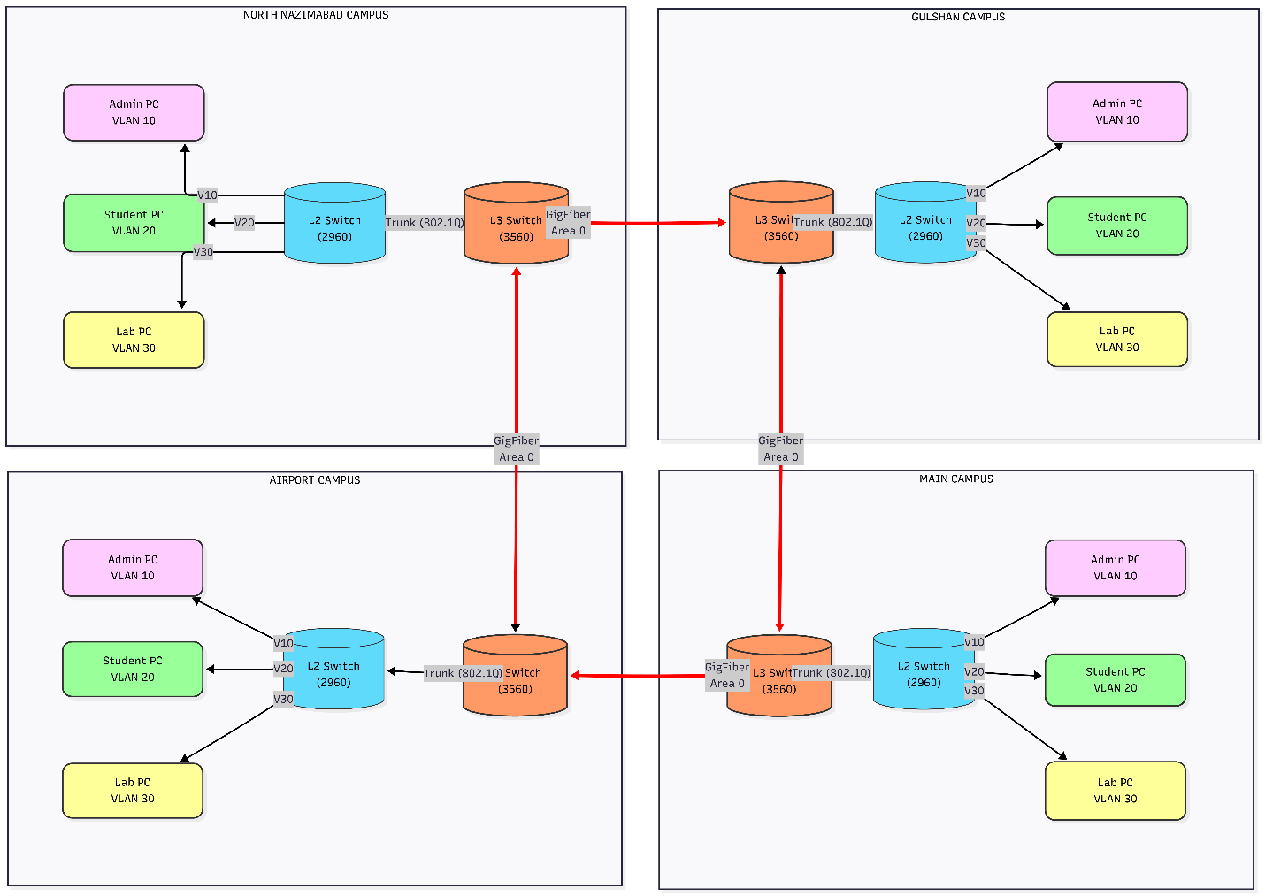
Figure 1- Topology Block Diagram

Expected Results & Analysis

Connectivity:
- Admin PCs can ping Admin PCs across all campuses (validates OSPF WAN routing).
- Student PCs can ping local Lab PCs (confirms inter-VLAN routing).
- Lab PCs can ping local Student PCs (confirms inter-VLAN routing).

Security:
- Student PCs are blocked from pinging Admin PCs (ACL enforcement).
- Lab PCs are blocked from pinging Admin PCs (ACL enforcement).
- Lab PCs cannot reach Students on other campuses (WAN restriction).
- Student PCs cannot reach Students on other campuses (WAN restriction).

Protocol Verification:
- “show ip route” displays OSPF entries for all remote subnets.
- “show ip access-lists” shows incrementing match counts for blocked packets.

Hardware / Devices Used:
Device | Purpose
PCs / Laptops | End-devices for Admin, Student, and Lab blocks.
Cisco 2960 Switch | Layer 2 Access: Connects PCs to the network and handles VLAN tagging (802.1Q).
Cisco 3560 Multilayer Switch | Core/Distribution: Handles Inter-VLAN Routing (SVIs) and Metro Ethernet WAN connections.
Fiber Optic Cable | WAN Backbone: High-speed Gigabit connections between the four Campus Multilayer Switches (Ring Topology).
Copper Straight-Through Cable | LAN Access: Connects PCs to Switches. (Used because they are different types of devices).
Copper Cross-Over Cable | Inter-Switch Links: Connects Access Switches (2960) to Core Switches (3560). (Used because they are the same type of device).

