Starting Website:  
<https://www.fca.gov/bank-oversight/call-report-data-for-download>  
Deliverable will be script which will go to above URL and downloads the latest file like   
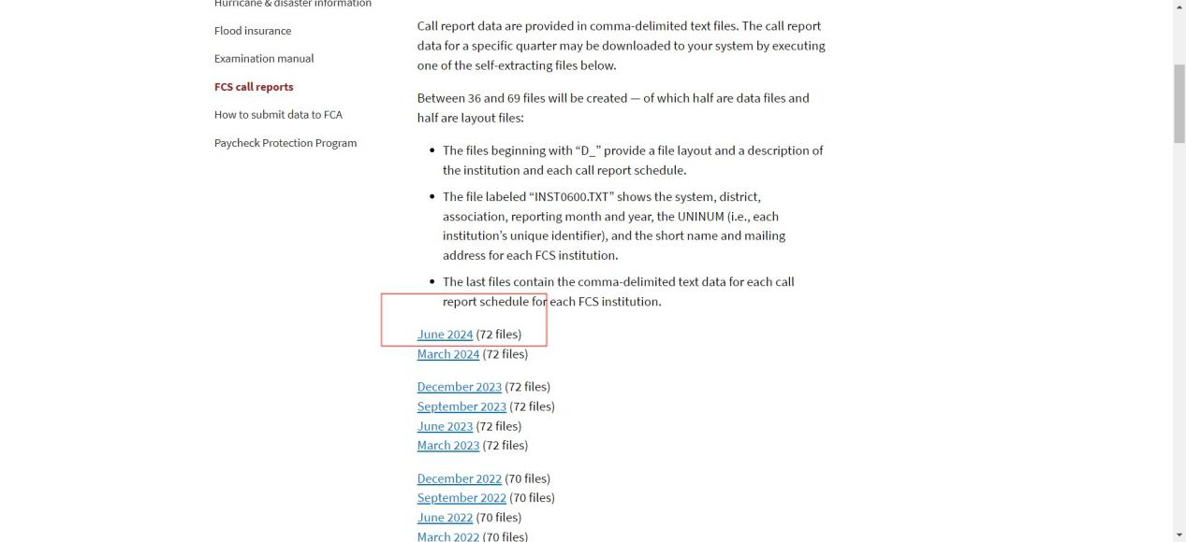

Currently june 2024 is latest file it will be in zip form then script should read that zip file and whether extract it or get all .txt files in it and then read only .txt file which have “D” at the start and get below data in CSV  
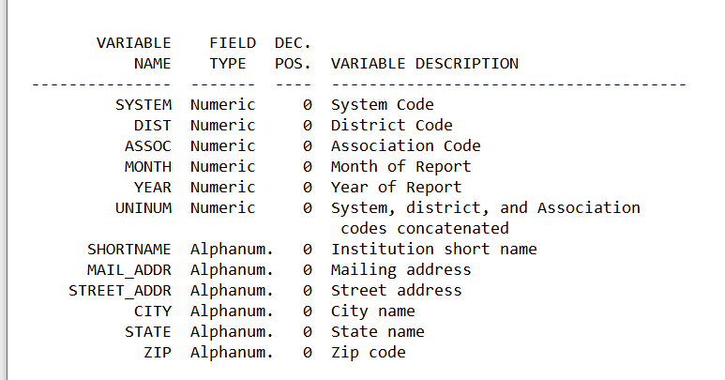

And add one more column at the end the file name from which that data is