**FlexRAN 제어기를 이용한 무선 접근 망 슬라이싱을 위한 테스트베드**

아흐메드 자한젭, 송왕철, 안기중

**Test Bed for Radio Access Network Slicing Using FlexRAN Controller**

Jahanzeb Ahmed

[seejahanzebahmed@gmail.com](mailto:seejahanzebahmed@gmail.com)

Department of Computer Engineering

Jeju National University

Wang-Cheol Song

[philo@jejunu.ac.kr](mailto:philo@jejunu.ac.kr)

Department of Computer Engineering

Jeju National University

Ahn, Khi Jung

[kjahn@jejunu.ac.kr](mailto:kjahn@jejunu.ac.kr)

Department of Computer Engineering

Jeju National University

**Abstract**

Slicing Radio Access Network (RAN) can help in effectively utilizing the network bandwidth and to better manage the increasing traffic over interent. RAN slicing system discussed in this paper is based on an open-source slicing mechanism in which we write a JSON configuration file for slicing policy and send it to the FlexRAN controller. FlexRAN controlls the core networks (CNs) through OAI-RAN on the evolved packet core (EPC) component of this system. Each CN is responsible for handling a saperate RAN slice. The type of internet traffic is identified by the FlexRAN crontroller and is sent to the respective CN through OAI-RAN. CN handles the traffic according to the allocated bandwidth and in this way the internet traffic is sliced inside the EPC component.

1. **Introduction**

Fifth-generation network and next-generation networks beyond 5G will introduce huge traffic over the internet due to the advancement of technology such as communication between vehicles, IoT devices, video streaming and much more that has not been introduced yet. However, due to the limited resources, it would not be possible to allocate the same bandwidth to every type of user over internet. Hence, a slicing mechanism is required to share the limited resources over internet and allocating resources to every user according to its need. This will make the network more manageable and effective because of the proper utilization of the bandwidth.

The slicing mechanism introduced in this paper is based on the FlexRAN which is an open-source platform for software-defined radio access networks (RAN) [1]. The FlexRAN is the backbone of this system which is used in this system for creating RAN slices and defining RAN slicing policy i.e. how many slices to be created and what resources to be allocated to each slice.

Moreover, FlexRAN also controls the slices’ working inside the evolved packet core (EPC) part of this system. Further, this EPC consists of core networks and radio access network, and the number of core networks has to be equal to the number of slices to be created.

Next in this paper, section.2 discusses the literature review, section.3 shows the development methodology followed for this slicing system, and section.4 presents the conclusion.

1. **Literature Review**

Several mechanisms have been developed and are being developed for slicing radio access network in order to effectively utilize the network bandwidth. Orion RAN Slicing System [2] is one of those system designs which provides a flexible and cost-effective slicing scenario. Figure.1 [2] shows the architecture of this Orion slicing system. The core of Orion slicing system is the Base Station Hypervisor which acts as a bridge between the data plane and the control planes of slices.

Mosaic5G is a non-profit software development community of academic and industrial contributors. It provides a channel for 5G R&D open-source platforms [3].

A Radio Access Network Slicing mechanism has been developed by Mosaic5G using FlexRAN [4]. This paper is based on that mechanism in order to develop a test-bed for the deployment of Radio Access Network slicing. The system is discussed in detail in the next section.

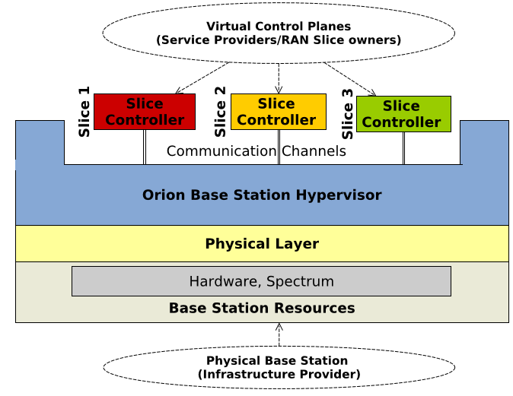

Figure 1: Orion Slicing System

1. **Methodology**

The radio access network slicing mechanism discussed in this paper is based on the documentation provided by the Mosaic5G on how to build a RAN sharing demo [4]. FlexRAN is the backbone of this system design and this slicing mechanism has four major components that are FlexRAN controller, Open Air Interface Core Network (OAI-CN) and Open Air Interface Radio Access Network (OAI-RAN). Furthermore, we have used four computer machines for running a radio access network slicing demo. OAI-RAN has been installed on one computer machine, OAI-CN has been installed on other two computer machines, and FlexRAN controller has been installed on another separate computer machines. The number of CNs depends on the number of slices we want to create, so in this demo we have created only two slices.

OAI-CN and OAI-RAN are the part of evolved packet core abbreviated as EPC. OAI-RAN and OAI-CN communicates with each other through S1-Flex interface, and OAI-CNs are visible to the internet world through IP address. The User Equipment (UE) connects to the OAI-RAN which transmits signals through USRP.

FlexRAN controller is present above the EPC and it controls and manages the RAN slices. A RAN sharing/slicing policy is defined using a JSON configuration file which is sent to the FlexRAN controller through REST API, and based on that policy the FlexRAN controller allocates the resources to the slices. For example in this demo, we have created two active RAN slices and we have allocated 50 percent resources to each slice. Each RAN slice has a unique ID which is used by the FlexRAN controller to identify the slice.

Figure.2 shows the detailed architecture of this RAN slicing system.

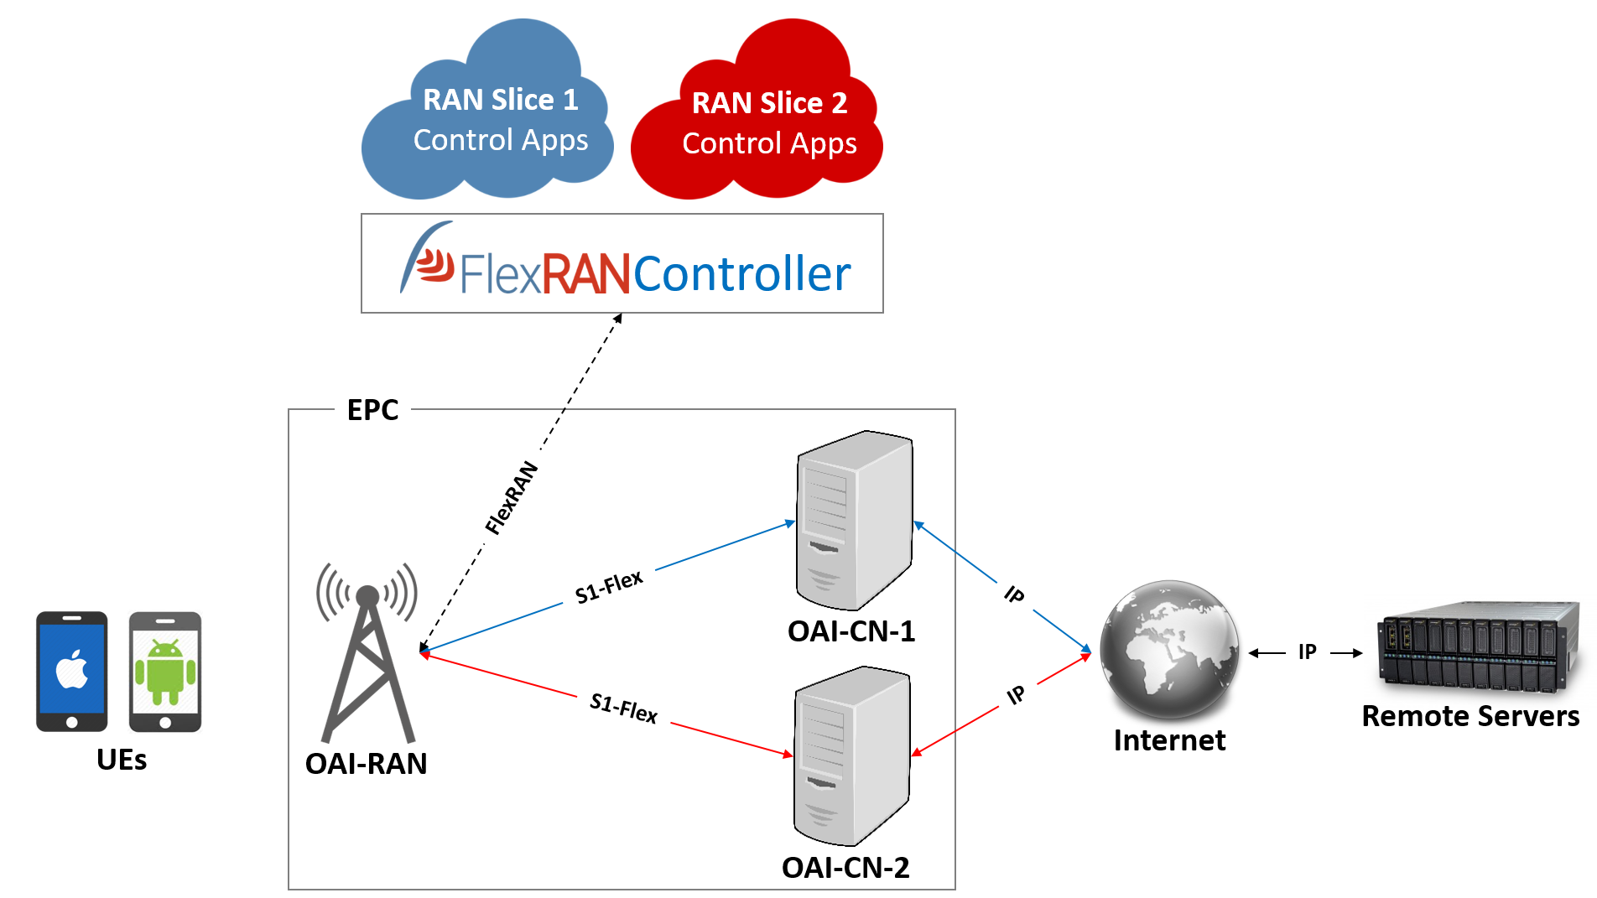

Figure 2: RAN Slicing Architecture

1. **Conclusion**

The radio access network slicing mechanism discussed in this paper is based on the Mosaic5G’s open-source slicing mechanism which uses FlexRAN controller for creating and controlling RAN slices. In this paper, we demonstrated a RAN slicing scenario in which we created two slices each having 50% resources.

**Acknowledgment**

This research was financially supported by the Ministry of Small and Medium-sized Enterprises (SMEs) and Startups (MSS), Korea, under the “Regional Enterprise Open-Innovative Voucher Program (R&D, P0010715)” supervised by the Korea Institute for Advancement of Technology (KIAT).

Further, this research was supported by the MSIT (Ministry of Science and ICT), Korea, under the ITRC (Information Technology Research Center) support program (IITP-2019-2017-0-01633) supervised by the IITP (Institute for Information & communications Technology Promotion).

**References**

1. FlexRAN. Flexible and Programmable Platform for Software-Defined Radio Access Networks. (<http://mosaic-5g.io/flexran/>)
2. Xenofon Foukas, Mahesh K. Marina, Kimon Kontovasilis. 2017. Orion: RAN Slicing for a Flexible and Cost-Effective Multi-Service Mobile Network Architecture. *MobiCom* (2017).
3. Mosaic5G. A Community Led Consortium. (<http://mosaic-5g.io/>)
4. How to build a RAN sharing demo. (<https://gitlab.eurecom.fr/mosaic5g/mosaic5g/wikis/tutorials/slicing>)