CE-312 Assignment # 1 (CLO-1)
Classification of Daily Site Conditions
Name: ______________________ Roll No: _______________
Section: _______ Date: _______________
Given Data
x = Crew productivity (m³/hour), y = Equipment utilization (hour/day), Label: 1 = Acceptable, 0 = Unacceptable
Day | x | y | Label
D1 | 1 | 5 | 1
D2 | 1 | 3 | 0
D3 | 2 | 3 | 1
D4 | 2 | 1 | 0
D5 | 3 | 2 | 1
D6 | 3 | 1 | 0
D7 | 4 | 2 | 1
D8 | 4 | 1 | 0
D9 | 5 | 1 | 0
D10 | 5 | 2 | 1

Part (a) Examining the data and 3D plot
First I looked at the data carefully before plotting. My observations are:
- There are 10 days in total. 5 days are Acceptable (D1, D3, D5, D7, D10) and 5 are Unacceptable (D2, D4, D6, D8, D9), so the data is balanced.
- x goes from 1 to 5 and every value of x comes exactly two times, once with label 1 and once with label 0. So x alone can not tell us the class.
- If I compare the two days having the same x, the day with the higher y is always class 1 (e.g. D1 y=5 vs D2 y=3, D3 y=3 vs D4 y=1, D9 y=1 vs D10 y=2). So y is important and both x and y together decide the class.
For the 3D plot I took x on the x-axis, y on the y-axis and the Label (0 or 1) on the z-axis. Green circles are class 1 and red triangles are class 0. Class 1 points are lifted up to z = 1 and class 0 points stay on the floor (z = 0).
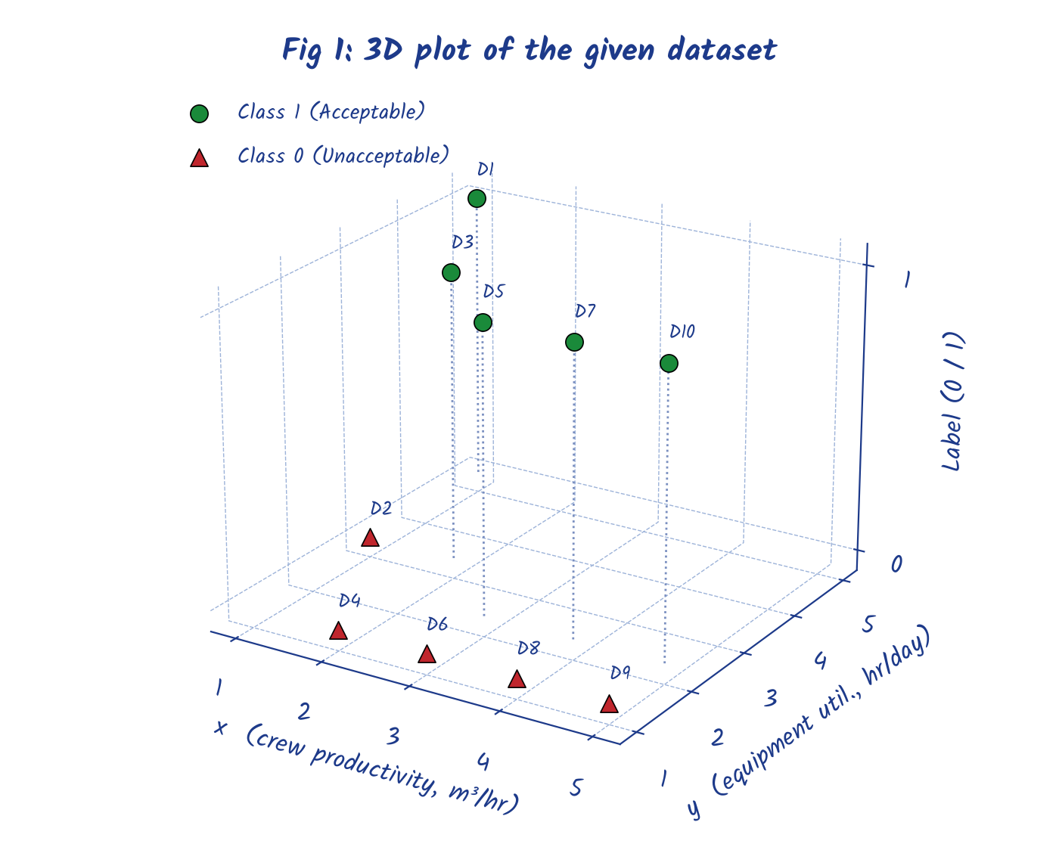
From Fig 1 it is clear that the green points are towards the higher y side of the graph while red points are mostly at y = 1 or at low y. There is no simple line on x only that can separate them.
Part (b) Comparing z = xy and z = -log(x)
I calculated both functions for every day. (log is taken to base 10. With natural log the numbers change but the conclusion stays same because it still depends only on x.)
Day | x | y | z = xy | z = -log(x) | Actual Label
D1 | 1 | 5 | 5 | 0 | 1
D2 | 1 | 3 | 3 | 0 | 0
D3 | 2 | 3 | 6 | -0.301 | 1
D4 | 2 | 1 | 2 | -0.301 | 0
D5 | 3 | 2 | 6 | -0.477 | 1
D6 | 3 | 1 | 3 | -0.477 | 0
D7 | 4 | 2 | 8 | -0.602 | 1
D8 | 4 | 1 | 4 | -0.602 | 0
D9 | 5 | 1 | 5 | -0.699 | 0
D10 | 5 | 2 | 10 | -0.699 | 1

Function 1: z = xy
This surface goes up when x or y increases (it is like a curved sheet, highest at x = 5, y = 5). When I put the data points on it (Fig 2), all green points are at z = 5, 6, 6, 8, 10 and red points are at z = 3, 2, 3, 4, 5. So green points sit higher on the surface and red points sit lower. Only D1 and D9 both have z = 5, so they overlap.
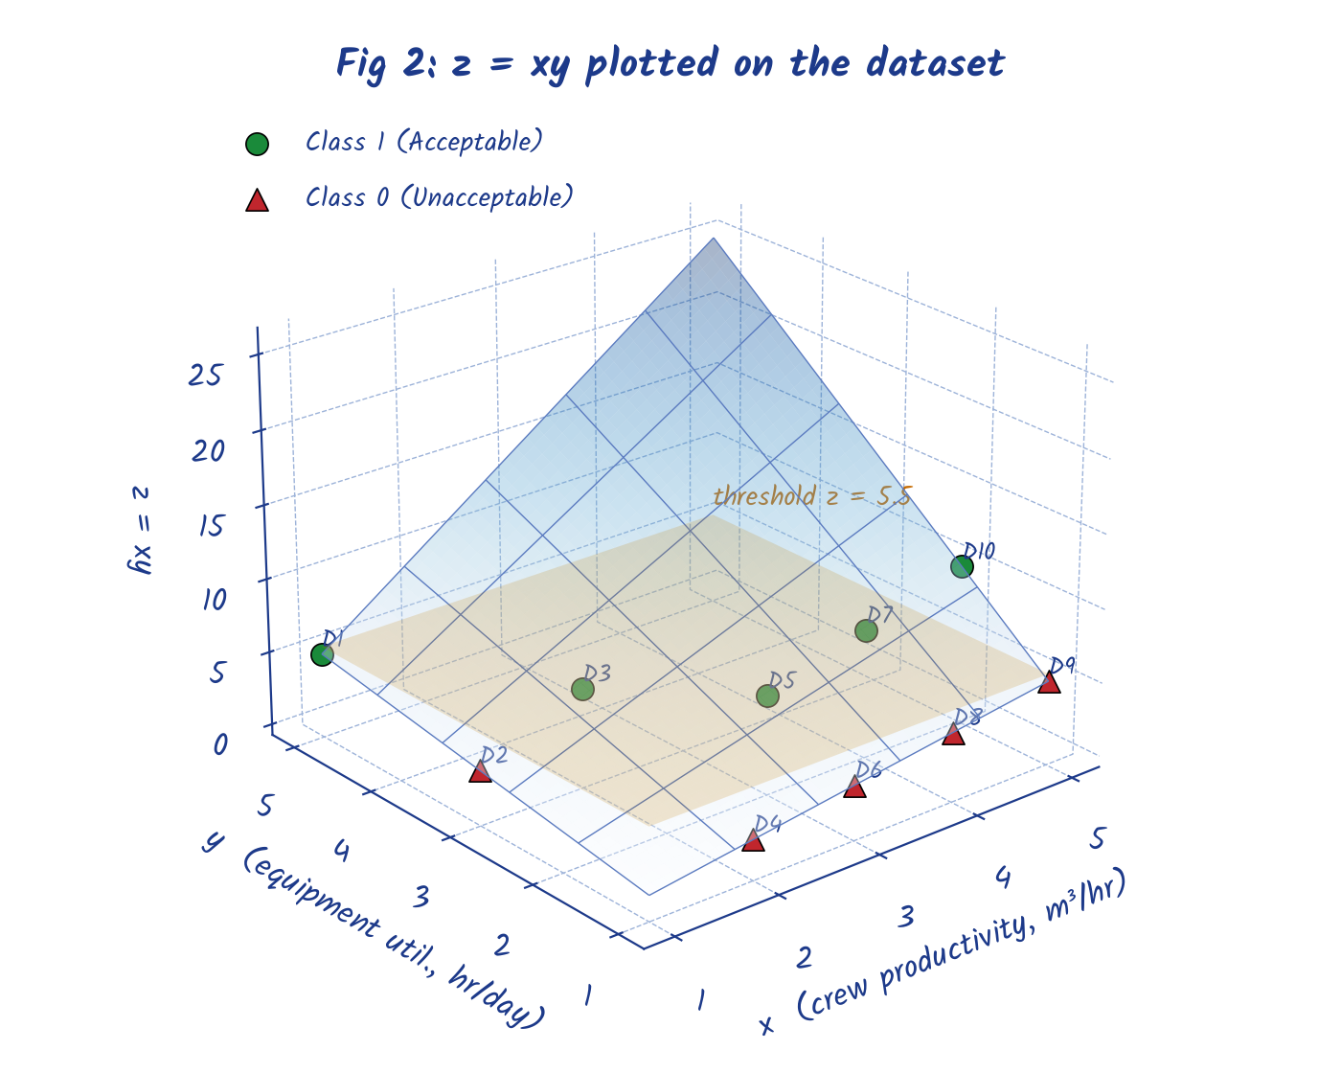
Average z of class 1 = (5+6+6+8+10)/5 = 7.0
Average z of class 0 = (3+2+3+4+5)/5 = 3.4
Function 2: z = -log(x)
This function only uses x, there is no y in it. So the surface is flat in the y direction and just goes down as x increases (Fig 3). Because each x value has one green and one red point, both points of the pair get the exact same z value (e.g. D1 and D2 both get 0, D3 and D4 both get -0.301).
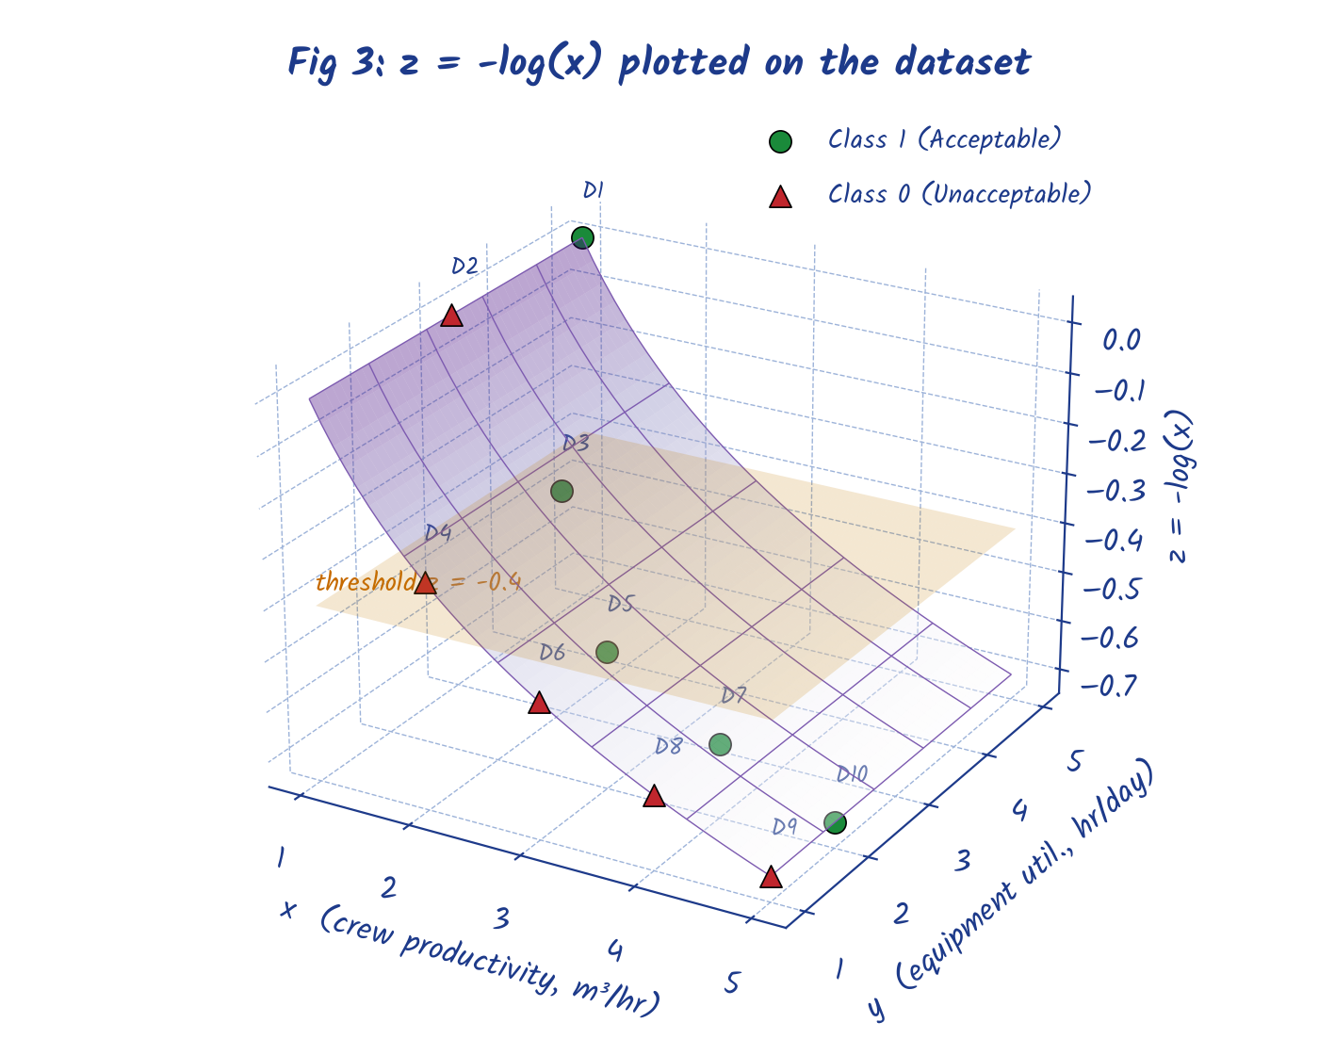
Average z of class 1 = (0 - 0.301 - 0.477 - 0.602 - 0.699)/5 = -0.416
Average z of class 0 = (0 - 0.301 - 0.477 - 0.602 - 0.699)/5 = -0.416
Both averages are exactly the same, which shows -log(x) has no ability to separate the two classes.
Comparison:
Point | z = xy | z = -log(x)
Variables used | x and y both | only x
Class 1 values | 5 to 10 (high) | same as class 0
Class 0 values | 2 to 5 (low) | same as class 1
Separation | good (only 1 overlap) | none

So from the plots, z = xy looks much better for this dataset.
Part (c) Method to test the accuracy
Method (as per hint, using a threshold T):
- Step 1: Calculate z for each day using the function.
- Step 2: Pick a threshold T. Rule: if z > T then predicted = 1 (Acceptable), otherwise predicted = 0.
- Step 3: Compare predicted label with the actual label for all 10 days.
- Step 4: Accuracy = (number of correct predictions / total days) x 100
To choose T, I tried a few values in between the z values and counted the correct ones:
Trying thresholds for z = xy
T | Correct | Accuracy
2.5 | 6 / 10 | 60 %
3.5 | 8 / 10 | 80 %
4.5 | 9 / 10 | 90 %
5.5 | 9 / 10 | 90 %
6.5 | 7 / 10 | 70 %

4.5 and 5.5 both give 90 %. I selected T = 5.5 because with this value no Unacceptable day is called Acceptable, which is the safer side for a construction site.
Trying thresholds for z = -log(x)
T | Correct | Accuracy
-0.15 | 5 / 10 | 50 %
-0.40 | 5 / 10 | 50 %
-0.55 | 5 / 10 | 50 %
-0.65 | 5 / 10 | 50 %

Every threshold gives 50 %. I selected T = -0.4 (i.e. predict acceptable when x is 1 or 2).
Checking predicted vs actual (day by day)
(xy uses T = 5.5 and -log(x) uses T = -0.4)
Day | Actual | xy | Pred | Result | -log(x) | Pred | Result
D1 | 1 | 5 | 0 | wrong | 0 | 1 | correct
D2 | 0 | 3 | 0 | correct | 0 | 1 | wrong
D3 | 1 | 6 | 1 | correct | -0.301 | 1 | correct
D4 | 0 | 2 | 0 | correct | -0.301 | 1 | wrong
D5 | 1 | 6 | 1 | correct | -0.477 | 0 | wrong
D6 | 0 | 3 | 0 | correct | -0.477 | 0 | correct
D7 | 1 | 8 | 1 | correct | -0.602 | 0 | wrong
D8 | 0 | 4 | 0 | correct | -0.602 | 0 | correct
D9 | 0 | 5 | 0 | correct | -0.699 | 0 | correct
D10 | 1 | 10 | 1 | correct | -0.699 | 0 | wrong

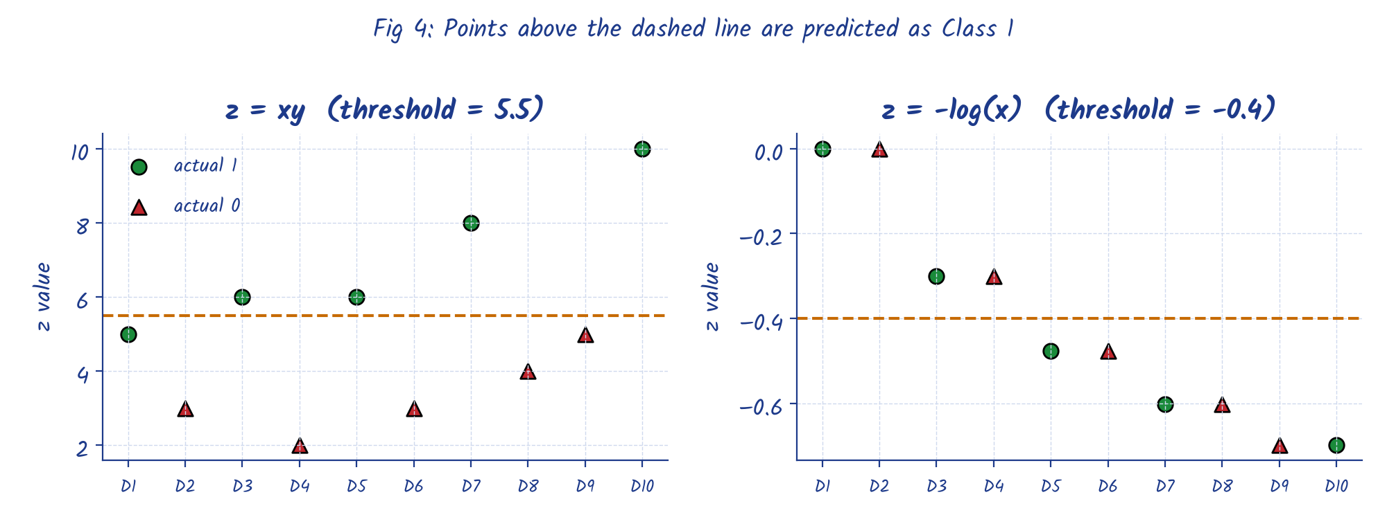
Confusion matrix
 | z = xy | z = -log(x)
TP (actual 1, pred 1) | 4 | 2
TN (actual 0, pred 0) | 5 | 3
FP (actual 0, pred 1) | 0 | 2
FN (actual 1, pred 0) | 1 (D1) | 3
Accuracy | (4+5)/10 = 90 % | (2+3)/10 = 50 %

Conclusion
- z = xy gives 90 % accuracy. Only D1 is wrong (its z = 5 is same as D9 which is unacceptable).
- z = -log(x) gives only 50 % accuracy for any threshold, which is same as guessing by tossing a coin. This is because it ignores y (equipment utilization) and the data has both classes at every x.
- So z = xy is the more suitable function to classify the site conditions. It makes sense also, because x times y is like the total work output of crew and equipment together.

