Name : Jahar Fatima
Email : jaharfatima32@gmail.com

Challenge Tasks:
Beginner Level

Task 1: Basic Linux Commands

- Create and Navigate Directories:
  - Create a directory structure as follows: /home/devops/academy/project.
  - Navigate into the project directory.

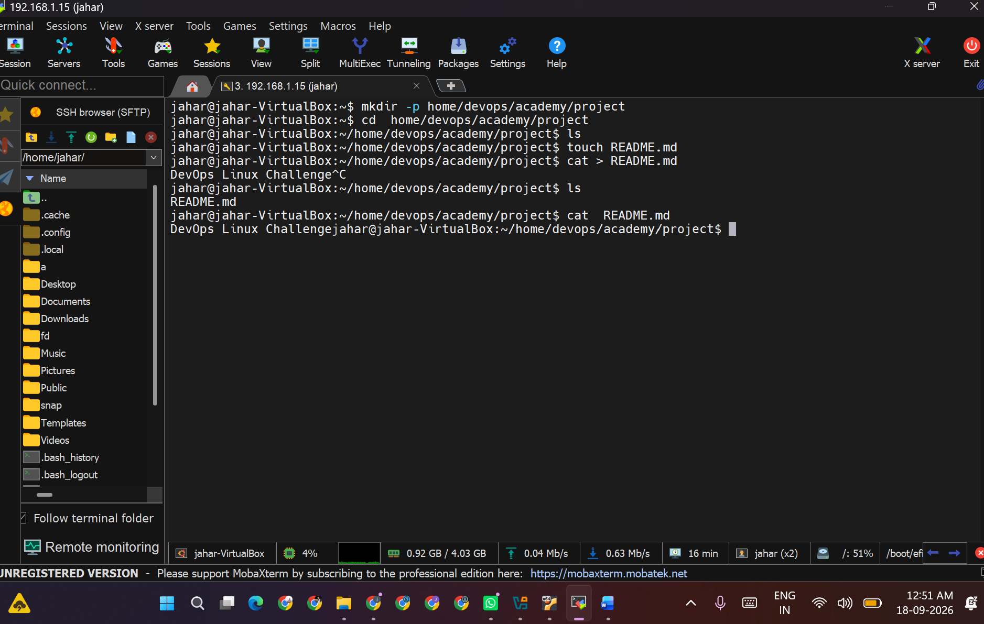

2.File Management:
  - Create an empty file named README.md inside the project directory.
  - Create another file named notes.txt and add the text "DevOps Linux Challenge" into it.
  - Copy notes.txt to /home/devops/academy/backup/.

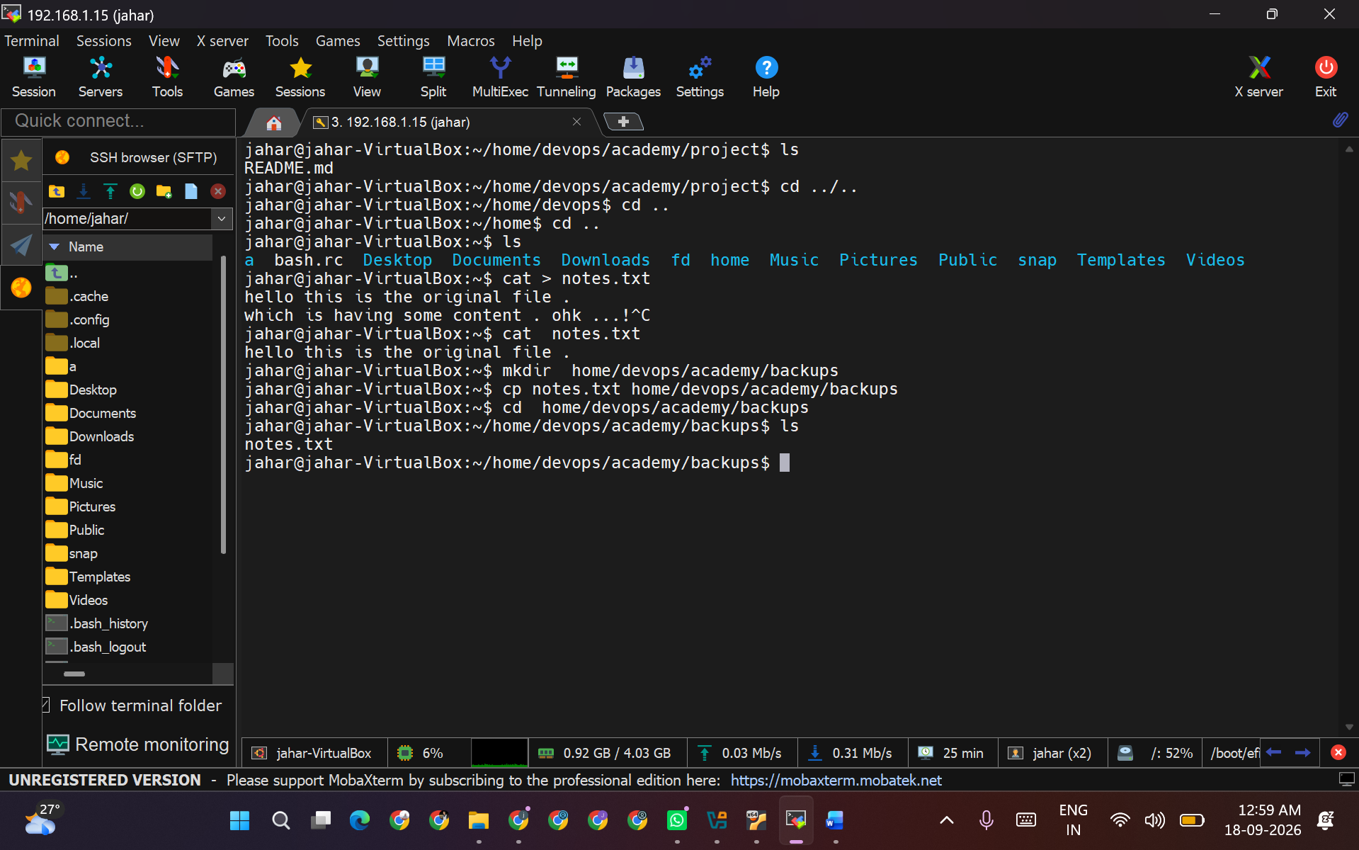

3.Permissions:
  - Change the permissions of README.md to be readable and writable only by the owner.
Make notes.txt readable by everyone, but writable only by the owner
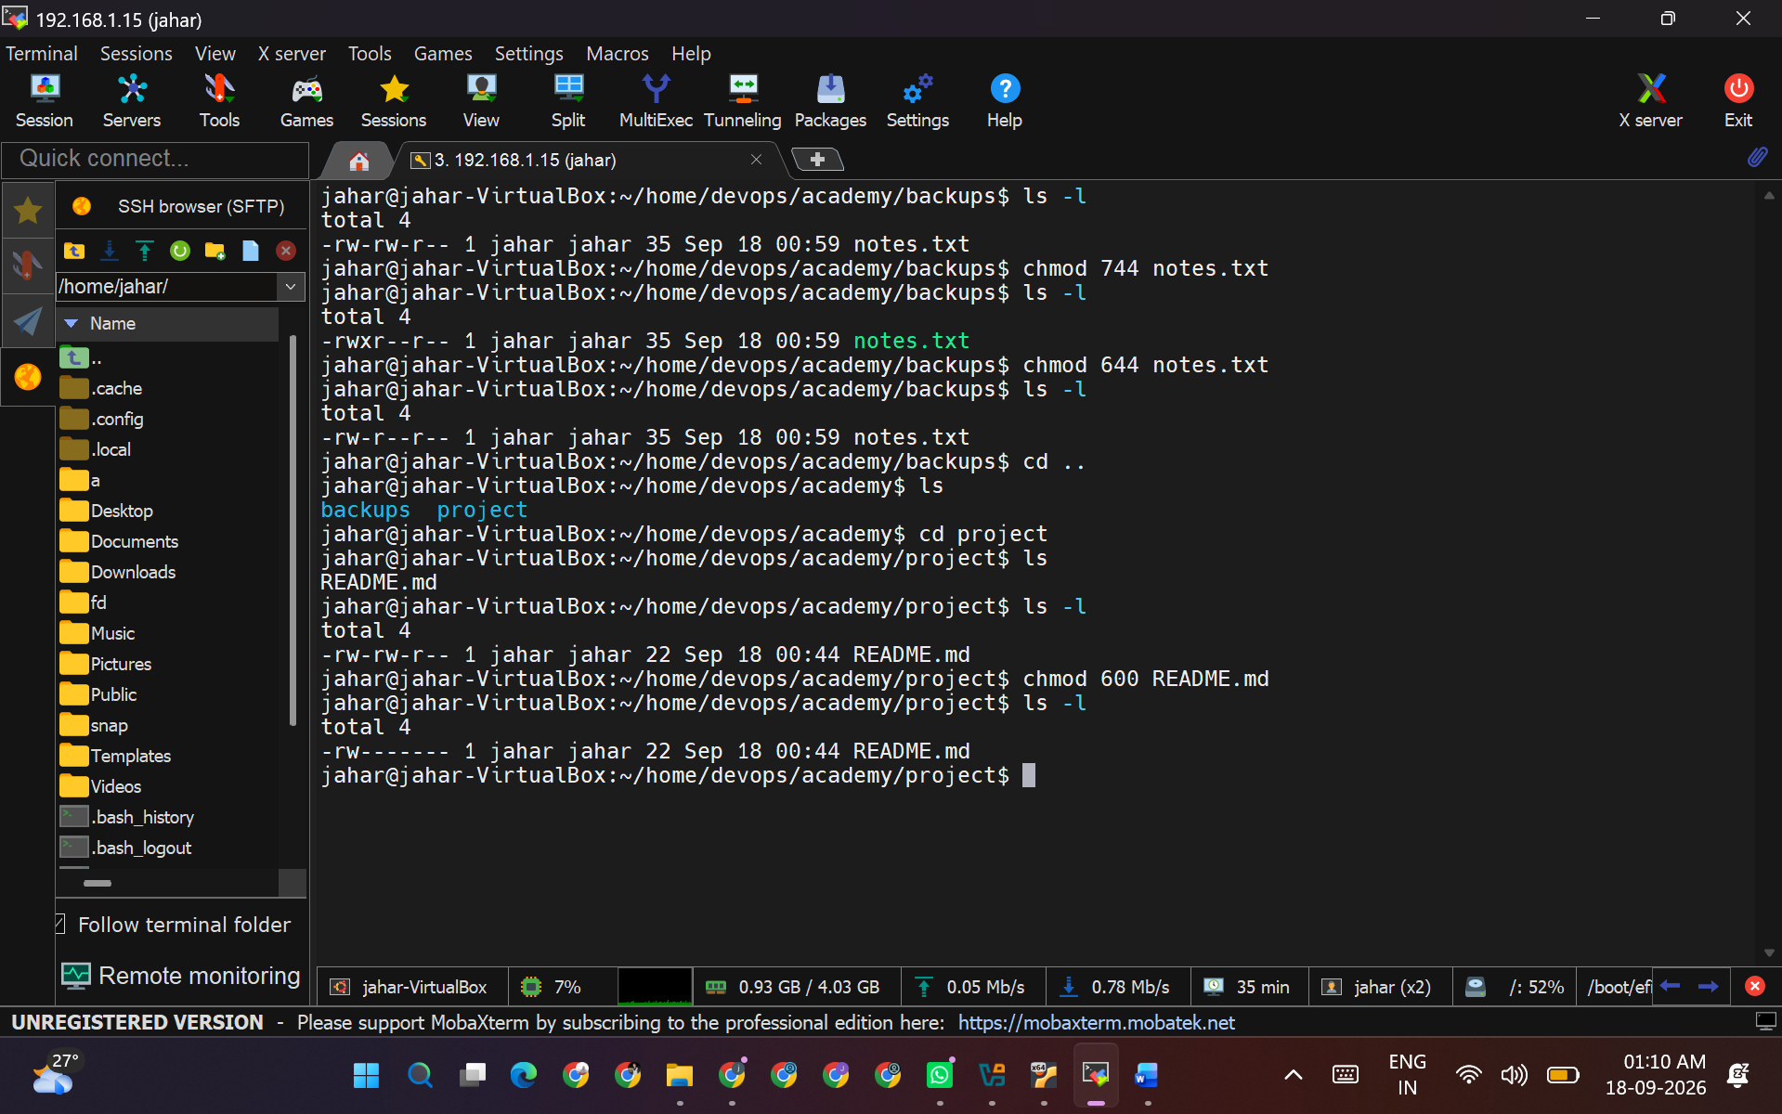

Task 2: User and Group Management

- Create Users:
  - Create a new user named student1.
  - Set a password for student1.

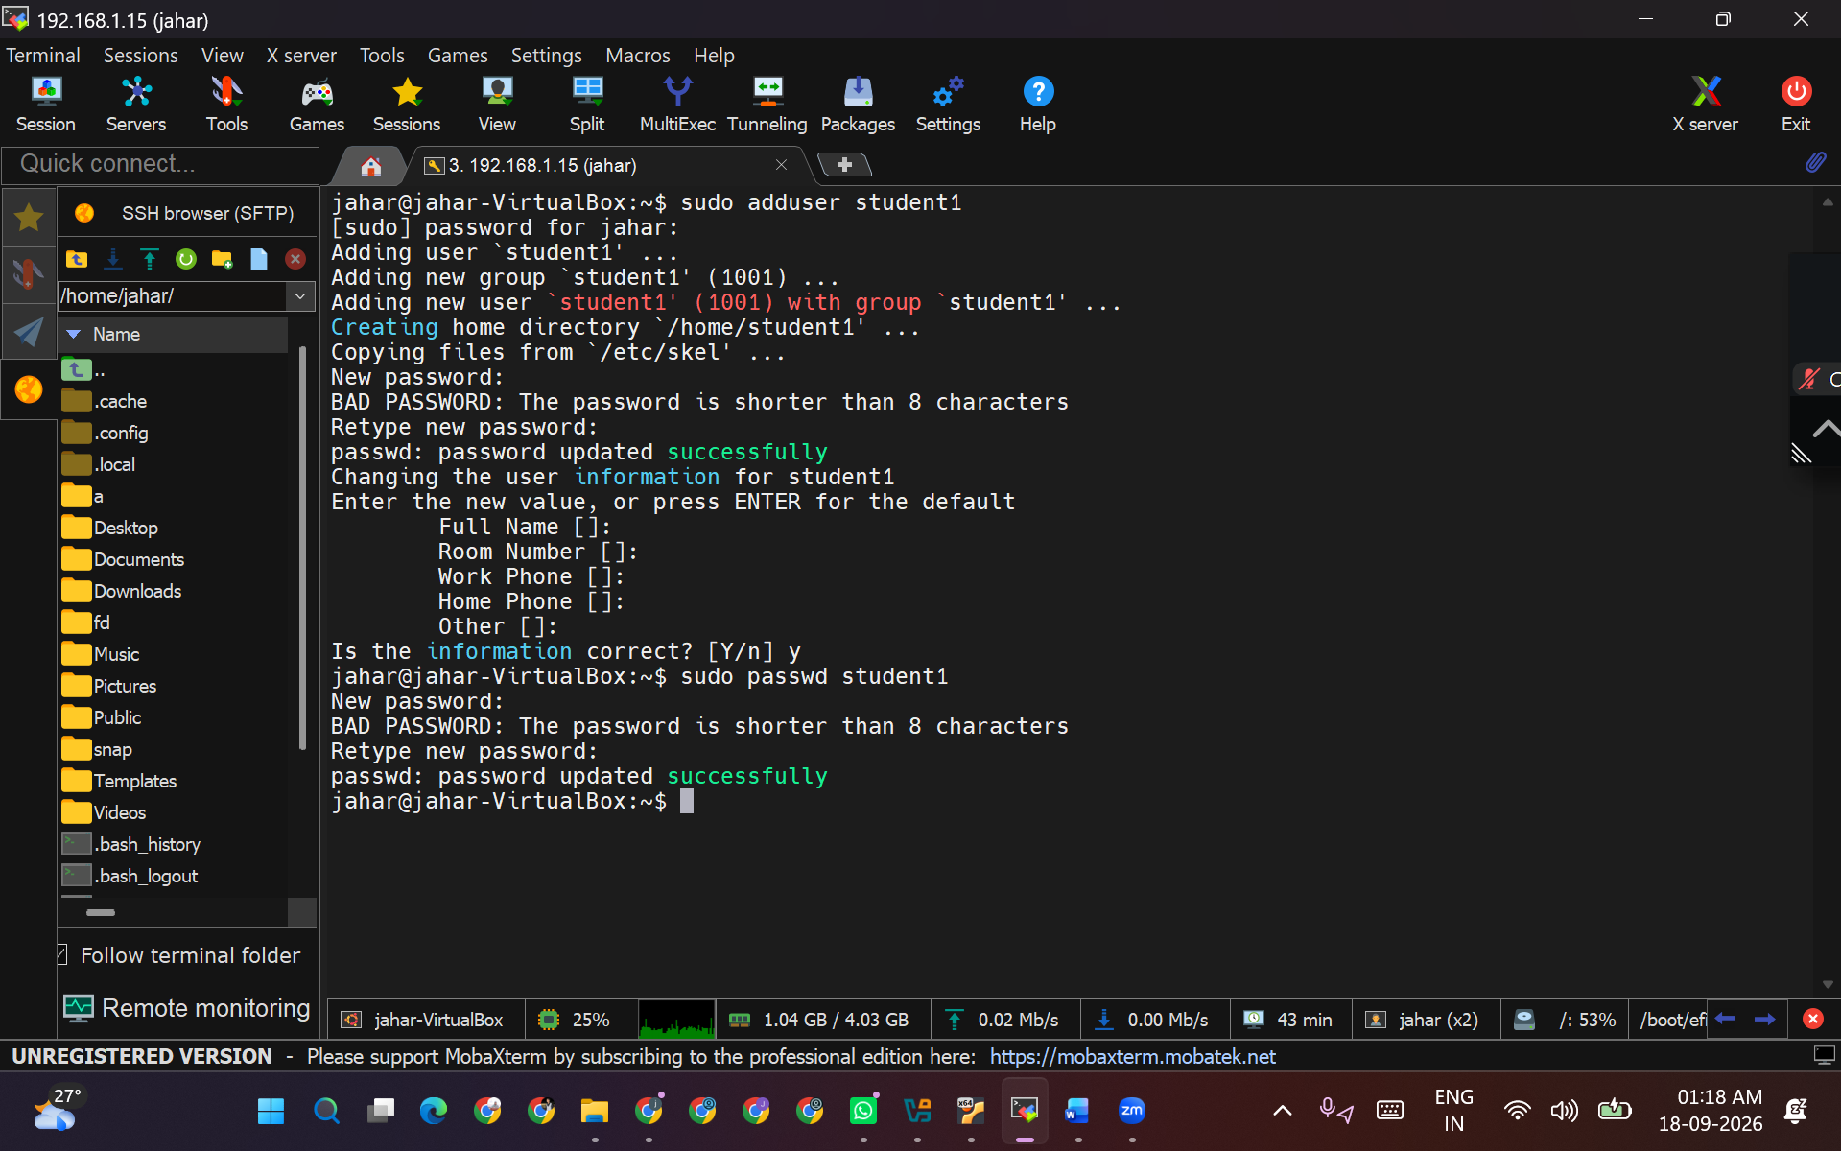

2.Groups:
  - Create a new group named devops.
  - Add student1 to the devops group.
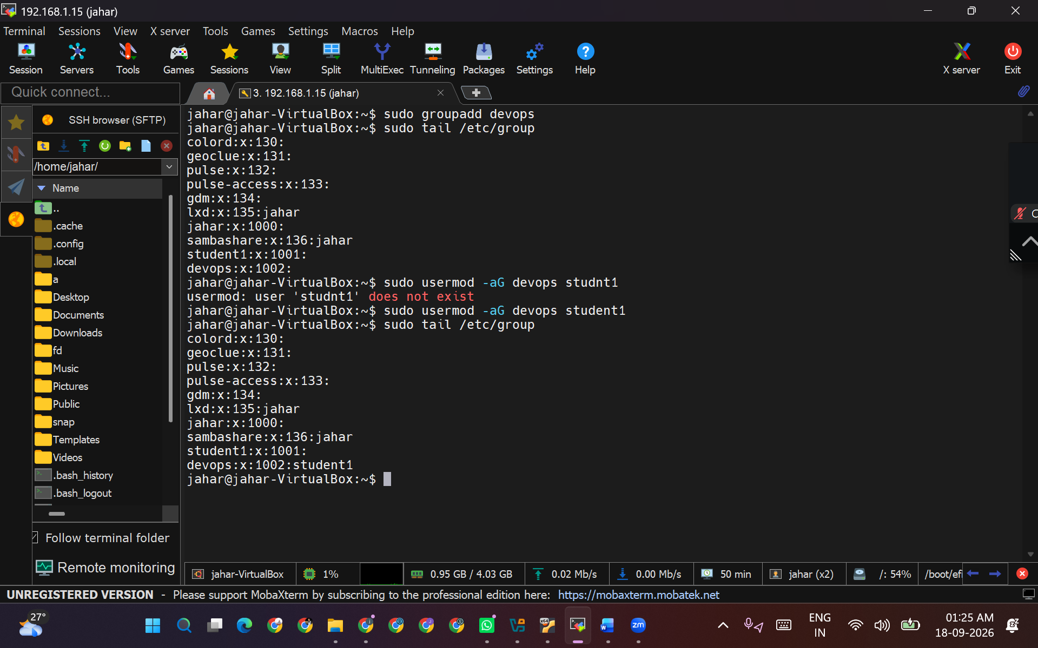

.User Permissions:
  - Ensure that the project directory is accessible to members of the devops
group.

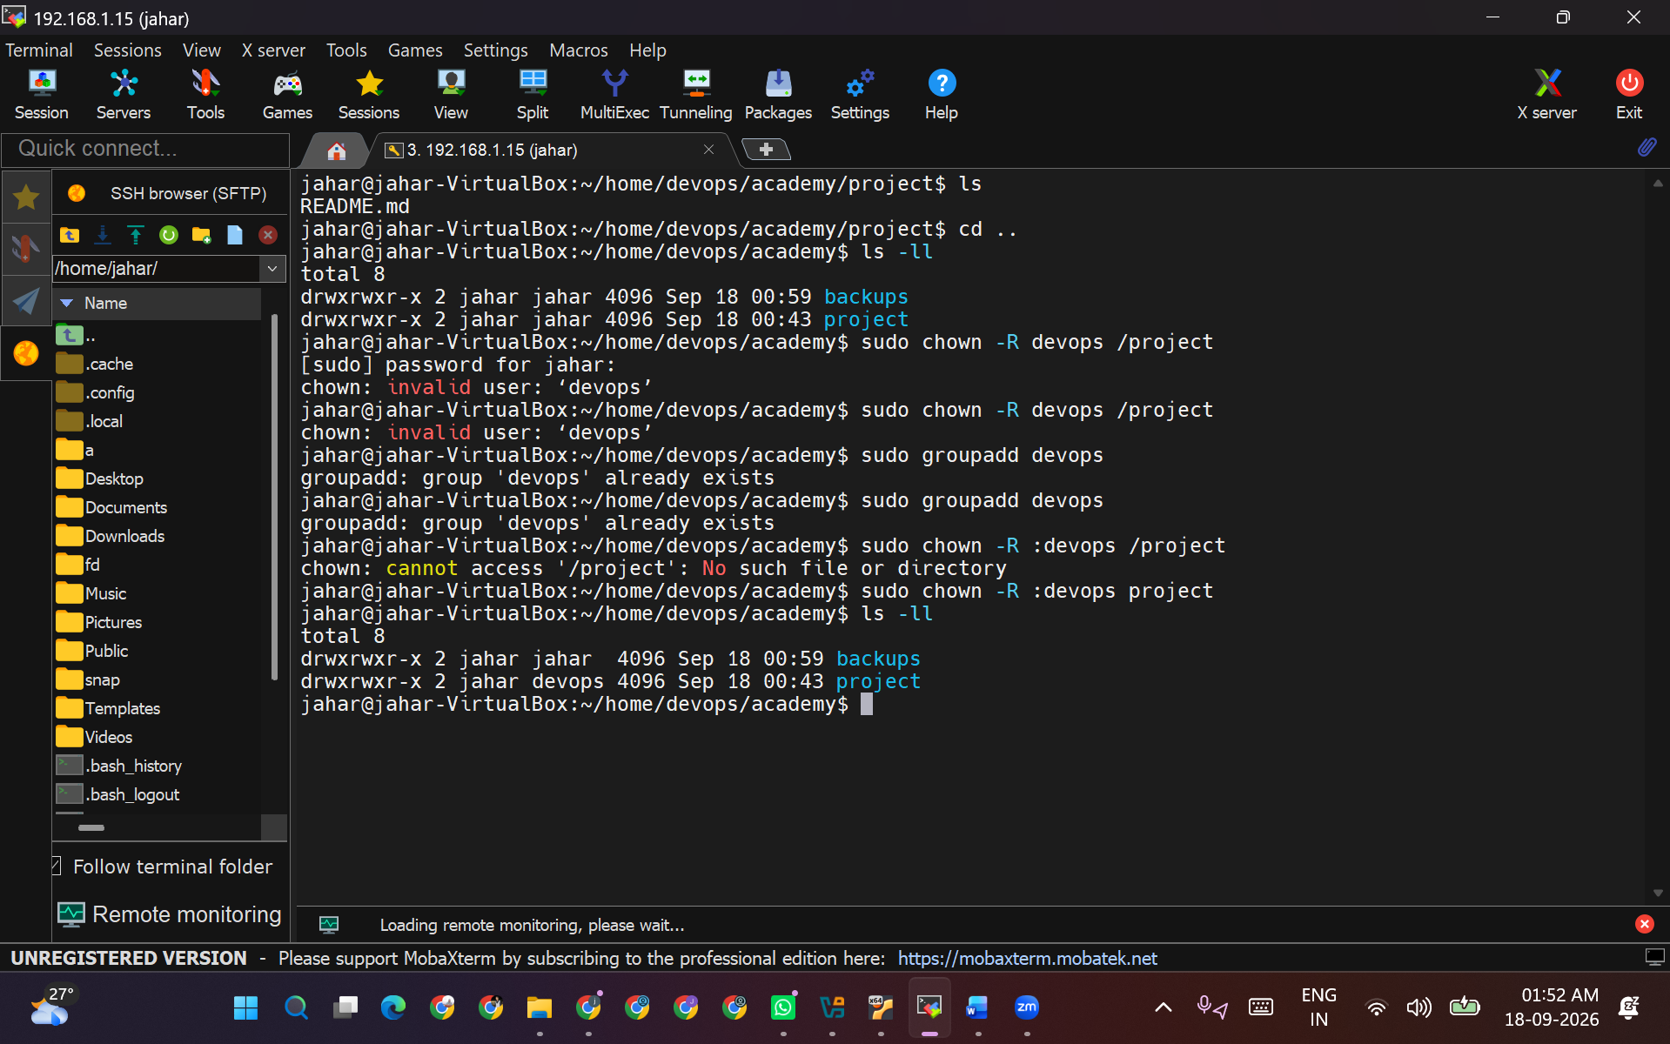

User Permissions:
  - Ensure that the project directory is accessible to members of the devops
group.

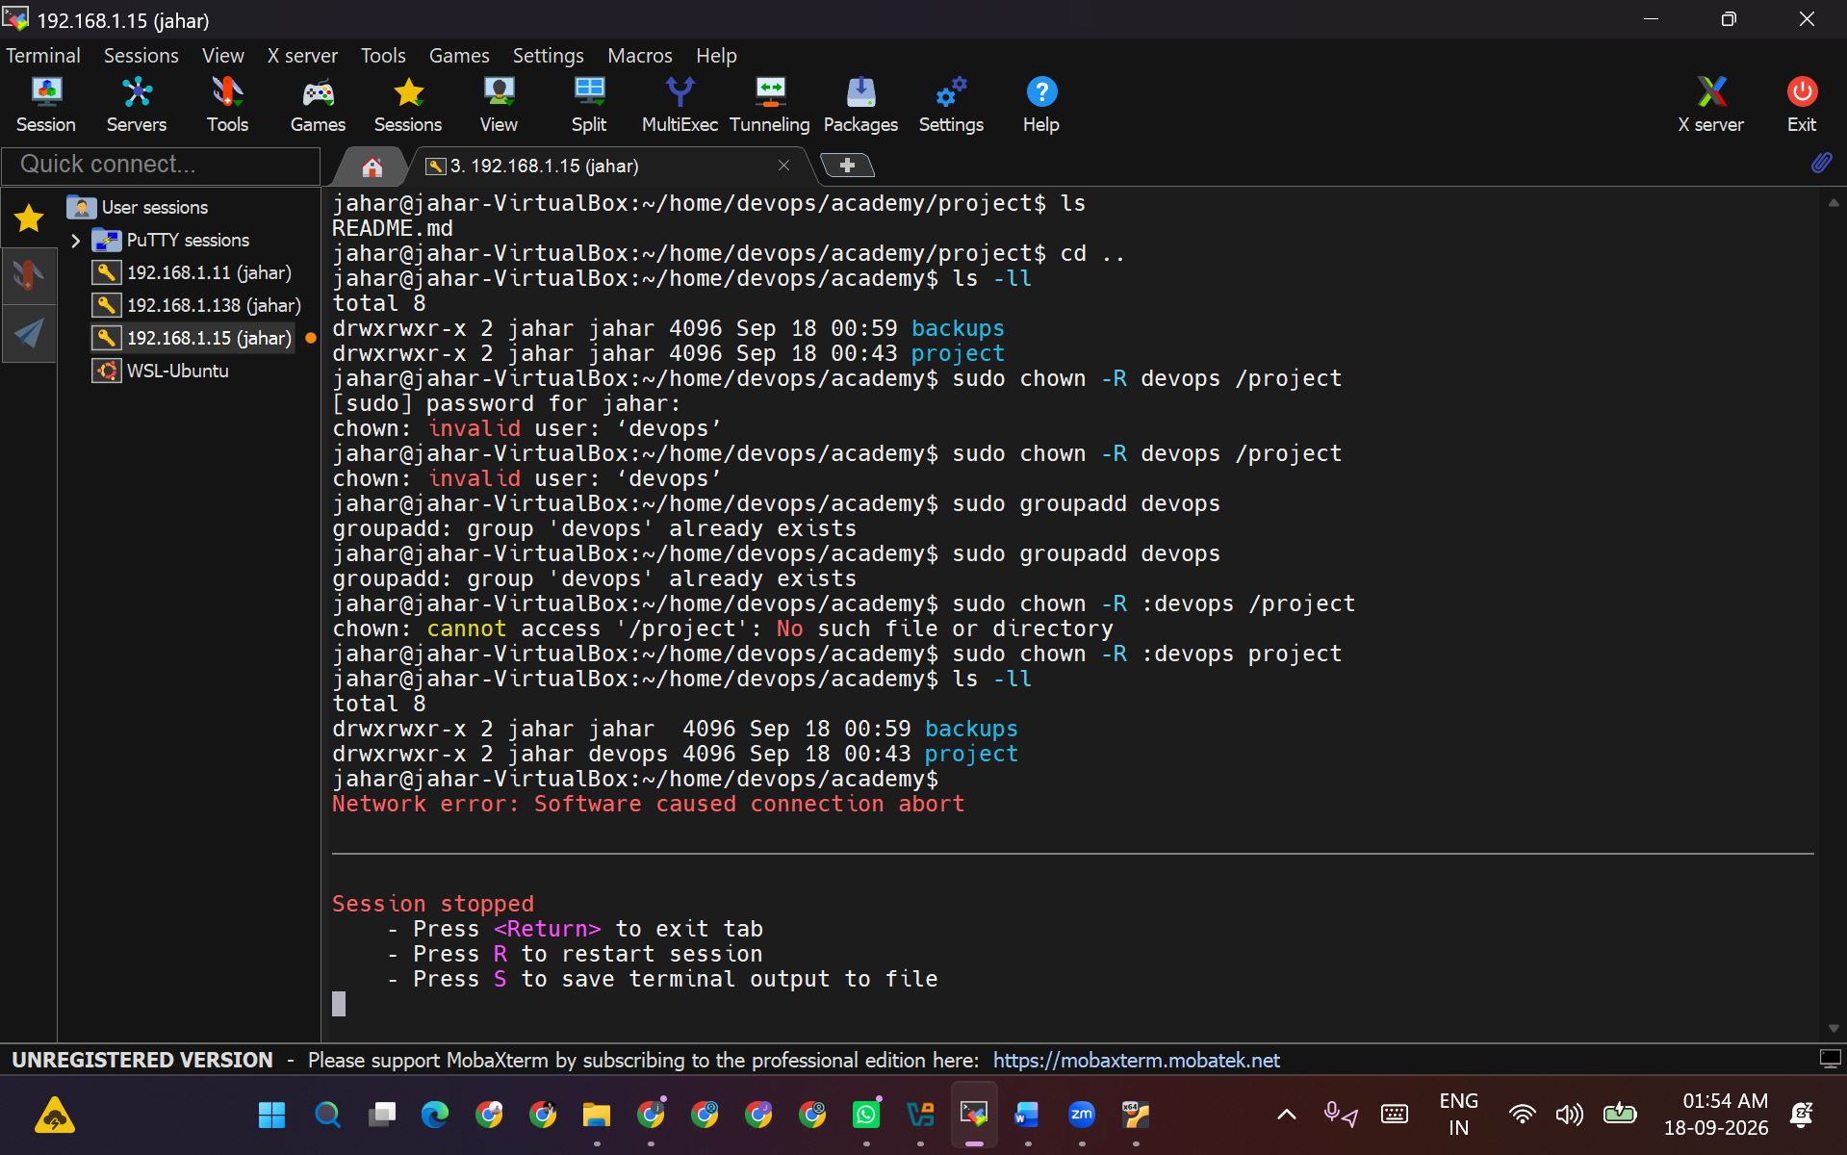

4.

Disk Usage:
  - Display disk usage in human-readable format for /home directory and save the output to a file named disk_usage.txt.
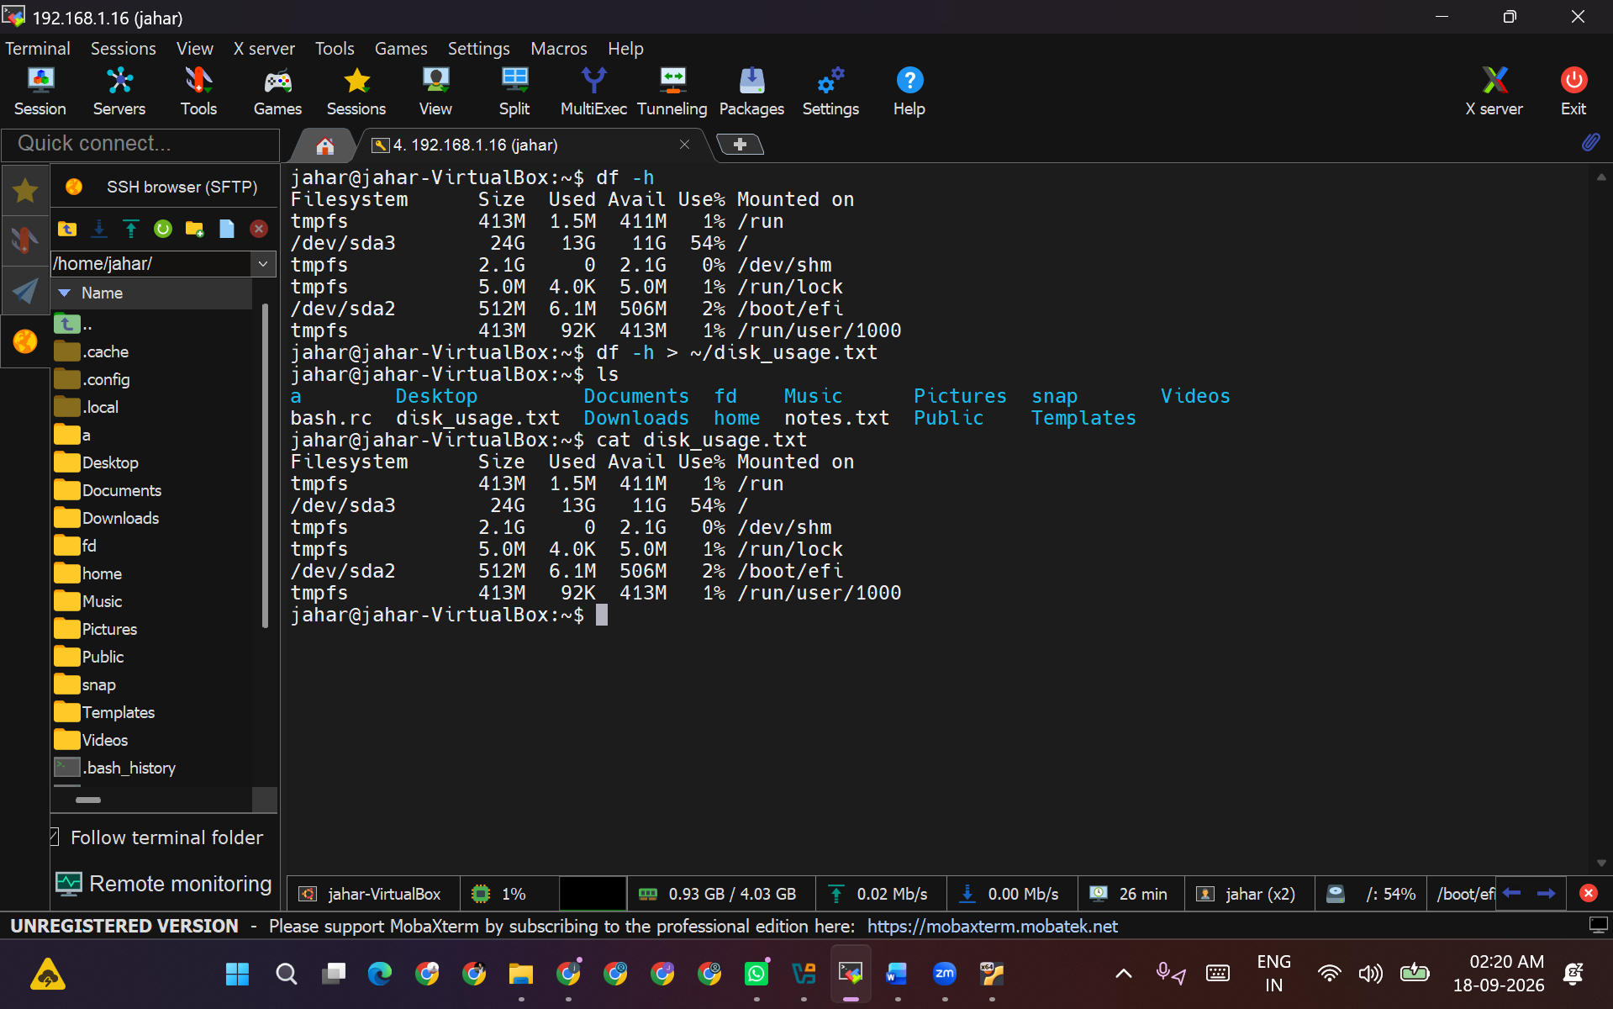

Intermediate Level

Task 3: Process Management

- List Processes:
Display all running processes and redirect the output to a file named
process_list.txt.

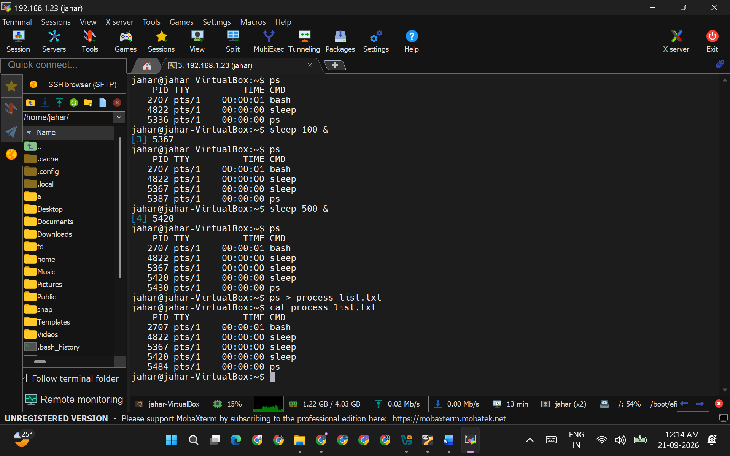

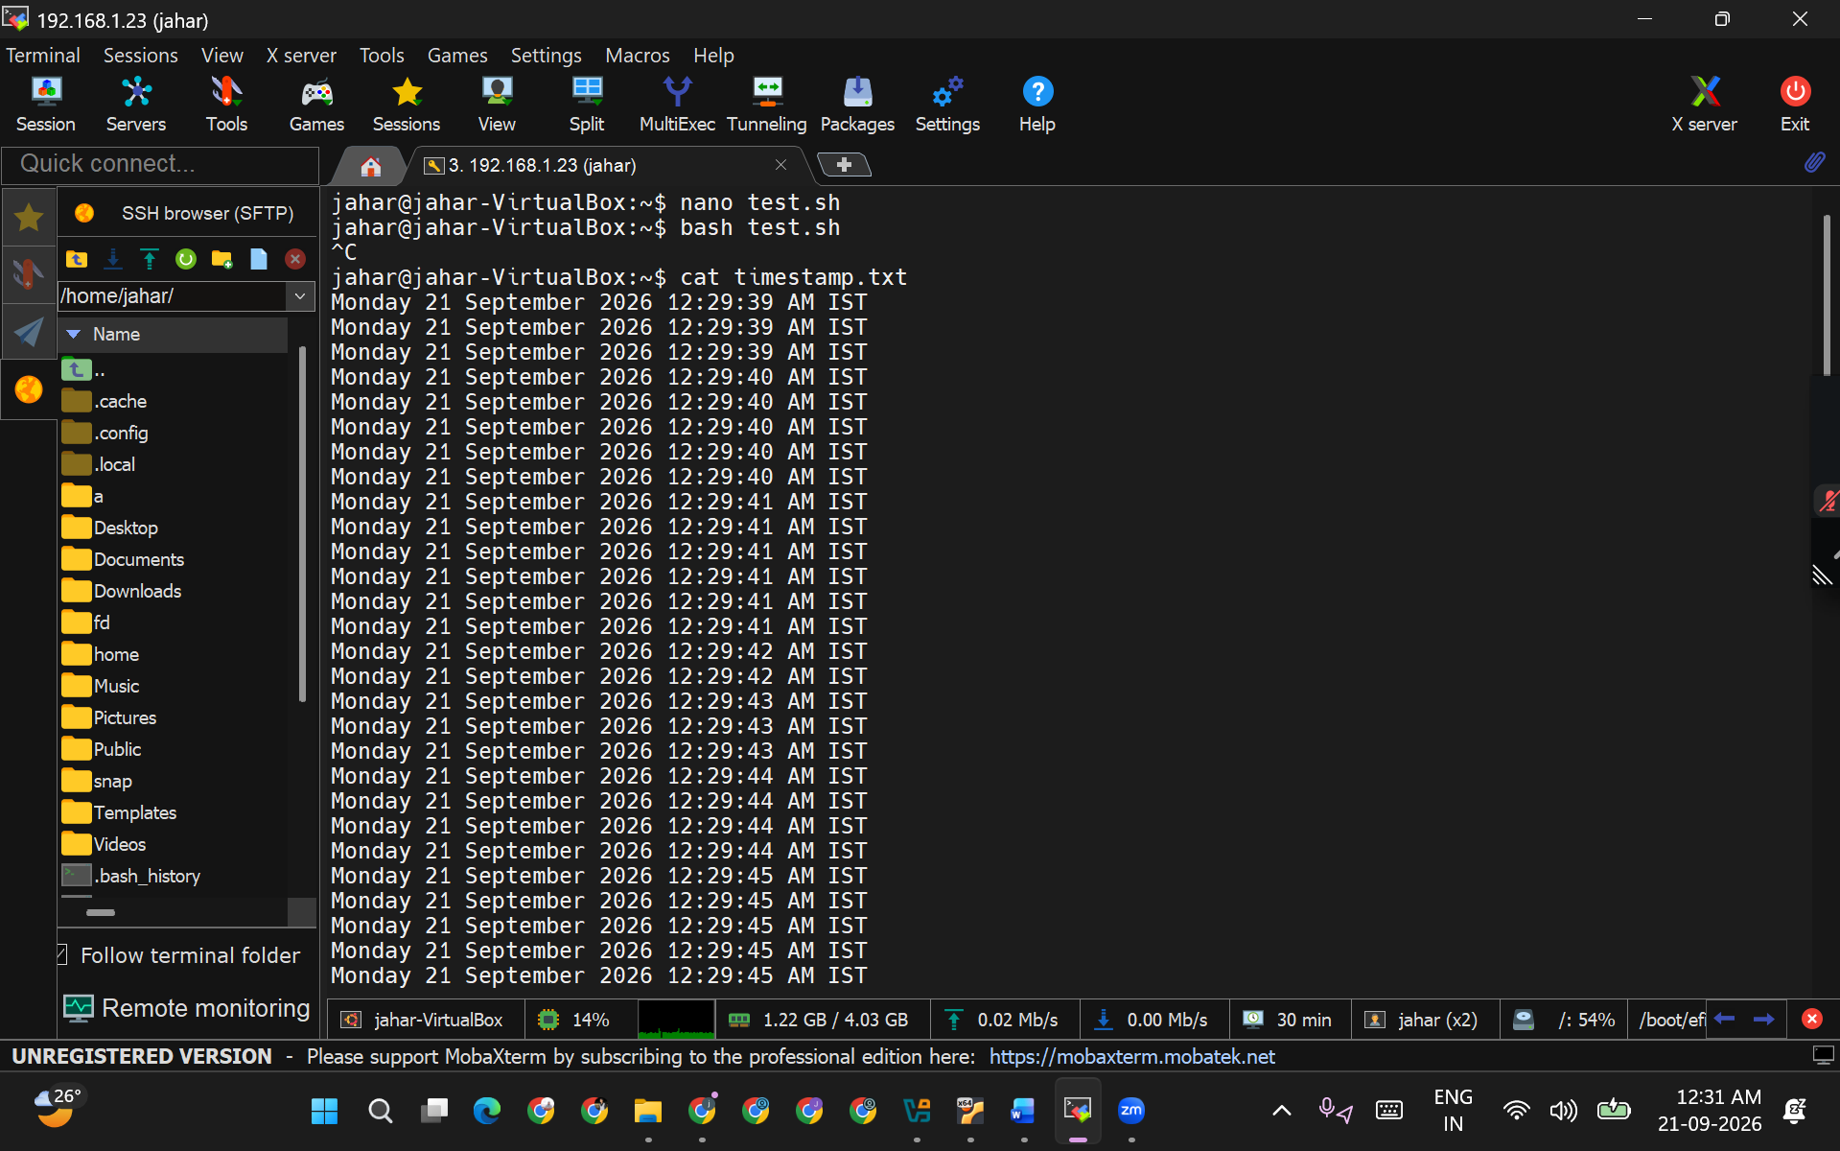

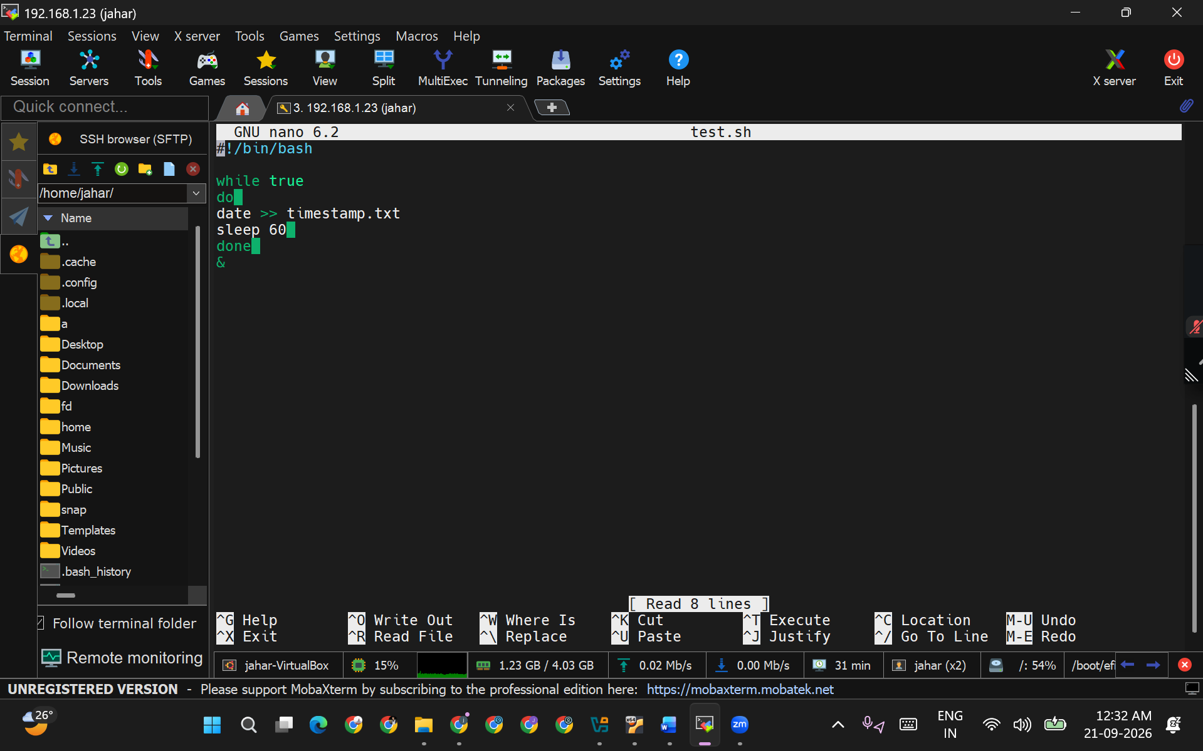

Background Process:
  - Start a simple background process that writes the current date and time to a file named timestamp.txt every minute using a while loop and sleep.

Kill Process:
  - Find the process ID (PID) of the background process started in the previous step and terminate it.

CPU and Memory Usage:
  - Display the current CPU and memory usage using top or htop, save a snapshot of this information to a file named cpu_mem_usage.txt

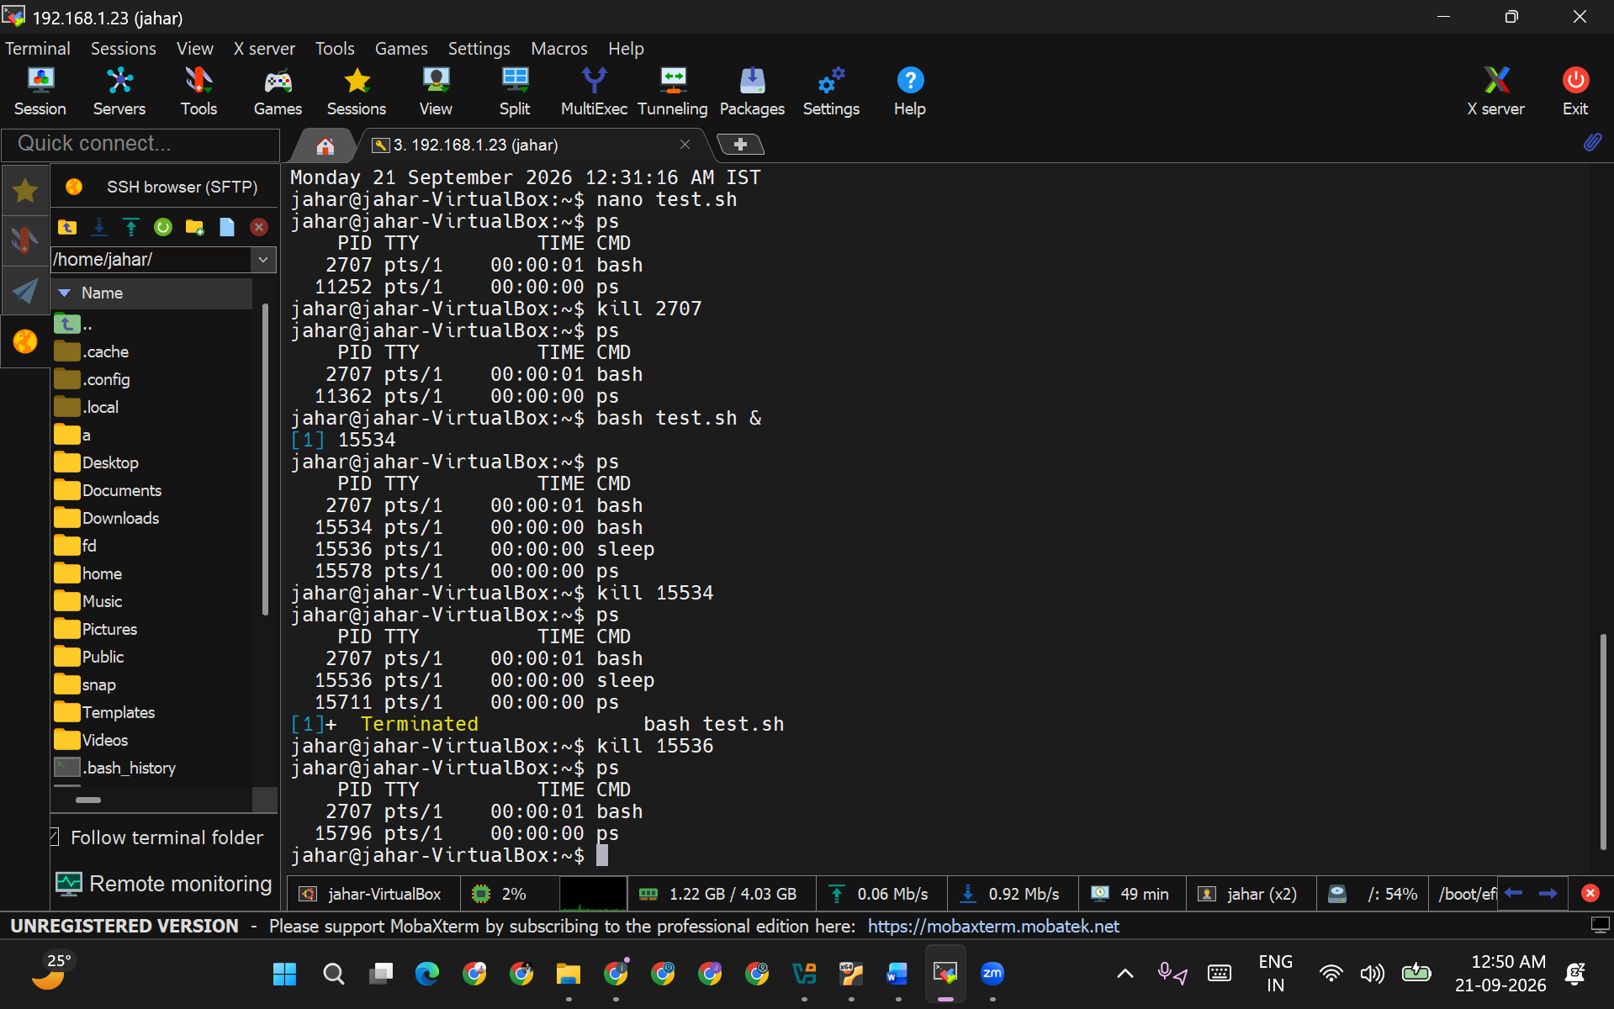

Task 4: Networking

- Network Configuration:
  - Display the current network configuration using ifconfig or ip addr.

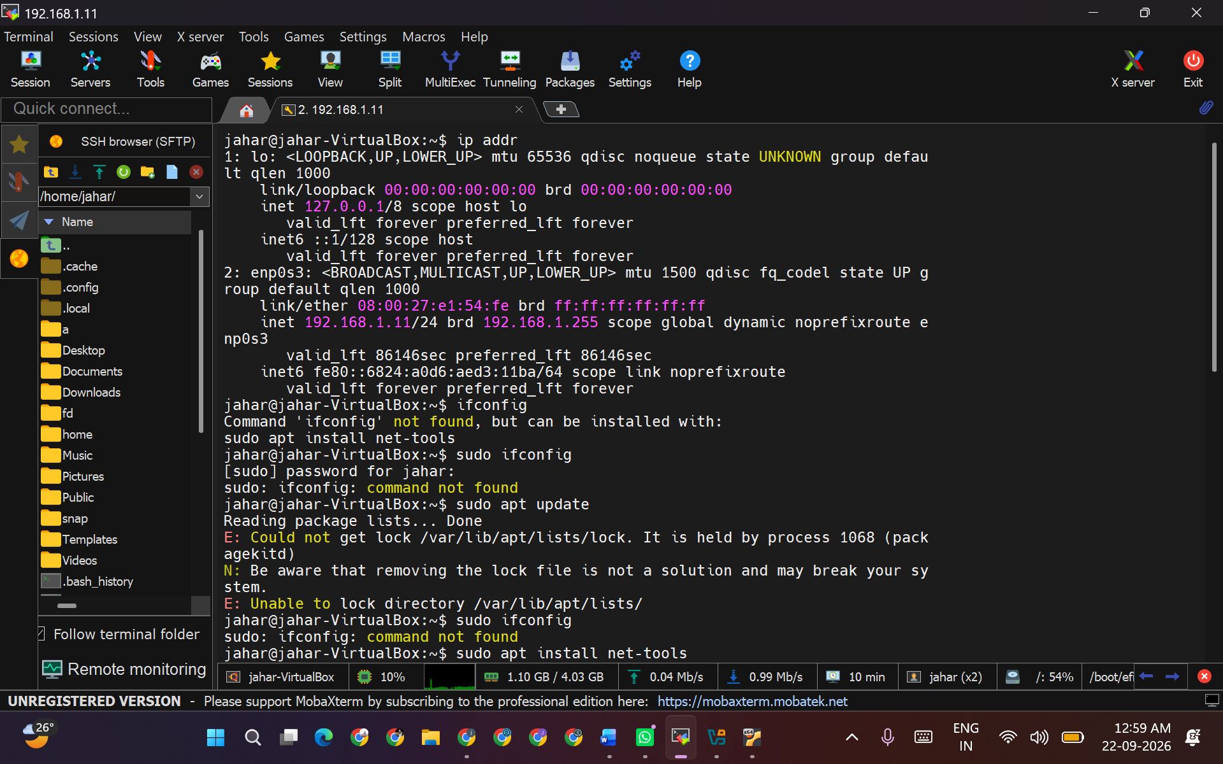

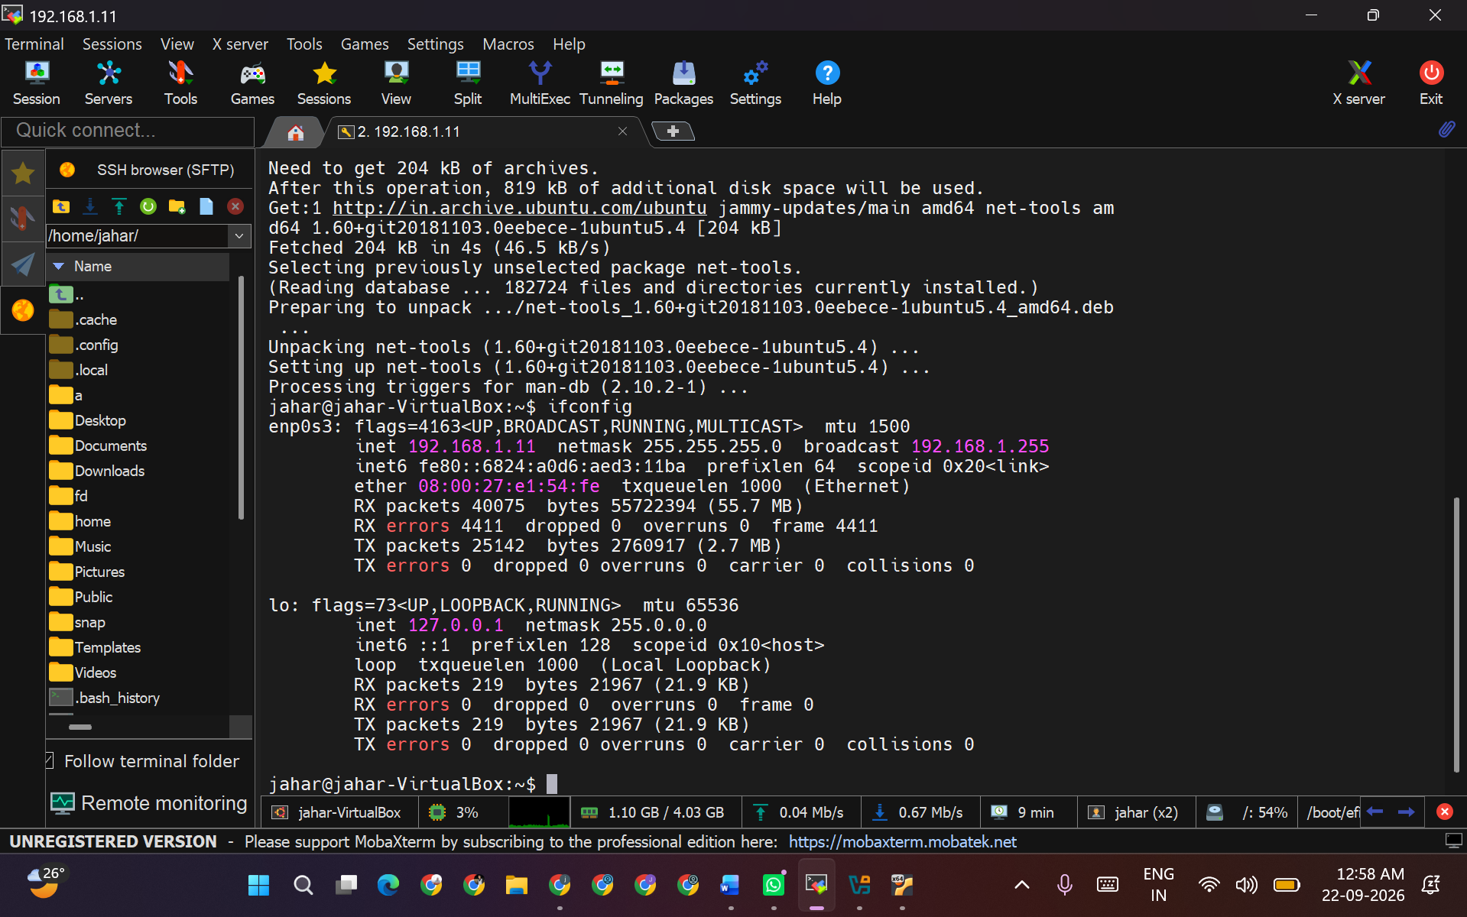

Ping Test:
  - Ping google.com and save the output to a file named ping_results.txt.

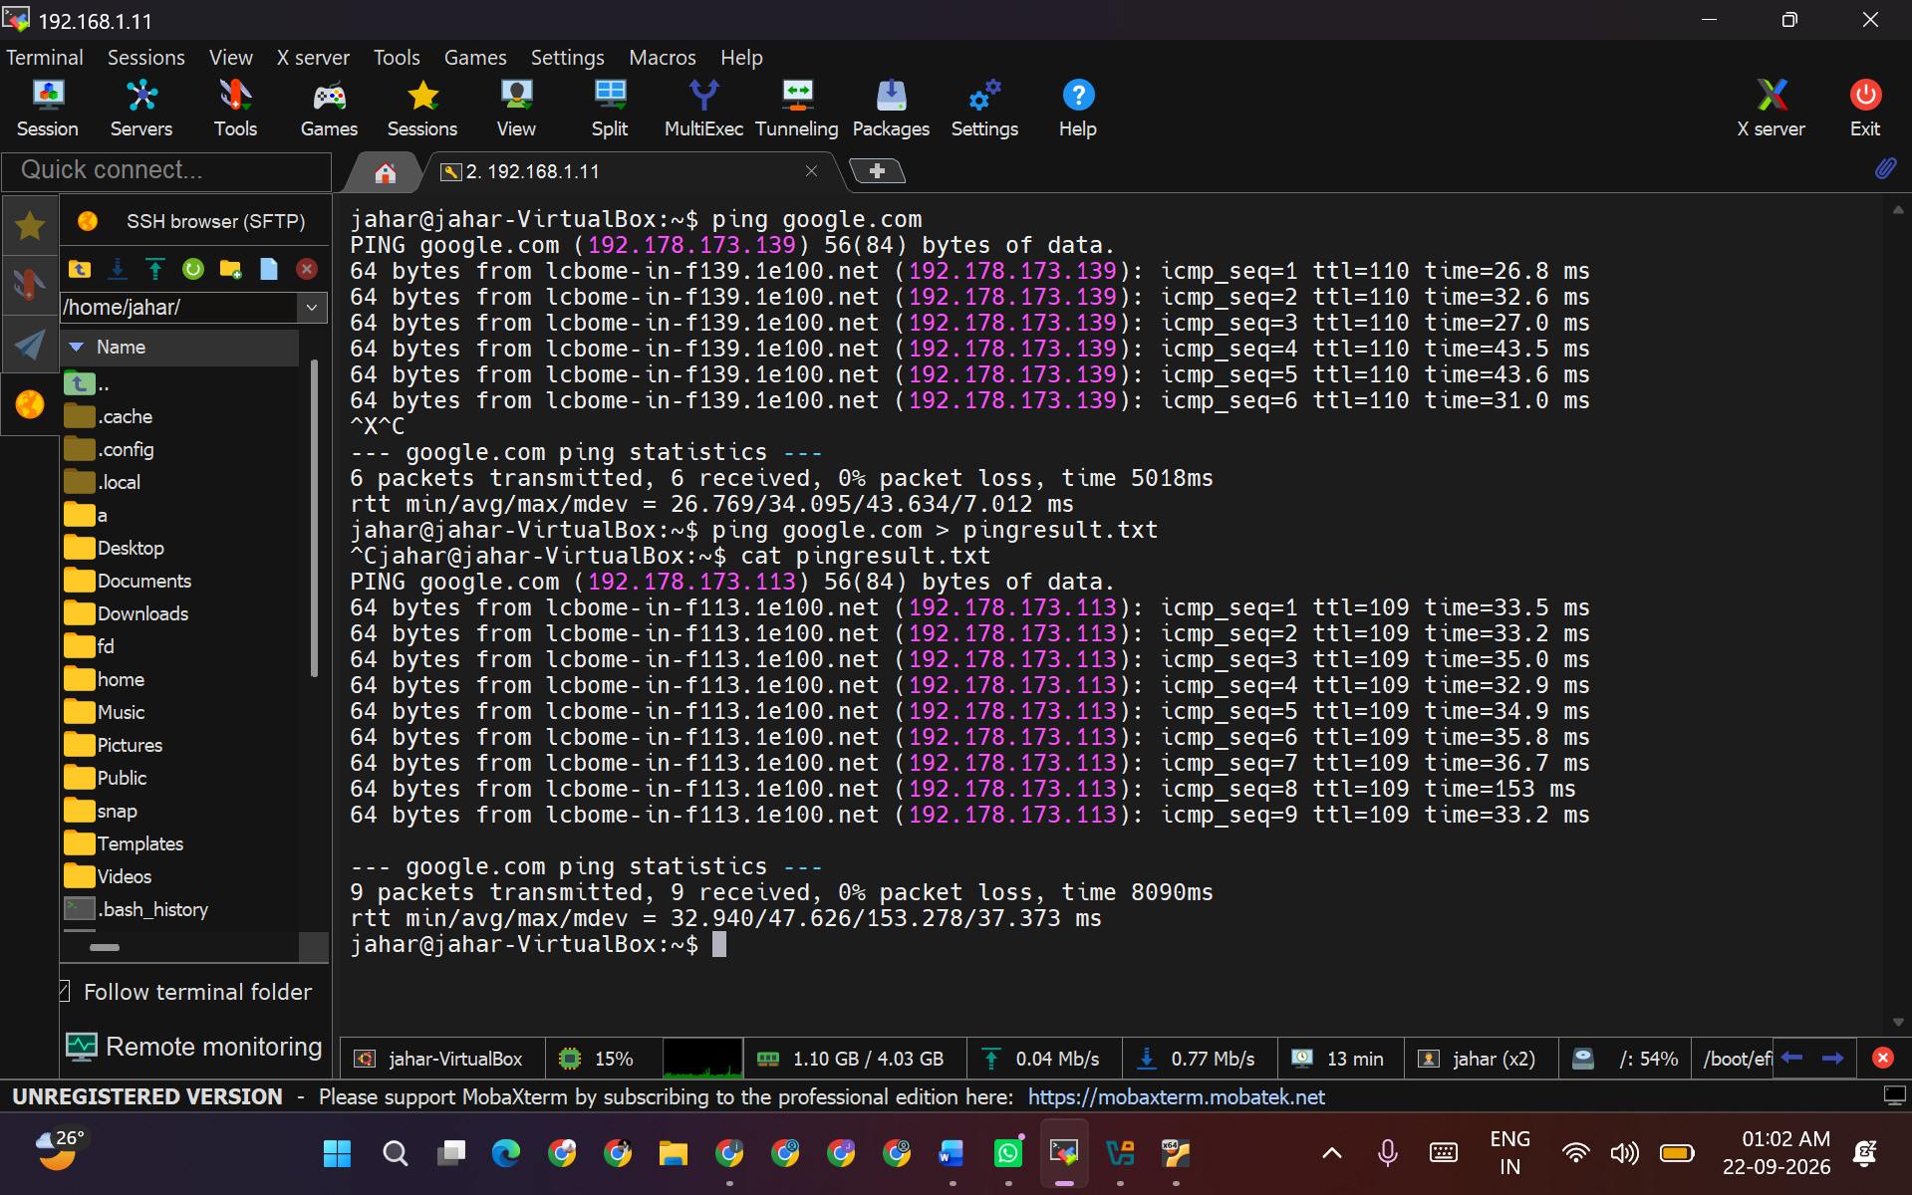

3.Open Ports:
  - List all open ports on the system using netstat or ss command.

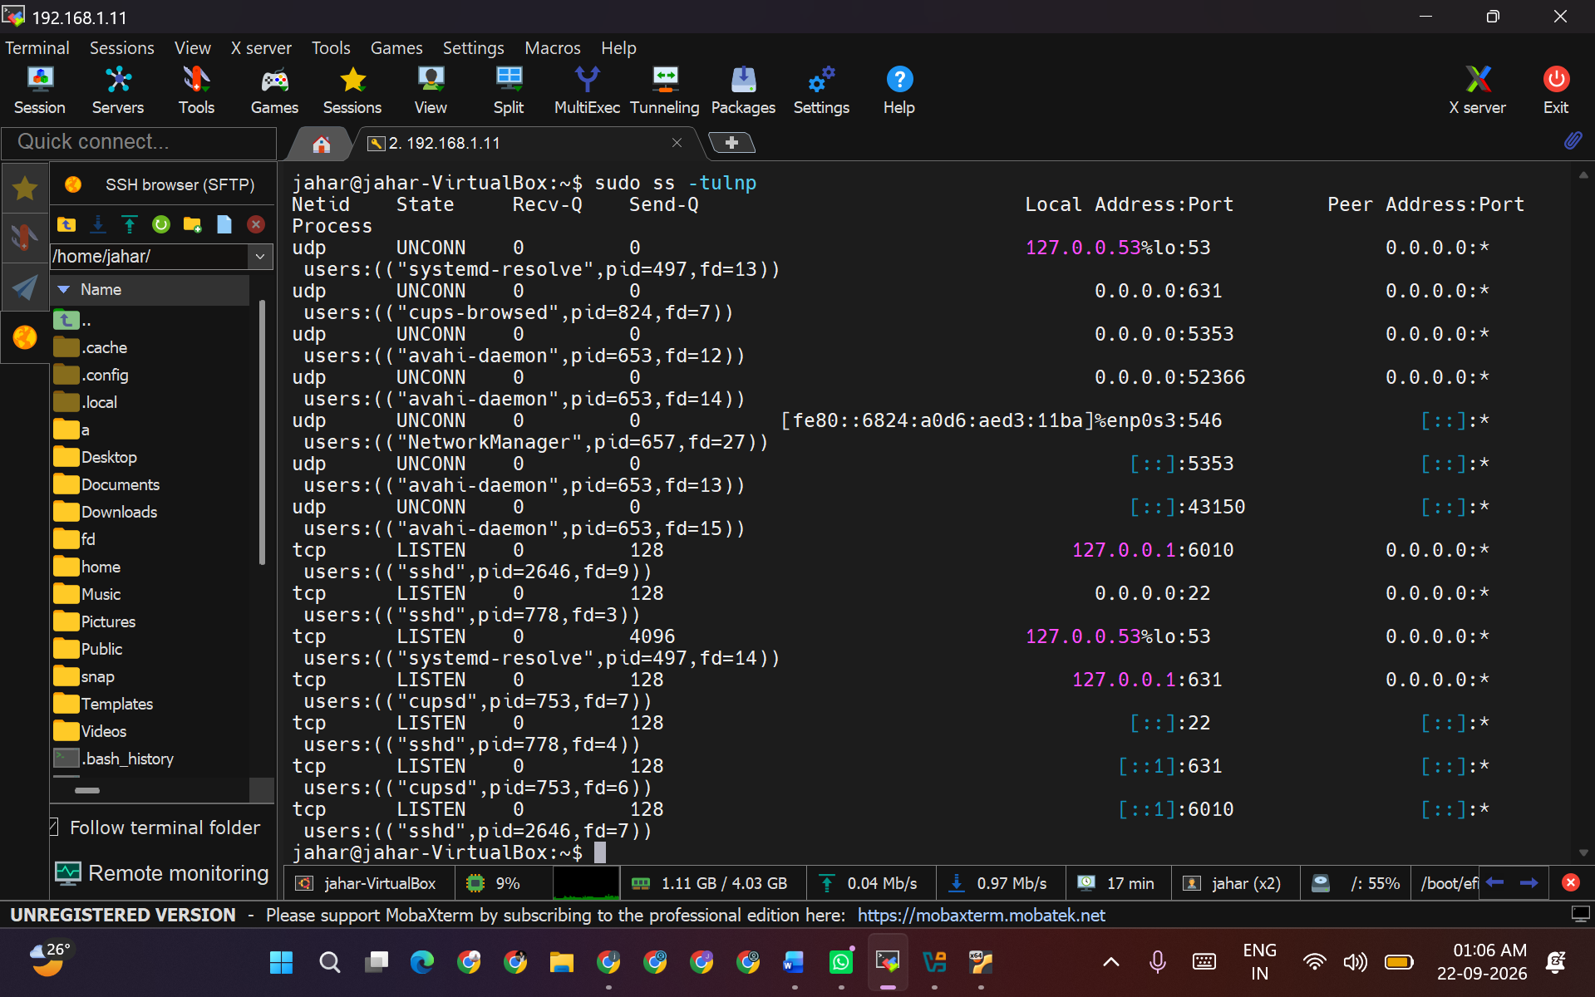
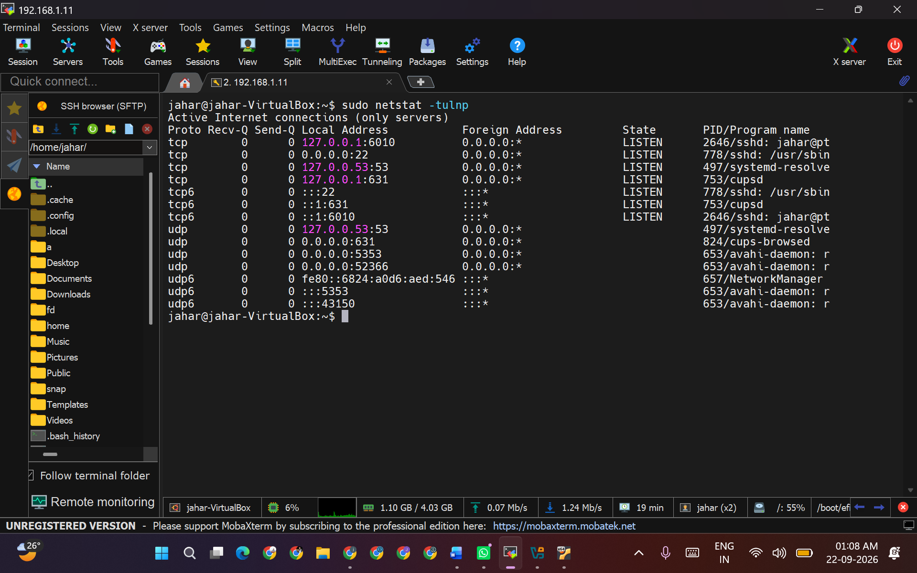

4.Firewall Configuration:
  - Check if the ufw (Uncomplicated Firewall) is installed and running. If not, install and enable it.
  - Allow incoming connections on port 80 (HTTP) and 443 (HTTPS).

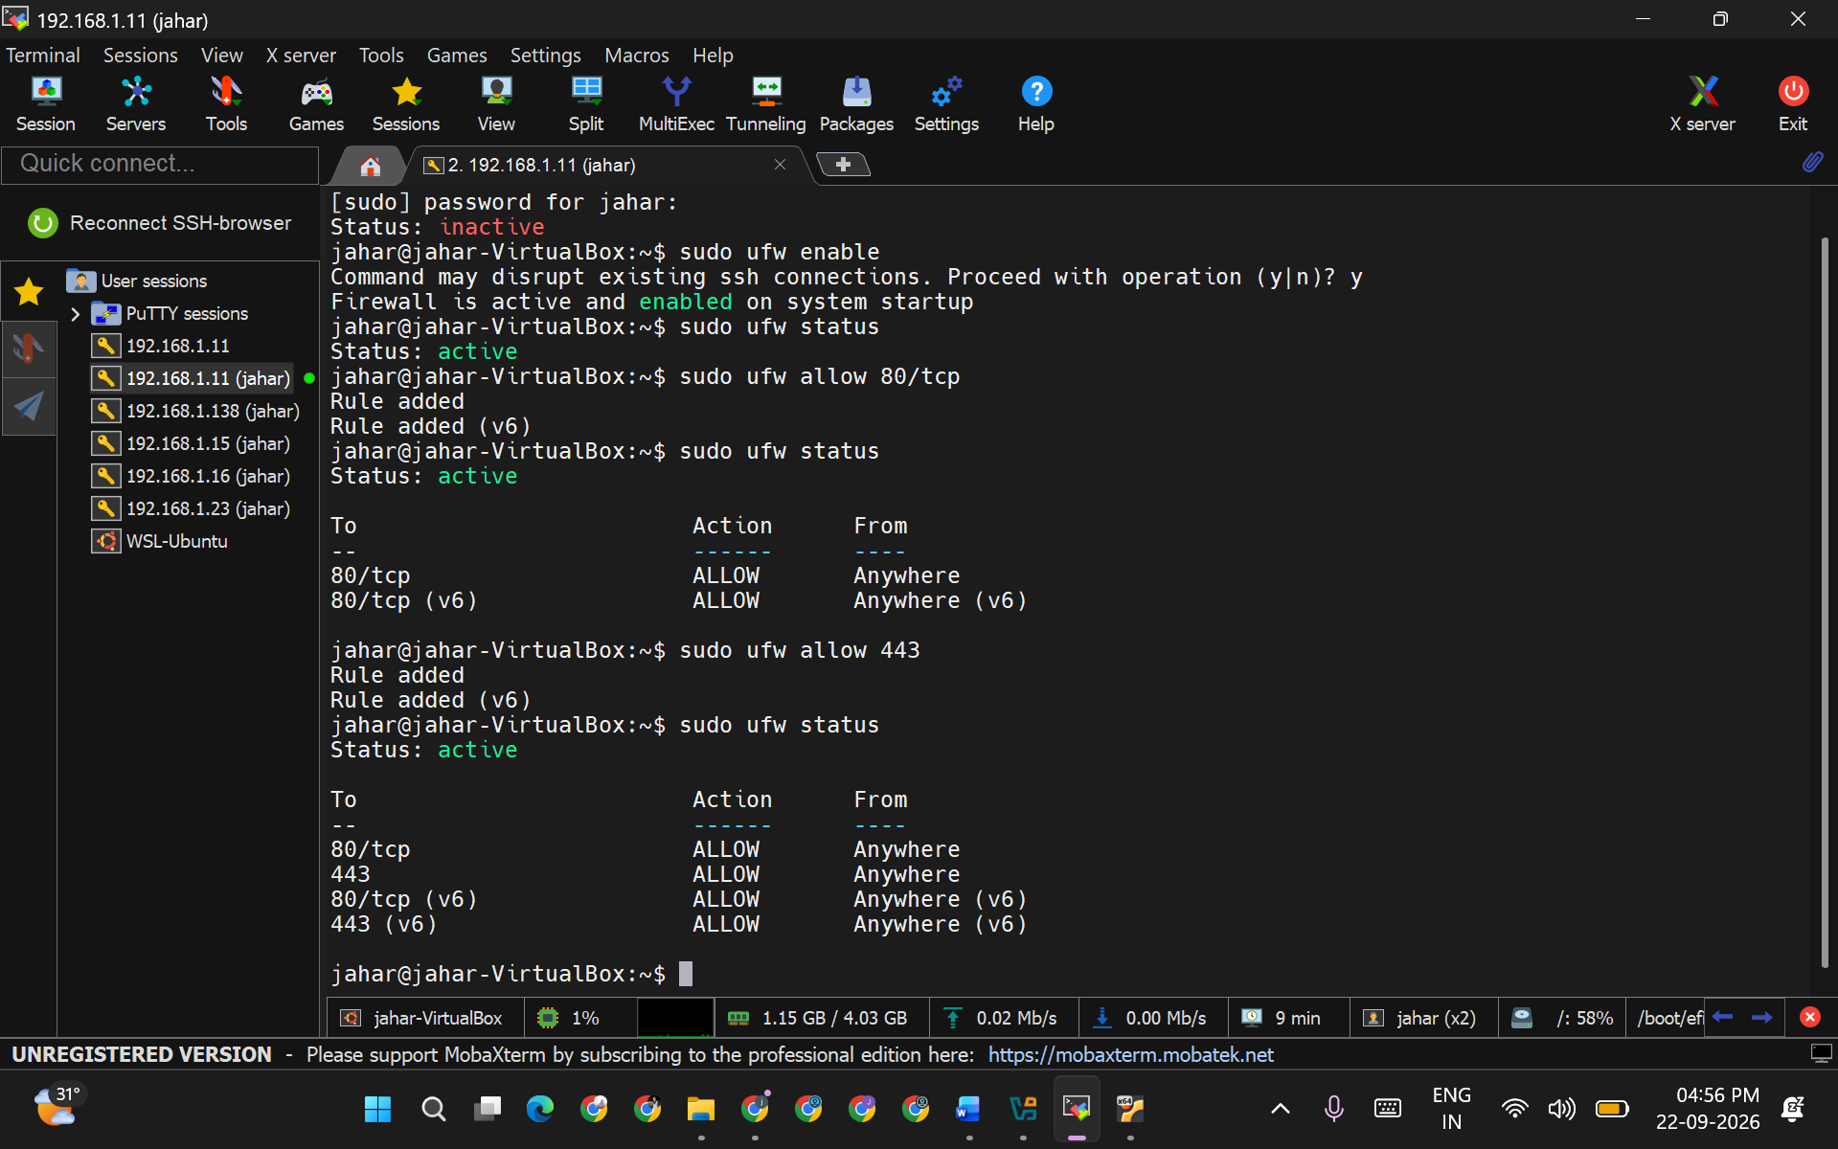

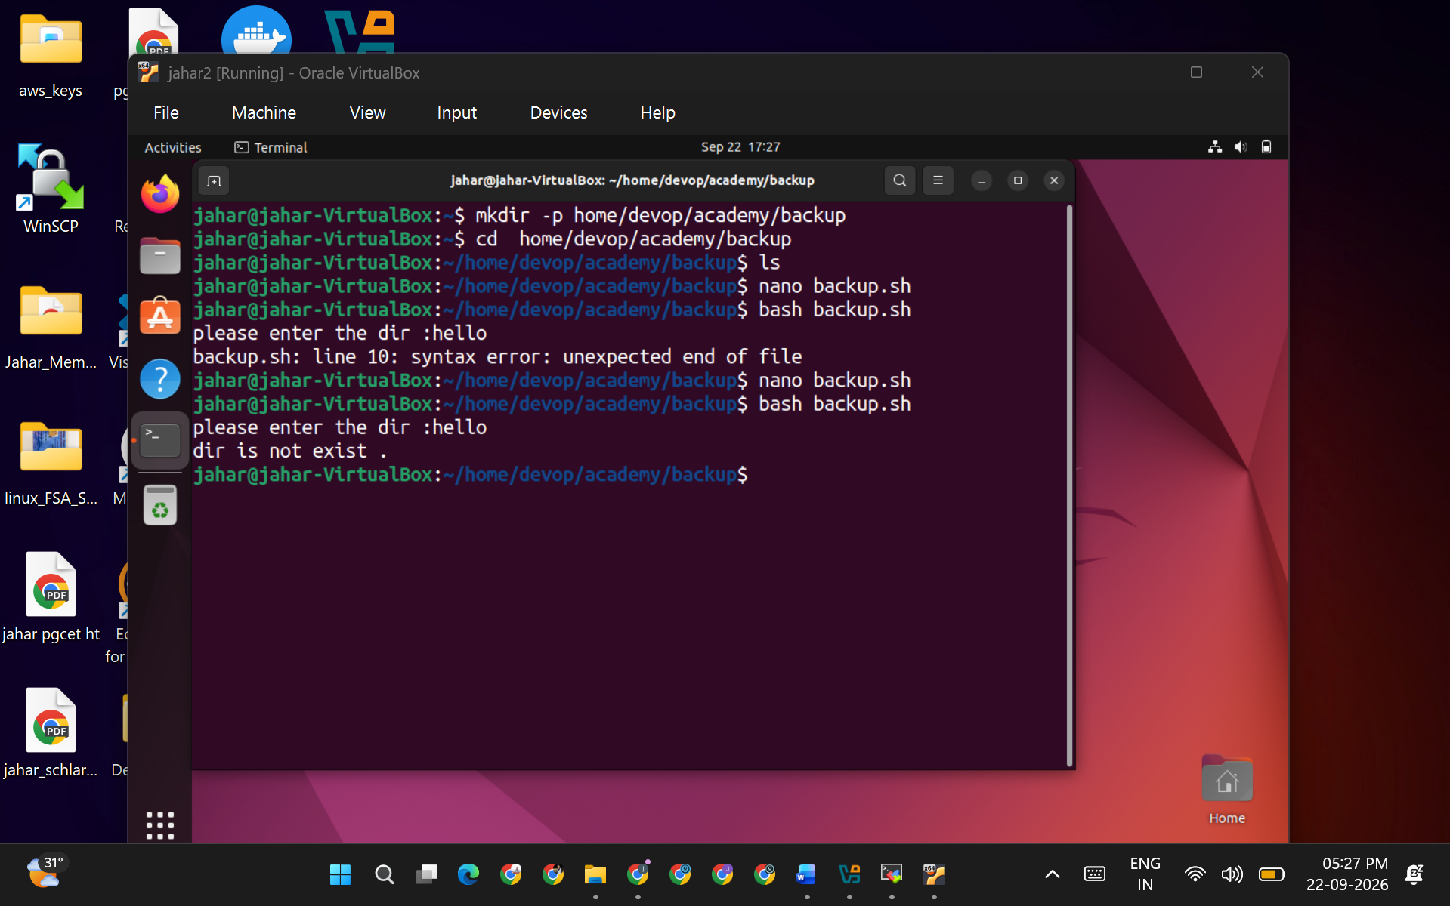

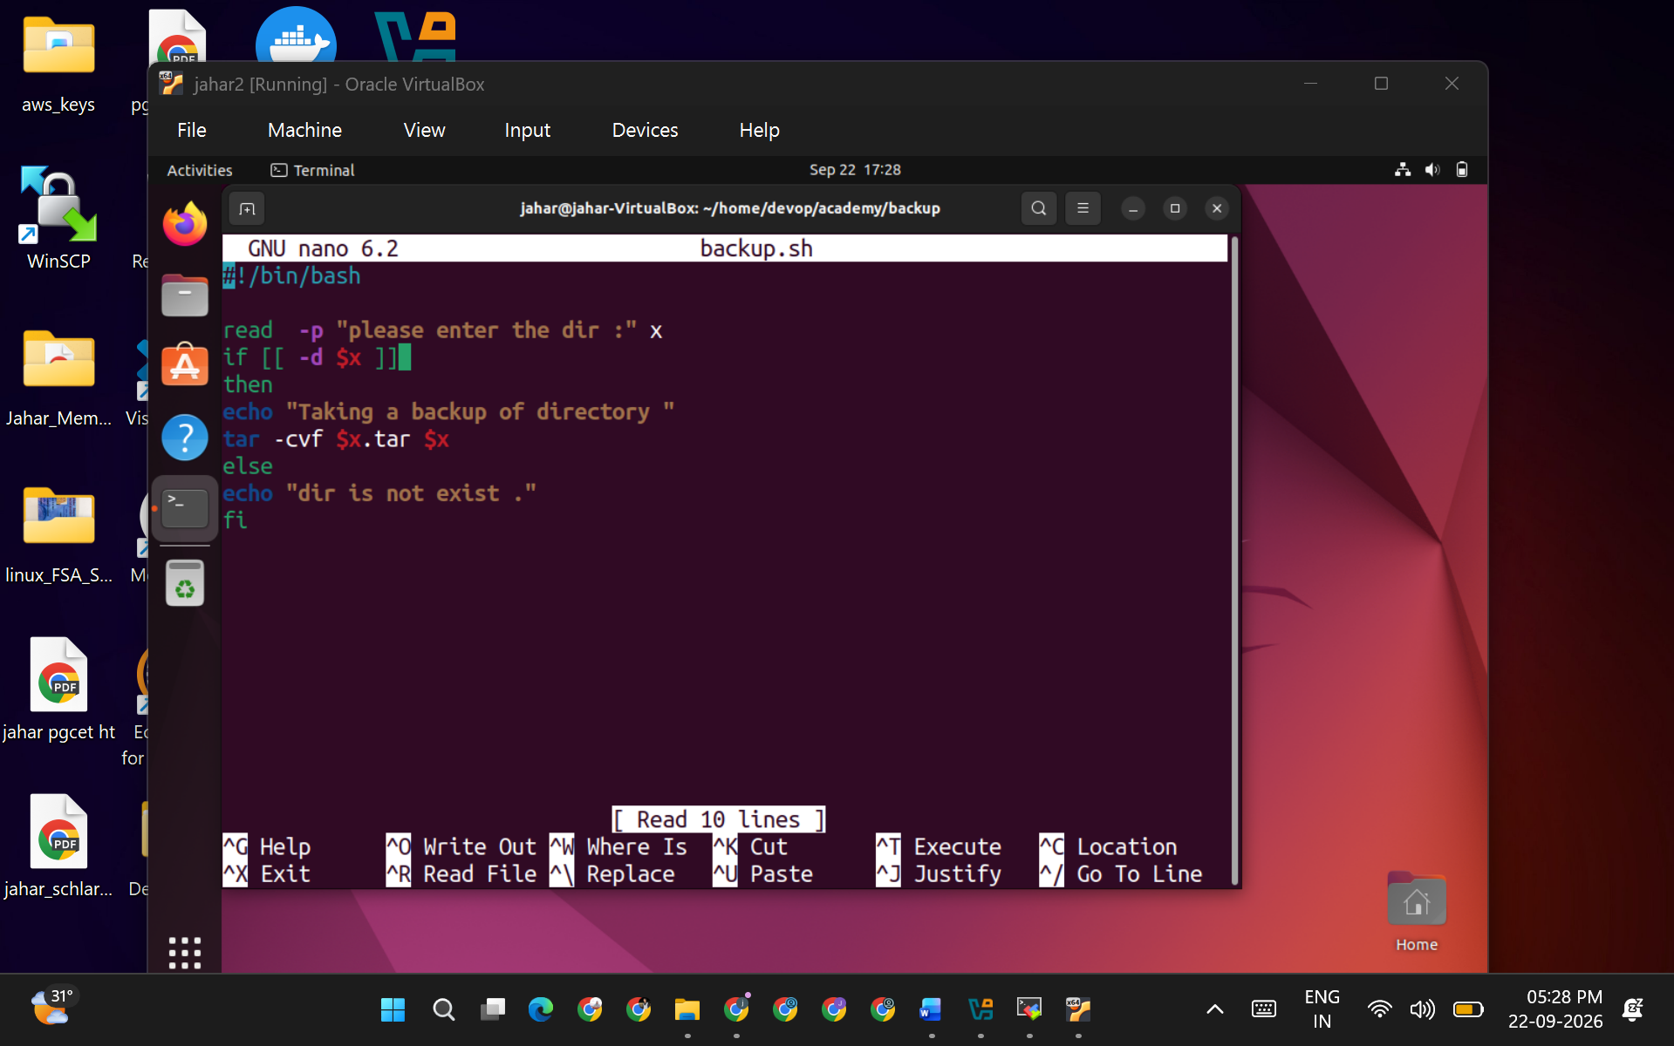

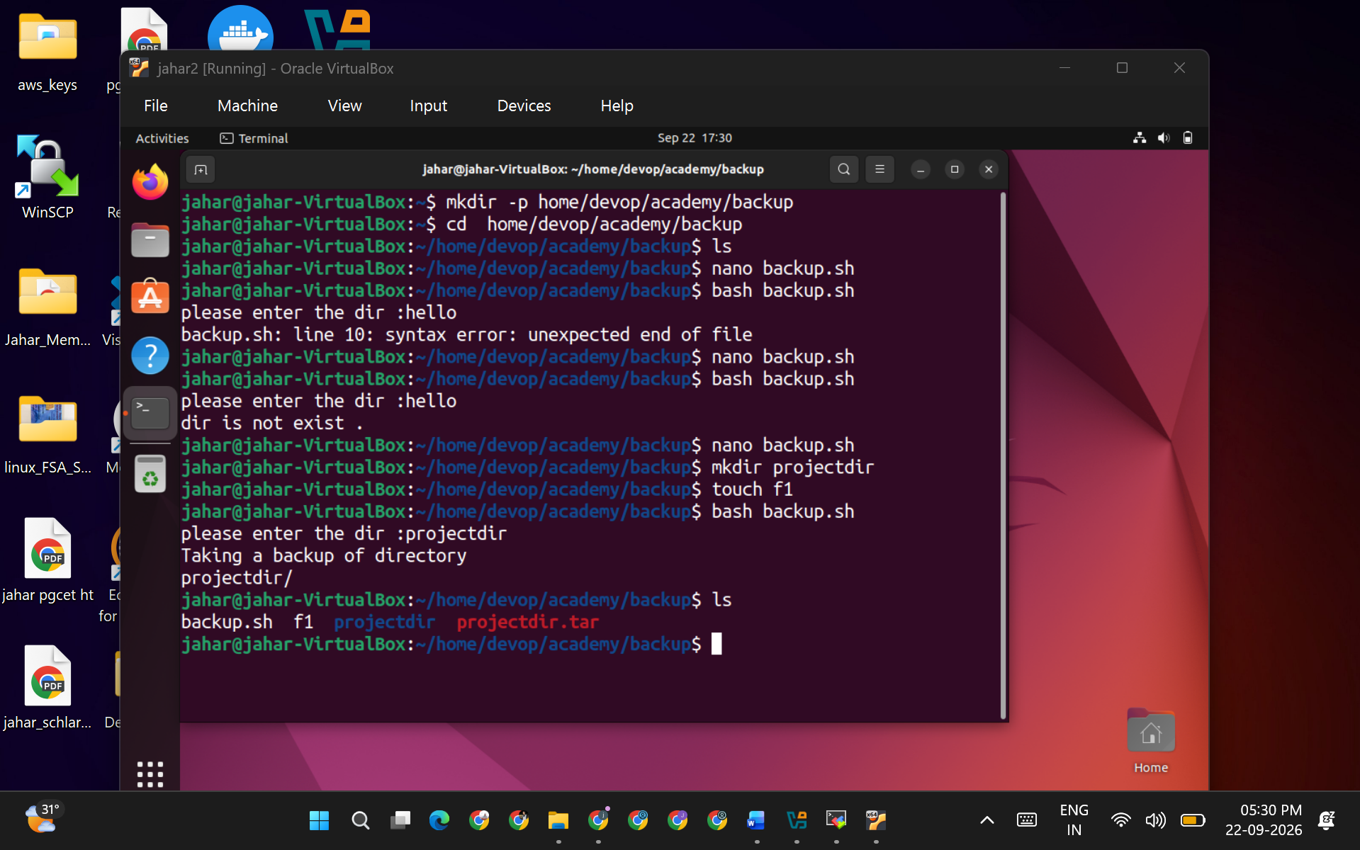

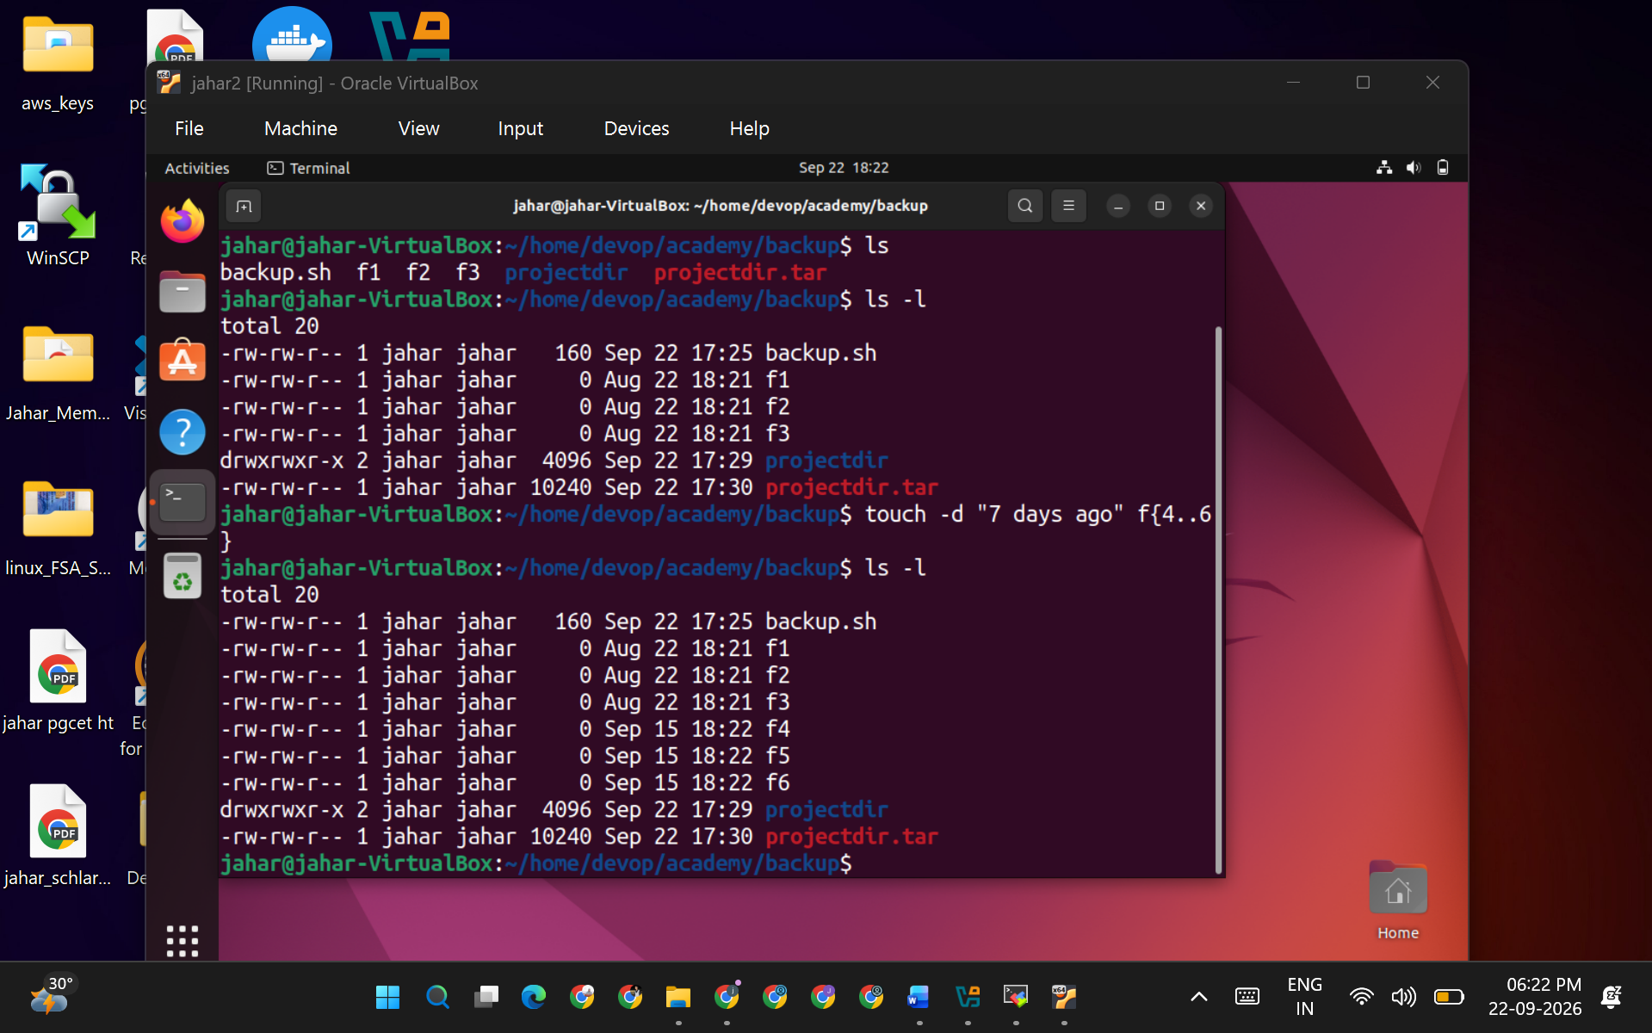

Task 5: Shell Scripting

- Backup Script:
  - Write a shell script named backup.sh that compresses the project directory into a tar.gz file and saves it in the /home/devops/academy/backup directory. The script should include error handling to ensure the backup only proceeds if the project directory exists.

Automation Script:
  - Create a script named cleanup.sh that deletes all files in the
/home/devops/academy/backup directory that are older than 7 days. Schedule this script to run daily using cron.

Log Rotation:
  - Write a script named rotate_logs.sh to rotate the timestamp.txt file if it exceeds 1MB in size and save old logs with a timestamp in the filename.
  - ​

Advanced Level:

Advanced Shell Scripting:

  - Write a script named resource_monitor.sh that:
    - Monitors CPU, memory, and disk usage.
    - Logs usage data every 5 minutes to a file named resource_usage.log.
    - Sends an alert email if CPU usage exceeds 80% or available disk space falls below 20%.

User Management Automation:

  - Write a script named bulk_user_add.sh that:
    - Reads a list of usernames from a file named user_list.txt.
    - Creates each user and sets a default password.
    - Adds each user to a specific group (e.g., students).
    - Ensures each user has a home directory created.

