# SOLUTION: Mock Technical Interview Written Section

You have 30 minutes. Please time yourself.

**Technical Questions:**

1. You have a users table, how do you select all the rows from the users table? **Note: the id is a primary key (autoincrements & is an integer, other fields are strings)**

Users Table

|  |  |  |  |
| --- | --- | --- | --- |
| id | username | email | password_hash |
| 1 | Sphen | [sphen@sphen.sphen](mailto:sphen@sphen.sphen) | GHTY75X1425 |
| 2 | Betty | [betty@betty.betty](mailto:fred@fred.fred) | YSTTOLA892J3 |
| 3 | George | [George@george.george](mailto:George@george.george) | FGK235JKG125 |
| 4 | Janet | Janet@janet.janet | GKWERGK124L |

1. How would I select the second user from the table?
2. You have a users table. And a meal belongs to user. What would the meals table look like? (hint: Create a table that will track meals with the user who owns it)

**Meals table**

|  |  |  |
| --- | --- | --- |
|  |  |  |
|  |  |  |
|  |  |  |
|  |  |  |

1. Write the syntax to create a meals table that you described above:
2. Insert a meal into the meals table for the user with an id of 1.
3. In the users table, update the user with an id of 3 to a username of “shamoontastic”.
4. What is the SQL query to delete a user with an id of 4?
5. How would you show all the columns of all the meals and all the columns for the user that owns each meal in one query?
6. CSS: Draw the box model and label the key components.
7. Given the following code, please draw out what you think the layout would look like: 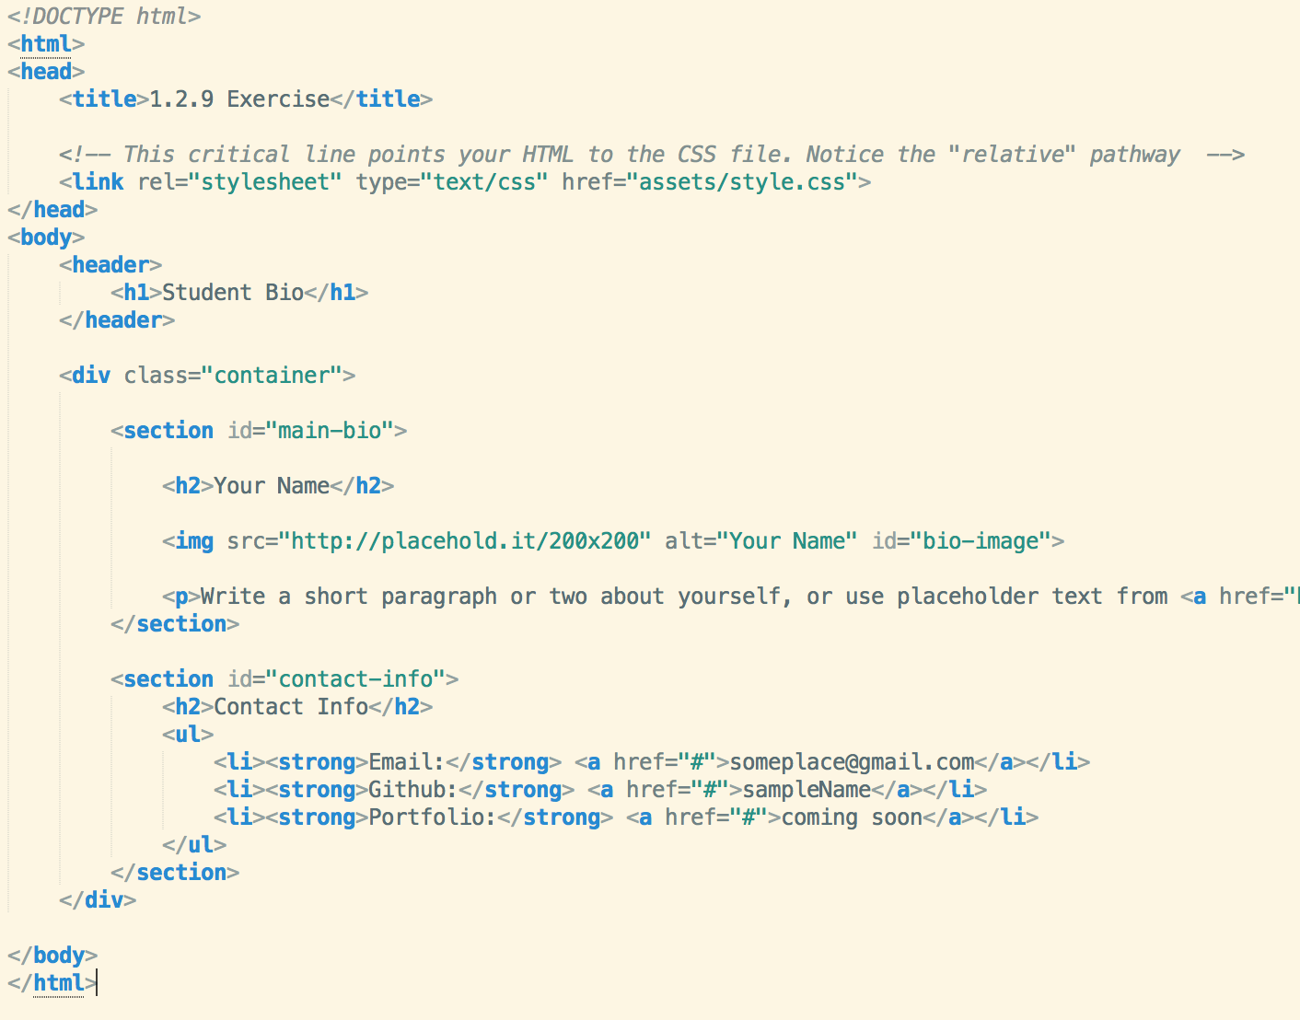

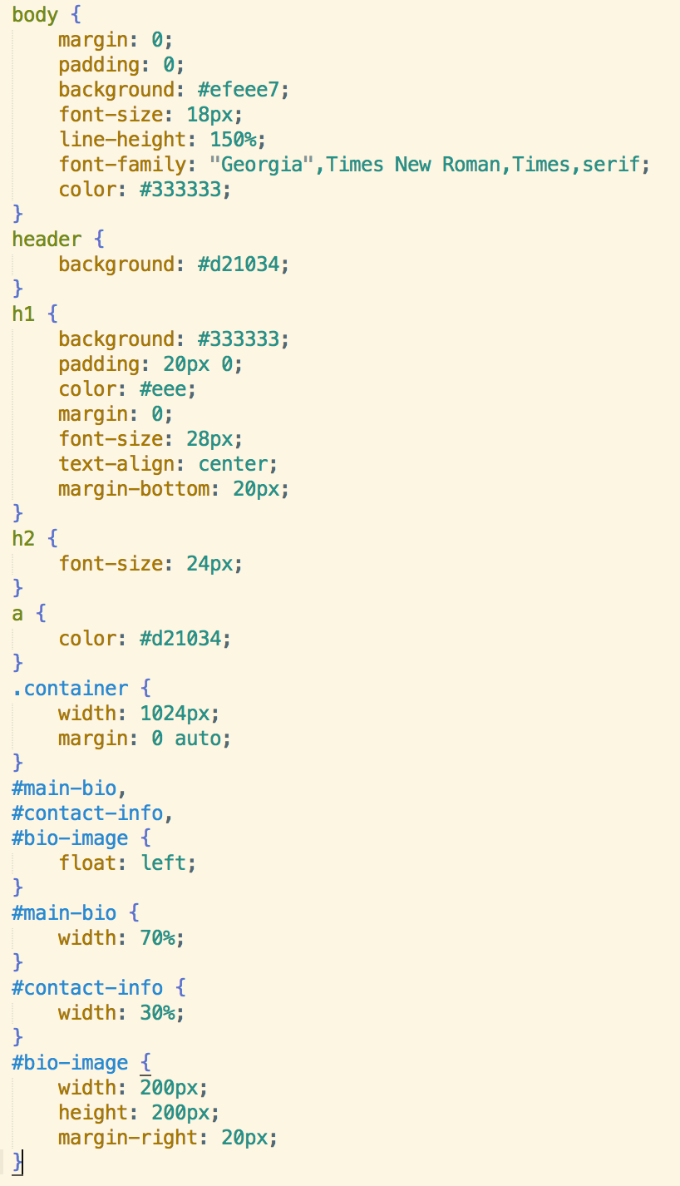

1. **Draw Resulting Layout here:**

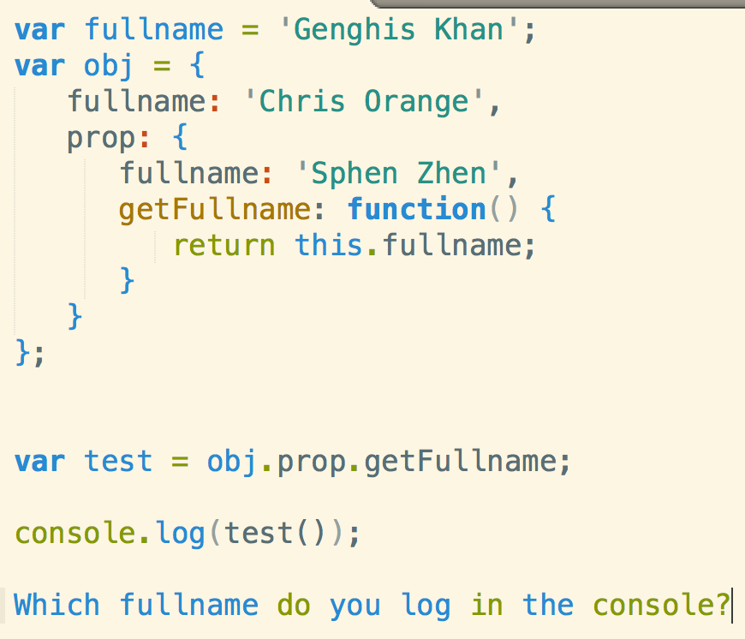

1. With the skills you have right now – what kind of program would you write to defend yourself against a pride of lions?