**Script-1**

**1. Retrieve a list of instances running in a specific AWS region.**

**2. Filter the instances based on their names.**

**3. Stop the matching instances.**

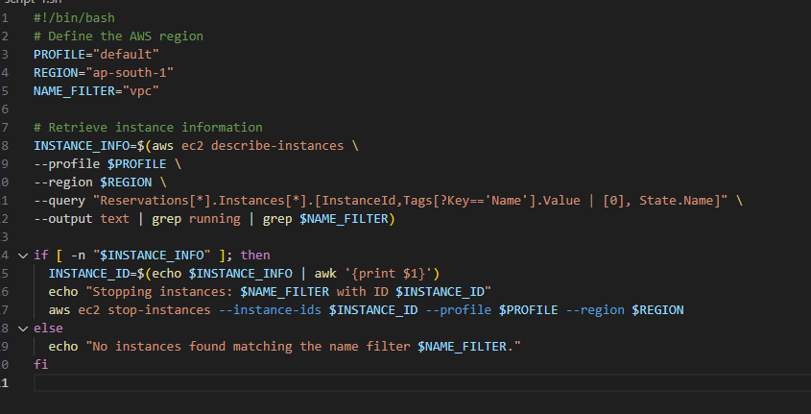

Output:

