Task-24

Use the AWS CLI to retrieve the list of private IP addresses of running instances. Start two instances with different operating systems (Red Hat, Ubuntu, CentOS) and get their private IP addresses.

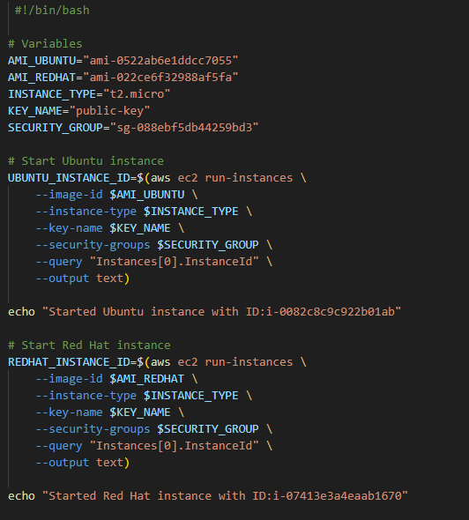

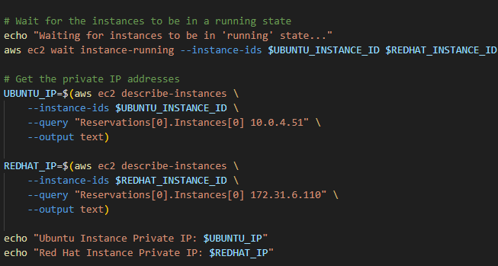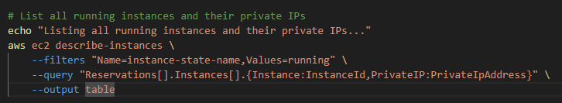

Outpu:

