PyP2PL
A Python Library for Pumped Two-Phase Loop Simulation
Methodology, Library Roadmap & Master Thesis Proposal
Based on the experimental and numerical work of:
Kokate, R. & Park, C. — PhD Thesis 2024, Applied Thermal Engineering 2023–2025
Working fluid: any CoolProp fluid | Reference system: R-134a / Microchannel evaporator

1. Overview and Motivation
Pumped two-phase loops (P2PLs) are closed-loop thermal management systems that exploit the latent heat of a refrigerant to transport large amounts of heat with relatively small fluid temperature rises. They are increasingly relevant for high-performance electronics cooling — GPUs, CPUs, power electronics — where air cooling is no longer sufficient and single-phase liquid cooling wastes the opportunity of phase change.

Kokate's body of work (2021–2025) provides the most complete published model and experimental dataset for a P2PL with a microchannel evaporator. The model is based on a thermal-hydraulic flow network, uses CoolProp for fluid properties, and has been validated against careful experiments using R-134a. This makes it the ideal foundation for an open-source Python library.

PyP2PL will allow users to:
- Define a P2PL system by assembling standard component objects (evaporator, condenser, pump, preheater, reservoir, accumulator, pipes).
- Run steady-state simulations to find operating points, temperatures, pressures, heat transfer coefficients, and pressure drops around the loop.
- Perform parametric sweeps over heat flux, mass flow rate, fluid charge ratio, coolant temperature, and component geometry.
- Compare different refrigerants using CoolProp's unified fluid database.
- Explore the effect of accumulator position and stiffness on system-level behaviour.
- (Future) Run transient simulations to study Ledinegg instability, pressure drop oscillations (PDOs), and GPU workload spikes.

2. Physical Model — Equations from Kokate
The library implements a one-dimensional thermal-hydraulic flow network model. Each component is described by conservation equations (mass, momentum, energy) coupled through nodal pressures and temperatures. At steady state, the time derivatives are zero and the system reduces to a set of nonlinear algebraic equations. The dynamic form retains the ODEs, which is exactly the architecture needed to extend to transient simulation later.

The working fluid is treated as a homogeneous two-phase mixture (equal phase velocities, saturated conditions). All fluid properties are obtained from CoolProp at each node.

2.1 System Topology and Nodes
The reference P2PL in Kokate (2023, 2024, PhD Thesis 2024) has the following nodal structure:

Reference Loop — Node Map (Kokate PhD 2024, Fig. 2.1)
Node 1: Pump outlet / Preheater inlet
Node 2: Preheater outlet (fluid reaches saturation temperature)
Node 3: Accumulator node (same pressure as Node 1 in Kokate 2021)
Node 4: Evaporator inlet → Node 5: Evaporator outlet (two-phase)
Node 6: Condenser inlet → Node 7: Condenser outlet (subcooled liquid)
Node 8: Reservoir outlet / Pump inlet
Loop closure: pump pressurizes fluid from Node 8 back to Node 1.

In PyP2PL, the node graph is user-defined, so the accumulator can be placed anywhere.

2.2 Evaporator
The evaporator is a multi-microchannel heat sink. Kokate uses idealized conditions: equal heat flux and mass flow rate in each of Nch parallel microchannels.

Mass conservation (each microchannel):
Eq. E1 | dm_e,ch/dt = (Ac,e / Le) * (p4 - p5 - delta_p_e) [momentum]

Energy equation (evaporator wall — lumped capacitance):
Eq. E2 | dTe,s/dt = (qe,s - alpha_e * As,e * (Te,s - Te,f)) / Ce,s

where Ce,s = cp,e,s * me,s is the wall thermal capacitance, alpha_e is the flow boiling HTC, As,e is the microchannel surface area. At steady state dTe,s/dt = 0 gives Te,s directly.

Pressure drop (Müller-Steinhagen & Heck correlation, Ould Didi et al.):
The evaporator volume is discretised into small control volumes from inlet to outlet. In each CV the local vapor quality x is computed from the enthalpy rise under uniform heat flux. The two-phase frictional pressure drop uses the Müller-Steinhagen & Heck (MSH) correlation. Acceleration pressure drop is computed from the momentum equation. Hydrostatic contribution is neglected for horizontal orientation.

Heat transfer coefficient — Shah's correlation (best performer, MAE 37.2%):
Eq. E3 (Shah) | alpha_e = max(alpha_nb, alpha_cv)
Eq. E4 | alpha_cv = 1.8 * alpha_l / N^0.8
Eq. E5 | alpha_nb = alpha_l * 230 * Bo^0.5 (when N>1, Bo>0.0003)
Eq. E6 (liquid) | alpha_l = 0.023 * Re_l^0.8 * Pr_l^0.4 * (kl / dh,e) [Dittus-Boelter]

N is a dimensionless convection number, Bo is the Boiling number, Fr_l is the liquid Froude number. The library will implement Shah as default and optionally: Chen, Gungor-Winterton, Kandlikar-Balasubramanian, Bennett-Chen, Lee-Mudawar.

2.3 Condenser (flat-plate heat exchanger)
The condenser has a condensation section (two-phase) followed by a subcooling section (single-phase). Kokate models it using the NTU-effectiveness method.

Energy equation (condenser wall):
Eq. C1 | dTc,s/dt = (qc,s - alpha_c * As,c * (Tc,s - Tc,f)) / Cc,s

Heat exchanger effectiveness (counter-flow):
Eq. C2 | epsilon = (1 - exp[-NTU*(1-Cr)]) / (1 - Cr*exp[-NTU*(1-Cr)])
Eq. C3 | NTU = alpha * As / Cmin

For the condensation section as Cr → 0: epsilon = 1 - exp(-NTU_cl). Pressure drop: Yan's correlation (condensation section) and Kumar's correlation (subcooling section, single-phase plate HX).

2.4 Preheater
Energy equation (preheater wall):
Eq. P1 | dTph,s/dt = (qph,s - epsilon_ph * Cmin,ph * (Tph,s - Tph,f,i)) / Cph,s

The preheater raises the subcooled fluid to saturation temperature before the evaporator inlet. Its heat input qph,s is calculated to achieve the required saturation condition at Node 2.

2.5 Reservoir (compressibility model)
The reservoir stores excess vapor and provides compressibility to the loop. The liquid is treated as incompressible and thermally insulated. The vapor undergoes a polytropic process.

Mass conservation:
Eq. R1 | m7_dot - m8_dot = rho_r,l * dVr,l/dt

Polytropic vapor pressure:
Eq. R2 | pr,v * Vr,v^n = pr,v,i * Vr,v,i^n = constant
Eq. R3 | dpr,v/dt = n * pr,v^(1+1/n) / (rho_r,l * pr,v,i^(1/n) * Vr,v,i) * (m7_dot - m8_dot)

n is the polytropic index (n = cp/cv for isentropic; Kokate uses n = cp/cv of ideal gas). Charge ratio CR = V_liquid / V_total defines the initial split between liquid and vapor volumes.

2.6 Accumulator (polytropic gas model)
The accumulator is used in fully-charged loops (100% liquid charge, aerospace applications) to accommodate fluid expansion. A diaphragm separates the compressible gas from the working fluid. From Kokate (2021, 2025):

Eq. A1 | p0 * V0^n = p0,ref * V0,ref^n = constant (polytropic gas)
Eq. A2 | dp0/dt = -n*p0^(1+1/n) / (p0,ref^(1/n) * V0,ref) * dV0/dt
Eq. A3 | m_a_dot = -rho_l * dV0/dt (liquid mass flow into accumulator)
Eq. A4 | dp0/dt = (n*p0^(1+1/n)) / (rho_l * p0,ref^(1/n) * V0,ref) * (m1_dot - m3_dot)

In PyP2PL the accumulator is implemented as an independent node object that can be inserted at any position in the loop graph — this is precisely the feature that enables the accumulator position study.

2.7 Pump
Two pump models are available. (1) Ideal pump: pressure head always equals total loop pressure drop (Kokate's reference model). (2) Pump curve model: user supplies (flow rate, pressure head) data pairs; the library interpolates using scipy. Pump work:
Eq. Pump | W_p = V_dot * delta_p_p / eta_p
where eta_p = 0.8 (Kokate assumption). The pump raises enthalpy isentropically: h_out = h_in + W_p / m_dot.

2.8 Connecting Pipes
Single-phase liquid pipes use the Darcy-Weisbach equation for pressure drop. The friction factor uses Churchill's correlation (valid for all Re, any roughness). Heat loss through pipes is neglected by default (Kokate assumption) but can be activated.
Eq. Pipe | delta_p_pipe = f * (L/D) * (rho * u^2 / 2)

2.9 Steady-State Solution Strategy
At steady state all time derivatives vanish. The system becomes a set of coupled nonlinear algebraic equations. The solution strategy is:

- Guess an initial system pressure (or use saturation pressure at condenser coolant temperature).
- Given the pump mass flow rate m_dot, compute fluid state at each node by marching around the loop.
- Apply energy balance at each component to find wall temperatures.
- Compute pressure drop at each component.
- Check pressure balance: sum of all pressure drops = pump head. If not balanced, update m_dot and iterate.
- Convergence: residual in pressure balance < tolerance (default 1 Pa).

Solver: scipy.optimize.fsolve (Newton-Raphson based). The Jacobian is computed by finite differences. Convergence is fast (< 20 iterations) for well-posed initial guesses.

3. Library Architecture — PyP2PL

3.1 Design Philosophy
The library is structured around three principles: (1) Simple for beginners — a user should be able to run a simulation by modifying a single main script without touching library internals. (2) Modular — each physical component is an independent Python class with a well-defined interface. (3) Extensible — the architecture anticipates dynamic simulation; adding ODE integration later requires only implementing the time-derivative methods already defined in each class.

3.2 File / Module Structure

Proposed Directory Structure
pyp2pl/
__init__.py ← top-level imports
fluid/
fluid.py ← CoolProp wrapper: get_props(fluid, T, P)
components/
evaporator.py ← MicrochannelEvaporator class
condenser.py ← FlatPlateCondenser class
pump.py ← Pump class (ideal + curve mode)
preheater.py ← Preheater class
reservoir.py ← Reservoir class
accumulator.py ← Accumulator class
pipe.py ← Pipe class
correlations/
htc_correlations.py ← Shah, Chen, Kandlikar, Gungor-Winterton, ...
dp_correlations.py ← MSH, Yan, Kumar, Churchill (Darcy-Weisbach)
system/
loop.py ← Loop class: assembles nodes + solves
solver.py ← Steady-state solver (fsolve wrapper)
utils/
parametric.py ← sweep(), compare_fluids() helpers
plotting.py ← plot_loop_state(), plot_sweep() helpers
validation.py ← load Kokate experimental data, compute errors
examples/
01_baseline_kokate.py ← Reproduce Kokate 2023 baseline
02_parametric_heatflux.py
03_accumulator_position.py
04_fluid_comparison.py
05_multiple_evaporators.py
tests/
test_correlations.py
test_components.py
test_system.py

3.3 Key Class Interfaces
Each component class follows the same pattern: it takes geometric and material parameters at construction, exposes a compute_steady_state(inlet_state) method that returns outlet state and performance metrics, and exposes a time_derivatives(state, t) method reserved for future dynamic use.

Example — MicrochannelEvaporator
evap = MicrochannelEvaporator(
fluid='R134a',
N_channels=44,
channel_width=0.5e-3, # m
channel_height=2.5e-3, # m
channel_length=25e-3, # m
wall_material='copper',
htc_correlation='shah' # or 'chen', 'kandlikar', ...
)

result = evap.compute_steady_state(
T_inlet=T_sat, # K
P_inlet=P_sat, # Pa
m_dot=5e-3, # kg/s
q_flux=10e4, # W/m²
)
# result contains: T_wall, HTC, delta_P, x_exit, q_total

Example — Loop assembly and solve
from pyp2pl import Loop
from pyp2pl.components import *

# Define components
pump = Pump(fluid='R134a', eta=0.8)
preh = Preheater(fluid='R134a', ...)
evap = MicrochannelEvaporator(fluid='R134a', N_channels=44, ...)
cond = FlatPlateCondenser(fluid='R134a', N_plates=30, ...)
res = Reservoir(fluid='R134a', V_total=780e-6, charge_ratio=0.70)

# Assemble loop (order defines topology)
loop = Loop([pump, preh, evap, cond, res])

# Solve steady state
state = loop.solve(T_coolant=5+273.15, q_evap=10e4)

# Access results
print(state.summary()) # pressures, temperatures, HTC, COP
loop.plot() # system pressure-enthalpy diagram

3.4 The Loop Class — Topology Engine
The Loop class takes an ordered list of components and internally builds a directed graph of nodes. When the accumulator is inserted at a different position, the user simply changes its index in the list. The solver adapts automatically because it builds the pressure-balance equation by traversing the graph. This is the key feature enabling the accumulator position study with minimal effort from the user.

3.5 CoolProp Integration
A thin CoolProp wrapper (fluid.py) provides a consistent interface. All components call get_props(fluid_name, T=..., P=...) or get_props_sat(fluid_name, P=...) which returns a FluidState dataclass. Adding a new refrigerant requires only changing the fluid string — no model modifications. Supported from day one: R134a, R1234yf, R245fa, R410A, R32, water, and any other CoolProp fluid.

4. Validation Strategy
Validation is a central pillar of the library and a required chapter of the master thesis. Kokate's published data provides three levels of validation targets.

4.1 Component-Level Validation
Quantity to Validate | Reference (Kokate data)
Evaporator HTC vs heat flux | Figs. 5–7, Kokate 2024 (Appl. Therm. Eng.)
Evaporator pressure drop vs heat flux | Fig. 7, Kokate 2024
Boiling curve (wall superheat vs q") | Fig. 4, Kokate 2024
Flow regime map comparison | Fig. 3, Kokate 2023 / 2024

4.2 System-Level Validation
Kokate PhD Thesis (2024), Appendix F provides measured steady-state pressures and temperatures at all nodal points for three parameter sweeps: varying pump mass flow rate, varying heat flux, and varying heat sink temperature. These are the primary validation targets for the Loop solver.

Validation Metrics
Mean Absolute Error (MAE) as defined in Kokate: MAE = (1/N) * sum(|pred - meas| / meas)
Target: MAE < 15% for all system-level quantities (pressures, temperatures, HTC)
Pressure drop: MAE < 25% (acceptable given the complexity of two-phase dp correlations)
Comparison plotted as parity charts (predicted vs measured) with ±20% error bands

4.3 Stability Validation
Kokate Chapter 3 (Ledinegg) and Chapter 5 (PDO) provide stability maps and oscillation data. Once the dynamic extension is implemented, these can be used to validate the transient model.

5. Development Roadmap
The roadmap is divided into five phases of approximately 2 months each, totalling 10 months — a realistic timeline for a master thesis. Each phase delivers a working, testable increment.

Phase | Title | Duration | Key Tasks | Deliverable
Phase 1 | Foundation | Months 1–2 | Literature review of Kokate papers. Set up project structure, CoolProp wrapper, unit tests scaffold. Implement all correlations (Shah, MSH, Yan, Kumar, Churchill) as standalone functions with unit tests. Validate correlations against published data tables. | Tested correlation library
Phase 2 | Components | Months 2–4 | Implement Evaporator, Condenser, Preheater, Pump, Pipe classes. Each class solves its own component-level problem. Validate each component against Kokate component-level data (HTC, delta_P, boiling curve). Write example notebooks for each component. | Component library + validation report
Phase 3 | System Solver | Months 4–6 | Implement Reservoir and Accumulator. Build Loop class and steady-state solver (scipy.optimize.fsolve). Implement mass balance and pressure balance. Reproduce Kokate 2023 baseline results. Full system-level validation vs Kokate PhD Appendix F. Write validation chapter draft. | Full steady-state loop solver
Phase 4 | Research Studies | Months 6–9 | Parametric sweeps (heat flux, mass flow, coolant temp, charge ratio). Accumulator position study. Fluid comparison (R-134a vs R-1234yf vs R-245fa). Multiple evaporators in parallel. Heat source transient analysis (step changes simulating GPU workloads — using quasi-steady approximation initially). Stability maps (Ledinegg onset). | Research results chapters (3–4 chapters)
Phase 5 | Dynamic Model + Thesis | Months 9–10 | Implement ODE time-integration (scipy.integrate.solve_ivp). Add dynamic evaporator and accumulator equations. Reproduce PDO results from Kokate 2025. Write up and polish thesis. Prepare defence presentation. | Full thesis + dynamic model

6. Master Thesis Proposal

Proposed Thesis Title
"PyP2PL: A Python Library for System-Level Simulation of Pumped Two-Phase Loops
with Application to Electronics Thermal Management"

or alternatively:

"System-Level Modelling and Parametric Analysis of a Pumped Two-Phase Loop
for High-Performance Electronics Cooling Using Python and CoolProp"

6.1 Research Objectives
- Develop and validate PyP2PL, an open-source Python library for steady-state (and preliminary transient) simulation of pumped two-phase cooling loops.
- Validate the library against Kokate's experimental and numerical data for system-level pressures, temperatures, heat transfer coefficients, and pressure drops.
- Conduct a system-level parametric study of the influence of heat flux, mass flow rate, coolant temperature, and fluid charge ratio on P2PL performance.
- Investigate the effect of accumulator position and stiffness on system behaviour and stability — a topic identified by Kokate as largely unexplored.
- Compare the performance of alternative low-GWP refrigerants (R-1234yf, R-245fa) against R-134a in the same loop, providing guidance for future system design.
- Analyse system response to transient heat loads representative of GPU workloads (step changes in heat flux) using quasi-steady and dynamic approaches.

6.2 Suggested Thesis Chapter Structure

Chapter | Content
Chapter 1 | Introduction — P2PL for electronics cooling, motivation, state of the art
Chapter 2 | Physical Model — governing equations, correlations, assumptions
Chapter 3 | PyP2PL Library — architecture, implementation, user guide
Chapter 4 | Validation — component-level and system-level vs Kokate data
Chapter 5 | Parametric Studies — heat flux, mass flow, charge ratio, coolant temperature
Chapter 6 | Advanced Topics — accumulator position, fluid comparison, transient analysis
Chapter 7 | Conclusions and future work

6.3 Research Topics in Detail

6.3.1 Parametric Sweeps — System Response Mapping
Using PyP2PL's sweep() utility, systematically vary: heat flux (5–25 W/cm²), mass flux (50–350 kg/m²-s), chiller inlet temperature (-5 to +15°C), and charge ratio (60–90%). For each combination record: evaporator wall temperature, HTC, pressure drop, exit quality, condenser load, COP, and pump power. Generate response surfaces to identify optimal operating windows. This directly extends Kokate's published parametric study to a wider operating space.

6.3.2 Accumulator Position Study
This is a novel contribution not systematically studied in Kokate's work. The accumulator in a fully-charged P2PL acts as a pressure buffer. Placing it at different positions changes the impedance seen by the pump and the pressure distribution around the loop. Using PyP2PL's topology engine, place the accumulator at positions: (a) upstream of evaporator [Kokate reference], (b) downstream of evaporator, (c) downstream of condenser, (d) at the pump outlet. For each position compute: system operating pressure, loop pressure distribution, evaporator inlet conditions, and the stiffness of the pressure response to heat flux perturbations. This study could reveal positions that reduce PDO susceptibility — a direct design recommendation for aerospace P2PLs.

6.3.3 Refrigerant Comparison
R-134a has a Global Warming Potential (GWP) of 1430. R-1234yf (GWP < 1) and R-245fa are key alternatives under consideration for next-generation cooling systems. Using CoolProp, substitute the working fluid and compare: saturation pressure levels (affects pump sizing), latent heat and HTC (affects evaporator size), pressure drop (affects pump power), and COP. This provides a quantitative basis for fluid selection in future P2PL designs and is directly relevant to industry.

6.3.4 Stability Analysis — Ledinegg Onset
Ledinegg instability occurs when the slope of the internal pressure drop curve (dΔP_evap/dm_dot) becomes negative, meaning the loop pressure drop decreases with increasing flow — a positive feedback that causes flow excursion. PyP2PL can map this in steady state by computing the P-m curve at different heat fluxes and identifying the onset of negative slope (OFI point). A stability map over the (heat flux, mass flux) space can be generated, directly comparable to Kokate's Figure 3.9 (PhD Thesis). The effect of accumulator position on the stability boundary is a particularly interesting extension.

6.3.5 GPU Workload Transients
Modern GPUs produce highly dynamic heat loads: a step from idle (20 W) to full load (300 W) can occur in milliseconds. In steady-state mode, PyP2PL can compute the trajectory of operating points under quasi-steady assumptions (assuming thermal time constants are much longer than fluid transit time). This gives estimates of peak wall temperature and pressure overshoot. As a thesis extension, the full dynamic model (Phase 5) can validate these estimates against the ODE solution, quantifying the error of the quasi-steady approximation as a function of heat load ramp rate.

6.3.6 Multiple Evaporators in Parallel
Data centres and high-performance computing boards often have multiple chips on one board. PyP2PL can model two or more evaporators in parallel by including each as a separate branch in the loop graph. Research questions: (a) How does maldistribution of flow between parallel evaporators affect thermal performance? (b) What is the penalty of having one evaporator at a higher heat load than the others? (c) How does the reservoir or accumulator respond to parallel boiling? This is an original study not present in Kokate's work.

7. Getting Started — First Steps

7.1 Installation
Installation (once library is created)
# Install dependencies
pip install coolprop scipy numpy matplotlib pandas

# Clone / install PyP2PL (once published)
pip install pyp2pl

# Or in development mode
git clone https://github.com/your-repo/pyp2pl
cd pyp2pl && pip install -e .

7.2 First Simulation — Reproduce Kokate 2023 Baseline
examples/01_baseline_kokate.py
from pyp2pl import Loop
from pyp2pl.components import (MicrochannelEvaporator, FlatPlateCondenser,
Pump, Preheater, Reservoir)

# --- Define components (Kokate 2023 geometry) ---
pump = Pump(fluid='R134a', eta=0.8, mode='ideal')

preh = Preheater(fluid='R134a',
UA=150.0, # W/K (estimated from Lytron CP30G01)
target='saturated')

evap = MicrochannelEvaporator(fluid='R134a',
N_channels=44,
W_ch=0.5e-3, H_ch=2.5e-3, L_ch=25e-3, # m
wall_material='copper',
htc_correlation='shah')

cond = FlatPlateCondenser(fluid='R134a',
N_plates=30, L_plate=0.12, W_plate=0.05, # m
coolant_fluid='EGW',
coolant_T_inlet=5+273.15)

res = Reservoir(fluid='R134a',
V_total=780e-6, # m³
charge_ratio=0.70,
polytropic_n=1.4)

# --- Assemble loop ---
loop = Loop([pump, preh, evap, cond, res])

# --- Solve steady state ---
state = loop.solve(q_evap=10e4) # 10 W/cm²

# --- Print results ---
print(state.summary())
loop.plot_state_diagram()

7.3 Parametric Sweep Example
examples/02_parametric_heatflux.py
from pyp2pl.utils import sweep
import numpy as np

q_values = np.linspace(5e4, 25e4, 20) # W/m²

results = sweep(loop,
parameter='q_evap',
values=q_values)

# results is a DataFrame with columns:
# q_evap, T_wall, HTC, delta_P_evap, x_exit, T_cond_out, W_pump, COP

results.plot(x='q_evap', y='T_wall')
results.plot(x='q_evap', y='HTC')

7.4 Accumulator Position Study Example
examples/03_accumulator_position.py
from pyp2pl.components import Accumulator

acc = Accumulator(fluid='R134a', V_gas=50e-6, P_gas_init=600e3, n=1.4)

results = {}
for pos, components in [
('upstream_evap', [pump, preh, acc, evap, cond, res]),
('downstream_evap', [pump, preh, evap, acc, cond, res]),
('downstream_cond', [pump, preh, evap, cond, acc, res]),
]:
loop = Loop(components)
results[pos] = loop.solve(q_evap=10e4)

# Compare operating pressures and T_wall across positions
compare_results(results)

8. Summary — Why This Makes an Outstanding Thesis

Originality
PyP2PL does not yet exist as an open-source Python library. Kokate's model was implemented in
MATLAB/EES (closed-source, expensive). A Python/CoolProp equivalent is a genuine contribution.
The accumulator position study and the refrigerant comparison are novel research directions not
covered in Kokate's published work.

Rigour
The library is grounded in peer-reviewed governing equations (Kokate 2021, 2023, 2024, 2025 + PhD 2024).
Validation against published experimental data (Appendix F of the PhD thesis) provides quantitative
evidence of model fidelity. Component-level correlation benchmarking ensures each building block is correct.

Relevance
Electronics thermal management is a major industrial challenge. GPUs, CPUs, and power electronics
are increasingly power-dense. P2PLs are a leading candidate technology. The library is immediately
useful to engineers assessing P2PL feasibility for new applications.

Scope
10-month plan delivers: a validated open-source library, 5+ original research studies, a full thesis.
Dynamic model is a bonus chapter that pushes the work toward PhD-level territory if time allows.
Each research study generates publishable results independently.

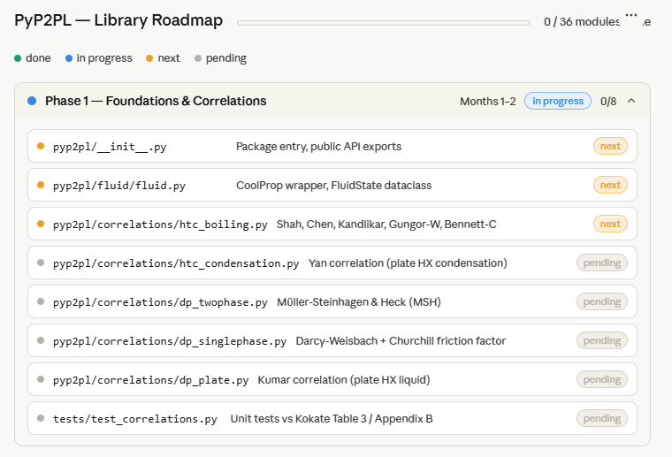
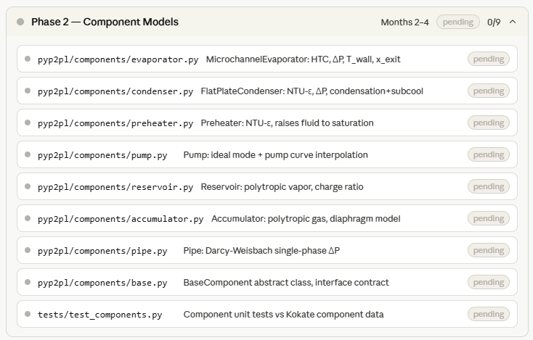
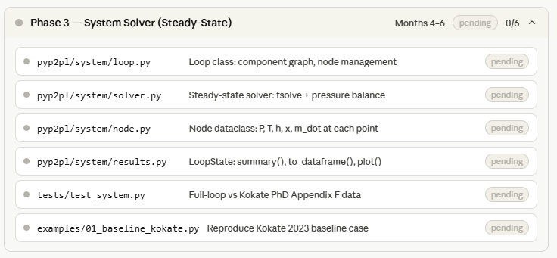
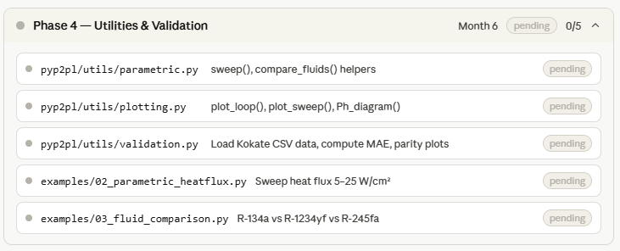

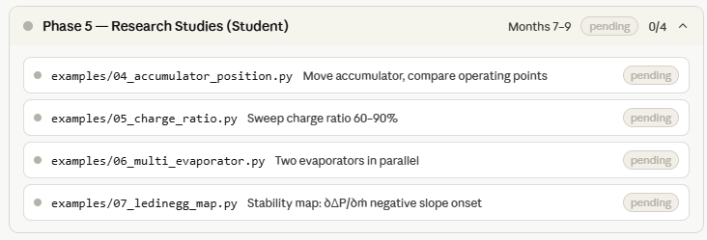
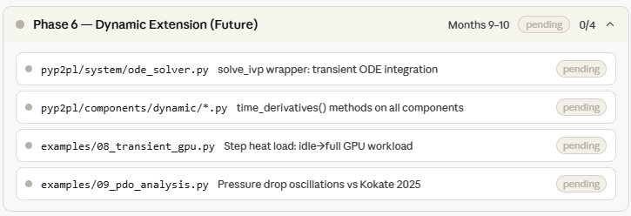
— End of Document —

