Moduel2 RMarkdown Document 1

Johnson W. Ahiadorme

6/7/2019

# This is a level One Hearder

## R Markdown

### This is a level Three Header

This is an R Markdown document. Markdown is a simple formatting syntax for authoring HTML, PDF, and MS Word documents. For more details on using R Markdown see <http://rmarkdown.rstudio.com>.

Here is the link to [GOOGLE](http://www.google.com)

This word is in **bold** and this is also in **bold**. This is in *italics* an this as well is in *italics*.

We seek to compile this report using rmarkdown.

mean(2,3,4,5,6)  
5+8

Here is an example of a non-numbered list:

* Water
  + ice drop
  + voltic
* Breakfast
  + food
    - eggs
    - toast
    - bacon
  + drink
    - apple juice
* Lunch
  + taco
* Dinner
  + baked chicken
  + broccoli
  + rice

Here is an example of a numbered list:

1. Water
   1. Ice Drop
   2. Voltic
      1. Sachet
      2. Bottle
2. Breakfast
   1. food
      1. eggs
      2. toast
      3. bacon
   2. drink
      1. apple juice
3. Lunch
   1. taco
4. Dinner
   1. baked chicken
   2. broccoli
   3. rice

Here is an example of a blockquote:

This is a block quote. This paragraph has two lines.

1. This is a list inside a block quote.
2. Second item.

This is one them.

1. Control
2. Treatment

Here is an example of a nested blockquote:

This is a block quote. This paragraph has two lines.

This text is nested

Take a lok at this code

Beautiful

What abot indenting

It looks like this.

Good  
2+5

When you click the **Knit** button a document will be generated that includes both content as well as the output of any embedded R code chunks within the document. You can embed an R code chunk like this:

summary(cars)

## speed dist   
## Min. : 4.0 Min. : 2.00   
## 1st Qu.:12.0 1st Qu.: 26.00   
## Median :15.0 Median : 36.00   
## Mean :15.4 Mean : 42.98   
## 3rd Qu.:19.0 3rd Qu.: 56.00   
## Max. :25.0 Max. :120.00

## Including Plots

You can also embed plots, for example:



Note that the echo = FALSE parameter was added to the code chunk to prevent printing of the R code that generated the plot.

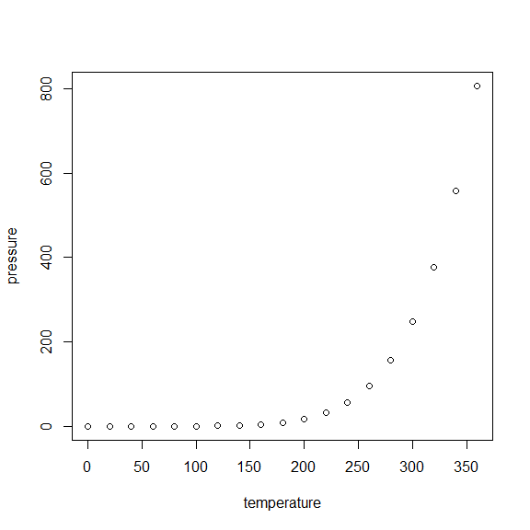

## Insert Table

knitr::kable(head(cars))

|  |  |
| --- | --- |
| speed | dist |
| 4 | 2 |
| 4 | 10 |
| 7 | 4 |
| 7 | 22 |
| 8 | 16 |
| 9 | 10 |