The Air Quality Dataset

Johnson W. Ahiadorme

6/12/2019

## Summary of Air Quality Dataset

This exercise will be working with the built-in air quality dataset.[1] This dataset contains 154 daily air quality measurements in New York from May 1, 1973 (a Tuesday) to September 30, 1973. The dataset contains 6 variables:

* **Ozone**: Mean ozone in parts per billion *(ppb)* from 1300 to 1500 hours at Roosevelt Island;
* **Solar.R**: Solar radiation in Langleys *(lang)* in the frequency band 4000–7700 Angstroms from 0800 to 1200 hours at Central Park;
* **Wind**: Average wind speed in miles per hour *(mph)* at 0700 and 1000 hours at LaGuardia Airport;
* **Temp**: Maximum daily temperature in degrees Fahrenheit *(oF)* at LaGuardia Airport;
* **Month**: numeric month *(1-12)* **Day**: numeric Day of the month *(1-31)*

Here is a summary of the data

## Ozone Solar.R Wind Temp   
## Min. : 1.00 Min. : 7.0 Min. : 1.700 Min. :56.00   
## 1st Qu.: 18.00 1st Qu.:115.8 1st Qu.: 7.400 1st Qu.:72.00   
## Median : 31.50 Median :205.0 Median : 9.700 Median :79.00   
## Mean : 42.13 Mean :185.9 Mean : 9.958 Mean :77.88   
## 3rd Qu.: 63.25 3rd Qu.:258.8 3rd Qu.:11.500 3rd Qu.:85.00   
## Max. :168.00 Max. :334.0 Max. :20.700 Max. :97.00   
## NA's :37 NA's :7   
## Month Day   
## Min. :5.000 Min. : 1.0   
## 1st Qu.:6.000 1st Qu.: 8.0   
## Median :7.000 Median :16.0   
## Mean :6.993 Mean :15.8   
## 3rd Qu.:8.000 3rd Qu.:23.0   
## Max. :9.000 Max. :31.0   
##

### Table of Top of the Air Quality Dataset

A table of the head of the air quality dataset

Top of the Air Quality Dataset

|  |  |  |  |  |  |
| --- | --- | --- | --- | --- | --- |
| Ozone | Solar.R | Wind | Temp | Month | Day |
| 41 | 190 | 7.4 | 67 | 5 | 1 |
| 36 | 118 | 8.0 | 72 | 5 | 2 |
| 12 | 149 | 12.6 | 74 | 5 | 3 |
| 18 | 313 | 11.5 | 62 | 5 | 4 |
| NA | NA | 14.3 | 56 | 5 | 5 |
| 28 | NA | 14.9 | 66 | 5 | 6 |

### Plot of Ozone by Temperature –Air Quality Dataset

A plot of the temperature and ozone from the built-in air quality dataset

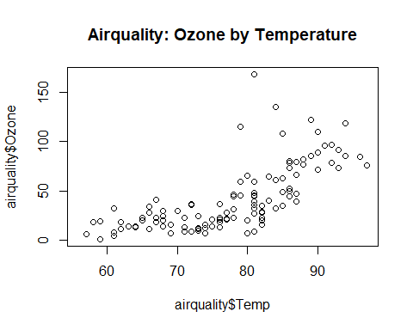

1. Chambers, J. M., Cleveland, W. S., Kleiner, B. and Tukey, P. A. (1983) Graphical Methods for Data Analysis. Belmont, CA: Wadsworth.