Lab Report — Vision‑Guided Pick & Place with Dobot MG400
Submitted by: Md Jahidul Islam, K M Arafat Islam (Group 13)

Objective
Design and implement a vision‑guided system that captures an image from a fixed camera, detects colored tiles/objects on a planar workspace, maps pixel coordinates to robot workspace coordinates via 4‑point homography, and commands a Dobot MG400 to pick and place objects.

Key Files:
Calibration- calibration/calibration.py: it takes 4‑point pixel collection and robot (X,Y) to compute homography and save to calibration/calibration.json.
calibration/calibration.json: it stores 3×3 homography matrix H.

Perception- perception/detect_color.py: It capture one frame, HSV masking (non‑white), morphology, contours, centroid also apply H to get (X,Y) and save annotated image in output.

Robot- robot/dobot_api.py: TCP/IP low‑level API (Dashboard 29999 / Move 30003 / Feed 30004).

robot/dobot_controller.py: connection, feedback thread, Wait Arrive, MoveL/MoveJ, digital outputs.
robot/robot_control.py: robot_connect, pick_one(X,Y), robot_disconnect (vacuum DO sequence + box pose).

Entry Point- main.py: CLI to run detection in plan or execute mode.

UI- ui/app.py: it provides an operator-friendly UI that captures a camera frame, detects objects, converts pixel coordinates to robot workspace coordinates, and displays annotated results. It also lets the operator connect to the Dobot MG400 and execute your full
pick-and-place cycle safely in Execute mode

Development Choices
Planar Homography: A 4‑point planar homography maps image pixels (u,v) to workspace coordinates (X,Y) in mm. This suits a rigid, planar workspace and avoids full 3D calibration when Z is fixed.

Color Segmentation & Centroid: A broad HSV range filters non‑white regions. Morphology cleans noise, external contours identify objects and centroids give robust pick points.

Single‑Frame Detection: On‑demand, single‑frame capture simplifies synchronization with the robot and ensures the operator validates what is being picked.

Dobot TCP/IP Control: Dashboard for enabling/IO/speeds, Move for trajectories, Feed for status. Deterministic sequencing with WaitArrive improves safety and repeatability.

Operation
Plan Mode (Detect Only)- We run python main.py detect --mode plan. The system detects objects, prints Pixel (u,v) and Robot (X,Y) mm, and saves an annotated image.

Execute Mode (Pick & Place)
After running python main.py detect --mode execute, it confirms to move. The system connects to the robot, picks each detected object, and places it into the box.
Streamlit- Some images for UI execution
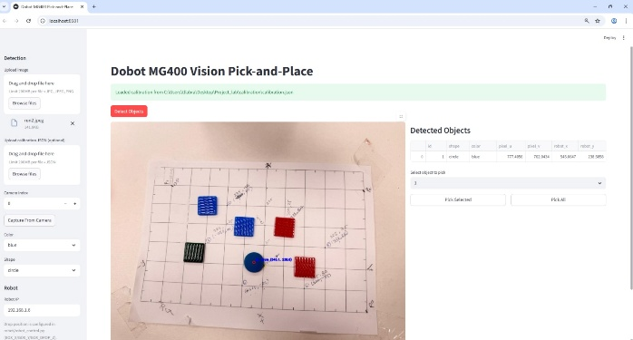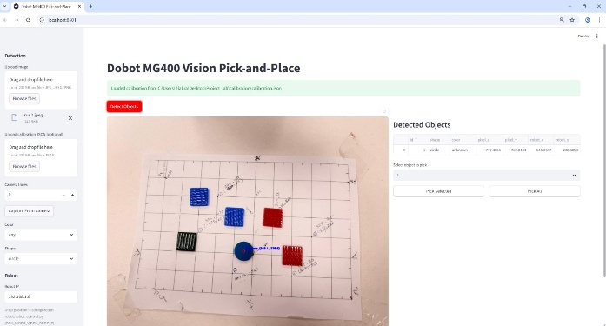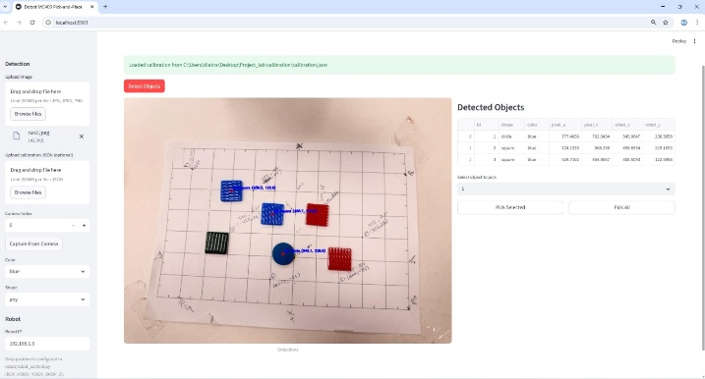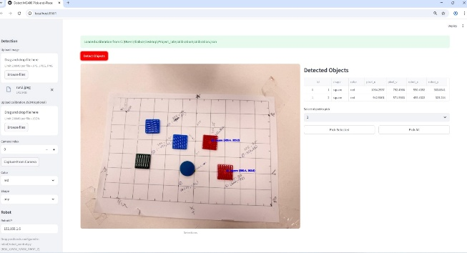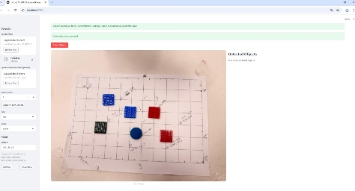

Discussion
The development of the system was relatively straightforward, as homography-based
pixel-to-workspace calibration and HSV color segmentation are simple and fast to implement, as we have done it in our previous lab sessions. Dobot’s TCP/IP API providing a clear structure for motion, IO control, and feedback. Building the calibration tool, detection pipeline, robot integration, and end-to-end testing required roughly 2 classes (8 hrs) in total. Pick-and-place cycles completed in about 10 seconds depending on travel distance. Future improvements could include adding color-specific detection which was a bonous task and a complete Streamlit operator UI. Overall, the system is reliable, accurate for tile manipulation, and easily extendable with additional features

