

**American International University- Bangladesh**

**CSC 3215: Web Technologies**

**CO2 and CO4 Evaluation**

**Finished Project Report**

**Fall 2019-2020**

**Project Title: Cart Management System**

**Section: J**

|  |  |
| --- | --- |
| Student Name | Student Id |
| Md. Jahidul Hasan | **17-34806-2** |
|  |  |
|  |  |
|  |  |

**Project Description:**

*My project name is “Cart Management System". In this project I have shown the product list in the Index page. In that page a customer can choose his product and get it in the cart by clicking in the “Add to cart” button. If a customer clicks that button then there will increase a number in cart icon which is = in the navigation bar. Then also show a message that “Product added to your cart”. If a customer clicks the Add to cart button for the same product again then there will be a message that “This product already added to your cart”. After choosing all the products if a customer clicks the Cart icon then it will redirect to Product list page that he chooses. There will be information of all products and he can also delete any product from the list. He can also add products to his product list by clicking the “Add Product” button. Then there is a “Check Out” button. After confirming all the products, he can check out by clicking the Checkout button.*

**Project Folder Structure:**

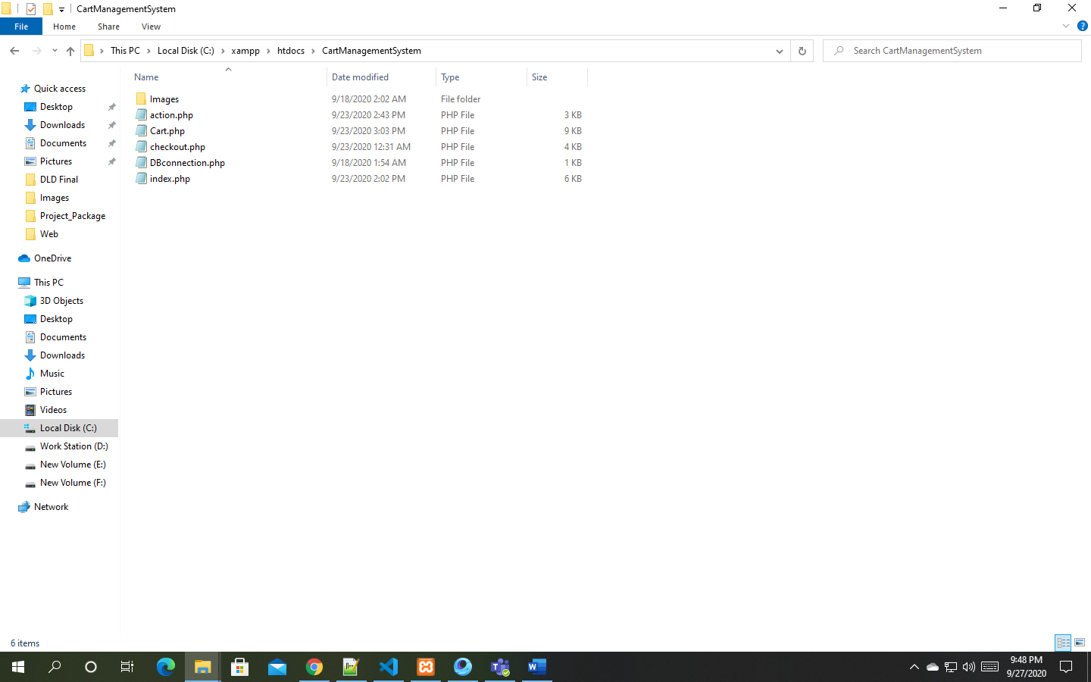

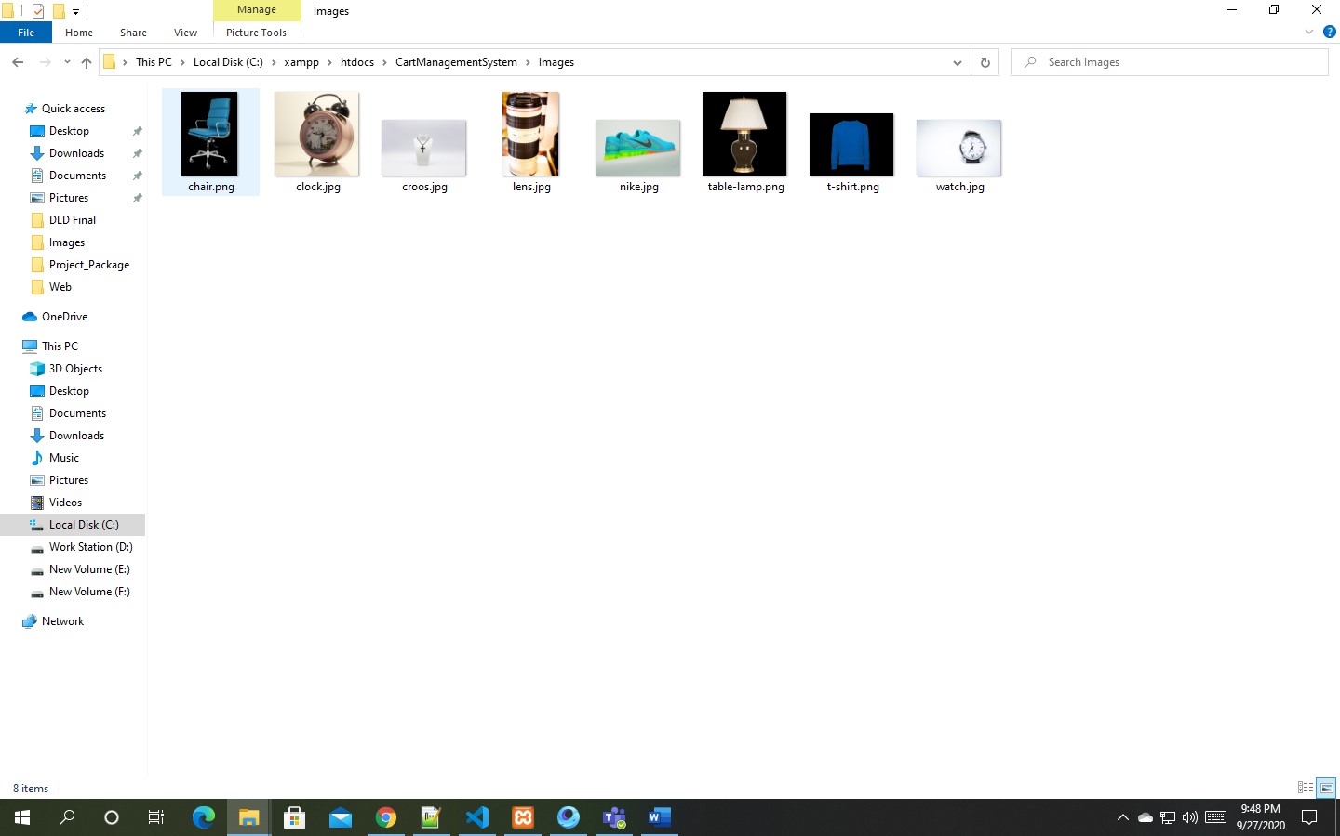

**Core Modules of the Project:**

***index.php***

*<!DOCTYPE html>*

*<html lang="en">*

*<head>*

*<meta charset="UTF-8">*

*<meta name="viewport" content="width=device-width, initial-scale=1.0">*

*<title>Cart Management System</title>*

*<link rel="stylesheet" href="https://maxcdn.bootstrapcdn.com/bootstrap/4.3.1/css/bootstrap.min.css">*

*<link rel= "stylesheet" href="https://use.fontawesome.com/releases/v5.7.0/css/all.css" integrity="sha384-lZN37f5QGtY3VHgisS14W3ExzMWZxybE1SJSEsQp9S+oqd12jhcu+A56Ebc1zFSJ" crossorigin="anonymous">*

*</head>*

*<body>*

*<nav class="navbar navbar-expand-md bg-dark navbar-dark">*

*<a class="navbar-brand" href="index.php"><i class="fas fa-cart-alt"></i>&nbsp;&nbsp;Amazon</a>*

*<button class="navbar-toggler" type="button" data-toggle="collapse" data-target="#collapsibleNavbar">*

*<span class="navbar-toggler-icon"></span>*

*</button>*

*<div class="collapse navbar-collapse" id="collapsibleNavbar">*

*<ul class="navbar-nav ml-auto">*

*<li class="nav-item">*

*<a class="nav-link" href="checkout.php"><!-check out-></a>*

*</li>*

*<li class="nav-item">*

*<a class="nav-link" href="cart.php">*

*<i class="fas fa-shopping-cart">*

*<span id="cart-item" class="badge badge-danger"></span> <!-cart item id->*

*</i>*

*</a>*

*</li>*

*</ul>*

*</div>*

*</nav>*

*<!--main portion-->*

*<div class="container">*

*<div id="message">*

*</div>*

*<div class="row mt-2 pb-3">*

*<?php*

*include 'DBconnection.php';*

*$stmt = $con->prepare("SELECT * FROM product");*

*$stmt->execute();*

*$result = $stmt-> get_result();*

*while($row = $result->fetch_assoc()):*

*?>*

*<div class="col-sm-6 col-md-4col-lg-3 mb-2">*

*<div class="card-deck">*

*<div class="card p-2 border-secondary mb-2">*

*<img src="<?= $row['product_image'] ?>" class="card-img-top" height="250"> <!-showing image->*

*<div class="card-body p-1">*

*<h4 class="card-title text-center text-black">*

*<?= $row['product_name'] ?> <!-showing product name->*

*</h4>*

*<h5 class="card-text text-center text-danger">*

*<?= number_format($row['product_price'],2) ?>/- <!-showing product price->*

*</h5>*

*</div>*

*<div class="card-footer p-1">*

*<form action="" class="form-submit">*

*<input type="hidden" class="pid" value=" <?= $row['id'] ?>" >*

*<input type="hidden" class="pname" value=" <?= $row['product_name'] ?>" >*

*<input type="hidden" class="pprice" value=" <?= $row['product_price'] ?>" >*

*<input type="hidden" class="pimage" value=" <?= $row['product_image'] ?>" >*

*<input type="hidden" class="pcode" value=" <?= $row['product_code'] ?>" >*

*<button class="btn btn-dark btn-block addItemBtn" ><i class="fas fa-cart-plus"></i>&nbsp;&nbsp; Add To Cart</button> <!-adding item button class->*

*</form>*

*</div>*

*</div>*

*</div>*

*</div>*

*<?php endwhile; ?>*

*</div>*

*</div>*

*<script src="https://ajax.googleapis.com/ajax/libs/jquery/3.4.0/jquery.min.js"></script>*

*<script src="https://cdnjs.cloudflare.com/ajax/libs/popper.js/1.14.7/umd/popper.min.js"></script>*

*<script src="https://maxcdn.bootstrapcdn.com/bootstrap/4.3.1/js/bootstrap.min.js"></script>*

*<script type="text/javascript">*

*$(document).ready(function(){*

*$(".addItemBtn").click(function(e){*

*e.preventDefault();*

*var $form = $(this).closest(".form-submit");*

*var pid = $form.find(".pid").val();*

*var pname = $form.find(".pname").val();*

*var pprice = $form.find(".pprice").val();*

*var pimage = $form.find(".pimage").val();*

*var pcode = $form.find(".pcode").val();*

*$.ajax({*

*url:'action.php',*

*method: 'post',*

*data: {pid:pid,pname:pname,pprice:pprice,pimage:pimage,pcode:pcode},*

*success: function(response){*

*$("#message").html(response);*

*window.scrollTo(0,0);*

*load_cart_item_number();*

*}*

*});*

*});*

*load_cart_item_number();*

*function load_cart_item_number()*

*{*

*$.ajax({*

*url:'action.php',*

*method: 'get',*

*data: {cartItem:"cart_item"},*

*success: function(response)*

*{*

*$("#cart-item").html(response);*

*}*

*})*

*}*

*});*

*</script>*

*</body>*

*</html>*

***action.php***

*<?php*

*session_start();*

*require 'DBconnection.php';*

*#Add to cart button*

*if(isset($_POST['pid']))*

*{*

*$pid = $_POST['pid'];*

*$pname = $_POST['pname'];*

*$pprice = $_POST['pprice'];*

*$pimage = $_POST['pimage'];*

*$pcode = $_POST['pcode'];*

*$pquantity = 1;*

*$stmt = $con->prepare("SELECT product_code FROM cart WHERE product_code=?");*

*$stmt->bind_param("s",$pcode);*

*$stmt->execute();*

*$res = $stmt->get_result();*

*$r = $res->fetch_assoc();*

*$code = $r['product_code'];*

*if(!$code)*

*{*

*$query = $con->prepare("INSERT INTO cart (product_name,product_price,product_image,quantity,total_price,product_code) VALUES (?,?,?,?,?,?)");*

*$query->bind_param("sssiss",$pname,$pprice,$pimage,$pquantity,$pprice,$pcode);*

*$query->execute();*

*echo '<div class="alert alert-info alert-dismissible mt-2">*

*<button type="button" class="close" data-dismiss="alert">&times;</button>*

*<strong>Product added to your Cart.</strong>*

*</div>';*

*}*

*else*

*{*

*echo '<div class="alert alert-info alert-dismissible mt-2">*

*<button type="button" class="close" data-dismiss="alert">&times;</button>*

*<strong>This product already added to your cart</strong>*

*</div>';*

*}*

*}*

*#cart item*

*if(isset($_GET['cartItem']) && isset($_GET['cartItem']) == 'cart_item')*

*{*

*$stmt = $con->prepare("SELECT * FROM cart");*

*$stmt->execute();*

*$stmt->store_result();*

*$rows = $stmt->num_rows;*

*echo $rows;*

*}*

*#Remove button*

*if(isset($_GET['remove']))*

*{*

*$id = $_GET['remove'];*

*$stmt = $con->prepare("DELETE FROM cart WHERE id=?");*

*$stmt->bind_param("i",$id);*

*$stmt->execute();*

*$_SESSION['showAlert'] = 'block';*

*$_SESSION['message'] = 'Product removed from the cart...!';*

*header('location:cart.php');*

*}*

*#Clear Cart button*

*if(isset($_GET['clear']))*

*{*

*$stmt = $con->prepare("DELETE FROM cart");*

*$stmt->execute();*

*$_SESSION['showAlert'] = 'block';*

*$_SESSION['message'] = 'All Product removed from the cart...!';*

*header('location:cart.php');*

*}*

*#quantity button*

*if(isset($_POST['qty']))*

*{*

*$qty = $_POST['qty'];*

*$pid = $_POST['pid'];*

*$pprice = $_POST['pprice'];*

*$tprice = $qty * $pprice;*

*$stmt = $con->prepare("UPDATE cart SET qty=?, total_price=? WHERE id=?");*

*$stmt->bind_param("isi",$qty,$tprice,$pid);*

*$stmt->execute();*

*}*

*?>*

***cart.php***

*<?php*

*session_start();*

*?>*

*<!DOCTYPE html>*

*<html lang="en">*

*<head>*

*<meta charset="UTF-8">*

*<meta name="viewport" content="width=device-width, initial-scale=1.0">*

*<title>Cart</title>*

*<link rel="stylesheet" href="https://maxcdn.bootstrapcdn.com/bootstrap/4.3.1/css/bootstrap.min.css">*

*<link rel= "stylesheet" href="https://use.fontawesome.com/releases/v5.7.0/css/all.css" integrity="sha384-lZN37f5QGtY3VHgisS14W3ExzMWZxybE1SJSEsQp9S+oqd12jhcu+A56Ebc1zFSJ" crossorigin="anonymous">*

*</head>*

*<body>*

*<!--nav bar-->*

*<nav class="navbar navbar-expand-md bg-dark navbar-dark">*

*<a class="navbar-brand" href="index.php"><i class="fas fa-cart-alt"></i>&nbsp;&nbsp;Amazon</a>*

*<button class="navbar-toggler" type="button" data-toggle="collapse" data-target="#collapsibleNavbar">*

*<span class="navbar-toggler-icon"></span>*

*</button>*

*<div class="collapse navbar-collapse" id="collapsibleNavbar">*

*<ul class="navbar-nav ml-auto">*

*<li class="nav-item">*

*<a class="nav-link" href="checkout.php"><!-check out-></a>*

*</li>*

*<li class="nav-item">*

*<a class="nav-link active" href="cart.php">*

*<i class="fas fa-shopping-cart">*

*<span id="cart-item" class="badge badge-danger"></span>*

*</i>*

*</a>*

*</li>*

*</ul>*

*</div>*

*</nav>*

*<!--main portion-->*

*<div class="container">*

*<div class="row justify-content-center">*

*<div class="col-lg-10">*

*<div style="display:*

*<?php*

*if(isset($_SESSION['showAlert']))*

*{*

*echo $_SESSION['showAlert'];*

*}*

*else*

*{*

*echo 'none';*

*}*

*unset($_SESSION['showAlert']);*

*?>"*

*class="alert alert-success alert-dismissible mt-3">*

*<button type="button" class="close" data-dismiss="alert">&times;</button>*

*<strong>*

*<?php*

*if(isset($_SESSION['message']))*

*{*

*echo $_SESSION['message'];*

*}*

*unset($_SESSION['showAlert']);*

*?>*

*</strong>.*

*</div>*

*<div class="table-responsive mt-2">*

*<table class="table-bordered table-striped text-center">*

*<thead>*

*<tr>*

*<td colspan="7">*

*<h4 class="text-center text-success m-0">Products List</h4>*

*</td>*

*</tr>*

*<tr>*

*<th width="50">ID</th>*

*<th width="100">Image</th>*

*<th width="150">Product</th>*

*<th width="100">Price</th>*

*<th width="150">Quantity</th>*

*<th width="100">Total Price</th>*

*<th>*

*<a href="action.php?clear=all" class="badge-blue badge p-1" onclick="return confirm('Are you sure want to clear your cart?');"><i class="fas fa-trash"></i>&nbsp;&nbsp;Clear Cart</a>*

*</th>*

*</tr>*

*</thead>*

*<tbody>*

*<?php*

*require 'DBconnection.php';*

*$stmt = $con->prepare("SELECT * FROM cart");*

*$stmt->execute();*

*$result = $stmt->get_result();*

*$grand_total = 0;*

*while($row = $result->fetch_assoc()):*

*?>*

*<tr>*

*<td width="50"><?= $row['id'] ?></td>*

*<input type="hidden" class="pid" value="<?= $row['id'] ?>">*

*<td><img src="<?= $row['product_image'] ?>" width="100"></td>*

*<td width="150"><?= $row['product_name'] ?></td>*

*<td width="100"><?= number_format($row['product_price'],2) ?></td>*

*<input type="hidden" class="pprice" value="<?= $row['product_price'] ?>">*

*<td width="150">*

*<input type="number" class="form-control itemQty" value="<?= $row['quantity'] ?>">*

*</td>*

*<td width="100"><?= number_format($row['total_price'],2) ?></td>*

*<td>*

*<a href="action.php?remove=<?= $row['id'] ?>" class="text-blue" onclick="return confirm('Are you want to remove the product?');">*

*<i class="fas fa-trash-alt"></i>*

*</a>*

*</td>*

*</tr>*

*<?php*

*$grand_total += $row['total_price']; #grand total*

*?>*

*<?php endwhile; ?>*

*<tr>*

*<td colspan="3">*

*<a href="index.php" class="btn btn-dark">Add Product</a>*

*</td>*

*<td colspan="2">*

*<b>Total</b>*

*</td>*

*<td>*

*<?= number_format($grand_total,2) ?>*

*</td>*

*<td>*

*<a href="checkout.php" class="btn btn-dark <?= ($grand_total>1)?"":"disabled"; ?>"><i class="far fa-credit-card"></i>&nbsp;&nbsp;CheckOut</a>*

*</td>*

*</tr>*

*</tbody>*

*</table>*

*</div>*

*</div>*

*</div>*

*</div>*

*<!-- jQuery library -->*

*<script src="https://ajax.googleapis.com/ajax/libs/jquery/3.4.0/jquery.min.js"></script>*

*<!-- Popper JS -->*

*<script src="https://cdnjs.cloudflare.com/ajax/libs/popper.js/1.14.7/umd/popper.min.js"></script>*

*<!-- Latest compiled JavaScript -->*

*<script src="https://maxcdn.bootstrapcdn.com/bootstrap/4.3.1/js/bootstrap.min.js"></script>*

*<script type="text/javascript">*

*$(document).ready(function(){*

*$(".itemQty").on('change',function(){*

*var $el = $(this).closest('tr');*

*var pid = $el.find(".pid").val();*

*var pprice = $el.find(".pprice").val();*

*var qty = $el.find(".itemQty").val();*

*//location.reload(true);*

*$.ajax({*

*url:'action.php',*

*method: 'post',*

*cache: false,*

*data: {qty:qty,pid:pid,pprice:pprice},*

*success: function(response)*

*{*

*console.log(response);*

*}*

*});*

*});*

*load_cart_item_number();*

*function load_cart_item_number()*

*{*

*$.ajax({*

*url:'action.php',*

*method: 'get',*

*data: {cartItem:"cart_item"},*

*success: function(response)*

*{*

*$("#cart-item").html(response);*

*}*

*})*

*}*

*});*

*</script>*

*</body>*

*</html>*

|  |  |  |  |  |  |
| --- | --- | --- | --- | --- | --- |
| **CO2 and CO4 Evaluation: Project Report Evaluation** | | | | | |
| **Completeness**  **(5)** | **Validation**  **(5)** | **Feature Implementation**  **(5)** | **Concept Understanding**  **(5)** | **Promptness (5)** | **Total (25)** |
|  |  |  |  |  |  |
|  | | | | | |