**A project submitted in partial fulfillment of the requirement for the 4th year promotion of the study of Bachelor of Science of Engineering.**



*Bachelor of Engineering*

*in*

*Computer Science and Engineering*

**“A School Website”**

Course Code: CSE-300

**Supervisor:**

Dr. Md. Saiful Islam

Professor

Department of CSE

Jatiya Kabi Kazi Nazrul Islam University

**Submitted by:**

Zahid Hasan

Roll: 18102027

Rony

Roll: 17102026

**Jatiya Kabi Kazi Nazrul Islam University**

**Trishal, Mymensingh-2220, Bangladesh**

**Submission Date: 28-02-2022**

**Certification of Project Work**

The project titled “**A School Website**” by Zahid Hasan, Roll No: 18102027, Rony, Roll No: 17102026 has been satisfactorily accepted for the degree of B.Sc. in Computer Science and Engineering.

**Examiner Board**

**Examiner no 1 :** -----------------------------------

**(Examiner no 1 Signature)**

**Examiner no 2 :** -----------------------------------

**(Examiner no 2 Signature)**

**External Examiner :** -----------------------------------

**(External Examiner Signature)**

**Declaration**

I want to declare that the entire project work entitled **“A School Website”** submitted to the Computer Science and Engineering department of **Jatiya Kabi Kazi Nazrul Islam University**, is a record of an original work done by Zahid Hasan and Rony under the direction of **Dr. Md. Saiful Islam,** Professor of Computer Science and Engineering Department of **Jatiya Kabi Kazi Nazrul Islam University,** and this project is submitted for the 4th year promotion of the study of Bachelor of Science in Engineering. I authorize **Jatiya Kabi Kazi Nazrul Islam University** to lend this project to other organizations or particular research. I further authorize **Jatiya Kabi Kazi Nazrul Islam University** to reproduce this project by photocopying or by other means, in total or in part, at the request of other organizations for particular research.

**Signature of the Candidate ….……………………….**

**Signature of the Candidate**

**………………………….**

**Table of Contents**

|  |  |
| --- | --- |
| **Content** | **Page No** |
| Acknowledgment | 06 |
| Abstract | 07 |
| Chapter-1 Introduction   * 1. Introduction   2. Motivation   3. Purpose of the Project   4. Scope of the entire project work   5. Overview of this report | 08  09  10  11  11  11 |
| Chapter-2 Requirements Specification  2.1 Functional Requirements  2.2 Non-Functional Requirements  2.2.1 Types of Non-Functional Requirements  2.2.1.1 Product Requirements  2.2.1.2 Organizational Requirements  2.2.1.3 External Requirements | 13  14  15  15  15  16  17 |
| Chapter-3 Methodology  3.1 Software Model  3.1.1 The Incremental Model  3.1.2 Benefits of Incremental Model  3.1.3 Selecting the Incremental Approach  3.2 Software Development Tools  3.2.1 Hardware Support  3.2.2 Software Support  3.2.3 Programming Language | 18  19  20  20  21  21  22  23  23 |
| Chapter-4 Design of Software and Implementation process  4.1 Architectural Design  4.1.1 Architectural data flow of the system  4.2 Development of the System  4.2.1 User Interface  4.2.1.1 User View  4.2.1.2 Admin View | 24  25  26  27  27  28  32 |
| Chapter-5 Software Testing  5.1 Test Plan  5.1.1 Test Plan Types  5.2 Types of Testing | 35  36  36  37 |
| Chapter-6 Conclusion  6.1 Limitations of the System  6.2 Future development of the System | 38  39  39 |
| References | 40 |

**Acknowledgment**

First of all, we want to express our thankfulness to Almighty God, the most graceful and the most benign, for allowing us to complete this work. Then I would like to thank my supervisor **Dr. Md. Saiful Islam**, Associate Professor, of Computer Science & Engineering Department of **Jatiya Kabi Kazi Nazrul Islam University**, Trishal, Mymensingh, for his helpful suggestions in planning and implementing the project work. Also, he greatly helped us in improving report writing and presentations, which, will guide us throughout our future life.

I wish to express thanks to **Dr. Mst. Jannatul Ferdous**, Professor and Head, of Computer Science & EngineeringDepartment of **Jatiya Kabi Kazi Nazrul Islam University** for providing lab facilities with lab materials related to my project work.

Finally, I want to thank the Department of Computer Science and Engineering for allowing studying here and supporting me greatly through my graduate study.

**Abstract**

School website affects the overall image and reputation of a school which can lead to increased admissions. Having good [school web design](https://www.schooljotter.com/school-websites/) is also very important for delivering a good user experience for its regular users, including teachers, students and parents. **A School Website** contains information like contact details, welcoming messages, school value and images to the homepage followed by learning resources, curriculum information, news, events calendar and other school information. By using this website one can get all the necessary information. This system is developed by using PHP, HTML, CSS, Bootstrap, and JavaScript.

**Chapter-1**

**Introduction**

* 1. **Introduction**

The idea is to create a website which will help the students and the teachers. One can find the required information just being in their home. The website has been developed in a very interactive way. We will use basic HTML, CSS, JavaScript, PHP programming language, and MySQL for building this website.

This **“A School Website”** is developed to organize the school system digitally, securely, and easily. It is a very cost-efficient and time-reducing system.

**1.1.a.** **HTML, CSS, PHP**

**HTML**

**HTML** means HyperText Markup Language. HTML is the most basic building block of the Web. HTML defines the basic structure of web content. Other technologies besides HTML are commonly used for describing a web page's countenance ([CSS](https://developer.mozilla.org/en-US/docs/Web/CSS)) or functionality/behavior ([JavaScript](https://developer.mozilla.org/en-US/docs/Web/JavaScript)).

In hypertext, links are used to make a connection between web pages. You can be an active individual in the WWW, by providing content to the Internet and linking the content to pages generated by other people,

**CSS**

* **CSS** is used for controlling the style and design of a web document.
* **CSS** means **"Cascading Style Sheet"**. CSS is used to change the web page style easily.

**Why Learn CSS?**

The process of making web pages by using CSS is simple and easy.

**CSS** is a must-needed language for students who want to become great Software Engineers. Some of the key advantages of learning CSS are given below:

**For Generating Amazing Web site** – You can create an amazing website with the help of CSS. You can change and control the number of columns, what background pictures or colors are used, different layout designs, variations in the display, and screen sizes as well as a variety of other effects by using CSS.

**To become a successful web designer** - To become a successful web designer he must have a good skill in CSS.

**For Controlling the web** – By using CSS you can control the presentation of an HTML document.

PHP

What is PHP?

* PHP is the short form of Hypertext Preprocessor
* It is an open-source scripting language
* The scripts of PHP is executed on the server

**1.2 Motivation**

Before a parent or student physically sets a foot into a school building, there is an opportunity for a [virtual](http://www.webopedia.com/TERM/V/virtual.html) visit. That virtual visit takes place through a school's [website](http://www.webopedia.com/TERM/W/web_site.html), and the information that is available on this website makes an [important first impression](https://www.thoughtco.com/characteristics-of-a-quality-school-8341).

That first impression is an opportunity to highlight the school's best qualities and to show how welcoming the school community is to all stakeholders-parents, students, educators, and community members. Once this positive impression is made, the website can provide a wide variety of information, from posting an exam schedule to announcing an early dismissal because of inclement weather. The website can also effectively communicate the school's vision and mission, the qualities, and the offerings to each of these stakeholders. In effect, the school website presents the personality of the school.

* 1. **Purpose of the Project**

The objectives of this project are shown below:

* Creating a page where all the teacher’s information will be shown.
* Creating a notice board page where all the updated notice will be shown.
* Creating a result page where the students can see their results.
* Creating a contact page by which user can contact the admin panel.
* Creating an admin panel where the admin can post, update or delete their uploaded files.
* Attractive user interfaces the system.
  1. **Scope of the Project work**

The scope of this project is to create a web-based system that can make it easy to organize a schooling system. Students and teachers can get their necessary information. It will help to digitalize the schooling system. It will reduce time and cost when admitting new students. Using this website, the school can publish their yearly prospectus, academic records, photos of different cultural functions. Admin panel can easily post, update and delete their notices. It will a be responsive website. On this website, the admin can control all the things or tools used in this system.

All the pages are generated by using PHP and MYSQL is used as the required database. Initially, all the web pages are generated along with the database tables. To improve the scope of the application required logic is included. To check all the required database validation, test cases are created in a manner.

* 1. **Overview of this report**

The rest of this report is organized in the following ways.

**Chapter-2: Requirements Specification**

In this chapter, we have discussed all the requirements of the users and the system where a system has functional, non-functional, and domain requirements.

**Chapter-3: Methodology**

In this chapter, we have described the software model we used for the system, its benefits, the reason behind selecting the model, and the software and hardware tools for the development.

**Chapter-4: Design of the Software and Implementation process**

In this chapter, we have described the architectural design, its data flow, and the actual development or implementation of the proposed system.

**Chapter-5: Testing**

In this section, we used the software testing process for executing a program with the intent of finding and disclosing errors. The testing makes the developed system error-free.

**Chapter-6: Conclusion**

In the conclusion part, we have discussed and shown the working level of the project, described the scope and limitations, and further developed the system.

**Chapter-2**

**Requirements Specification**

A requirement specification is a way of writing about the user and system requirements in a document. The user and system requirements should be obvious, clear, simple, and easy to understand, complete, and access.

In practice, this is difficult to achieve as stakeholders interpret the requirements in different ways and there are often inherent conflicts and inconsistencies in the requirements [3]. For a system, the functional and non-functional requirements should be described so that they are easily understandable by the system users. They should specify only the external behavior of the system and the requirement’s document should not include the details of the system. System requirements are the expanded versions of the user requirements that are used by software engineers as the starting point for the system design. They may be used as part of the contract for the implementation of the system and should be a complete and detailed specification of the whole system.

**2.1 Functional Requirements**

The functional requirements describe what the system needs to do. The functional requirements depend on the general approach taken by the organization when writing requirements, the type of software being developed. when expressed as user requirements, functional requirements are usually described in an abstract way that can be understood by the system users. The system functions, their inputs, and outputs can be described by specific functional system requirements.

Functional system requirements vary from general requirements covering what the system should do to very specific requirements reflecting local ways of working or an organization’s existing systems.

**2.2 Non-Functional Requirements**

Non-functional requirements are not directly concerned with the specific services delivered by the system to its users. They may relate to emergent system properties such as reliability, response time, and store occupancy. Individual functional requirements are often less critical than non-functional requirements.

For the reasons of budget constraints, institutional policies, the need for interoperability with other software or hardware systems, or external factors such as safety regulations or privacy legislation, non-functional requirements arise through user needs,

The implementation of the requirements may be diffused throughout the system. Two reasons for this:

1. Non-functional requirements may affect the whole architecture of a system.
2. A non-functional requirement can generate some related functional requirements that define new system services.

**2.2.1 Types of Non-Functional Requirements**

There are three types of non-functional requirements.

**2.2.1.1 Product Requirements**

The product requirements specify the behavior/characteristics of the software system. Examples include performance requirements on how much memory it requires, how fast the system must execute, and access and also the reliability requirements that find out the usability requirements, acceptable failure rate, and security requirements.

**Product requirements of the “A School Website” are:**

**User Modules:**

* User can find notices provided by the school
* User can get prospectus about the school
* User can find information about the teachers and staffs.
* User can contact with the school authority by given contact information.
* Users can log in with their ID, Regi. No. and Password.
* Users can send their complaints through email to the admin panel.

**Admin Modules:**

* Admin can add, modify, and delete the notices.
* Admin can add, modify and delete classes.
* Admin can add, modify and delete Employee’s category.
* Admin can add, modify and delete employee’s designation.
* Admin can add employee’s information.
* Admin can add employee’s cv and profile photo.

To design this **“A School Website”** the above modules are required as product requirements.

**2.2.1.2 Organizational Requirements**

The organizational requirements are wide system requirements that are derived from the procedures in the customer’s or developer’s organization. Examples include the operational requirements that define how the system can be applied, development process requirements that specify the programming language, and environmental requirements that specify the operating environment of the system.

**The organizational requirements of our system are:**

**Software Requirements:**

|  |  |
| --- | --- |
| **Specifications** | **Description** |
| Platform: | Web Server (Apache) |
| Database: | MYSQL |
| Browsers: | Firefox, Google Chrome, Opera Mini. |

**Hardware Requirements:**

This system is online-based and it is already uploaded to a domain. Therefore, any device able to connect to the Internet and browse pages can be used to access this system. To access and use the system properly, a computing device like a computer, mobile, or laptop is needed. There is no specific configuration or platform for this proposed system. Any computer or laptop which can connect to the internet can use this system.

**2.2.1.3 External Requirements**

This broad heading covers all requirements that are derived from external factors to the system and its improvement process. These requirements may be added regulatory requirements by a regulator, such as a central bank; legislative requirements that must be followed to ensure that the system operates within the law, and ethical requirements that ensure that the system will be acceptable to its users that set out what must be done for the system to be approved for use.

**Chapter-3**

**Methodology**

In this chapter, we discuss how to define a system model. It also discusses software and hardware tools that need for system development. It also discusses the reason behind selecting the model.

**3.1 Software Model**

A system model is a conceptual model because of system modeling that describes and represents a system. A system comprises multiple views such as planning, the requirement (analysis), design, implementation, deployment, structure, behavior, input data, and output data views. A system model is required to describe and represent all these multiple views [4].

There are various software development models or methodologies [5]. They are as follows:

* [Waterfall model](http://istqbexamcertification.com/what-is-waterfall-model-advantages-disadvantages-and-when-to-use-it/)
* [V model](http://istqbexamcertification.com/what-is-v-model-advantages-disadvantages-and-when-to-use-it/)
* [Incremental model](http://istqbexamcertification.com/what-is-incremental-model-advantages-disadvantages-and-when-to-use-it/)
* [RAD model](http://istqbexamcertification.com/what-is-rad-model-advantages-disadvantages-and-when-to-use-it/)
* [Agile model](http://istqbexamcertification.com/what-is-agile-model-advantages-disadvantages-and-when-to-use-it/)
* [Iterative model](http://istqbexamcertification.com/what-is-iterative-model-advantages-disadvantages-and-when-to-use-it/)
* [Spiral model](http://istqbexamcertification.com/what-is-spiral-model-advantages-disadvantages-and-when-to-use-it/)
* [Prototype model](http://istqbexamcertification.com/what-is-prototype-model-advantages-disadvantages-and-when-to-use-it/)

In this project, we have used the “incremental model” for the processing of **“A School Website”**.

**3.1.1 The Incremental Model**

In the incremental model, the overall requirement of the system is divided into different parts. Many development cycles take place here. Cycles are divided into smaller cycles. Every module fulfills and passes through the requirements, tests, and designs. During the first module, an active and working version of the software is produced, so we have active working software early on during the software development life cycle. Each subsequent release of the module adds functionalities to the previous release. The process will be continued till the entire system is achieved [6].

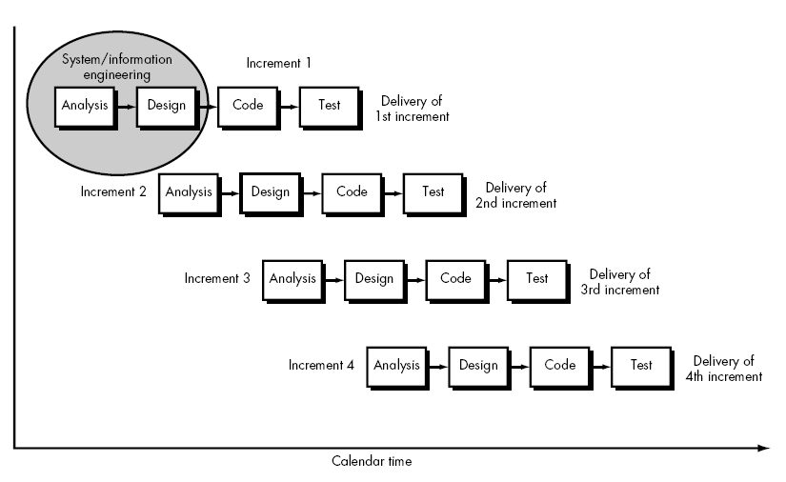

Figure 3.1: The Incremental Model

**3.1.2 Benefits of Incremental Model**

* This model is very flexible.
* Quickly generates software.
* Less costly to change scope and requirements.
* Can be changed the requirements.
* Easier to test and debug during a smaller iteration.
* Customers can respond easily.
* The initial delivery cost is low.
* This model is effective to manage risk.
  + 1. **Selecting the Incremental Approach**

It is necessary to determine whether the system to be built is suitable for incremental or not. This is decided depending on the application area, complexity, and projects characteristics. We choose it for the following reasons:

* Clearly define all the requirements of the system.
* An incremental model improves the quality of software day by day.
* Most of the requirements must be clearly defined.
* There is a requirement to get a product to the market early.
* A recent technology is being used.
* Resources with the needed skill sets are not available.

**3.2 Software Development Tools**

To maintain, control, create, debug, or otherwise support other programs software developers use a computer program called a software development tool. The term usually refers to the very simple programs, that can be combined to complete a task. One hallmark of a skilled software engineer is having the ability to use a variety of tools productively.

A source code editor and a compiler are the basic tools that are used ubiquitously and continuously. Tools may be discrete programs, executed separately, or maybe parts of a single large program called an integrated development environment (IDE).

Therefore, to develop this system the required tools will be hardware, software, programming language.

**3.2.1 Hardware Support**

* Processor –Core-i3 or i5
* Hard Disk – Minimum 5 GB Space
* Memory – Minimum 1GB RAM

**3.2.2 Software Support**

* Web server - Apache
* Database - MYSQL
* Notepad++/Atom/Visual Studio Code
* Google Chrome/Mozilla Firefox

**3.2.3 Programming Language**

As our system is on the web platform, we used PHP language to develop our system’s back-end. We also use MYSQL as a database. For developing the front-end, we used HTML, CSS, Bootstrap Framework, and JavaScript.

**Chapter-4**

**Design of Software and Implementation process**

Software design is the process by which an [agent](https://en.wikipedia.org/wiki/Agency_(philosophy)) creates a specification of a [software artifact](https://en.wikipedia.org/wiki/Artifact_(software_development)), intended to accomplish [goals](https://en.wikipedia.org/wiki/Goal), using a set of primitive components and subject to [constraints](https://en.wikipedia.org/wiki/Constraint_(mathematics)) [[7]](https://en.wikipedia.org/wiki/Software_design#cite_note-1). Software design refers to either "all the activity of implementing, framing, conceptualizing, commissioning, and modifyingcomplex systems" or "the activity following [requirements](https://en.wikipedia.org/wiki/Software_requirements) specification and before [programming](https://en.wikipedia.org/wiki/Computer_programming)".

**4.1 Architectural Design**

Architectural design talks about how a system should be organized and designing the overall structure of the system . Architectural design is the first stage in the model the software design process. It is the critical link between requirements engineering and software design, it identifies the main structural components in a system and the relationships between them. The output of the architectural design process describes how the system is organized as a set of communicating components. Architectural decomposition is usually necessary to structure and organize the specification.

In practice, conceptual views are almost always developed during the design process and are used to support architectural decision-making. They are a way of communicating the essence of a system to different stakeholders. During the design process, some of the other views may also be developed when different aspects of the system are discussed, but there is no need for a complete description from all perspectives.

**4.1.1 Architectural data flow of a system**

**View Notice**

**Notice**

**Admin**

**Add Notice**

**Student Dashboard**

**Add Teacher**

**Delete Teacher**

**Add Staff**

**Teacher and Staff**

**Delete Staff**

**Add Governing-Body**

**Delete Governing-Body**

**Dashboard**

**Add Slide**

**View Slide**

**Slides**

**Delete Slide**

**View Registered Students and Teachers**

**User Login Panel**

**System**

**User**

Figure 4.1: Architectural Diagram

To implement the system, we need to use here UML diagram which has become a standard modeling language for object-oriented modeling. When developing system models, it can often be flexible in the way that the graphical notation is used. It does not always need to stick rigidly to the details of a notation. The detail and rigor of a model depend on how we intend to use it.

**4.2 Development of the System**

To achieve deliverable of acceptance and meeting of objectives, the new system being built must be tested. The construction phase does two things: builds and tests a functional system that fulfills business or organizational design requirements and implements the interface between the new system and the existing production system. The project team must construct the database, application programs, user and system interfaces, and networks. Developing a system includes programs and structured databases.

The stages of development of our system are described below:-

**4.2.1 User Interface**

The user interface is the communication between a user and the system. In our proposed system, there are two types of users: admin and user.

**4.2.1.1: Home page**

**a) Header Section**

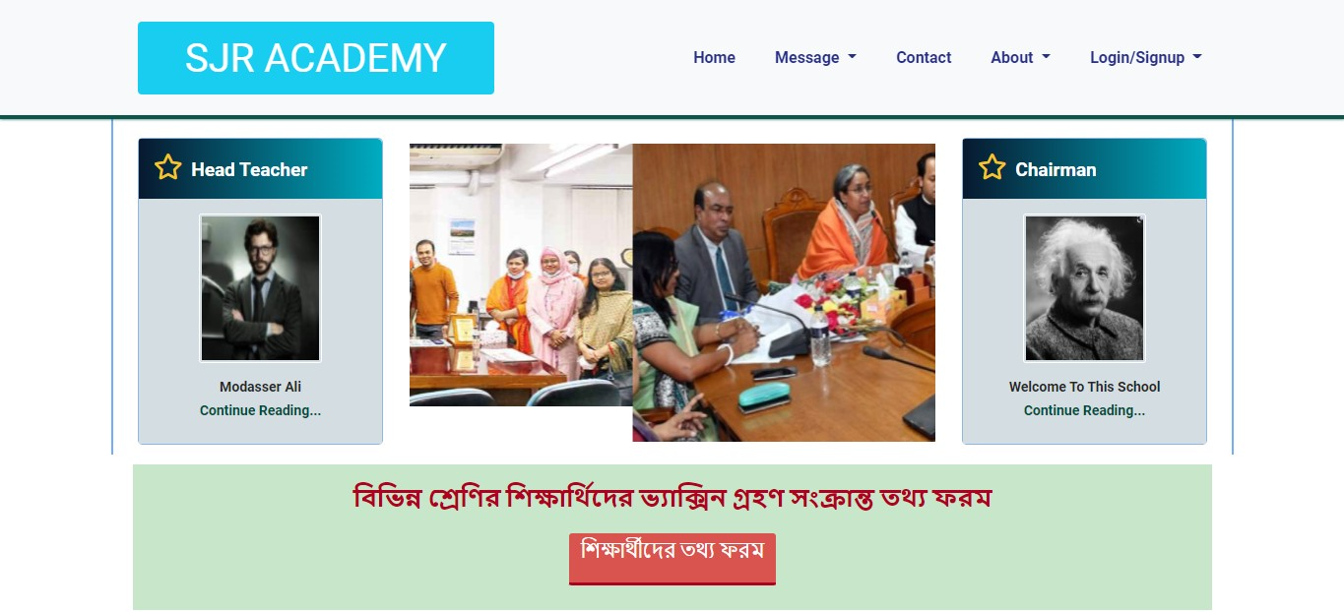

**b) Middle Section**

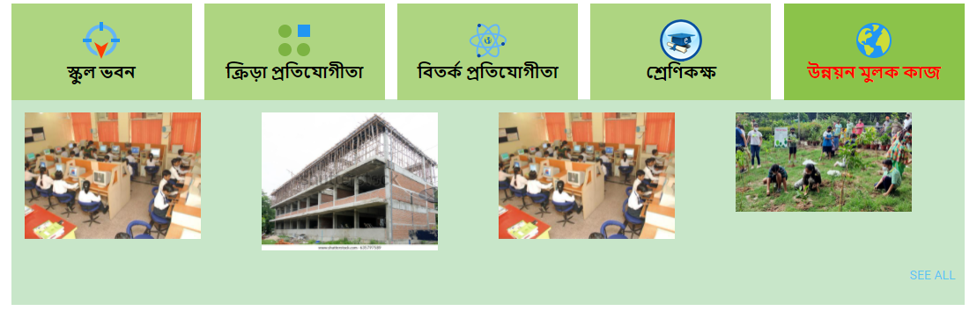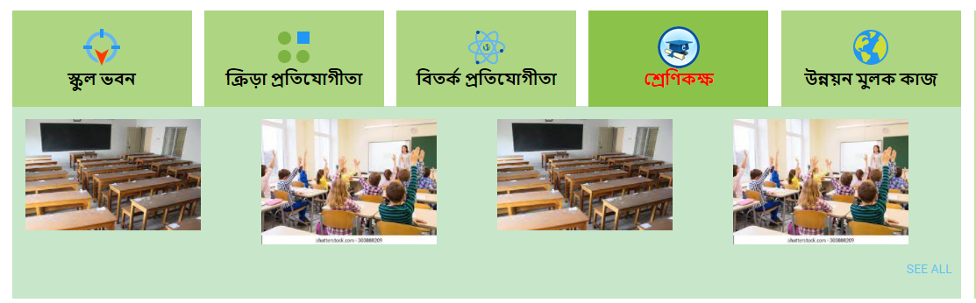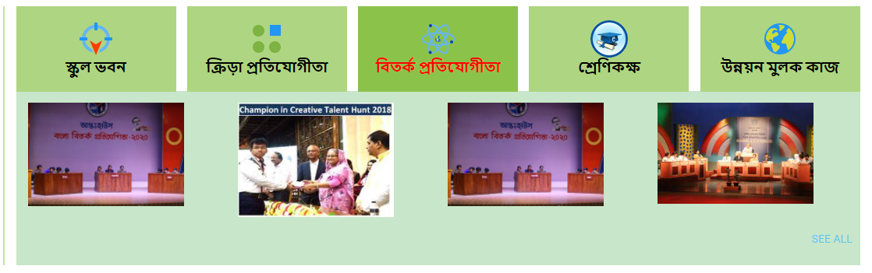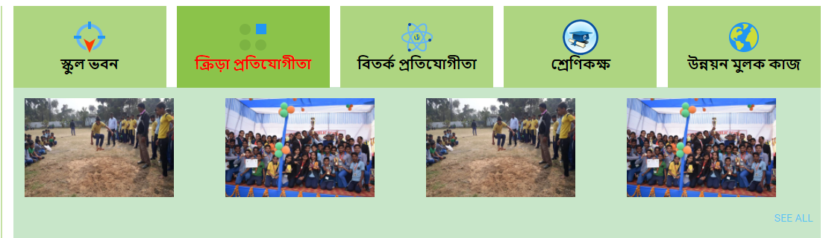 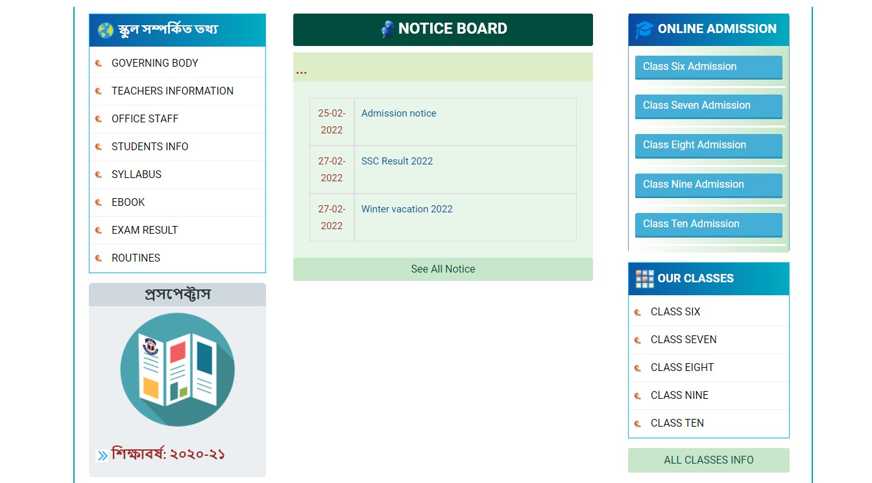

17

**Figure: Home page,Section3**

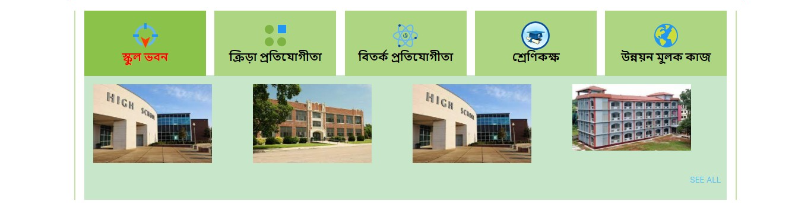

**b.1:**

**b.2:**



**b.3:**



**b.4:**



**b.5:**



**4.2.1.2: Contact Page:**

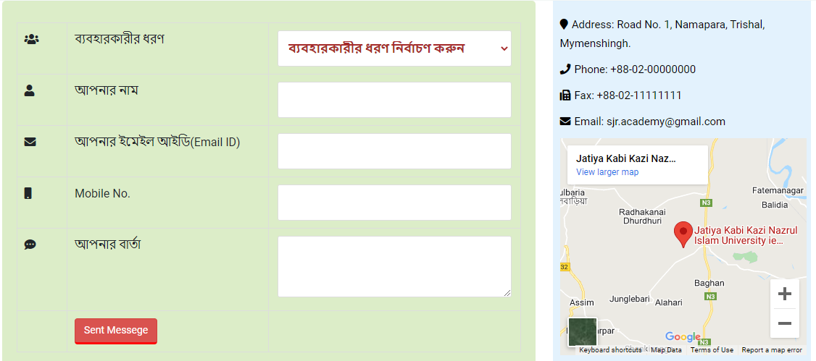

**4.2.1.4: Headmaster’s Message Page:**

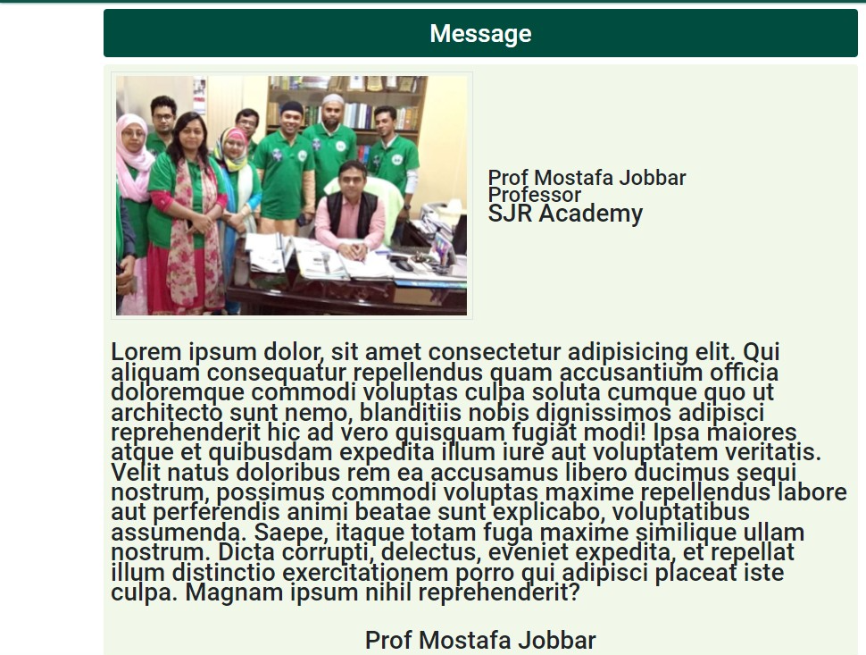

**4.2.1.3: Admin View**

**a) Notice**

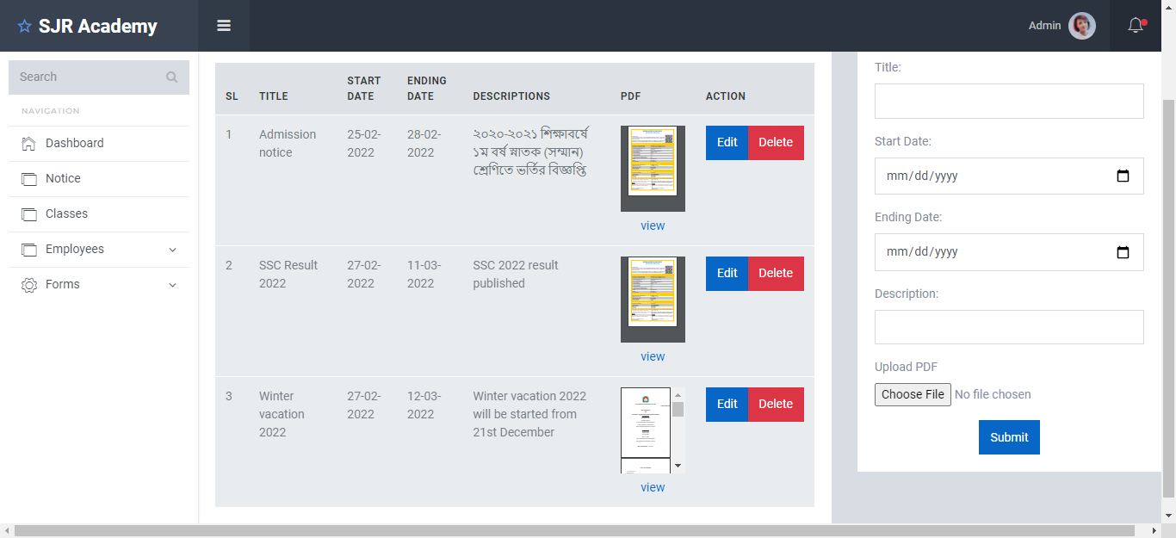

**b) Add Employee**

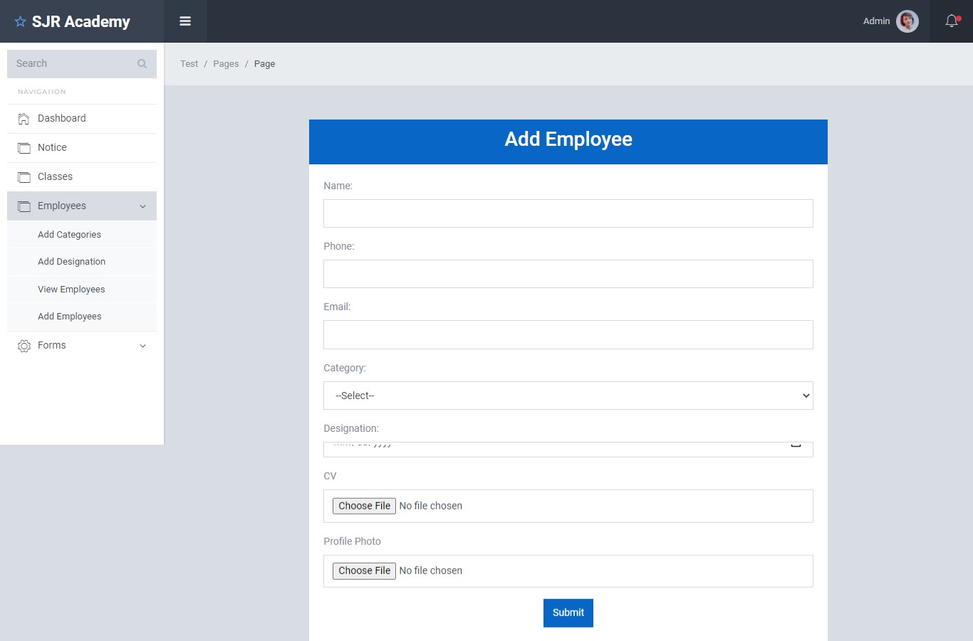

**c) Add Designation**

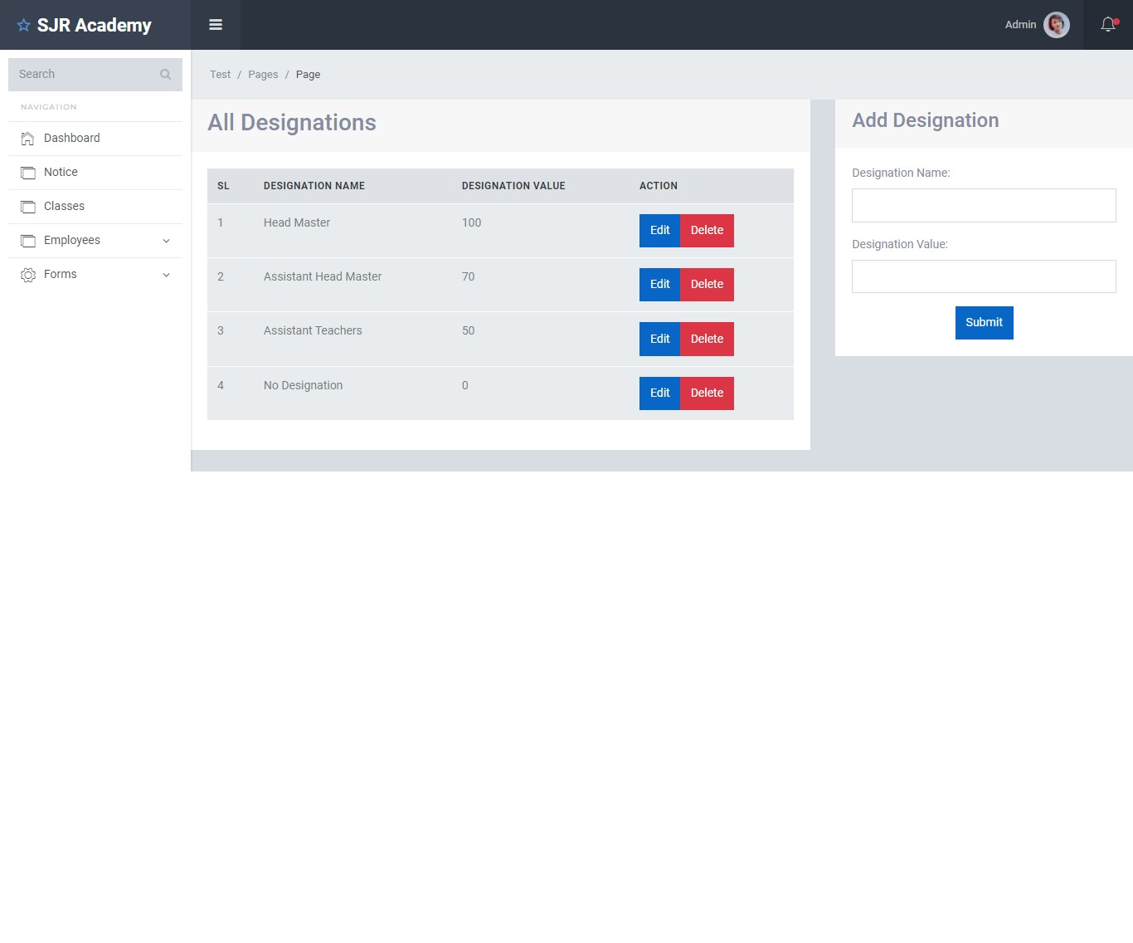

**Chapter-5**

**Software Testing**

Testing is intended to show that a program does what it is intended to do and to discover program errors before it is put into use. When we test our system, we execute a program using artificial data. We check the results of the test run for errors, anomalies, or information about the program’s non-functional attributes. The testing process has two distinct goals:

* To demonstrate to the developer and the customer that the software meets its requirements.
* To discover situations in which the behavior of the software is incorrect, undesirable, or does not conform to its specification.

**5.1 Test Plan**

A software test plan is a document describing the testing scope and activities. It is the basis for formally testing any software/product in a project [9]. It is a document that provides a central artifact to govern the planning and control of the test effort.

**5.1.1 Test Plan Types**

* **Master Test Plan:** A single high-level test plan for a project that unifies all other test plans.
* **Testing Level Specific Test Plans:** Plans for each level of testing unit testing, sub-system testing, system testing, module testing, etc.

**5.2 Types of Testing**

Here we just mentioned that the types of testing that we use in the project.

* **Unit Testing**

In unit testing, individual program units or object classes are tested. Hereby using this testing we have focused on testing the functionality of methods of **“A School Website”** system.

* **Module Testing**

The combination of the unit program is called a module. Here we tested the modules program have dependency such as all information are stored in the database and admin can find all information by their records.

* **Subsystem Testing**

Then we combined some modules such as admin modules, user modules for the preliminary system testing in this project.

* **System Testing**

It is the combination of two or more sub-systems and then it is tested. Here we tested the entire system as per the requirements.

* **Acceptance Testing**

Normally this type of testing is done to verify if the system meets the customer specified requirements. After submitting the project to the user then they tested it and determine whether to accept an application.

**Chapter-6**

**Conclusion**

In this report, we have discussed the development process of **“A School Website”**. After finishing the work, it could be said that our developed system is an efficient and easy system to organize and maintain a school website. We have implemented a complete system. However, we find some limitations which we will recover in near future.

**6.1 Limitations of the System**

**6.2 Future development of the System**

The system has all the functionalities expected. Some important features that we want to add in further development of our project, are pointed below:

* Interactive home page.
* User password recovery system.
* Enhancement of security.
* User interface.
* Online Payment system.

**References**

1. <https://www.w3schools.com/>
2. <https://www.tutorialspoint.com/index.htm>
3. <https://www.khanacademy.org/>
4. <https://en.wikipedia.org/wiki/Web_development>
5. <https://www.youtube.com/>
6. <https://www.javatpoint.com/>
7. https://jkkniu.edu.bd/