SkyQuest Airways: Crisis Sentiment Analytics and Reputation Recovery
MIS5308 Social and Web Analytics – Assessment 1, Week 5 PBL | Student name: [Your name] | Student ID: [Your ID]

Strategic brief for the CEO
Situation. Holiday-peak cancellations (2–6 January 2025) triggered a backlash on Twitter/X, Facebook and TripAdvisor: net aspect sentiment is −0.32, and 56% of posts are negative.
Data strategy. API-first collection from X, Facebook, TripAdvisor and news RSS. Posts are filtered by a multilingual taxonomy across a before, during and after window, split by market, and analysed at three levels: overall, by aspect and over time. A Data Protection Impact Assessment (DPIA) governs the pipeline.
Findings.
- The problem is communication, not the cancellation itself. Communication is the most negative (−0.85) and most frequent aspect (5 of 18 mentions): "no warning", "nobody told us".
- The recovery journey is failing too. Support (−0.76), baggage (−0.56) and refunds (−0.33) are negative.
- Staff are the strongest asset. Crew and staff are the only positive aspect (+0.56), praised on all three platforms.
- Sentiment is turning. The daily mean rose from −0.82 to +0.31 as refunds arrived. Twitter/X (−0.44) and domestic customers (−0.37) are the most negative.
Table 1. Three actions for the next 30 days
Action | Evidence | 30-day plan | KPI
1. Proactive disruption alerts | Communication −0.85 on all platforms | Weeks 1–2: SMS, email and app alerts sent automatically within 30 minutes of a cancellation. Weeks 3–4: live status page | Communication sentiment above −0.30
2. Fix refunds and baggage | Refunds −0.33, baggage −0.56, site crashes | Week 1: refund surge team. Week 2: refund tracker and extra website capacity. Weeks 3–4: baggage-status updates | Refunds paid within 7 days
3. Staff-led apology and goodwill | Crew the only positive aspect | Week 1: CEO apology crediting staff (a rebuild strategy; Coombs, 2007). Weeks 2–4: staff goodwill vouchers; reply to every TripAdvisor review | Net sentiment above 0

1. Data collection architecture
Table 2. Collection plan (pipeline in Appendix A, Figure A1; full platform detail in Table A1)
Platform | Access | Constraint and compliance
Twitter/X (social) | API v2 filtered stream | Paid tier, OAuth 2.0, monthly caps; the Developer Agreement bans scraping
Facebook (social) | Graph API, SkyQuest Page | Page token, app review, hourly limits; public comments only
TripAdvisor (reviews) | Content API and Management Center export | The ToS prohibits scraping, so no HTML scraping
News and blogs | RSS; HTML scraping only where robots.txt allows | 1 request per second; headlines and metadata only

Taxonomy, time window and location.
- Taxonomy: the provided taxonomy caught only 78% of posts, missing "waiting… support not responding" (post 102) and "unexpected delays" (post 109). The expanded version (Table A2) adds delay, support and website categories, misspellings ("canceled", "lugage"), hashtags (#SkyQuestFail) and eight languages, for example 欠航 (Japanese) and 航班取消 (Chinese).
- Time window: a T−14-day baseline, the incident, and a T+30-day recovery period, so shifts can be measured against normal sentiment.
- Location: geotag, then profile location, then language, separating domestic (Australia) from international customers.
- Preprocessing: normalisation, language detection and translation, MinHash de-duplication, bot and spam filtering, and masking of personal information.

2. Multi-stage sentiment analysis
Table 3. Model comparison (full detail in Table B1)
 | VADER + airline lexicon (Hutto & Gilbert, 2014) | Attention BiLSTM (Wang et al., 2016) | Transformer, e.g., BERT or DeBERTa (Devlin et al., 2019; Sun et al., 2019)
Accuracy | Run here: r = 0.84, 78% agreement (generic lexicon 0.67, 56%) | Good once trained; weaker on context | Best on the SemEval aspect-sentiment benchmarks (Pontiki et al., 2014); handles "helpful but delayed"
Interpretability | High | Medium (attention) | Low (needs SHAP)
Cost | Negligible | Moderate | High (GPU); multilingual
Role | Transparent cross-check | Not selected | Selected for production

Model choice. The generic lexicon scored "cancelled my flight without warning" as positive, because generic dictionaries do not treat airline terms as negative. Adding domain terms raised agreement from 56% to 78%. That lexicon was tuned on the same nine posts, however, so a multilingual transformer, validated on held-out labelled data, is the production choice.
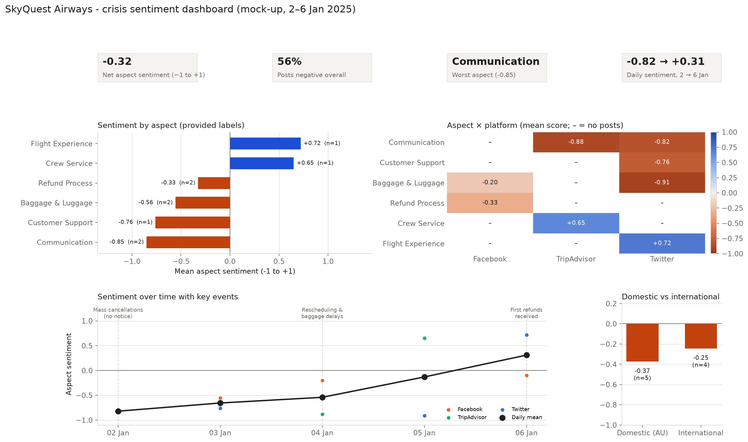
Figure 1. Crisis dashboard mock-up showing sentiment by aspect, platform, time and market (full-size charts in Appendix B).
Aspect insights.
- Most negative: communication (−0.85), support (−0.76), baggage (−0.56, after merging two inconsistent luggage labels) and refunds (−0.33).
- Positive: crew and staff, and the flight experience.
- What single labels miss: clause-level extraction found 18 aspect mentions in 9 posts, against 9 single labels. It recovered praise for crew hidden in a baggage complaint (post 104), a delay complaint inside a positive landing review (post 109), and a website failure (post 103) (Figure B1).
Changes over time. Sentiment improved every day, from −0.82 after the unannounced cancellations to +0.31 once refunds landed. With one or two posts per day, this is a directional signal rather than a confirmed trend.

3. Ethical-legal risk governance
Table 4. Legal and ethical risks (full detail in Appendix C)
Risk | Mitigation
Legal 1. Privacy: over-collecting handles and geotags breaches Australian Privacy Principles 3 and 11 (Privacy Act 1988 (Cth); OAIC, 2022) and GDPR data minimisation (European Parliament and Council of the European Union, 2016) | DPIA; collect only aspect-relevant fields; pseudonymise handles; delete raw data after 90 days
Legal 2. Platform terms: scraping TripAdvisor or exceeding X API limits risks contract breach, bans and copyright claims | API-first design; ToS register; rate-limit monitoring
Ethical 1. Language bias: English-trained models mis-score translated posts, slang and sarcasm (the generic lexicon misread 3 of 9 English posts) | Accuracy tested per language; human review of low-confidence scores; quarterly bias audit
Ethical 2. Unfair prioritisation: fast-tracking loud or high-follower complainants, or singling out individuals | Compensation handled strictly in booking order; aggregated reporting only

Table 5. Ethical compliance checklist
Area | Check before release | ✓
Legal alignment | DPIA signed off; ToS register current; data kept 90 days or less; lawful basis recorded for each region | ☐
Bias mitigation | Accuracy tested by language, platform and market; bot filter validated; low-confidence scores reviewed | ☐
Responsible communication | Sample size shown on every chart; no individual identifiable; findings framed as signals, not verdicts | ☐

References
Coombs, W. T. (2007). Protecting organization reputations during a crisis: The development and application of situational crisis communication theory. Corporate Reputation Review, 10(3), 163–176. https://doi.org/10.1057/palgrave.crr.1550049
Devlin, J., Chang, M.-W., Lee, K., & Toutanova, K. (2019). BERT: Pre-training of deep bidirectional transformers for language understanding. In Proceedings of the 2019 Conference of the North American Chapter of the Association for Computational Linguistics (pp. 4171–4186). https://doi.org/10.18653/v1/N19-1423
European Parliament and Council of the European Union. (2016). Regulation (EU) 2016/679 (General Data Protection Regulation). https://eur-lex.europa.eu/eli/reg/2016/679/oj
Hutto, C. J., & Gilbert, E. (2014). VADER: A parsimonious rule-based model for sentiment analysis of social media text. In Proceedings of the International AAAI Conference on Web and Social Media, 8(1), 216–225. https://doi.org/10.1609/icwsm.v8i1.14550
Office of the Australian Information Commissioner. (2022). Australian Privacy Principles guidelines. https://www.oaic.gov.au/privacy/australian-privacy-principles/australian-privacy-principles-guidelines
Pontiki, M., Galanis, D., Pavlopoulos, J., Papageorgiou, H., Androutsopoulos, I., & Manandhar, S. (2014). SemEval-2014 Task 4: Aspect based sentiment analysis. In Proceedings of the 8th International Workshop on Semantic Evaluation (pp. 27–35). https://doi.org/10.3115/v1/S14-2004
Privacy Act 1988 (Cth). https://www.legislation.gov.au/C2004A03712/latest
Sun, C., Huang, L., & Qiu, X. (2019). Utilizing BERT for aspect-based sentiment analysis via constructing auxiliary sentence. In Proceedings of the 2019 Conference of the North American Chapter of the Association for Computational Linguistics (pp. 380–385). https://doi.org/10.18653/v1/N19-1035
Wang, Y., Huang, M., Zhu, X., & Zhao, L. (2016). Attention-based LSTM for aspect-level sentiment classification. In Proceedings of the 2016 Conference on Empirical Methods in Natural Language Processing (pp. 606–615). https://doi.org/10.18653/v1/D16-1058

Appendix A. Data collection detail
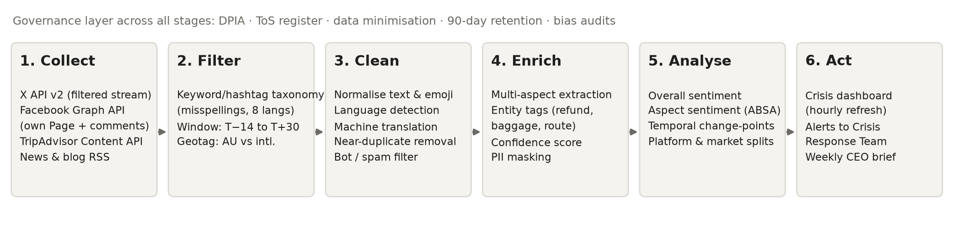
Figure A1. End-to-end analytics pipeline, with a governance layer applied at every stage.
Table A1. Detailed collection plan by platform
Platform | Method | Rate limits, authentication and terms of service (ToS) | Why this platform
Twitter/X | API: v2 filtered stream and recent search | Paid access tier with OAuth 2.0 bearer token; post volume capped per month; the Developer Agreement bans scraping | Real-time venting; earliest signal of each spike
Facebook | API: Graph API for the SkyQuest Page | Page token, app review required, hourly rate limits; public comments on the company's own Page only | Longer complaints; refund threads
TripAdvisor | API: Content API, with reviews exported from the company's own Management Center | Approved API key; HTML scraping is prohibited by the ToS, so it is not used | Considered reviews; lasting reputational damage
News and travel blogs | RSS feeds, plus HTML scraping only where robots.txt allows | Polite crawling at 1 request per second; headlines and metadata only, no full-text copies | Media amplification of the story

Time window and location. Collection covers three periods:
- a baseline of T−14 days (19 December 2024 onwards)
- the incident itself (2–6 January 2025)
- recovery, up to T+30 days (5 February 2025)
This window allows change-point detection against normal sentiment. Location comes from geotags where available, then from the profile location, then from the language. Posts are classed as domestic (Australia) or international.
Preprocessing. Each post is normalised (URLs, emoji and case), then:
- its language is detected and it is machine-translated
- near-duplicates are removed (MinHash)
- bots and spam are filtered out by account age, posting rate and duplicate text
- personal information is masked
Table A2. Expanded keyword and hashtag taxonomy (additions to the provided taxonomy are in italics)
Category | English terms and variants | Misspellings and hashtags | Multilingual equivalents
Cancellations | cancelled, rescheduled, no update, no warning | canceled, cancelation, cancled, #SkyQuestFail, #SkyQuestCancelled | 欠航 / キャンセル (ja), 航班取消 (zh), 결항 (ko), penerbangan dibatalkan (id/ms), ยกเลิกเที่ยวบิน (th), إلغاء الرحلة (ar)
Delays | delay, delayed, waiting, stuck, hours at gate | dealyed, #SkyQuestDelay | 遅延 (ja), 延误 (zh), 지연 (ko), tertunda (id)
Refunds | refund, compensation, money back | refun, refnd, #SkyQuestRefund | 払い戻し (ja), 退款 (zh), 환불 (ko), pengembalian dana (id), استرداد (ar)
Communication | no email, no message, poor communication | no notif, noone told us | 連絡なし (ja), 没有通知 (zh)
Customer support | support, call centre, on hold, not responding, chatbot | call center, custmer service | 客服 (zh), 고객센터 (ko)
Website and app | website, app, crashed, error, can't log in | webiste, #SkyQuestApp | 网站崩溃 (zh)
Luggage | lost luggage, baggage delayed, missing bag | lugage, bagage, #lostbag | 手荷物 (ja), 行李丢失 (zh), 수하물 (ko)
Positive | great staff, helpful, good service, excellent | grate staff, #ThankYouCrew | 親切 (ja), 服务好 (zh), 친절 (ko)

Table A3. Data quality of the provided sample
Check | Result | Implication
Posts, platforms, days | 9 posts, 3 platforms, 5 days | Too small for statistical inference; findings are directional only
Bot-flagged posts | 0 | The bot filter has not been tested on real bot traffic
Non-English posts | 0 | Multilingual pipeline untested; a test set per language is needed
Duplicate clean text | 0 | —
Coverage of the provided taxonomy | 78% (misses posts 102 and 109) | Expanded taxonomy in Table A2
Inconsistent aspect labels | "Luggage" and "Baggage Handling" are used for the same theme | Merged into "Baggage & Luggage"; a controlled vocabulary is needed

Appendix B. Sentiment analysis detail
Table B1. Model comparison: full detail
Criterion | VADER + airline lexicon (Hutto & Gilbert, 2014), run as a baseline | Attention-based BiLSTM for aspect sentiment (Wang et al., 2016) | Transformer for aspect sentiment, e.g., BERT or DeBERTa (Devlin et al., 2019; Sun et al., 2019) – selected
Accuracy | r = 0.84 and 78% label agreement with the reference scores after domain tuning; the generic lexicon only reaches r = 0.67 and 56% | Good once trained on labelled airline data; weaker on long-range context | Best results on the SemEval aspect-sentiment benchmarks (Pontiki et al., 2014); handles negation and contrast ("helpful but delayed")
Interpretability | High: every word's contribution is visible | Medium: attention weights | Lower: needs SHAP or attention explanations
Computational cost | Negligible | Moderate (GPU training) | High (GPU training and inference); multilingual versions available

Table B2. Aspect sentiment from the provided labels, with clause-level extraction for comparison
Aspect | Provided labels: mean (n) | Clause-level: mean (n) | Platforms
Communication | −0.85 (2) | −0.34 (5) | Twitter/X, TripAdvisor
Customer support | −0.76 (1) | −0.22 (1) | Twitter/X
Baggage and luggage | −0.56 (2) | −0.39 (2) | Twitter/X, Facebook
Refund process | −0.33 (2) | −0.19 (2) | Facebook
Cancellations and delays | not labelled | −0.32 (4) | Twitter/X, TripAdvisor
Website and digital | not labelled | −0.46 (1) | Facebook
Crew, staff and flight experience | +0.65 and +0.72 (1 each) | +0.56 (3) | All three platforms

Clause-level scores come from the domain-tuned VADER model, which gives smaller magnitudes than the reference scores, so compare the ranking of aspects across the two columns rather than the raw values.
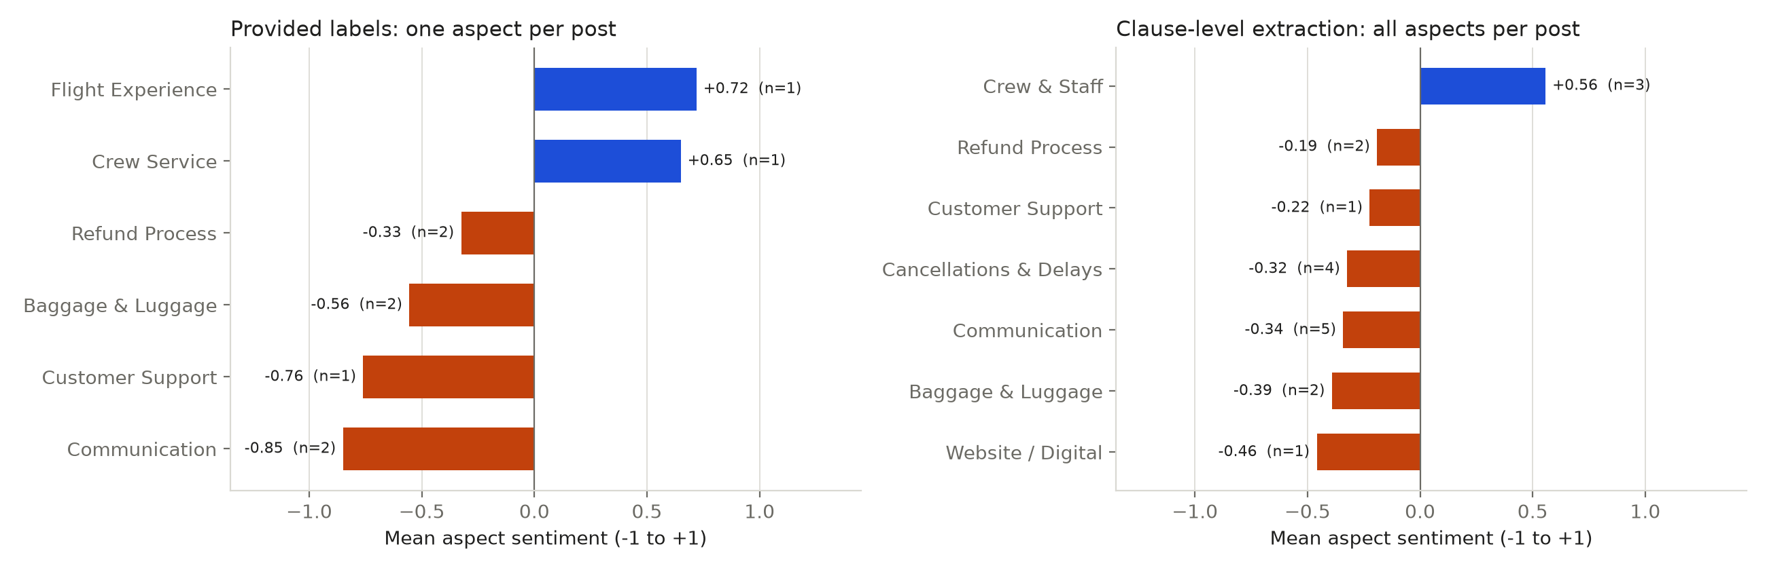
Figure B1. Provided single-aspect labels compared with clause-level multi-aspect extraction.
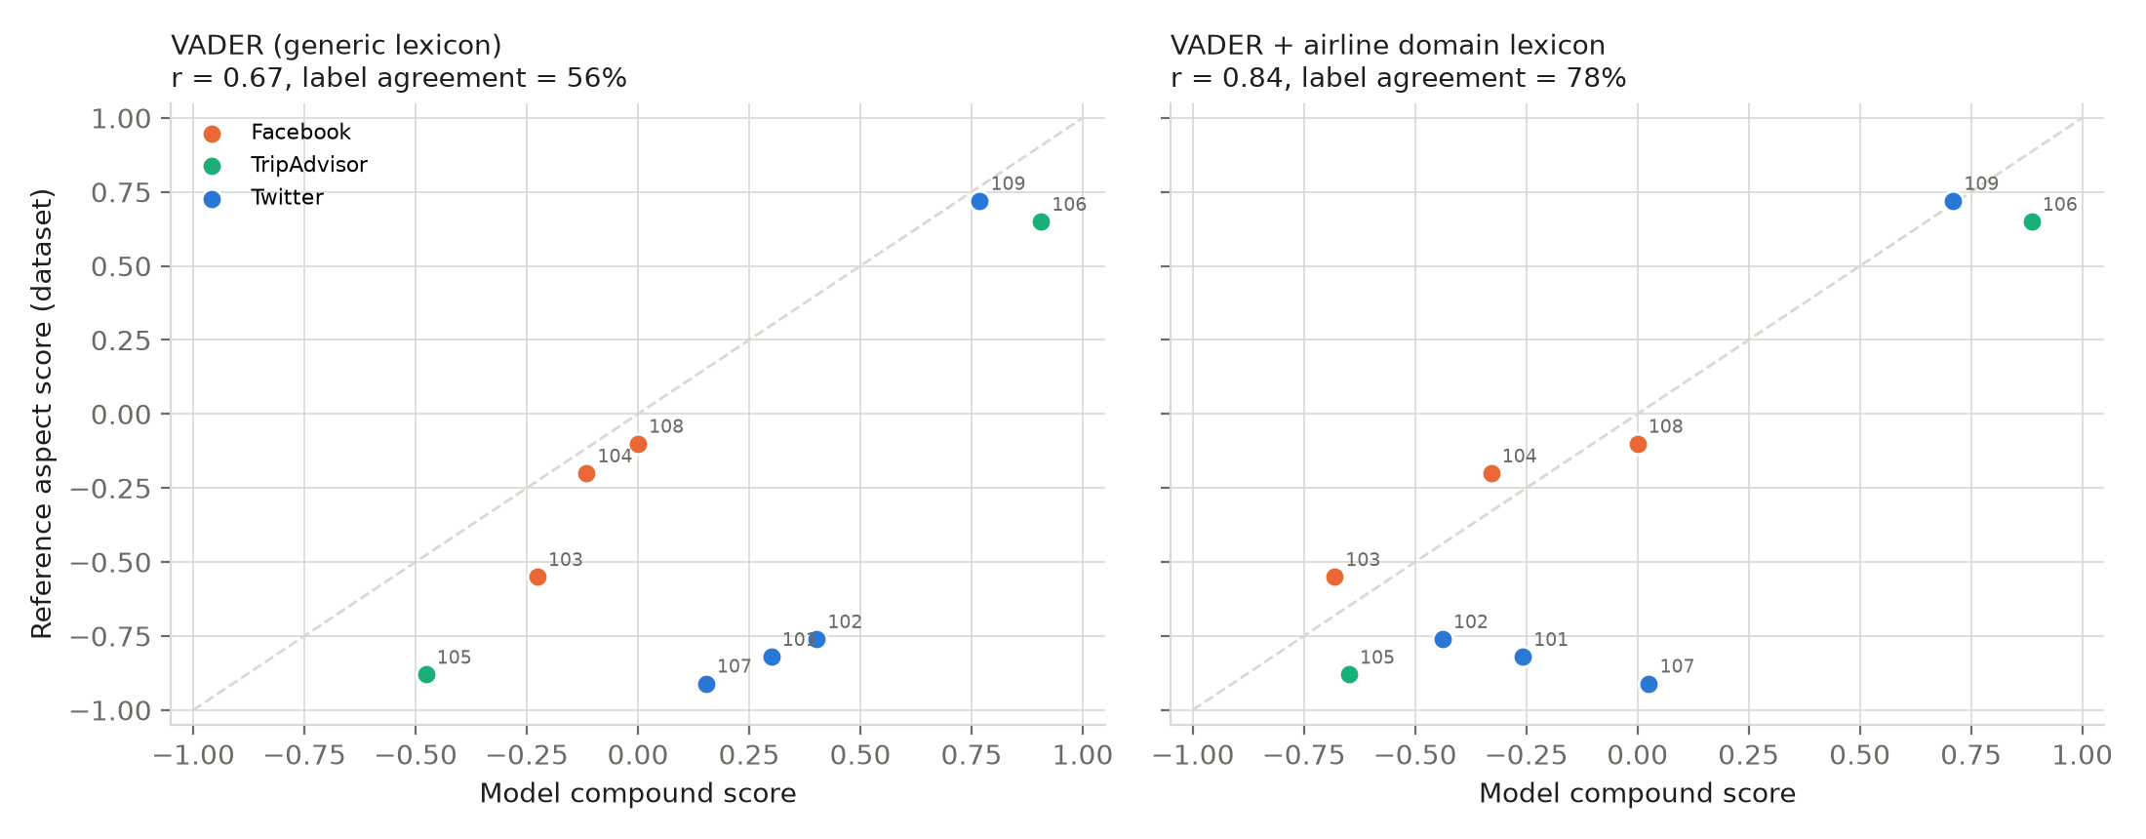
Figure B2. Agreement between model scores and the reference aspect scores; the dashed line marks perfect agreement.
Table B3. Model evaluation against the reference scores (n = 9)
Model | Pearson r | Spearman ρ | Label agreement | Mean absolute error
VADER, generic lexicon | 0.67 | 0.47 | 56% | 0.51
VADER + airline domain lexicon | 0.84 | 0.47 | 78% | 0.30

Domain terms added to the lexicon: cancelled (−2.0), rescheduled (−1.2), delayed and delays (−1.5), crashing (−2.0), lost (−1.8), waiting (−1.0), confusing (−1.6) and chaos (−1.5). "Support" was neutralised because it is a noun here, and "responding" was made positive so that "not responding" flips to negative. The lexicon was tuned on these same nine posts, so these scores are optimistic.
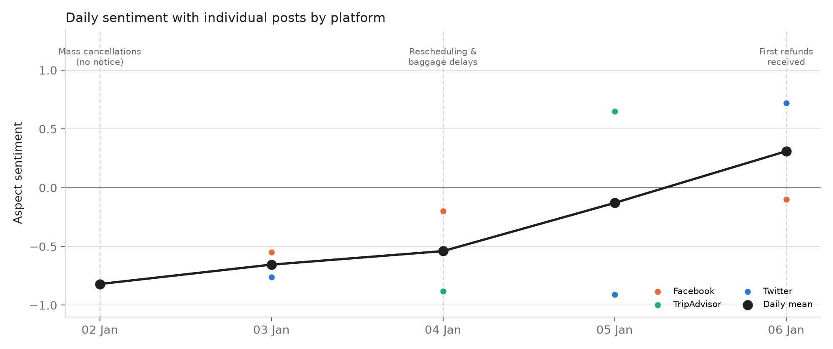
Figure B3. Daily mean sentiment, with individual posts coloured by platform and key events marked.
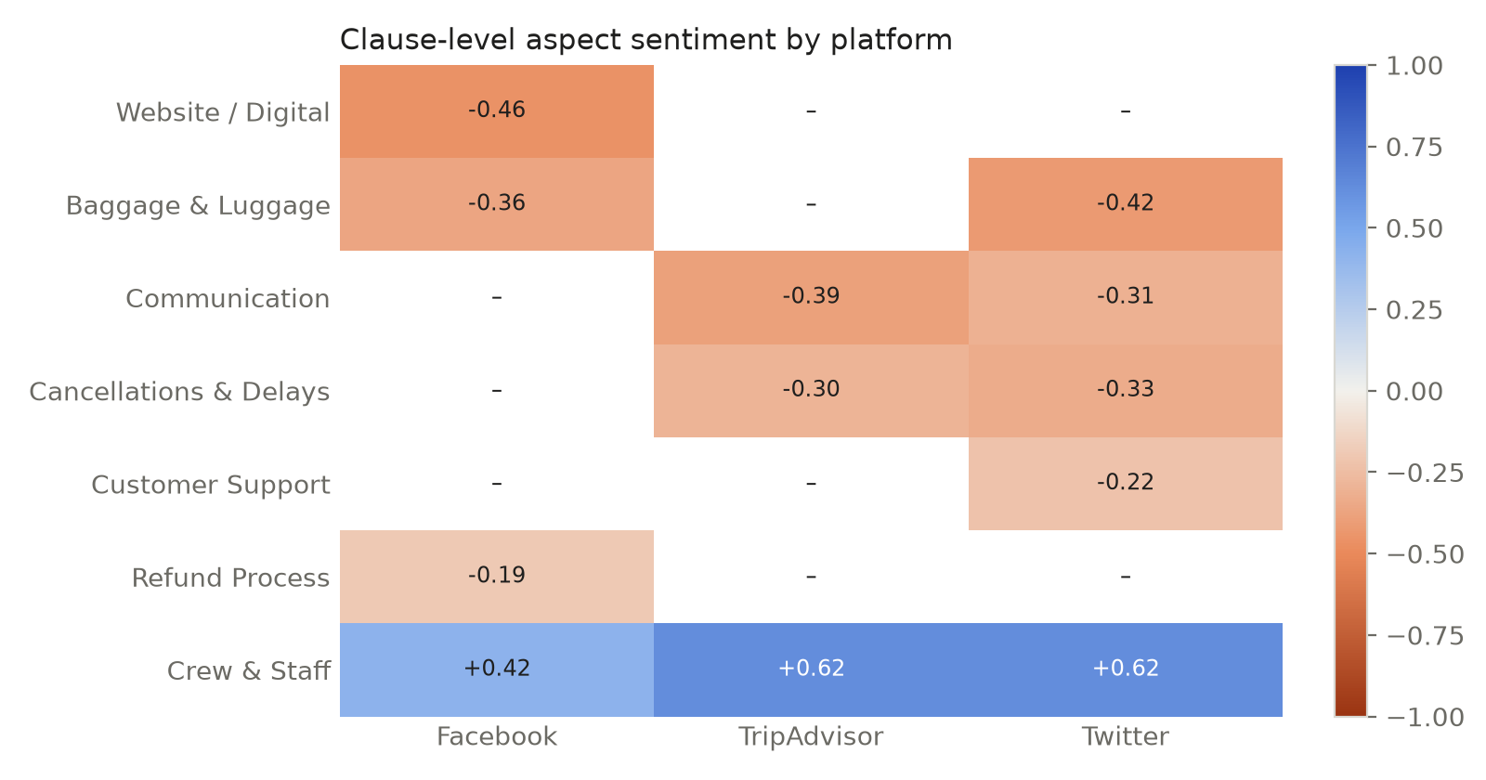
Figure B4. Clause-level aspect sentiment by platform.
Table B4. Sentiment by platform and market
Segment | Mean aspect sentiment | Posts
Twitter/X | −0.44 | 4
Facebook | −0.28 | 3
TripAdvisor | −0.12 | 2
Domestic (Australia) | −0.37 | 5
International | −0.25 | 4

Appendix C. Ethical-legal risk detail
Table C1. Legal and ethical risks: full detail
Type | Risk | Mitigation
Legal 1 | Privacy breach: collecting names, handles and geotags beyond what is necessary breaches Australian Privacy Principles 3 and 11 (Privacy Act 1988 (Cth); OAIC, 2022), GDPR data minimisation (Art. 5(1)(c); European Parliament and Council of the European Union, 2016) for EU travellers, and Singapore's PDPA and New Zealand's Privacy Act 2020 | DPIA before launch; keep only aspect-relevant fields; pseudonymise handles; mask personal information; delete raw data after 90 days; region-specific legal review
Legal 2 | Breaching platform terms: scraping TripAdvisor or exceeding X API limits breaches contracts and copyright, risking account bans and litigation | API-first design; a register of each platform's ToS; rate-limit monitoring; no storage of full review text beyond analysis
Ethical 1 | Language and dialect bias: English-trained models mis-score translated Japanese, Arabic or Bahasa posts, and Australian slang or sarcasm | Test accuracy separately for each language; human review of low-confidence scores; quarterly bias audit; report confidence bands
Ethical 2 | Unfair prioritisation and public shaming: fast-tracking refunds for loud or high-follower complainants, or singling out individuals in responses | Handle compensation strictly in booking order; never name users in reports; show aggregated insights only

