BC400 Communication and Media Management

Assessment 1A Toolkit: Meat & Livestock Australia (MLA) Communication Audit
Evidence pack, theory toolkit, stakeholder and channel frameworks, and a section-by-section writing guide. These are planning notes, not report text.

How to use this pack
Everything here is research notes, frameworks and prompts. Write every sentence of your report in your own words. The brief bans submitting AI-generated text, and the Assessment 1B quiz tests your own understanding of the audit.
Open and check every source before you cite it. The brief warns against unverified AI-generated information. Items marked [check] need extra verification.
Declare AI use as Moodle instructs. A possible wording to adapt: "I used Claude (Anthropic) to help plan the report structure, locate sources and organise evidence. All analysis, writing and source checking are my own."

Correction to the earlier plan
The 2024–25 cattle transaction levy review, including the consultation meetings some producers said were poorly promoted, is run by Cattle Australia (the grass-fed cattle peak council), not MLA. Use this evidence to show what levy payers want from MLA (more transparency about levy spending). Do not present it as MLA’s own communication failure.

1. Suggested audit scope
Element | Suggested framing (adapt in your words)
Organisation | MLA: a producer-owned, not-for-profit company delivering research, development and marketing for Australia’s red meat industry. It is funded mainly by livestock transaction levies plus federal government R&D co-funding (E1, E2).
Audit focus | External communication with levy-paying producers (main focus), plus brief coverage of government and peak councils, consumers, and internal communication.
Method | Desk-based "outside-in" audit of public materials: website, publications, campaigns, annual reports and industry media.
Limitation | No access to internal channels or staff. Internal analysis is therefore limited and inferred. State this openly, because markers reward honesty about scope.

2. Evidence bank
Facts gathered from public sources. Cite the original source, not this pack. "Use in" shows the report section each fact supports.
# | Evidence | Source | Use in
E1 | MLA’s 2024–25 operating budget is just under $300m across 16 program areas. Funding includes government R&D co-funding $93.7m, grass-fed cattle levies $55.6m, grain-fed cattle levies $15.8m, sheep levies $39m, AMPC $26.5m and external (mostly research) $67.6m. | Beef Central (2024) | Intro; Stakeholders (government and processor influence)
E2 | 2023–24 total income $283.1m; levy income $108.8m, up 11.4%. | MLA Annual Report 2023–24; Farm Weekly | Intro
E3 | MLA membership is voluntary and free for levy-paying producers, but producers must apply to become members to vote at the AGM. | Australian Government Directory; The Land | Stakeholders; Evaluation
E4 | Senate evidence: only about one-third of levy payers were MLA members; many small producers did not apply because they felt they had no voice. [check: 2014 evidence; look for a newer figure] | Senate RRAT References Committee (2014), ch. 4 | Stakeholders (salience); Barriers
E5 | Voting entitlements rely on producers self-declaring the levies they paid, because levies are collected in bulk by intermediaries. | Senate (2014); Beef Central | Evaluation (trust, accountability)
E6 | Feedback magazine is distributed to about 50,000 producers and stakeholders and reports where levy dollars are spent on marketing and R&D. | MLA, Feedback magazine page | Channels
E7 | E-newsletters Friday Feedback and Prices & Markets each have about 30,000 subscribers. | MLA | Channels
E8 | myMLA: a customisable online dashboard giving access to NLIS, eNVDs and LPA, and letting producers set their communication preferences. | MLA, myMLA page; Beef Central | Channels (personalisation)
E9 | BeefUp forums: one- and two-day events across Queensland, NT and northern WA, typically 20–70 attendees. | MLA, event types page | Channels (rich, face-to-face)
E10 | The Red Meat event is held with the MLA AGM each November, where members receive financial statements and vote on directors and resolutions. | MLA | Channels (governance communication)
E11 | Summer Lamb 2025 (by Droga5): digital-first, built on real online comments. During the 2024 campaign, purchase volume rose 18.9% on the previous year. | MLA news; Mumbrella | Channels (consumers); Strengths
E12 | "The Greatest" beef campaign returned on 13 October 2025, including Ashes cricket telecasts reaching an expected 13.5m+ Australians, plus online video, social media and outdoor advertising. | MLA news | Channels (consumers)
E13 | Levy review survey: marketing returns rated "very well to moderately well" by about 50%, "slight" by 42%, "none" by 8%. Research returns: 41% / 52% / 7%. | Beef Central (on Cattle Australia discussion paper) | Evaluation (perceived value gap)
E14 | The most consistent consultation theme: producers want more transparency and accountability about what the levy delivers. | Beef Central | Evaluation (key gap)
E15 | Some producers said review consultation meetings were poorly promoted, leading to very low attendance at some venues (Cattle Australia meetings). | Beef Central | Barriers (sector-wide); Recommendations
E16 | Farmers and farm managers had markedly lower digital inclusion scores than the rural and national averages. | Marshall et al. (2020) | Barriers (digital-first risk)
E17 | 2023 Australian Digital Inclusion Index: metro 74.8 vs non-metro 69.8; the digital ability gap remains considerable. | ADII (2023) | Barriers

3. Theory toolkit
Use at least two theories as lenses for judgement, not as definitions. The pattern markers reward: the theory says X; MLA’s evidence shows Y; therefore Z.

Stakeholder theory and salience
Aspect | Notes
Key sources | Freeman (1984); Mitchell, Agle & Wood (1997)
Core idea | Organisations should consider every group that affects or is affected by them. Salience depends on power, legitimacy and urgency.
Questions to apply to MLA | • Which groups receive most of MLA’s communication effort?  • Non-member levy payers have legitimacy and urgency but little power. Mitchell et al. call this a "dependent" stakeholder. Are they heard?  • Does government co-funding give government more salience than producers?
Evidence to use | E1, E3, E4, E13, E14
Critical point (for depth) | Salience changes over time (the levy review raised urgency). The model identifies who matters, but not how to communicate with them.

Two-way symmetrical communication
Aspect | Notes
Key sources | Grunig & Hunt (1984); Dozier, Grunig & Grunig (1995)
Core idea | Four models: press agentry, public information, two-way asymmetrical and two-way symmetrical. Excellence means dialogue and mutual adjustment.
Questions to apply to MLA | • Classify each MLA channel. Most (magazine, newsletters, ads) are one-way.  • Do producers’ views visibly change decisions, or are producers only informed?  • Is there a published "you said, we did" loop?
Evidence to use | E6–E10, E14
Critical point (for depth) | Often called idealistic: power is unequal and organisations rarely act fully symmetrically. The "mixed-motive" model is a more realistic benchmark.

Media richness theory
Aspect | Notes
Key sources | Daft & Lengel (1986); Dennis & Valacich (1999)
Core idea | Channels differ in richness (instant feedback, multiple cues, personal focus). Complex or ambiguous messages need rich channels; routine messages suit lean ones.
Questions to apply to MLA | • Routine market data via lean channels (newsletters, dashboards) is a good fit.  • Contested topics like levy value are mostly delivered through lean, one-way channels. Is that a mismatch?  • Rich channels like BeefUp reach only small, regional audiences.
Evidence to use | E7, E8, E9, E16, E17
Critical point (for depth) | People adapt "lean" media over time (media synchronicity). In rural areas, connectivity limits which rich digital channels are actually usable.

Barriers and noise (optional 4th)
Aspect | Notes
Key sources | Shannon & Weaver (1949)
Core idea | Noise distorts messages between sender and receiver: physical, semantic and psychological.
Questions to apply to MLA | • Physical: rural connectivity (E16, E17).  • Semantic: technical R&D language.  • Psychological: distrust about levy use (E5, E14).
Evidence to use | E5, E14, E16, E17
Critical point (for depth) | A linear model that ignores feedback. Pair it with a transactional or two-way view.

4. Stakeholder framework
A working power–interest map. Check and justify every placement yourself: the reasoning behind each position is what earns marks. If you use the figure, adapt it or redraw it, and cite the evidence.
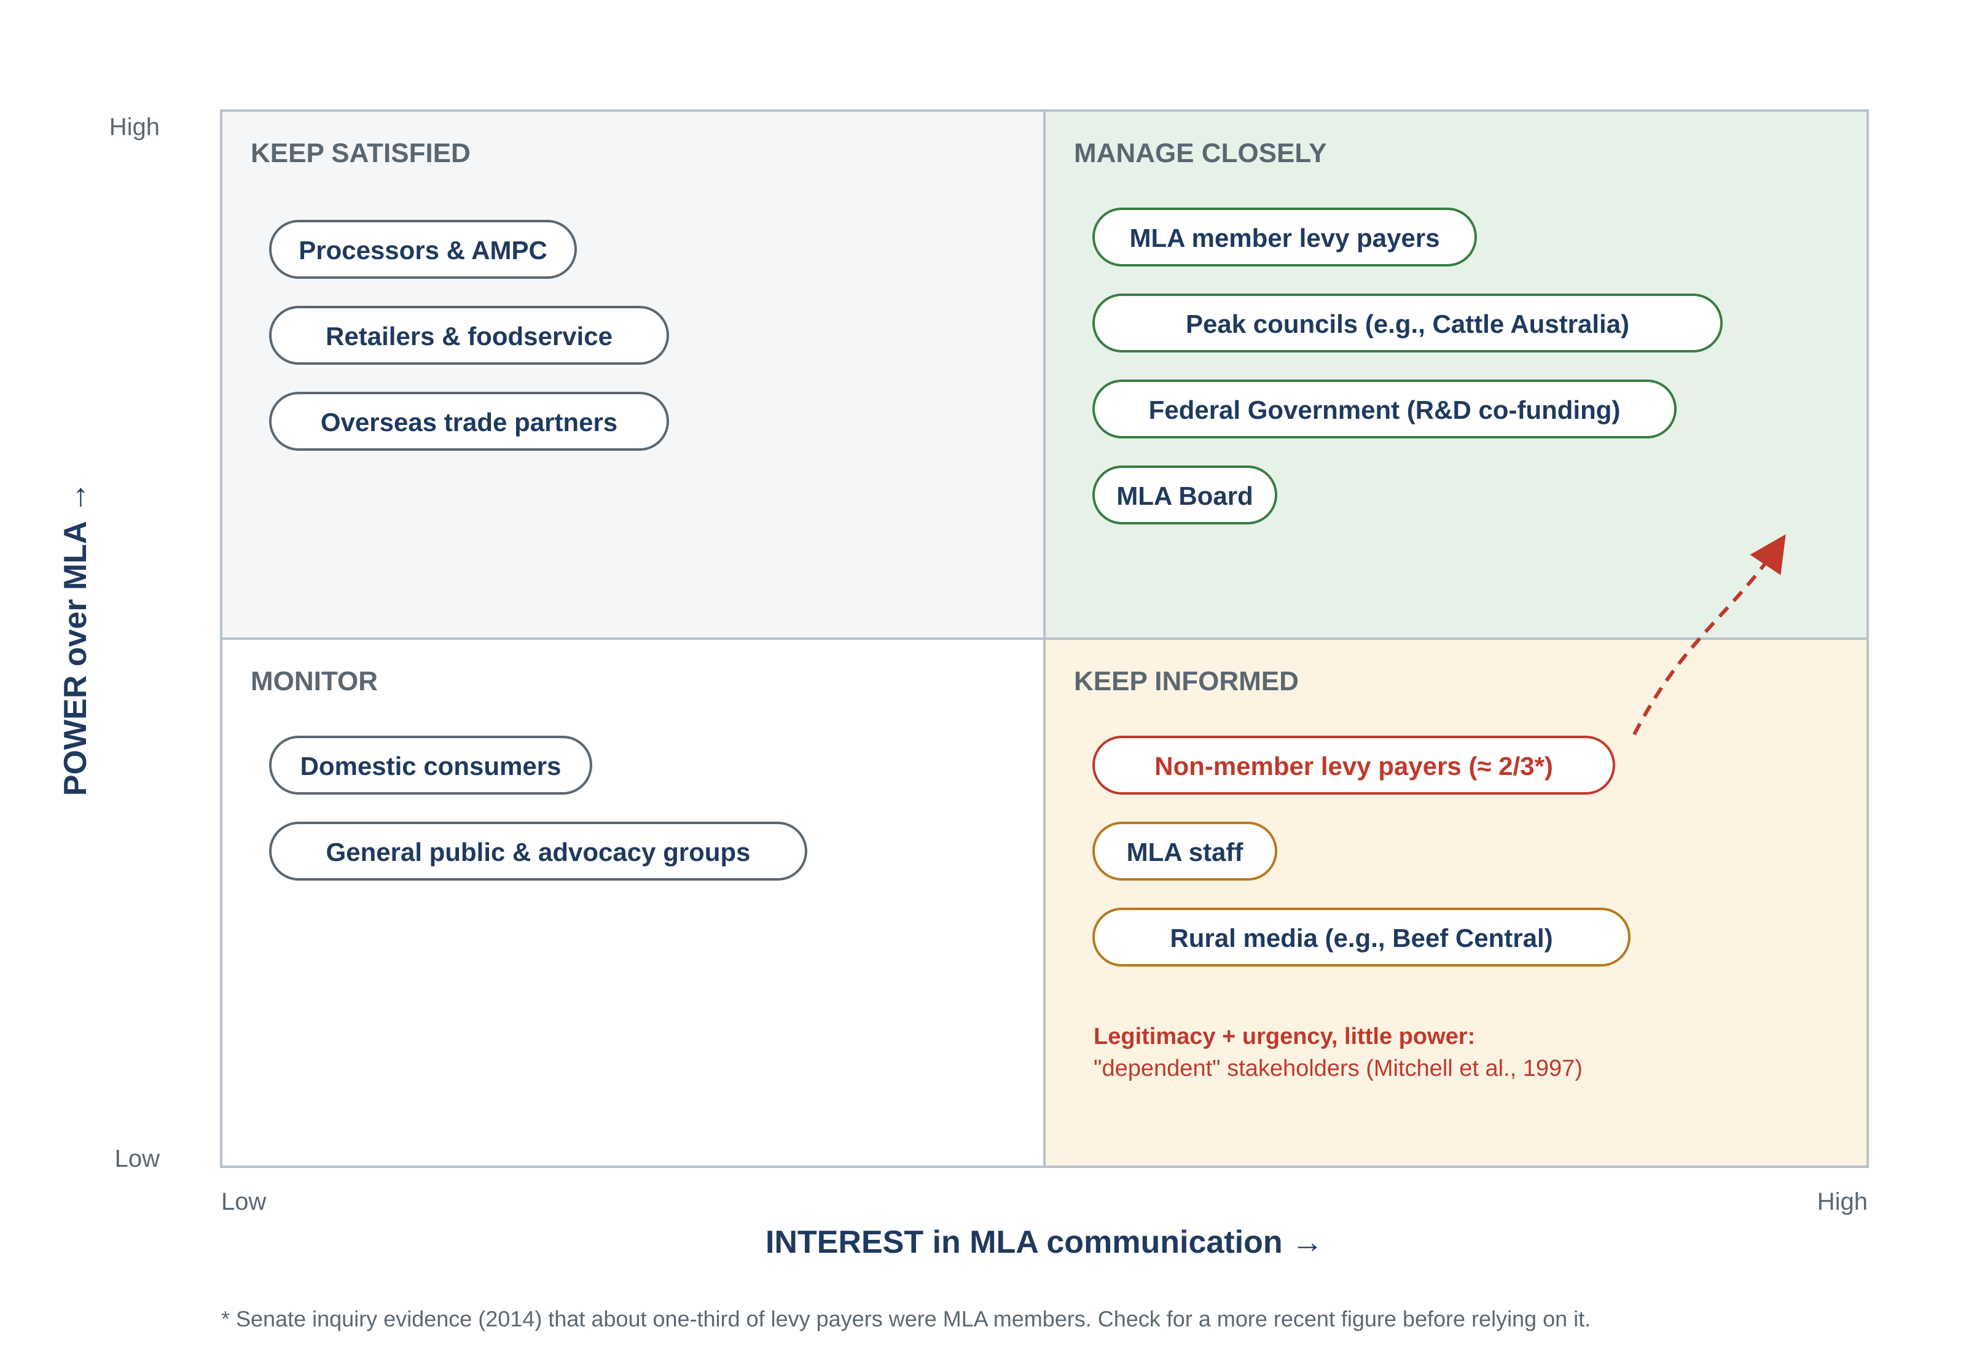
Stakeholder | Int./Ext. | Communication needs and interests | Influence / salience | Main channels to check
MLA member levy payers | Ext. | Value for money, R&D results, market information, a say in governance | High: legitimacy plus votes | Feedback, newsletters, myMLA, AGM, events
Non-member levy payers | Ext. | The same needs as members, but no formal voice | Dependent: legitimate and urgent, little power | Mostly one-way channels
Peak councils (e.g., Cattle Australia) | Ext. | Consultation, accountability, input into strategy | High power | Formal meetings and planning
Federal Government (Dept of Agriculture) | Ext. | Compliance, reporting, value for co-funding | High power (E1) | Annual reports, formal reporting
Processors and AMPC | Ext. | Market insights, joint programs | Medium–high: co-funders, collect levies | Industry reports, meetings
Consumers (domestic and overseas) | Ext. | Product appeal, trust, food information | Low individually, high collectively | TV, social, outdoor campaigns
MLA staff and board | Int. | Strategy alignment, consistent messaging | Medium (staff); high (board) | No public evidence; state the limitation

5. Channel audit grid
Your judgement on fit is the analysis. Answer the prompts in your own words, citing the evidence.
Channel | Main audience | Direction | Richness | Evidence | Questions to judge fit
Feedback magazine | Producers | One-way | Lean–medium | E6 | Strong reach. Does it show levy results clearly enough to answer E14?
E-newsletters | Producers | One-way | Lean | E7 | Good for routine market data. Does it suit contested topics?
myMLA dashboard | Producers | Partly two-way | Medium | E8 | Personalised, but useful only for digitally included producers (E16)?
Website and market reports | Producers, industry | One-way | Lean | MLA site | Easy to navigate? Plain language?
BeefUp and other events | Northern producers | Two-way | Rich | E9 | Rich, but small reach (20–70 people). Who is left out?
AGM, Red Meat and annual report | Members, government | Mostly one-way | Medium | E10, E2 | Do non-members have any voice? (E3, E4)
Consumer campaigns | Consumers | One-way (some social engagement) | Medium | E11, E12 | An evidence-based strength: measurable results.
Media releases and rural media | Producers, public | One-way; media can be critical | Lean | E13–E15 | Rural media also carries criticism. How does MLA respond?
Internal (intranet, staff updates) | Staff | Unknown | Unknown | None public | Treat as a scope limitation; do not invent detail.

6. Section-by-section writing guide
Total target 1,500 words (allowed range 1,350–1,650). The title page and references are not counted. Ask your lecturer whether tables count.

1. Introduction (150 words)
- Who MLA is, its sector, and how it is funded (E1, E2).
- The audit purpose and scope, including the limitation.
- A one-sentence roadmap of the report.
HD tip: Avoid long company history. Use one fact to show scale, then move on.

2. Literature review and theory (300 words)
- 2–3 theories from Section 3.
- For each: the core idea, its source, a critique, and how you will use it on MLA.
HD tip: Do not just define. End each theory with a sentence on what it reveals about MLA.

3. Stakeholder analysis (250 words)
- The map (as a figure) plus discussion of 4–5 key groups.
- Needs, interests and influence for each group.
- The "dependent stakeholder" point about non-member levy payers.
HD tip: Name the tension: who has power versus who has legitimacy.

4. Channels and tools (350 words)
- Internal and external channels.
- A summary table, plus discussion of fit using media richness and the four PR models.
HD tip: Group channels by purpose (routine information, governance, engagement, marketing) instead of listing them one by one.

5. Evaluation (250 words)
- Strengths, weaknesses, barriers and gaps, each with evidence.
- Link each point back to a theory.
HD tip: Balance matters. Credit real strengths (E6, E7, E11) before the gaps (E14).

6. Recommendations (150 words)
- 2–3 recommendations built with the table in Section 7.
HD tip: Each needs: finding, theory, action, channel and measure of success.

7. Conclusion (50 words)
- Key findings and one professional communication implication.
HD tip: No new evidence.

7. Recommendation builder
Pick 2–3 options, then justify them in your own words. The rubric rewards recommendations "clearly linked to audit findings and theory".
Finding | Theory link | Possible action | Channel / audience | Success measure
Producers want transparency on levy results (E13, E14) | Stakeholder salience; two-way symmetrical | An annual interactive "levy at work" report with plain-language results by program | myMLA, Feedback and print summary / all levy payers | Higher share of producers rating returns as moderate or better in the next review
Most channels are one-way (E6, E7) | Two-way symmetrical | A published "you said, we did" loop after consultations and surveys | Newsletters, events / members and non-members | Number of producer inputs acknowledged and acted on
Few levy payers are members (E3, E4) | Salience (dependent stakeholders) | Simplify membership sign-up, e.g., a prompt when using myMLA or eNVDs | myMLA / non-member levy payers | Membership rate year on year
Digital gap among farmers (E16, E17) | Media richness; noise | Keep print and SMS options; run hybrid forums with phone dial-in | Multiple channels / low-connectivity producers | Attendance and reach outside major regions

8. Starter reference list (APA 7)
Academic sources (verified details; still check each one in your library):
Daft, R. L., & Lengel, R. H. (1986). Organizational information requirements, media richness and structural design. Management Science, 32(5), 554–571. https://doi.org/10.1287/mnsc.32.5.554
Dennis, A. R., & Valacich, J. S. (1999). Rethinking media richness: Towards a theory of media synchronicity. In Proceedings of the 32nd Annual Hawaii International Conference on System Sciences. IEEE. https://doi.org/10.1109/HICSS.1999.772701
Dozier, D. M., Grunig, L. A., & Grunig, J. E. (1995). Manager’s guide to excellence in public relations and communication management. Lawrence Erlbaum.
Freeman, R. E. (1984). Strategic management: A stakeholder approach. Pitman.
Grunig, J. E., & Hunt, T. (1984). Managing public relations. Holt, Rinehart and Winston.
Marshall, A., Dezuanni, M., Burgess, J., Thomas, J., & Wilson, C. K. (2020). Australian farmers left behind in the digital economy: Insights from the Australian Digital Inclusion Index. Journal of Rural Studies, 80, 195–210. https://doi.org/10.1016/j.jrurstud.2020.09.001
Mitchell, R. K., Agle, B. R., & Wood, D. J. (1997). Toward a theory of stakeholder identification and salience: Defining the principle of who and what really counts. Academy of Management Review, 22(4), 853–886. https://doi.org/10.5465/amr.1997.9711022105
Shannon, C. E., & Weaver, W. (1949). The mathematical theory of communication. University of Illinois Press.
Plus your unit’s prescribed textbook. It counts toward the three academic sources.
Organisational, industry and media sources: open each one and add the author and exact date before formatting in APA 7.
- Beef Central: MLA’s $300m operating budget for 2024/25: https://www.beefcentral.com/news/mlas-300m-operating-budget-for-2024-25-how-will-it-be-spent/
- MLA Annual Report 2023–24: https://annualreport.mla.com.au/
- MLA: Feedback magazine: https://www.mla.com.au/news-and-events/publications/feedback-magazine/
- MLA: myMLA: https://www.mla.com.au/about-mla/mymla/
- MLA: Event types (BeefUp): https://www.mla.com.au/news-and-events/events-and-workshops/mla-event-types/
- MLA: Annual General Meeting and voting entitlements: https://www.mla.com.au/news-and-events/industry-news/mlas-annual-general-meeting--your-voting-entitlements/
- MLA: Summer Lamb 2025 campaign: https://www.mla.com.au/news-and-events/industry-news/out-of-the-comments-and-into-the-cutlets-mla-latest-summer-lamb-campaign/
- MLA: The Greatest beef campaign returns: https://www.mla.com.au/news-and-events/industry-news/the-greatest-beef-campaign-is-back--bigger-bolder-and-beefier-than-ever/
- Beef Central: Feedback from cattle levy review consultation meetings: https://www.beefcentral.com/news/findings-from-cattle-levy-review-consultation-meetings-released/
- Beef Central: Early levy review feedback: https://www.beefcentral.com/news/early-levy-review-feedback-reveals-support-for-marketing-biosecurity-and-representation/
- Beef Central: Producer questions zero in on cattle levy: https://www.beefcentral.com/news/producer-questions-zero-in-on-cattle-levy-as-review-consultations-begin/
- Senate RRAT References Committee (2014): Grass-fed cattle levies inquiry, Chapter 4: https://www.aph.gov.au/Parliamentary_Business/Committees/Senate/Rural_and_Regional_Affairs_and_Transport/Beef_levies/~/media/Committees/rrat_ctte/beef_levies/c04.pdf
- The Land: MLA levy payer register: https://www.theland.com.au/story/7335745/mla-levy-register-about-time/
- Australian Digital Inclusion Index 2023: https://digitalinclusionindex.org.au/

9. HD self-check against the rubric
Criterion (marks) | Tick when true
Introduction and scope (2) | ☐ Agribusiness context in one or two facts  ☐ Purpose, scope and limitation stated  ☐ Roadmap sentence
Theory (3) | ☐ At least 2 theories, each with a critique  ☐ Every theory used later as an evaluation lens  ☐ Not just definitions
Stakeholders (3) | ☐ Internal and external groups  ☐ Needs, interests and influence for each  ☐ Figure or table, justified in text
Channels (3) | ☐ Internal and external channels  ☐ Suitability, strengths, limits and stakeholder fit judged  ☐ Linked to media richness or PR models
Evaluation and recommendations (2) | ☐ Every finding has evidence  ☐ Each recommendation links finding + theory + action + measure
Research, writing, APA (2) | ☐ At least 3 academic and 2 organisational sources (aim for 10+)  ☐ Every source opened and checked  ☐ APA 7 in-text and reference list  ☐ Title page, numbered headings, .docx  ☐ AI use declared

