RS703 Advanced Business Research Methods
Assessment 1: Quantitative Research Critique

A Critique of Petrič and Just (2025): Information Security Culture and Employees' Reporting of Phishing Emails
Student name / ID: [Your name] / [Your student ID]
Word count: 1,105 (excluding title block, headings, figure caption and references)
Article critiqued: Petrič, G., & Just, J. N. (2025). Information security culture and phishing-reporting model: Structural equivalence across Germany, UK, and USA. Journal of Cybersecurity, 11(1), tyaf011. https://doi.org/10.1093/cybsec/tyaf011

1. Introduction
Phishing remains a persistent threat to organisations, and employees who report suspicious emails act as an early-warning "human sensor", allowing security teams to contain attacks before they cause financial loss or operational disruption (Petrič & Just, 2025). The authors argue that, although susceptibility to phishing is extensively researched, the drivers of reporting are not. Their objectives were to test whether four components of information security culture (ISC), namely policy awareness, communication quality, security knowledge and supportive norms, predict phishing reporting through employees' attitudes and sense of responsibility, and whether this model holds across Germany, the United Kingdom and the United States. The study is significant because it shifts managerial attention from preventing clicks to mobilising employees as active defenders. This critique argues that the study is theoretically coherent and statistically sophisticated, but that its cross-sectional, single-source, self-report design limits the causal and behavioural conclusions it can support.

2. Methodological Analysis
Research design. The study adopts a deductive, cross-sectional survey design consistent with a positivist stance, which is appropriate for testing theory-derived hypotheses across a large population (Saunders et al., 2023). However, the model specifies mediation (culture → attitudes and responsibility → reporting), which implies a temporal sequence that a single measurement occasion cannot establish; cross-sectional estimates of mediation can be substantially biased (Maxwell & Cole, 2007).
Sampling. Employees of organisations with at least 50 staff were recruited through an online survey panel (Germany n = 306; UK n = 205; USA n = 506; N = 1,017). Panels offer efficient cross-national access, but they are non-probability samples prone to self-selection and "professional respondent" effects, and panellists may be more digitally literate than typical employees (Callegaro et al., 2014). The unequal group sizes make UK estimates less precise and reduce power to detect cross-country differences, and no a priori power analysis is reported [verify]. Moreover, ISC is an organisational-level construct, yet respondents appear to come from different organisations, so "culture" is captured as individual perception rather than as a shared property.
Data collection. All constructs, including the outcome, were measured with a single self-administered questionnaire. The authors acknowledge that the quality of the self-reported reporting measure is unclear, noting that surveys yield higher reporting rates than experimental studies. Collecting predictors and outcome from the same source at the same time invites common method variance and social desirability bias (Podsakoff et al., 2003), while administering the instrument in German requires evidence of translation equivalence, such as back-translation (Brislin, 1970) [verify]. Procedural remedies, such as psychologically separating predictor and outcome items, and statistical checks, such as a marker variable, should be reported, because Harman's single-factor test alone is widely regarded as insufficient (Podsakoff et al., 2003).
Statistical analysis. Multigroup structural equation modelling (SEM) is a strong choice: it accounts for measurement error and, crucially, tests measurement invariance before structural paths are compared, a prerequisite for valid cross-cultural comparison (Vandenberg & Lance, 2000). Discriminant validity should nonetheless be demonstrated with the heterotrait–monotrait ratio, which is stricter than older criteria (Henseler et al., 2015) [verify]. The negative paths from communication quality to attitudes and responsibility also warrant caution: when conceptually overlapping ISC dimensions are estimated simultaneously, sign reversals can reflect statistical suppression rather than substantive effects, so the zero-order correlations should be inspected before this finding is interpreted.
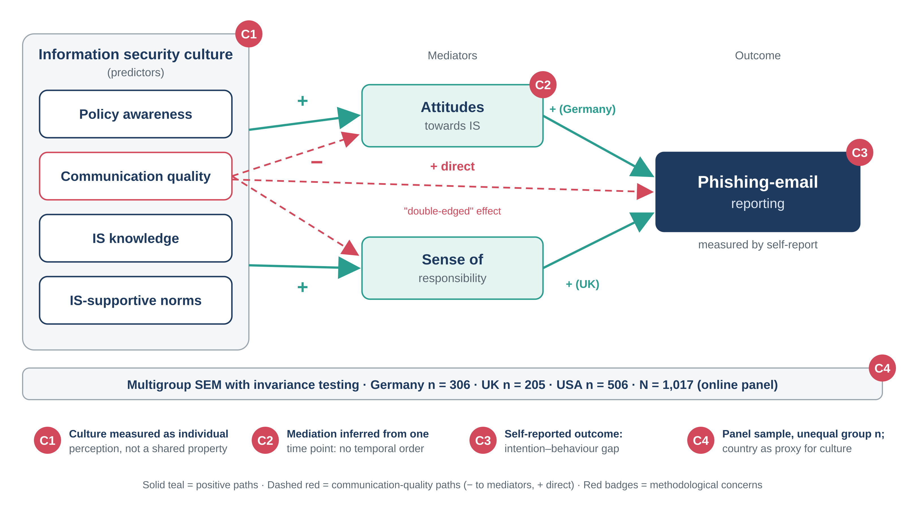
Figure 1. Simplified structure of Petrič and Just's (2025) model, annotated with the four principal methodological concerns raised in this critique (C1–C4). Path detail is simplified; see the original article for exact hypotheses.

3. Evaluation of Strengths and Limitations
Strengths. The model is theory-driven and parsimonious, linking manageable cultural levers to an outcome of clear business value. The three-country sample of over 1,000 employees and the demonstrated cross-cultural stability of the model strengthen construct validity, giving managers confidence that the ISC measures mean the same thing in each country. The finding that communication quality is "double-edged", raising reporting directly while lowering responsibility and attitudes, shows the value of modelling indirect paths rather than simple correlations. The authors' candour about the weakness of their outcome measure also enhances transparency.
Limitations. Internal validity is weak: without temporal separation or manipulation, the direction of effects cannot be confirmed, since employees who report often may develop more positive attitudes rather than the reverse (Shadish et al., 2002). Construct validity is threatened because recalled or intended reporting is an imperfect proxy for action, given the well-documented intention–behaviour gap (Sheeran, 2002). Reliability evidence is limited to one occasion, and shared-method variance may inflate both internal consistency and path coefficients (Podsakoff et al., 2003). Statistical conclusion validity also needs attention: with over 1,000 respondents, trivially small paths become significant, so effect sizes rather than p-values should guide managerial interpretation. Finally, generalisability is confined to three Western economies, larger organisations and panel members, and because country is used as a proxy for culture without measuring cultural values, explanations for why attitudes drive reporting in Germany but responsibility does in the UK remain speculative.

4. Suggestions for Improvement
Four evidence-based refinements would address these limitations. First, the outcome should be measured behaviourally by partnering with organisations that run simulated phishing campaigns and linking survey responses to logged reports, as Lain et al. (2022) did in a long-term field study of more than 14,000 employees [verify]. This removes recall and desirability bias. Second, a time-lagged design measuring culture at Time 1, attitudes and responsibility at Time 2 and reporting at Time 3 would establish temporal precedence and reduce common method variance (Maxwell & Cole, 2007; Podsakoff et al., 2003). Third, surveying several employees per organisation would allow ISC to be aggregated and analysed as a genuinely shared property using multilevel SEM, while stratified recruitment guided by a priori power analysis (Faul et al., 2007) would equalise group sizes. Pre-registering hypotheses and publishing the full instrument would further strengthen transparency and replicability. Fourth, measuring national cultural values directly and extending sampling to non-Western and smaller organisations would test whether country differences reflect culture or confounds such as regulation or reporting-tool design. These refinements would move the field from correlational towards causal, behaviourally grounded evidence, although they raise costs and ethical demands, particularly around deception in phishing simulations. A complementary qualitative phase, such as interviews with employees, could also explain why better communication appears to reduce personal responsibility, for example through diffusion of responsibility to the IT function.

5. Conclusion
Petrič and Just (2025) make a valuable contribution by reframing employees as active defenders and by testing a culture-based reporting model with methodological care, particularly through invariance testing across three countries. However, the cross-sectional, single-source, self-report design means the study demonstrates association rather than causation, and self-reported rather than observed behaviour. For business research, it illustrates both the power and the limits of survey-based SEM: the method is well suited to mapping relationships among perceptions, but claims about organisational culture and behaviour require multilevel, longitudinal and behavioural evidence. Managers should therefore treat its recommendations as promising hypotheses to test within their own organisations, and researchers should treat it as a strong foundation for more rigorous designs.

References
Brislin, R. W. (1970). Back-translation for cross-cultural research. Journal of Cross-Cultural Psychology, 1(3), 185–216. https://doi.org/10.1177/135910457000100301
Callegaro, M., Baker, R., Bethlehem, J., Göritz, A. S., Krosnick, J. A., & Lavrakas, P. J. (Eds.). (2014). Online panel research: A data quality perspective. Wiley.
Faul, F., Erdfelder, E., Lang, A.-G., & Buchner, A. (2007). G*Power 3: A flexible statistical power analysis program for the social, behavioral, and biomedical sciences. Behavior Research Methods, 39(2), 175–191. https://doi.org/10.3758/BF03193146
Henseler, J., Ringle, C. M., & Sarstedt, M. (2015). A new criterion for assessing discriminant validity in variance-based structural equation modeling. Journal of the Academy of Marketing Science, 43(1), 115–135. https://doi.org/10.1007/s11747-014-0403-8
Lain, D., Kostiainen, K., & Čapkun, S. (2022). Phishing in organizations: Findings from a large-scale and long-term study. In 2022 IEEE Symposium on Security and Privacy (pp. 842–859). IEEE. https://doi.org/10.1109/SP46214.2022.9833766
Maxwell, S. E., & Cole, D. A. (2007). Bias in cross-sectional analyses of longitudinal mediation. Psychological Methods, 12(1), 23–44. https://doi.org/10.1037/1082-989X.12.1.23
Petrič, G., & Just, J. N. (2025). Information security culture and phishing-reporting model: Structural equivalence across Germany, UK, and USA. Journal of Cybersecurity, 11(1), Article tyaf011. https://doi.org/10.1093/cybsec/tyaf011
Podsakoff, P. M., MacKenzie, S. B., Lee, J.-Y., & Podsakoff, N. P. (2003). Common method biases in behavioral research: A critical review of the literature and recommended remedies. Journal of Applied Psychology, 88(5), 879–903. https://doi.org/10.1037/0021-9010.88.5.879
Saunders, M. N. K., Lewis, P., & Thornhill, A. (2023). Research methods for business students (9th ed.). Pearson.
Shadish, W. R., Cook, T. D., & Campbell, D. T. (2002). Experimental and quasi-experimental designs for generalized causal inference. Houghton Mifflin.
Sheeran, P. (2002). Intention–behavior relations: A conceptual and empirical review. European Review of Social Psychology, 12(1), 1–36. https://doi.org/10.1080/14792772143000003
Vandenberg, R. J., & Lance, C. E. (2000). A review and synthesis of the measurement invariance literature: Suggestions, practices, and recommendations for organizational research. Organizational Research Methods, 3(1), 4–70. https://doi.org/10.1177/109442810031002

