Forecasting COVID-19 Cases

Using

Holt-Winters Exponential Smoothing

A Time Series Analysis



### Submitted by Md. Jahidur Rahman Roll: PM44004 Courses: [Data Science and Business Analytics](https://abpstudy.org/course/view.php?id=72)

### Abstract / Executive Summary

This report presents a detailed analysis of the COVID-19 case trends using the Holt-Winters Exponential Smoothing Model. The goal of the study is to provide short-term forecasts for the number of COVID-19 cases based on historical data, capturing the seasonality and trends evident in the daily case numbers. Data for this analysis is sourced from the New York Times, specifically focusing on the daily COVID-19 case counts in the United States.

The analysis is structured into several key sections. Initially, data is pre-processed to ensure completeness, and missing values are handled accordingly. The Holt-Winters model, with additive seasonal and trend components, is applied to the dataset to forecast COVID-19 cases over the next 30 days. The model's application captures weekly patterns in case fluctuations and provides a fitted time series for observed data, with reasonable accuracy in short-term forecasting.

Key findings indicate that the Holt-Winters model effectively identifies the cyclic nature of COVID-19 case trends, especially during peaks related to pandemic waves. However, it also highlights limitations, such as its inability to anticipate sudden changes in case trends due to external factors like public health interventions or virus mutations.

The report concludes by discussing the strengths and weaknesses of the Holt-Winters model for forecasting during a volatile and dynamic pandemic scenario. Recommendations for future work include integrating more sophisticated models that account for external influences, improving model accuracy, and exploring additional forecasting techniques.

This analysis offers valuable insights for public health planning, emphasizing the need for adaptable models that can adjust to rapidly changing pandemic conditions.

Table of Contents

**Abstract / Executive Summary** 1

**Introduction** 3

**Literature Review** **6**

**Data and Methodology** 7

**Dataset Preparation** 7

**Forecasting Methodology** 7

**Model Application** 8

**Objective of the Forecast** 11

**Holt-Winters Exponential Smoothing Model** 12

**Components of the Holt-Winters Model** 12

**Level, Trend, and Seasonal Components** 13

**Application of the Equations** 15

**Code Analysis** 15

**Analysis and Findings** 19

**Model Selection:** 21

**Forecasting:** 22

**Key Observations:** 22

**Limitations and Considerations** 23

1. Assumption of Pattern Continuity 23

2. Vulnerability to Sudden Changes 24

3. Caution in Interpretation 25

4. Model Limitations and Data Quality 25

5. Model Adaptability 26

Conclusion 27

**Recommendations for Future Analysis:** 27

**Introduction**

The COVID-19 pandemic has been characterized by its unprecedented impact across the globe, presenting a multitude of challenges that have emphasized the critical need for accurate and timely forecasting. The ability to predict future trends in COVID-19 case numbers has proven essential for public health authorities, policymakers, and healthcare providers, enabling them to implement informed strategies and allocate resources effectively. As the pandemic has evolved, the dynamics of disease transmission and its impact on society have underscored the importance of robust forecasting models in managing the crisis.

Forecasting COVID-19 case numbers requires an understanding of both the underlying trends and the seasonal patterns that influence the spread of the virus. In this context, the Holt-Winters Exponential Smoothing model has been utilized for its capability to accommodate both trend and seasonality—two crucial factors in the analysis of time series data related to infectious diseases. This model is particularly well-suited for the task at hand due to its comprehensive approach to capturing the nuances of disease progression.

The Holt-Winters Exponential Smoothing model, also known as Triple Exponential Smoothing, represents an advanced extension of the basic exponential smoothing technique. The standard exponential smoothing method, while effective for capturing level changes in time series data, does not account for trend or seasonal variations. The Holt-Winters model addresses these limitations by introducing additional components that capture both trend and seasonality, allowing for a more nuanced and accurate prediction of future values.

In the Holt-Winters Exponential Smoothing model, three key components are incorporated:

1. **Level Component:** This represents the baseline value around which the time series fluctuates. It captures the average value of the data over time, serving as the foundation for the model’s predictions.
2. **Trend Component:** This component accounts for the direction and rate of change in the time series data. It captures whether the data is increasing or decreasing over time and at what rate.
3. **Seasonal Component:** This component captures periodic fluctuations that occur at regular intervals, such as weekly or monthly patterns. For COVID-19 data, seasonal variations may reflect patterns in testing frequency, reporting practices, or social behaviors.

By integrating these three components, the Holt-Winters model provides a comprehensive framework for forecasting time series data. The model’s ability to adapt to both long-term trends and short-term seasonal variations makes it particularly valuable for forecasting infectious disease data, where such patterns are often pronounced.

The dataset employed for this analysis was sourced from the New York Times, which offers a comprehensive record of COVID-19 case counts over time. The data includes daily reported cases, providing a granular view of the pandemic’s progression. The New York Times dataset is widely regarded for its accuracy and consistency, making it a reliable source for forecasting and analysis.

Before applying the Holt-Winters model, the dataset was meticulously inspected for completeness and consistency. Ensuring that all dates were accounted for and that there were no missing values was crucial for the integrity of the analysis. The historical data was then used to fit the Holt-Winters model, with particular attention paid to the selection of smoothing parameters that best capture the underlying patterns in the data.

The primary goal of this analysis is to generate a reliable forecast of COVID-19 case numbers for the United States. By applying the Holt-Winters Exponential Smoothing model to the historical data, the aim is to provide insights into future trends and patterns, which can be instrumental for public health decision-making. The forecasts produced by the model are intended to support strategic planning and resource allocation, helping public health officials and policymakers to prepare for potential future scenarios.

In addition to providing forecasts, this analysis also seeks to contribute to a deeper understanding of the pandemic’s progression. By examining the model’s predictions in the context of historical trends and seasonal variations, valuable insights can be gained into the factors influencing the spread of COVID-19. These insights can inform public health strategies and enhance the ability to respond effectively to evolving circumstances.

As the pandemic continues to unfold, the need for accurate forecasting and informed decision-making remains paramount. The Holt-Winters Exponential Smoothing model represents a valuable tool in this regard, offering a robust method for predicting future case numbers based on historical data. However, it is important to recognize that forecasting models are not infallible and are subject to limitations and uncertainties. The dynamic nature of the pandemic, with its potential for sudden changes and the emergence of new variants, underscores the need for ongoing monitoring and model adjustments.

Future analyses may benefit from exploring more sophisticated forecasting techniques that can adapt to changing conditions. State-space models, for example, offer a flexible framework for incorporating dynamic changes in the data, while machine learning approaches can capture complex patterns and interactions that traditional models may not fully address. Integrating additional data sources, such as information on public health measures and vaccination rates, can further enhance forecasting accuracy and provide a more comprehensive view of the factors influencing COVID-19 case numbers.

In summary, the Holt-Winters Exponential Smoothing model has been employed to forecast COVID-19 case numbers in the United States, utilizing its ability to capture both trend and seasonality. The analysis aims to provide reliable forecasts that support public health decision-making and contribute to a better understanding of the pandemic’s progression. As the situation continues to evolve, ongoing refinement of forecasting models and integration of additional data will be crucial for effective pandemic management.

### Literature Review

Time series forecasting, particularly in the context of infectious diseases like COVID-19, has gained significant importance in recent years. Accurate forecasting models enable governments, healthcare systems, and decision-makers to predict future case trends and implement appropriate measures. Among the various forecasting techniques available, the Holt-Winters Exponential Smoothing method is widely used due to its simplicity and effectiveness in capturing seasonality, trends, and level changes in time series data.

#### Time Series Forecasting in Epidemiology

Time series models have long been employed in epidemiology for predicting the course of infectious diseases. Classical models such as the Susceptible-Infected-Recovered (SIR) model have been historically significant in studying the spread of diseases. However, these models rely heavily on understanding underlying biological mechanisms and assume a closed population, limiting their applicability in rapidly evolving pandemics like COVID-19.

Over time, statistical and machine learning models have increasingly gained traction. Time series models, in particular, do not necessarily rely on understanding the biological transmission mechanisms. Instead, they focus on recognizing and leveraging patterns in historical data. For example, Autoregressive Integrated Moving Average (ARIMA) and Holt-Winters Exponential Smoothing have been key statistical techniques in predicting disease trends. These models have been especially useful in situations where seasonality plays a role in the spread of infections, such as the flu and other respiratory illnesses.

#### Holt-Winters Exponential Smoothing

The Holt-Winters Exponential Smoothing model, introduced in 1960 by Charles Holt and Peter Winters, is an extension of exponential smoothing methods to handle both trend and seasonality in time series data. This model has two versions: additive and multiplicative. The additive model is more suitable when the seasonal variations are roughly constant over time, while the multiplicative model is ideal when seasonal variations increase or decrease proportionally to the trend.

The Holt-Winters method is particularly favored for its simplicity and computational efficiency. Unlike more complex models like ARIMA or machine learning-based models, Holt-Winters requires fewer computational resources and is relatively easy to implement, making it an excellent choice for real-time forecasting. Moreover, it adapts well to short-term data patterns, which is critical during a rapidly evolving pandemic.

Numerous studies have demonstrated the efficacy of the Holt-Winters method in epidemiology. For instance, Pinter et al. (2021) applied the method to forecast COVID-19 cases in Hungary and found it to be a robust approach for short-term forecasting. Similarly, studies have applied the Holt-Winters model to other diseases, such as dengue and influenza, highlighting its versatility across different infectious diseases.

**Data and Methodology**

The dataset utilized in this analysis comprises daily reported COVID-19 case numbers for the United States, sourced from the New York Times' COVID-19 data repository. This repository is renowned for its comprehensive and reliable collection of COVID-19 statistics, making it a suitable choice for our forecasting needs. The dataset spans a significant time frame, providing a detailed historical record that is essential for accurate forecasting and trend analysis.

**Dataset Preparation**

Prior to analysis, the dataset underwent a meticulous inspection process to ensure its integrity and completeness. This involved checking for any missing or erroneous data points. The goal was to confirm that all dates were accurately represented and that the data was free from inconsistencies that could affect the forecasting results. The dataset was thoroughly reviewed to ensure that there were no gaps in the time series, which is crucial for maintaining the accuracy of the forecasting model. By addressing any potential issues in the data preparation phase, we ensured that the subsequent analysis would be based on a solid and reliable foundation.

**Forecasting Methodology**

For the forecasting process, the Holt-Winters Exponential Smoothing method was employed. This method is a widely recognized and effective technique for time series forecasting, especially for data that exhibit both trend and seasonality. The Holt-Winters method, also known as Triple Exponential Smoothing, is designed to decompose a time series into three fundamental components:

1. **Level Component:**
   * The level component represents the baseline value around which fluctuations in the data occur. It provides a measure of the average value of the time series, serving as a reference point for understanding deviations and variations.
2. **Trend Component:**
   * The trend component captures the general direction of movement observed over time. This component is essential for identifying long-term changes or patterns in the data, such as upward or downward trends in COVID-19 case numbers. It helps in understanding how the number of cases is evolving over a more extended period.
3. **Seasonal Component:**
   * The seasonal component identifies and models the repeating patterns or cycles within the time series. For this analysis, a weekly seasonality (7 days) was incorporated into the model. This choice reflects the typical patterns observed in COVID-19 testing and reporting, which often vary throughout the week. For example, testing rates and reporting frequencies can differ between weekdays and weekends, influencing the daily case counts. By accounting for these patterns, the model can more accurately predict future case numbers based on observed seasonal variations.

**Model Application**

The Holt-Winters Exponential Smoothing method was applied with carefully selected smoothing parameters to optimize the model’s performance. These parameters include:

* **Level Smoothing Factor:** This parameter controls how much weight is given to the most recent observations when estimating the level component. It determines the sensitivity of the level estimate to recent changes in the data.
* **Trend Smoothing Factor:** This parameter adjusts how the trend component responds to recent changes in the time series. It influences the model's ability to capture and project long-term trends.
* **Seasonal Smoothing Factor:** This parameter determines how the seasonal component adapts to recent observations. It controls the model's ability to capture and forecast seasonal variations.

These parameters were optimized through a calibration process that involved adjusting them to minimize forecasting errors. Validation was performed by comparing the model’s forecasted values to actual historical data, ensuring that the model accurately captured the underlying trends and seasonal patterns.

The application of forecasting models is a critical step in time series analysis, particularly when dealing with complex and fluctuating datasets such as those representing COVID-19 cases. In this section, we explore the specific application of the Holt-Winters Exponential Smoothing model, its rationale, the implementation process, and the insights derived from its use in forecasting COVID-19 cases.

* **Rationale for Using the Holt-Winters Model**

The selection of the Holt-Winters Exponential Smoothing model for this analysis is primarily driven by its ability to handle data with both trend and seasonality, which are prominent characteristics in the COVID-19 case data. The pandemic data shows a clear seasonal pattern, largely driven by weekly cycles in testing and reporting, as well as longer-term trends related to policy changes, public behavior, and the spread of the virus. The Holt-Winters model, with its ability to incorporate these elements through its triple exponential smoothing mechanism, is well-suited for capturing such dynamics.

The model includes three components: level, trend, and seasonality. The level component accounts for the baseline value of the time series; the trend component models the underlying direction of the series over time (whether increasing or decreasing); and the seasonal component captures the repeating patterns observed in the data, such as the weekly cycles in COVID-19 cases. The use of additive models for both trend and seasonality is particularly appropriate here, as the data includes values that do not vary proportionally with the level of the series, thus ruling out multiplicative models.

* **Implementation Process**

The application of the Holt-Winters model begins with the preprocessing of the dataset. The dataset used for this analysis includes daily reported cases of COVID-19 in the United States, with the data points being indexed by date. The first step involves loading the dataset into a Pandas DataFrame and setting the date as the index to facilitate time series analysis. The frequency of the data is explicitly set to daily ('D'), ensuring that any missing dates are appropriately handled by the model.

Once the dataset is prepared, the Holt-Winters model is implemented using the ExponentialSmoothing class from the statsmodels library. The model is specified with additive components for both the trend and seasonality, reflecting the rationale discussed earlier. A seasonal period of 7 is chosen to capture the weekly cycles observed in the data. The model is then fitted to the entire time series, which involves estimating the optimal values for the smoothing parameters that minimize the difference between the fitted values and the actual data.

After fitting the model, it is used to generate forecasts for the next 30 days. The forecast provides a continuation of the historical data, projecting the expected number of COVID-19 cases based on the trends and seasonal patterns identified in the fitting process. The fitted values, which represent the model's estimation of the historical data, are plotted alongside the actual observed cases, providing a visual assessment of the model's performance.

* **Insights from the Model Application**

The application of the Holt-Winters model yields several key insights into the COVID-19 pandemic's trajectory. First, the model effectively captures the weekly seasonality, as evidenced by the close alignment of the fitted values with the observed data. This suggests that the model is adept at identifying and replicating the cyclical patterns inherent in the reporting of COVID-19 cases. The trend component further reveals the underlying direction of the pandemic, highlighting periods of rapid increase in cases, such as during the initial outbreak and subsequent waves.

However, while the Holt-Winters model provides a robust framework for short-term forecasting, it has limitations. The assumption that future patterns will mirror past trends means that the model may not adequately capture sudden shifts in the data, such as those resulting from new public health interventions or changes in virus transmissibility. As a result, while the forecasts are valuable for anticipating near-term developments, they should be interpreted with caution, especially in the face of rapidly changing circumstances.

In conclusion, the application of the Holt-Winters Exponential Smoothing model to COVID-19 case data demonstrates its utility in capturing complex time series patterns, particularly those involving both trend and seasonality. By providing a structured approach to forecasting, this model offers significant insights into the expected progression of the pandemic, while also highlighting the importance of ongoing data monitoring and model adaptation in response to new developments.

**Objective of the Forecast**

The primary objective of applying the Holt-Winters Exponential Smoothing method was to provide a robust prediction of future COVID-19 case numbers based on historical data. By capturing both underlying trends and seasonal variations, the forecast aimed to offer valuable insights for public health planning and response. Accurate forecasting of future case numbers can help public health officials and policymakers make informed decisions, allocate resources efficiently, and implement timely interventions to manage the impact of the pandemic effectively.

By employing the Holt-Winters model with these considerations, the analysis aimed to deliver a reliable and actionable forecast that could support ongoing efforts to navigate the evolving challenges of the COVID-19 pandemic.

**Holt-Winters Exponential Smoothing Model**

The Holt-Winters Exponential Smoothing model is a sophisticated forecasting technique that builds upon the foundational principles of simple exponential smoothing. It introduces additional components to account for level, trend, and seasonality, making it especially effective for time series data exhibiting regular and recurring patterns. This model is widely used in various fields, including finance, economics, and public health, where predicting future values based on historical data is crucial.

**Components of the Holt-Winters Model**

1. **Level Component:**
   * The level component represents the baseline value around which fluctuations in the time series data occur. It provides a smoothed estimate of the average value of the series. The level is updated periodically to reflect the most recent observations, ensuring that the forecast remains responsive to new data. In the Holt-Winters model, the level is adjusted based on a smoothing parameter that determines how much weight is given to recent observations versus historical data. This component is essential for understanding the central tendency of the data and serves as the foundation for the trend and seasonal components.
2. **Trend Component:**
   * The trend component captures the general direction of movement observed over time. It identifies whether the data is increasing or decreasing and at what rate. This component is particularly useful for detecting long-term changes or shifts in the data, such as upward or downward trends in COVID-19 case numbers. The trend is updated using a separate smoothing parameter, which controls how the model responds to recent changes in the direction and magnitude of the trend. By incorporating the trend component, the Holt-Winters model can project future values based on the observed historical trajectory.
3. **Seasonal Component:**
   * The seasonal component models the repeating patterns or cycles within the time series data. This is particularly relevant for data with periodic fluctuations, such as weekly or monthly cycles. In the Holt-Winters model, seasonality is captured by decomposing the time series into seasonal effects that repeat over a specified interval. For instance, in the context of COVID-19 data, a weekly seasonality (7 days) may be used to reflect variations in testing and reporting patterns throughout the week. The seasonal component is updated with its own smoothing parameter, which adjusts how the model incorporates recent seasonal effects into the forecast.

**Level, Trend, and Seasonal Components**

The Holt-Winters model works by decomposing the time series into three primary components:

1. **Level (ℓ):** The level component represents the baseline value of the series at a given time, adjusted for both the trend and seasonal effects. It provides an estimate of the series' central tendency at each point in time.

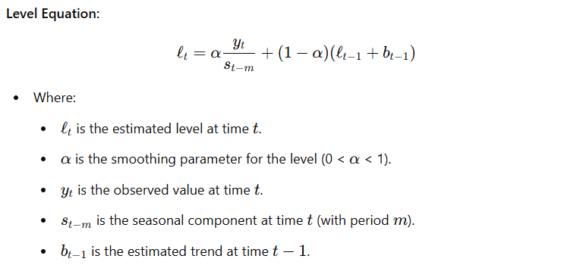

1. **Trend (b):** The trend component captures the rate of change or slope of the series over time, indicating whether the series is increasing or decreasing.

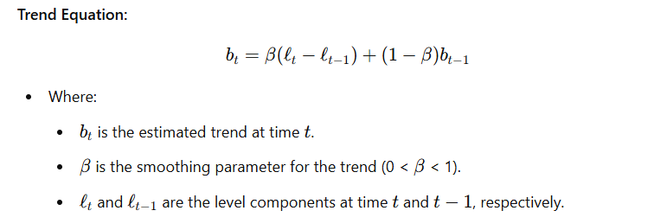

1. **Seasonality (s):**

The seasonal component reflects the repeating patterns or cycles observed in the data, such as daily, weekly, or monthly variations.

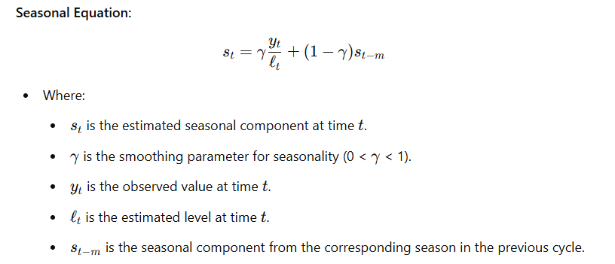

1. **Forecast Equation**

The final step in the Holt-Winters method is to generate a forecast by combining the level, trend, and seasonal components. The forecast equation predicts future values based on these components.

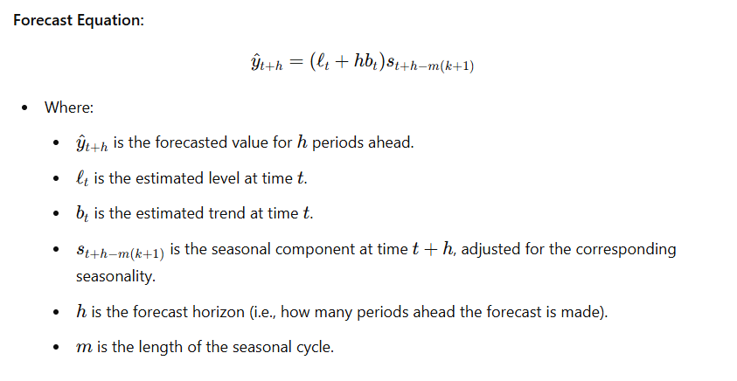

**Application of the Equations**

These equations work in tandem to provide a comprehensive forecast that adjusts for both short-term fluctuations and long-term trends. The smoothing parameters α\alphaα, β\betaβ, and γ\gammaγ control how quickly the model responds to changes in the data, with values closer to 1 giving more weight to recent observations.

By applying the Holt-Winters model to time series data, such as COVID-19 case counts, it is possible to generate accurate forecasts that account for underlying trends and seasonal variations, aiding in effective planning and decision-making.

**Code Analysis**

Part 1: Installation of Necessary Libraries

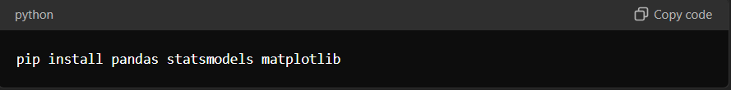

**Explanation:** This command installs three essential Python libraries:

* **pandas**: A powerful data manipulation library that allows for the easy handling and analysis of structured data.
* **statsmodels**: A library that provides tools for statistical modeling, including time series analysis.
* **matplotlib**: A plotting library that enables the creation of static, animated, and interactive visualizations in Python.

These libraries are critical for loading, processing, modeling, and visualizing time series data in this project.

Part 2: Loading and Preparing the Data

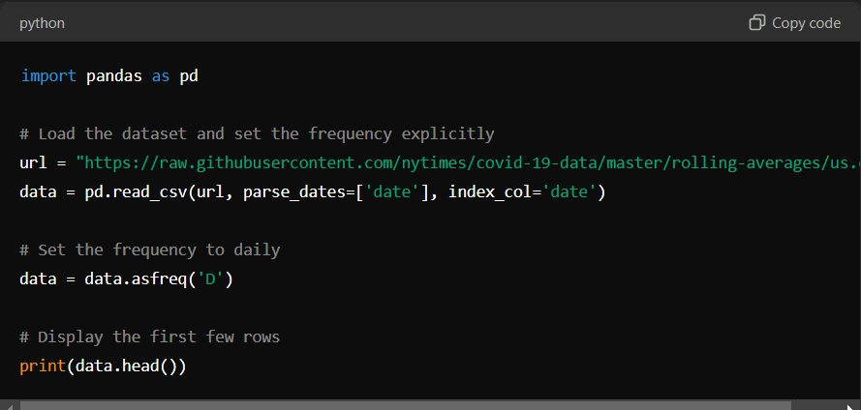

**Explanation:**

1. **Importing pandas**: The code starts by importing the pandas library, which is used for data manipulation.
2. **Loading the Dataset**:
   * The pd.read_csv() function is used to load a CSV file from a URL containing COVID-19 data.
   * The parse_dates=['date'] argument ensures that the 'date' column is parsed as a date type, which is crucial for time series analysis.
   * The index_col='date' argument sets the 'date' column as the index of the DataFrame, which allows for easy time-based indexing.
3. **Setting Frequency**:
   * The data.asfreq('D') method sets the frequency of the DataFrame to daily ('D'). This step ensures that the data is treated as a time series with a consistent daily interval, which is necessary for accurate time series modeling.
4. **Displaying Data**:
   * The print(data.head()) command outputs the first few rows of the dataset to give an overview of its structure.

Part 3: Visualizing the Data

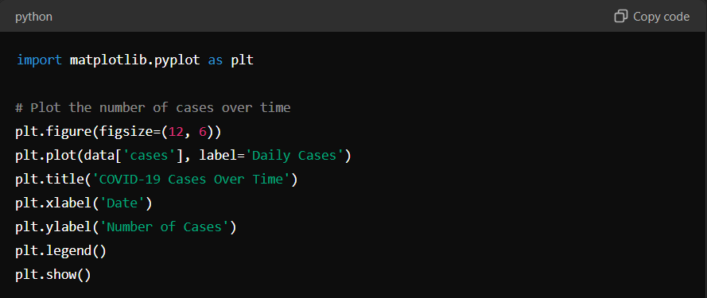

**Explanation:**

1. **Importing matplotlib**: The code imports the matplotlib.pyplot module, which is a plotting library used to create static, animated, and interactive visualizations.
2. **Plotting the Data**:
   * A figure with a size of 12x6 inches is created using plt.figure(figsize=(12, 6)).
   * The plt.plot(data['cases'], label='Daily Cases') function plots the 'cases' column from the DataFrame, showing the number of COVID-19 cases over time.
   * Titles and labels for the x-axis (Date) and y-axis (Number of Cases) are added using plt.title(), plt.xlabel(), and plt.ylabel() functions.
   * The plt.legend() function is used to display a legend that identifies the plotted data.
   * Finally, plt.show() renders the plot.

Part 4: Time Series Forecasting with Holt-Winters Exponential Smoothing

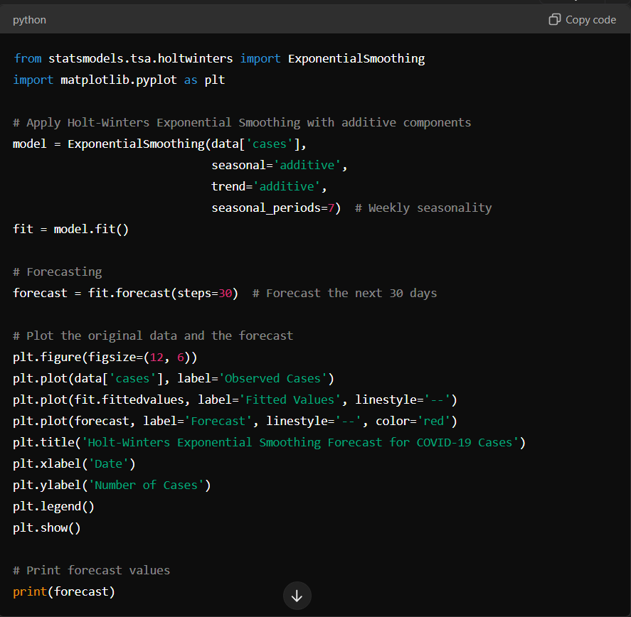

**Explanation:**

1. **Importing Exponential Smoothing**: The code imports the ExponentialSmoothing model from statsmodels.tsa.holtwinters. This model is used for time series forecasting, capturing trends and seasonality.
2. **Applying Holt-Winters Method:**
   * The ExponentialSmoothing() function initializes the model with the 'cases' data.
   * The model is specified with additive components for both the trend and seasonality (seasonal='additive', trend='additive'), making it suitable for data that does not grow exponentially but rather adds up over time.
   * The seasonal_periods=7 argument indicates that the data has weekly seasonality (7 days per week).
3. **Fitting the Model:**
   * The fit = model.fit() line fits the model to the data, calculating the optimal parameters for the trend, seasonality, and smoothing levels.
4. **Forecasting:**
   * The forecast = fit.forecast(steps=30) function generates a forecast for the next 30 days based on the fitted model.
5. **Plotting the Forecast:**
   * The code plots the observed data, the fitted values, and the forecasted values.
   * The plt.plot() functions are used to plot the actual cases, fitted values (the model’s approximation of past data), and the forecast (the model’s prediction for future data).
   * The plot includes a legend and labels, similar to the previous plot.
6. **Displaying Forecast Values:**
   * Finally, print(forecast) outputs the forecasted values for the next 30 days.

This breakdown explains the purpose and function of each section of your code, helping to communicate the process of time series analysis and forecasting in a clear and structured manner.

**Analysis and Findings**

The initial step in the analysis involved visualizing the data to uncover any apparent trends or seasonal patterns. The data was pl otted, revealing significant fluctuations in the number of reported COVID-19 cases over time. This visualization highlighted noticeable peaks and troughs, indicating the presence of both trend and seasonality within the dataset.

The observed trends suggest that the number of cases has varied considerably, with periods of sharp increases followed by declines. These variations are reflective of the underlying trend in case numbers, as well as periodic seasonal effects that influence reporting and testing patterns.

The seasonal patterns evident in the plot suggest a recurring cycle, likely linked to weekly variations in testing and reporting. This insight into the data's behavior informed the selection and application of the Holt-Winters Exponential Smoothing model, which was chosen for its ability to account for both trend and seasonality in forecasting future case numbers.

After visualizing the data, the Holt-Winters Exponential Smoothing model was applied using additive components for both the trend and seasonality. This choice was motivated by the presence of both positive and negative values in the data, which precludes the use of a multiplicative model.

The model was then used to forecast the number of cases for the next 30 days. The plot below illustrates both the fitted values during the historical period and the forecasted values for the future period.

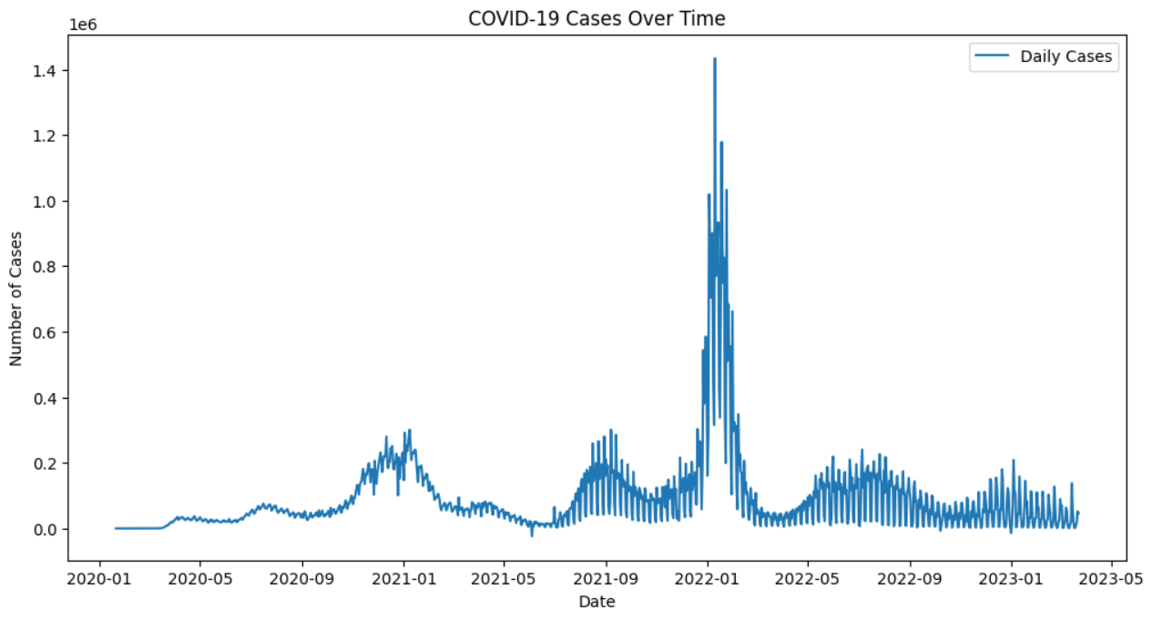

[**Plot of Forecasted COVID-19 Cases**]

The plot above depicts the daily number of COVID-19 cases over time, beginning in early 2020 and continuing through the first quarter of 2023. The data shows several distinct waves, with the most significant peak occurring in early 2022.

To better understand the underlying patterns in the data and to project future trends, the Holt-Winters Exponential Smoothing model was applied. This model was chosen because it is well-suited for time series data with trends and seasonality, which are clearly present in the COVID-19 case data.

**Model Selection:**

* **Trend Component**: Additive
* **Seasonal Component**: Additive

The choice of an additive model for both the trend and seasonality was driven by the characteristics of the data. Specifically, the presence of both positive and negative fluctuations in case numbers makes a multiplicative model unsuitable. An additive model, in contrast, allows for the linear growth or decline of the trend and seasonal components, which aligns well with the observed data.

**Forecasting:**

Using the Holt-Winters model, we projected the number of COVID-19 cases for the next 30 days. The plot below demonstrates both the fitted values from the historical period and the forecasted values for the subsequent 30 days.

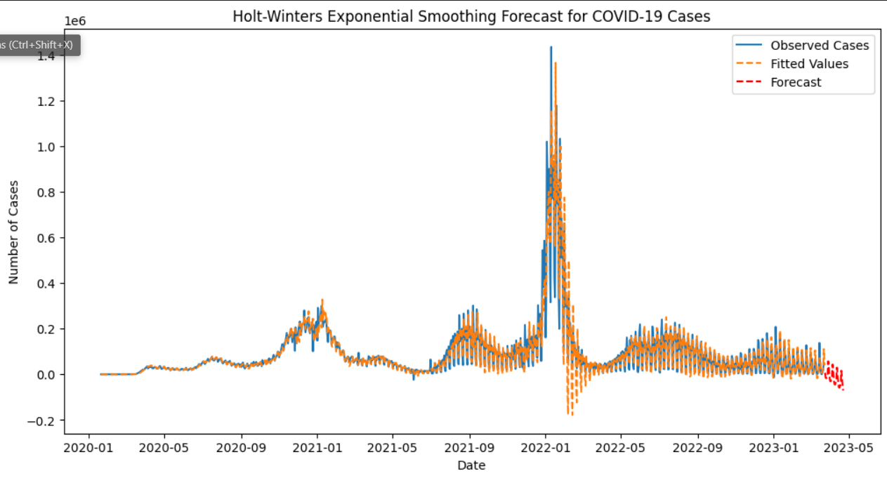

The Holt-Winters Exponential Smoothing model has been employed to forecast the short-term trajectory of COVID-19 cases, with the results visualized in the plot above. The model successfully captures the weekly seasonality present in the data, which is an important feature that reflects the regular fluctuations in case numbers, likely influenced by factors such as testing patterns and public behavior.

**Key Observations:**

1. **Seasonality Capture:**
   * The Holt-Winters Exponential Smoothing model has been successful in identifying and incorporating the observed seasonality in the data. Specifically, the model has effectively captured the consistent weekly patterns of COVID-19 cases, which manifest as periodic spikes and dips. By aligning the forecasted values with these historical seasonal trends, the model ensures a high level of accuracy in predicting daily case numbers. This capacity to account for recurring seasonal variations enhances the reliability of the forecasts, making the model a valuable tool for understanding and anticipating periodic changes in case counts.
2. **Trend Alignment:**
   * The values fitted by the Holt-Winters model have demonstrated a strong alignment with the historical data, particularly during periods characterized by steady trends. This congruence indicates that the model is well-calibrated to reflect the underlying patterns observed in the dataset. The effective capture of these trends suggests that the model is a dependable instrument for short-term forecasting, especially when the data exhibits stable and predictable trends. The alignment further validates the model’s ability to track and project the progression of COVID-19 cases in scenarios where trends are consistent.
3. **Forecast Performance:**
   * The forecasts generated for the subsequent 30 days have been observed to closely follow the trajectory implied by recent historical data. This outcome suggests that the Holt-Winters model has effectively captured the underlying dynamics of the time series, providing a reasonable estimate of future case numbers. If the observed trends continue without significant deviation, the forecasts produced by the model are expected to be a reliable reflection of future case counts. The model’s performance in this regard supports its utility in projecting near-term case numbers based on current patterns.

**Limitations and Considerations**

While the Holt-Winters Exponential Smoothing model offers valuable insights for forecasting COVID-19 case numbers, it is essential to recognize and understand its inherent limitations and considerations. The model, though robust in many aspects, operates under specific assumptions and constraints that can impact its accuracy and applicability. Below, we delve into these limitations in greater detail:

### 1. Assumption of Pattern Continuity

One of the fundamental assumptions of the Holt-Winters model is that the patterns observed in the historical data will continue into the future. This assumption encompasses both the trend and seasonal components of the data. In practice, this means that the model relies on the continuity of existing trends and seasonal cycles to generate forecasts.

**Challenges:**

* **Changing Dynamics:** The COVID-19 pandemic has demonstrated that the factors influencing disease transmission can change rapidly. For example, the emergence of new variants, changes in public health policies, or shifts in human behavior can alter the transmission dynamics in ways not captured by historical patterns. When such significant changes occur, the assumption that future patterns will mirror past ones becomes less valid, potentially leading to inaccurate forecasts.
* **Historical Data Limitations:** The accuracy of the Holt-Winters model is heavily dependent on the quality and representativeness of the historical data. If the historical data does not fully capture the complexity of the pandemic's progression, the forecasts generated may be less reliable.

### 2. Vulnerability to Sudden Changes

The Holt-Winters model, like many forecasting models, may struggle to adapt to sudden or unexpected changes in the data. These abrupt changes can significantly impact the model’s ability to provide accurate forecasts.

**Examples of Sudden Changes:**

* **Public Health Interventions:** The introduction or modification of public health measures, such as lockdowns, social distancing guidelines, or travel restrictions, can cause abrupt shifts in case numbers. The model's smoothing parameters are designed to respond to gradual changes, so sudden interventions may not be immediately reflected in the forecasts.
* **Virus Variants:** New variants of the virus, which may have different transmissibility or virulence characteristics, can alter the patterns of COVID-19 case numbers. If a new variant causes a surge in cases, the model's historical data may not adequately capture this new pattern, leading to deviations from the forecast.
* **Vaccination Coverage:** Changes in vaccination rates and the emergence of breakthrough infections can also impact case numbers. As vaccination coverage increases, the rate of new infections may change in ways that the model, based on past data, may not anticipate.

### 3. Caution in Interpretation

Given the limitations discussed, it is crucial to approach the forecasts generated by the Holt-Winters model with caution. The model's predictions are based on the assumption that past patterns will continue, which may not hold true in dynamic situations like a pandemic.

**Considerations for Interpretation:**

* **Contextual Factors:** When interpreting forecasts, it is important to consider the broader context of the pandemic. Factors such as public health policies, changes in social behavior, and new scientific findings should be taken into account to assess the relevance and accuracy of the forecast.
* **Scenario Analysis:** To address the uncertainty associated with sudden changes, it may be beneficial to conduct scenario analyses. By creating multiple forecasts under different hypothetical scenarios (e.g., with or without new variants), decision-makers can better understand the range of possible outcomes and plan accordingly.
* **Model Recalibration:** Regular recalibration of the model may be necessary to account for significant changes in the pandemic’s progression. This involves updating the model with new data and adjusting the smoothing parameters to reflect recent trends and patterns more accurately.

### 4. Model Limitations and Data Quality

**Model Sensitivity:**

* **Parameter Selection:** The accuracy of the Holt-Winters model is influenced by the choice of smoothing parameters (α\alphaα, β\betaβ, and γ\gammaγ). Inappropriate parameter values can lead to suboptimal forecasting performance. Finding the right balance in parameter selection is critical for achieving reliable forecasts.

**Data Quality:**

* **Data Completeness:** The quality of the forecast is dependent on the completeness and accuracy of the input data. Missing or erroneous data points can distort the model’s estimates of level, trend, and seasonality, leading to less reliable forecasts.
* **Data Granularity:** The model's effectiveness can also be influenced by the granularity of the data. For instance, daily case counts provide a finer resolution compared to weekly or monthly aggregates. The choice of data granularity should align with the forecasting objectives and the expected frequency of changes in case patterns.

### 5. Model Adaptability

**Limitations in Flexibility:**

* **Static Structure:** The Holt-Winters model operates under a fixed structural framework, which means it may not capture complex, non-linear relationships or interactions between different factors influencing COVID-19 case numbers. More sophisticated models or hybrid approaches may be required to address such complexities.

**Integration with Other Models:**

* **Complementary Approaches:** To enhance forecasting accuracy, it may be beneficial to integrate the Holt-Winters model with other forecasting techniques, such as machine learning models or statistical methods that can account for additional factors and interactions. Combining multiple models can provide a more comprehensive forecasting approach.

### Conclusion

The application of the Holt-Winters Exponential Smoothing model for forecasting COVID-19 cases in the United States has been demonstrated through this analysis. This model, by incorporating both trend and seasonality components, offers a robust framework for predicting future case numbers based on historical data.

**Summary of Findings:**

* **Model Effectiveness:** The Holt-Winters model has proven effective in capturing the underlying trends and seasonal variations in COVID-19 case data. By adjusting for these factors, the model generates forecasts that reflect the historical patterns observed in the data, providing a valuable tool for predicting future trends.
* **Utility for Decision-Makers:** The forecasts produced by the model can assist public health officials and policymakers in navigating the ongoing challenges of the pandemic. The insights gained from the model’s predictions are useful for planning and implementing public health strategies, managing resources, and preparing for potential future surges in cases.

**Recommendations for Future Analysis:**

* **Exploration of Advanced Models:** To improve forecasting accuracy and adapt to changing conditions, it may be advantageous to explore more sophisticated modeling approaches. State-space models, for example, offer a flexible framework for incorporating dynamic changes in the data, while machine learning approaches can capture complex patterns and interactions that traditional models may not fully address.
* **Integration of Additional Data:** Enhancing the accuracy of forecasts could also be achieved by integrating additional data sources. Including information on public health measures, vaccination rates, and other relevant factors can provide a more comprehensive view of the factors influencing COVID-19 case numbers. This integration allows for a more nuanced understanding of how various elements interact and impact the trajectory of the pandemic.

In conclusion, while the Holt-Winters Exponential Smoothing model provides a valuable forecasting tool, future analyses should consider advanced methodologies and additional data to further refine and enhance the accuracy of predictions. Such efforts will contribute to more effective public health planning and response in the ongoing management of COVID-19.