**Assembly language Lab Final**

**Submission Date: 09.12.2020**

Submitted by:

Iren Azad Bristy

181-15-11192

Sec: R1

**1. Task 1**

INCLUDE 'EMU8086.INC'

.MODEL SMALL

.STACK 100H

.DATA

.CODE

MAIN PROC

PRINTN " RESTURANT "

PRINTN "Product Name: "

PRINTN " 1. Soup"

PRINTN " 2. Noodles"

PRINTN " 3. Kabab"

PRINTN "Press 1, 2 or 3"

MOV AH, 01

INT 21H

MOV BL, AL

CMP BL, 49

JE CONSOLE2

JNE I1

CONSOLE2:

PRINTN ""

PRINTN " SOUP "

PRINTN "Select from menu: "

PRINTN " 1. Thai Soup"

PRINTN " 2. Corn Soup"

PRINTN " 3. Vegetable Soup"

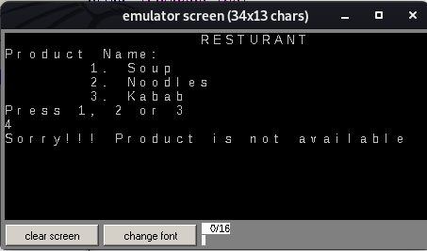PRINTN "Press 1, 2 or 3"

JMP INPUT

I1:

CMP BL, 50

JE CONSOLE2

JNE I2

I2:

CMP BL, 51

JE CONSOLE2

JNE I3

I3:

PRINTN ""

PRINTN "Sorry!!! Product is not available"

JMP EXIT

INPUT:

MOV AH, 01

INT 21H

MOV BH, AL

CMP BH, 51

JLE CONSOLE3

JNE EXIT

CONSOLE3:

CMP BH, 48

JE EXIT

JNE ORDER

ORDER:

PRINTN ""

PRINTN "Thank you for your order!!"

JMP EXIT

EXIT:

MOV AH, 4CH

INT 21H

MAIN ENDP

END MAIN

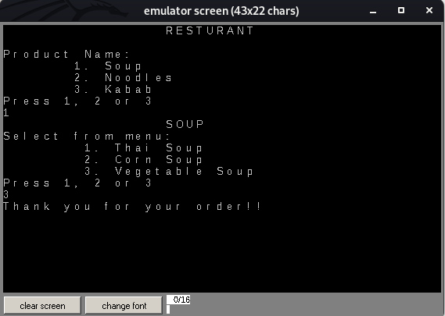

**2. Task 2**

INCLUDE 'EMU8086.INC'

TITLE EQUATION_SOLVING 2A-B+3C

.MODEL SMALL

.STACK 100H

.DATA

A DB ?

B DB ?

C DB ?

CNST1 DB 2

CNST2 DB 3

.CODE

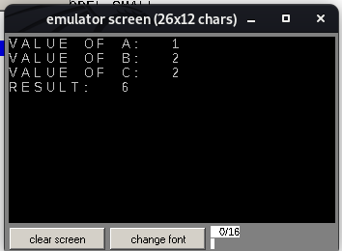MAIN PROC

MOV AX, @DATA

MOV DS, AX

PRINT "VALUE OF A: "

MOV AH, 01

INT 21H

SUB AL, 48

MUL CNST1

MOV A, AL

PRINTN

PRINT "VALUE OF B: "

MOV AH, 01

INT 21H

SUB AL, 48

SUB AL, A

MOV B, AL

PRINTN

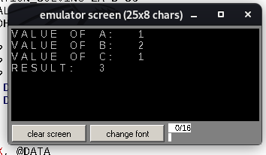PRINT "VALUE OF C: "

MOV AH, 01

INT 21H

SUB AL, 48

MUL CNST2

ADD AL, B

MOV C, AL

ADD C, 48

PRINTN

PRINT "RESULT: "

MOV AH, 02

MOV DL, C

INT 21H

EXIT:

MOV AH, 4CH

INT 21H

MAIN ENDP

END MAIN

**3. Task 3**

INCLUDE 'EMU8086.INC'

.MODEL SMALL

.STACK 100H

.DATA

.CODE

MAIN PROC

MOV AH, 01

INT 21H

MOV BL, AL

CMP BL, 65

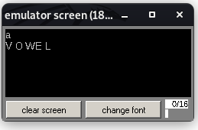JL EXIT

JE VOWEL

JNE V1

V1:

CMP BL, 69

JE VOWEL

JNE V2

V2:

CMP BL, 73

JE VOWEL

JNE V3

V3:

CMP BL, 79

JE VOWEL

JNE V4

V4:

CMP BL, 85

JE VOWEL

JNE V5

V5:

CMP BL, 97

JE VOWEL

JNE V6

V6:

CMP BL, 101

JE VOWEL

JNE V7

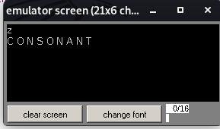

V7:

CMP BL, 105

JE VOWEL

JNE V8

V8:

CMP BL, 111

JE VOWEL

JNE V9

V9:

CMP BL, 117

JE VOWEL

JNE CONSONANT

VOWEL:

PRINTN ""

PRINTN "VOWEL"

JMP EXIT

CONSONANT:

CMP BL, 91

JGE INS

JNE INS2

INS:

CMP BL, 96

JLE EXIT

INS2:

PRINTN ""

PRINTN "CONSONANT"

JMP EXIT

EXIT:

MOV AH, 4CH

INT 21H

MAIN ENDP

END MAIN