# **VLAN**

**What is VLAN?**

**VLANs (Virtual LANs)** are logical grouping of devices in the same broadcast domain. VLANs are usually configured on switches by placing some interfaces into one broadcast domain and some interfaces into another. Each VLAN acts as a subgroup of the switch ports in an Ethernet LAN.

**Benefits of VLAN**

1. Smaller broadcast
2. Improved Security
3. Improved efficiency
4. Reduced cost
5. Better performance
6. Simpler management

**VLAN configuration:**

**Step 1:** Set up all the end device and connect them in switches on FastEthernet port . And also connect switch on Giga port. In this figure all the color box contain a VLAN.

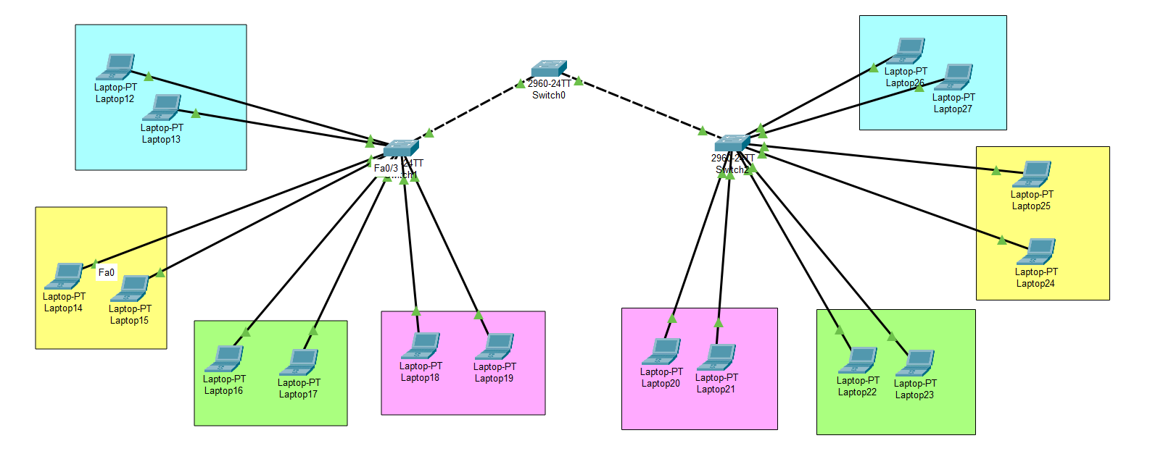

**Step 2:** Configure the ip address all the end devices. All the VLAN network should have different VLAN address so that we can trouble shoot any problem in the long run.

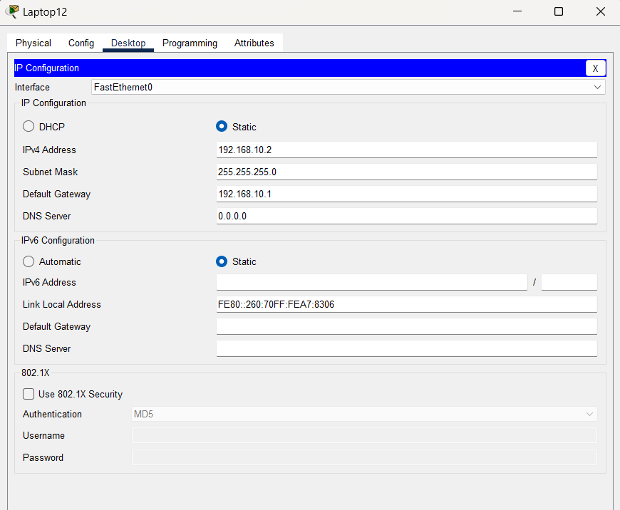

**Step 3:** Define all the VLAN

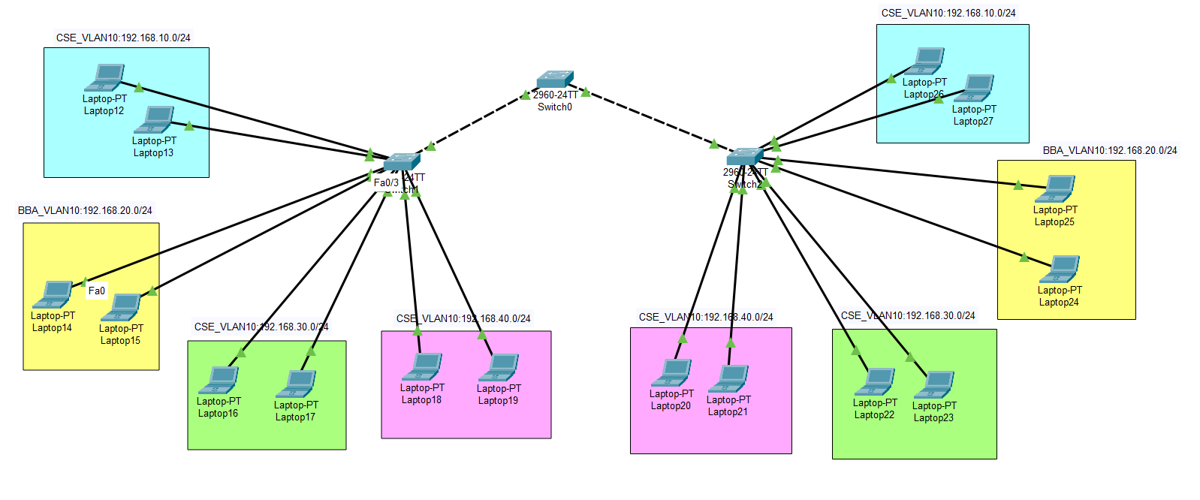

**Step 4:** create vlan with his id also named the network.

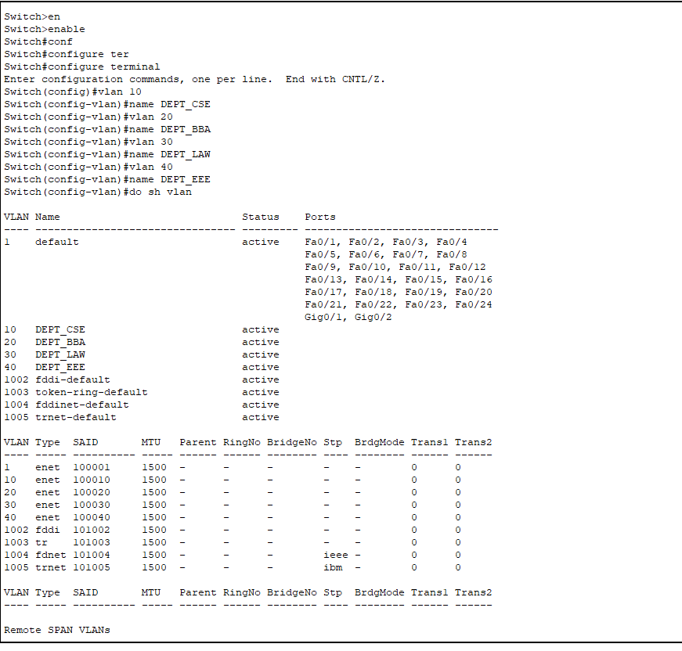

**VLAN has two mode:**

|  |
| --- |
| VLAN |

|  |
| --- |
| Trunk Mode |

|  |
| --- |
| Access Mode |

**Access Mode:** Configure the access mode of switches.

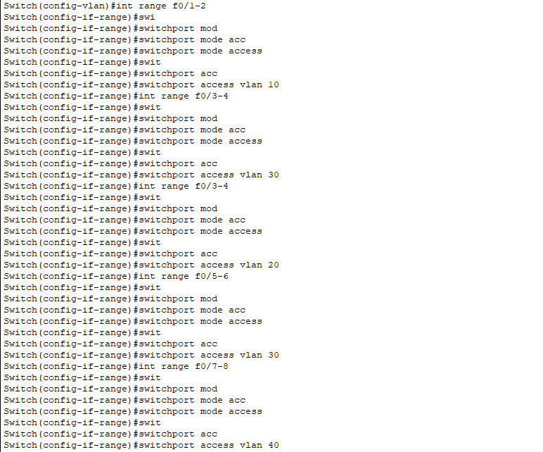

Output of Access mode:

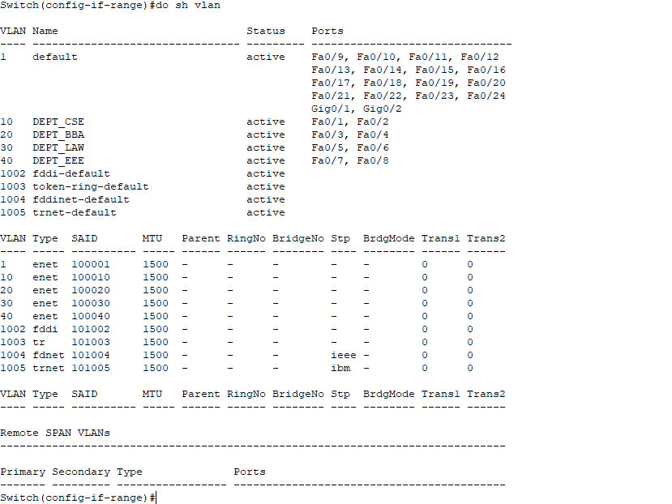

**Trunk Mode:** Configure the trunk mode of switches.

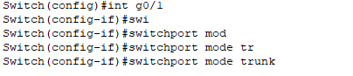

Output:

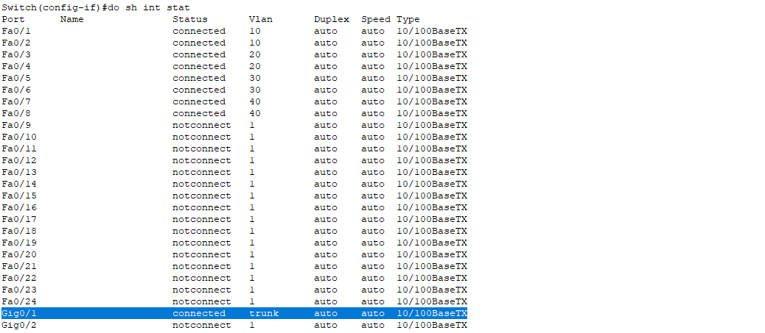

**Configure the layer-1 switch:**

create vlan in this switch. And also trunk the switch so that all data transmit with the id without any blockage.

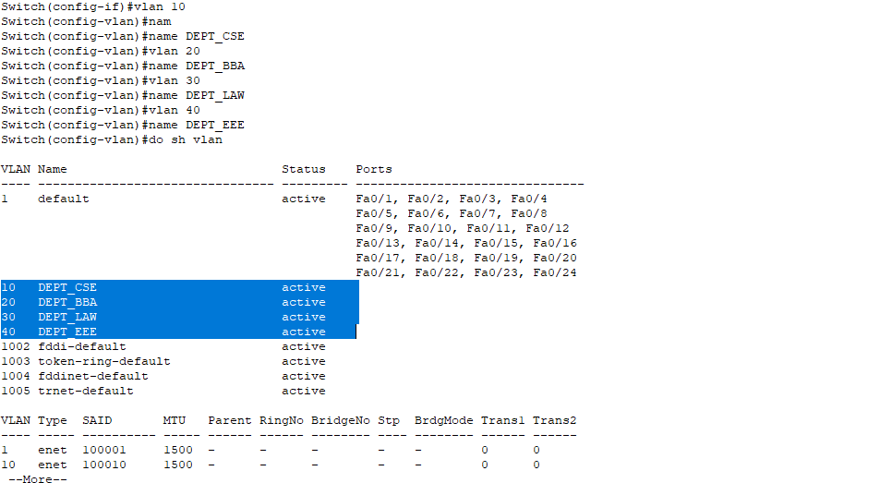

Output the VLAN:

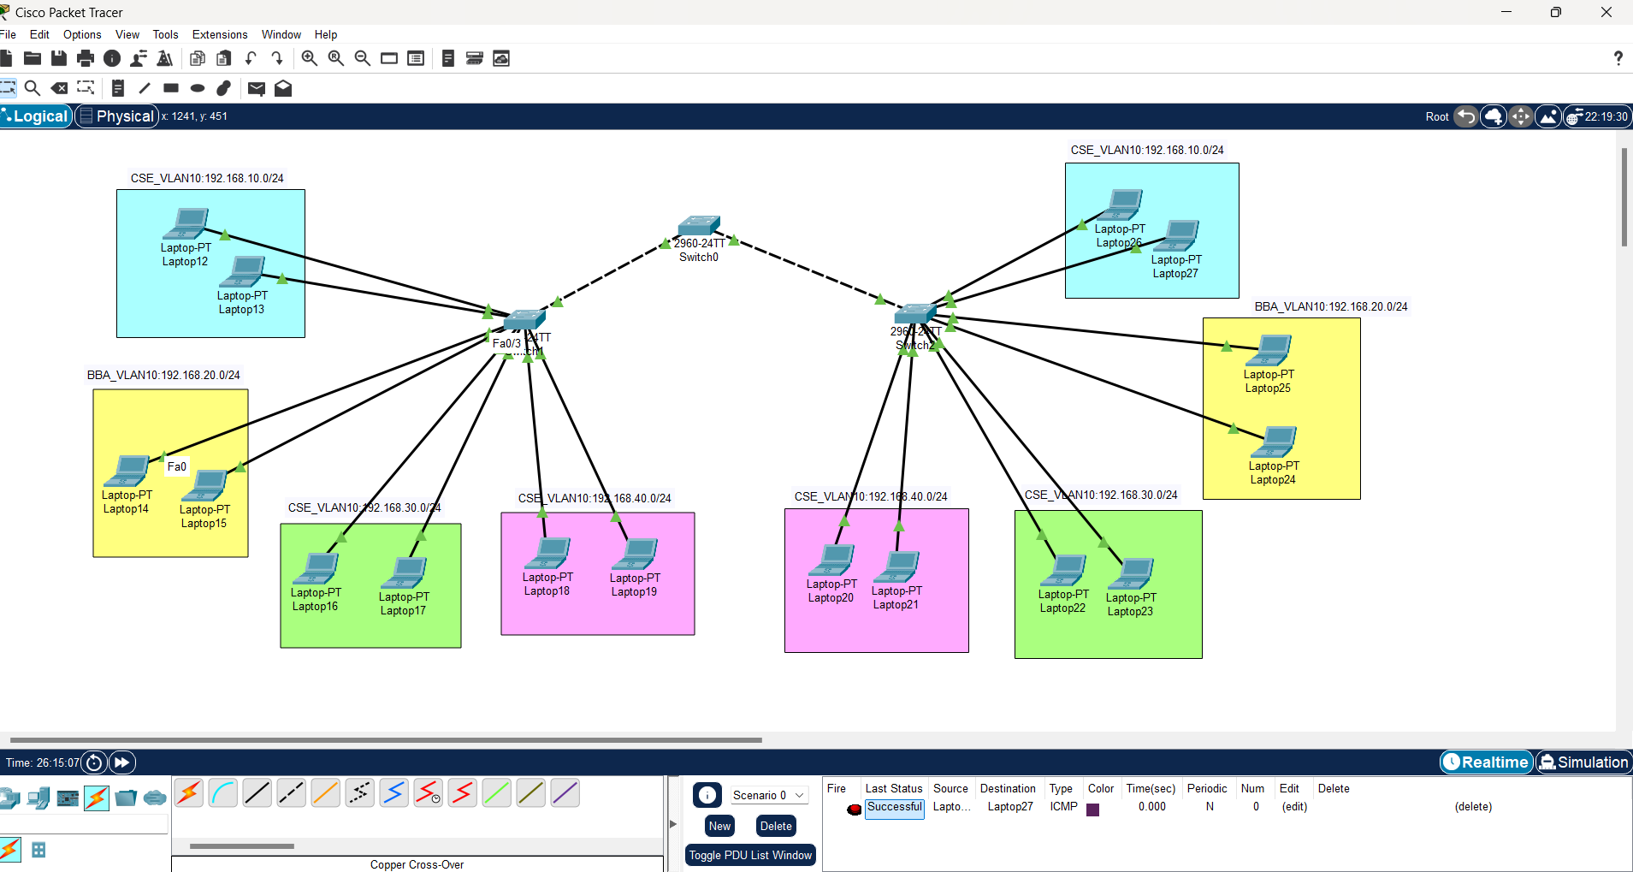

** Check the file ** [VLAN_packetTracer](https://drive.google.com/file/d/1dfvQIIstcBH82aKHckibiay1Z7jqHlFm/view?usp=sharing)

Md Jahidul Islam

Mail: jahidislam1204.bd@gmail.com