**EtherChannel/Link-aggregation**

Ethernet Channel, also known as Link Aggregation or Port Channel, is a networking technology that combines multiple physical Ethernet links into a single logical link.

**Benefits of EtherChannel:**

* Increase Bandwidth
* Provide Redundency

**Lab For EtherChannel:**

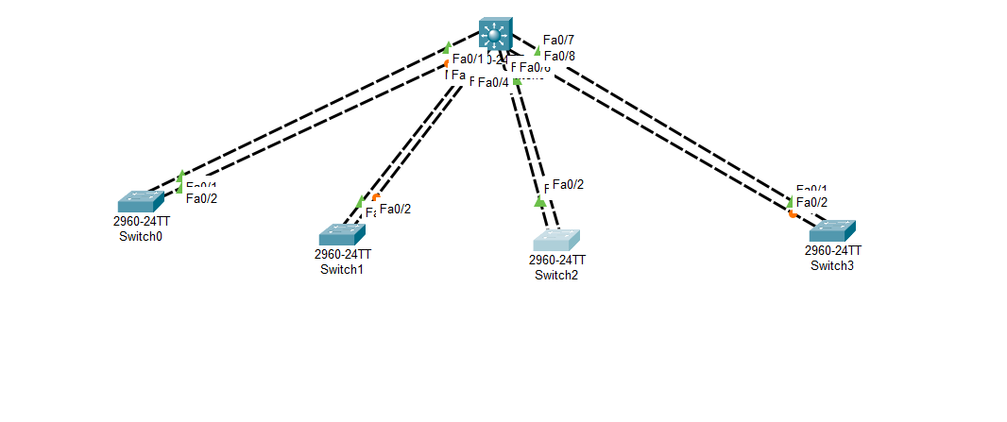

**Create EtherChannel for switch-01:**

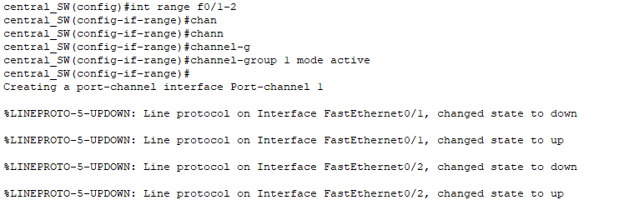

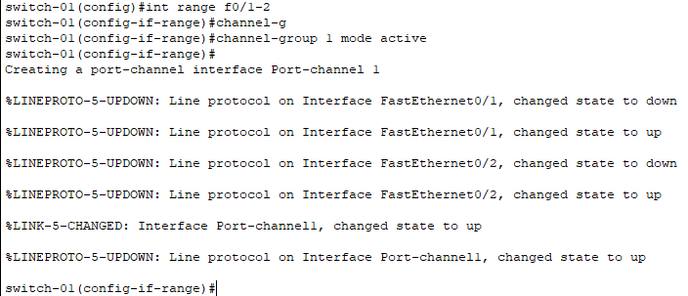

**Create EtherChannel for switch-02:**

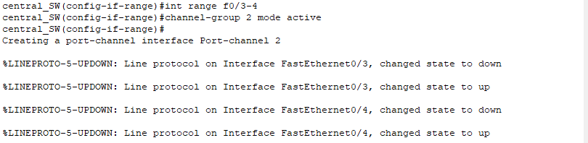

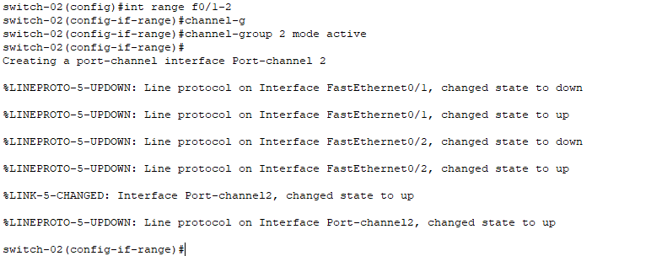

**Create EtherChannel for switch-03:**

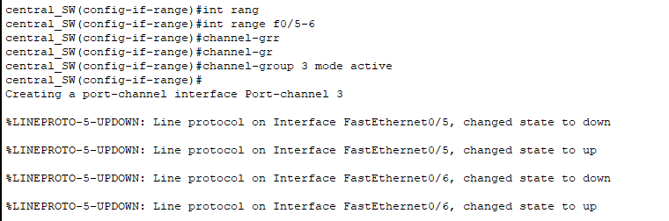

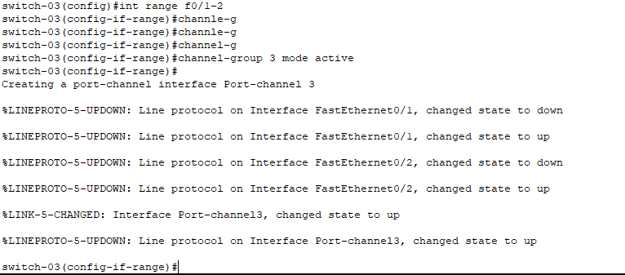

**Create EtherChannel for switch-04:**

