**FTP & TFTP**

**FTP:** FTP (File Transfer Protocol) is a standard network protocol used to transfer files between a client and a server over a network.

**TFTP:** TFTP (Trivial File Transfer Protocol) is a simplified version of FTP used for transferring files over a network.

**\*\*\*** The main difference between FTP and TFTP is FTP needs id password that’s why it is called safe transfer protocol, but TFTP don’t need any id password that is why it is called less safe transfer protocol.**\*\*\***

**TFTP:**

**Network Architecture:**

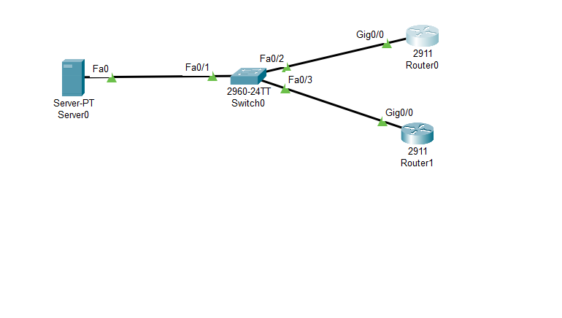

**Required commands are given below:**

**Check version of router software:**

* show version
* show flash:

**Install update version on router:**

* copy tftp: flash:

[server-ip: 192.168.1.10]

[Software model/version that you want to install your router]

* show flash
* config t
* boot system flash:
* exit
* write
* reload

**Cisco Packet Tracer screenshort:**

