**NAT (Network Address Translation)**

**What is NAT?**

NAT (Network Address Translation) is a networking technique used to modify IP addresses in packet headers as they pass through a router. It allows multiple devices on a local network to share a single public IP address when accessing the internet.

**Types of NAT:**

1. **Static NAT** – Maps one private IP to one public IP.
2. **Dynamic NAT** – Assigns a public IP dynamically from a pool of available addresses.
3. **PAT (Port Address Translation)** – A type of NAT that maps multiple private IPs to a single public IP using different ports (also known as NAT Overload).

**Why is NAT Used?**

* **Conserves IPv4 addresses** (since public IPv4 addresses are limited).
* **Provides security** by hiding internal network details.
* Allows multiple devices to access the internet with a single public IP.

**Static NAT Config:**

**Network Architecture:**

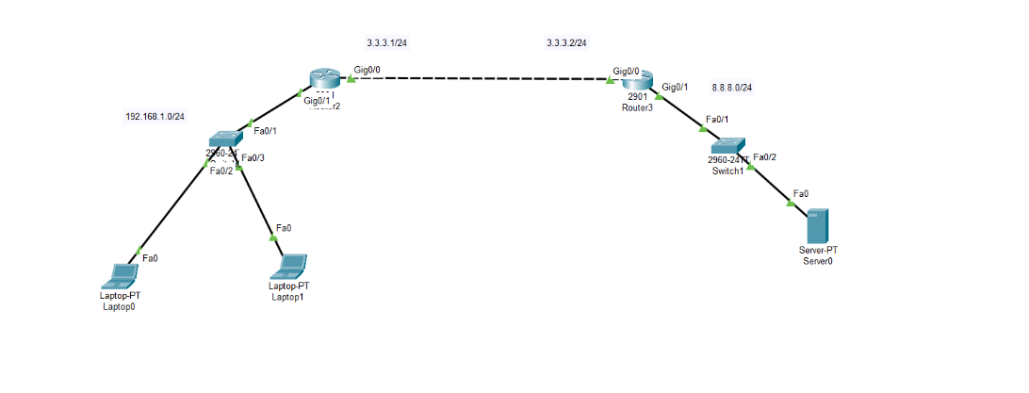

**IP Assign:**

Router 0:

int g0/0

no sh

ip add 3.3.3.1 255.255.255.0

int g0/1

no sh

ip add 192.168.1.1 255.255.255.0

Router 1:

int g0/0

no sh

ip add 3.3.3.2 255.255.255.0

int g0/1

no sh

ip add 8.8.8.1 255.255.255.0

**DHCP Config:**

Router 0:

ip dhcp excluded-address 192.168.1.1 192.168.1.10

ip dhcp pool LAN_POOL

network 192.168.1.0 255.255.255.0

default-router 192.168.1.1

dns-server 8.8.8.8

**Router Config (OSPF):**

Router 0:

router ospf 1

router-id 1.1.1.1

network 192.168.1.0 0.0.0.255 area 0

network 3.3.3.0 0.0.0.255 area 0

Router 0:

router ospf 1

router-id 2.2.2.2

network 3.3.3.0 0.0.0.255 area 0

network 8.8.8.0 0.0.0.255 area 0

**NAT Config:**

Router 0

ip nat inside source static 192.168.1.11 3.3.3.1

int g0/1

ip nat inside

int g0/0

ip nat outside

exit

show ip nat translations

**OUTPUT:**

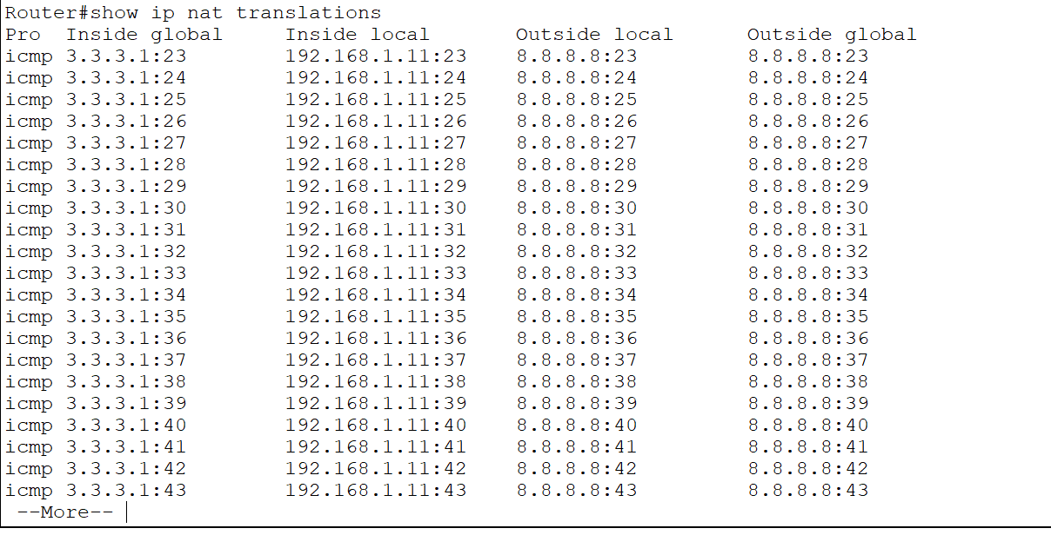

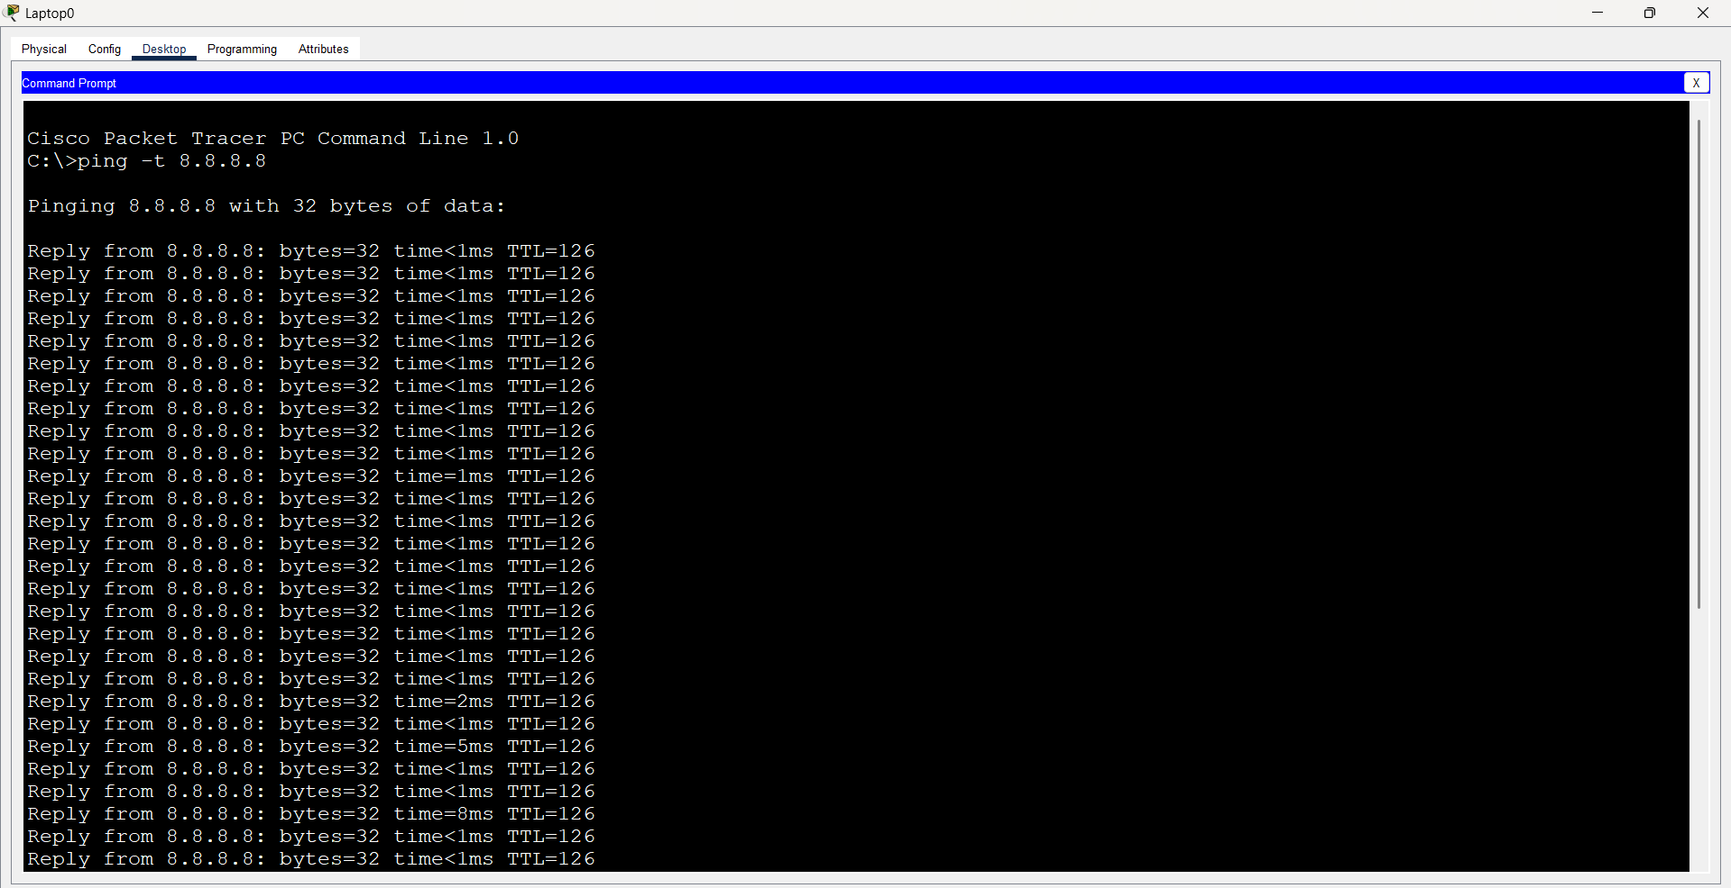

**PAT Config:**

Router 0

int g0/1

ip nat inside

int g0/0

ip nat outside

exit

access-list 10 permit 192.168.1.0 0.0.0.255

ip nat pool NAT_POOL 3.3.3.1 3.3.3.1 netmask 255.255.255.255

ip nat inside source list 10 pool NAT_POOL overload

**output:**

* + show ip nat translation

