**OSPF(Open Shortest Path First)**

**What is OSPF?**

**OSPF (Open Shortest Path First)** is a dynamic routing protocol used in Internet Protocol (IP) networks to determine the best path for data packets. It is based on the **link-state routing** algorithm and is widely used in medium-to-large enterprise networks.

**Why we use OSPF?**

* Highly efficient
* Reliable
* Scable
* Shortest path calculation

**Network Architecture:**

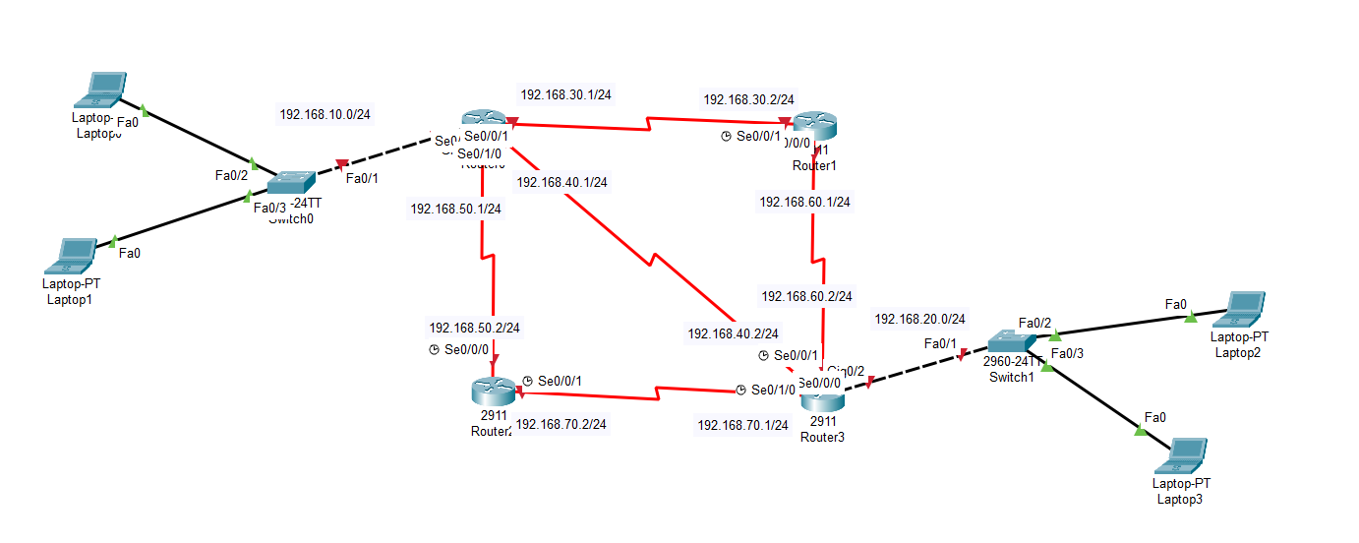

**Ip Configure at each router for every port:**

* enable
* config t

**Router 0:**

Giga port 0/0

* int g0/0
* no sh
* ip add 192.168.10.1 255.255.255.0

Serial port 0/0/0

* int se0/0/0
* no sh
* ip add 192.168.50.1 255.255.255.0

Serial port 0/1/0

* int se0/1/0
* no sh
* ip add 192.168.40.1 255.255.255.0

Serial port 0/0/1

* int se0/0/1
* no sh
* ip add 192.168.30.1 255.255.255.0

**Router 1:**

Serial port 0/0/1

* int se0/0/1
* no sh
* ip add 192.168.30.2 255.255.255.0

Serial port 0/0/0

* int se0/0/0
* no sh
* ip add 192.168.60.1 255.255.255.0

**Router 2:**

Serial port 0/0/0

* int se0/0/0
* no sh
* ip add 192.168.50.2 255.255.255.0

Serial port 0/0/1

* int se0/0/1
* no sh
* ip add 192.168.70.2 255.255.255.0

**Router 3:**

Giga port 0/0

* int g0/0
* no sh
* ip add 192.168.20.1 255.255.255.0

Serial port 0/0/0

* int se0/0/0
* no sh
* ip add 192.168.70.1 255.255.255.0

Serial port 0/1/0

* int se0/1/0
* no sh
* ip add 192.168.40.2 255.255.255.0

Serial port 0/0/1

* int se0/0/1
* no sh
* ip add 192.168.60.2 255.255.255.0

**OSPF Configuration at each router:**

**Router 0:**

* router ospf 1
* router id 1.1.1.1
* network 192.168.10.0 0.0.0.255 area 0
* network 192.168.30.0 0.0.0.255 area 0
* network 192.168.40.0 0.0.0.255 area 0
* network 192.168.50.0 0.0.0.255 area 0

**Router 1:**

* router ospf 1
* router id 2.2.2.2
* network 192.168.30.0 0.0.0.255 area 0
* network 192.168.60.0 0.0.0.255 area 0

**Router 2:**

* router ospf 1
* router id 1.1.1.1
* network 192.168.70.0 0.0.0.255 area 0
* network 192.168.50.0 0.0.0.255 area 0

**Router 0:**

* router ospf 1
* router id 1.1.1.1
* network 192.168.20.0 0.0.0.255 area 0
* network 192.168.60.0 0.0.0.255 area 0
* network 192.168.40.0 0.0.0.255 area 0
* network 192.168.70.0 0.0.0.255 area 0