**VPN (Virtual Proxy Network)**

**What is VPN?**

A **VPN (Virtual Private Network)** is a technology that creates a secure and encrypted connection over a less secure network, such as the internet. It allows users to securely access private networks and share data remotely as if they were directly connected to the network.

**Benefit:**

* Data Secure
* Remote Access

**Network Architecture:**

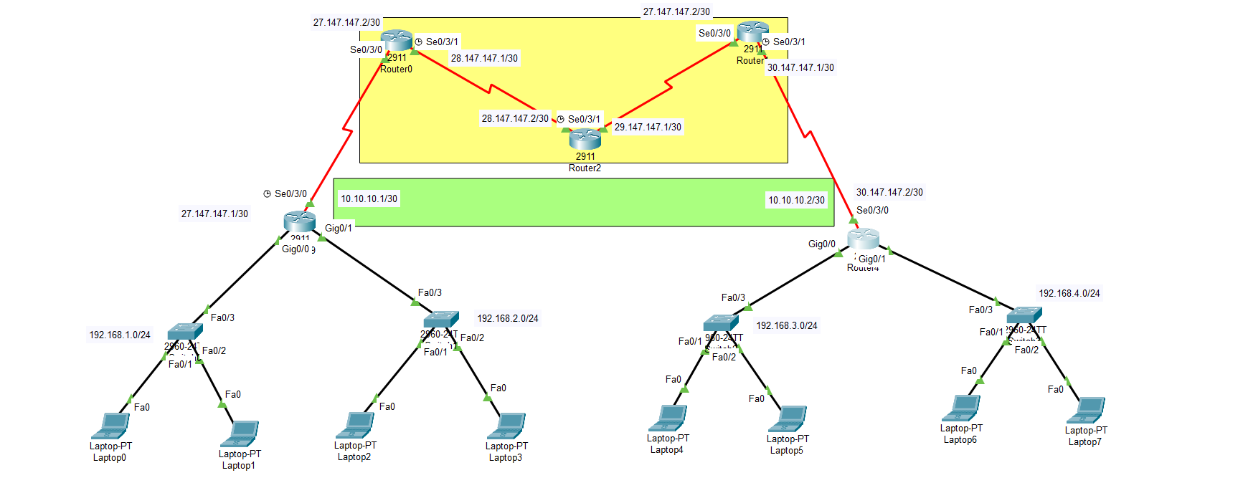

**Step 01 :** Config ip

**Step 02:** Config Routing (I use here OSPF)

**Step 03:** Tunneling between router 0 and router 4

**Tunneling Command:**

**Router 0:**

* int tunnel
* ip add 10.10.10.1 255.255.255.252
* tunnel source se0/3/0
* tunnel destination 30.147.147.2

**Router 1:**

* int tunnel
* ip add 10.10.10.2 255.255.255.252
* tunnel source se0/3/0
* tunnel destination 27.147.147.1