**VTP(virtual trunking protocol)**

**Network Architecture:**

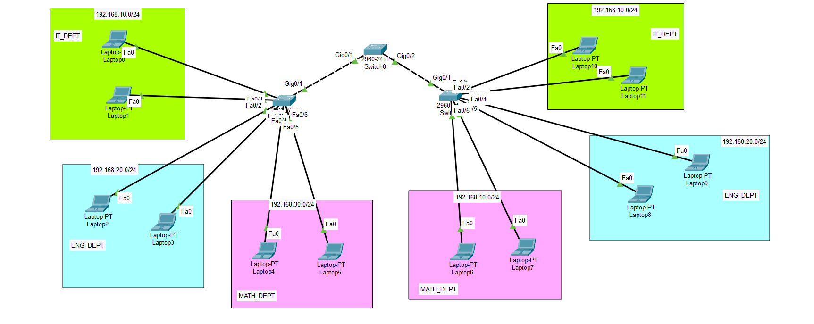

**IP config at each end device:**

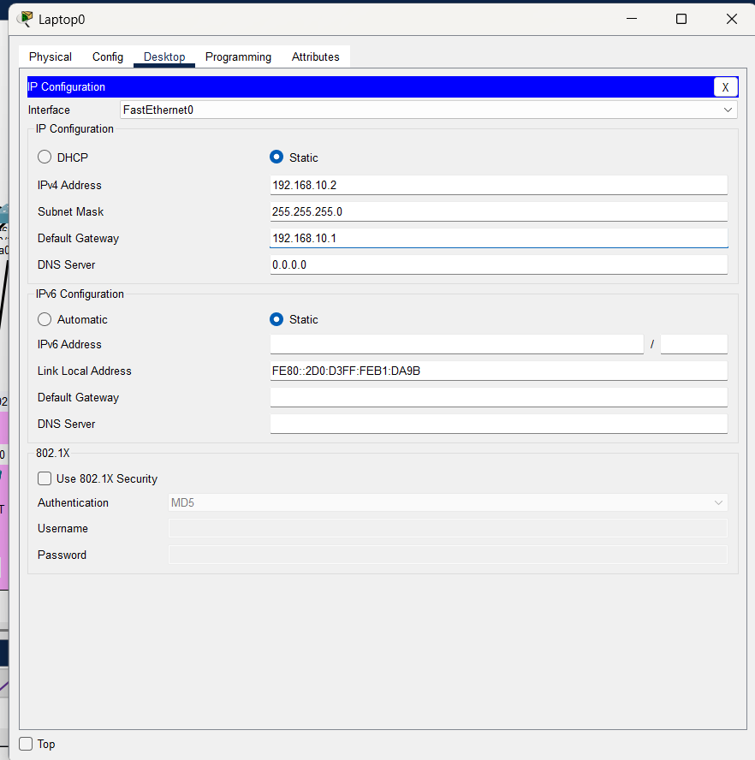

**Create VLAN in left switch:**

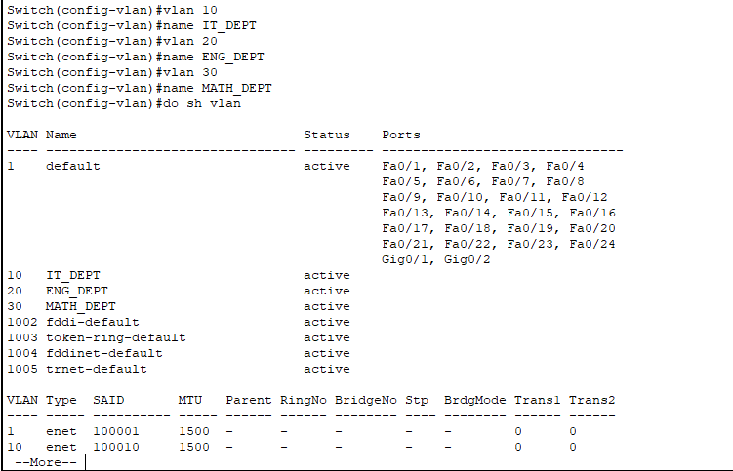

**Assign VLAN in different port:**

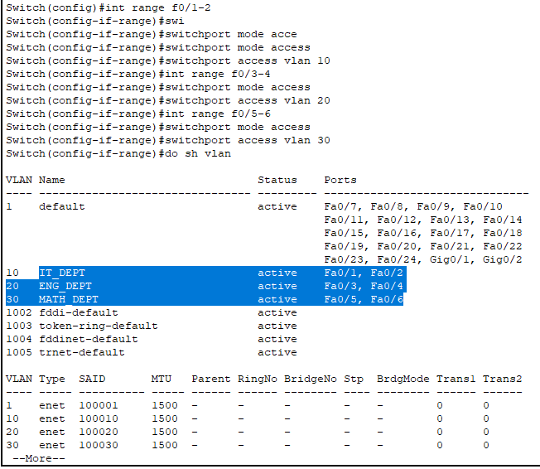

**Check the vtp status of left switch:**

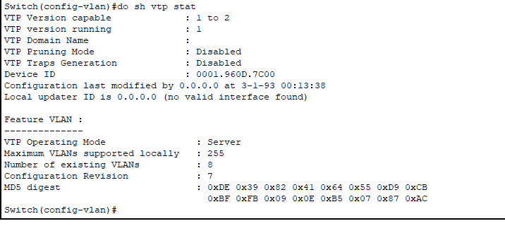

**Check VTP status in the right switch:**

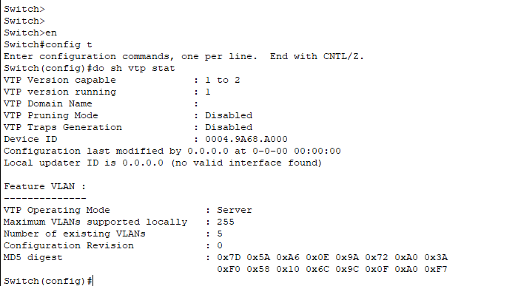

**Check VTP status in the middle switch:**

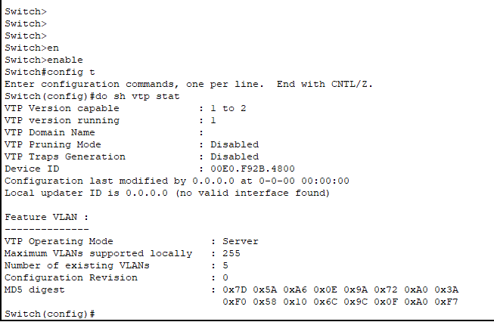

**Trunking the giga port of all switch:**

**Left switch**

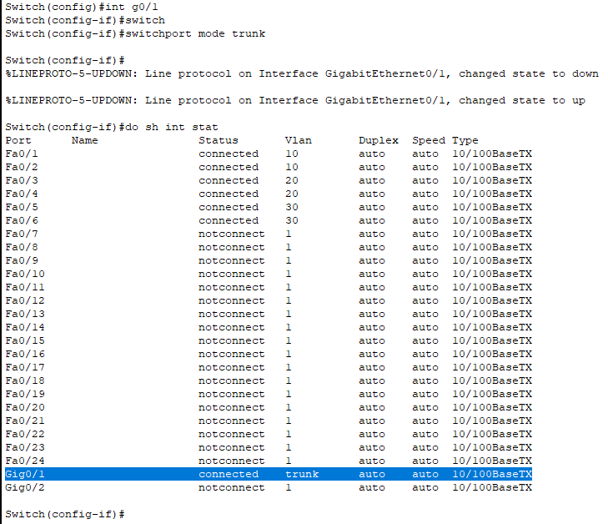

**Middle switch**

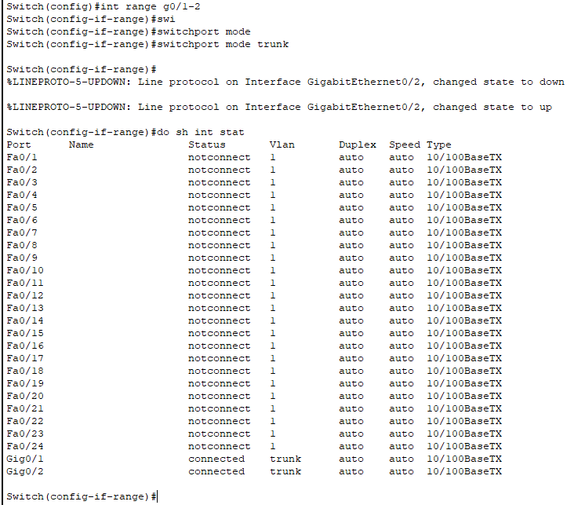

**Right switch**

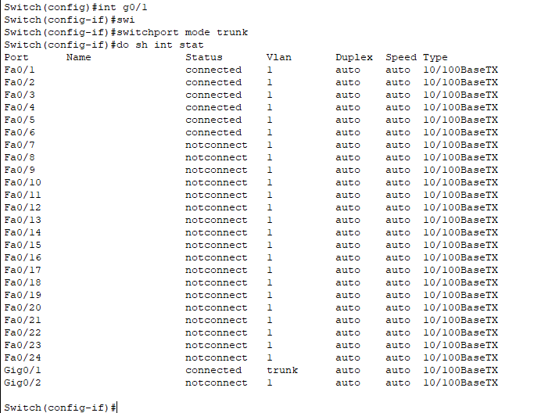

**Set VTP domain name :**

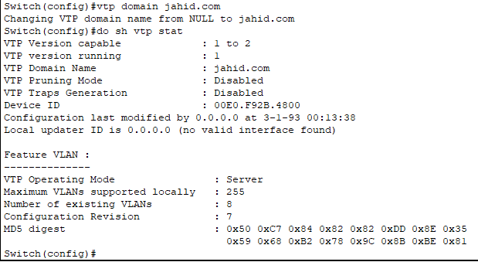

**It update the number of existings VLAN in other switches.**

