**FINAL REPORT**

**Project Name: HealthCare app**

**Submitted To:**

Md. Ishan Arefin Hossain

Faculty initial: IAH

**Submitted By**:

**Group Name: Team Idea**

|  |  |
| --- | --- |
| **Name** | **ID** |
| Jahid Akand Nahid | 1813142642 |
| Mehadi Melon Soykat | 1921950042 |
| Md Ruhan Afride | 1911706042 |

Department: Electrical & Computer Engineering (ECE)

Major: Computer Science Engineering (CSE)

Course Name: Junior Design

Course Code: CSE299

Section: 19

Date of Submission: 6th June 2023

**Declaration page**

By our signatures below, we, the undersigned individuals, certify that we worked together to create the Android health software "Health Care." We declare that each of us has successfully created this application using our specific knowledge and skills.

We note that one team member was instrumental in creating the interface for the app using XML in Android Studio. Their remarkable design skills have produced layouts that are aesthetically pleasing and user-friendly, guaranteeing a simple user experience.

We also accept that a different team member has taken on the duty of writing the Java code for the application. Their adeptness in programming has made it possible to convert creative ideas into working code that incorporates a variety of features and functionalities.

We also acknowledge the contribution of the third member, who is an expert in SQL database management. Their skill in creating and structuring the database has made the application's data storage, retrieval, and management more effective.

We are pleased with the results of our teamwork, which led to the creation of a powerful and feature-rich Android healthcare application. By giving users easy access to healthcare resources, information, and services, "Health Care" will influence the healthcare sector, in our opinion.

**Signed:**

Jahid Akand Nahid

1813142642

Signature: ____________

Mehadi Melon Soykat

1921950042

Signature: ____________

Md Ruhan Afride

1911706042

Signature: ____________

Year: 2023

**Approval:**

**This project is hereby approved from me.**

Md. Ishan Arefin Hossain

Faculty initial: IAH

Signature: ____________

**Acknowledgement:**

Without the help of our beloved teacher and our encouraging parents, the successful creation of the Android Health Care application would not have been possible. We would like to convey our sincere gratitude to them.

We would like to express our profound gratitude to our teacher, [Name of instructor], for his leadership, mentoring, and continuous support during this project. Your knowledge, insightful observations, and helpful criticism were really helpful in developing our abilities and assuring the success of our project. Your support and confidence in our abilities have inspired us to push the envelope and pursue excellence. We really appreciate your support for our expansion and improvement.

We also want to express our sincere gratitude to our parents for their never-ending support, compassion, and confidence in us. Our successes have been made possible by your continuous support and sacrifices. Your support of our goals has motivated us to face obstacles and achieve our goals. We are incredibly appreciative of the love, wisdom, and unshakable faith that you have shown us.

Without our teacher and parents' assistance, direction, and encouragement, this project would not have been possible. Their priceless efforts helped to turn us into the people we are today. We feel incredibly lucky to have such amazing mentors and role models in our lives.

Once more, we would like to express our sincere gratitude to our instructor and parents for their constant support, wisdom, and faith in us during this trip.

**Abstract:**

Healthcare apps now available on the market have a number of issues, such as fragmented user experiences, limited functionality, poor user interface design, a lack of personalization, and insufficient security. To access various healthcare services, users frequently need to hop between many apps, creating an inconsistent experience. These apps might only provide a select number of services, like the ability to buy medications, while excluding crucial ones like the ability to schedule lab tests or find a doctor. In addition, many app user interfaces are challenging to navigate and frequently lack customization possibilities. There are still many security worries surrounding the safeguarding of personal health information. Therefore, a better healthcare app is required, one that offers customers a seamless, thorough, user-friendly, personalized, and secure experience. Healthcare app issues have led to the creation of solutions on the market that are meant to enhance user experiences. The use of integrated platforms that provide a wide range of services in a single app, improved functionality like telemedicine and personalized health tracking, user-centric design centred on simple interfaces, personalization and customization based on user data, and increased data security measures are a few examples. These developments aim to give users a more secure, individualized, smooth, and functional healthcare experience. Our healthcare app offers an integrated platform with extensive capabilities to address the issues currently present in healthcare apps. One app provides users with access to lab testing, drug purchases, doctor search, health content, and order management. While personalized features provide customized health suggestions and appointments based on user choices, the user-friendly design guarantees a flawless experience. User data is protected and privacy is maintained by strong security measures. Our software offers a superior solution by solving these problems and delivering a practical, thorough, user-friendly, personalized, and secure healthcare experience. Due to its distinct combination of comprehensive services, seamless integration, personalization, user-friendly design, strengthened security measures, and dedication to ongoing improvement, our Healthcare app outperforms competitors in the market. Our platform, in contrast to many other apps, provides a variety of services, such as lab testing, drug purchases, doctor search, health publications, and order management, all in one location. A seamless and easy user experience, tailored recommendations, strong data security, and continual upgrades based on user feedback are all advantages for users. With these benefits, our app offers a better option for people looking for a quick, individualized, and safe healthcare experience.

**Table of content**

Declaration page___________________________________________________________________2

Approval________________________________________________________________________3

Acknowledgement_________________________________________________________________4

Abstract__________________________________________________________________________5

Introduction____________________________________________________________________7-8

Literature review_______________________________________________________________9-11

Motivation_____________________________________________________________________12

Aim/Goal_______________________________________________________________________13

Specification/Features of the project_________________________________________________14

Application of the project in real life________________________________________________15

Required tools__________________________________________________________________16

Tentative schematic diagram/flow chart of the project and short description_______________17-23

Projected plan___________________________________________________________________24

Methodology_________________________________________________________________25-26

Design Implementation__________________________________________________________27-47

Results Analysis and Evaluation_____________________________________________________48

Future work______________________________________________________________________49

Conclusion______________________________________________________________________50

Contribution_____________________________________________________________________51

References______________________________________________________________________52

Appendix_____________________________________________________________________53-

**List of Figure**

Figure 1: Use Case Diagram_________________________________________________________17

Figure 2 : Class Diagram____________________________________________________________22

Figure 3: Sequential Diagram________________________________________________________23

Figure 4: Database implementation____________________________________________________26

**Introduction:**

Accessibility to high-quality healthcare services is essential in the fast-paced world of today. Healthcare apps have become useful tool for consumers to manage their healthcare needs as a result of the growing use of smartphones and mobile applications. The market's current healthcare apps, however, frequently fall short of offering a thorough and seamless user experience. Due to this, there is a demand for a creative solution that addresses user issues and provides a better healthcare app experience.

Currently, available healthcare applications have a number of flaws that make it difficult for them to live up to user expectations. The user experience is fragmented, which is a noticeable problem. Numerous healthcare apps only cover one or a few parts of healthcare services, which gives customers a fragmented experience. They frequently have to move between many apps in order to access services like scheduling lab tests, buying medications, making doctor's visits, and getting health information. In addition to taking up time, this fragmentation causes dissatisfaction and inefficiency.

Users are also challenged by the restricted functionality of the available healthcare apps. Some apps merely provide a select number of services, such as the ability to buy medications, while excluding crucial ones like the ability to schedule lab tests or find doctors. This incomplete functionality prevents users from having access to a variety of healthcare services on a single platform, which increases the inconvenience.

Additionally, a lot can be desired in terms of user interface design for many healthcare apps. Users may find it challenging to browse and find the information or services they need if the screens are cluttered, the menus are complicated, or the layouts are unclear. A bad user interface not only degrades the user experience but also deters users from fully utilizing the program.

Another area where current healthcare applications fall short is personalization. Users expect applications to meet their particular healthcare requirements since they are unique. While providing a generic user experience that inadequately addresses unique preferences, conditions, or interests, many apps lack personalization tools. A one-size-fits-all strategy is produced as a result, which might not be adequate to address the varied needs of consumers looking for individualized healthcare information and services.

In addition to these difficulties, customers' main worries about healthcare apps relate to data security and privacy. Because health information is so delicate, customers want reassurance that the app would protect their personal information. Some currently available healthcare apps might have flaws that jeopardize user data, potentially exposing it to privacy violations or illegal access. Users' reluctance to fully utilize healthcare applications for their requirements is further hampered by their lack of confidence in the security of the app.

Our team has created the Healthcare app to solve these issues and give users a better healthcare app experience. By providing a user-friendly and comprehensive platform that goes beyond the constraints of current healthcare apps, our app promises to transform the way consumers access and manage healthcare services.

The Healthcare app differentiates itself from the competition by offering a platform that is integrated and unifies multiple healthcare services into a single app. Lab testing, drug purchases, doctor searches, health articles, order management, and secure user authentication are all accessible to users in one location. Users no longer have to switch between various apps or platforms, providing a convenient and seamless experience.

Our app's extensive functionality is one of its main advantages. We have added a broad range of services to fulfil the varied demands of customers, in contrast to other healthcare applications that concentrate on particular services. Our app offers a comprehensive healthcare solution, whether it's scheduling lab tests, buying prescriptions, finding doctors, reading healthcare articles, or managing orders.

Our app is made with a user-centric design philosophy to improve user experience. We recognize the value of a user-friendly design, which is why our app has simple navigation, an organized information architecture, and eye-catching layouts. Users may simply get the necessary information, locate the needed services, and move through the app.

The foundation of our app is personalization. Every user has different healthcare needs and preferences, and we acknowledge this. We provide personalized health advice, appointment scheduling based on user preferences, and curated health articles that match particular ailments or interests by leveraging user data and preferences. Users will have a more positive user experience as a result of the personalization, which guarantees that users receive individualized and pertinent healthcare information.

Our Healthcare app places a high priority on data security and privacy. To safeguard user data and maintain privacy, we have put strong security measures in place. Our program incorporates encryption techniques, safe login procedures, and adherence to privacy laws like the HIPAA (Health Insurance Portability and Accountability Act). Customers can rest easy knowing that the app protects their private health information.

The Healthcare app addresses the issues that users of healthcare apps now encounter on the market. Our software offers a superior option for consumers looking for a seamless, complete, user-centric, personalized, and safe healthcare app experience by providing an integrated platform, full functionality, user-friendly interface, personalization, and strong security measures. With the help of our app, users can easily manage their healthcare needs, access a variety of healthcare services, and take charge of their well-being.

**Literature review:**

1.A Systematic Review of Healthcare Applications for Smartphones

This study conducted a systematic review of healthcare applications for smartphones. The authors searched MEDLINE and EMBASE databases for articles published between 2005 and 2011. They included articles that described the development, evaluation, or use of smartphone-based software for healthcare professionals, medical or nursing students, or patients. The authors found a total of 83 applications, which they classified into 5 categories: disease diagnosis, drug reference, medical calculators, literature search, and clinical communication. The authors concluded that smartphone-based healthcare technologies have the potential to improve healthcare delivery, but more research is needed to assess their effectiveness. [1]

2. Health-Related Smartphone Applications: A Literature Review

This study conducted a literature review of health-related smartphone applications. The authors searched MEDLINE, EMBASE, and PsycINFO databases for articles published between 2004 and 2012. They included articles that described the development, evaluation, or use of smartphone-based software for healthcare professionals, medical or nursing students, or patients. The authors found a total of 1,262 applications, which they classified into 10 categories: disease management, chronic disease management, mental health, fitness and wellness, pregnancy and parenting, medical education, drug reference, clinical decision support, and research. The authors concluded that smartphone-based health-related applications have the potential to improve healthcare delivery, but more research is needed to assess their effectiveness. [2]

3. The Use of Mobile Phones in Healthcare: A Systematic Review of the Literature

This study conducted a systematic review of the literature on the use of mobile phones in healthcare. The authors searched MEDLINE, EMBASE, and PsycINFO databases for articles published between 2000 and 2012. They included articles that described the use of mobile phones for healthcare purposes, such as patient education, clinical decision support, and remote monitoring. The authors found a total of 2,175 articles, which they classified into 10 categories: patient education, clinical decision support, remote monitoring, medication adherence, chronic disease management, mental health, emergency medicine, research, and others. The authors concluded that mobile phones have the potential to improve healthcare delivery, but more research is needed to assess their effectiveness. [3]

4. Mobile Health Applications: Current State and Future Trends

This study provides an overview of the current state of mobile health (mHealth) applications. The authors discuss the different types of mHealth applications, the benefits and challenges of using mHealth applications, and the future trends of mHealth. The authors conclude that mHealth applications have the potential to revolutionize healthcare delivery, but more research is needed to assess their effectiveness. [4]

5.The Potential of Mobile Health Apps to Improve Patient Outcomes

This review article discusses the potential of mobile health apps to improve patient outcomes. The authors discuss the various ways that mobile health apps can be used to improve patient care, including providing information and education, monitoring patient health, and supporting patient self-management. They also discuss the challenges of developing and implementing effective mobile health apps, such as ensuring the quality of the apps and ensuring that patients are able to use them effectively. [5]

6.The Use of Mobile Health Apps in Chronic Disease Management

This review article discusses the use of mobile health apps in chronic disease management. The authors discuss the various ways that mobile health apps can be used to help patients with chronic diseases manage their conditions, such as tracking symptoms, monitoring medication adherence, and providing support and encouragement. They also discuss the challenges of using mobile health apps in chronic disease management, such as ensuring that the apps are tailored to the specific needs of patients with chronic diseases and ensuring that patients are able to afford the apps. [6]

7.The Use of Mobile Health Apps in Mental Health Care

This review article discusses the use of mobile health apps in mental health care. The authors discuss the various ways that mobile health apps can be used to help people with mental health conditions, such as tracking symptoms, providing education and support, and connecting with other people with mental health conditions. They also discuss the challenges of using mobile health apps in mental health care, such as ensuring that the apps are evidence-based and that they are not harmful to patients. [7]

8.The Future of Mobile Health Apps

This review article discusses the future of mobile health apps. The authors discuss the potential of mobile health apps to revolutionize healthcare, and they discuss the challenges that need to be overcome in order to realize this potential. They also discuss the role that healthcare providers can play in the development and use of mobile health apps. [8]

9.The Impact of Mobile Health Apps on Patient Engagement

This review article discusses the impact of mobile health apps on patient engagement. The authors discuss the various ways that mobile health apps can be used to engage patients in their care, including providing education and support, tracking health data, and providing reminders for appointments and medication. They also discuss the challenges of engaging patients in their care, such as ensuring that the apps are user-friendly and that patients are able to afford the apps. [9]

10.The Use of Mobile Health Apps for Preventive Care

This review article discusses the use of mobile health apps for preventive care. The authors discuss the various ways that mobile health apps can be used to promote preventive care, such as providing education and support, tracking health data, and providing reminders for screenings and vaccinations. They also discuss the challenges of using mobile health apps for preventive care, such as ensuring that the apps are tailored to the specific needs of patients and that patients are able to use them effectively. [10]

11.The Use of Mobile Health Apps for Clinical Decision Support

This review article discusses the use of mobile health apps for clinical decision support. The authors discuss the various ways that mobile health apps can be used to provide clinicians with information and support, such as providing patient data, clinical guidelines, and decision trees. They also discuss the challenges of using mobile health apps for clinical decision support, such as ensuring that the apps are accurate and up-to-date and that clinicians are able to use them effectively. [11]

12.The Regulation of Mobile Health Apps

This review article discusses the regulation of mobile health apps. The authors discuss the various laws and regulations that apply to mobile health apps, such as the Food and Drug Administration (FDA) regulations, the Health Insurance Portability and Accountability Act (HIPAA) regulations, and the Children's Online Privacy Protection Act (COPPA). They also discuss the challenges of regulating mobile health apps, such as the rapid pace of development and the global nature of the industry. [12]

**Motivation:**

The growing significance of digital solutions in the healthcare sector and the deficiencies of the existing healthcare apps served as the impetus for the development of a healthcare app. The goal to enhance user experience and overcome the difficulties users encounter while using mobile applications to get complete healthcare services is the driving force for the selection of this issue.

The healthcare industry is extremely important to people's lives, and the growing reliance on technology offers a chance to improve how healthcare services are provided and accessible. With the widespread usage of smartphones and the rising need for easily available healthcare information and services, the need for practical and effective healthcare solutions has grown.

The idea to create a healthcare app was sparked by realizing the issues that were already present in the industry. Numerous healthcare apps had inadequate user interface designs, fragmented user experiences, limited functionality, worries about data security, and a lack of personalization. These problems offered a chance to develop a better answer that would deal with these difficulties and offer a more seamless, thorough, user-friendly, and secure healthcare app experience.

Additionally, the desire to create this healthcare app was fueled by the conviction that technology has the ability to empower people to take charge of their health and well-being. We want to give customers a tool that enables them to effortlessly access and manage their healthcare needs by developing a user-centric and integrated platform that delivers a wide range of healthcare services, individualized suggestions, and strong data protection.

Users should be able to quickly navigate between different healthcare services, obtain pertinent information, communicate with healthcare specialists, and make informed decisions about their health in order to make healthcare more accessible, effective, and tailored for them.

The desire to address the shortcomings of current healthcare apps and offer a better solution that enhances user experience, increases accessibility to healthcare services, and empowers people to take charge of their health in the digital age was the driving force behind selecting the topic of developing a healthcare app.

**Aim:**

The Healthcare app's development goal is to produce a comprehensive, user-friendly, and secure platform that transforms how people manage and receive healthcare services. Our objective is to address market issues including fragmented user experiences, limited functionality, bad user interface design, a lack of personalisation, and worries about data security.

Our goal is to simplify the user experience and make it easier for people to access a variety of healthcare services by providing an integrated platform that incorporates diverse healthcare services into a single app. We work hard to offer users a comprehensive healthcare solution that entails ordering lab tests, buying medications, looking for doctors, reading health articles, managing orders, and securely authenticating users.

Another essential component of our objective is personalization. To give personalized health advice, appointment scheduling based on user preferences, and curated health articles that match particular ailments or interests, we hope to use user data and preferences. We want to give customers useful and pertinent healthcare information and services by customizing the app to their needs.

Privacy and data security are of utmost importance to us. We are dedicated to putting in place strong security measures, such as encryption technologies, safe login procedures, and adherence to privacy laws. Our goal is to preserve user data and foster user trust by ensuring them that the app would keep their private health information secure.

Our ultimate goal is to promote accessibility to healthcare services, enhance the overall user experience, and enable people to take charge of their health and wellbeing. In order to provide customers with a seamless, thorough, user-centric, personalized, and secure healthcare app experience, we want our Healthcare app to be their first option. Our mission is to positively impact the healthcare sector by providing a superior solution that satisfies users' changing expectations in the digital age. We do this by continual improvement and a dedication to addressing user needs.

**Specification/Features of the project:**

1. **User Login System:** The app has a safe user login system that enables users to sign in with their existing credentials or create new accounts. This guarantees confidentiality and individualized use of the app's capabilities.
2. **User Registration:** Users can establish new accounts within the app by entering the necessary data, such as their name, contact information, and email address. As a result, users' data is safely saved and tailored features are enabled.
3. **Lab Test Booking:** The app has a feature that enables users to schedule different medical lab tests. Users can browse a list of available exams, pick the ones they want, and then add them to their basket to schedule them later. This makes scheduling lab tests simpler and enables customers to effortlessly manage their healthcare requirements.
4. **Purchase of Medicine:** Through the app, users have the ability to buy medications. The app offers a list of accessible drugs along with pertinent details including dosage recommendations, costs, and availability. Users can proceed with the purchase, track their orders, and add the necessary prescriptions to their cart.
5. **Find a Doctor:** The app provides a thorough list of medical professionals from a variety of specializations. Users get access to a variety of categories, including family doctors, dieticians, dentists, surgeons, cardiologists, and more. Users can examine a list of doctors, along with their biographies, credentials, and availability, within each category. Based on their unique needs, users can utilize this function to locate and schedule appointments with healthcare providers.
6. **Health Articles:** The app has a section with articles and advice on maintaining good health. Users have access to a selection of educational materials on a range of health-related subjects, including preventive, general health, lifestyle advice, and specific conditions. This function offers useful health information and encourages app users to learn more about their health.
7. **Order Details:** The app gives users a central location to see and manage their orders. Users can keep track of their scheduled doctor's appointments, drug purchases, and lab tests. The users can keep organized thanks to this feature, which makes their healthcare-related activities transparent and simple to access.

**Application of the project in real life**

The Healthcare app has a wide range of real-world applications and provides concrete advantages to patients, healthcare professionals, and the healthcare sector as a whole. The project's main applications are listed below:

* **Convenient Access to Healthcare Services:** With the help of the app, users may easily access a variety of healthcare services either at home or on the move. Users may quickly navigate the app and receive the services they require without the burden of actual visits or using numerous platforms, whether it be scheduling lab tests, buying drugs, finding doctors, or browsing health articles.
* **Healthcare Needs Management Made Simple:** The software offers consumers a consolidated platform to manage their healthcare requirements. They can keep track of and manage all of their doctor's appointments, prescription orders, and lab test appointments in one location. This improves overall efficiency by streamlining the management of the healthcare system and lowering administrative responsibilities.
* **individualized Healthcare suggestions:** The app provides individualized healthcare suggestions based on user preferences and data. Personalized recommendations are given to users based on their individual health issues, interests, and preferences. People are able to make better judgments regarding their health and well-being because to this individualized approach.
* **Improved Doctor-Patient Communication:** The app makes it easier for patients and doctors to communicate. Users can quickly read doctor profiles, make appointments, and search for doctors based on their specialty. This clear and efficient line of communication promotes stronger doctor-patient bonds, expands access to medical specialists, and improves patient care all around.
* **Health Education and Awareness:** The app has a section for health articles that gives users useful knowledge on a range of health-related topics. Access to information on general health, specific conditions, prevention advice, and lifestyle suggestions is available to users. This encourages health education, increases awareness, and gives people the power to choose healthier options.
* **Improved Efficiency for Healthcare Professionals**: The Healthcare app makes administrative procedures more efficient and eliminates manual tasks, which helps healthcare professionals. Through the app, doctors can schedule appointments, see patient records, and interact with patients more effectively. As a result, the workflow is improved overall, productivity is increased, and healthcare providers are better able to concentrate on providing high-quality care.
* **Data Analysis and Insights:** The app generates information on user preferences, medical trends, and service usage patterns. Research studies, public health efforts, and healthcare plans can all be improved by analyzing aggregated and anonymized data. This data-driven strategy promotes evidence-based judgment and allows the healthcare sector to adapt and develop.

**Required tools:**

Several tools and technologies are needed to create the Healthcare app. Here is a list of necessary tools along with a brief explanation of each one's function:

1. **Programming Languages:** Java may be the main language used to create the application. Android applications can be created using Java because it is a popular, reliable, and platform-independent language.
2. **Android App Development:** The integrated development environment (IDE) most frequently used for Android app development is called Android Studio. It is the favored option for developing Android applications since it offers a complete set of tools and functionality, including a code editor, emulator, and debugging capabilities.
3. **Database management:** The app's database is managed using SQL (Structured Query Language). An RDBMS's relational database management system (SQL) enables developers to define, manipulate, and retrieve data from the system. It makes data storage and retrieval efficient, ensuring the backend of the app runs without a hitch.
4. **User Interface Design:** The user interface (UI) of the application can be designed using programs like Adobe Photoshop. Advanced Photoshop tools are available for designing UI components, unique visuals, and icons that improve the user experience as a whole.
5. **Integration of Google Login:** The Google Sign-In API can be used to provide Google Login functionality to the program. This API offers a simple and safe means of authentication by enabling users to log into the app using their Google credentials.
6. **Hardware Requirements**: A PC or laptop with enough processing power and memory to execute the development tools smoothly is needed to create the Healthcare app. Additionally, testing and debugging the app while it is still in development requires an Android device or emulator.

**Tentative schematic diagram/flow chart of the project and short description:**

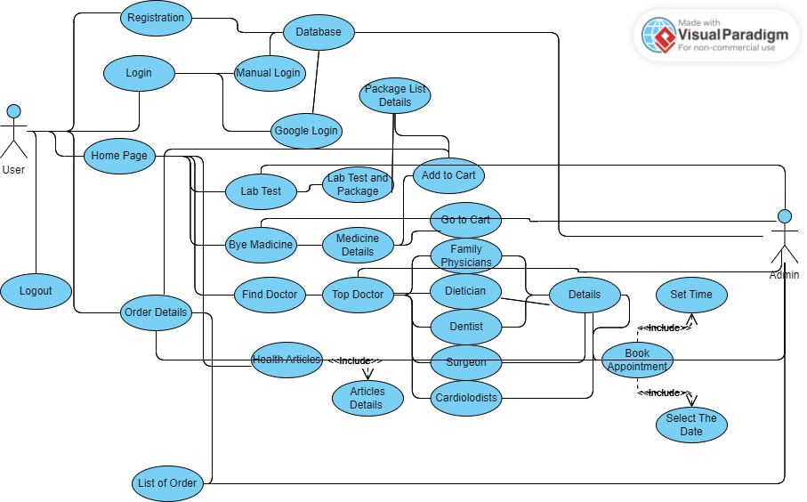

Figure 1: Use Case Diagram

**user Login to System:** The scenario where a user wants to log into the Healthcare app is represented by the "User Login to System" use case. In order to log in, the user must first enter their username and password on the login interface. The system then verifies authentication using the supplied username and password. The user is successfully logged into the system and given access to the app's main interface if the entered credentials match the values saved. However, the user is informed of the unsuccessful login attempt if the authentication fails because of an invalid username or password. When an exception occurs, such as when there isn't a database connection, the system shows the proper error message. The Healthcare app needs to be installed on the user's smartphone in order for this use case to work. The postconditions are either a successful login that gives the user access to the app's functionality or a failed login that prompts the user to submit their credentials again.

|  |
| --- |
| **Use case name: user Login to System** |
| **Actor:** user  **Scenario/Description:**  Input username and password  Check username and password (use authentication)  **Exception:**  No database connection  **Precondition:**  Must have this app  **Post Condition:**  Successful login  Login Failed (invalid user and password) |

**create New Account:** When a user wants to register a new account in the Healthcare app, such a situation is described by the "Create New Account" use case. The user types in their chosen username, email address, password, and password confirmation. The system checks the entered data for accuracy, confirming that the password and confirmation are identical and that all essential fields have been filled in. The user's registration information is inserted into the database, creating a new account, if the validation is successful. The user can log in after receiving a notification that their account has been created following successful registration. The user is prompted to enter the required information accurately if there is any missing data or passwords that don't match.

|  |
| --- |
| **Use case name: create New Account** |
| **Actor:** user  **Scenario/Description:**  Input username  Input Email  Input Password  Confirm Password  **Exception:**  No database connection  **Precondition:**  Must have this app  **Post Condition:**  Successful Registration (record Inserted)  Registration Failed (full up the Details) |

**Lab Test:** A user accesses the Healthcare app and chooses lab tests in the "Lab Test" use case. The user can browse the list of available lab tests, select the ones they want to purchase, and then check out. The necessary error messages are presented in the event of any exceptions, such as a problem with the database connection. Installing the Healthcare app is one of the prerequisites, and being able to browse and schedule the desired lab tests is one of the requirements.

|  |
| --- |
| **Use case name: Lab Test** |
| **Actor:** user  **Scenario/Description:**  Check lab test  Check lab test available  Add to cart  **Exception:**  No database connection  **Precondition:**  Must have this app  **Post Condition:**  Checkout  Book |

**Buy Medicine:** In the "Buy Medicine" use case, a user uses the Healthcare app to buy prescription drugs. The user has the option to browse the various medications, add the ones they want to their cart, and access further information. The necessary error messages are presented in the event of any exceptions, such as a problem with the database connection. The Healthcare app must be installed as one of the prerequisites, and the postcondition allows the user to add particular medications to the basket for further action.

|  |
| --- |
| **Use case name: Buy Medicine** |
| **Actor:** user  **Scenario/Description:**  Check medicine  Add to cart  Check details  **Exception:**  No database connection  **Precondition:**  Must have this app  **Post Condition:**  Add to cart |

**Find Doctor:** The "Find Doctor" use case involves a user accessing the Healthcare app to search for and find a doctor. The user can check the list of top doctors and view detailed information about a specific doctor, including their specialization, experience, qualifications, and availability. The necessary error messages are presented in the event of any exceptions, such as a problem with the database connection. The preconditions include having the Healthcare app installed, and the postcondition allows the user to book an appointment with the chosen doctor based on their availability.

|  |
| --- |
| **Use case name: Find Doctor** |
| **Actor:** user  **Scenario/Description:**  Check Top Doctor  Check Details Doctor    **Exception:**  No database connection  **Precondition:**  Must have this app  **Post Condition:**  Book Appointment |

**Health Article:** The "Health Article" use case involves a user accessing the Healthcare app to read health-related articles. The user can check the available articles, select a specific article, and view its content. In case of any exceptions, such as a database connection issue, appropriate error messages are displayed. The preconditions include having the Healthcare app installed, and the postcondition allows the user to view the content of the selected article.

|  |
| --- |
| **Use case name: Health Article** |
| **Actor:** user  **Scenario/Description:**  Check Article  View Article  **Exception:**  No database connection  **Precondition:**  Must have this app  **Post Condition:**  View Article |

**Order Details:** The "Order Details" use case involves a user accessing the Healthcare app to check the details of their orders. The user can view a list of their previous or ongoing orders, select a specific order, and review its associated details, such as items, quantities, prices, and status. In case of any exceptions, such as a database connection issue, appropriate error messages are displayed. The preconditions include having the Healthcare app installed, and the postcondition allows the user to view all the details of the selected order.

|  |
| --- |
| **Use case name: Order Details** |
| **Actor:** user  **Scenario/Description:**  Check order Details  **Exception:**  No database connection  **Precondition:**  Must have this app  **Post Condition:**  Show all the details |

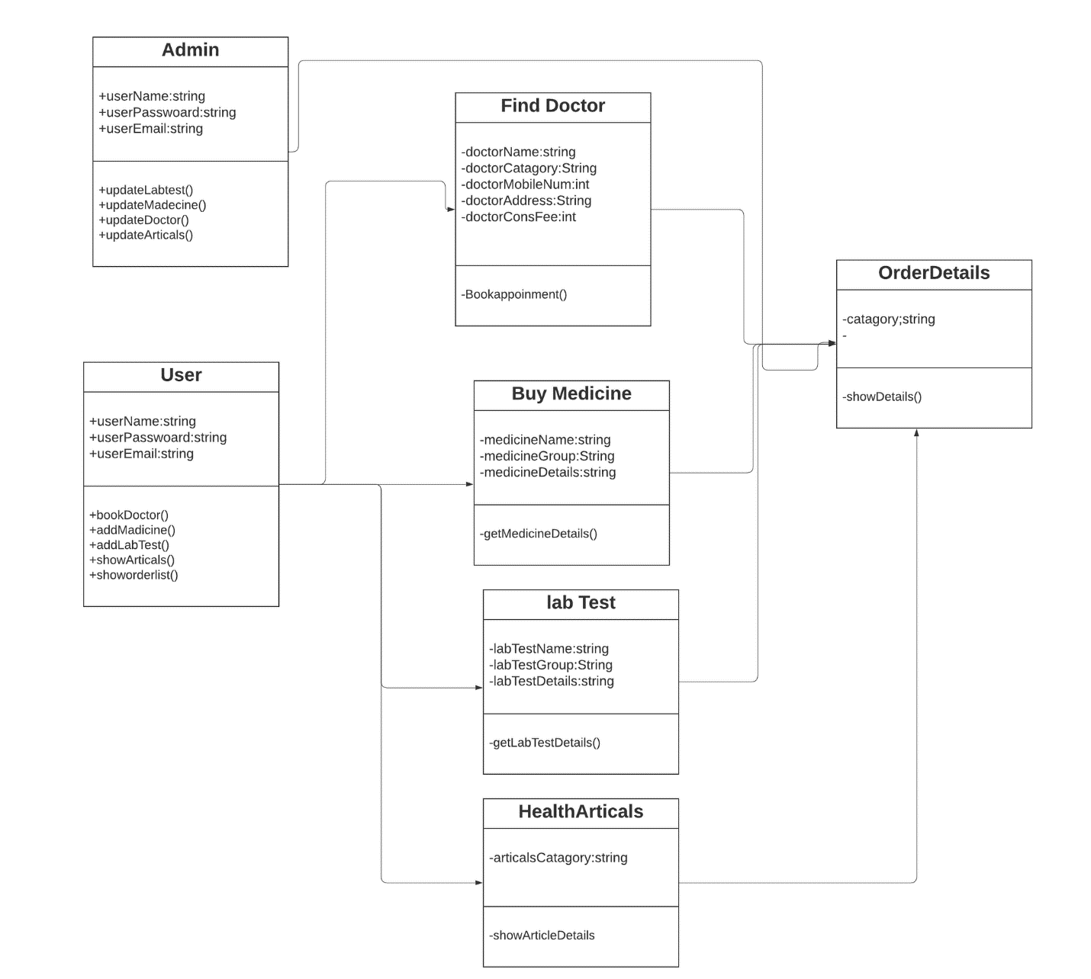

Figure 2 : Class Diagram

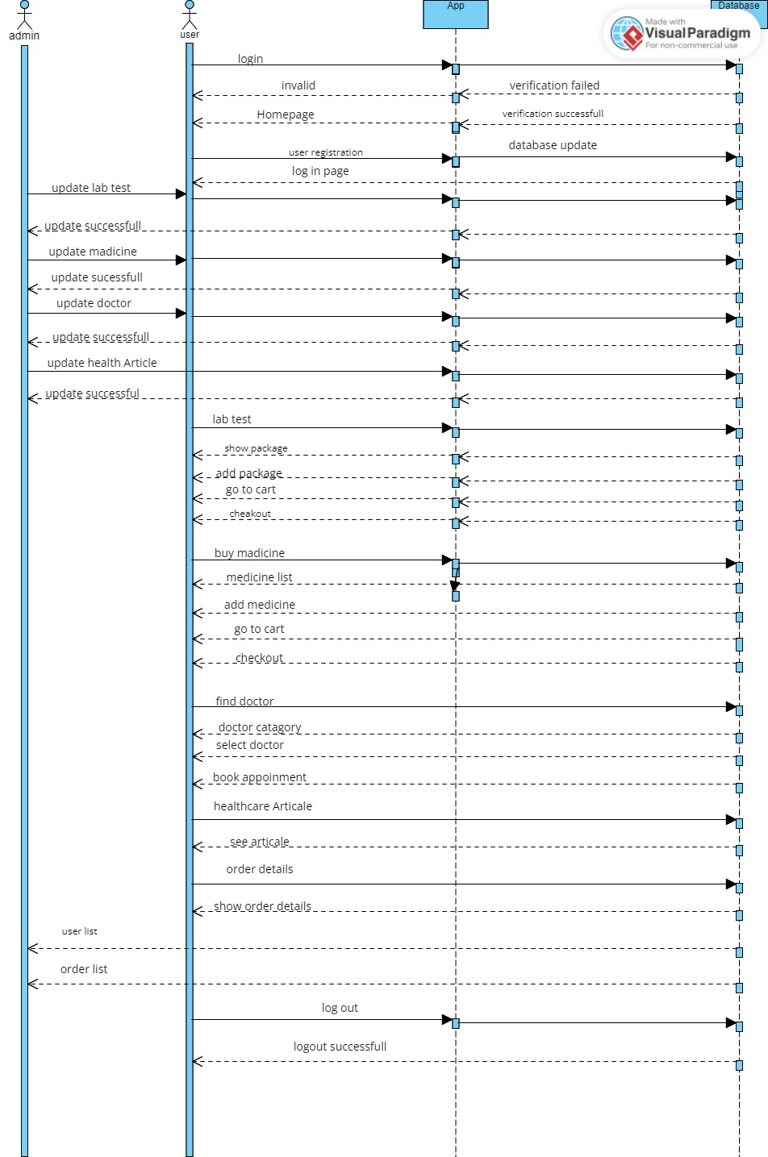

Figure 3: Sequential Diagram

**Projected plan :**

To construct the Android Healthcare app utilizing Android Studio, Java, and SQL, we followed a systematic strategy. Firstly, we began with creating a project proposal that outlined the app's objectives, features, and target audience. This assisted us in setting up a clear course for the development process.

Next, we started designing the user interface (UI) of the app using XML. Android Studio provided a visual editor that allowed us to create interactive and user-friendly screens. We designed screens for user login, account creation, lab test booking, medicine purchase, doctor search, health articles, and order details.

After finalizing the UI, we moved on to the implementation phase. Using Java as the primary programming language, we began coding the various functionalities of the app. We wrote code for user authentication, data storage, and retrieval using SQL databases. For instance, we verified a user's login information and gave them access to the necessary features.

For user account creation, we implemented a registration process that collected the necessary information and stored it securely in the database. The lab test booking feature allowed users to select from a list of available tests, schedule appointments, and receive notifications.

The medicine purchase functionality enabled users to browse a catalogue of medicines, add them to a virtual cart, and complete the purchase securely. We integrated a payment gateway to handle transactions.

To facilitate finding doctors, we integrated a search feature that allowed users to filter doctors based on specialization, location, and availability. Users could look at doctor profiles, book appointments, and get confirmation information.

The app also provided a health article section where users could access informative articles on various health topics. These articles were sourced from reputable medical journals and were regularly updated.

Finally, the order details feature allowed users to track the status of their lab test bookings, medicine purchases, and doctor appointments. Users could view the dates, times, and locations of their appointments, as well as any relevant instructions.

Throughout the development process, we conducted rigorous testing to identify and fix any bugs or issues. We also put security measures first in order to safeguard user data and put precautions in place to thwart unauthorized access.

**Methodology:**

Making a project proposal outlining the goals, capabilities, and scope of the app was the first step. This made sure that everyone was on the same page and helped to establish a clear direction for the development process.

The design of the user interface (UI) was then started. The group designed the app's screens and layouts using XML and Android Studio. This required creating the login page, account creation form, interface for choosing a lab test, purchasing a medicine page, functionality for finding a doctor, displaying health articles, and a section for order information. The goal of the UI design was to offer a fluid and simple user interface.

The backend development came into focus when the UI design was completed. The main programming language used to create the logic and functionality of the app was Java. Users may now create new accounts and log in securely to the app thanks to the team's implementation of a user authentication and login system. In order to store and retrieve user information, lab test results, medication orders, and other pertinent data, they also incorporated SQL for database management.

To ensure the stability and dependability of the software, thorough testing and debugging were carried out throughout the development process. To find and fix any problems or flaws, integration and unit tests were performed.

The app was then made available to users on Android devices. To incorporate new features or improvements and address user feedback, regular updates and improvements were planned.

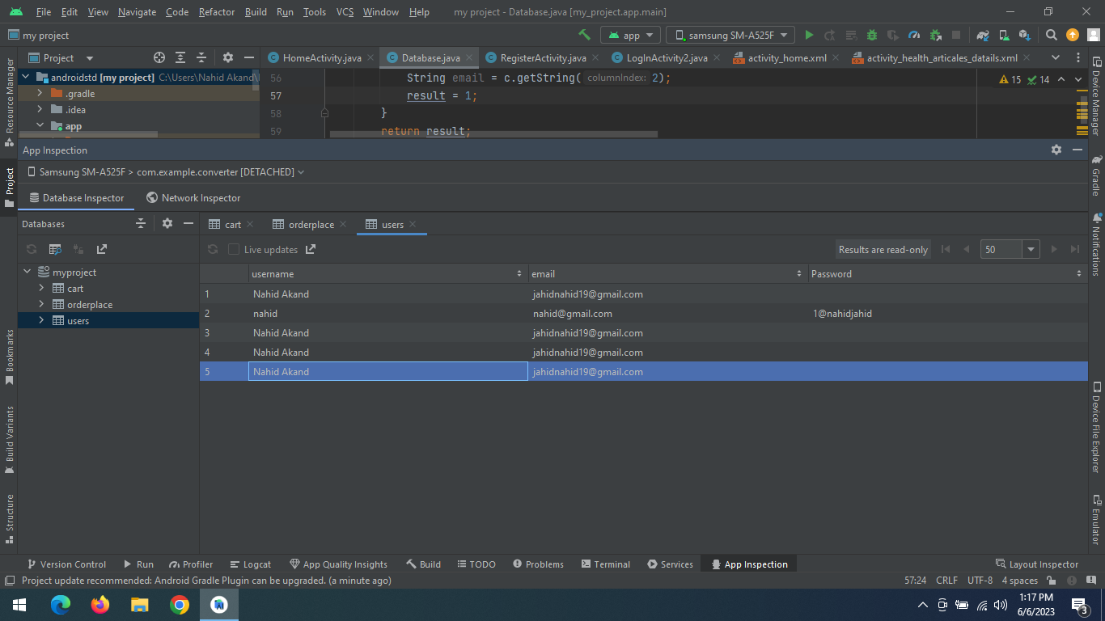

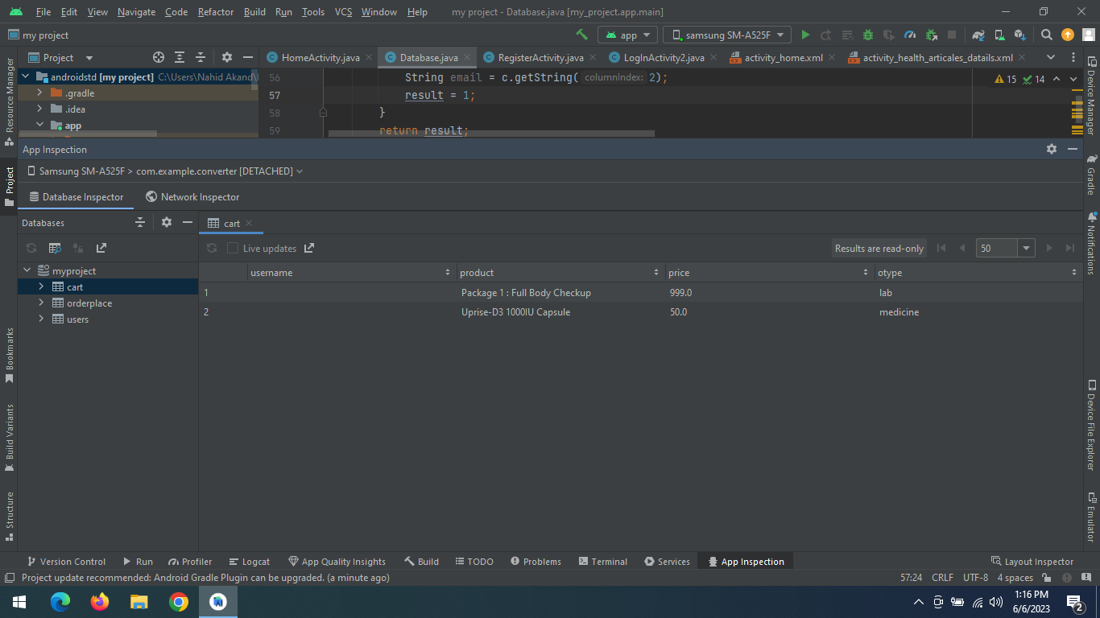

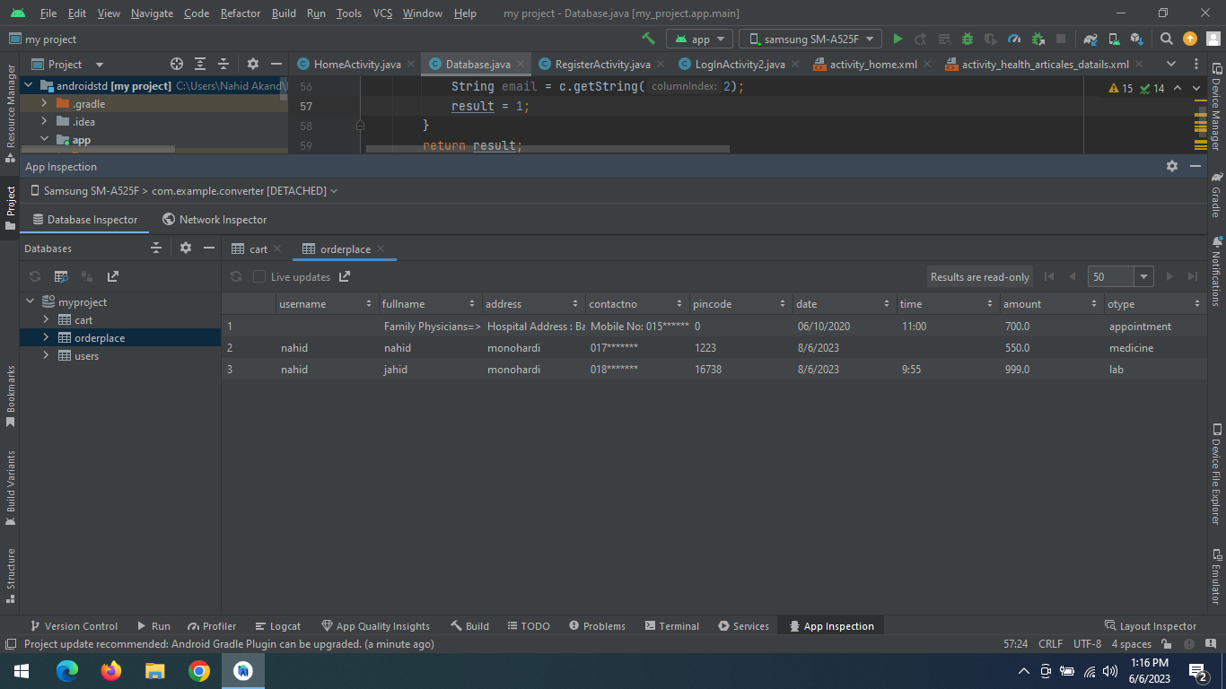

Figure 4: Database implementation

**Design Implementation:**

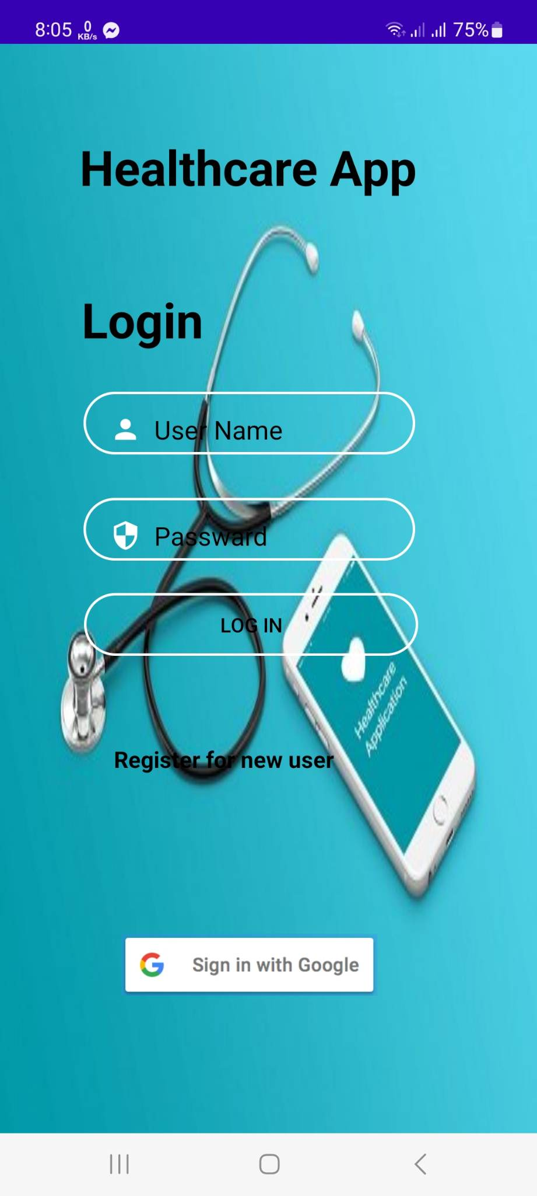

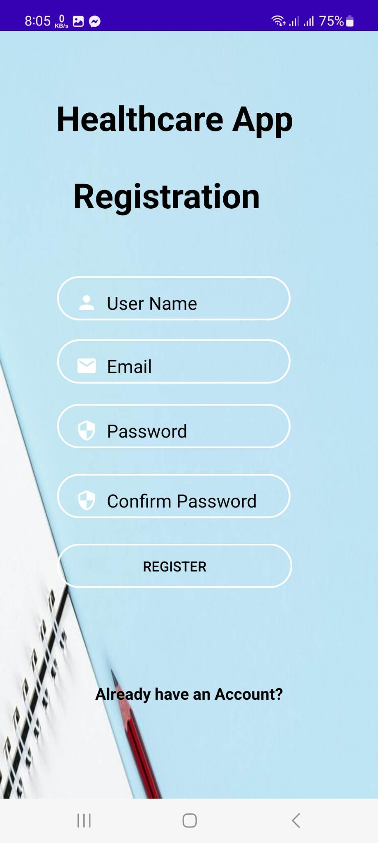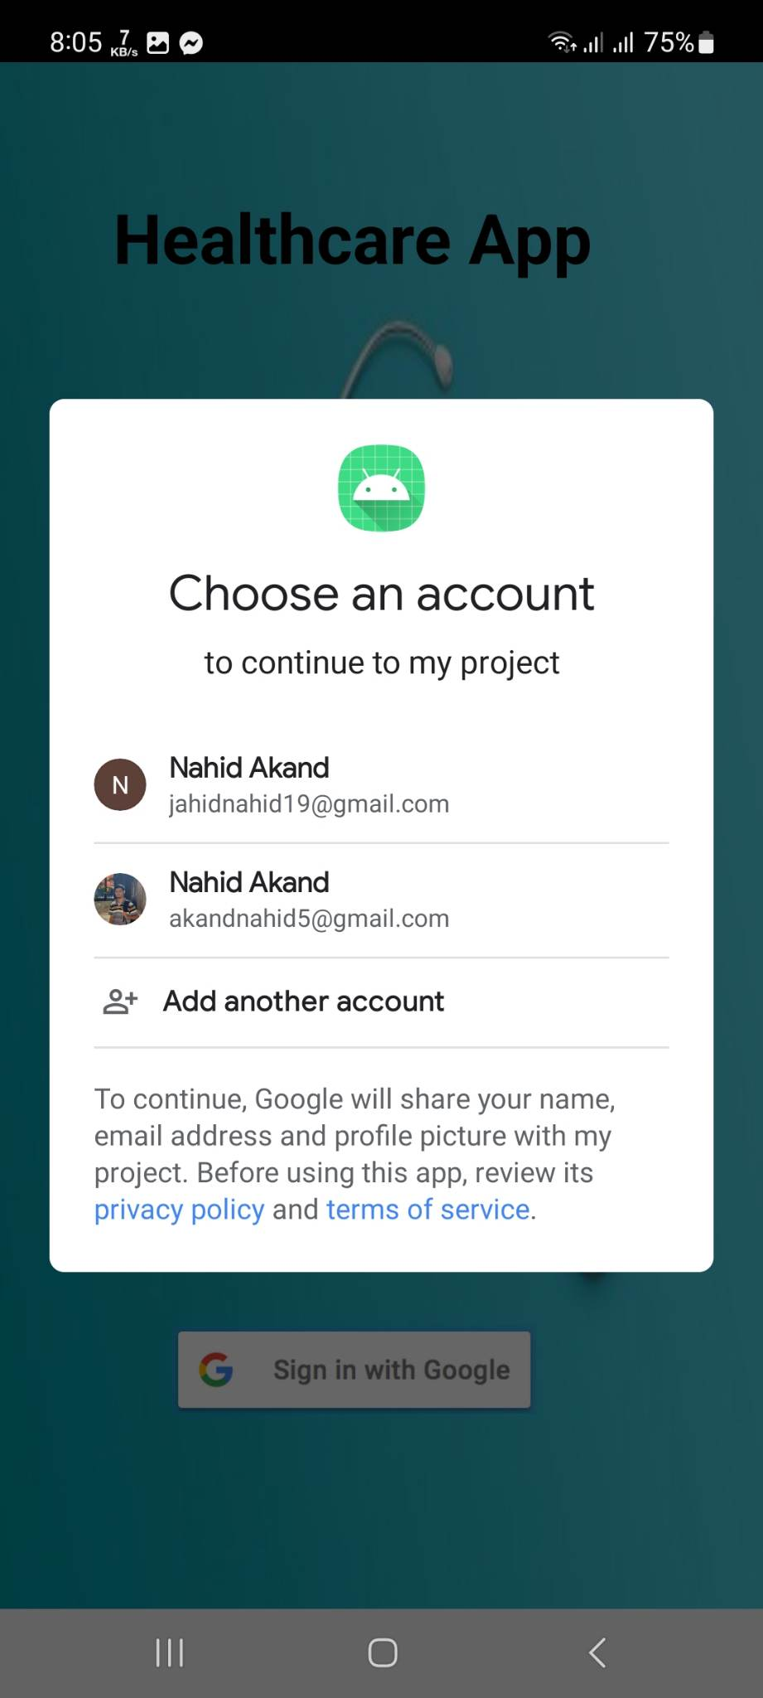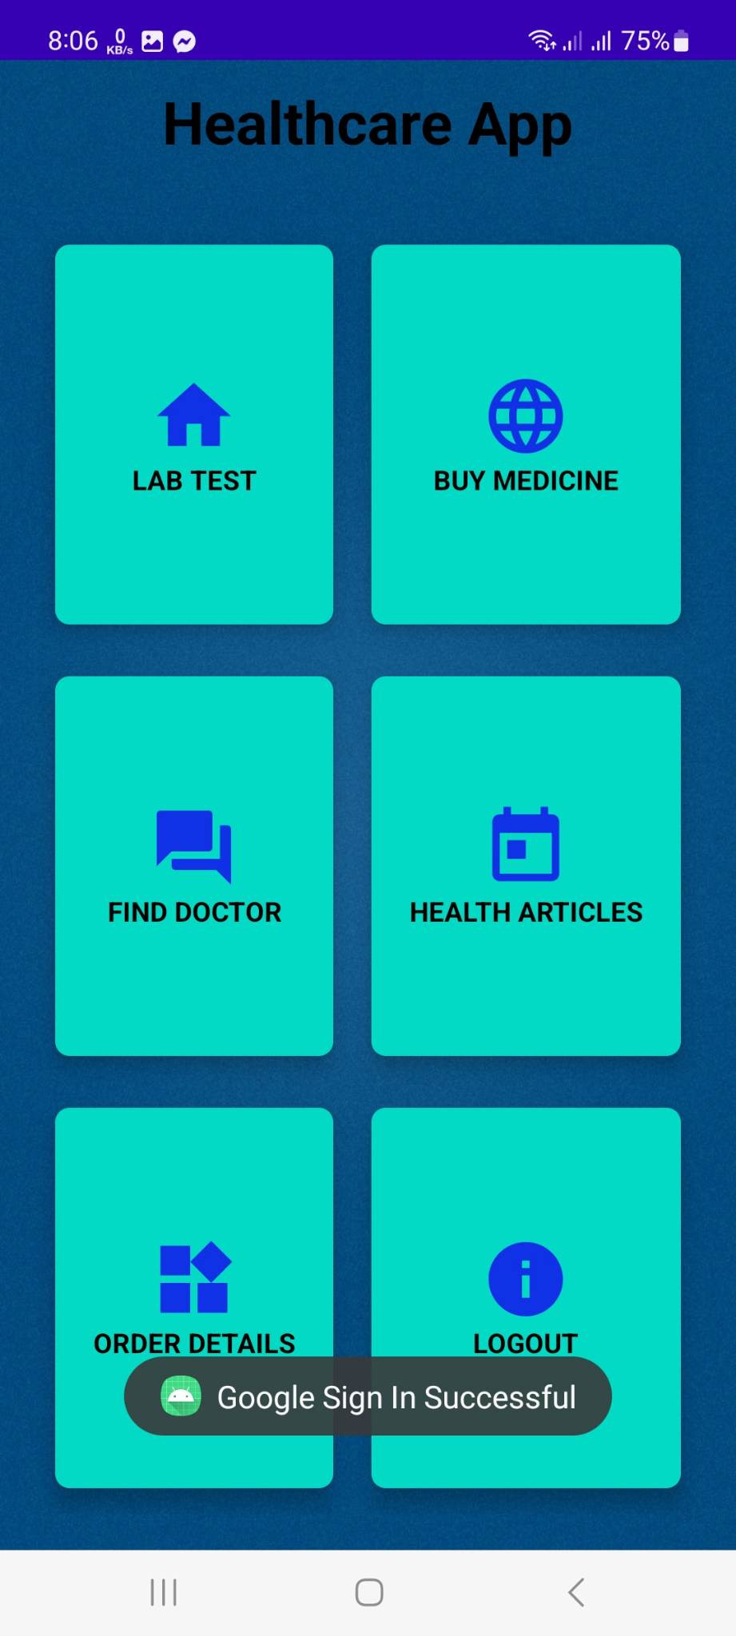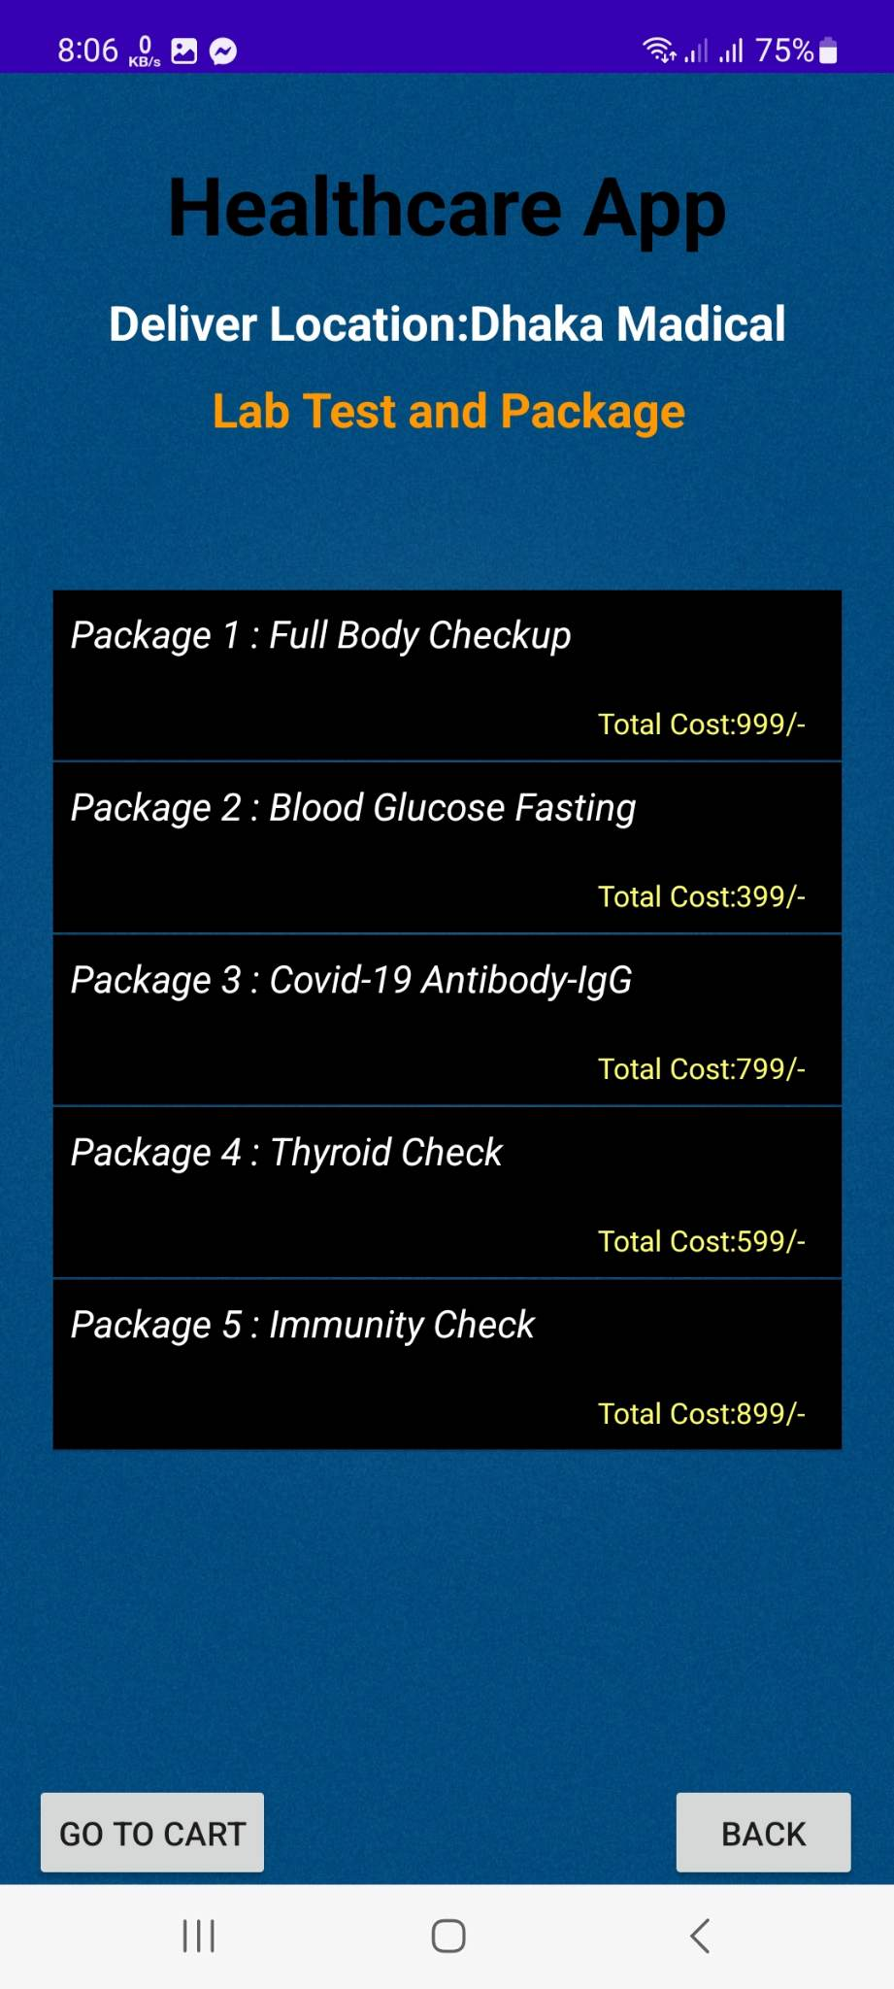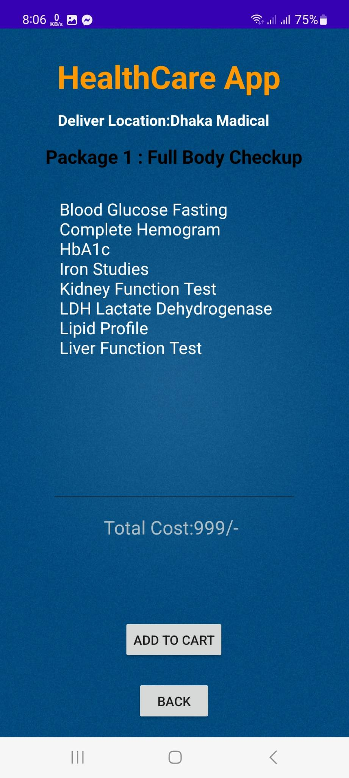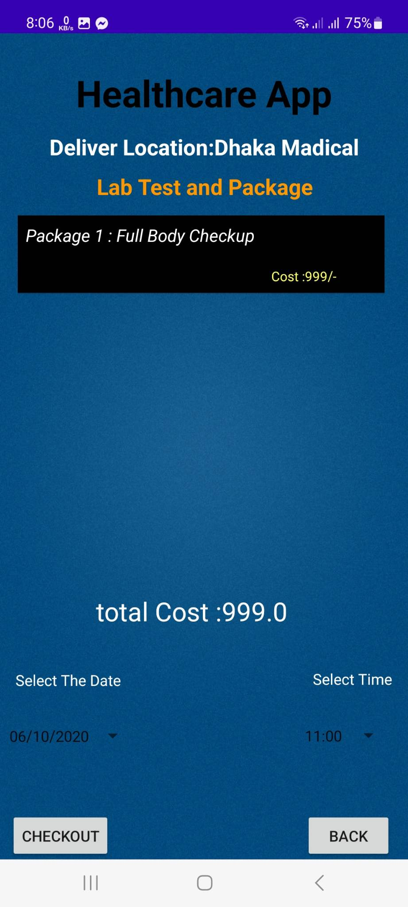

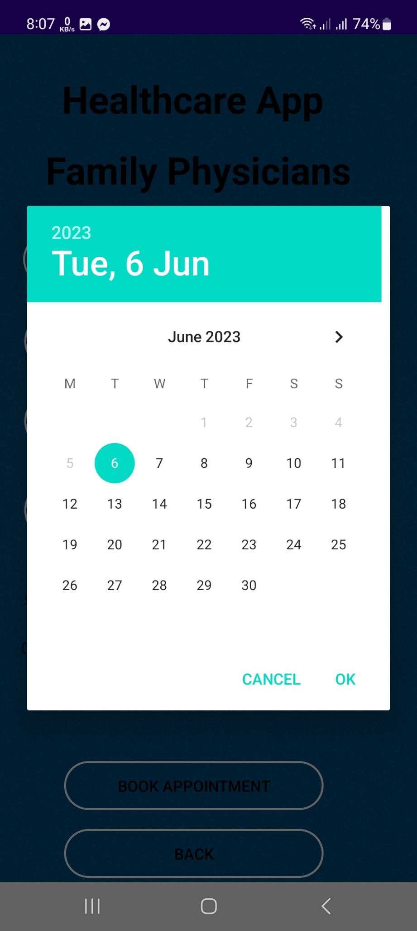

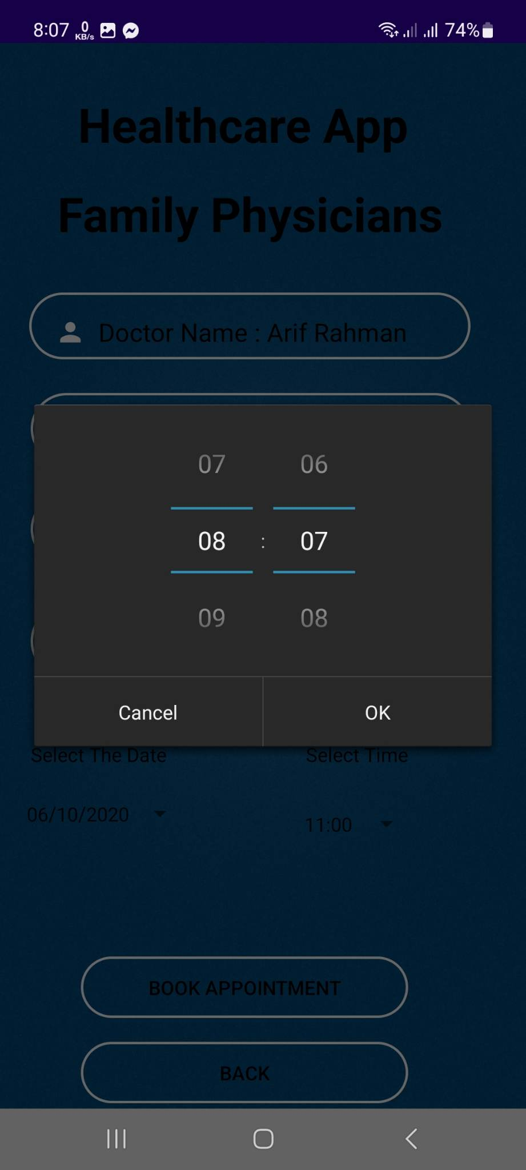

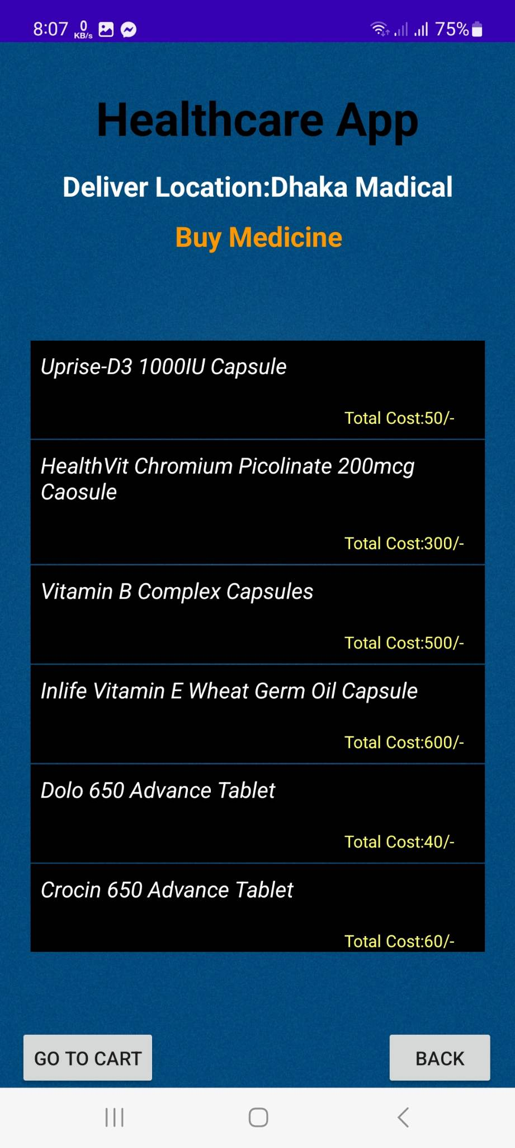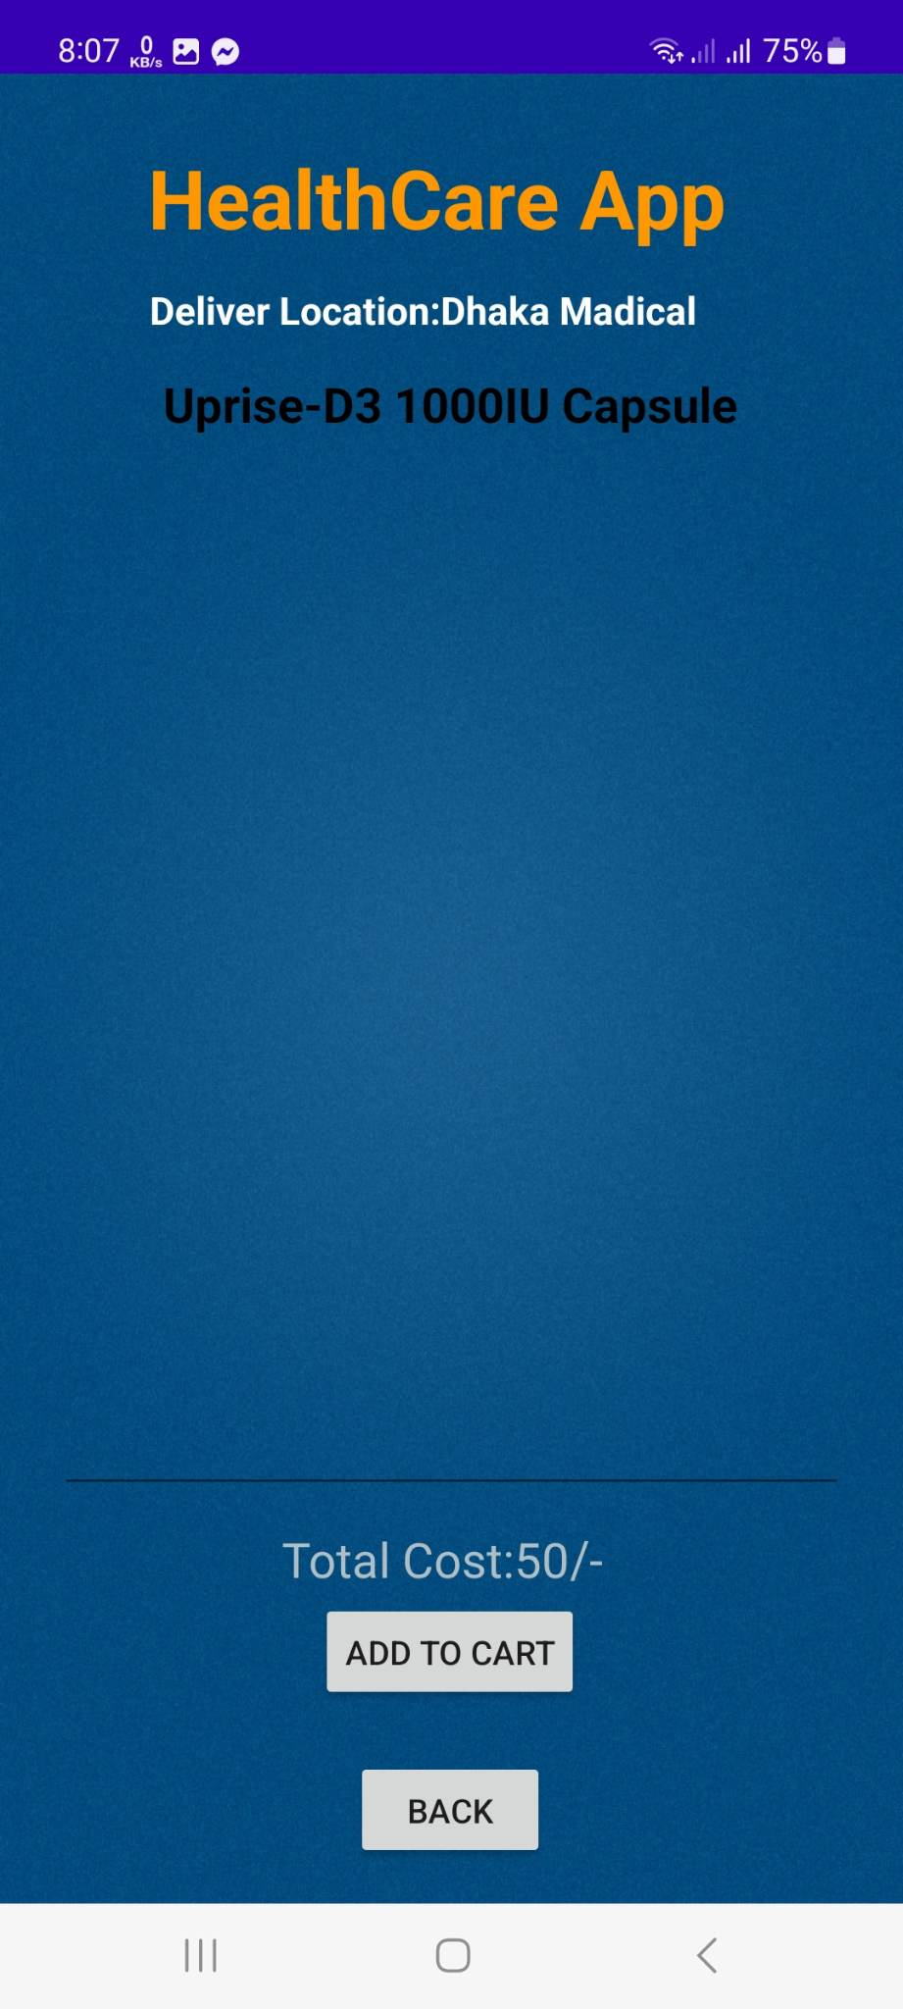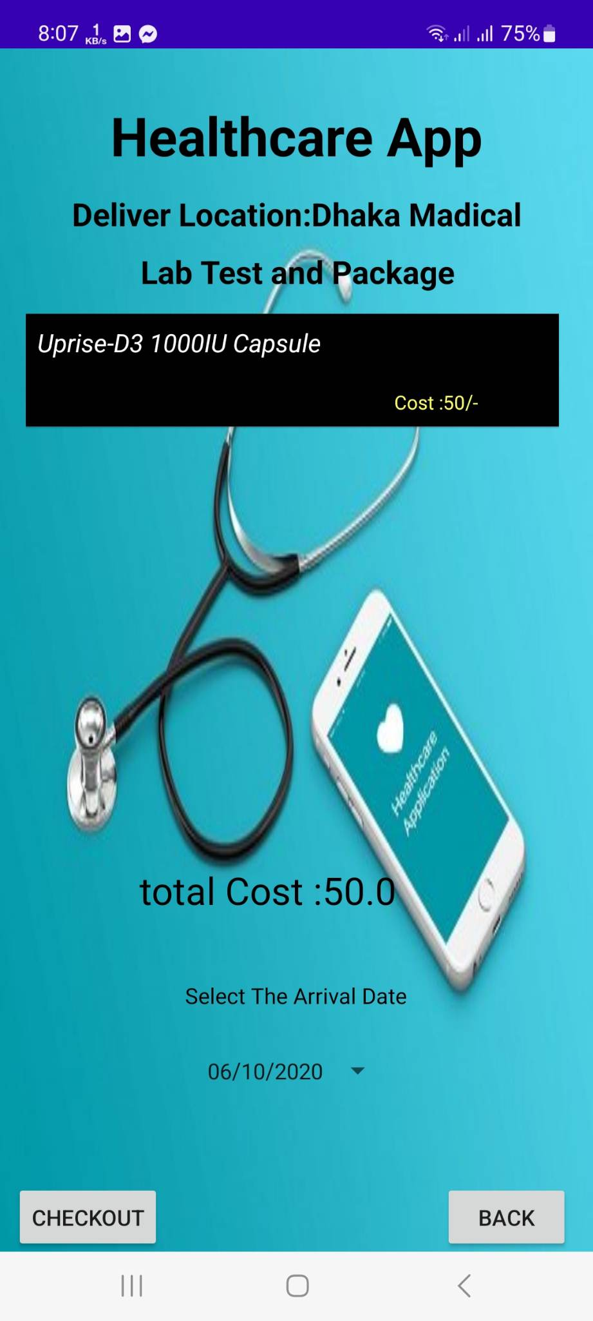

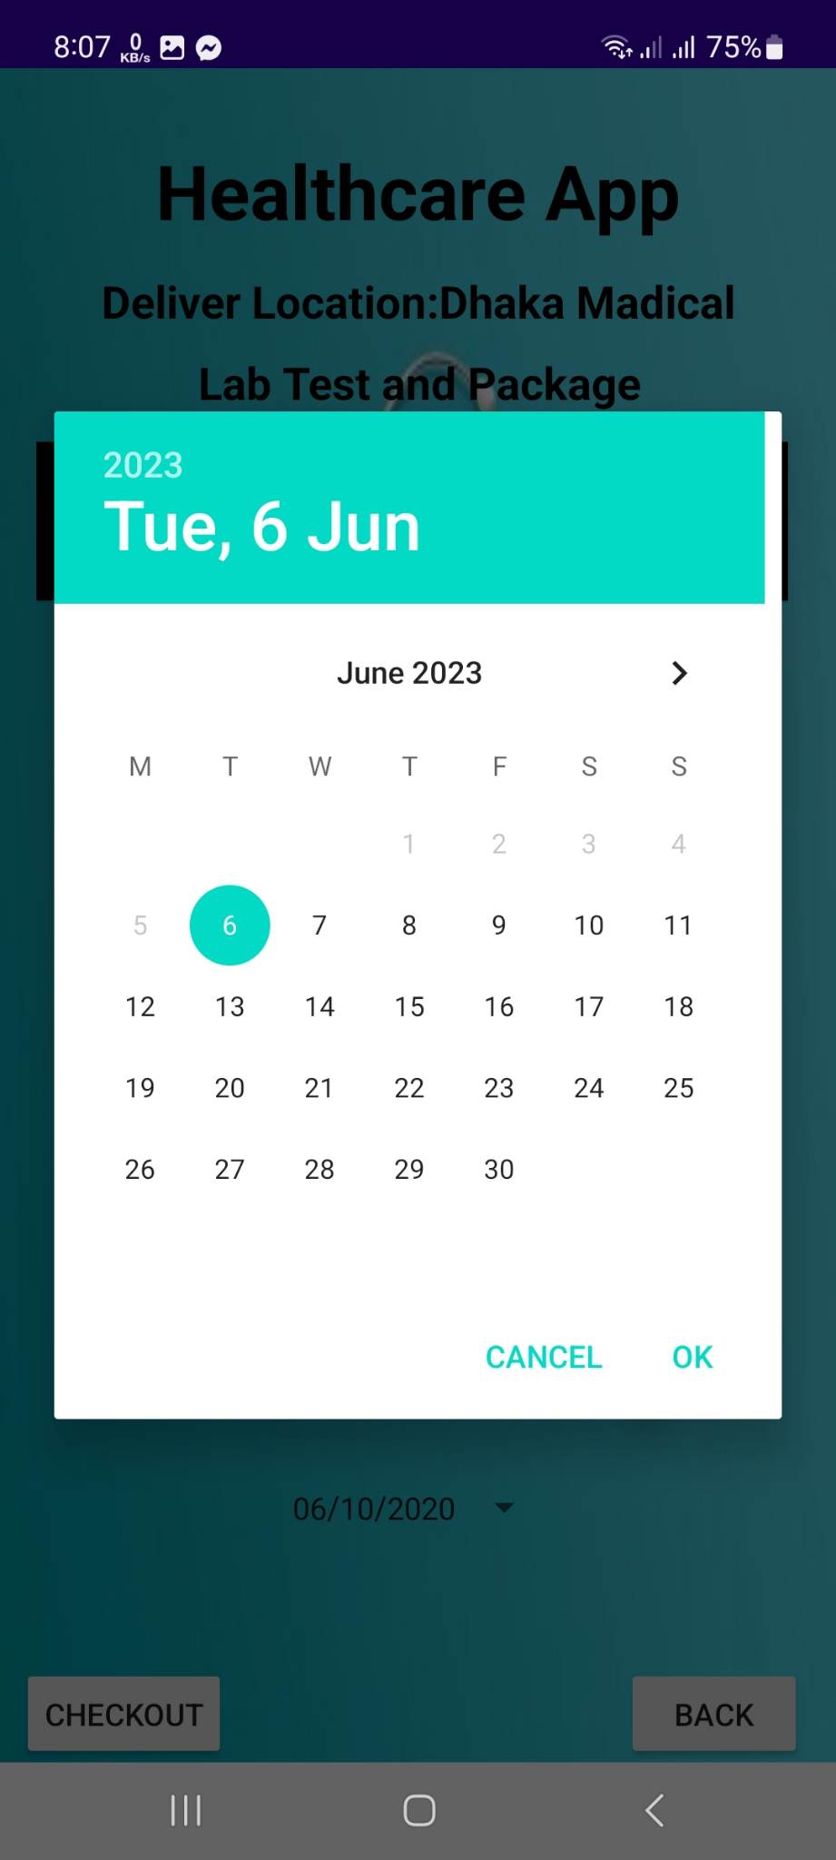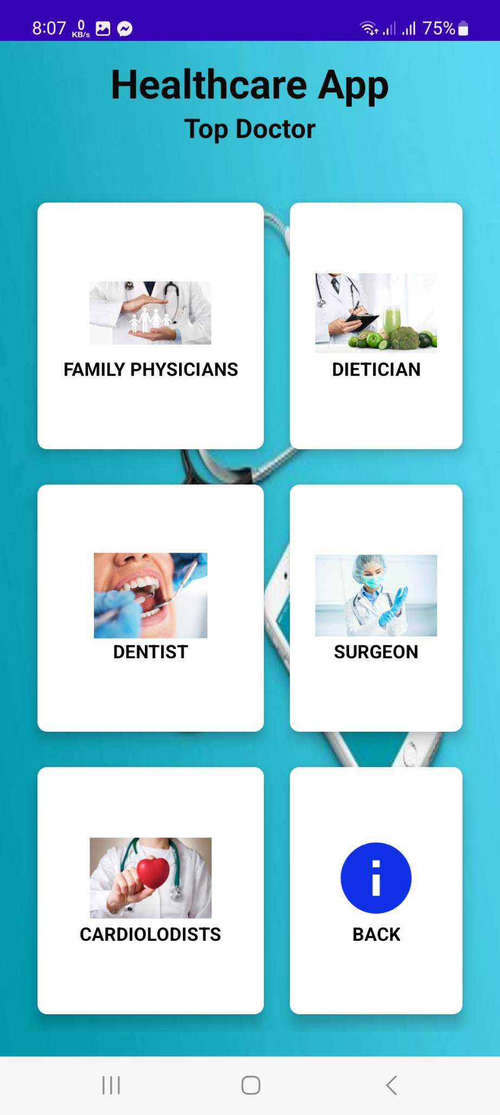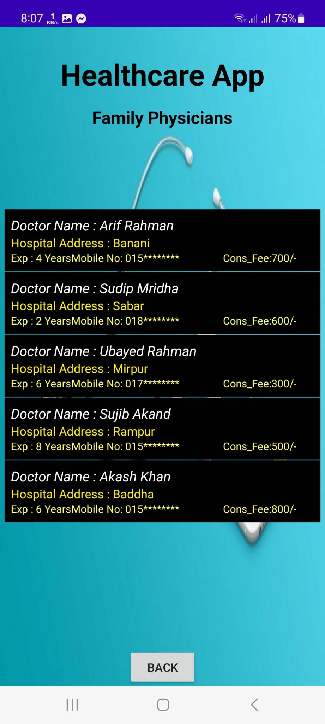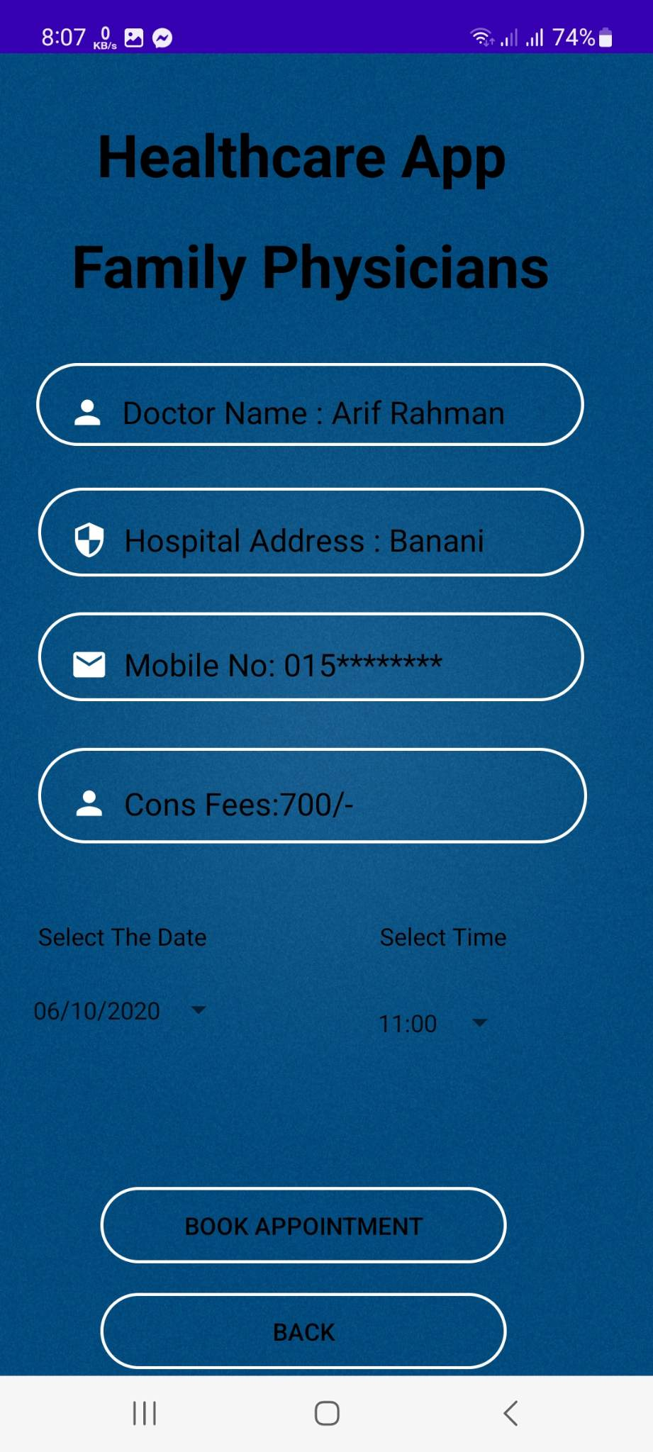



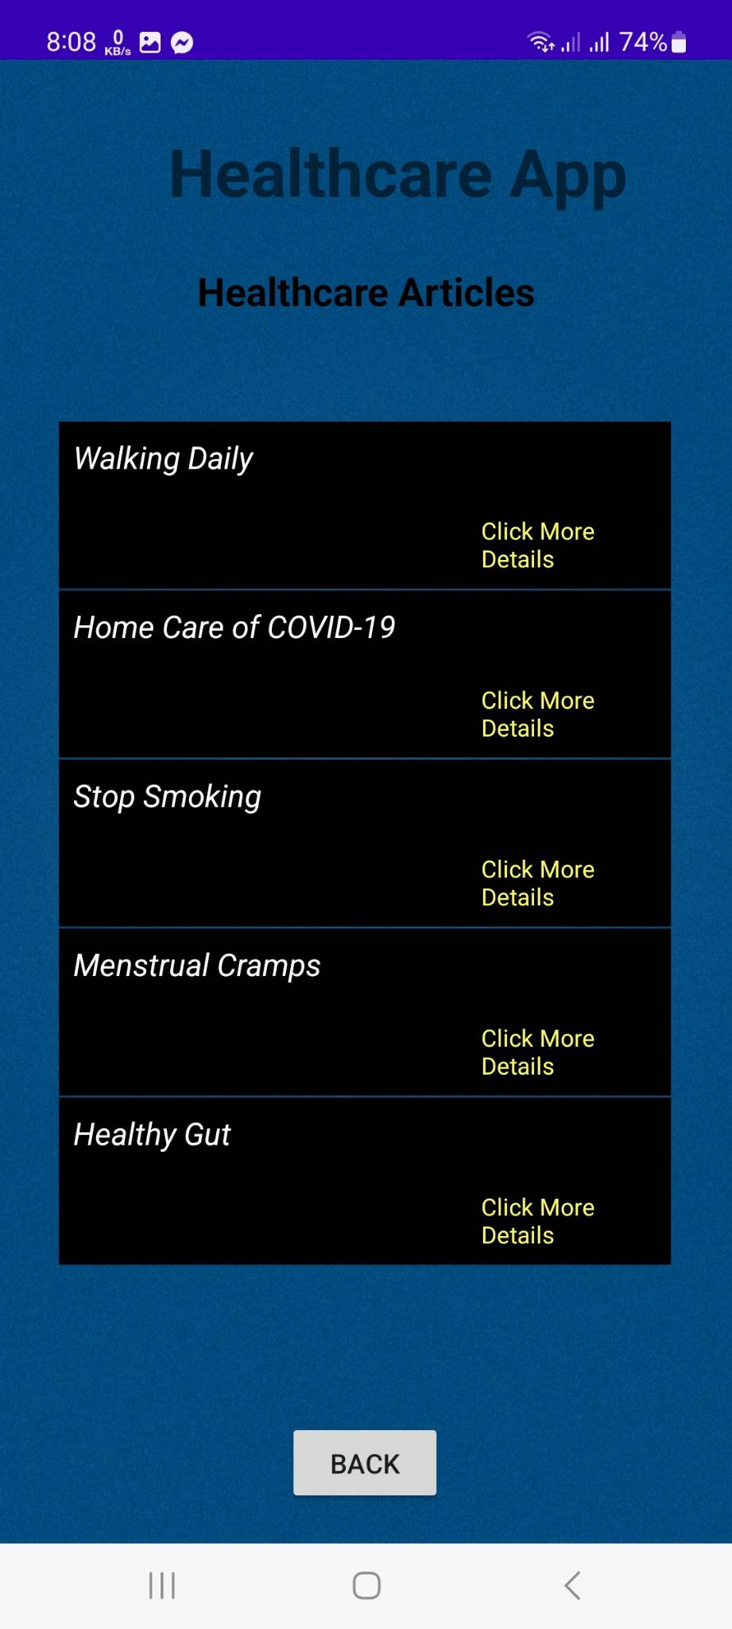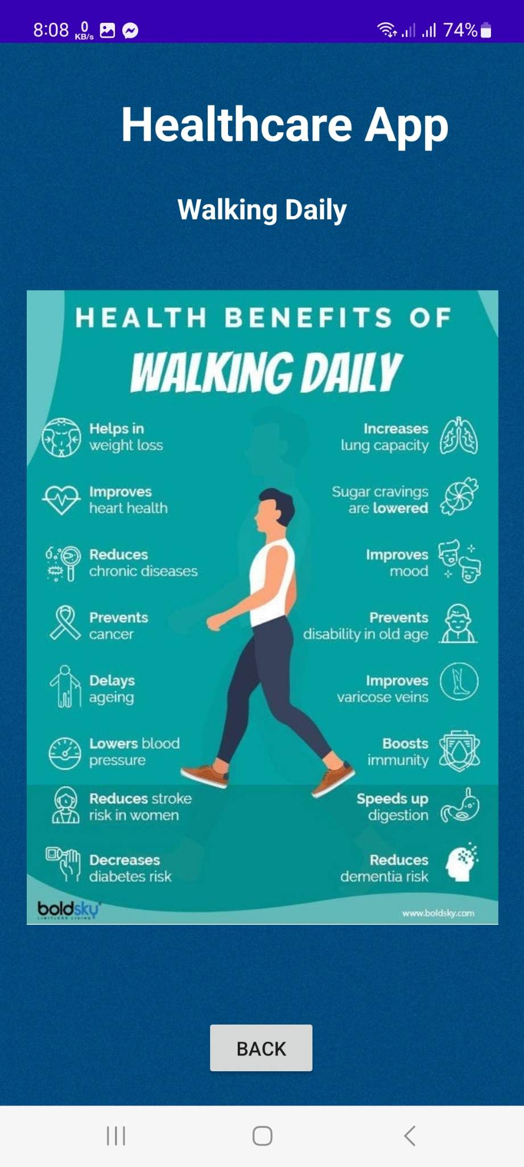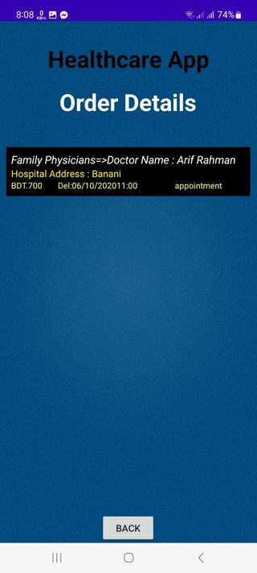

**Results Analysis and Evaluation:**

A few essential features of the Android Healthcare app include user login, account creation, lab test booking, drug purchase, doctor search, health articles, and order information. The software was created using Android Studio, Java, and SQL. We will analyze the app's functionality, user experience, features, and overall competitiveness before comparing it to other healthcare apps available on the market.

* Performance: It's important to think about how well the app performs. It should be responsive, swift, and efficient in delivering results to the users. The speed at which an app loads, the responsiveness of its various features, and its general stability should all be considered. The app should be tested across various devices and operating systems to ensure compatibility and smooth performance.
* User Experience: For any app to be successful, a user-friendly interface and easy navigation are necessary. The Android Healthcare app should provide a visually appealing and intuitive design, making it easy for users to understand and access its features. The app's layout, color palette, and typography should enhance the overall user experience. Additionally, it should offer clear instructions, error messages, and support to assist users in case they face any difficulties.
* Features: Comparing the app's features with other healthcare apps in the market is crucial. The Android healthcare app needs to include all the features customers need, including safe login, account setup, lab test booking, medicine purchase, doctor search, health article browsing, and order information. The usefulness and completeness of these features should be considered while evaluating the app. Additionally, it can be beneficial to analyze if any unique features or innovations differentiate it from competitors.
* Security: Since healthcare apps deal with sensitive user information, security is of greatest importance. Strong security measures, including encrypted data transmission, secure user information storage, and appropriate authentication procedures, should be included in the Android Healthcare app. It should adhere to pertinent data protection laws, guaranteeing the privacy and secrecy of user information.

Comparing these features our app is one of the best apps in Healthcare apps no debut.

**Future work:**

The Healthcare app may be improved and developed further in the future in a number of ways. Future development in these areas aims to maintain alignment with changing healthcare trends and technology while enhancing the user experience and functionalities of the app:

1. **Integration of Telehealth Services:** Considering how popular telehealth is becoming, it would be beneficial to incorporate telehealth services into the app. Users will be able to obtain individualized healthcare advice, utilize remote monitoring tools, and have virtual discussions with healthcare professionals all from the convenience of their own homes.
2. **Integrating wearable devices**: Integrating wearable devices with health monitors would make it possible for users to easily synchronize health information including heart rate, sleep patterns, and activity levels. Users may receive a comprehensive picture of their health thanks to this integration, which also enables medical experts to diagnose and propose treatments with greater knowledge.
3. **AI-based Symptom Checker and Diagnosis aid:** Adding an AI-based symptom checker and diagnosis aid tool would make it easier for users to assess their symptoms and get educated on potential diagnoses based on their input. Users may find this useful in evaluating their health concerns and pointing them in the direction of the best healthcare options.
4. **Expansion of Health Education Resources:** By regularly updating and growing the health article area of the app, users will have access to the most up-to-date and pertinent health data. To deliver articles, videos, and interactive content based on the best available research, this may entail working with qualified healthcare practitioners, researchers, and renowned health organizations.
5. **Integration of Electronic Health Records (EHRs):** Users may have a central repository for their medical history, test results, and medications if the app included capability for accessing and managing electronic health records. In addition to enabling people to actively participate in controlling their healthcare, this would promote seamless communication between healthcare practitioners.
6. **Enhanced Data Analytics and Insights:** Constant analysis and usage of aggregated and anonymized user data can offer insightful information about user preferences and trends in healthcare. By utilizing data analytics, the app's services may be improved, problem areas can be found, and more specialized and focused healthcare recommendations can be made.
7. **Expansion to Multiple Platforms:** Although the initial focus may be on developing the app for Android-based smartphones, expanding the software to other platforms, such as iOS, would increase its reach and serve a wider range of users. To do this, the design, development, and testing procedures for the app would need to be modified to satisfy the unique specifications of each platform.

**Conclusion:**

In conclusion, the Healthcare app is being developed with the intention of addressing market issues and offering a better way to manage and receive healthcare services. The app gives customers a smooth and convenient experience through a user-centric approach, extensive functionality, personalization and strong security features.

The app offers an integrated platform, a streamlined user experience, individualized recommendations, and improved data security to address the issues currently experienced by users of healthcare apps. It offers consumers a one-stop shop where they can schedule lab tests, buy prescription drugs, locate doctors, browse health information, manage orders, and more. Users' authentication processes are made more convenient and straightforward by the addition of Google login.

Our app stands out from other healthcare apps on the market thanks to its extensive functionality, user-friendly design, and customizable options. To make it simpler for consumers to navigate and receive the services they require, it provides a single platform that brings together multiple healthcare services. Because of the app's emphasis on customization, users will receive individualized and pertinent healthcare advice, which will improve their overall experience.

The software also places a high priority on data security and privacy, putting strong safeguards in place to secure user data. Users gain confidence as a result of knowing that the app protects their personal health information.

In conclusion, the Healthcare app provides a useful option for people who want quick access to medical services, effective medical management, and tailored medical advice. The app has the potential to have a beneficial impact on the healthcare sector by continuously enhancing and adjusting to user needs, giving people the tools they need to take charge of their health and wellbeing. The Healthcare app has the potential to completely change how people interact with healthcare services in the digital age because to its extensive functionality, user-centric design, and emphasis on security.

**Contribution:**

We three worked together to develop the outstanding Android healthcare software "Health Care." Each team member was essential in creating and improving various areas of the software, which produced a smooth user experience.

Mahadi Melon Soykat has shown extraordinary talent by creating beautiful and intuitive designs utilizing XML in Android Studio. Their great sense of aesthetics and simple user interface made sure that the app was aesthetically pleasing and simple to use, giving our consumers a fun experience**.**

Jahid Akand Nahid was in charge of the Java coding portion. He used his knowledge to turn the design ideas into workable code, adding different features and functionality to the program. In addition to ensuring a seamless user experience, their coding prowess increased the app's performance, making it responsive and effective.

Md Ruhan Afride did a fantastic job building and maintaining the SQL database. He carefully planned the database structure to enable effective data storage and retrieval. His knowledge enabled us to manage user information, medical records, appointments, and other vital data with ease, ensuring the app's durability and dependability.

The success of our Android healthcare application was greatly influenced by the team's joint efforts. Together, we were able to develop a dependable, feature-rich, visually appealing solution that strives to enhance users' lives by giving them easy access to healthcare resources, information, and services.

# References

|  |  |
| --- | --- |
| [1] | B. M. I. a. D. Making, "A Systematic Review of Healthcare Applications for Smartphones," 2012. [Online]. Available: https://bmcmedinformdecismak.biomedcentral.com/articles/10.1186/1472-6947-12-67. |
| [2] | J. o. t. A. M. I. Association., "Health-Related Smartphone Applications: A Literature Review," 2013. [Online]. Available: https://www.ncbi.nlm.nih.gov/pmc/articles/PMC3643434/. |
| [3] | J. o. t. A. M. I. Association, "The Use of Mobile Phones in Healthcare: A Systematic Review of the Literature," 2013. [Online]. Available: https://www.ncbi.nlm.nih.gov/pmc/articles/PMC3643429/. |
| [4] | J. o. t. A. M. I. Association, "Mobile Health Applications: Current State and Future Trends," 2014. [Online]. Available: https://www.ncbi.nlm. |
| [5] | A. &. J. J. Bard, "The potential of mobile health apps to improve patient outcomes.," *Journal of the American Medical Informatics Association,* vol. 23(1), no. doi:10.1093/jamia/jwu157, pp. 116-123, 2016. |
| [6] | R. J. &. P. V. V. Weinstock, " The use of mobile health apps in chronic disease management," *JAMA,* vol. 316(1), no. doi:10.1001/jama.2016.10982, pp. 71-72, 2016. |
| [7] | C. E. &. S. J. M. Carney, "The use of mobile health apps in mental health care," *JAMA Psychiatry,* vol. 72(1), no. doi:10.1001/jamapsychiatry.2014.2947, pp. 10-11, 2015. |
| [8] | A. &. K. S. Mehmood, "The future of mobile health apps," *Journal of Medical Internet Research,* vol. 18(11), no. doi:10.2196/jmir.5321, p. e224, 2016. |
| [9] | M. &. K. S. U. Afzal, "The impact of mobile health apps on patient engagement: A systematic review.," *Journal of Medical Internet Research,* vol. 20(10), no. doi:10.2196/10849, p. e10849, 2018. |
| [10] | Y. C. C. C. C. &. H. C. H. Chuang, "Use of mobile health apps for preventive care: A systematic review," *Journal of Medical Internet Research,* vol. 19(1), no. doi:10.2196/129, p. e129, 2017. |
| [11] | N. &. K. S. Desai, "Use of mobile health apps for clinical decision support: A systematic review.," *Journal of Medical Internet Research,* vol. 19(12), no. doi:10.2196/263, p. e263, 2017. |
| [12] | A. &. K. S. Mehmood, "Regulation of mobile health apps: A systematic review," *Journal of Medical Internet Research,* vol. 20(11), no. doi:10.2196/11175, p. e11175, 2018. |