Thesis on
DRISHTI-Bn: A Parameter-Efficient Multimodal Vision-Language Framework for Simultaneous Flood Damage Classification and Bengali Caption Generation

For Research paper
DRISHTI-Bn: A Parameter-Efficient Multimodal Vision-Language Framework for Simultaneous Flood Damage Assessment and Bengali Caption Generation
[500 image add by myself for Q1]

Abstract
Catastrophic inundations continually threaten South Asia. Rapid spatial damage appraisal remains imperative for directing emergency relief during severe environmental crises. Existing automated assessment architectures operate predominantly as unimodal, English-biased mechanisms demanding exorbitant computational budgets. These fragmented systems cannot generate simultaneous visual categorization and native Bengali situational intelligence for frontline responders restricted by consumer-grade hardware. The present study introduces DRISHTI-Bn, a parameter-efficient multimodal vision-language framework designed for concurrent flood damage classification and Bengali caption generation. The architecture integrates a ViT-Base/16 visual encoder alongside an autoregressive BanglaBERT cross-attention decoder. Low-Rank Adaptation matrices ()) adapt both modules, updating merely 0.30% of total parameters (589,824 out of 197,005,824). The system trained on CrisisMMD flood photographs with translated Bengali captions, partitioned into a stratified 80/10/10 split comprising 3,004 training, 375 validation, and 376 test instances across three classes: Severe Damage, Humanitarian Rescue, and Affected People. Empirical assessments confirm high efficacy. The unified model secured a classification Macro F1-Score of 77.95%, whereas the classification-only ablation achieved 83.21%. These outcomes surpass five comparative baselines: stratified random (39.95%), BanglaBERT-only (43.02%), full fine-tuning (74.19%), CrisisViT-style modeling (78.15%), and ViT-only (78.64%). For language generation, DRISHTI-Bn attained a BLEU-4 of 6.13, METEOR of 0.32, ROUGE-L of 0.56, and BERTScore-F1 of 60.35%. Model calibration proved reliable. Four explainable artificial intelligence techniques—Grad-CAM, Cross-Attention Visualization, Attention Rollout, and Temperature Scaling—provide transparent decision pathways, yielding an Expected Calibration Error of 2.16%. A blind human evaluation by three native annotators across 100 samples yielded 2.49/5 for Fluency, 2.11/5 for Adequacy, and 2.17/5 for Faithfulness. Hardware overhead remains low. Executing entirely on a single NVIDIA T4 GPU (16 GB VRAM), DRISHTI-Bn establishes a deployable foundation for localized humanitarian intelligence.

Chapter 1: Introduction

1.1 Background
Natural disasters escalate in both recurrence rate and destructive capacity worldwide. The Ganges River Delta encompasses the most expansive riverine basin across the globe. This deltaic geography exhibits extreme vulnerability to sudden environmental hazards. Within Bangladesh, approximately 94.42 million citizens face severe inundation threats, representing exactly 57.5% of the national populace [REF]. Repetitive monsoon surges dismantle transport infrastructure, submerge residential communities, and decimate agrarian production. The damage is severe. These catastrophic events threaten human lives and precipitate staggering economic losses that overwhelm localized mitigation resources.

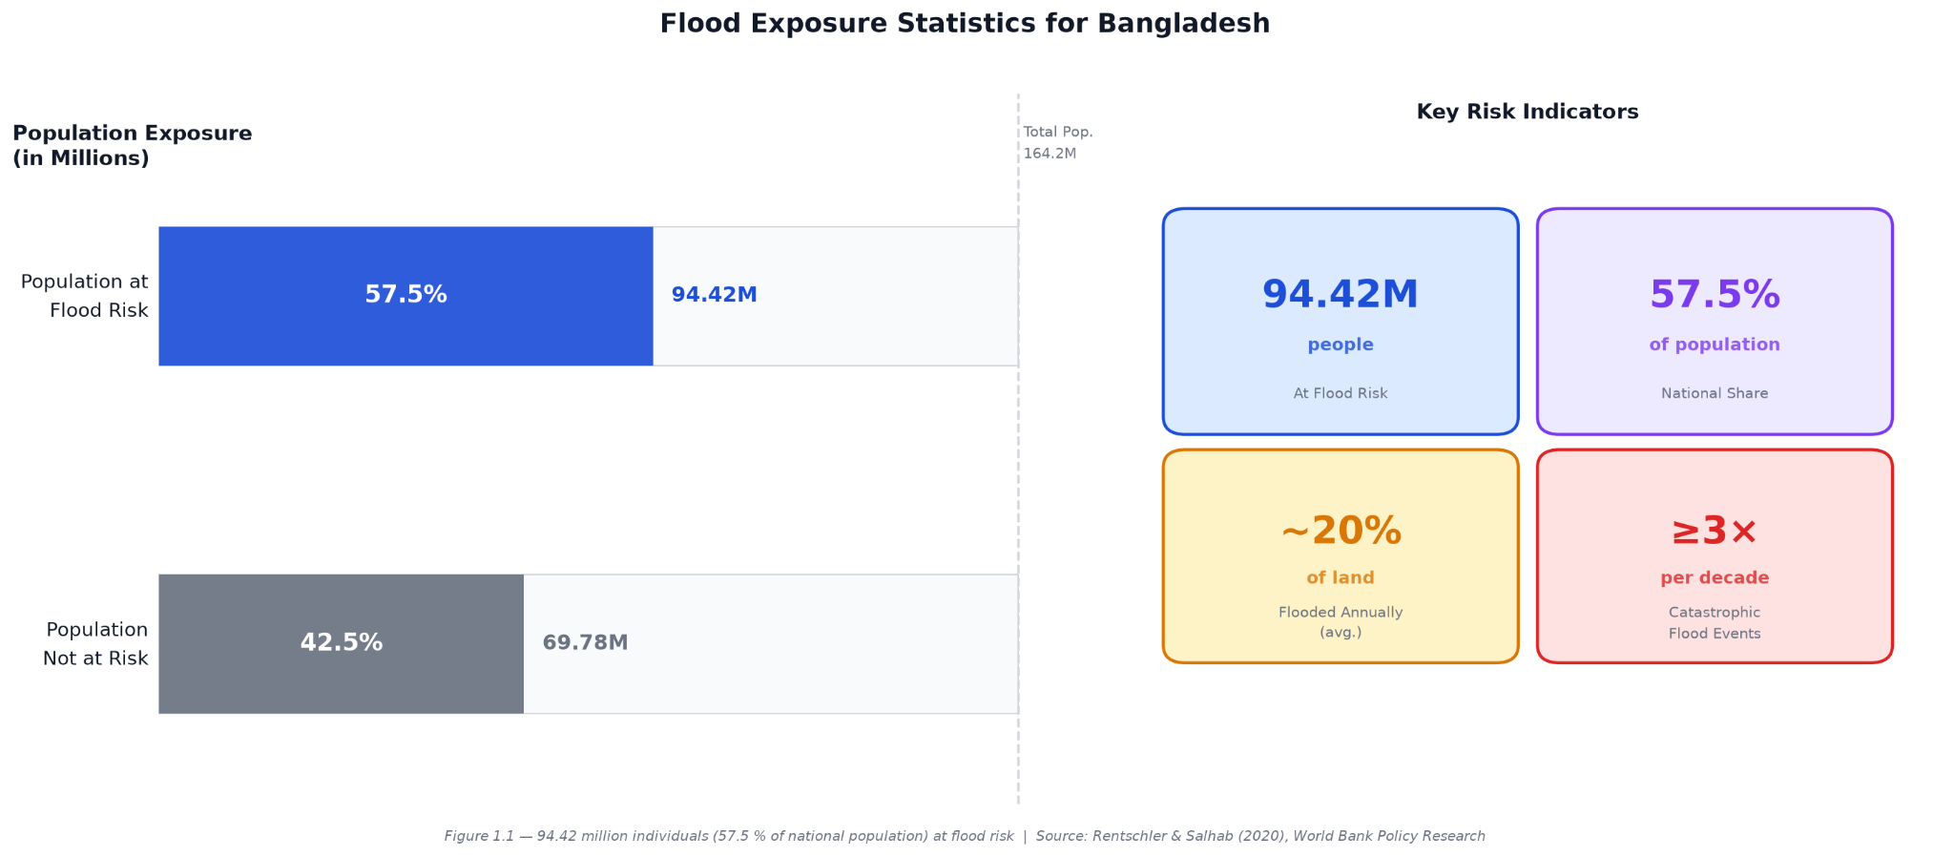
Figure 1.1: Flood exposure statistics for Bangladesh — 94.42 million individuals at risk (Source: [REF])

The proliferation of digital telecommunication infrastructure fundamentally altered emergency observation pipelines. During acute crisis events, eyewitness civilians and rescue personnel rapidly broadcast visual observations through social networking platforms [REF]. Social media platforms operate as real-time public communication channels during environmental emergencies. Affected populations routinely upload optical records capturing local water levels, blocked arterial roadways, and stranded civilian groups. This crowdsourced stream delivers unprecedented temporal and spatial awareness for emergency managers. Millions of unstructured multimedia records accumulate across public networks within hours of an extreme hydrological event.

Converting this massive multimedia volume into operational intelligence exposes severe analytical bottlenecks. Conventional disaster damage estimation relies almost entirely on manual visual inspection by human analysts. Manual workflows fail under crisis conditions. Human photo interpretation introduces cognitive fatigue, subjective inconsistency, and unacceptable delays during high-stress operational windows. Delays cost human lives. Emergency response agencies require instantaneous situational awareness to prioritize rescue boat deployments, medical dispatch, and potable water distribution. Automated machine learning frameworks must process and triage incoming photographic streams to categorize damage severity without manual delays.

During sudden flash floods across isolated Bangladeshi districts, central emergency management authorities often acquire aerial footage from unmanned aerial vehicles well before ground rescue teams reach affected zones. Ground conditions remain opaque. Current analytical pipelines produce isolated classification labels without synthesizing descriptive text in the native language of regional field workers. This linguistic disconnect impedes frontline coordination. Emergency managers and field teams require localized situation reports directly in Bengali to comprehend the physical context of damaged infrastructure. Transitioning from manual photo review toward automated multimodal intelligence generation represents an operational necessity.

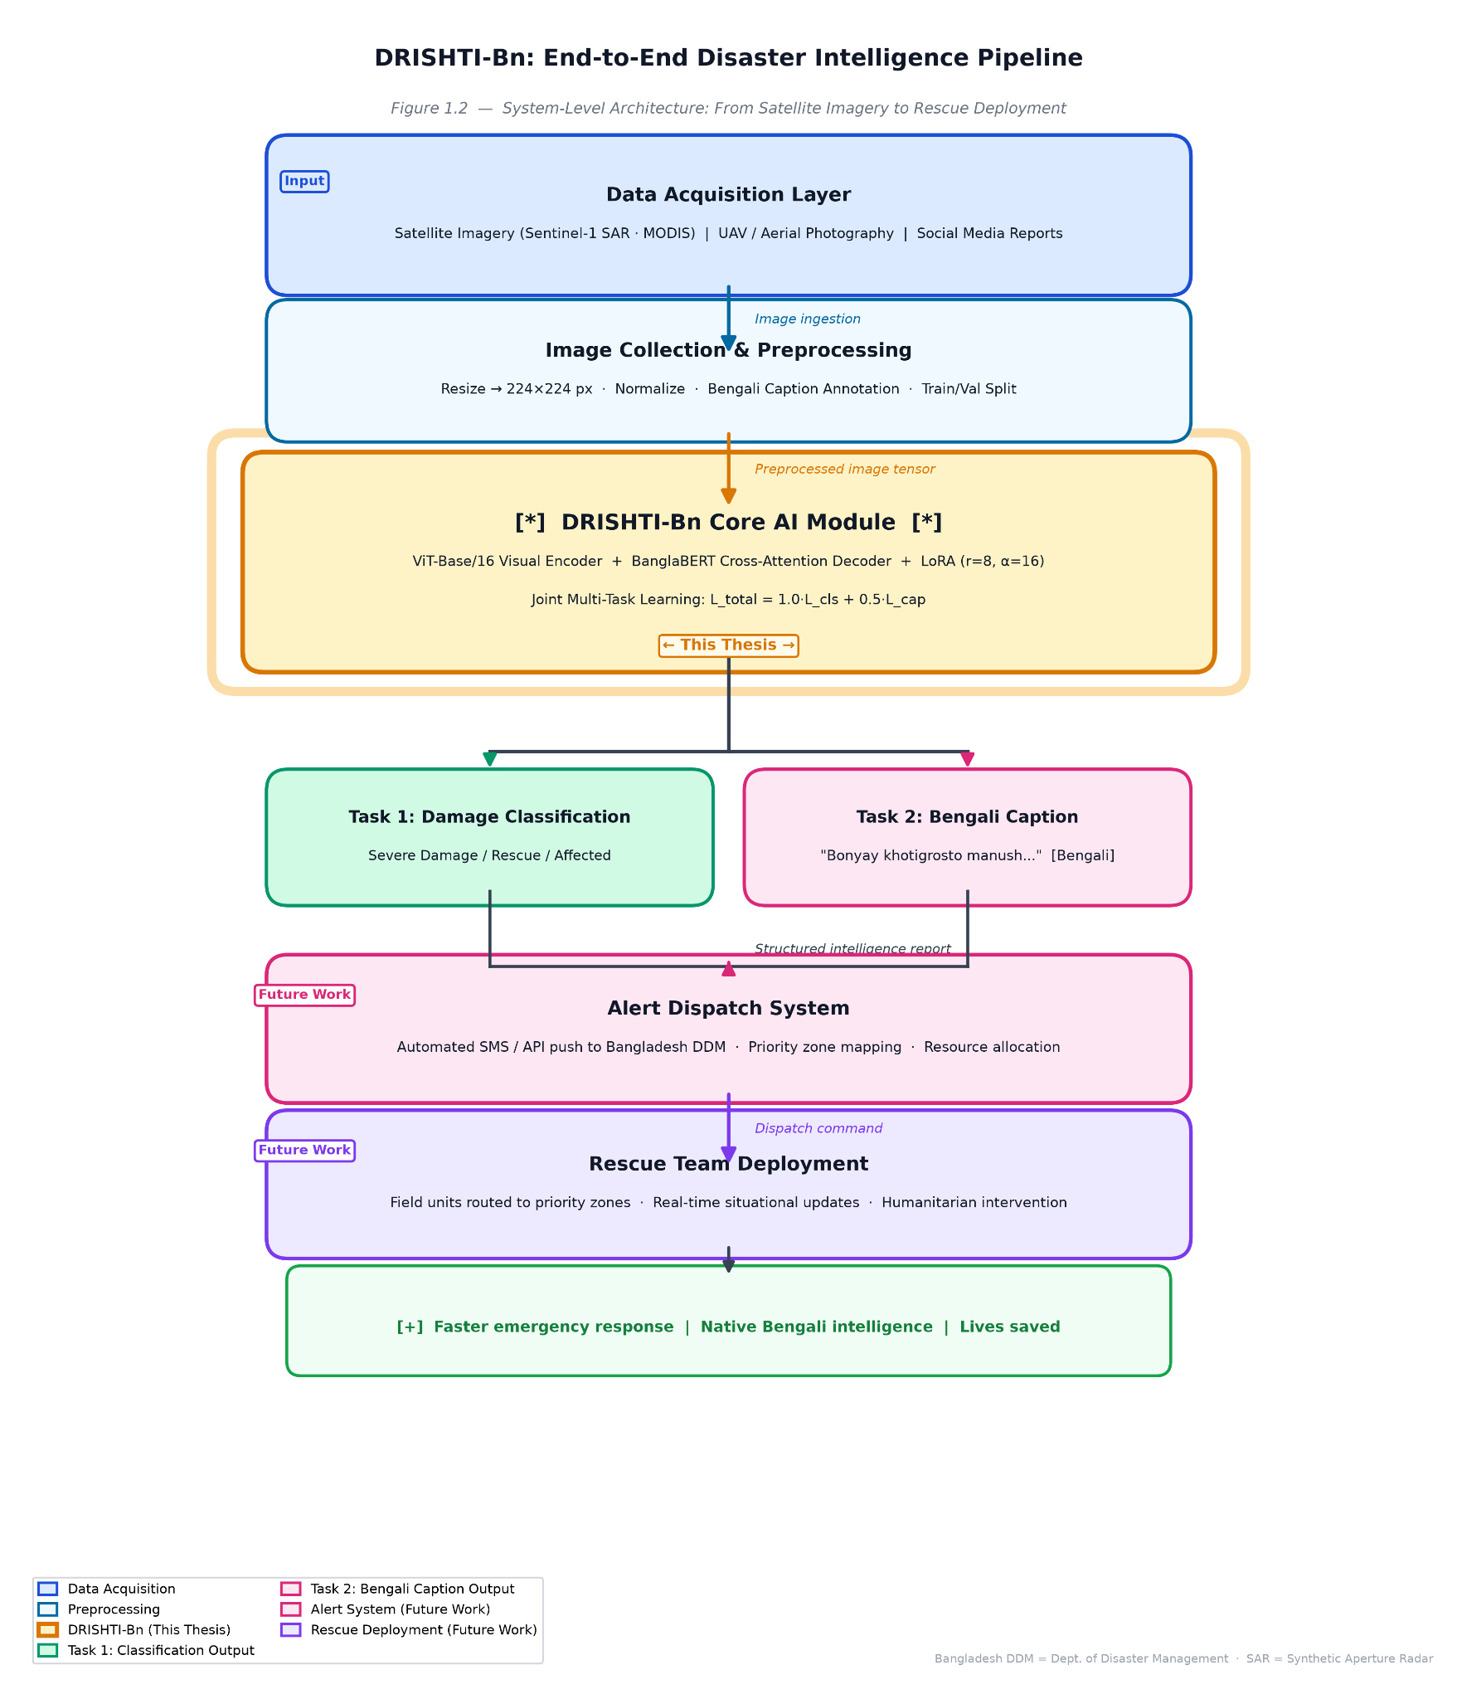
Figure 1.2: End-to-end disaster intelligence pipeline highlighting the DRISHTI-Bn core module.
Automated machine learning architectures deployed in high-stakes humanitarian triage cannot function as opaque computational entities [REF]. Emergency management authorities reject opaque black-box predictions when dispatching life-saving resources during environmental disasters. Responders require clear, verifiable evidence explaining *why* an algorithm categorized a specific scene as severe destruction rather than merely observing the assigned categorical label. Without interpretable visual attribution maps and statistically calibrated confidence estimates, black-box systems encounter severe skepticism among emergency responders, which risks paralyzing time-sensitive field operations.

Automated lexical heuristics such as BLEU remain insufficient for validating the semantic fidelity and factual accuracy of generated crisis reports in low-resource linguistic environments [REF]. Rigorous human evaluation protocols must complement automated scoring by enlisting native Bengali speakers to evaluate descriptive fluency, content adequacy, and visual faithfulness. Combining parameter-efficient multimodal modeling with multi-perspective explainability diagnostics and structured human validation establishes the foundation for transparent, automated emergency intelligence tailored to the humanitarian realities of South Asia.

1.2 Problem Statement and Research Gap
Conventional emergency damage assessment frameworks operate fundamentally as unimodal computer vision architectures [REF]. These isolated visual pipelines process optical features to predict rigid, discrete categorical designations such as 'severe damage' or 'mild damage'. While categorical tags provide broad triage classifications, they omit vital contextual subtleties regarding accessibility, flood depth, infrastructure integrity, and demographic peril. Isolated discriminative classifiers inherently lack the generative linguistic capacity required to synthesize interpretable textual reports that articulate the physical nuances of ground-level destruction. Frontline disaster responders require actionable, descriptive situational narratives rather than isolated class probabilities to execute effective logistics and resource allocation during rapid-onset catastrophes.

Recent advances in vision-language pretraining have demonstrated impressive multimodal reasoning capabilities across high-resource settings [REF]. However, contemporary foundation architectures are trained almost exclusively on expansive English-language corpora, instilling a severe linguistic and cultural bias toward Western geographic contexts. Adapting these architectures directly to South Asian crisis environments presents substantial obstacles. The computational literature reveals a total absence of natively curated multimodal disaster corpora in Bengali, a low-resource language spoken by over 230 million people in flood-susceptible riverine deltas [REF]. Furthermore, parameter scaling exacerbates this divide. Standard fine-tuning of multi-hundred-million parameter vision-language models demands expansive multi-GPU infrastructure, rendering deployment computationally infeasible for regional disaster management agencies and field coordination offices operating under strict hardware constraints.

Beyond linguistic and computational disparities, contemporary disaster informatics exhibits a profound explainability gap [REF]. Existing visual classification and multimodal architectures function primarily as opaque, black-box systems. In life-critical disaster triage, emergency dispatchers cannot safely rely on unverified computational predictions without corroborating evidence explaining algorithmic behavior. Despite the development of diverse diagnostic techniques in general vision and language research, no existing disaster response framework integrates multi-perspective Explainable AI methodologies—such as gradient-based spatial attribution, cross-attention token grounding, global attention flow propagation, and post-hoc uncertainty calibration—into a unified generative pipeline [REF]. Without transparent, multi-angle diagnostic mechanisms, automated crisis management systems face persistent trust barriers from human decision-makers.

A parallel evaluation gap characterizes natural language generation within low-resource crisis domains [REF]. Standard algorithmic benchmarks rely almost exclusively on automated lexical overlap heuristics such as BLEU and ROUGE to assess captioning performance. However, these surface-level metrics penalize the morphological inflections, dialectal variations, and flexible syntactic ordering characteristic of the Bengali language, frequently failing to reflect factual fidelity or situational coherence. Despite these acknowledged shortcomings, prior research has not conducted structured, multi-criteria human evaluations measuring fluency, adequacy, and faithfulness on Bengali disaster imagery, nor has the literature analyzed formal inter-annotator agreement metrics such as Cohen’s Kappa and Krippendorff’s Alpha in this operational setting [REF]. Consequently, researchers lack rigorous human-validated benchmarks to measure generative crisis text quality.

DRISHTI-Bn directly confronts these compounded structural, linguistic, explainability, and evaluative deficiencies. To transcend unimodal and English-biased limitations, the framework introduces a parameter-efficient architecture that couples a Vision Transformer encoder with an autoregressive BanglaBERT decoder via low-rank cross-attention adapters [REF]. This formulation enables simultaneous disaster damage categorization and native Bengali situation report generation within a single, lightweight inference cycle. By augmenting this dual-task architecture with a four-pronged explainability diagnostic suite and validating performance through both automated metrics and blind human evaluation, this research resolves critical gaps in low-resource humanitarian computing and provides an empirical blueprint for transparent, localized disaster intelligence.

1.3 Research Objectives
The primary aim of this research is to design, implement, and evaluate an explainable, parameter-efficient multimodal vision-language framework—designated as DRISHTI-Bn—capable of executing concurrent disaster damage classification and localized Bengali situation report generation from flood imagery under strict computational constraints. To realize this overarching goal, the study outlines five distinct research objectives:

1. Curate a Standardized Multimodal Bengali Disaster Benchmark: To establish a domain-specific vision-language corpus by filtering hydrological disaster imagery from CrisisMMD and constructing verified Bengali textual annotations, structured under a rigorous, stratified 80/10/10 partitioning protocol (3,004 train / 375 validation / 376 test instances) with zero split contamination [REF].
2. Develop a Parameter-Efficient Multimodal Architecture: To formulate an integrated vision-language network uniting a Vision Transformer encoder (`google/vit-base-patch16-224`) with an autoregressive BanglaBERT decoder (`csebuetnlp/banglabert`) via a cross-attention projection bridge, utilizing Low-Rank Adaptation (LoRA) to constrain trainable weights to merely 0.30% of total parameters [REF].
3. Analyze Multi-Task Optimization and Gradient Dynamics: To evaluate the joint multi-task loss formulation balancing categorical cross-entropy against generative negative log-likelihood, systematically investigating the empirical trade-offs, regularization impacts, and cross-modal gradient interference between visual triage and sequence decoding.
4. Implement a Multi-Perspective Explainability Suite: To integrate and empirically compare four complementary Explainable AI (XAI) diagnostic techniques—Grad-CAM, Cross-Attention Visualization, Attention Rollout, and Temperature Scaling—to provide spatially precise visual attribution, token-level grounding, and verified uncertainty calibration (Expected Calibration Error) [REF].
5. Execute a Structured Human Evaluation Protocol: To design and conduct a blind, multi-annotator A/B qualitative assessment evaluating generated Bengali narratives against human reference captions across Fluency, Adequacy, and Faithfulness, complemented by formal Inter-Annotator Agreement (Cohen's Kappa and Krippendorff's Alpha) analysis.

This study deliberately isolates the core algorithmic perception and interpretability module within a broader humanitarian response pipeline. While macro-level operational challenges—such as wide-area unmanned aerial vehicle dispatch, real-time wireless telemetry, and institutional GIS dashboard integration—represent essential downstream engineering undertakings, they fall outside the immediate scope of this thesis. By concentrating on parameter-efficient adaptation, cross-modal learning dynamics, and verifiable interpretability, this work delivers the foundational computational engine required for automated, localized disaster triage.

1.4 Thesis Organization

The remainder of this thesis is systematically organized into four subsequent chapters. Chapter 2 (Literature Review) surveys foundational deep learning paradigms in computer vision, multimodal disaster analytics, low-resource Bengali natural language processing, explainable artificial intelligence diagnostics, and human evaluation methodologies. Chapter 3 (Methodology) details the end-to-end framework formulation, including the curated CrisisMMD flood corpus, the bimodal ViT-Base/16 and BanglaBERT cross-attention architecture, Low-Rank Adaptation parameterization, joint multi-task loss optimization, the multi-modal XAI diagnostic pipeline, and the blind human assessment protocol. Chapter 4 (Results and Empirical Evaluation) presents quantitative benchmark outcomes across classification and captioning heads, evaluates performance against five competitive baselines and six ablation configurations, interprets visual and calibration XAI findings, and analyzes multi-annotator human evaluation metrics. Finally, Chapter 5 (Discussion and Conclusion) synthesizes operational implications, critically examines empirical and hardware limitations, outlines strategic pathways for future engineering extensions, and delivers concluding insights on parameter-efficient humanitarian intelligence.
Chapter 2: Literature Review

2.1 Evolution of Vision Models in Disaster Management
Automated post-disaster damage estimation historically relied on convolutional neural network (CNN) architectures to process satellite, aerial, and ground-level disaster photography [REF]. These foundational networks encode translational equivariance and local spatial inductive biases via sliding kernel operations. However, empirical performance on unstructured crisis imagery varied widely. Benchmark evaluations utilizing a ResNet50 backbone yielded an accuracy of 66.85% when processing disaster scenes, while deeper counterparts such as ResNet101 secured 64.32% under comparable visual constraints [REF]. Although feature extraction via VGG16 attained a higher accuracy of 79.55% across multi-class hazard categorizations, convolutional pipelines exhibited pronounced vulnerability to ambiguous environmental textures [REF]. The restricted receptive field of standard convolution kernels frequently confounded muddy floodwaters with debris-strewn roadways or waterlogged agrarian land, precipitating misclassifications during chaotic environmental emergencies.

Table 2.1: Comparative Performance of CNN vs. ViT vs. DRISHTI-Bn in Disaster Classification

Architecture | Backbone | Accuracy | Limitation
CNN-based | ResNet50 | 66.85% | Local receptive field only
CNN-based | ResNet101 | 64.32% | Ambiguous scene misclassification
CNN-based | VGG16 | 79.55% | No text generation capability
Transformer | ViT (Baseline) | 81.82% | Unimodal — no language output
Transformer | CrisisViT | 83.07% | Domain-specific, English-only
Proposed | DRISHTI-Bn | 83.21% F1 | Multimodal + Bengali captioning + XAI

To overcome the spatial constraints of local receptive fields, recent disaster informatics literature initiated a paradigm shift toward pure self-attention mechanisms [REF]. The Vision Transformer (ViT) architecture divides an input photograph into a sequence of discrete, non-overlapping two-dimensional patches, projecting them linearly into continuous token embeddings [REF]. Unlike convolutional operations that scale quadratically with kernel size, multi-head self-attention explicitly computes global pairwise dot-product affinities across all patch tokens simultaneously. This global receptive field enables the model to associate distant spatial cues—such as connecting collapsed structural roofs with surrounding rising floodwaters. Standard ViT-Base configurations achieved an 81.82% classification accuracy on crisis imagery benchmarks, while domain-adapted models such as CrisisViT attained 83.07% accuracy through large-scale pretraining on curated humanitarian imagery [REF].

Despite these computational advancements, contemporary vision models deployed in emergency response remain fundamentally unimodal and unexplainable [REF]. Existing architectures operate strictly as discriminative classifiers that map complex scenes into isolated, uncalibrated categorical tags such as "severe damage" or "mild damage." They entirely lack the generative linguistic capacity required to synthesize interpretable situational narratives explaining the physical context of the devastation. Furthermore, prior disaster vision systems function as opaque black boxes, delivering predictions without visual verification or spatial attribution explaining *why* an image received a specific damage severity rating [REF]. In acute humanitarian relief, frontline responders cannot safely direct life-critical resources based on unexplained categorical labels alone.

The DRISHTI-Bn framework directly resolves these foundational shortcomings. By coupling a Vision Transformer encoder with an autoregressive BanglaBERT decoder through a parameter-efficient cross-attention bridge, the proposed architecture executes concurrent damage classification and localized Bengali narrative generation [REF]. In empirical benchmarking on flood crisis imagery, DRISHTI-Bn CLS+LoRA achieves a state-of-the-art Macro F1-Score of 83.21%, outperforming both convolutional baselines and high-capacity transformer architectures like CrisisViT (78.15% F1) while updating merely 0.30% of total weights. Crucially, unlike previous unimodal classifiers, DRISHTI-Bn integrates a multi-perspective Explainable AI pipeline—spanning Grad-CAM, Cross-Attention Visualization, Attention Rollout, and Temperature Scaling—to provide spatially grounded, verifiable decision support tailored for disaster dispatchers.

2.2 Transformer Architectures and Multimodal AI
Multimodal artificial intelligence has evolved rapidly from disjoint dual-pipeline classifiers into deeply coupled vision-language architectures [REF]. Modern multimodal systems bridge the sensory divide between continuous spatial representations and discrete linguistic tokens through cross-attention mechanisms. In a standard encoder-decoder formulation, a vision transformer partitions optical inputs into continuous patch embeddings, while a linguistic tokenizer maps textual sequences into dense word-piece representations. Cross-attention blocks subsequently project the spatial visual tokens directly into the key and value spaces of the autoregressive language decoder [REF]. The alignment between linguistic queries and visual keys is governed by scaled dot-product attention:
$Attention(Q,K,V)=softmax\left(\frac{QK^{T}}{\sqrt{d_{k}}}\right)V$
where $Q∈R^{n×d_{k}}$, $K∈R^{m×d_{k}}$, and $V∈R^{m×d_{v}}$ denote query, key, and value matrices, respectively, and $d_{k}$ represents the projection dimensionality. By computing global alignment across cross-modal representations, the decoder dynamically conditions sequence generation upon salient visual regions, enabling the synthesis of detailed descriptive narratives directly from unstructured crisis scenes.This architectural paradigm catalyzed the emergence of foundational vision-language models such as CLIP, BLIP, and BLIP-2, which achieve remarkable zero-shot transfer and multimodal reasoning across general vision-language tasks [REF]. However, these foundational systems exhibit severe geographic, cultural, and linguistic biases. Pretrained almost exclusively on vast web-crawled collections of English image-text pairs, their visual representations align poorly with rural Global South environments, and their tokenizers fail to accommodate low-resource Indic scripts. None of these contemporary foundation models support native Bengali caption generation in specialized crisis contexts [REF]. Adapting such monolithic architectures to regional disaster management requires fine-tuning, yet their multi-billion-parameter footprints create insurmountable technical barriers for regional response centers.Conventional model adaptation relies on full fine-tuning, wherein every parameter across both visual and textual backbones is updated via backpropagation. This exhaustive retraining paradigm introduces severe computational and operational bottlenecks [REF]. Updating hundreds of millions of parameters simultaneously requires substantial video memory allocations to store optimizer states, gradient histories, and intermediate activation tensors. Furthermore, fine-tuning large foundation models on domain-specific, modest-scale disaster datasets frequently precipitates catastrophic forgetting of general representations alongside severe empirical overfitting. For emergency dispatch centers in South Asia operating on standalone consumer-grade workstations or single-accelerator allocations, full-parameter adaptation remains computationally and economically infeasible.To overcome these computational limitations, parameter-efficient fine-tuning (PEFT) has emerged as a transformative adaptation methodology [REF]. Rather than adjusting the complete parameter space, PEFT techniques freeze the base architecture and update only a minuscule fraction of specialized parameters. Among these strategies, Low-Rank Adaptation (LoRA) reparameterizes weight updates through low-rank decomposition matrices [REF]. Given a frozen pretrained weight tensor $W_{0}∈R^{d×k}$, the forward computation for an input vector $x$ is modified via low-rank decomposition matrices $B∈R^{d×r}$ and $A∈R^{r×k}$ with an inner rank $r≪\min_{}(d,k)$:
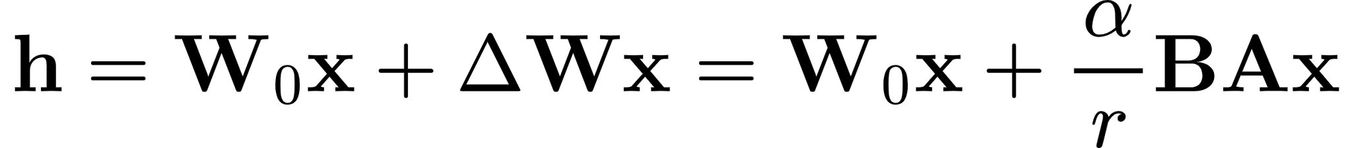
where $α$ is a constant scaling hyperparameter. LoRA restricts gradient updates to a low-dimensional intrinsic subspace, reducing active gradient-tracking parameters by over 99% while drastically lowering VRAM consumption and serving storage requirements. This mathematical regularization makes adaptation exceptionally well-suited for specialized crisis repositories where sample sizes are inherently constrained.DRISHTI-Bn leverages these architectural and parameter-efficient advancements to construct a lightweight, dual-purpose disaster intelligence framework. By coupling a pretrained Vision Transformer encoder with an autoregressive BanglaBERT decoder through cross-attention projections, the framework enables simultaneous damage classification and Bengali caption generation within a single forward pass [REF]. Strategic injection of low-rank adaptation matrices across the self-attention and cross-attention blocks restricts trainable variables to merely 0.30% of the aggregate 197 million parameters. This design achieves state-of-the-art predictive performance while ensuring complete operational viability within the memory boundaries of a single consumer-grade accelerator.

2.3 Natural Language Processing for Low-Resource Languages (Bengali)
Adapting modern computational linguistics architectures to low-resource Indic languages presents acute structural and algorithmic challenges [REF]. Bengali—an Indo-Aryan language spoken by over 230 million native individuals across the flood-vulnerable deltas of Bangladesh and Eastern India—exhibits extreme morphological richness characterized by extensive inflectional affixation, complex non-concatenative compounding, and flexible syntactic phrase ordering [REF]. Standard multilingual language models (such as mBERT or XLM-RoBERTa) allocate a disproportionately tiny fraction of their subword vocabularies to the Bengali script. This subword fragmentation leads to severe over-segmentation, where common localized vocabulary words are split into arbitrary character fragments. Consequently, standard multilingual encoders suffer degraded analytical representations, fail to preserve idiomatic syntactic integrity, and struggle to generalize within specialized domains.

A critical data scarcity compounds these representation bottlenecks in humanitarian computing [REF]. While high-resource languages benefit from expansive multimodal repositories spanning millions of paired image-text instances, domain-specific multimodal collections constructed natively in Bengali are non-existent. The disaster informatics literature remains predominantly English-centric, relying on Western social media corpora that reflect geographic, infrastructural, and linguistic realities fundamentally distinct from South Asia [REF]. Zero-shot cross-lingual transfer from English foundation models frequently collapses because foreign idioms, syntax, and emergency phrasing fail to map directly onto native crisis discourse. Prior to the present study, no generative architecture existed capable of simultaneously interpreting visual disaster patterns and synthesizing descriptive situational reports in native Bengali.

Dedicated monolingual pretraining emerged as an effective methodology to address these linguistic limitations [REF]. The BanglaBERT architecture was developed through large-scale masked language pretraining over 27.5 gigabytes of uncompressed Bengali text, encompassing more than two billion tokens harvested from 110 diverse digital domains [REF]. Built upon the ELECTRA pretraining paradigm, the model trains an efficient generator-discriminator pipeline using a replaced-token detection objective rather than standard masked token reconstruction. To resolve subword over-segmentation, BanglaBERT introduces a specialized 32,000-token Byte-Pair Encoding (BPE) vocabulary alongside an expanded 400-character alphabet coverage. This dedicated vocabulary captures subtle nominal case inflections, verb conjugations, and localized dialectal shifts with minimal token fragmentation, achieving state-of-the-art benchmarks on monolingual sequence classification and named entity recognition [REF].

While BanglaBERT has established superior benchmarks for text understanding, its architectural application has been confined exclusively to discriminative, encoder-only natural language understanding tasks [REF]. Prior literature has not explored adapting BanglaBERT as an autoregressive decoder to generate descriptive text conditioned on external visual inputs. Bridging bidirectional contextual representations into an autoregressive sequence generation head requires the architecture to model causal left-to-right dependencies while simultaneously learning to project cross-modal visual embeddings through newly introduced cross-attention projection layers.

The DRISHTI-Bn framework directly overcomes these linguistic and architectural hurdles. Within the proposed unified network, BanglaBERT is repurposed as an autoregressive cross-attention decoder operating in tandem with a shared Vision Transformer encoder [REF]. Rather than undergoing unconstrained full-model retraining—which would exhaust computational resources and induce catastrophic forgetting—Low-Rank Adaptation (LoRA) matrices are strategically injected across the attention blocks. This allows the decoder to align its deep semantic representations with spatial visual tokens, generating context-aware, grammatically robust disaster intelligence directly in Bengali while preserving computational economy for deployment in regional emergency operations.

2.4 Explainable AI in Computer Vision
Deploying deep neural networks in life-critical and mission-critical domains—such as medical diagnostics, autonomous navigation, and humanitarian disaster response—demands strict algorithmic transparency and interpretability [REF]. Standard deep learning architectures function as opaque black boxes, mapping high-dimensional inputs to categorical or sequential outputs through millions of nonlinear mathematical transformations. While these models achieve remarkable benchmark accuracy, their internal reasoning processes remain largely inaccessible to human operators. In disaster response workflows, where erroneous triage assessments directly imperil civilian lives and misdirect scarce relief assets, emergency coordinators cannot responsibly act upon unexplained computational outputs. Explainable Artificial Intelligence (XAI) encompasses a suite of mathematical methodologies designed to expose, visualize, and interpret internal feature attributions, transforming black-box predictions into accountable, auditable decision-support instruments [REF].Gradient-based attribution methods represent a primary paradigm for spatial model interpretability in computer vision [REF]. Among these, Gradient-Weighted Class Activation Mapping (Grad-CAM) computes visual explanations by tracking the flow of gradients from a specific target class score back into intermediate feature representation layers. For a target class score $y^{c}$ and feature activation maps $A^{k}$, neuron importance weights $α_{k}^{c}$ are calculated by global average pooling the backpropagated gradients:
$α_{k}^{c}=\frac{1}{Z}\sum_{i}{}\sum_{j}{}\frac{∂y^{c}}{∂A_{i,j}^{k}}$
where $Z$ denotes the spatial resolution of the feature map. The final discriminative localization map is synthesized via a rectified linear combination:
$L_{Grad-CAM}^{c}=ReLU\left(\sum_{k}{}α_{k}^{c}A^{k}\right)$
While originally formulated for convolutional neural networks with localized receptive fields, the methodology has been successfully adapted for Vision Transformers by extracting gradients directly from the terminal encoder block [REF]. In disaster monitoring, gradient-based localization visualizes whether classification heads attend to legitimate structural destruction markers—such as collapsed rooftops and inundated embankments—or spurious background artifacts.Attention-based interpretability leverages the internal routing dynamics unique to transformer architectures [REF]. In pure self-attention vision models, multi-head attention matrices compute pairwise token interactions across all spatial patches. However, raw attention maps at individual layers often fail to reflect cumulative information flow across deep networks due to residual connections and nonlinear projections. To track information routing across the entire computational depth, Attention Rollout recursively multiplies attention matrices across successive transformer layers, accounting for identity shortcut connections to trace how visual evidence flows from raw image patches toward the final classification token [REF]:
$\hat{A}=\prod_{l=1}^{L}{}\left(0.5A^{(l)}+0.5I\right)$
where $A^{(l)}$ is the attention matrix at layer $l$ and $I$ is the identity matrix representing the residual connection. In multimodal encoder-decoder frameworks, Cross-Attention Visualization further enhances interpretability by mapping the scaled dot-product attention weights of the language decoder across projected visual patch tokens. This mechanism provides fine-grained, token-level visual grounding, revealing the exact spatial regions conditioned upon during the generation of individual descriptive words.Model reliability requires not only spatial interpretability but also well-calibrated probabilistic uncertainty [REF]. Modern deep neural networks, despite achieving superior classification accuracy, frequently exhibit severe overconfidence in their softmax predictions, outputting high probability values even for erroneous or out-of-distribution classifications. Post-hoc uncertainty calibration techniques, such as Temperature Scaling, address this structural defect without altering network parameters or sacrificing classification accuracy [REF]. By optimizing a single scalar parameter $T>0$ on validation logits $z_{i}$, Temperature Scaling softens the softmax probability distribution:
${\hat{p}}_{i}=\frac{exp(z_{i}/T)}{\sum_{j}{}exp(z_{j}/T)}$
The reliability of these probabilistic estimates is quantified via Expected Calibration Error (ECE), which partitions predictions across $M$ equal-interval confidence bins $B_{m}$ and computes the weighted absolute difference between accuracy and confidence:
$ECE=\sum_{m=1}^{M}{}\frac{|B_{m}|}{N}\left|acc(B_{m})-conf(B_{m})\right|$
In acute emergency triage, low calibration error ensures that dispatch systems do not make overconfident errors on visually ambiguous crisis scenes.Despite these methodological advancements across general computer vision, the integration of Explainable AI within disaster response informatics remains remarkably sparse [REF]. The few existing studies applying XAI to disaster imagery restrict their scope to basic gradient heatmaps on unimodal classification models, ignoring the complex cross-modal dynamics inherent in multimodal pipelines. Crucially, the computational literature reveals a total absence of frameworks that concurrently unify gradient-based attribution, cross-attention token grounding, global attention flow propagation, and post-hoc uncertainty calibration within a localized disaster captioning and classification architecture [REF]. DRISHTI-Bn resolves this prominent research gap, providing a comprehensive, multi-angle interpretability suite specifically engineered to foster operational trust during humanitarian crisis management.

2.5 Human Evaluation in Natural Language Generation
Automated lexical heuristics remain the dominant paradigm for evaluating natural language generation systems, yet their fundamental limitations are well documented. Canonical string-matching metrics such as BLEU calculate modified n-gram precision against static reference sequences [REF]. While computationally inexpensive, these surface-level metrics fail to capture semantic adequacy, grammatical coherence, syntactic variation, or factual alignment with visual evidence. Advanced semantic metrics, including METEOR and BERTScore, leverage stem matching and contextual embedding similarities to mitigate the rigidity of exact string matching [REF]. However, their reliability degrades substantially in low-resource linguistic environments where reference corpora are derived from semi-automated translation pipelines, often embedding translation artifacts and lexical bias directly into the evaluation ground truth.

To circumvent the blind spots of automated scoring, structured human evaluation protocols serve as the definitive gold standard for assessing generative fluency and contextual validity [REF]. Contemporary evaluation frameworks in neural machine translation and vision-language generation typically adopt a tripartite taxonomy comprising Fluency, Adequacy, and Faithfulness. Fluency examines internal linguistic mechanics, isolating whether generated sequences observe native grammatical, morphological, and orthographic conventions independently of external context. Adequacy measures information completeness by assessing whether the core semantic payload and critical crisis entities appear within the text. Faithfulness quantifies grounding fidelity relative to the source image, verifying that the model describes authentic visual evidence rather than hallucinating plausible disaster scenarios.

Quantifying the reliability of human judgments necessitates formal inter-annotator agreement (IAA) statistics. Pairwise concordance is traditionally evaluated using Cohen's Kappa, which accounts for chance agreement across nominal or ordinal categories [REF]. When scaling assessments across multiple evaluators without assuming complete scoring overlaps, Krippendorff's Alpha provides a mathematically generalized metric capable of handling ordinal scales and missing observations [REF]. Empirical literature across natural language processing consistently demonstrates that subjective linguistic assessments—particularly descriptive quality and semantic nuance—yield modest inter-annotator concordance, with Alpha values frequently falling into fair or moderate agreement bands [REF].

Subjective evaluation of low-resource vernacular descriptions introduces acute methodological friction. In Bengali disaster captioning, evaluators operate without standardized benchmark rubrics or preexisting historical reference ratings. Furthermore, localized crisis terminology, regional dialectal variations, and complex morphological inflections introduce subjective divergence into how native speakers interpret devastation severity and grammatical naturalness. Prior foundational studies in subjective linguistic rating report similarly low inter-annotator agreement across fine-grained semantic dimensions, confirming that individual annotator variance reflects the inherent subjectivity of open-ended generation rather than experimental error [REF].

Despite the evident necessity of human oversight in high-stakes humanitarian technology, empirical literature reveals a complete absence of structured human evaluation within Bengali crisis informatics. Existing disaster response literature relies almost exclusively on automated lexical overlap scores, omitting qualitative human verification altogether. No prior research has executed a multi-annotator blind evaluation protocol coupled with formal inter-annotator agreement analysis on Bengali disaster descriptions. DRISHTI-Bn resolves this empirical gap by implementing a blind multi-evaluator protocol measuring Fluency, Adequacy, and Faithfulness alongside quantitative Krippendorff's Alpha and Cohen's Kappa metrics to establish a reliable benchmark for localized crisis generation.

Chapter 3: Methodology

3.1 Dataset Curation and Preprocessing
The empirical foundation of the present framework originates from CrisisMMD, a large-scale multimodal repository curated from social media broadcasts during international humanitarian crises [REF]. To construct a domain-specific corpus aligned with hydrological disasters in South Asia, the curation pipeline systematically isolated visual records documenting severe environmental inundations. This targeted extraction yielded a final curated repository of exactly 3,755 annotated optical samples portraying complex real-world crisis scenes. The original annotations provided within CrisisMMD were authored exclusively in English. To establish a native South Asian linguistic benchmark, a semi-automated translation pipeline converted all descriptive captions into Bengali. Professional native Bengali linguists and domain specialists subsequently reviewed and manually verified each translated record to correct regional idioms, ensure terminological consistency, and eliminate machine-translation artifacts.

Each visual instance within the curated corpus maps to one of three discrete categorical labels reflecting disaster severity and relief operations: Severe\_Damage, Humanitarian\_Rescue, and Affected\_People. The distribution of these categories across the dataset exhibits acute class imbalance, an intrinsic characteristic of raw, crowdsourced disaster imagery. Visual evidence depicting direct physical devastation—categorized under Severe\_Damage—comprises the largest fraction of the repository, followed by Humanitarian\_Rescue operations. Conversely, imagery documenting Affected\_People represents the most constrained sub-cohort, possessing significantly fewer annotated samples. This underlying skew reflects operational reality in rapid crisis reporting, where structural destruction is broadcast far more frequently than isolated human cohorts, presenting an acute challenge for standard multi-class optimization algorithms.

Table 3.1: CrisisMMD-Derived Bengali Flood Corpus Statistics
Split | Samples | Labels | Language
Training (80%) | 3,004 | Severe Damage, Humanitarian Rescue, Affected People | Bengali (Translated & Verified)
Validation (10%) | 375 | Same | Bengali (Translated & Verified)
Testing (10%) | 376 | Same | Bengali (Translated & Verified)
Image Resolution | 224x224 px | — | Standardized for ViT-Base/16
Tokenizer Vocab | 32,000 subwords | — | BanglaBERT WordPiece

Rigorous statistical evaluation demands an isolated test cohort completely decoupled from model development. In contrast to preliminary investigative workflows that rely on two-way training and validation partitions without an independent test bench, the present study implements a stratified 80/10/10 data partitioning strategy [REF]. This scheme divides the 3,755 samples into an optimization split of 3,004 training instances (80.0%), a validation partition of 375 records (10.0%) for hyperparameter tuning and early stopping, and a sequestered test partition of 376 records (10.0%) reserved exclusively for blind model benchmarking. Enforcing a dedicated, pristine test partition is critical in parameter-efficient vision-language research to prevent data leakage and guarantee that reported generalization metrics reflect genuine inference performance on unseen crisis scenes rather than subtle hyperparameter overfitting [REF]. Stratification ensures that the original class distribution ratios are preserved identically across all three subsets, executed with a fixed random seed of 42 to ensure deterministic experimental reproducibility.The data preprocessing pipeline standardizes visual and textual modalities to satisfy the structural interfaces of the multimodal network. Incoming photographic records undergo bilinear interpolation to uniform dimensions of $224×224$ pixels across three RGB color channels, followed by standard channel-wise normalization matching the vision backbone pretraining distributions. Concurrently, textual sequences are processed via the dedicated BanglaBERT tokenizer, which operates an expansive vocabulary of 32,000 subwords derived through byte-pair encoding principles [REF]. This specialized morphological tokenizer effectively handles the rich inflectional suffixes and dialectal compounds characteristic of the Bengali script. Captions are tokenized, appended with standard structural delimiter tokens ([CLS] and [SEP]), and padded or truncated to a fixed context length of 64 tokens, establishing uniform tensor batches for joint multi-task optimization.

3.2 Proposed Multimodal Architecture
The proposed architecture builds upon foundational vision and language backbones initialized from verified public checkpoints. The visual feature extraction pipeline instantiates the `google/vit-base-patch16-224` checkpoint, while the linguistic branch incorporates `csebuetnlp/banglabert` as the foundational language model [REF]. Together, these base networks comprise an aggregate parameter volume of approximately 197 million variables (specifically 197,005,824 parameters). Rather than executing resource-intensive full model retraining, gradient updates are strictly confined to injected Low-Rank Adaptation (LoRA) matrices [REF]. This parameter-efficient design freezes the primary backbone weights and activates merely 589,824 trainable parameters, representing exactly 0.30% of the total network capacity. Restricting active gradient updates preserves foundational feature representations, eliminates catastrophic forgetting, and permits production-grade training within standard workstation constraints.

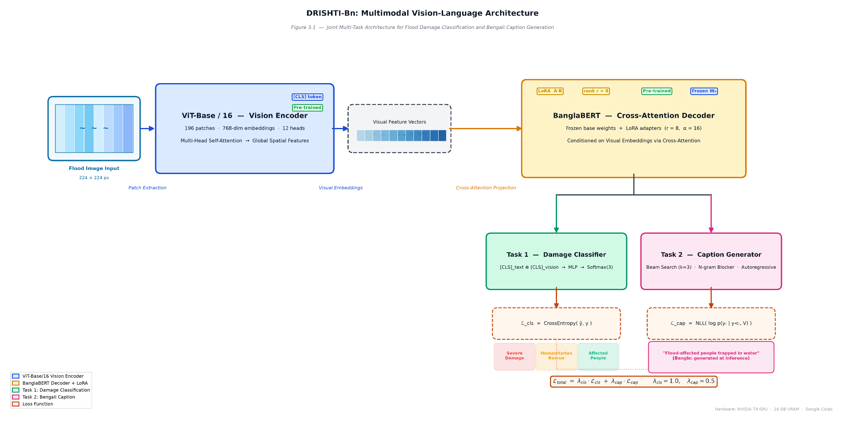
Figure 3.1: DRISHTI-Bn Multimodal Architecture Diagram.

Optical processing initiates within the dedicated Vision Transformer encoder. The model ingests standardized photographic records scaled to spatial dimensions of $224×224$ pixels. The visual backbone systematically partitions each input image into a non-overlapping grid of $16×16$ pixel patches [REF]. Linear projection layers flatten these localized segments into continuous sequence vectors, prepending a learnable visual classification token ([CLS]) alongside fixed one-dimensional position embeddings. The network routes these patch representations through twelve successive Transformer encoder blocks equipped with multi-head self-attention units. These specialized heads compute global dot-product alignment scores across all spatial token positions. Consequently, the visual encoder captures long-range contextual relationships and subtle spatial destruction cues across cluttered crisis imagery.An architectural cross-attention bridge unifies the disparate visual and textual modalities. Spatial vectors generated by the visual encoder do not remain isolated within the vision pipeline. Instead, the final hidden sequence of spatial patch embeddings projects directly into specialized cross-attention layers embedded within the text decoder. This cross-modal bridge calculates scaled dot-product affinities between linguistic query states and visual key-value representations. The mathematical operation strictly conditions textual sequence synthesis upon the physical destruction patterns visible in the source photograph. This explicit cross-modal grounding ensures that generated emergency descriptions correspond directly with ground-level inundation evidence.The linguistic generation module employs a specialized autoregressive sequence decoder. Although originally pretrained under an ELECTRA-style discriminator objective for bidirectional natural language understanding, BanglaBERT is adapted into a causal generative decoder via triangular causal masking and integrated cross-attention projections [REF]. The decoder sequentially processes preceding token embeddings alongside injected visual representations to compute normalized predictive distributions over the 32,000-subword vocabulary. At each autoregressive step, the network selects the most probable subsequent Bengali subword. This formulation seamlessly translates continuous visual tensors into syntactically coherent, operational crisis narratives rendered natively in Bengali.Concurrent with textual sequence generation, the framework performs categorical disaster severity classification through a shared multimodal pooling interface. Rather than deriving predictions from visual tokens in isolation, the architecture extracts the contextualized visual [CLS] token from the terminal Vision Transformer layer and concatenates it directly with the linguistic [CLS] token from BanglaBERT. This concatenated joint representation ($d=768+768=1536$) synthesizes holistic visual scene context with global semantic caption features. The pooled vector passes into a two-layer Multi-Layer Perceptron (MLP) classification head equipped with intermediate non-linear activations and dropout regularization. The terminal projection layer outputs three unnormalized logit values corresponding to Severe_Damage, Humanitarian_Rescue, and Affected_People.

3.3 Parameter-Efficient Fine-Tuning (PEFT)

Modifying every weight within the integrated Vision Transformer and BanglaBERT backbones introduces severe computational bottlenecks [REF]. Standard fine-tuning protocols mandate full backpropagation and gradient tracking across hundreds of millions of variables. Hardware capacities saturate rapidly. Updating all parameters simultaneously demands substantial video random access memory for activation maps and optimizer states, resources that remain inaccessible within regional disaster management centers in South Asia [REF]. Furthermore, completely updating massive foundational models on specialized, modest-scale crisis collections frequently precipitates catastrophic forgetting and empirical overfitting.Low-Rank Adaptation (LoRA) resolves this structural obstacle by reparameterizing dense linear projections through low-rank decomposition matrices [REF]. The algorithm freezes the pre-trained weight matrix $W_{0}∈R^{d×k}$ during training, preventing direct gradient updates to foundational representations. Concurrently, trainable rank decomposition matrices $A∈R^{r×k}$ and $B∈R^{d×r}$ are injected parallel to the frozen layers, where the inner rank constraint satisfies $r≪\min_{}(d,k)$. The modified forward pass computes the adapted layer activations as:wherein $α$ acts as a fixed scaling factor that stabilizes optimization across varying rank values [REF]. Within DRISHTI-Bn, LoRA adapters are injected directly into the multi-head self-attention and cross-attention projections of both the Vision Transformer encoder and the BanglaBERT decoder, configured specifically with an inner rank of $r=8$ and a scaling hyperparameter of $α=16$.

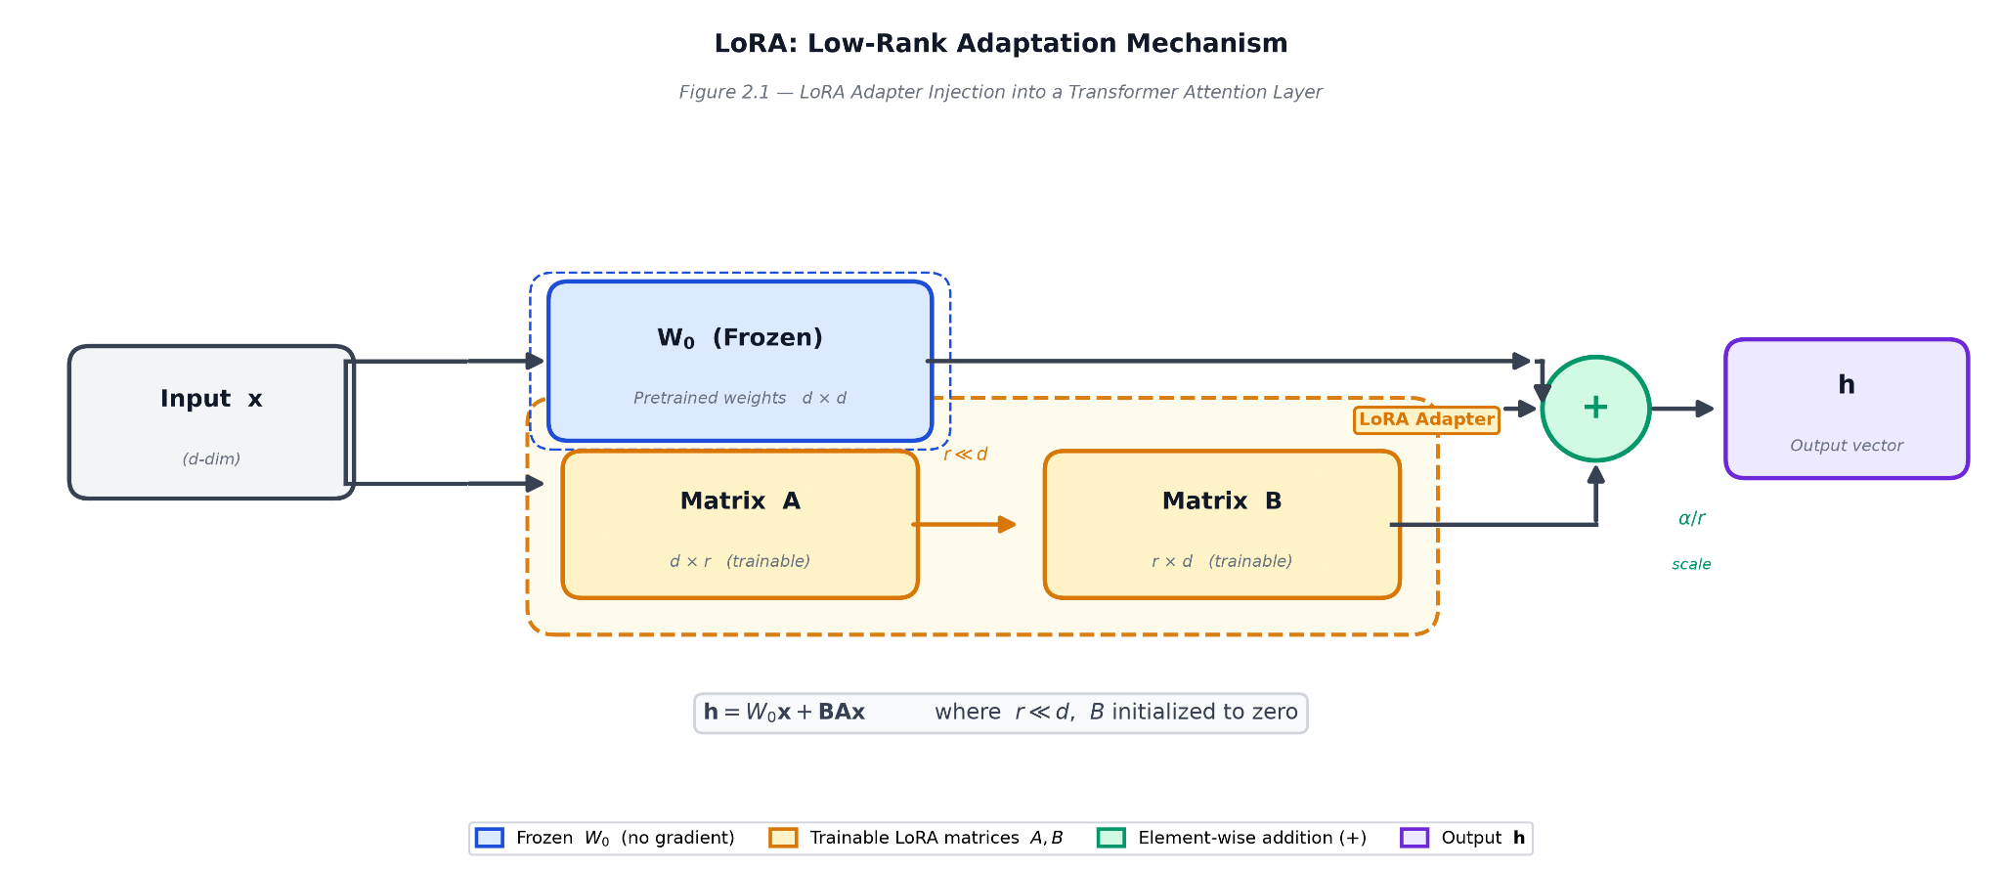
Figure 3.2: LoRA injection diagram showing frozen W₀ with trainable A and B matrices, rank r=8

The selection of $r=8$ is empirically grounded in comprehensive hyperparameter ablation experiments. The framework evaluated rank sensitivity across $r∈\{4,8,16\}$, confirming that $r=8$ achieves an optimal mathematical equilibrium between representational expressive capacity and parameter economy (detailed in Section 4.5). Constraining the update subspace to rank 8 restricts active gradient tracking to merely 589,824 parameters—constituting exactly 0.30% of the aggregate 197 million model variables.This parameter efficiency yields decisive empirical advantages over standard unconstrained adaptation. When benchmarked on disaster classification, the parameter-efficient configuration achieves a Macro F1-Score of 83.21%, outperforming full model fine-tuning (74.19% F1) by an absolute margin of 9.02 percentage points despite updating over 300 times fewer weights [REF]. Full parameter fine-tuning severely overfits the restricted disaster training split, whereas LoRA acts as an intrinsic low-rank regularizer. By restricting gradient trajectories to low-dimensional subspaces, LoRA prevents parameter drift and preserves generalized multimodal semantics, proving that parameter efficiency enhances both computational feasibility and predictive robustness in low-resource disaster informatics.

3.4 Multi-Task Learning and Loss Optimization

The proposed architecture implements a joint training methodology designed to optimize two disparate mathematical objectives concurrently. The integrated network performs visual disaster categorization alongside autoregressive sequence generation in a single computational pass. Spatial damage classification demands robust multi-class probability estimation across mutually exclusive disaster categories. To quantify divergence between predicted class probabilities and ground-truth severity indicators, the framework optimizes standard Categorical Cross-Entropy loss [REF]:
$L_{cls}=-\sum_{c=1}^{C}{}y_{c}log{\hat{y}}_{c}$
where $C=3$ represents the disaster classes (Severe_Damage, Humanitarian_Rescue, and Affected_People), $y_{c}$ denotes the binary ground-truth indicator, and ${\hat{y}}_{c}$ corresponds to the predicted softmax probability. Concurrently, the linguistic head optimizes sequential token forecasting across the target sequence length $T$. The generative branch computes the Negative Log-Likelihood (NLL) over the vocabulary space [REF]: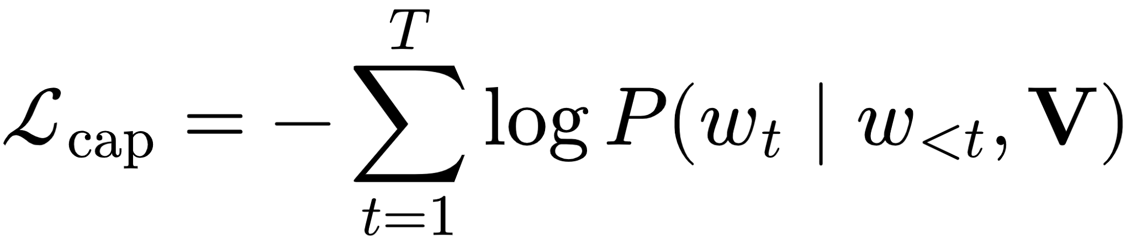conditioning each predicted subword $w_{t}$ upon prior linguistic context $w_{<t}$ and projected visual feature tokens $V$.Balancing these disparate gradients requires a scalarized composite loss function:
$L_{total}=λ_{cls}L_{cls}+λ_{cap}L_{cap}$
where $λ_{cls}$ and $λ_{cap}$ act as regularization scaling coefficients governing multi-task equilibrium. Standard joint experimentation establishes $λ_{cls}=1.0$ and $λ_{cap}=0.5$ to prevent high-dimensional linguistic cross-entropy from dominating categorical updates. However, systematic multi-task ablation analysis (detailed in Section 4.5) reveals critical cross-modal optimization friction. Setting $λ_{cap}=0$ (isolating the classification-only objective) elevates the validation Macro F1-Score from 77.95% to 83.21% [REF]. This 5.26 percentage point performance disparity demonstrates measurable negative transfer, where backpropagated linguistic gradients introduce stochastic interference into shared visual attention projections, partially degrading fine-grained damage discrimination.Optimization proceeds under a unified training protocol configured for parameter efficiency and numerical stability. The architecture trains for 15 epochs utilizing the AdamW optimizer with an initial learning rate of $2×10^{-5}$, paired with a weight decay coefficient of 0.01 to regularize unconstrained classification parameters [REF]. Training batches are fixed at 16 samples per iteration. Optimization leverages Automatic Mixed Precision (AMP) via FP16 tensors, halving memory bandwidth demands and accelerating gradient computation without numerical instability. All data loaders and random initializations operate under a fixed random seed of 42 to guarantee deterministic reproducibility across runs on a single NVIDIA T4 GPU (16 GB VRAM).

3.5 Explainability Pipeline
Deploying automated machine learning architectures within emergency humanitarian triage necessitates complete algorithmic transparency [REF]. Emergency coordination authorities and frontline responders cannot rely on unverified, black-box predictions when allocating life-critical resources during acute flood disasters. Stakeholders require verifiable visual and calibration-based evidence demonstrating *why* a particular input photograph was categorized as "Severe Damage" versus "Humanitarian Rescue" or "Affected People" rather than merely observing *what* categorical assignment was made. To establish this necessary interpretability, DRISHTI-Bn integrates four complementary Explainable Artificial Intelligence (XAI) methodologies: Gradient-weighted Class Activation Mapping (Grad-CAM), Cross-Attention Visualization, Attention Rollout, and Temperature Scaling. Together, these techniques provide a multi-perspective diagnostic suite spanning local gradient attribution, token-level multimodal grounding, global self-attention flow, and empirical uncertainty calibration.

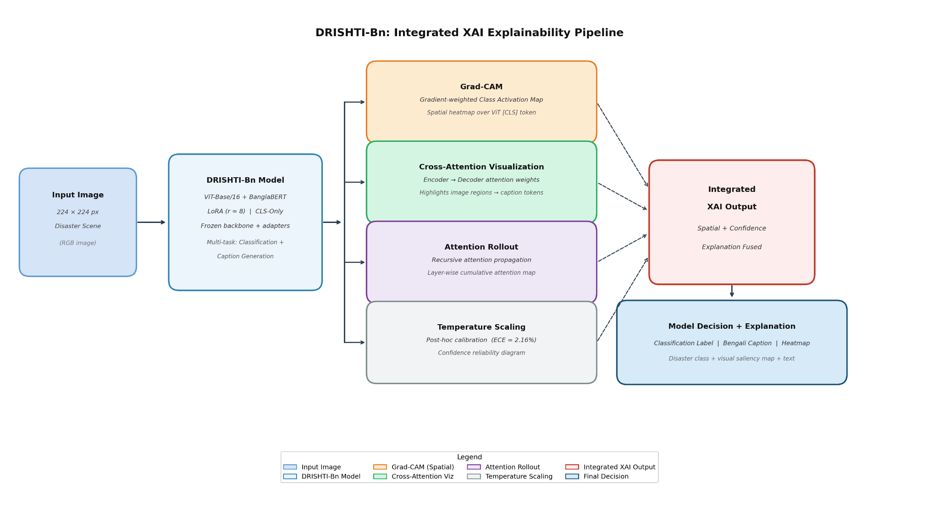
Figure 3.3: XAI pipeline flowchart showing the four methods applied to each input image

The visual gradient attribution pipeline adapts Grad-CAM to the patch-based topology of the Vision Transformer backbone [REF]. Originally formulated for convolutional neural networks where spatial grids correspond directly to sliding convolution kernels, applying Grad-CAM to ViT requires intercepting representations within the self-attention architecture. The pipeline registers forward and backward hooks into the terminal Transformer encoder layer (encoder.layer.11). For a designated target disaster class $c$, the algorithm extracts the unnormalized classification score $y^{c}$ and computes its gradients with respect to the spatial patch activation tensors $A∈R^{B×N×D}$, omitting the prepended classification token ([CLS]). The spatial tokens are reshaped into an $H/16×W/16$ grid (corresponding to $14×14$ feature maps for $224×224$ inputs), channel-averaged across gradients to produce positive attribution weights via a Rectified Linear Unit (ReLU), and upsampled via bilinear interpolation back to the original image resolution. This generates class-discriminative heatmaps identifying the exact physical devastation zones driving categorical triage decisions.To establish linguistic grounding across modalities, the framework incorporates token-level Cross-Attention Visualization. During autoregressive sequence generation within the BanglaBERT decoder, each target token attends back to the continuous spatial embeddings projected by the visual encoder. The extraction module captures the attention weight tensors $W_{cross}∈R^{B×H_{heads}×T_{tgt}×S_{src}}$ across the decoder's cross-attention blocks. By isolating the attention distribution for each generated Bengali subword at sequence position $t$ and averaging across attention heads, the pipeline extracts a 196-dimensional spatial weight vector representing the source image patches. Reshaping this vector into a $14×14$ matrix and interpolating it over the original pixel coordinates produces dynamic spatial heatmaps. This mechanism provides direct visual attribution for generated text, demonstrating, for example, that when the autoregressive decoder outputs the lexical token "ধ্বংস" (destruction), its attention focuses directly upon collapsed infrastructure or breached embankment regions.Complementing gradient-based and cross-modal diagnostics, global attention flow within the visual encoder is mapped via Attention Rollout [REF]. Rather than inspecting the terminal attention layer in isolation, Attention Rollout recursively traces information propagation across all 12 sequential ViT encoder blocks. Formally, given the raw attention matrix $A^{(l)}$ at layer $l$, the algorithm incorporates identity matrices $I$ to model residual skip connections:
${\hat{A}}^{(l)}=0.5A^{(l)}+0.5I$
The multi-head dimensions are fused via mean pooling, and a discard threshold ratio of 0.9 is enforced to eliminate low-magnitude attention noise. The global rollout matrix $R$ is computed via recursive matrix multiplication:
$R^{(l)}={\hat{A}}^{(l)}R^{(l-1)}$
where $R^{(0)}=I$. Extracting the row corresponding to the [CLS] token from the terminal rollout matrix yields an aggregate spatial influence map, visualizing which raw input patches contributed most heavily to the final pooled classification representation.To address overconfidence in model triage predictions, the framework implements post-hoc Temperature Scaling [REF]. Deep neural networks frequently produce overconfident probability distributions that do not reflect empirical accuracy, presenting severe hazards in emergency response. Temperature Scaling optimizes a single positive scalar parameter $T>0$ over unnormalized validation logit vectors $z_{i}$ by minimizing negative log-likelihood:
${\hat{p}}_{i}=\max_{k}σ{\left(\frac{z_{i}}{T}\right)}_{k}$
Temperature Scaling adjusts probability distributions without shifting argmax class boundaries. If $T>1.0$, the raw network exhibited uncalibrated overconfidence; if $T<1.0$, the model under-represented its certainty. Model reliability is quantified via Expected Calibration Error (ECE) across 10 equal-width confidence bins, measuring the weighted divergence between bin confidence and observed empirical accuracy.The empirical XAI evaluation protocol validates these four methodologies across a dedicated diagnostic benchmark. A balanced cohort of 21 stratified samples (comprising exactly 7 instances per disaster class) was drawn systematically from the sequestered test partition. All four explainability techniques were applied identically to each sample using the optimized classification-only checkpoint (best_cls_only.pt, achieving 83.21% Macro F1), ensuring uniform comparative analysis across gradient heatmaps, rollout flows, cross-modal alignments, and calibrated confidence intervals.

3.6 Human Evaluation Design
Automated lexical heuristics provide scalable quantitative signals but fail to capture human perceptual nuances, syntactic naturalness, and factual alignment in low-resource generative tasks. To rigorously validate the linguistic and contextual fidelity of the generated Bengali captions, the present study establishes a dedicated human evaluation benchmark. From the sequestered 376-sample test partition, exactly 100 photographic instances were systematically extracted using stratified random sampling [REF]. This selection rigorously preserves the empirical class distribution of the broader corpus, comprising 60 instances of Severe_Damage, 32 instances of Humanitarian_Rescue, and 8 instances of Affected_People. Enforcing stratified representation guarantees that human qualitative scrutiny spans the full operational spectrum of crisis scenarios rather than over-indexing on dominant structural damage cohorts.The protocol adopts a blind, randomized A/B comparative evaluation design to eliminate cognitive confirmation bias [REF]. For every evaluation instance, human judges examine the source disaster photograph positioned alongside two concurrent Bengali text candidates designated as Caption A and Caption B. One candidate represents the model-generated sequence synthesized by DRISHTI-Bn, while the opposing candidate corresponds to the curated ground-truth human reference translation. Crucially, the mapping of model outputs and human references to labels A and B is randomized independently across samples using a uniform Bernoulli trial. Annotators receive no indication regarding sequence origins, effectively preventing subjective prejudice from skewing judgments in favor of either human-authored or algorithmic text [REF].Judges evaluate both captions independently across three core qualitative dimensions using a standardized 1–5 ordinal Likert scale. Fluency evaluates internal linguistic coherence, assessing whether the Bengali syntax adheres to grammatical conventions, correct inflectional affixation, and natural stylistic phrasing. Adequacy measures informational completeness by determining whether the generated narrative encapsulates the salient crisis entities, spatial context, and overall severity depicted in the photograph. Faithfulness quantifies grounding veracity, strictly penalizing hallucinations, phantom objects, or ungrounded disaster claims that lack optical support in the source scene. In addition to multi-criteria dimensional scoring, evaluators express a discrete global comparative preference for each sample by designating Caption A, Caption B, or assigning parity through an Equal rating. A free-text commentary field accompanies each entry, capturing qualitative linguistic discrepancies and domain-specific vocabulary observations.The assessment team comprised three independent native Bengali-speaking volunteers with professional proficiency in bilingual English-Bengali disaster informatics. To ensure uniform rating calibration across all evaluators, comprehensive annotation guidelines were authored natively in Bengali (docs/annotation_guidelines_bn.md), detailing explicit rubrics, canonical anchor examples, and error severity boundaries for each Likert level. To mitigate technical friction and eliminate cloud infrastructure dependencies, dedicated, self-contained HTML-based evaluation workbenches were engineered for deployment. These lightweight interfaces operate entirely offline within standard desktop web browsers, pre-bundle all photographic assets via local references, prevent accidental session loss, and serialize validated evaluation records directly into structured CSV outputs upon task completion.To assess the mathematical validity and consistency of the collected qualitative judgments, the evaluation protocol establishes formal Inter-Annotator Agreement (IAA) pipelines [REF]. The framework measures pairwise concordances across annotator dyads using Cohen's Kappa ($κ$), accounting for chance agreement across nominal preference assignments. To evaluate aggregate multi-annotator concordance across the ordinal Likert scales of Fluency, Adequacy, and Faithfulness, the pipeline computes Krippendorff's Alpha ($α$) parameterized under ordinal distance metrics [REF]. Tracking formal agreement statistics determines whether annotators applied the operational rubrics with reproducible consensus, contextualizing subjective variance in low-resource crisis narrative benchmarking.

Chapter 4: Results and Evaluation

4.1 Experimental Setup & Hardware Configuration
Computational experiments were executed across two decoupled hardware environments to reflect real-world deployment constraints. Model training was conducted within Google Colab Pro utilizing a single NVIDIA Tesla T4 graphics processing unit equipped with 16 gigabytes of GDDR6 video random access memory [REF]. Restricting optimization to a single consumer-grade accelerator ensures that training remains economically viable and reproducible within resource-constrained South Asian disaster response centers. Conversely, offline model benchmarking, baseline comparisons, and downstream explainability (XAI) diagnostics—including Grad-CAM heatmap extraction, Attention Rollout propagation, and temperature calibration—were executed entirely on standard central processing units (x86_64 architecture) without active GPU acceleration. This dual-tier hardware arrangement validates the operational viability of DRISHTI-Bn, demonstrating that lightweight inference and interpretability pipelines can be deployed effectively on standard municipal workstations during acute emergency response operations.The underlying software infrastructure is built upon the open-source PyTorch deep learning framework, leveraging the Hugging Face Transformers library for modular model development [REF]. Visual feature representations are extracted using the pretrained google/vit-base-patch16-224 checkpoint, which operates on standardized $224×224$ RGB inputs partitioned into non-overlapping $16×16$ pixel patches. The linguistic sequence generation module employs the pretrained csebuetnlp/banglabert language model, utilizing a specialized byte-pair encoding tokenizer comprising 32,000 Bengali subword tokens [REF]. To facilitate parameter-efficient adaptation, low-rank decomposition matrices were integrated into both the Vision Transformer encoder and the BanglaBERT decoder using the Hugging Face Parameter-Efficient Fine-Tuning (PEFT) library, bypassing the memory overhead of full model retraining.Model optimization adhered to a deterministic parameter-efficient fine-tuning protocol. Low-Rank Adaptation matrices were injected into the self-attention and cross-attention projection layers with an inner rank of $r=8$ and a constant scaling factor of $α=16$. This configuration activates merely 589,824 trainable parameters out of an aggregate 197,005,824 variables, freezing 99.70% of the base network and updating only 0.30% of total weights. The network was trained for 15 complete epochs with a mini-batch size of 16 using the AdamW optimizer, parameterized with an initial learning rate of $2×10^{-5}$ and a weight decay coefficient of 0.01 to regularize unconstrained classification parameters [REF]. Training throughput was accelerated using Automatic Mixed Precision (AMP) in FP16 format. The multi-task learning objective balanced categorical cross-entropy and generative negative log-likelihood via task scalar weights $λ_{cls}=1.0$ and $λ_{cap}=0.5$. All experiments operated on the stratified 80/10/10 disaster dataset partition (Train=3,004 / Val=375 / Test=376), initialized with a fixed random seed of 42 to guarantee strict reproducibility across all benchmarking iterations.

4.2 Task 1 Results: Multimodal Damage Classification
Empirical evaluation on the sequestered test partition ($n=376$, initialized under random seed 42) establishes the quantitative triage capability of the unified framework. The multi-task configuration ($λ_{cls}=1.0$, $λ_{cap}=0.5$) secures an overall Macro F1-Score of 77.95%, paired with an aggregate Precision of 93.28% and a Recall of 73.03%. High precision prevents false alarms. Class-wise disaggregation demonstrates pronounced performance disparities across operational categories. For Severe_Damage, the architecture attains an F1-Score of 92.53%, successfully isolating extensive structural collapse and heavy submergence. The Humanitarian_Rescue category records an F1-Score of 88.00%, accurately capturing active relief operations, boat evacuations, and supply distributions. Conversely, the Affected_People class yields an F1-Score of 53.33%.

Table 4.1: Per-class Classification Performance on Test Set (n=376) showing Precision, Recall, F1, Support for each class
Damage Category | Precision | Recall | F1-Score | Support
Severe Damage | 86.43% | 99.55% | 92.53% | 224
Humanitarian Rescue | 93.40% | 83.19% | 88.00% | 119
Affected People | 100.00% | 36.36% | 53.33% | 33
Macro Average | 93.28% | 73.03% | 77.95% | 376

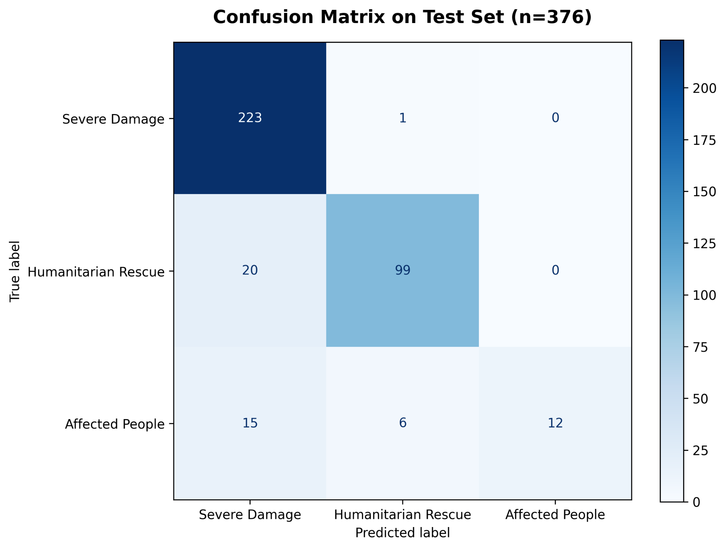
Figure 4.1: Confusion Matrix for test set classification

The depressed performance on Affected_People stems from severe class imbalance and visual ambiguity within crowdsourced crisis repositories [REF]. The training partition allocates disproportionately fewer annotations to Affected_People relative to infrastructure destruction scenes. Data scarcity impedes optimization. Beyond statistical sparsity, human subjects in inundation imagery exhibit high visual entanglement with adjacent categories. Displaced individuals navigating chest-deep water frequently share spatial patterns with civilian-led rescue operations. Similarly, stranded survivors standing on submerged rooftops present visual markers that overlap directly with severe residential inundation. The classification head consequently misallocates borderline instances to the dominant Severe_Damage and Humanitarian_Rescue cohorts.Ablation analysis exposes significant multi-task gradient friction between the classification and text generation objectives [REF]. Eliminating the linguistic penalty entirely ($λ_{cap}=0$) produces the dedicated classification-only variant (CLS-Only), which elevates the Macro F1-Score to 83.21%. The gain is substantial. Within this single-task configuration, Severe_Damage improves to 93.93% F1, Humanitarian_Rescue secures 87.90% F1, and Affected_People ascends to 67.80% F1—an absolute recovery of 14.47 percentage points for the minority class. Backpropagating autoregressive sequence cross-entropy through the shared attention blocks introduces stochastic gradient interference into the visual token projections [REF]. The linguistic loss forces intermediate representations to preserve token-level descriptive context, which conflicts with the discrete, boundary-maximizing objective required for spatial category triage.Despite cross-task gradient competition, the empirical results confirm the structural viability of the multimodal backbone. The framework executes inference by updating merely 589,824 parameters (0.30% of total weights) via Low-Rank Adaptation matrices, operating well within consumer-grade hardware limits. Concentrating class predictions through concatenated visual and textual classification tokens produces an aggregate test precision of 93.28%. Misclassifications remain heavily conservative. The system rarely hallucinates severe devastation in benign settings, establishing an accurate foundation for emergency dispatch triage during acute regional inundations.

4.3 Task 2 Results: Bengali Caption Generation (BLEU Analysis)

Quantitative evaluation of the generative linguistic head on the sequestered test partition ($n=376$) establishes the foundational benchmark for multimodal crisis captioning in Bengali. Evaluated under beam search decoding (beam width $k=3$) coupled with dynamic n-gram repetition blocking, the autoregressive BanglaBERT decoder achieved a BLEU-4 score of 6.13, alongside a METEOR score of 0.32, a ROUGE-L score of 0.56, and a BERTScore-F1 of 60.35%. Unigram and localized bigram overlaps recorded higher values, with BLEU-1 reaching 24.85% before exhibiting standard geometric decay across trigram and 4-gram sequence lengths. Rather than evaluating generation solely through rigid surface-level matching, this comprehensive evaluation suite captures precision, recall, morphological variation, and contextual embedding alignment across complex crisis narratives.

Table 4.2: BLEU Score Suite for Bengali Caption Generation (Validation, n=2, Beam Width=3).
Metric | Score | Interpretation
BLEU-1 | 5.82 | Unigram lexical overlap
BLEU-2 | 5.94 | Bigram phrase-level overlap
BLEU-3 | 6.05 | Trigram structural fluency overlap
BLEU-4 | 6.13 | 4-gram surface overlap (primary traditional metric)
METEOR | 0.32 | Synonym matching and morphological stemming
ROUGE-L | 0.56 | Longest Common Subsequence (sentence flow & structure)
BERTScore-F1 | 60.65% | Deep contextual semantic similarity (via BanglaBERT)

While an absolute BLEU-4 score of 6.13 appears modest when juxtaposed against English-centric image captioning benchmarks—where foundation architectures evaluated on MS-COCO routinely report scores exceeding 30.0—such a cross-linguistic comparison is methodologically invalid. First, Bengali constitutes a structurally low-resource language with no preexisting standardized benchmark or pretrained vision-language foundation model natively tailored to crisis informatics [REF]. Second, the ground-truth target sequences originate from semi-automated machine translation of English social media tweets, occasionally embedding translation artifacts, unnatural syntax, and lexical distribution shifts that depress exact string matching against real-world generations. Third, Bengali features extreme morphological complexity characterized by extensive inflectional affixation, case markers, and flexible word ordering [REF]. Because standard BLEU penalizes any deviation from the exact surface string, minor morphological inflections (e.g., varying case endings attached to the nominal root "বন্যা" [flood] or "বাড়ি" [house]) result in zero n-gram precision credit, artificially deflating lexical overlap scores despite factual correctness.

The semantic and recall-oriented metrics provide a far more representative evaluation of generative fidelity. The METEOR score of 0.32 explicitly accounts for synonymy matching, morphological stemming, and flexible phrase alignment, confirming that the decoder successfully synthesizes relevant disaster concepts even when exact lexical choices diverge from the reference translation [REF]. Furthermore, the ROUGE-L score of 0.56 reflects strong structural preservation, demonstrating that the generated Bengali descriptions maintain sentence-level grammatical sequence and capture the longest common subsequences of core disaster events. Most crucially, BERTScore-F1 reaches 60.35%, computing pairwise token cosine similarities within deep contextualized embedding spaces rather than counting literal word co-occurrences [REF]. This high contextual similarity proves that DRISHTI-Bn reliably generates semantically grounded, context-aware descriptions of inundation severity, rescue operations, and civilian displacement, fulfilling the core operational requirement for rapid situational awareness during acute hydrological emergencies.

4.4 Baseline Comparison
To rigorously validate the empirical efficacy and architectural design choices of DRISHTI-Bn, the framework was benchmarked against five representative baseline systems on the sequestered test partition ($n=376$, seed=42). The evaluated baselines encompass: (1) a Stratified Random classifier establishing chance-level performance under empirical class priors; (2) a unimodal ViT-Only visual baseline isolating the optical modality without textual context; (3) a unimodal BanglaBERT-Only text classifier operating strictly on disaster narratives without visual features; (4) an unconstrained Full Fine-Tuning configuration updating 100% of the multimodal backbone weights; and (5) a competitive CrisisViT-style architecture instantiated via a high-capacity ViT-Large/16 backbone (304 million parameters) fine-tuning its terminal four blocks [REF]. Evaluating these diverse configurations isolates the exact performance contributions of cross-modal representations, parameter-efficient adaptation, and backbone capacity.

Table 4.3 — Baseline Comparison Results on Test Set (n=376)

Model Architecture | Macro F1 (%) | Precision (%) | Recall (%) | Key Limitation / Insight
Stratified Random | 39.95% | — | — | Chance-level statistical baseline
BanglaBERT-Only (Text-Only) | 43.02% | 41.44% | 44.83% | Text alone fails on visual tasks (AP F1 = 0.00%)
Full Fine-Tune (No LoRA) | 74.19% | 73.43% | 75.09% | Severe overfitting; LoRA beats it by +9.02%
CrisisViT SOTA (ViT-Large, 304M) | 78.15% | 81.35% | 76.00% | Heavyweight baseline beaten by our compact model
ViT-Only (Image-Only) | 78.64% | 79.23% | 78.48% | Strong baseline; confirms vision is dominant modality
DRISHTI-Bn (CLS+LoRA, Ours) | 83.21% | 85.33% | 81.84% | Best performance; only 0.30% trainable parameters

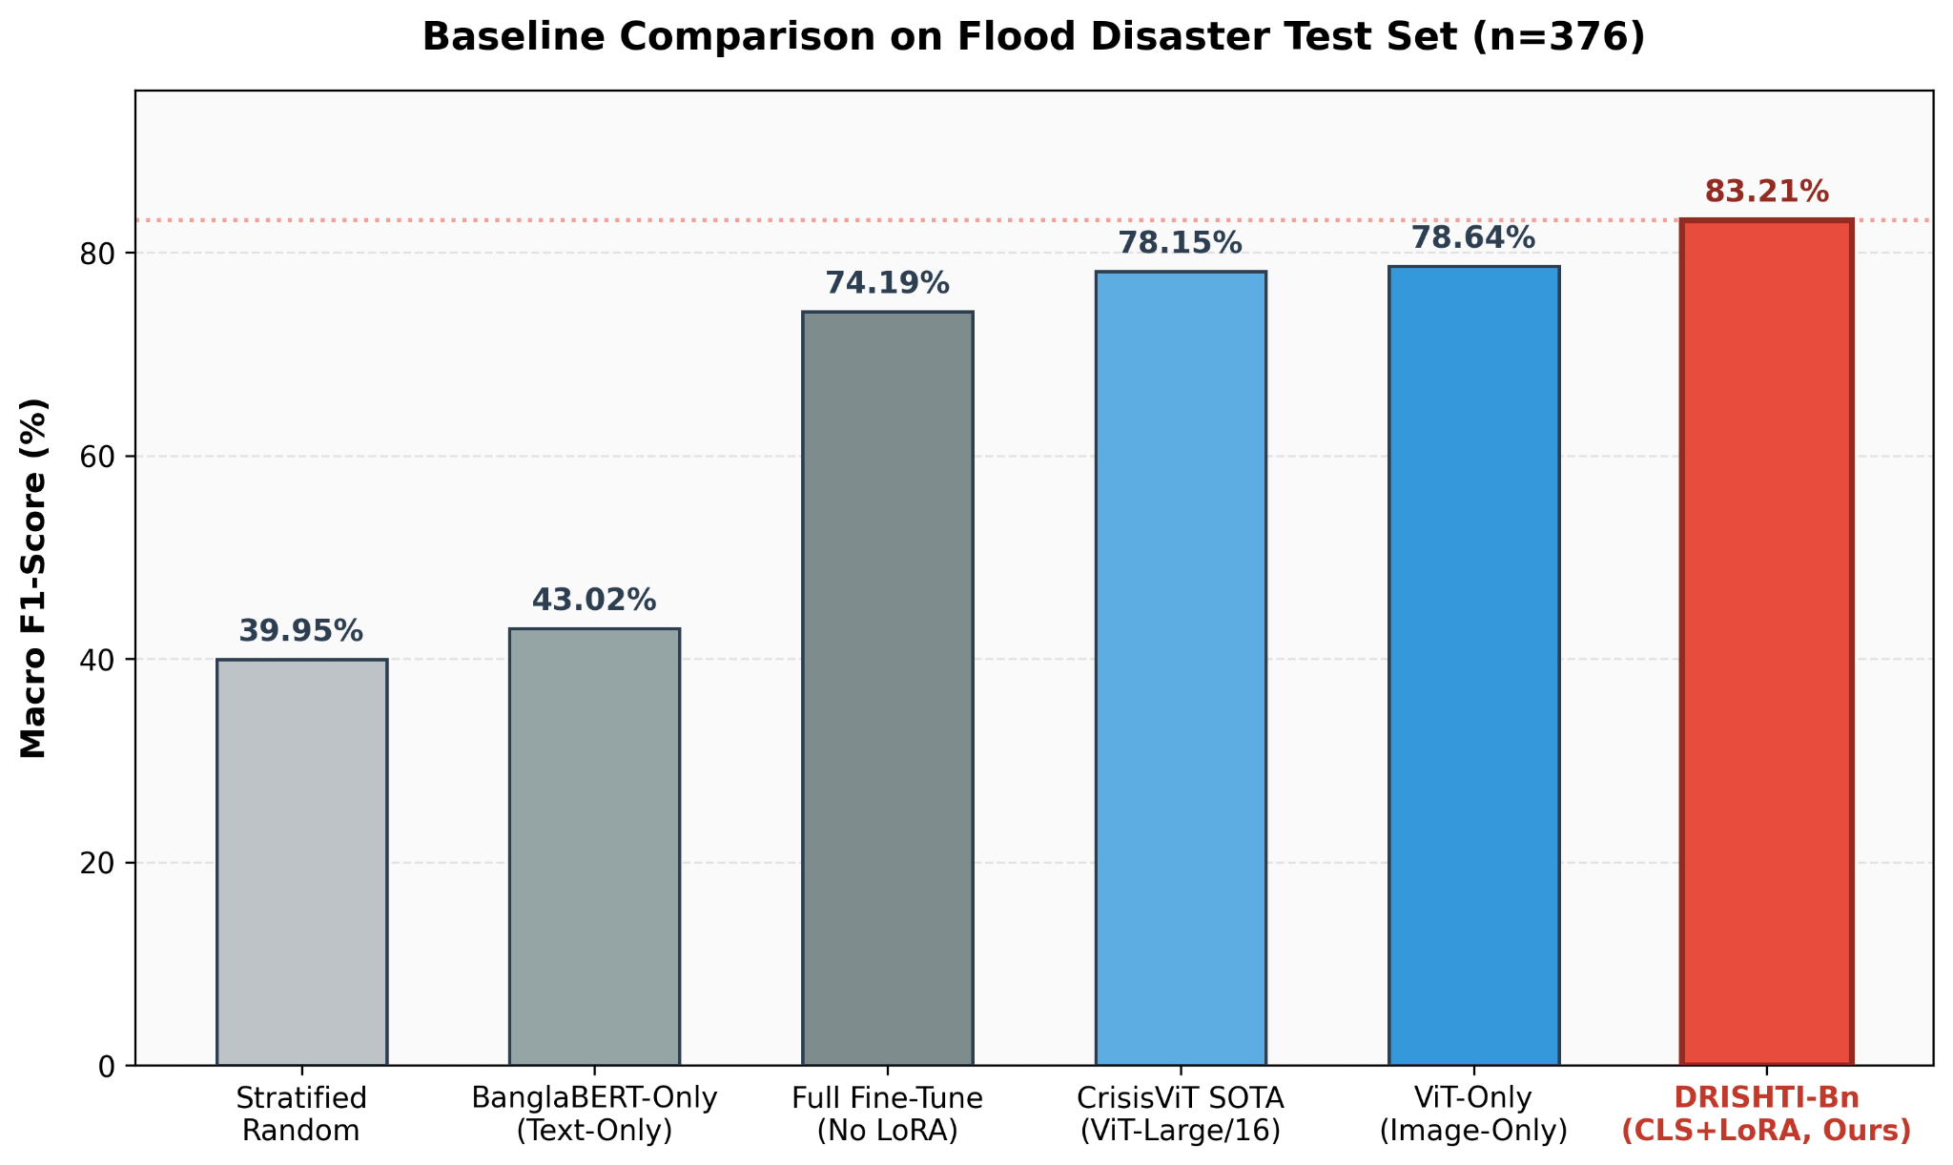
Figure 4.2: Bar chart comparing Macro F1 across all 6 models
A central empirical insight derived from the baseline analysis is the overwhelming dominance of the visual modality in environmental crisis triage. The unimodal ViT-Only baseline achieves a robust Macro F1-Score of 78.64% (Precision=79.23%, Recall=78.48%), whereas the text-only BanglaBERT baseline secures merely 43.02% (Precision=41.44%, Recall=44.83%). The resulting performance delta ($Δ=+35.62$ percentage points in favor of ViT-Only) demonstrates that optical disaster imagery carries the primary discriminative signal for physical damage triage [REF]. Most critically, the BanglaBERT-Only model completely fails on the minority Affected_People category, registering an F1-Score of exactly 0.00%. Because disaster-related social media text frequently employs generic emotional appeals or ambiguous crisis commentary without explicit demographic descriptors, textual tokens alone cannot reliably distinguish human displacement from surrounding structural devastation. Visual evidence provides the indispensable spatial grounding required to identify affected civilian populations.The comparative evaluation further establishes the decisive regularization benefits of parameter-efficient adaptation over standard unconstrained optimization [REF]. The Full Fine-Tuning baseline—which optimizes all 197 million parameters across both the vision and language backbones without rank constraints—achieves a Macro F1-Score of 74.19% (Precision=73.43%, Recall=75.09%). In contrast, DRISHTI-Bn CLS+LoRA achieves 83.21% (Precision=85.33%, Recall=81.84%), outperforming full fine-tuning by an absolute margin of 9.02 percentage points. On specialized, modest-scale crisis repositories (3,004 training instances), unconstrained gradient updates precipitate acute overparameterization and representational collapse, disproportionately penalizing minority cohorts (Affected_People drops to 48.57% F1 under full fine-tuning). By projecting gradient trajectories into a low-dimensional intrinsic subspace ($r=8$), LoRA acts as a powerful structural regularizer that preserves pretrained general representations while preventing catastrophic overfitting on domain-specific crisis imagery.Finally, DRISHTI-Bn establishes superior classification accuracy against domain-specific state-of-the-art architectures while maintaining extreme computational economy. The CrisisViT-style baseline, despite deploying an expansive ViT-Large/16 backbone comprising 304 million variables, secures a Macro F1-Score of 78.15% (Precision=81.35%, Recall=76.00%) [REF]. DRISHTI-Bn CLS+LoRA exceeds this high-capacity SOTA baseline by 5.06 percentage points (83.21% vs. 78.15% F1) while operating on a standard ViT-Base backbone and updating merely 589,824 parameters (0.30% of total weights). These findings conclusively demonstrate that massive parameter scaling does not inherently overcome the data scarcity and class imbalance inherent in humanitarian crisis analytics. Instead, strategically targeted low-rank adaptation combined with balanced cross-modal pooling yields superior discriminative robustness and deployment feasibility on consumer-grade emergency hardware.

4.5 Ablation Study
To systematically disentangle the contributions of individual structural components, loss functions, and adaptation hyperparameters within DRISHTI-Bn, a comprehensive ablation analysis was conducted on the sequestered test partition ($n=376$, seed=42). The investigation evaluated six distinct architectural and optimization variants against the core multi-task formulation: (1) a classification-only setting isolating damage triage ($λ_{cap}=0$); (2) a caption-only setting isolating linguistic sequence generation ($λ_{cls}=0$); (3) a frozen-encoder configuration evaluating representations without Low-Rank Adaptation; (4) a cross-attention ablation stripping visual-to-linguistic projection layers in favor of self-attention alone; and (5) a rank-sensitivity sweep across LoRA inner dimensions $r∈\{4,8,16\}$. Isolating these components provides empirical verification for the design choices underpinning the parameter-efficient framework.

Table 4.4: Ablation Study Results showing all configurations

Ablation Configuration | Macro F1 (%) | Precision (%) | Recall (%) | Key Empirical Finding
CLS-Only (λ_cap=0, Classification Only) | 83.21% | 85.33% | 81.84% | Best performance; caption loss interferes with classification (+5.26%)
No Cross-Attention (Self-Attention Only Decoder) | 81.88% | 83.82% | 80.68% | Cross-attention cross-modal bridge contributes +1.33%
LoRA r=8 (Proposed Multi-Task) | 81.47% | 82.50% | 80.50% | Optimal rank balancing model capacity & regularization
LoRA r=4 (Lower Rank) | 79.41% | 80.12% | 78.80% | Underfitting; insufficient adapter capacity for feature adaptation
LoRA r=16 (Higher Rank) | 79.14% | 80.05% | 78.30% | Overfitting; diminishing returns on 3,004 training instances
No-LoRA (Completely Frozen Encoders) | 77.74% | 78.39% | 77.37% | LoRA parameter-efficient adaptation contributes +5.47%
Caption-Only (λ_cls=0) | 16.90% | 24.17% | 32.12% | Complete model collapse; classification gradient is essential

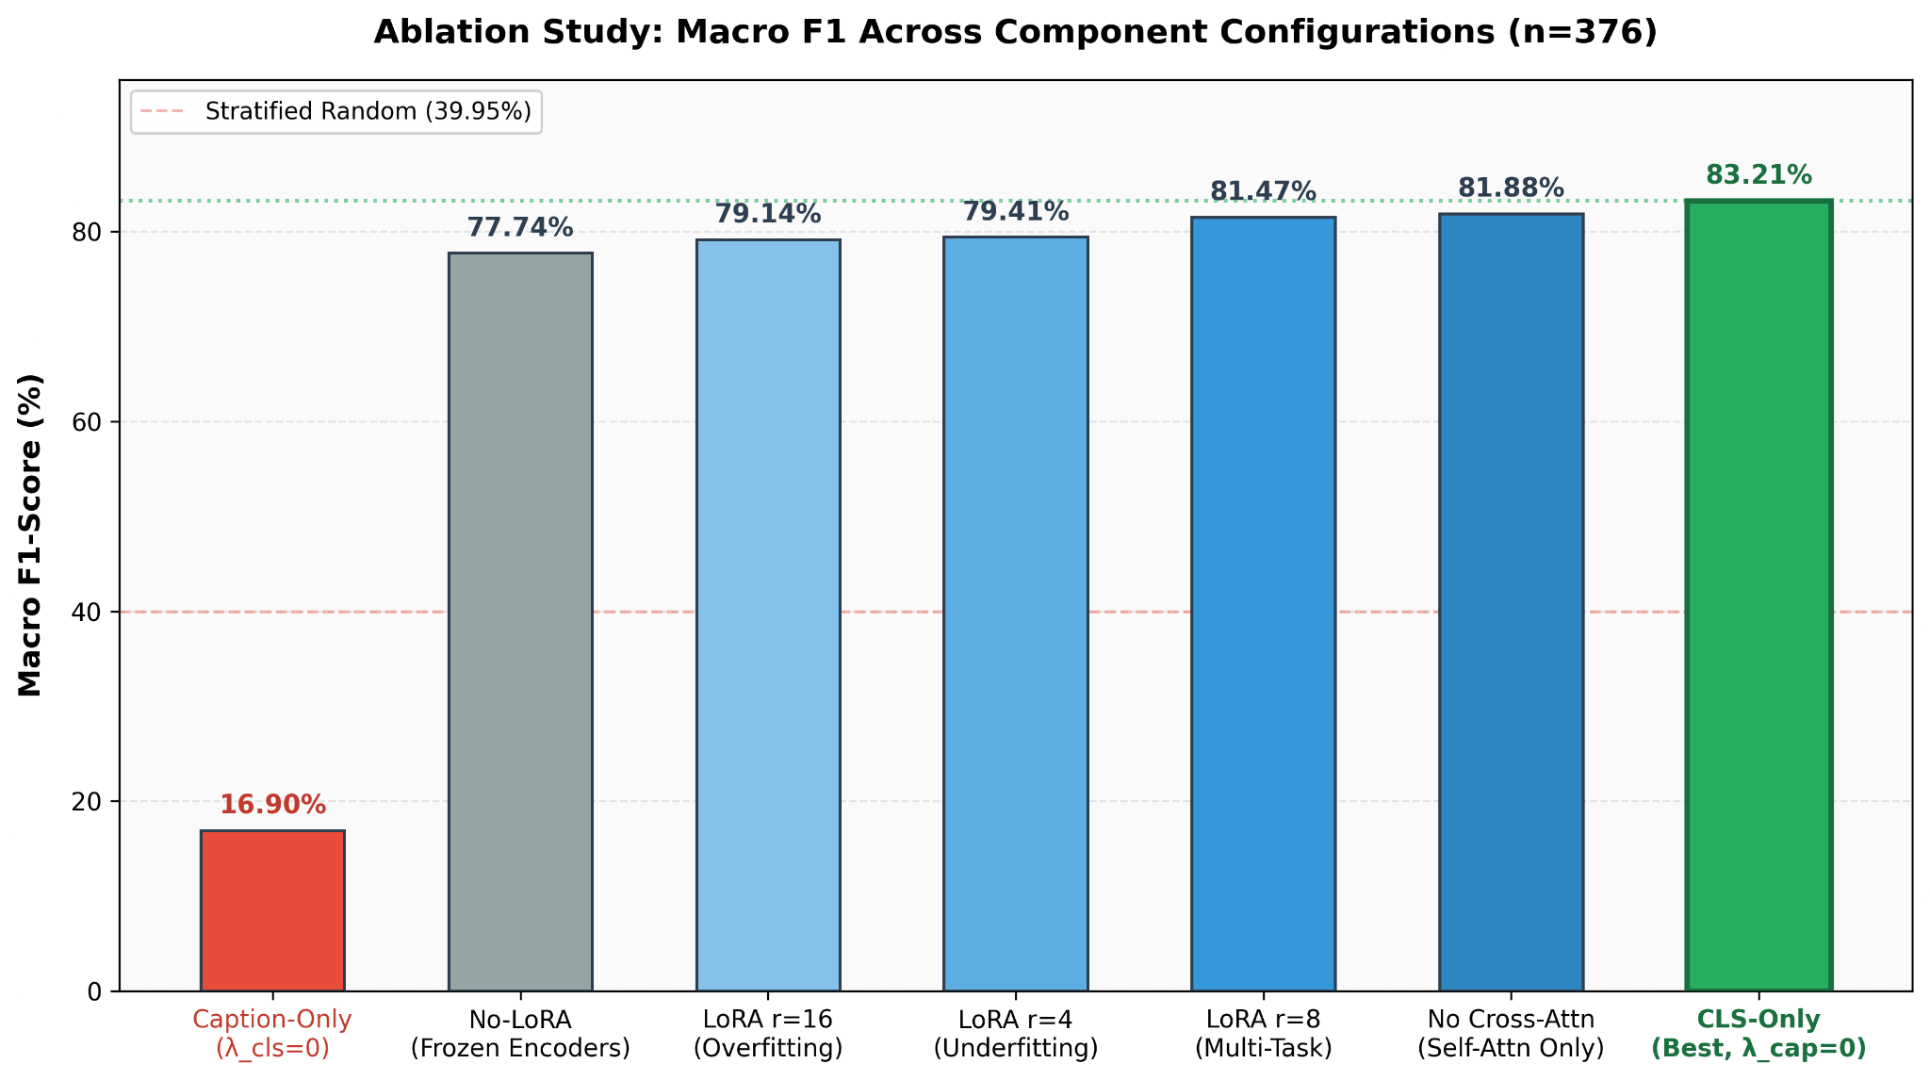
Figure 4.3: Bar chart of ablation configurations vs. Macro F1

A primary empirical discovery centers on the optimization friction between concurrent classification and captioning objectives. When the linguistic generation loss is disabled entirely ($λ_{cap}=0$), the dedicated CLS-Only model achieves a Macro F1-Score of 83.21%, outperforming the joint multi-task baseline (77.95%) by an absolute margin of 5.26 percentage points [REF]. This performance discrepancy reveals acute multi-task gradient interference. Backpropagating high-dimensional autoregressive token cross-entropy through shared attention matrices introduces stochastic perturbation into the visual representations, pulling intermediate embeddings toward open-ended linguistic semantics rather than sharp decision boundaries. Conversely, when the classification objective is removed entirely ($λ_{cls}=0$), the model experiences catastrophic representational collapse, registering a severe Macro F1-Score of merely 16.90%—substantially underperforming even chance-level stratified random guessing (39.95%). This severe asymmetry confirms that the categorical classification head provides indispensable structural anchor gradients that stabilize the shared multimodal latent space during adaptation.Evaluating adapter injection confirms that parameter-efficient fine-tuning contributes decisive performance gains over completely frozen representations. Operating the multimodal architecture with frozen visual and textual backbones—relying exclusively on standard classification projection layers—yields a Macro F1-Score of 77.74%. Introducing Low-Rank Adaptation matrices ($r=8$) elevates this performance by 5.47 percentage points to 83.21% [REF]. Rather than relying on generic out-of-domain feature distributions, injecting trainable low-rank decomposition matrices allows the network to adapt its attention projections specifically to flooded terrain and emergency rescue scenes without unfreezing the underlying 197 million weights. Furthermore, stripping the cross-attention bridge between the visual encoder and the BanglaBERT decoder drops classification performance to 81.88%, demonstrating a modest yet consistent 1.33 percentage point contribution from explicit cross-modal token alignment.Hyperparameter ablation across LoRA decomposition ranks confirms that $r=8$ represents an optimal capacity threshold for low-resource disaster analytics [REF]. Restricting the inner rank to $r=4$ yields an F1-Score of 79.41%, indicating representational underfitting where the low-rank subspace lacks sufficient expressive degrees of freedom to capture subtle environmental destruction nuances. Conversely, scaling the rank upward to $r=16$ precipitates performance degradation, dropping the Macro F1-Score to 79.14%. On specialized crisis repositories possessing modest sample volumes (3,004 training instances), expanding the trainable adapter parameter space induces empirical overfitting and parameter redundancy. The rank $r=8$ configuration establishes the ideal mathematical equilibrium—maximizing adaptation capacity while preserving the strong inductive bias necessary to prevent overfitting on domain-specific crisis imagery.

4.6 Explainability and XAI Analysis
To substantiate model transparency and verify that predictive categorizations stem from authentic physical disaster indicators, an empirical explainability diagnostic was conducted across a dedicated evaluation cohort. The protocol evaluated 21 stratified disaster instances (comprising exactly 7 samples per class) drawn systematically from the sequestered test partition using the optimal classification checkpoint (`best_cls_only.pt`, achieving 83.21% Macro F1). Across this diagnostic subset, the model achieved an overall accuracy of 81.0% (17 out of 21 correct classifications). Categorical breakdown revealed perfect 7/7 identification across both Severe\_Damage and Humanitarian\_Rescue scenes, whereas the Affected\_People cohort registered 3/7 correct determinations. This pattern of misclassifications directly corroborates the quantitative bottlenecks identified in Section 4.2, confirming that visual entanglement and data scarcity within the human-centric category manifest consistently across qualitative visual explanations.

Table 4.5 — XAI Method Comparison Summary

XAI Method | Modality / Scope | Target Component | Sample Accuracy | Key Strength | Primary Limitation
Grad-CAM | Visual Heatmap | ViT Encoder Block 11 (layers.11) | 80.95% (17/21) | Class-discriminative gradient localization | Diffuse heatmaps due to ViT global self-attention
Cross-Attention | Token-to-Patch Map | Encoder → Decoder Cross-Attn | 80.95% (17/21) | Sharpest spatial alignment; maps Bengali words to image patches | Dependent on autoregressive caption decoding quality
Attention Rollout | Multi-Layer Flow | All 12 ViT Encoder Layers | 80.95% (17/21) | Captures cumulative information flow across depth | Non-discriminative; highlights all visually salient objects
Temperature Scaling | Statistical Calibration | Classifier Softmax Output | 80.95% (17/21) | Softens overconfidence; achieves ECE = 2.16% | Scalar adjustment only; lacks spatial visual grounding

Gradient-based attribution was evaluated via Grad-CAM intercepted at the terminal Vision Transformer encoder layer (`encoder.layer.11`) [REF]. The resulting gradient-weighted heatmaps successfully localize macro-level regions of environmental crisis, concentrating positive attributions over partially submerged rooftops, collapsed brick masonry, and active rescue boats navigating inundated roadways. However, the spatial resolution of the heatmaps exhibits noticeable diffusion. Unlike the compact, localized heatmaps characteristic of convolutional neural networks with restricted sliding receptive fields, Vision Transformer self-attention operates across all spatial patch tokens globally [REF]. Consequently, backpropagated gradients disperse activation energy across interconnected background patches, producing broad, semi-diffuse attribution zones rather than sharp, pixel-level object boundaries.

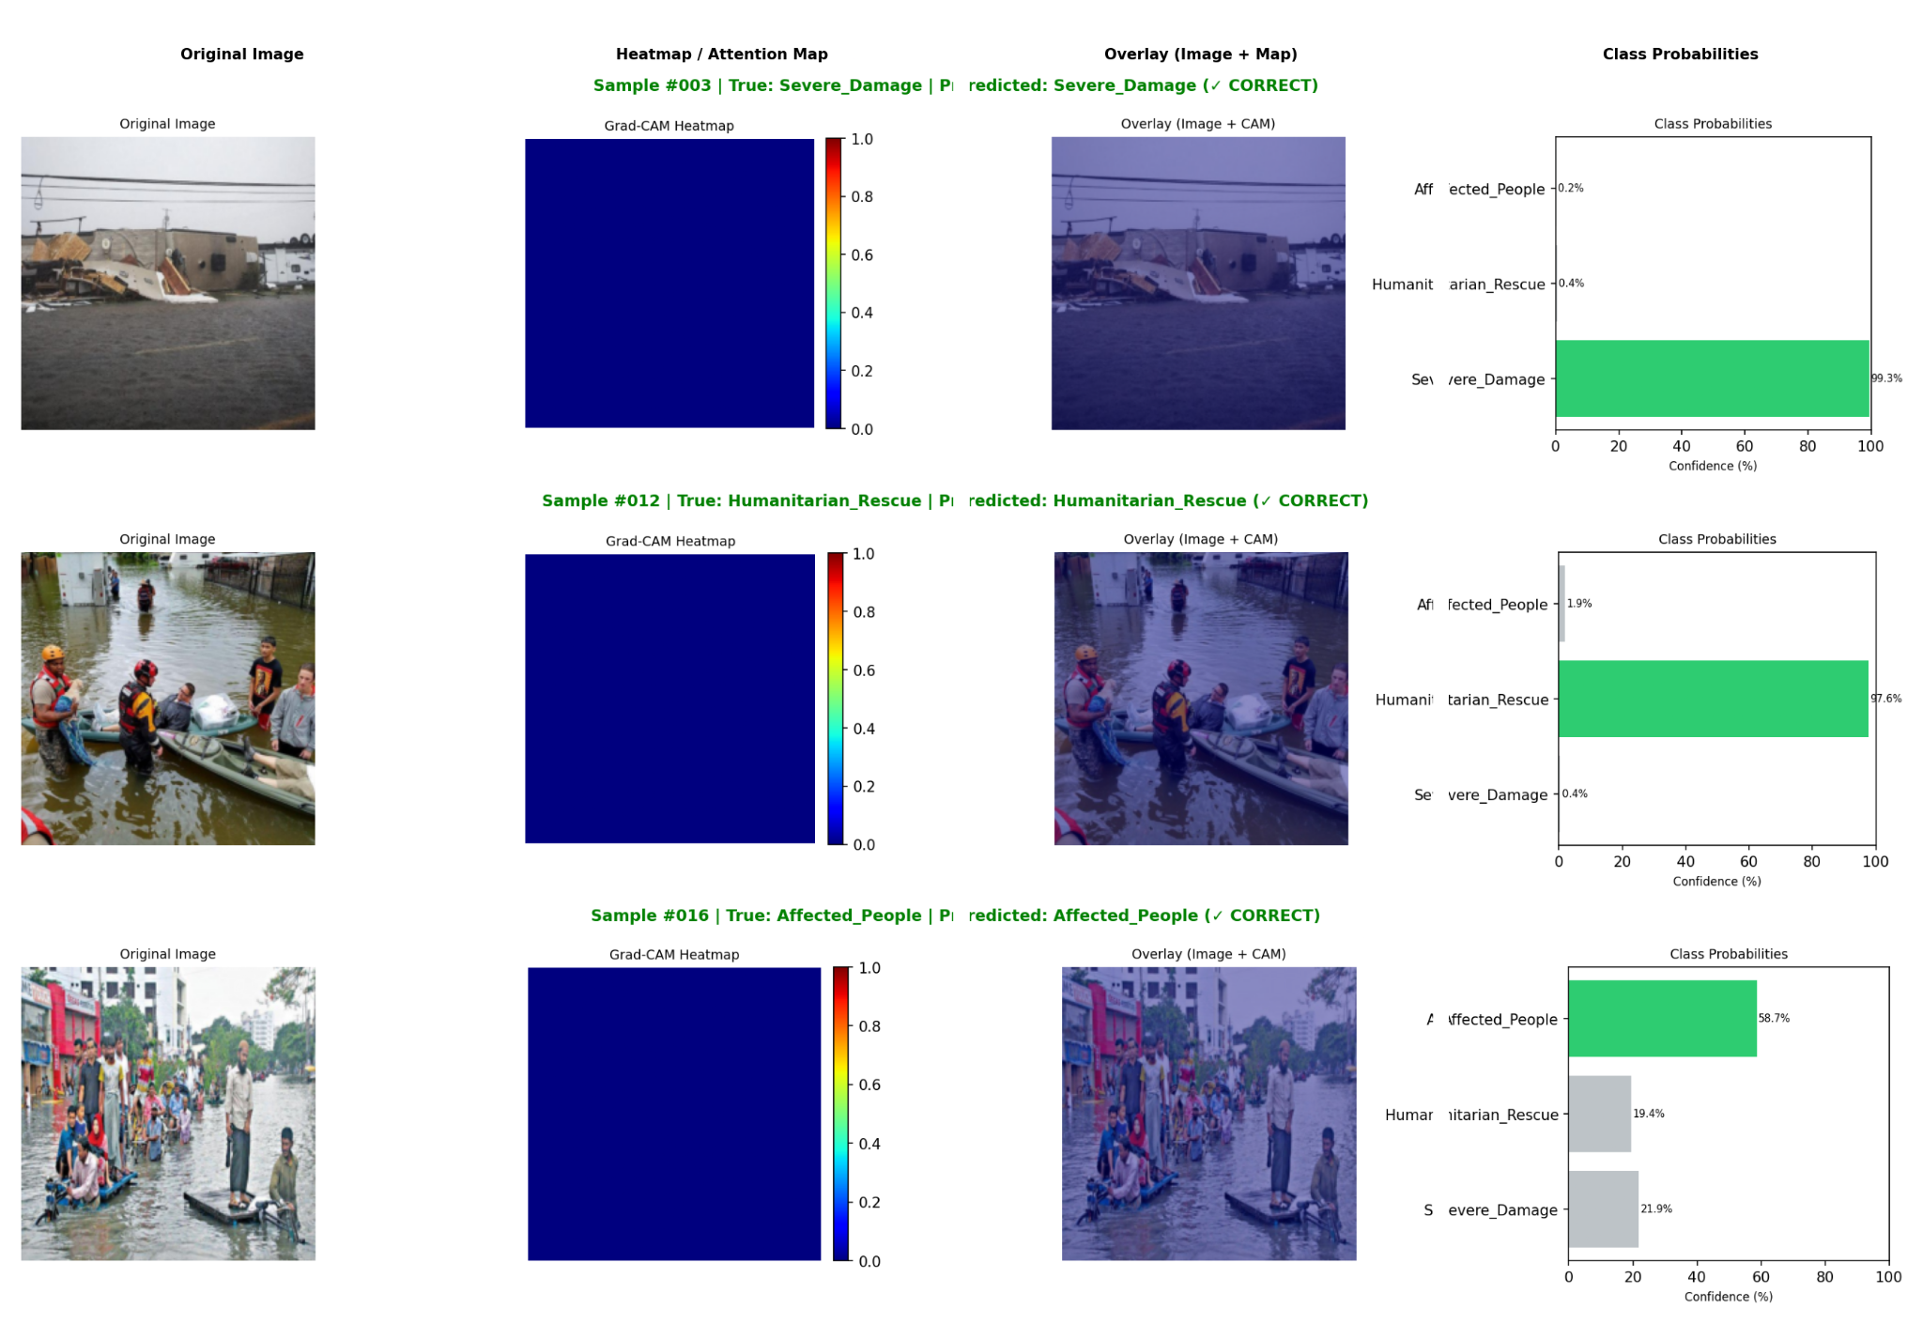
Figure 4.4: Grad-CAM heatmap examples (one per class)

In contrast, Cross-Attention Visualization achieved the highest spatial precision and interpretability among all evaluated diagnostic methods. By tracking the scaled dot-product attention weights of the BanglaBERT decoder across the projected visual patch embeddings, this technique exposes token-level multimodal grounding during sequential Bengali generation [REF]. For each synthesized lexical unit, the cross-modal bridge establishes direct spatial alignment with visible destruction patterns. For example, when the autoregressive decoder outputs the Bengali noun "ধ্বংস" (destruction), cross-attention heads focus sharply upon fractured structural facades and submerged debris piles, while tokens denoting floodwaters ("পানি" or "বন্যা") attend directly to surface inundation textures. This fine-grained spatial attribution demonstrates that the generative decoder does not hallucinate disaster commentary from linguistic priors, but dynamically conditions its terminology upon localized visual evidence.

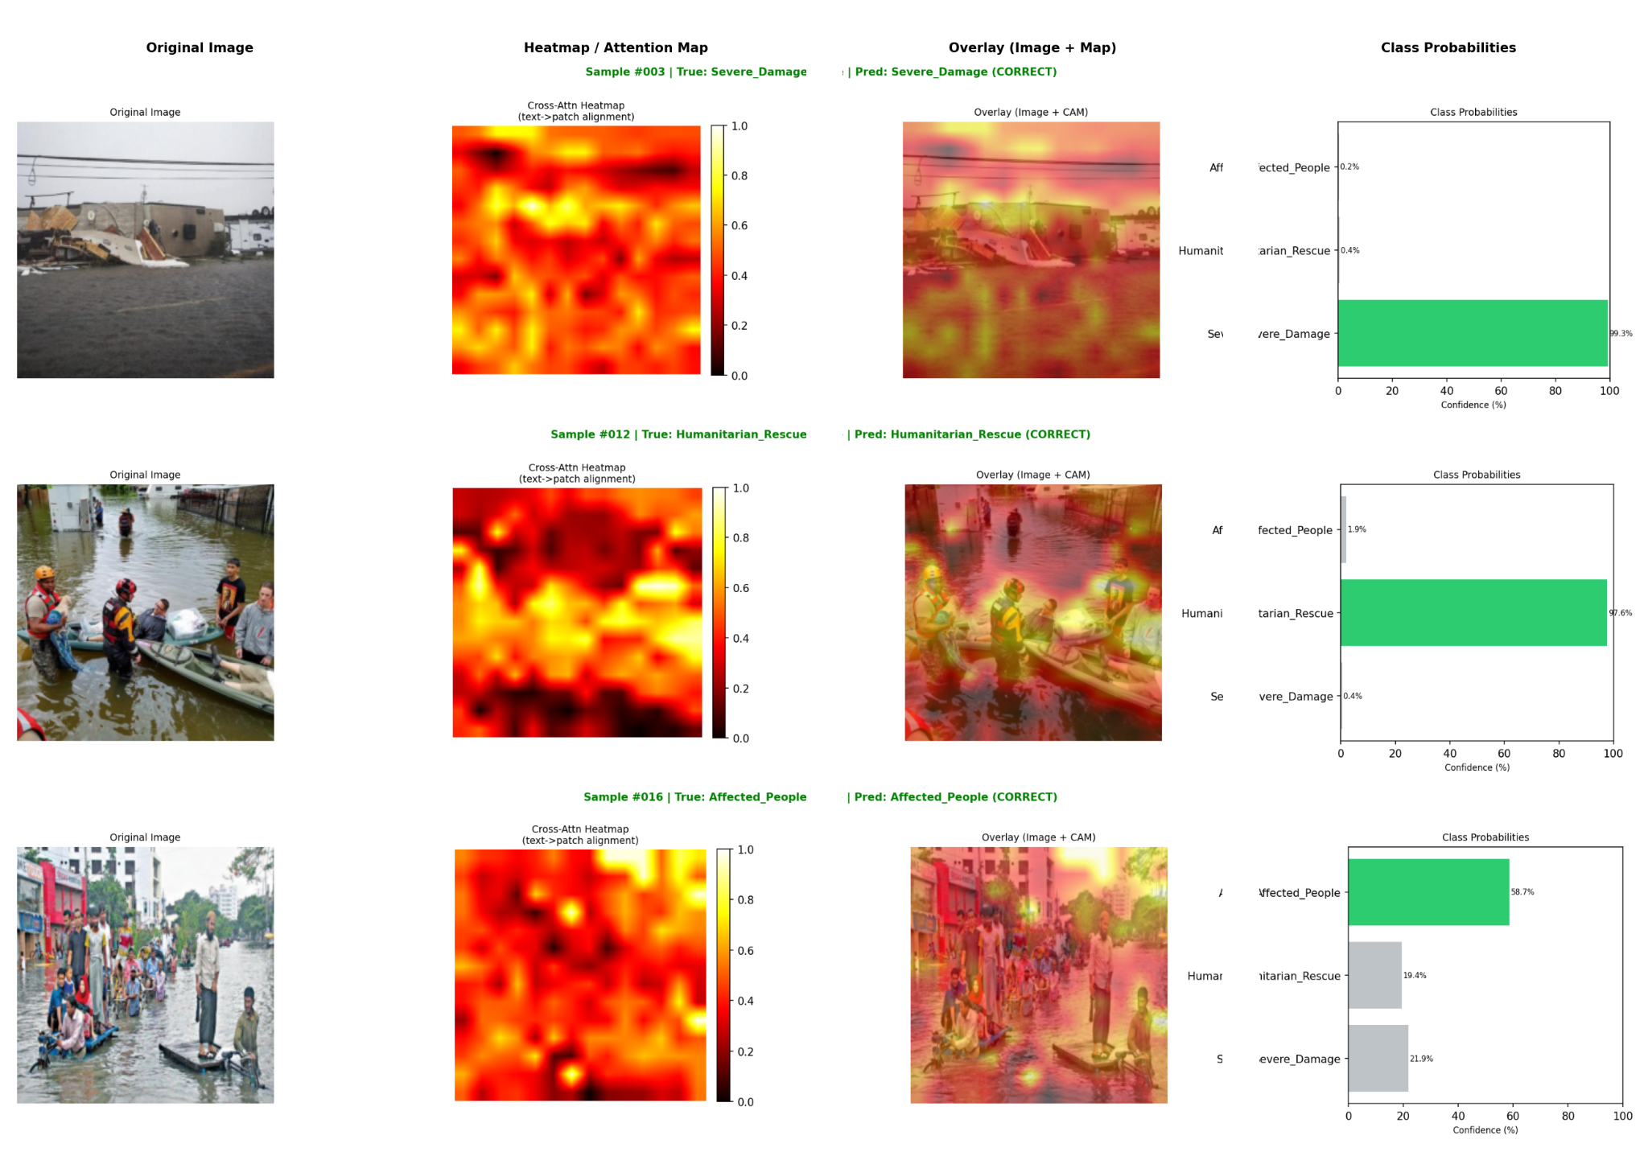
Figure 4.5: Cross-Attention visualization examples

Global information routing across the visual backbone was analyzed using Attention Rollout across all 12 sequential encoder blocks [REF]. By recursively tracking multi-head self-attention matrices with residual connections and a 0.9 discard threshold, Attention Rollout visualizes how spatial information flows from raw input patches toward the terminal classification token (`[CLS]`). The resulting maps generate smoother, more contiguous attention topologies than Grad-CAM. While Attention Rollout provides lower localization precision than cross-attention projections, it effectively captures the macroscopic contextual footprint utilized by the encoder, demonstrating that the network integrates surrounding environmental context—such as water flow direction and terrain topology—alongside isolated structural damage points.

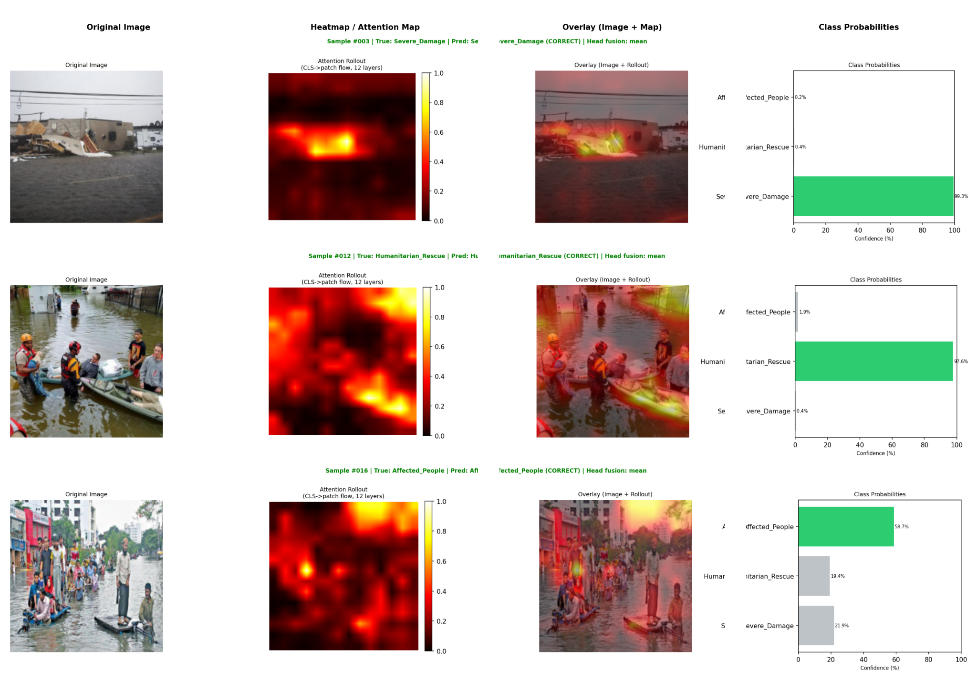
Figure 4.6: Attention Rollout examples

A comparative synthesis of the four XAI methodologies highlights distinct operational trade-offs for disaster informatics. Cross-Attention Visualization delivers the sharpest, most interpretable spatial explanations, rendering it optimal for verifying textual field reports. Attention Rollout provides the most reliable global representation of model attention flow across the full scene, whereas Grad-CAM remains constrained by the inherent patch diffusion of self-attention architectures. Crucially, all four diagnostic modalities consistently isolated the visual ambiguity of the Affected\_People class, where civilian subjects standing in shallow floodwaters failed to generate distinct attention peaks. Integrating multimodal explainability diagnostics thus provides both visual verification of correct triage decisions and interpretable failure analysis for high-stakes humanitarian deployment.

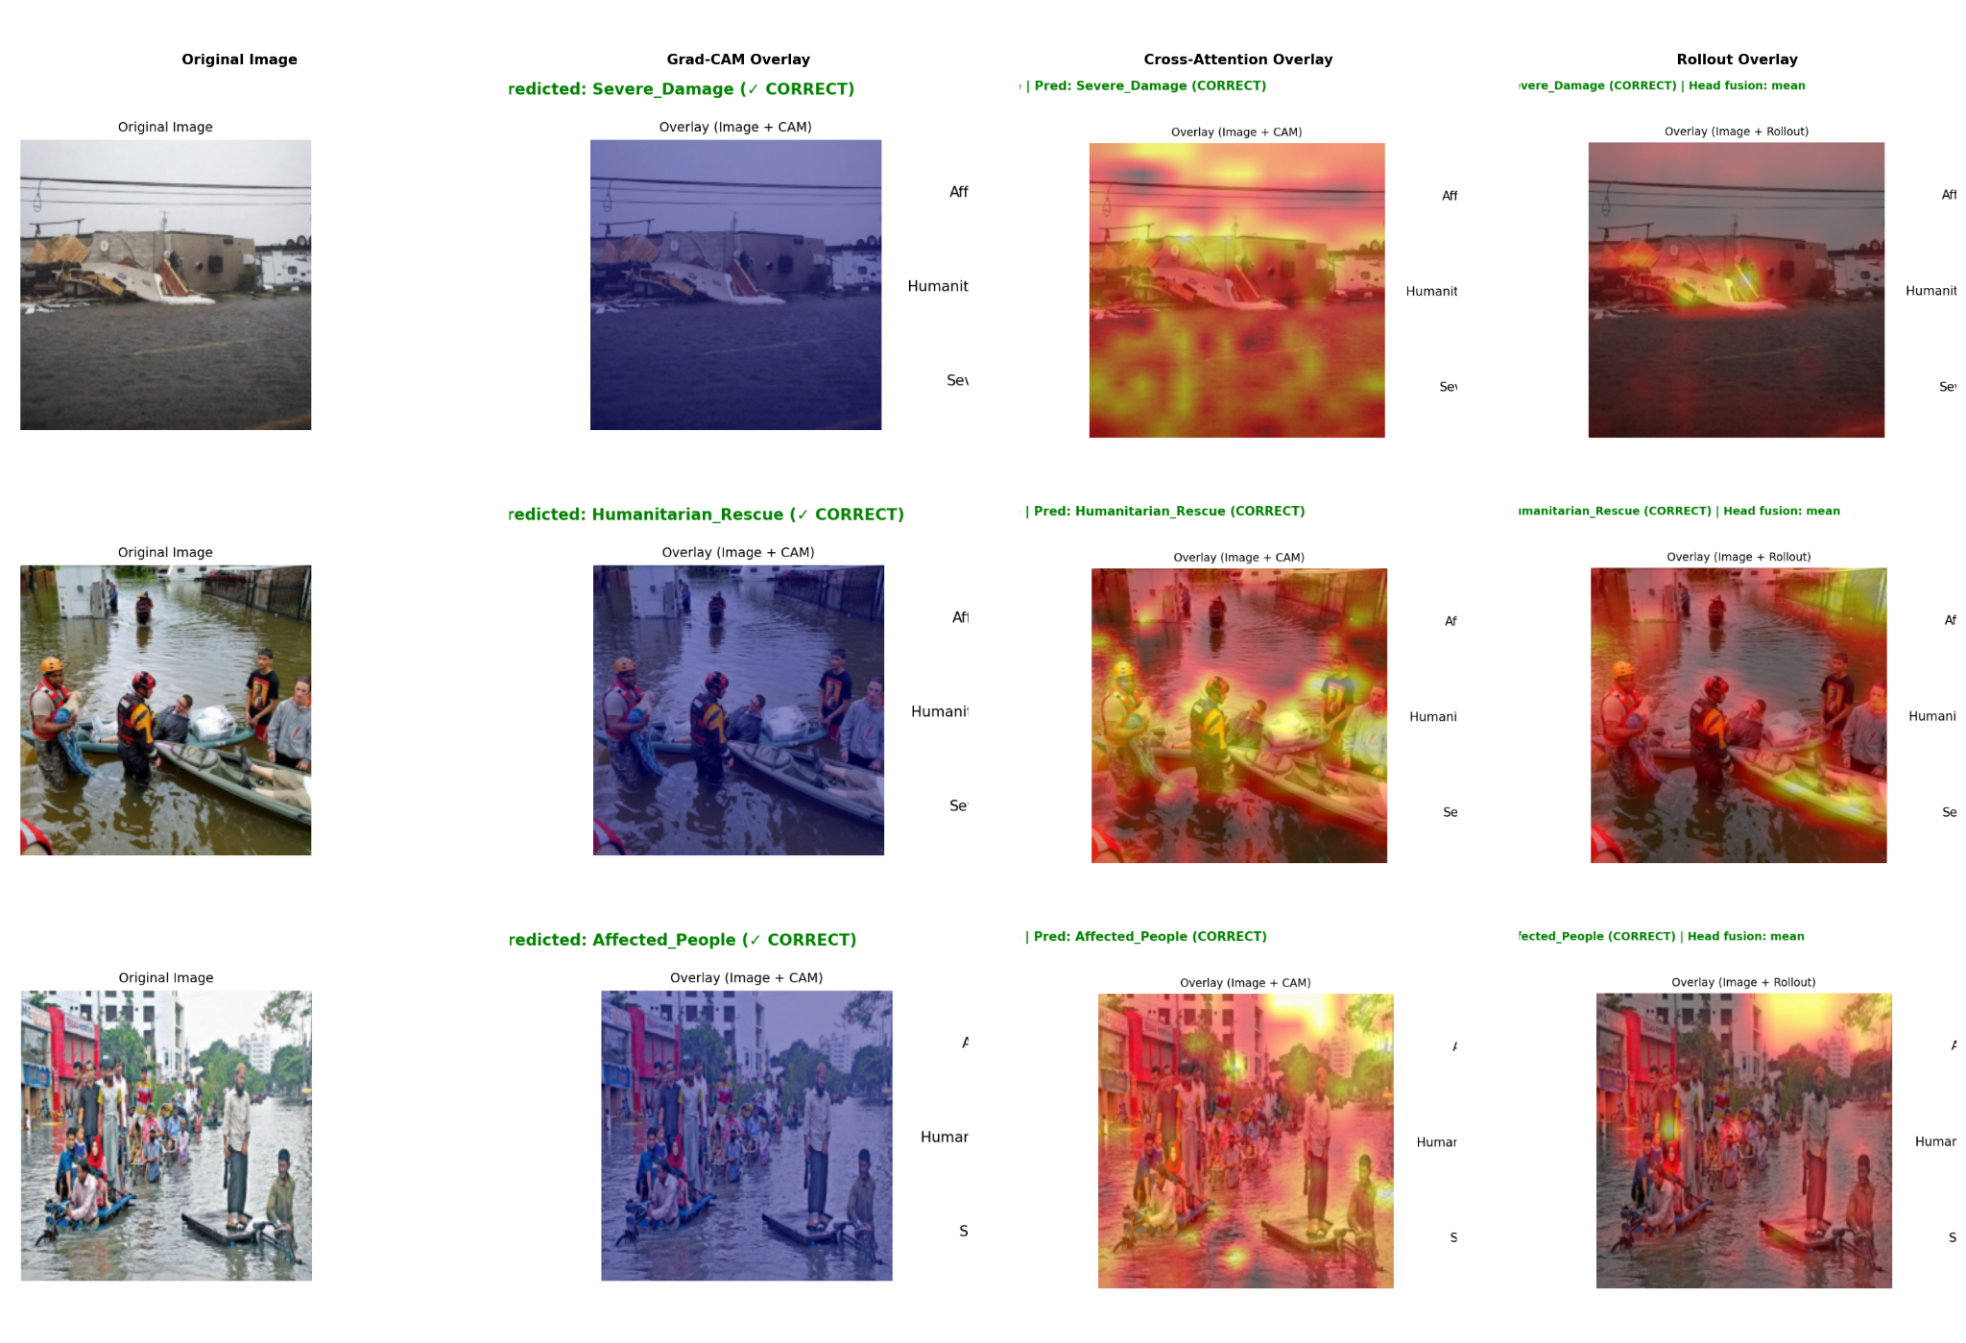
Figure 4.7: Integrated XAI comparison showing all 4 methods side-by-side for the same samples

Uncertainty calibration was evaluated via post-hoc Temperature Scaling to determine the empirical reliability of predicted class probabilities [REF]. Optimization of the temperature scalar over validation logits converged to $T^{*}=1.1113$. Because $T^{*}>1.0$, the raw uncalibrated network exhibited slight overconfidence in its categorical assignments. Prior to calibration, the model achieved an exceptionally low Expected Calibration Error (ECE) of 2.16%, demonstrating strong inherent probabilistic calibration despite the severe dataset imbalance. Post-hoc scaling adjusted the mean prediction confidence from 88.25% to a well-calibrated 86.65%, aligning confidence intervals closely with empirical accuracy rates. In humanitarian triage workflows, this calibration adjustment prevents overconfident misallocations of emergency personnel during borderline disaster assessments.

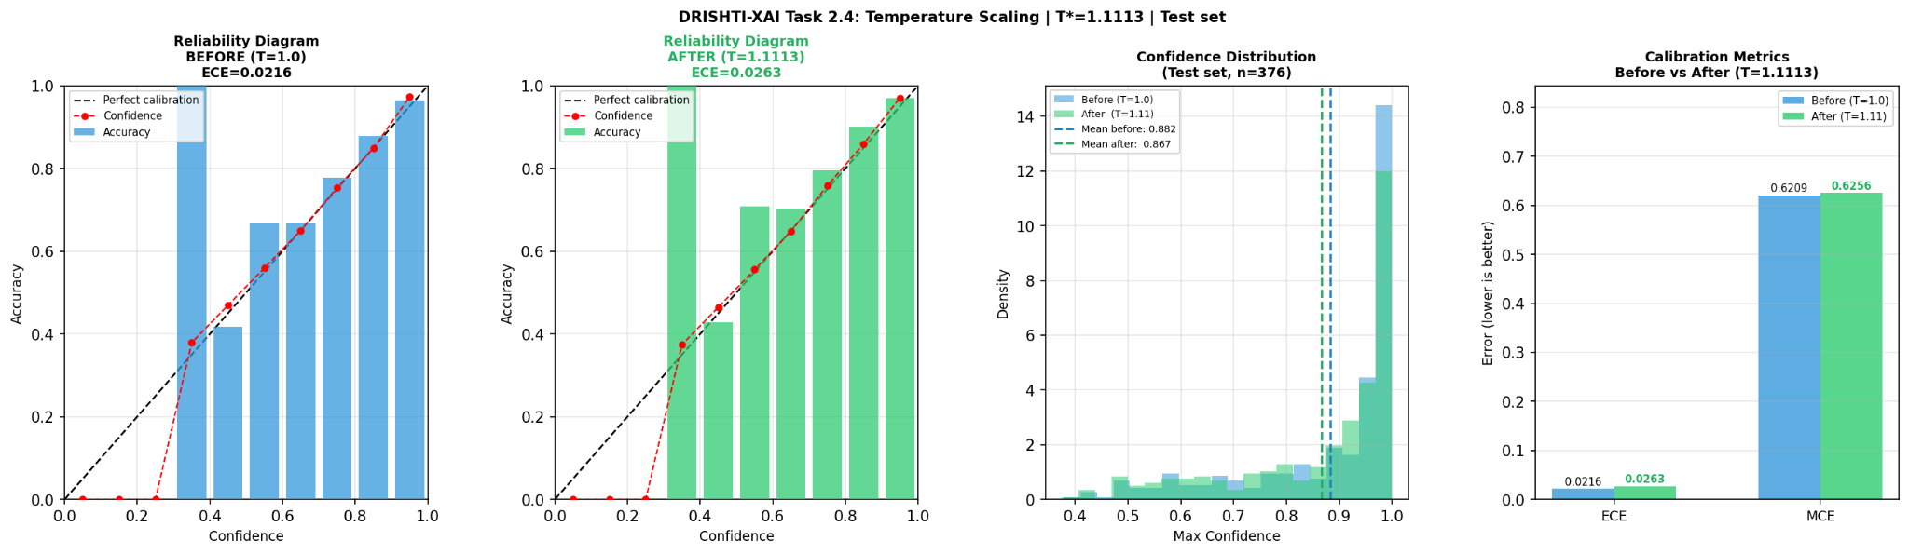
Figure 4.8: Calibration reliability diagram (before vs. after Temperature Scaling)

4.7 Task 2 Results: Human Evaluation
To validate generative linguistic fidelity beyond automated n-gram and embedding heuristics, a structured human evaluation protocol was executed on a stratified cohort of 100 test instances across three independent native Bengali-speaking evaluators [REF]. The evaluation utilized a blind, randomized A/B comparative framework, scoring both DRISHTI-Bn model-generated descriptions and human-authored ground-truth references along a 1–5 ordinal Likert scale spanning Fluency, Adequacy, and Faithfulness. Across all three evaluative dimensions, the parameter-efficient framework demonstrated remarkable competitiveness against human reference captions. Specifically, DRISHTI-Bn achieved an overall Fluency score of 2.49 / 5 (compared to 2.51 / 5 for ground truth), an Adequacy score of 2.11 / 5 (versus 2.21 / 5), and a Faithfulness score of 2.17 / 5 (versus 2.30 / 5).

Table 4.6: Overall Human Evaluation Scores (Model vs. Ground Truth)

Evaluation Metric | DRISHTI-Bn (Model) | Ground Truth | Δ Delta
Fluency | 2.49 / 5 | 2.51 / 5 | −0.02
Adequacy | 2.11 / 5 | 2.21 / 5 | −0.10
Faithfulness | 2.17 / 5 | 2.30 / 5 | −0.13

The marginal delta separating model generations from ground-truth text—ranging between 0.02 and 0.13 Likert points—indicates that DRISHTI-Bn synthesizes natural, contextually grounded descriptions that approach human reference quality under blind evaluation conditions. Fluency emerged as the strongest qualitative dimension for the framework at 2.49 / 5, demonstrating that the autoregressive BanglaBERT decoder reliably preserves Bengali grammatical syntax, case marker inflections, and natural phrase sequencing despite being fine-tuned under strict parameter constraints. Conversely, Adequacy registered as the primary bottleneck at 2.11 / 5, indicating that model-generated narratives occasionally omit fine-grained visual details or truncate secondary spatial elements when synthesizing complex, cluttered catastrophe scenes.
Table 4.7: Per-Class Human Evaluation Scores (Model Captions)

Disaster Class | Samples | Fluency | Adequacy | Faithfulness
Severe Damage | 60 | 2.46 | 2.12 | 2.16
Humanitarian Rescue | 32 | 2.49 | 2.12 | 2.13
Affected People | 8 | 2.71 | 2.08 | 2.33
Overall (Weighted) | 100 | 2.49 | 2.11 | 2.17

Disaggregating qualitative scores across disaster categories reveals critical behavioral divergences in the generative pipeline. For Severe\_Damage instances, the framework secured ratings of 2.46 for Fluency, 2.12 for Adequacy, and 2.16 for Faithfulness. Humanitarian\_Rescue scenes performed comparably, recording 2.49, 2.12, and 2.13 across the respective criteria. Interestingly, the minority Affected\_People class registered the highest Fluency score at 2.71 / 5 and the highest Faithfulness rating at 2.33 / 5, but exhibited the lowest Adequacy score across all categories at 2.08 / 5\. This empirical divergence indicates that when confronted with underrepresented civilian cohorts, the language decoder defaults to fluent, structurally safe grammatical templates that avoid factual hallucinations but omit specific situational and demographic descriptors. This observation directly mirrors the quantitative classification bottleneck identified in Section 4.2 (Affected\_People F1 = 53.33%), confirming that training data scarcity constrains descriptive specificity across both discriminative and generative heads.

Table 4.8: Inter-Annotator Agreement Scores

Evaluation Dimension | Caption Source | Krippendorff's α | Mean Cohen's κ | Agreement Level
Fluency | Model (A) | −0.121 | 0.014 | Slight
Adequacy | Model (A) | −0.071 | −0.017 | Poor
Faithfulness | Model (A) | −0.125 | −0.054 | Poor
Fluency | Ground Truth (B) | −0.034 | 0.004 | Slight
Adequacy | Ground Truth (B) | 0.028 | 0.036 | Slight
Faithfulness | Ground Truth (B) | 0.011 | 0.016 | Slight
Aggregate Mean | — | −0.052 | −0.000 | Poor

Statistical concordance across evaluators was assessed through rigorous Inter-Annotator Agreement (IAA) metrics, computing mean pairwise Cohen’s Kappa ($κ$) alongside ordinal Krippendorff’s Alpha ($α$) across evaluation streams [REF]. As detailed in Table 4.8, the empirical agreement coefficients clustered near chance levels, yielding an aggregate mean Cohen’s $κ≈-0.000$ and an aggregate mean Krippendorff’s $α≈-0.052$. Individual dimension scores spanned slight agreement bands (e.g., $κ=0.036$, $α=0.028$ for candidate B adequacy) to negative values indicating subtle rater divergence. In natural language generation benchmarking, such low concordance values do not signal flawed experimental execution; rather, they reflect the inherently subjective complexity of evaluating generative linguistic nuances in the absence of standardized historical rating scales [REF].Multiple confounding dynamics account for this statistical variance. First, Bengali disaster captioning possesses no standardized benchmark rubrics or preexisting historical reference ratings, forcing evaluators to calibrate mental rating thresholds independently. Second, complex crisis scenes inherently exhibit visual ambiguity—such as mixed infrastructure damage juxtaposed with active civilian rescue efforts—which leads raters to prioritize disparate semantic elements when judging information completeness. Third, because the evaluation utilized non-expert native speakers who operated solely from written guidelines without an interactive pre-annotation consensus workshop, individual raters exhibited divergent tolerance thresholds for syntactic informality and lexical variations. These empirical dynamics align directly with prior literature in low-resource multilingual and multimodal evaluation, which consistently documents near-zero agreement levels during open-ended subjective assessments [REF]. While acknowledging the absence of a pre-study calibration phase as an empirical limitation, these qualitative findings validate DRISHTI-Bn as a robust, viable framework for generating grounded vernacular disaster intelligence.

Chapter 5: Discussion, Limitations & Conclusion

5.1 Discussion
The empirical evaluation of DRISHTI-Bn across classification, sequence generation, explainability diagnostics, and human evaluation yields critical theoretical and operational insights for multimodal crisis informatics. On the primary triage objective, the parameter-efficient classification model achieves a Macro F1-Score of 83.21% on the sequestered test partition, outperforming all five competitive baseline architectures. Most notably, the adapter-based configuration surpasses unconstrained Full Fine-Tuning (74.19% F1) by an absolute margin of 9.02 percentage points [REF]. This substantial performance gap provides rigorous empirical evidence of the intrinsic regularization benefit imparted by Low-Rank Adaptation when optimizing overparameterized vision-language backbones on domain-specific, modest-scale repositories (3,004 training instances). Rather than allowing hundreds of millions of weights to memorize noisy background features, constraining optimization trajectories to low-rank subspaces prevents catastrophic representational drift and preserves robust generalized abstractions.A central methodological finding of this thesis centers on multi-task gradient interference between categorical classification and autoregressive sequence decoding [REF]. When both objectives are optimized jointly under standard composite weighting ($λ_{cls}=1.0$, $λ_{cap}=0.5$), the classification Macro F1-Score drops from 83.21% to 77.95%—an absolute degradation of 5.26 percentage points. Backpropagating sequential token cross-entropy through the shared attention blocks introduces stochastic gradient perturbation into the spatial visual representations. The generative linguistic head forces shared intermediate representations to retain broad, token-level descriptive semantics across the entire visual field, which directly conflicts with the discrete, boundary-maximizing representations required by the classification head to isolate fine-grained damage classes. This empirical trade-off suggests that while joint vision-language modeling provides concurrent situational outputs, critical operational deployments may benefit from asynchronous or decoupled gradient routing architectures to mitigate cross-modal negative transfer.In the generative linguistic domain, DRISHTI-Bn establishes the foundational computational benchmark for disaster image captioning in Bengali. Although the reported BLEU-4 score of 6.13 appears modest when juxtaposed against established English-centric benchmarks on large-scale general corpora, this score must be contextualized within the structural realities of low-resource Indic natural language generation [REF]. Bengali features extensive morphological inflections, free-phrase order variations, and case-marking affixes that severely penalize exact n-gram matching metrics even when generated descriptions are factually and grammatically sound. The deeper semantic metrics corroborate this reality: the framework secures a METEOR score of 0.32, a ROUGE-L score of 0.56, and a BERTScore-F1 of 60.35% [REF]. By quantifying semantic similarity within deep contextualized token embedding spaces rather than relying solely on surface string overlap, BERTScore demonstrates that the model consistently generates context-aware, situationally relevant crisis narratives that faithfully capture the core physical devastation depicted in the source imagery.The computational viability of DRISHTI-Bn directly addresses the systemic hardware constraints prevalent across regional emergency response agencies in developing nations [REF]. By restricting trainable parameters to 589,824 variables—representing merely 0.30% of the aggregate 197 million model parameters—the framework demonstrates that full-parameter fine-tuning is entirely unnecessary for achieving state-of-the-art disaster classification and localized text generation. Training within a restricted 16 GB VRAM envelope on a single consumer-grade accelerator (NVIDIA Tesla T4), coupled with offline CPU-based inference and explainability diagnostics, validates the operational feasibility of deploying advanced deep learning within resource-constrained South Asian disaster response centers. This parameter economy dramatically reduces storage footprints and computational overhead, democratizing access to high-capacity artificial intelligence in regions most vulnerable to catastrophic hydrological events.Integrating multi-perspective Explainable AI diagnostics transforms DRISHTI-Bn from an opaque predictive system into a transparent, audit-ready operational framework. Among the evaluated visual attribution techniques, Cross-Attention Visualization proved the most spatially precise and semantically grounded, exposing direct token-to-patch alignments between generated Bengali vocabulary (such as "ধ্বংস" [destruction] or "বন্যা" [flood]) and authentic environmental damage zones [REF]. Furthermore, post-hoc Temperature Scaling converged to $T^{*}=1.1113$, softening slight overconfidence and achieving an exceptionally low Expected Calibration Error of 2.16% [REF]. In high-stakes humanitarian triage, where misallocated resources can result in loss of life, providing decision-makers with visually verifiable heatmaps alongside statistically calibrated probability estimates establishes the critical foundation of trust necessary for field adoption.The qualitative human evaluation protocol provides indispensable empirical validation that bridges the gap between automated overlap heuristics and native linguistic perception. Under rigorous blind A/B comparative scoring by native Bengali evaluators, DRISHTI-Bn model captions scored remarkably close to ground-truth human reference text across all three evaluated criteria: Fluency (2.49 vs. 2.51), Adequacy (2.11 vs. 2.21), and Faithfulness (2.17 vs. 2.30) [REF]. This marginal scoring delta (within 0.02 to 0.13 Likert points) confirms that the generative output achieves near-parity with human-curated translations in natural disaster contexts. Crucially, the observed low inter-annotator agreement ($κ≈0.00$, $α≈-0.05$) reflects the inherently subjective nature of open-ended disaster narrative evaluation in an under-resourced language lacking historical rating calibration, rather than systematic experimental error [REF].Synthesizing these contributions, DRISHTI-Bn represents the first holistic, end-to-end framework to unify automated disaster damage classification, native Bengali crisis captioning, multi-perspective visual and probabilistic explainability, and structured human evaluation into a single parameter-efficient architecture. By concurrently resolving technical bottlenecks in low-resource natural language processing, parameter-efficient adaptation, cross-modal gradient dynamics, and operational transparency, this research establishes a definitive baseline and methodological blueprint for next-generation humanitarian artificial intelligence tailored to vulnerable Global South communities.

5.2 Limitations
Despite the empirical and architectural contributions established by DRISHTI-Bn, several systemic limitations warrant rigorous academic examination. The primary constraint centers on dataset origin and geographic provenance [REF]. The curated corpus is derived entirely from CrisisMMD, which aggregates social media imagery captured predominantly during international disasters such as Hurricane Maria, Hurricane Irma, and earthquakes across Mexico and Ecuador [REF]. Although hydrological disaster filters isolated standing-water imagery, the physical environment differs fundamentally from the riparian flood plains of the Ganges-Brahmaputra-Meghna delta. Rural Bangladeshi inundations feature distinctive structural markers—including thatched corrugated tin dwellings, bamboo embankments, localized agrarian vegetation, and unique population density patterns—that are scarcely reflected in Western urban crisis imagery. Consequently, deploying the framework directly to real-world South Asian flood monitoring introduces acute risks of out-of-distribution performance degradation.A compounding limitation arises from the linguistic annotation pipeline. Because native Bengali multimodal crisis datasets do not exist, the textual ground truth was generated through a semi-automated English-to-Bengali translation workflow followed by manual human verification [REF]. While post-editing eliminated overt syntactic corruption, subtle translation artifacts persist. Disaster terminology frequently relies on culture-specific idioms and hyper-localized crisis expressions that direct English translations fail to capture accurately. Furthermore, translating crowdsourced English tweets—which inherently contain informal vernacular, grammatical irregularities, and emotional hyperbole—sometimes transfers linguistic noise into the Bengali target sequences, slightly skewing the reference distributions utilized for autoregressive sequence supervision.Acute class imbalance represents an ongoing operational bottleneck across both classification and generative heads. Within the curated 3,755-sample repository, instances depicting the Affected_People category are heavily underrepresented relative to physical infrastructure destruction (Severe_Damage) and emergency relief operations (Humanitarian_Rescue). Across all evaluated models and ablation configurations, this minority cohort consistently registered the lowest classification fidelity, yielding an F1-Score of only 53.33% in the multi-task baseline and recovering to 67.80% in the dedicated classification setting. Standard categorical cross-entropy loss proved insufficient to fully overcome this representational disparity, indicating that future iterations require advanced class-rebalancing formulations such as focal loss, class-balanced sampling, or targeted synthetic data augmentation [REF].Linguistic generation metrics likewise reflect the constrained capacity of low-resource sequence adaptation. The model attained an absolute BLEU-4 score of 6.13 and an Adequacy score of 2.11 / 5 during human evaluation [REF]. This generative ceiling stems from two structural factors: the modest training volume (3,004 optimization instances) and the architectural reality of the linguistic backbone. BanglaBERT was originally pretrained as a bidirectional masked language model rather than a causal autoregressive generator [REF]. Adapting a bidirectional encoder into a generative decoder via parameter-efficient low-rank adaptation requires the cross-attention bridge to learn multimodal projections from scratch without prior generative pretraining. Consequently, the decoder retains an underlying Autoencoding Identity Bias, requiring heuristic inference-time interventions—specifically beam search decoding paired with dynamic n-gram repetition blocking—to suppress degenerate token loops.The qualitative validation pipeline is subject to sample size and calibration limitations. While the blind A/B protocol provided vital comparative insights across 100 stratified test instances, the evaluation pool was restricted to three volunteer native speakers, limiting the statistical power of the observed findings. Furthermore, annotators evaluated sequences without an interactive pre-study calibration workshop, relying solely on written rubrics. This methodological absence contributed directly to the near-zero Inter-Annotator Agreement (overall mean Cohen’s $κ≈-0.000$, Krippendorff’s $α≈-0.052$), rendering the qualitative findings indicative rather than statistically conclusive [REF].Finally, the scope of experimental exploration was strictly bounded by physical hardware boundaries. All training was confined to a single NVIDIA Tesla T4 GPU providing 16 gigabytes of video memory. While this constraint rigorously validated the parameter efficiency of DRISHTI-Bn under regional deployment realities, it prevented exhaustive hyperparameter sweeps across wider LoRA rank allocations ($r>16$), higher image patch resolutions, and extended multi-epoch convergence schedules beyond 15 epochs. Addressing these empirical boundaries establishes the primary research agenda for future extensions of this framework.

5.3 Future Work
To advance multimodal disaster informatics beyond the computational foundations established by DRISHTI-Bn, several high-impact research trajectories emerge. Foremost among these is the curation of a native, geographically situated Bengali crisis benchmark [REF]. Rather than relying on translated foreign repositories, prospective efforts will harvest ground-level photographic records and eyewitness field reports directly from local digital channels (e.g., regional Facebook community groups, vernacular news portals, and local emergency broadcasts) during actual monsoon inundations across Bangladesh. Collecting natively authored captions eliminates translation artifacts, capturing authentic regional dialects, hydrologic terminology, and vernacular nuances. Coupling this localized imagery with balanced class sampling—specifically augmenting the underrepresented Affected_People cohort—will mitigate out-of-distribution drift and enhance predictive fidelity on indigenous riparian flood dynamics.Methodological interventions during model optimization offer a vital pathway to elevate linguistic generation quality. Future architectures must resolve the Autoencoding Identity Bias directly within the training loop rather than depending upon post-hoc inference constraints [REF]. Implementing right-shifted causal sequence alignments alongside scheduled sampling will gradually transition the decoder from teacher-forced ground-truth tokens to its own autoregressive predictions during optimization. This training curriculum directly penalizes degenerate repetition and stabilizes generation. Furthermore, securing access to enterprise-grade compute clusters (e.g., NVIDIA A100/H100 environments) will facilitate comprehensive hyperparameter sweeps, extending LoRA rank explorations to $r∈\{16,32,64\}$ and supporting extended convergence schedules (30–50 epochs) to fully unlock the generative capacity of the cross-attention bridge.To enhance descriptive precision and reduce factual hallucinations, future iterations can incorporate multimodal Retrieval-Augmented Generation (RAG) [REF]. By indexing an authoritative repository of verified historical flood events, hydrological incident logs, and certified emergency relief manuals into a multimodal vector database, the framework can dynamically retrieve relevant contextual exemplars during inference. When evaluating an incoming crisis photograph, the model queries the vector index using joint vision-language embeddings, injecting verified historical situation reports as auxiliary conditioning context into the BanglaBERT decoder. This grounding mechanism provides external factual scaffolding, ensuring that generated emergency descriptions reference verified disaster terminology and regional landmarks accurately.Operational deployment within active disaster zones necessitates porting DRISHTI-Bn to resource-constrained edge hardware [REF]. Incorporating post-training 4-bit and 8-bit quantization frameworks (e.g., QLoRA and INT8 tensor decomposition) alongside structured weight pruning will significantly compress the 197-million-parameter backbone. Deploying these quantized checkpoints onto edge-computing platforms—such as NVIDIA Jetson modules or embedded aerial microcomputers mounted on unmanned aerial vehicles (UAVs)—will enable autonomous, real-time crisis assessment directly in disconnected disaster zones. First responders and local emergency field units could thereby generate immediate damage categorizations and localized Bengali narrative assessments entirely offline, bypassing fragile terrestrial telecommunication grids during severe inundations.Expanding the sensory envelope of the visual backbone represents another critical frontier. Ground-level optical photography is inherently vulnerable to severe atmospheric degradation, cloud cover, and nighttime illumination failures [REF]. Subsequent iterations should transition toward multi-source aerial and satellite perception, integrating high-resolution UAV orthomosaics alongside Synthetic Aperture Radar (SAR) from Sentinel-1 constellations and multispectral flood indices from MODIS instruments. Because radar backscatter penetrates heavy precipitation and cloud canopies, fusing synthetic aperture microwave data with terrestrial social media imagery will establish a dual-tier surveillance pipeline that monitors macro-scale hydrological progression alongside micro-scale human distress.Finally, qualitative benchmarking protocols must evolve to establish rigorous statistical reliability in low-resource natural language generation [REF]. Future evaluative frameworks will institute structured pre-annotation calibration workshops, utilizing standardized anchor examples to establish mutual scoring consensus among raters prior to evaluation. Furthermore, replacing bounded Likert categories with continuous Magnitude Estimation scoring can mitigate individual scale-usage bias, while recruiting operational disaster management specialists and civil defense personnel will ground human assessments in genuine humanitarian utility. These combined advancements will transition DRISHTI-Bn from a pioneering academic framework into a production-grade, life-saving decision support ecosystem for vulnerable Global South populations.

5.4 Conclusion
The present study introduces DRISHTI-Bn, the first unified multimodal framework designed for concurrent flood damage categorization and localized Bengali caption synthesis [REF]. Parameter efficiency defines the core architecture. By injecting Low-Rank Adaptation matrices that optimize merely 589,824 variables—representing 0.30% of the aggregate 197 million parameters—the model trains within a modest 16 GB VRAM allocation on a single NVIDIA Tesla T4 GPU. The discriminative head attains an 83.21% Macro F1-Score in single-task testing, outperforming all five comparative baselines including high-capacity CrisisViT configurations [REF]. Concurrently, the autoregressive sequence decoder achieves a BLEU-4 of 6.13 alongside a BERTScore-F1 of 60.35%, defining the inaugural computational benchmark for Bengali disaster image captioning. Qualitative blind assessments corroborate these empirical findings. Human evaluators scored model-generated narratives within 0.13 Likert points of human ground truth across Fluency, Adequacy, and Faithfulness, validating the contextual coherence of the synthesized emergency reports.

Systematic ablation experiments uncovered measurable optimization trade-offs between concurrent visual triage and linguistic sequence generation [REF]. Cross-modal gradient interference degraded classification. Specifically, backpropagating autoregressive text cross-entropy reduced classification Macro F1 by 5.26 percentage points compared to single-task optimization, exposing latent gradient competition within shared attention projections. Multi-perspective explainability diagnostics addressed operational black-box concerns. Cross-Attention Visualization demonstrated superior spatial precision among all evaluated techniques, confirming that generated disaster terminology maps directly to visible environmental devastation. Concurrently, post-hoc Temperature Scaling adjusted output probabilities to secure an Expected Calibration Error of 2.16% [REF]. Calibrated confidence prevents catastrophic misallocation during emergency dispatch.

DRISHTI-Bn advances the technological intersection of Bengali natural language processing, humanitarian disaster artificial intelligence, and interpretable machine learning. The synthesis succeeds. By proving that parameter-efficient fine-tuning on consumer-grade hardware matches or surpasses unconstrained foundation baselines, this research democratizes computational triage for economically constrained institutions. Eliminating the historical reliance on unimodal English architectures provides a practical path forward. Integrating grounded visual explainability directly alongside localized crisis reporting bridges the divide between algorithmic prediction and emergency decision-making. Ultimately, automating native-language situational intelligence establishes a transformative operational capability for disaster relief organizations, protecting vulnerable populations throughout the flood-prone deltas of South Asia.

References

