**BANGLADESH UNIVERSITY OF ENGINEERING AND TECHNOLOGY**

**BUET**

**Department of Electrical and Electronic Engineering**

**EEE 306 Project Report**

**Topic:** Wind Power Plant Simulation Using Simulink

**Date of Submission:** 20-06-2021

**Submitted by:**

Md. Jahidul Hoq Emon

Swapnil Siddiky

Md. Redwan Hossen

Shafin Shadman Ahmed

**Student ID:**

S201706017

S201706018

S201706019

S201706020

**Department:** EEE, **Section:** A (A1)

**Level:** 3, **Term:** 1

**Introduction**

Wind power means using wind to provide mechanical power through wind turbines to enable electric generators to produce electric power. Wind power is much popular in modern times because wind is available anytime and wind power is a renewable energy source which has no harmful effect on the environment. Wind turbine is the most effective way to make the best use of wind power.

At present, wind turbines are designed so that this natural resource called wind is harnessed in the best possible way. All the wind turbines used today are either horizontal-axis or vertical-axis machines with 3-bladed rotor spinning in a vertical plane, although horizontal-axis setup is more common. Wind energy is used to rotate these blades, which are usually mounted at a height of almost 40 meters. This arrangement facilitates the conversion of kinetic energy of the wind into mechanical energy. This mechanical energy is then converted to electrical energy using a generator in the wind power plant.

This project aims to simulate a wind power plant in Simulink. The power plant produces 1.5 MW rated electrical power at an operating voltage of 600 V. The output voltage from the wind turbine is sent to a 33 kV grid via a step-up transformer. This project displays variations in different power plant characteristics relative to wind speed which itself is variable with respect to time. Then the graphs are studied and described. At last, the limitations encountered while performing the project are discussed.

**Objectives of the Project**

The objectives of this project are briefly described below:

1. To make a wind turbine model using Simulink. The wind turbine model will be Induction Generator type. The wind turbine model is connected with a high-voltage grid via a step-up transformer.

2. To vary the wind speed to observe the change in different characteristics of the turbine. The characteristics to be examined are power, torque, efficiency etc. It is well-known that if wind speed changes with time, the characteristics such as real power, torque and efficiency will also show variations.

3. Plotting the various aforementioned characteristics with varying speed. Actually, the wind speed itself varies with respect to time, so the characteristics can also be plotted with respect to time without any change in graph.

4. Finding the maximum efficiency which can be extracted from the turbine (Betz limit).

**Theories regarding the project :**

* **Working of a wind turbine:** Wind turbines work on a simple principle: instead of using electricity to make wind—like a fan—wind turbines use wind to make electricity. Wind turns the propeller-like blades of a turbine around a rotor, which spins a generator, which creates electricity.A wind turbine turns wind energy into electricity using the aerodynamic force from the rotor blades, which work like an airplane wing or helicopter rotor blade. When wind flows across the blade, the air pressure on one side of the blade decreases. The difference in air pressure across the two sides of the blade creates both lift and drag. The force of the lift is stronger than the drag and this causes the rotor to spin. The rotor connects to the generator, either directly (if it’s a direct drive turbine) or through a shaft and a series of gears (a gearbox) that speed up the rotation and allow for a physically smaller generator. This translation of aerodynamic force to rotation of a generator creates electricity.

In a wind turbine induction generator,the stator winding is connected directly to the grid and the rotor is driven by the wind turbine. The power captured by the wind turbine is converted into electrical power by the induction generator and is transmitted to the grid by the stator winding. The pitch angle is controlled in order to limit the generator output power to its nominal value for high wind speeds. In order to generate power the induction generator speed must be slightly above the synchronous speed. But the speed variation is typically so small that the WTIG is considered to be a fixed-speed wind generator.

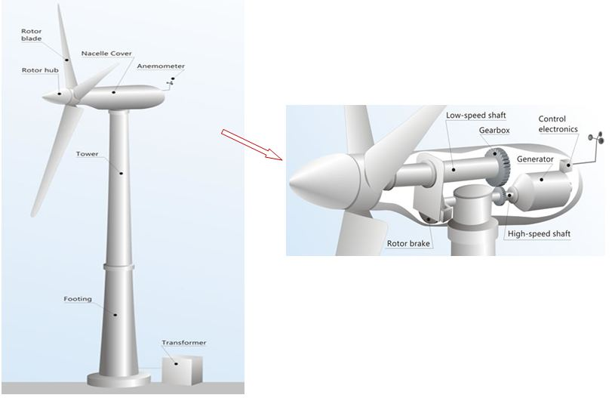

***Fig 1:*** Internals of a Wind Turbine

## Types of Wind Turbines:

## The majority of wind turbines fall into two basic types:

## HORIZONTAL-AXIS TURBINES: They have three blades and operate "upwind," with the turbine pivoting at the top of the tower so the blades face into the wind.

## 

***Fig 2:*** Horizontal Axis Wind Turbine

1. **VERTICAL-AXIS TURBINES:** Vertical-axis wind turbines come in several varieties.These turbines are omnidirectional, meaning they don’t need to be adjusted to point into the wind to operate.

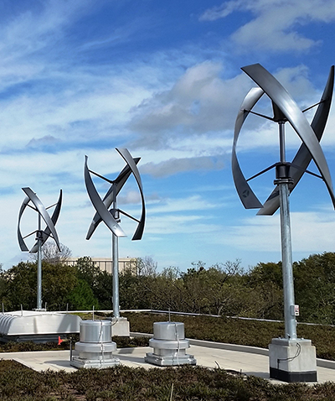

***Fig 3:*** Vertical Axis Wind Turbine

* **Efficiency of a Wind Turbine:** The efficiency of a wind turbine is described as η = × 100%, where P is the output electric power produced by the wind turbine and Pwind is the power produced due to rotation of the turbine’s blades. It can be described as

**Pwind = ρAv3**

where v is the wind speed, A = πr2 is the area swept by the turbine blades (r = radius of the rotor blade) and ρ is the density of air at approximately 1.29 kgm−3.

* **Betz limit:** It can be described as the theoretical maximum efficiency of a wind turbine regardless of the turbine’s design. The Betz limit is at 59.3%%(Cpmax), indicating that a wind power plant can never have efficiency greater than this limit.

In this project, some areas swept by rotor blades of different radii are taken and the efficiency of the wind turbine is determined using these areas and the obtained efficiencies are plotted and compared.

**Components with Description**

At first, the wind power plant made in Simulink is shown below:

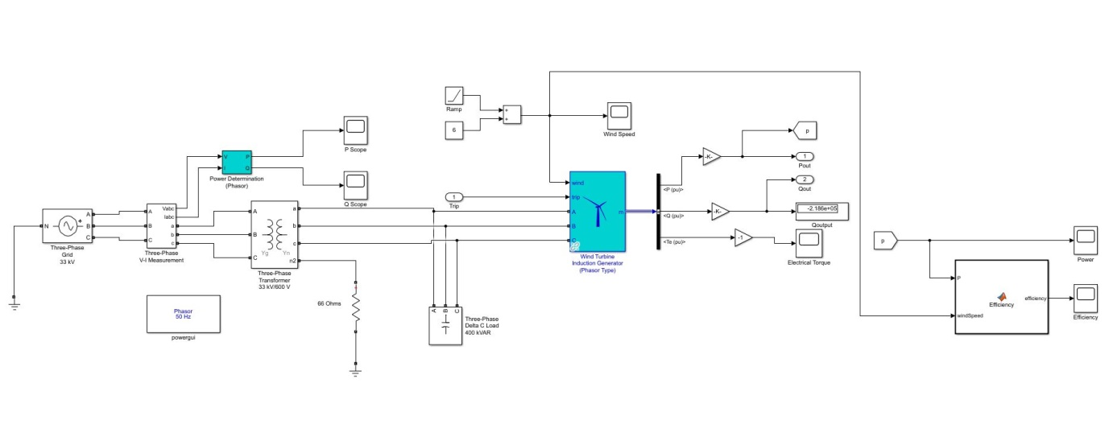

***Fig 4:*** Wind Power Plant modelling in Simulink

It is seen by looking under mask that the wind power plant consists of several components. These are described below:

**1. Wind Turbine Induction Generator**

This is the most important component of the project. The generator unit is responsible for producing 1.5 MW rated electrical power at an operating voltage of 600 V. The generator converts the mechanical energy obtained from the movement of the rotor blades of the wind turbine due to wind flow into electrical energy.

Advantages of using Induction Generator in this model :

* An induction generator requires less maintenance because of its robust construction. An ordinary cage motor is used as an induction generator as it is cheaper in comparison.
* Parallel operation is possible without hunting.
* Speed variation of the prime mover is less prominent.
* The induction generator is smaller in size per Kilowatt output power.
* It needs less auxiliary equipment.
* It does not have to be synchronized to the supply line as that of the synchronous generator.
* The induction generator has self-protection feature. In the case of the short circuit, if a fault occurs on its terminals, the excitation fails, and the machine stops the generation itself.

## Limitation of an Induction Generator:

The major limitation of an Induction Generator is that it requires reactive volt-amperes from the auxiliary equipment.An Induction Generator cannot generate reactive volt-amperes. It requires reactive volt-amperes from the supply mains for the excitation process.So,to supply reactive power, a capacitor bank was used in this model to illustrate this.

The wind turbine induction generator itself is composed of several components, these are described below:

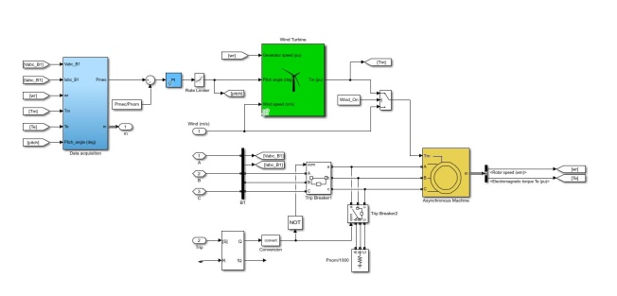

***Fig 5***:Wind Turbine Induction Generator Model in Simulink

**a. Wind Turbine:** It is the principal part of the generator component. It calculates the real power depending on wind speed and mechanical torque. The outputs from the wind turbine are collected in the data acquisition block.

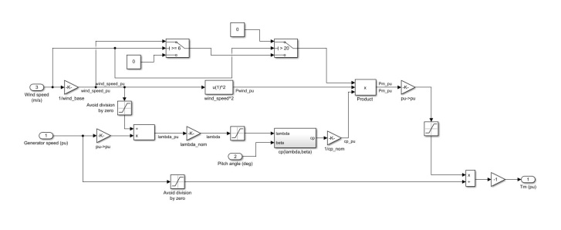

***Fig 6***:Wind Turbine Model in Simulink

This is inside the wind turbine. The wind speed is variable, and counted from 6 ms−1 to 20 ms−1. The base speed is at 12 ms−1. The real power is limited to 1.5 MW so that excess power flow does not occur.A logical threshold has been implemented so that the turbine doesn’t cross its rated power value.A cut in speed of 6 ms−1 and cutoff speed of 20 ms−1 have been chosen.

**b. Data Acquisition Block:** This block collects data from outside (Voltage, Current) and inside (Electrical and Mechanical Torques, Pitch Angle, Rotor Speed) the induction generator component. It gives some data as output; from those, real and reactive powers and electrical torque are needed to display in this project.

**c. PI (Proportional Integral) controller:** It controls the pitch angle. Pitch angle is the measurement of change in angle of rotor blade. Practically, depending on wind direction, pitch is changed. In this simulation, pitch angle has been kept at 0°.

**d. Asynchronous Machine:** It takes mechanical torque and voltages as inputs and gives rotor speed and electrical torque as outputs. Both outputs are sent to the Data Acquisition block.

**2. Three-phase transformer**

A three phase step-up transformer is used in the simulation. The step-up transformer operates at 600 V/33 kV range. That is, it takes current at the operating voltage of the wind turbine and transfers current at a higher voltage to the grid.

**3. Three-phase 33 kV grid**

The grid accepts the power produced by the wind turbine. The power at high voltage can later be distributed elsewhere by lowering the voltage using transformers. However, in this experiment, the grid is only intended to accept the power at a higher voltage.

**4. Three-phase 400 kVar capacitor bank**

A capacitor bank is applied after the wind turbine generator and before the transformer. Its task is to supply reactive power to the wind turbine. Capacitors are known to be sources of reactive power, and induction generators consume reactive power, so a capacitor bank is used.

**5. 66 Ω Grounding Resistor**

It is seen that the transformer is Yg−Yn type, so for the Yn part, a neutral grounding is added. This grounding is done with a resistor of value 66 Ω.

**6. Scopes**

Scopes are used to demonstrate the graphs obtained during the simulation. The graphs shown through scopes are: Real power obtained from the wind turbine induction generator, electrical torque and efficiency.

**7. V-I measurement block**

This particular block measures voltage and current which is being sent to the grid form the wind turbine induction generator via step-up transformer. This block also helps in determining the real and reactive powers consumed by the grid.

**8. Powergui (Phasor) Block**

The wind turbine simulated in this project is of phasor type. So a powergui block is added to ensure that the calculations throughout the simulation remain phasor type. The frequency is set at 50 Hz.

**9. Ramp Function**

A ramp function is used to denote varying wind speed with respect to time. The starting speed at t = 0 is taken to be 6 ms−1 and wind speed is taken for 40 seconds.

**10. MATLAB Function Block**

A MATLAB function block has been implemented for calculating efficiency of the wind turbine. The function takes the output power generated and the wind speed as inputs and the efficiency is sent as output. The code used inside the function block is shown below:

|  |
| --- |
| function efficiency = Efficiency(P, windSpeed)  rho = 1.29;  Area = [2290.22 6647.61 13273.23];  windPower = 0.5 * (windSpeed) ^ 3 * rho .* Area;  efficiency = 100 * P ./ windPower;  end |

**Work Flow**

The work flow of this project is briefly described below:

1. At first, the Simulink model of the wind turbine was made. Necessary data were given as inputs.

2. Next, a ramp function was implemented to vary wind speed. Inside the wind turbine, adjustments were made so that the cut-in and cut-out speeds of the turbine can be shown in the power output.

3. A MATLAB function was created to calculate the efficiency of the simulated wind power plant.

4. Then the simulation is set so that the graphs of wind speed, real power form the turbine, electrical torque and efficiency, all with respect to time, can be plotted.

5. After the simulation is run, the output graphs are obtained. These graphs are compared with real-life graphs.

6. The limitations are detected and some ways to improve the simulation are discussed.

**Results and Observations :**

1. Wind vs Time graph :

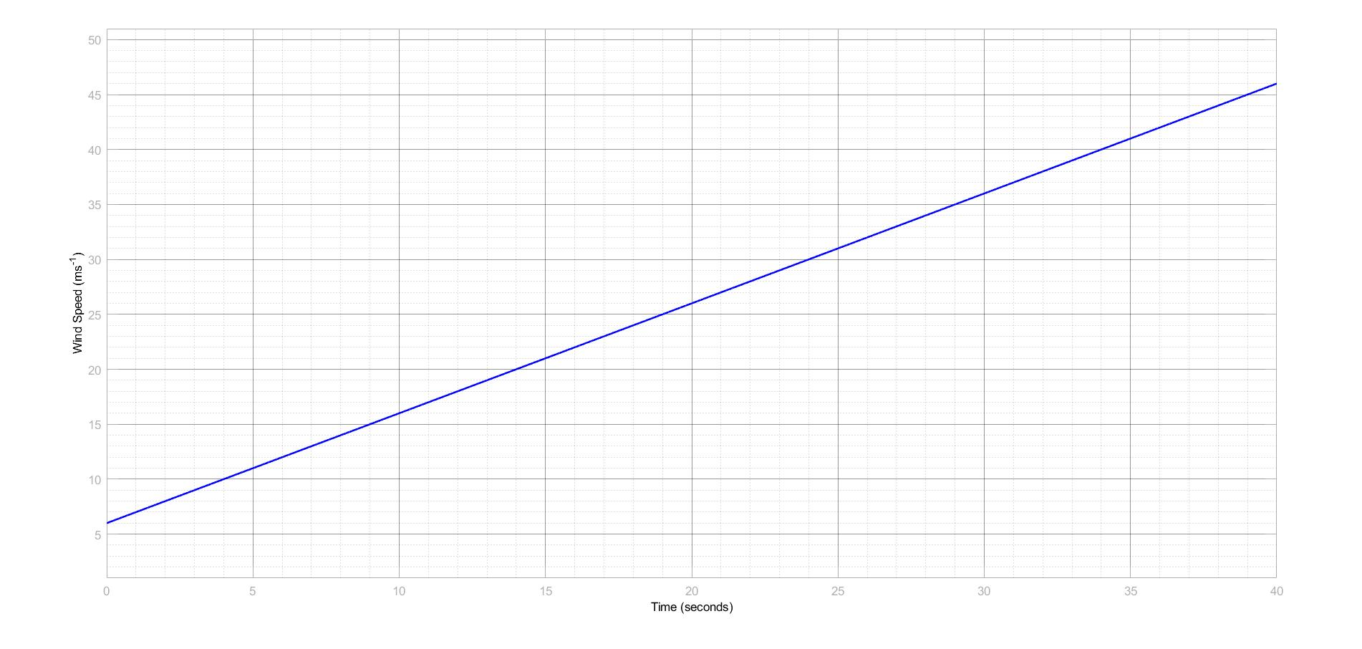

***Fig 7 :*** Wind vs Time graph

Here,Wind vs Time graph is plotted from scope.We see that the wind is varied linearly from 6 m/s at time t=0 s until t=40s(total simulation time). The variation was found using a ramp function of slope =1 in the Simulink block.This is the fundamental graph of this project as we varied wind speed to measure different characteristics of the plant.

1. Real Power vs Time graph :

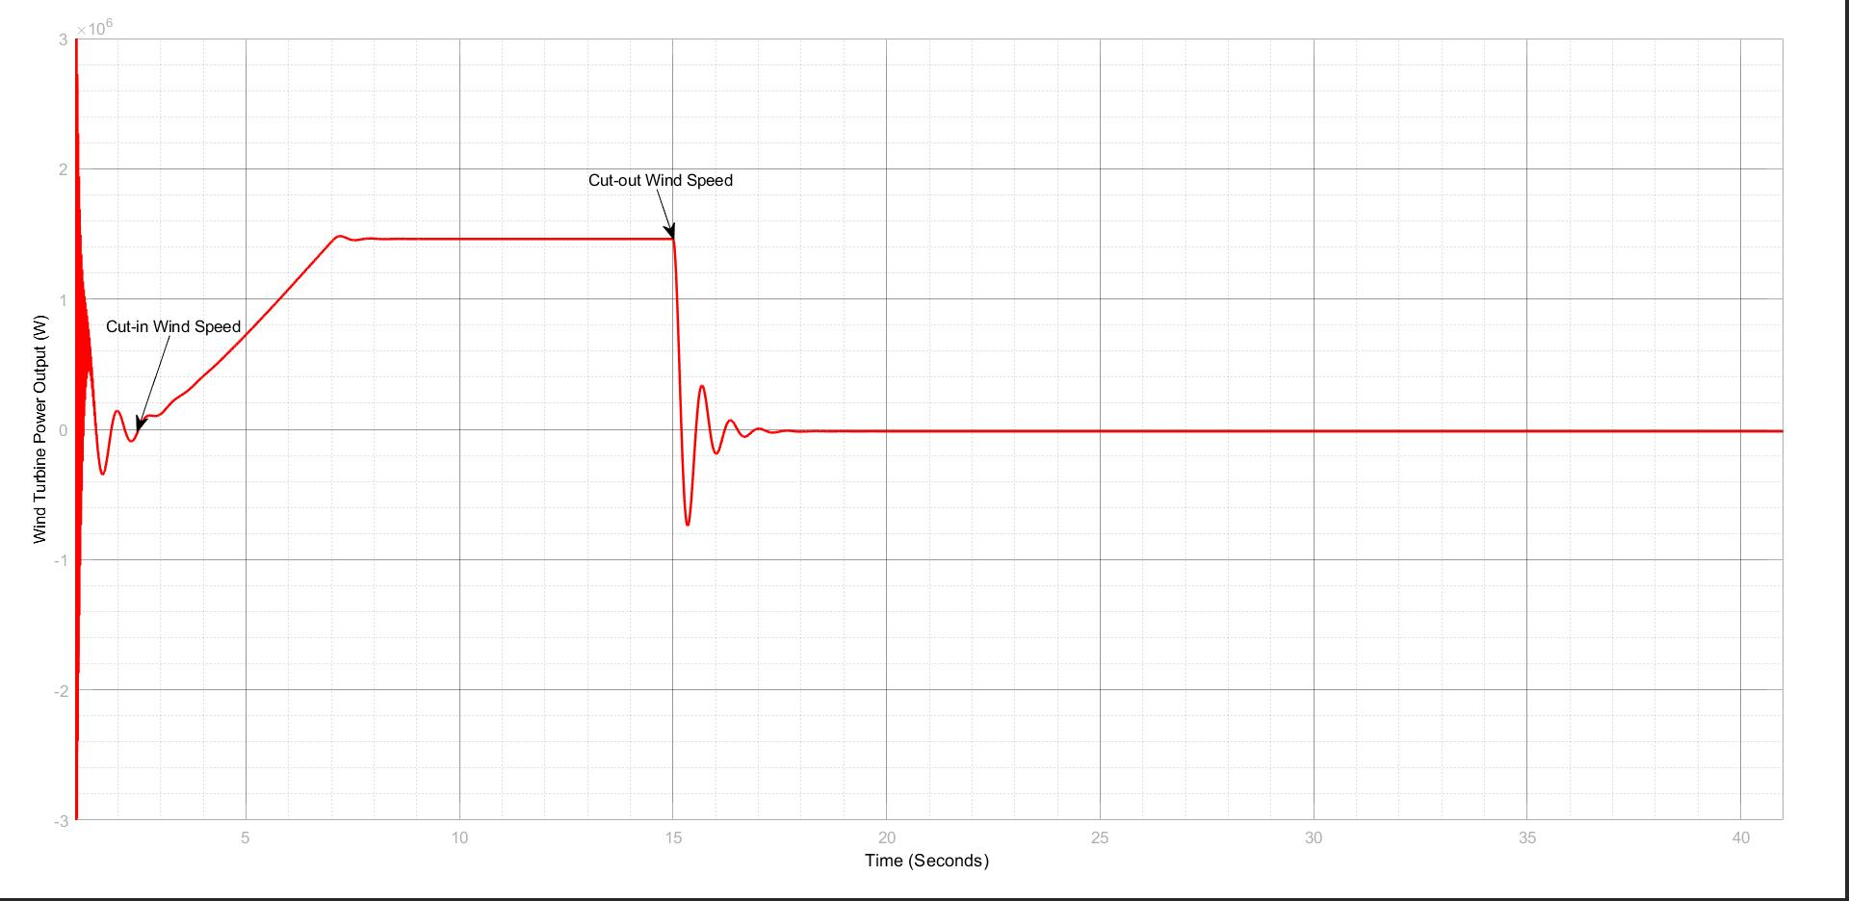

***Fig 8 :*** Real Power vs Time graph

This graph shows that real power generated by the turbine increases with time as wind speed increases with time also. From the graph,Power at cut-in speed

& Power at cut-out speed is also shown.We observe that,the turbine doesn’t produce smooth power instantaneously but at a certain speed which is the cut-in speed and then increases with wind speed. But the increment stops at a certain power which the rated power of 1.5 MW and then it is almost constant for some time until the turbine reaches it maximum wind speed threshold which is the cutoff speed(20 m/s).When this situation occurs,the turbine stops generating power. Some transition periods during starting and stopping of the wind turbine are observed.

The plot we found here imitates the real life scenario of a wind turbine power graph.

1. Electric Torque vs Time graph :

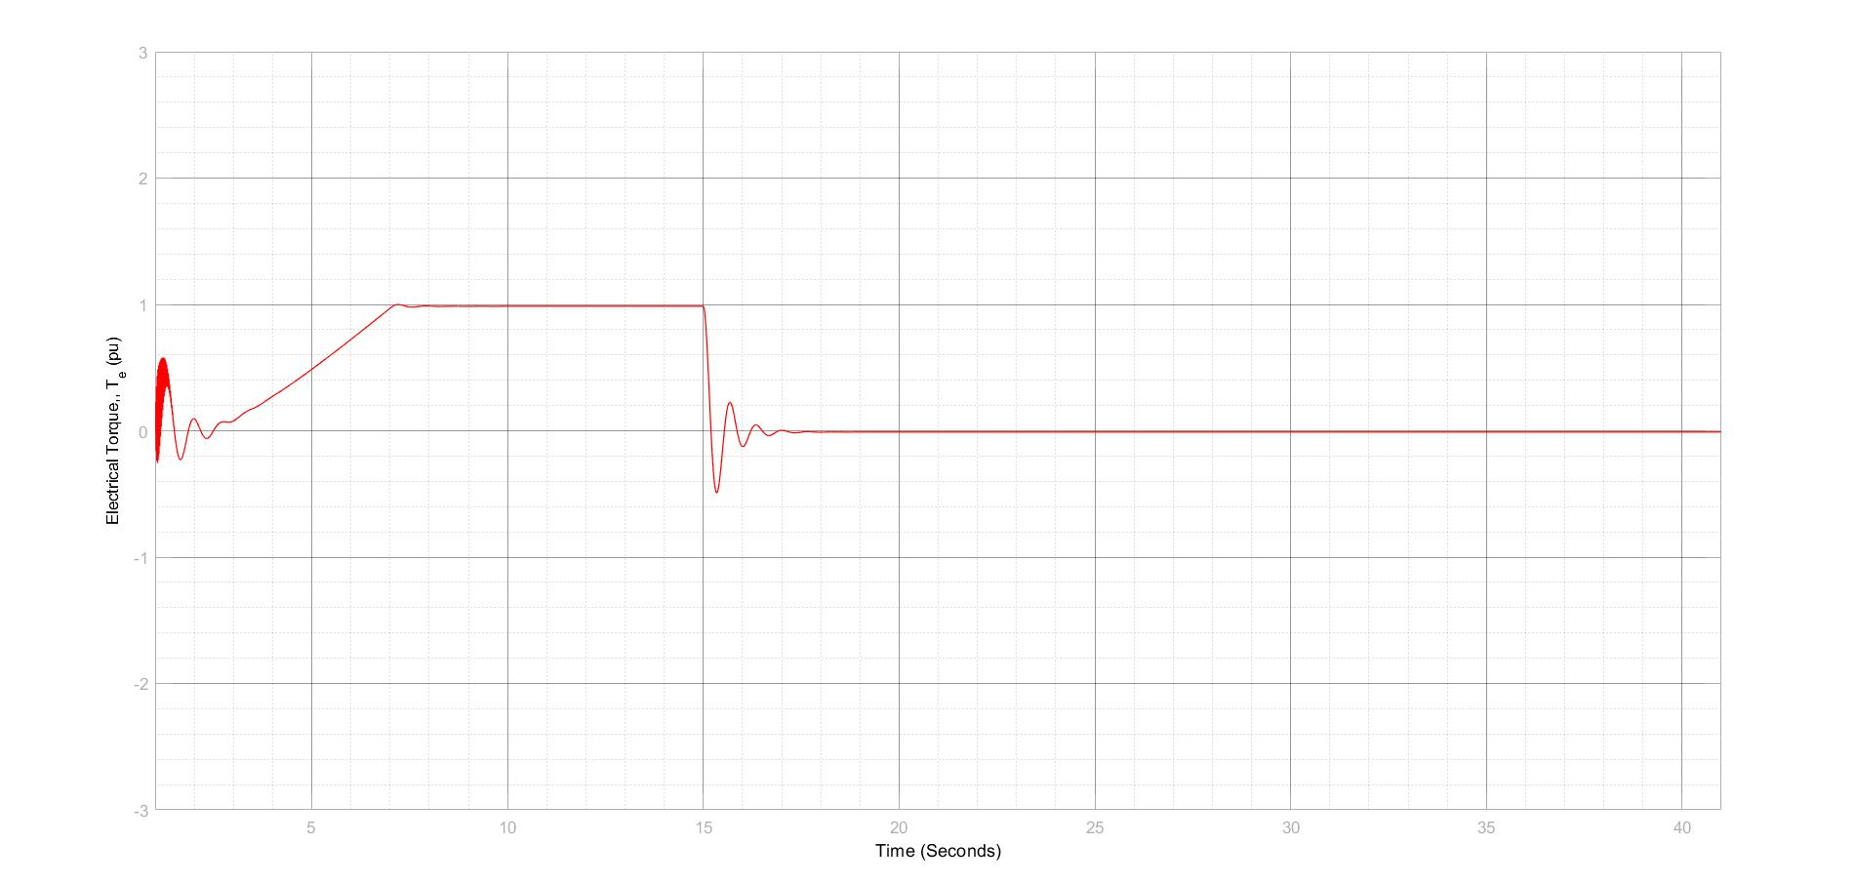

***Fig 9 :***Electric Torque vs Time graph

Here,electric torque produced by the turbine generator is shown (PU). Here,the torque initially increases with the cut-in speed and then saturates at rated power condition and then finally decreases down to 0 when there is no power generated by turbine for the cut-out speed.

1. Grid Real Power vs Time graph :

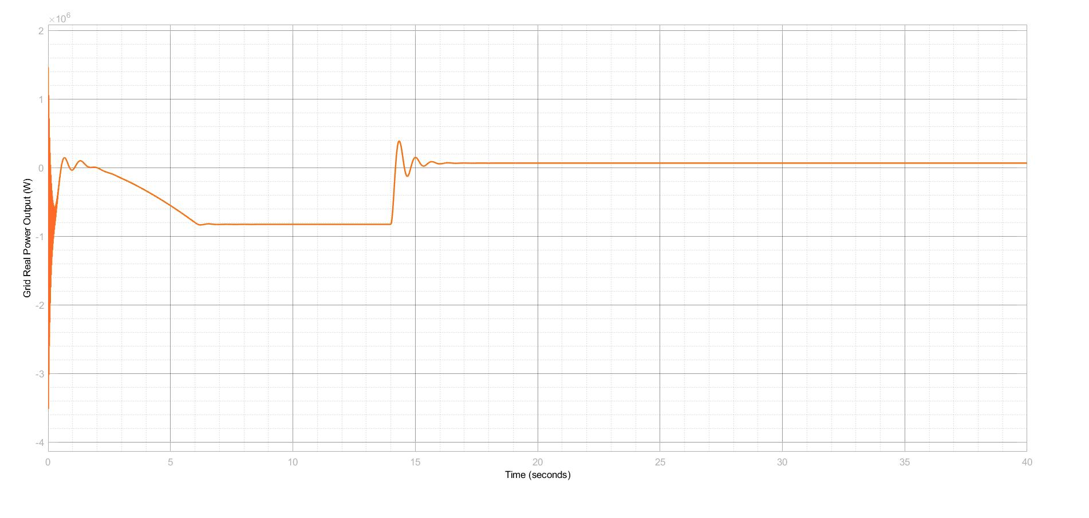

***Fig 10 :***Grid Real Power vs Time graph

Here, we observe that the grid real power graph is nothing but a mirror image about the time axis of the real power graph of the turbine(Because the grid is consuming Power). This proves that the power we produced from the turbine is successfully transmitted to 33kV grid.

1. Efficiency vs Time graph:

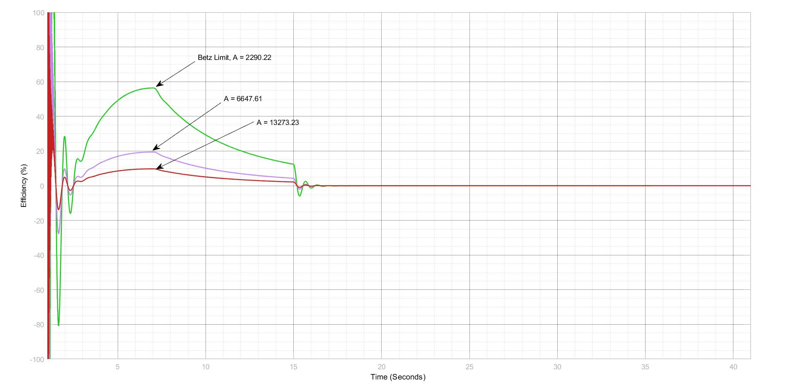

***Fig 11 :*** Efficiency(Cp) vs Time graph

Here, efficiency curves are observed.We choose different rotor blade swept areas to observe different scenarios.We have chosen area as a design parameter here because a wind turbine can be designed according to power limits.The green curve is for A=2290.22 m2 which shows the maximum efficiency from the model(around 59%). The rest two graphs are below this efficiency.All the curves follow the same trend. They increase with time till a certain point when it hits maximum and then again decrease with increase in wind speed and fall to zero in cut-out speed as output is zero then.

This graph has helped to prove the Betz limit of a wind turbine generator which states that maximum efficiency that can be found from a wind turbine generator is 59.3%(Cpmax). The green curve has showed us this.Also, a point to be noted that,all the graphs hit maximum efficiency at the same time when the turbine reaches its base speed(12 m/s).

**Limitations :**

While performing the project, although the expected graphs were produced, there were some limitations which were not possible to overcome. These are described below:

1. A plant protection unit for the system was not integrated in the model. Modern wind turbines have a plant protection unit to protect the plant components from unexpected natural and man-made accidents. In the simulation, however, this protection unit was not implemented due to time constraints.

2. Some transient phases have been seen in the graphs which couldn’t be mitigated. The transient phases predominantly occur at the beginning of a graph. This occurs because the wind power plant is inductive, so there is an initial transient period which has to be overcome by the plant.

3. A rather simple grid model has been used to demonstrate the project. Modern wind power plants are usually connected to grids via high-voltage lines. The lines also contain transformers to facilitate smooth increases in voltage. Also, compared to the simplistic representation of a grid in the simulation, a grid in reality is much more complex

4. How to control the plant in overloaded condition has not been projected. There can be circumstances where the power plant has to work under an excessive load. The simulation does not give an idea about how to act in an overloaded situation.

**Discussions**

The objectives of this experiment were to make a wind turbine model using Simulink, then varying the wind speed to observe the effects on turbine characteristics, and then using Betz limit to determine the maximum efficiency of a turbine. The objective of observing different characteristics with respect to varying speed was fulfilled. The graphs were matched with their real-life counterparts. Since the whole work was done in simulation, the output graphs do not correspond perfectly with the real-life ones, but it was seen that the graph patterns of output power and efficiency for the wind turbine followed the real-life plot trends. Also, this experiment helped a lot in gaining sufficient knowledge about Simulink and wind power plant systems.

Some limitations had to be faced while performing this simulation. For better simulation that can be closer to real-life wind turbines, these limitations should be checked. A plant protection unit should be integrated into the system so that any damage of equipment due to accidents can be prevented. The working components should be fine-tuned and data should be more precise so that transients can be suppressed. The grid model shown in this project is too simplistic. In reality, grids are more complex and have more components, so this problem should be checked. Last but not the least importantly, some more adjustments should be taken so that the power plant does not operate at overload conditions.