1. Write a C program that takes a string as input and reverses each of the word without
using built in function.

Solution of 01:

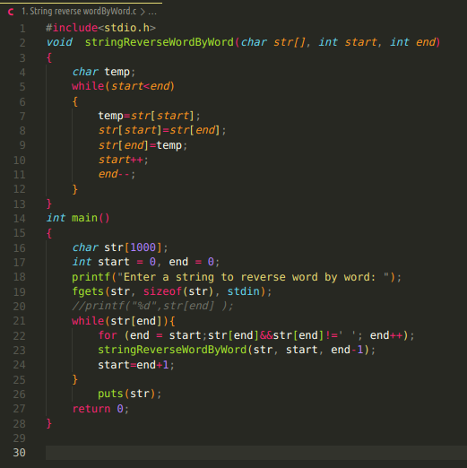

Output of question 01:

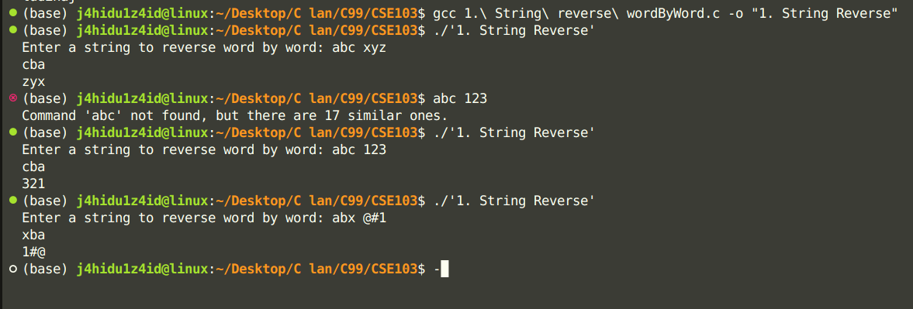

2. Write a C program that takes a string as input and finds the length of that string using
recursive function.

Solution of Question 2:
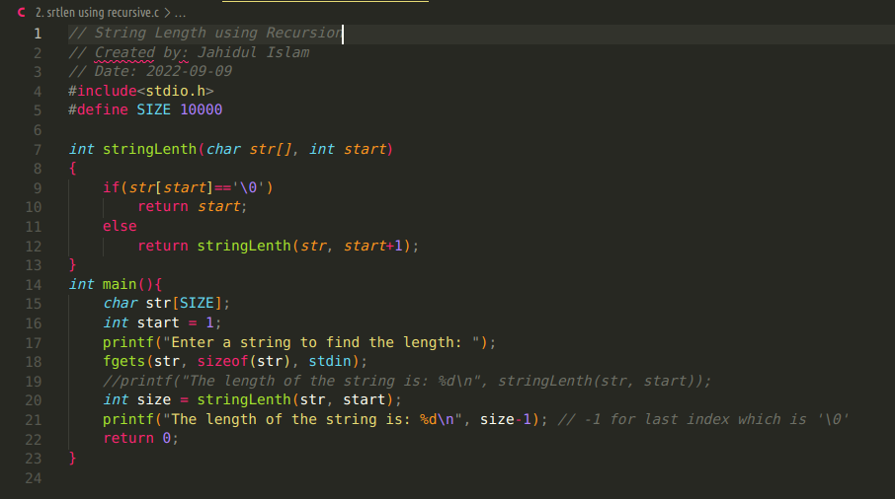

Output of question 2:

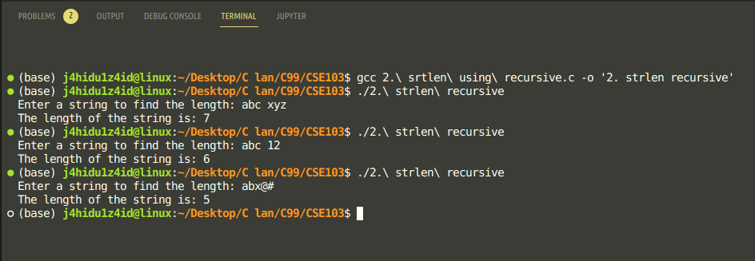

3. Suppose you have some words and you want to right justify them, that is, align them to
the right. Create a program that reads some words and print it all right justified, in the
same order as they appear in the input.

Solution of question 03:

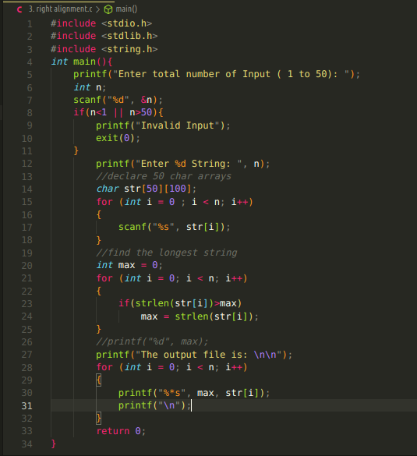

Output of question 03:

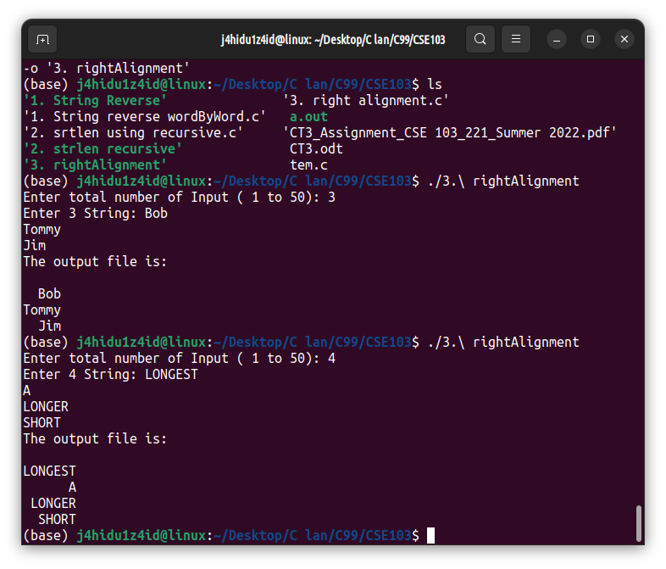

4.

Solution of question 04:

Output of question 04:

5. In programming terms a recursive function can be defined as a routine that calls itself directly or indirectly. Using recursive algorithm, certain problems can be solved quite easily.
Write a program using recursive function that can convert a Decimal number to its equivalent Binary number.

Solution of question 05:

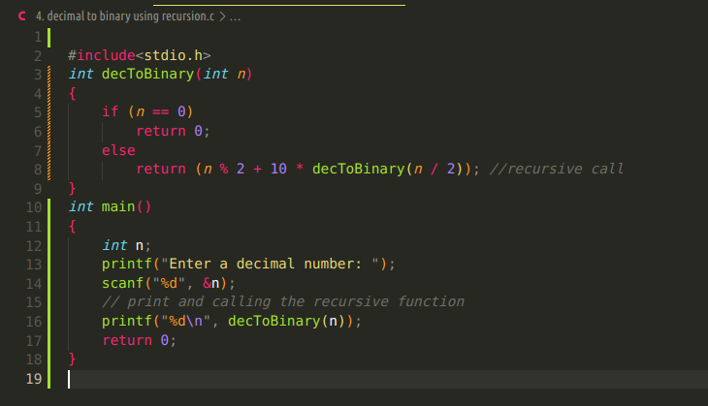

Output of question 05:
