Cup Plant Data

Jacob Hill

December 17, 2016

# Read the cup plant data file into Rstudio. Create factors for richness and time treatments.

cratio <- read.csv("C:/Users/Jacob Hill/Documents/HonorsProject/Datasets/cup-plant/GitHub/HonorsProject_FEEL_Tidied_Labeled_2016.csv")  
cratio

# Initial Graphical Analysis:

Produce a scatterplot matrix to examine correlations of all explanatory variables with foliar C:N and with each other.Do sampling date and planted richness have any obvious association with foliar C:N? Are there any Simpson's Diversity relationships? Are there any non-linear relationships?

# C:N?  
  
pairs(cratio[ , c(1,4,5,6,7)],labels=c("C:N","Richness", "Time", "Plot", "Wet Weight"),  
 panel=function(x,y){panel.smooth(x,y)   
 abline(lsfit(x,y),lty=2) })

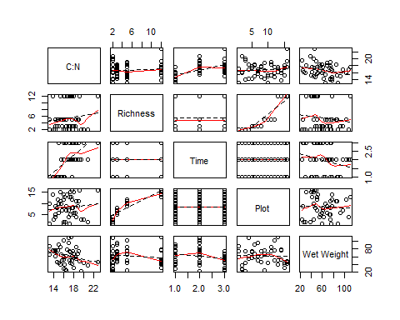

pairs(cratio[ , c(1,8,9,10,11,12)],labels=c("C:N","Dry Weight", "% Moisture","Diversity","Stem Density","Average Shoot Height"),  
 panel=function(x,y){panel.smooth(x,y)   
 abline(lsfit(x,y),lty=2) })

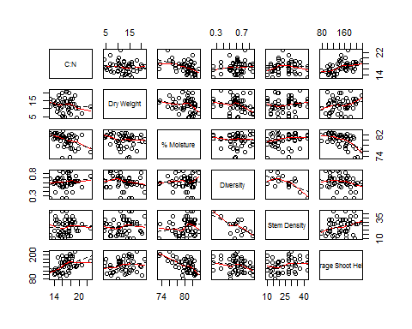

# Diversity?  
  
pairs(cratio[ , c(10,1,4,5,6,7)],labels=c("Diversity","C:N","Richness", "Time", "Plot", "Wet Weight"),  
 panel=function(x,y){panel.smooth(x,y)   
 abline(lsfit(x,y),lty=2) })

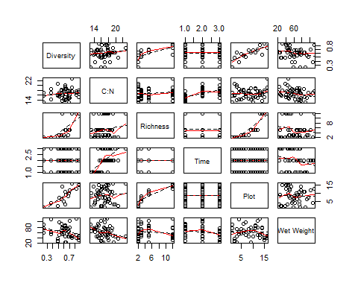

pairs(cratio[ , c(10,8,9,11,12)],labels=c("Diversity","Dry Weight", "% Moisture","Stem Density","Average Shoot Height"),  
 panel=function(x,y){panel.smooth(x,y)   
 abline(lsfit(x,y),lty=2) })

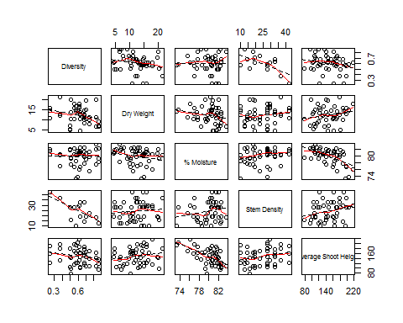

dreg <- lm(cn ~ sdi, data=cratio)  
summary(dreg)

##   
## Call:  
## lm(formula = cn ~ sdi, data = cratio)  
##   
## Residuals:  
## Min 1Q Median 3Q Max   
## -3.8240 -1.5169 -0.0324 1.1371 5.8005   
##   
## Coefficients:  
## Estimate Std. Error t value Pr(>|t|)   
## (Intercept) 15.366 1.194 12.873 <2e-16 ***  
## sdi 2.258 1.911 1.181 0.243   
## ---  
## Signif. codes: 0 '***' 0.001 '**' 0.01 '*' 0.05 '.' 0.1 ' ' 1  
##   
## Residual standard error: 2.003 on 46 degrees of freedom  
## Multiple R-squared: 0.02945, Adjusted R-squared: 0.008351   
## F-statistic: 1.396 on 1 and 46 DF, p-value: 0.2435

anova(dreg)

## Analysis of Variance Table  
##   
## Response: cn  
## Df Sum Sq Mean Sq F value Pr(>F)  
## sdi 1 5.60 5.5999 1.3958 0.2435  
## Residuals 46 184.55 4.0120

plot(cn ~ sdi, data=cratio,  
 xlab = "Simpson's Diversity",  
 ylab = "C:N", main="Cup Plant Leaf Stoichiometry")  
abline(dreg)

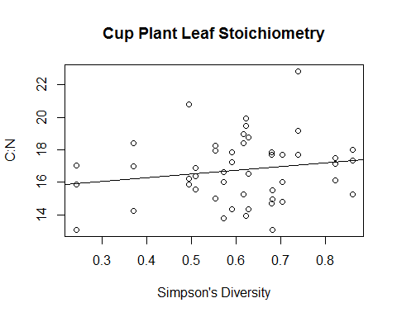

# Log transform C:N to see if a better fit is obtained.  
  
cratio$logcn <- log(cratio$cn)  
dlogreg <- lm(logcn ~ sdi, data=cratio)  
summary(dlogreg)

##   
## Call:  
## lm(formula = logcn ~ sdi, data = cratio)  
##   
## Residuals:  
## Min 1Q Median 3Q Max   
## -0.249670 -0.088138 0.004778 0.074862 0.299529   
##   
## Coefficients:  
## Estimate Std. Error t value Pr(>|t|)   
## (Intercept) 2.72738 0.07057 38.645 <2e-16 ***  
## sdi 0.13718 0.11301 1.214 0.231   
## ---  
## Signif. codes: 0 '***' 0.001 '**' 0.01 '*' 0.05 '.' 0.1 ' ' 1  
##   
## Residual standard error: 0.1184 on 46 degrees of freedom  
## Multiple R-squared: 0.03104, Adjusted R-squared: 0.009976   
## F-statistic: 1.474 on 1 and 46 DF, p-value: 0.231

anova(dlogreg)

## Analysis of Variance Table  
##   
## Response: logcn  
## Df Sum Sq Mean Sq F value Pr(>F)  
## sdi 1 0.02067 0.020668 1.4736 0.231  
## Residuals 46 0.64516 0.014025

plot(logcn ~ sdi, data=cratio,  
 xlab = "Simpson's Diversity",  
 ylab = "Log(C:N)", main="Cup Plant Leaf Stoichiometry")  
abline(dlogreg)

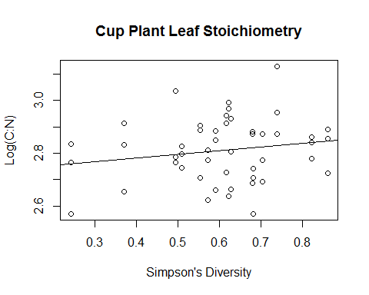

# The log transformation doesn't provide a better fit.

Are any of the individual explanatory variables significantly linearly correlated with foliar C:N, with diversity, with each other?

round(cor(cratio[ , c(1,4,5,6,7,8,9,10,11,12)]), 4)

## cn rich date plot wweight dweight pmoist sdi  
## cn 1.0000 0.1223 0.5970 0.1069 -0.2686 -0.1335 -0.4167 0.1716  
## rich 0.1223 1.0000 0.0000 0.8888 -0.1355 -0.1004 -0.1492 0.6633  
## date 0.5970 0.0000 1.0000 0.0000 -0.2364 -0.0192 -0.6946 0.0000  
## plot 0.1069 0.8888 0.0000 1.0000 -0.0331 0.0099 -0.1687 0.7769  
## wweight -0.2686 -0.1355 -0.2364 -0.0331 1.0000 0.9492 0.0985 -0.2295  
## dweight -0.1335 -0.1004 -0.0192 0.0099 0.9492 1.0000 -0.2114 -0.2370  
## pmoist -0.4167 -0.1492 -0.6946 -0.1687 0.0985 -0.2114 1.0000 -0.0083  
## sdi 0.1716 0.6633 0.0000 0.7769 -0.2295 -0.2370 -0.0083 1.0000  
## isd 0.0414 -0.5992 0.0000 -0.6156 0.1722 0.1109 0.2113 -0.6373  
## cheight 0.4724 -0.1364 0.8067 -0.1190 0.0011 0.1874 -0.5826 -0.2083  
## isd cheight  
## cn 0.0414 0.4724  
## rich -0.5992 -0.1364  
## date 0.0000 0.8067  
## plot -0.6156 -0.1190  
## wweight 0.1722 0.0011  
## dweight 0.1109 0.1874  
## pmoist 0.2113 -0.5826  
## sdi -0.6373 -0.2083  
## isd 1.0000 0.2507  
## cheight 0.2507 1.0000

library(biotools)

## Warning: package 'biotools' was built under R version 3.3.2

## Loading required package: rpanel

## Warning: package 'rpanel' was built under R version 3.3.2

## Loading required package: tcltk

## Package `rpanel', version 1.1-3: type help(rpanel) for summary information

## Loading required package: tkrplot

## Warning: package 'tkrplot' was built under R version 3.3.2

## Loading required package: MASS

## Loading required package: lattice

## Loading required package: SpatialEpi

## Warning: package 'SpatialEpi' was built under R version 3.3.2

## Loading required package: sp

## Warning: package 'sp' was built under R version 3.3.2

## ---  
## biotools version 3.0

##

multcor.test(cor(cratio[ , c(1,4,5,6,7,8,9,10,11,12)]), n=nrow(cratio))

##   
## Pairwise correlation t-test  
##   
## data: cor(cratio[, c(1, 4, 5, 6, 7, 8, 9, 10, 11, 12)])  
## degrees of freedom: 46   
## alternative hypothesis: the true correlation is not equal to 0   
## p-values (with none adjustment for multiple tests):   
## cn rich date plot wweight dweight pmoist sdi isd   
## cn <NA> *** . **   
## rich 0.4077 <NA> *** *** ***   
## date 0 1 <NA> ***   
## plot 0.4696 0 1 <NA> *** ***   
## wweight 0.0649 0.3586 0.1058 0.8233 <NA> ***   
## dweight 0.3657 0.497 0.8969 0.9465 0 <NA>   
## pmoist 0.0032 0.3115 0 0.2517 0.5053 0.1491 <NA>   
## sdi 0.2435 0 1 0 0.1167 0.1048 0.9552 <NA> ***   
## isd 0.7797 0 1 0 0.2419 0.453 0.1494 0 <NA>   
## cheight 7e-04 0.3552 0 0.4206 0.9938 0.2022 0 0.1554 0.0856  
## cheight  
## cn   
## rich   
## date ***   
## plot   
## wweight   
## dweight   
## pmoist ***   
## sdi   
## isd .   
## cheight <NA>   
## ---   
## Signif. codes: '***'0.001 '**'0.01 '*'0.05 '.'0.1 ' '1

Produce a profile plot with planted richness on the x-axis and C:N on the y-axis.

# Compute a matrix of mean responses for all combinations   
# of sampling dates and planted richness. Make a profile plot.  
  
means <- tapply(cratio$cn,  
 list(cratio$rich,cratio$date), mean)  
means

## 1 2 3  
## 2 14.28524 18.27730 17.89058  
## 3 14.88883 17.55924 17.47507  
## 5 14.37093 17.16874 17.03746  
## 12 15.70158 17.67144 18.48652

# Construct a matrix of standard deviations  
  
stdev <- tapply(cratio$cn,  
 list(cratio$rich,cratio$date), sd)  
stdev

## 1 2 3  
## 2 1.1655944 2.2587465 1.6363205  
## 3 0.5263641 0.6025271 0.7315331  
## 5 0.9416175 1.6565159 1.6975133  
## 12 1.6372331 1.0837544 3.0100464

par(cex=1.0,lwd=3, mex=1.0, mkh=.80, cex.axis=0.8, cex.lab=1.0 )  
x.axis <- unique(cratio$rich)  
matplot( c(2, 12), c(13, 23),  
 type="n", xlab="Richness",   
 ylab="C:N",   
 main= "Foliar C:N Across Richness over Time")   
  
matlines(x.axis,means,type='l', lty=c(1,3,4),lwd=2)   
  
# Plot symbols for the sample means  
  
matpoints(x.axis,means, pch=c(2,5,16))   
  
legend(1.0,15, legend=c('Pre-Flowering','Flowering','Senescence'), lwd=2,  
 cex=0.8,lty=c(1,3,4),pch=c(2,5,16), col=cratio$date, bty='n')

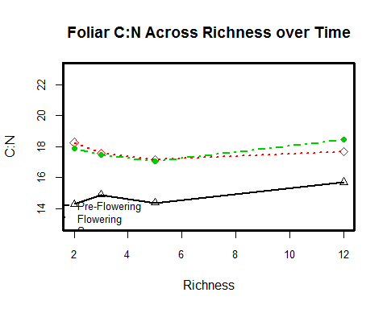

A clear difference between the mean average foliar C:N is observed between pre-flowering sampling time and the flowering and post-flowering sampling periods. However, a difference between flowering and post flowering C:N is not evident. Ignoring sampling date, planted richness grading from 2 to 3 to 5 to 12 does not reveal a clear trend. Perhaps there is a slight increase in C:N with planted richness, but likely not enough to be detected. Below, I will test these relationships with an ANOVA test and Tukey multiple comparisons procedure.

Did removing leaves affect stem growth? Compare slopes of different measurement clusters.

# Compute a matrix of mean responses for all combinations   
# of sampling dates and planted richness.   
  
meansf <- tapply(cratio$fheight,  
 list(cratio$rich,cratio$date), mean)  
meansf

## 1 2 3  
## 2 122.5833 169.9167 195.9167  
## 3 100.5833 134.5000 175.9167  
## 5 124.3333 170.5833 194.6667  
## 12 97.5000 129.1667 162.2500

meanss <- tapply(cratio$sheight,  
 list(cratio$rich,cratio$date), mean)  
meanss

## 1 2 3  
## 2 112.9167 139.0000 165.8333  
## 3 114.8333 165.5000 190.5000  
## 5 125.9167 185.2500 211.4167  
## 12 111.3333 149.9167 169.5833

meanst <- tapply(cratio$theight,  
 list(cratio$rich,cratio$date), mean)  
meanst

## 1 2 3  
## 2 106.5833 159.1667 173.8333  
## 3 107.7500 143.5000 179.5833  
## 5 105.8333 133.7500 151.5833  
## 12 115.1667 139.0833 158.2500

meansc <- tapply(cratio$cheight,  
 list(cratio$rich,cratio$date), mean)  
meansc

## 1 2 3  
## 2 115.025 158.525 182.375  
## 3 107.850 147.750 180.325  
## 5 117.400 160.475 184.050  
## 12 108.800 141.225 165.875

stdevc <- tapply(cratio$cheight,  
 list(cratio$rich,cratio$date), sd)  
stdevc

## 1 2 3  
## 2 13.29821 15.27228 16.36243  
## 3 20.03372 34.01279 28.62253  
## 5 13.57571 20.26218 24.67691  
## 12 11.97024 18.79049 24.44032

freg <- lm(cratio$fheight ~ cratio$date)  
summary(freg)

##   
## Call:  
## lm(formula = cratio$fheight ~ cratio$date)  
##   
## Residuals:  
## Min 1Q Median 3Q Max   
## -76.160 -17.977 3.408 16.658 50.507   
##   
## Coefficients:  
## Estimate Std. Error t value Pr(>|t|)   
## (Intercept) 77.222 9.777 7.899 4.18e-10 ***  
## cratio$date 35.469 4.526 7.837 5.15e-10 ***  
## ---  
## Signif. codes: 0 '***' 0.001 '**' 0.01 '*' 0.05 '.' 0.1 ' ' 1  
##   
## Residual standard error: 25.6 on 46 degrees of freedom  
## Multiple R-squared: 0.5718, Adjusted R-squared: 0.5625   
## F-statistic: 61.42 on 1 and 46 DF, p-value: 5.147e-10

sreg <- lm(cratio$sheight ~ cratio$date)  
summary(sreg)

##   
## Call:  
## lm(formula = cratio$sheight ~ cratio$date)  
##   
## Residuals:  
## Min 1Q Median 3Q Max   
## -66.167 -20.583 2.187 21.240 49.125   
##   
## Coefficients:  
## Estimate Std. Error t value Pr(>|t|)   
## (Intercept) 85.417 11.604 7.361 2.62e-09 ***  
## cratio$date 34.042 5.371 6.338 9.02e-08 ***  
## ---  
## Signif. codes: 0 '***' 0.001 '**' 0.01 '*' 0.05 '.' 0.1 ' ' 1  
##   
## Residual standard error: 30.39 on 46 degrees of freedom  
## Multiple R-squared: 0.4661, Adjusted R-squared: 0.4545   
## F-statistic: 40.16 on 1 and 46 DF, p-value: 9.015e-08

treg <- lm(cratio$theight ~ cratio$date)  
summary(treg)

##   
## Call:  
## lm(formula = cratio$theight ~ cratio$date)  
##   
## Residuals:  
## Min 1Q Median 3Q Max   
## -79.997 -12.434 9.082 16.204 46.670   
##   
## Coefficients:  
## Estimate Std. Error t value Pr(>|t|)   
## (Intercept) 82.528 10.605 7.782 6.21e-10 ***  
## cratio$date 28.490 4.909 5.803 5.70e-07 ***  
## ---  
## Signif. codes: 0 '***' 0.001 '**' 0.01 '*' 0.05 '.' 0.1 ' ' 1  
##   
## Residual standard error: 27.77 on 46 degrees of freedom  
## Multiple R-squared: 0.4227, Adjusted R-squared: 0.4101   
## F-statistic: 33.68 on 1 and 46 DF, p-value: 5.705e-07

creg <- lm(cratio$cheight ~ cratio$date)  
summary(creg)

##   
## Call:  
## lm(formula = cratio$cheight ~ cratio$date)  
##   
## Residuals:  
## Min 1Q Median 3Q Max   
## -49.573 -9.745 -0.145 14.894 40.327   
##   
## Coefficients:  
## Estimate Std. Error t value Pr(>|t|)   
## (Intercept) 81.585 7.687 10.614 5.92e-14 ***  
## cratio$date 32.944 3.558 9.258 4.45e-12 ***  
## ---  
## Signif. codes: 0 '***' 0.001 '**' 0.01 '*' 0.05 '.' 0.1 ' ' 1  
##   
## Residual standard error: 20.13 on 46 degrees of freedom  
## Multiple R-squared: 0.6508, Adjusted R-squared: 0.6432   
## F-statistic: 85.72 on 1 and 46 DF, p-value: 4.45e-12

# It doesn't appear as though leaf harvest had any effect on stem growth over the summer, but no statistical comparisons performed as of yet.

# Model Assumptions

Assume independent random sampling of leaves based upon stratified quadrat leaf sampling procedure, although the repeated measures may be a problem. How should I deal with this? Consult an expert.

Construct box plots to check for homogeneous variances of C:N at different dates and at different richness levels.Also check using Levene's test.

boxplot(cn ~ date, data=cratio,   
 ylab= "C:N",  
 names=c("Pre-Flowering","Flowering","Senescence"),  
 main= "Foliar C:N Across Growing Season")

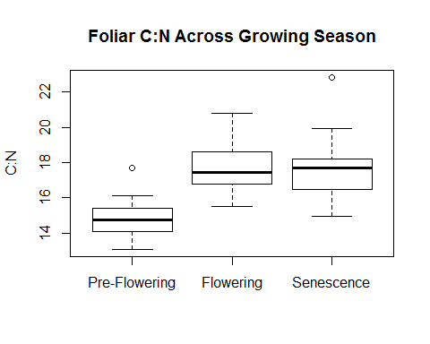

library(DescTools)

## Warning: package 'DescTools' was built under R version 3.3.2

LeveneTest(cratio$cn, cratio$date)

## Warning in LeveneTest.default(cratio$cn, cratio$date): cratio$date coerced  
## to factor.

## Levene's Test for Homogeneity of Variance (center = median)  
## Df F value Pr(>F)  
## group 2 0.4961 0.6122  
## 45

boxplot(cn ~ rich, data=cratio,   
 ylab= "C:N",  
 names=c("2 Species","3 Species","5 Species","12 Species"),  
 main= "Foliar C:N Across Planted Community Richness")

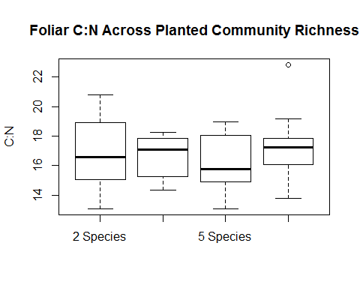

library(DescTools)  
 LeveneTest(cratio$cn, cratio$rich)

## Warning in LeveneTest.default(cratio$cn, cratio$rich): cratio$rich coerced  
## to factor.

## Levene's Test for Homogeneity of Variance (center = median)  
## Df F value Pr(>F)  
## group 3 0.7579 0.5238  
## 44

# Assumptions of homogeneous variance appears to be satisfied

Check for assumption of sampling from normally distributed population of C:N foliar chemistries. Use a histogram of residuals, Shapiro-Wilk test.

hist( cratio$cn, freq=T,  
 ylab="Count", xlab="C:N",   
 main="Foliar C:N")

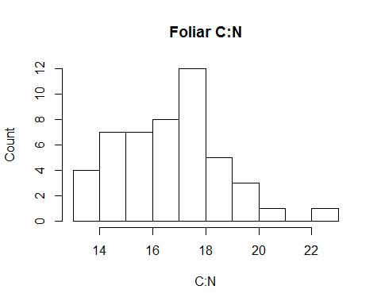

shapiro.test(cratio$cn)

##   
## Shapiro-Wilk normality test  
##   
## data: cratio$cn  
## W = 0.97937, p-value = 0.5528

# Foliar C:N appears to be sampled from a normally distributed population.

# ANOVA Models

Fit a linear model with main effects and interaction effects on foliar C:N. Compute both sets of Type I sums of squares.

options(contrasts=c('contr.treatment','contr.ploy'))  
  
lm.int <- lm(cn~r*d, data=cratio)  
summary(lm.int)

##   
## Call:  
## lm(formula = cn ~ r * d, data = cratio)  
##   
## Residuals:  
## Min 1Q Median 3Q Max   
## -2.4753 -1.0489 -0.1119 0.6759 4.3505   
##   
## Coefficients:  
## Estimate Std. Error t value Pr(>|t|)   
## (Intercept) 14.28524 0.78715 18.148 < 2e-16 ***  
## r3 0.60358 1.11320 0.542 0.591016   
## r5 0.08569 1.11320 0.077 0.939069   
## r12 1.41634 1.11320 1.272 0.211418   
## d2 3.99205 1.11320 3.586 0.000989 ***  
## d3 3.60534 1.11320 3.239 0.002583 **   
## r3:d2 -1.32164 1.57430 -0.840 0.406724   
## r5:d2 -1.19424 1.57430 -0.759 0.453038   
## r12:d2 -2.02220 1.57430 -1.285 0.207169   
## r3:d3 -1.01910 1.57430 -0.647 0.521520   
## r5:d3 -0.93881 1.57430 -0.596 0.554683   
## r12:d3 -0.82040 1.57430 -0.521 0.605474   
## ---  
## Signif. codes: 0 '***' 0.001 '**' 0.01 '*' 0.05 '.' 0.1 ' ' 1  
##   
## Residual standard error: 1.574 on 36 degrees of freedom  
## Multiple R-squared: 0.5308, Adjusted R-squared: 0.3874   
## F-statistic: 3.702 on 11 and 36 DF, p-value: 0.001401

anova(lm.int)

## Analysis of Variance Table  
##   
## Response: cn  
## Df Sum Sq Mean Sq F value Pr(>F)   
## r 3 7.371 2.457 0.9914 0.4078   
## d 2 88.751 44.376 17.9048 4.001e-06 ***  
## r:d 6 4.805 0.801 0.3231 0.9205   
## Residuals 36 89.223 2.478   
## ---  
## Signif. codes: 0 '***' 0.001 '**' 0.01 '*' 0.05 '.' 0.1 ' ' 1

Result: there is no significant main effect of planted richness or interaction effect, but there is a significant time effect.

Fit a linear model with additive effects.

lm.add <- lm(cn~r+d, data=cratio)  
summary(lm.add)

##   
## Call:  
## lm(formula = cn ~ r + d, data = cratio)  
##   
## Residuals:  
## Min 1Q Median 3Q Max   
## -2.2633 -0.9845 -0.0777 0.7698 4.5625   
##   
## Coefficients:  
## Estimate Std. Error t value Pr(>|t|)   
## (Intercept) 14.8949 0.5290 28.157 < 2e-16 ***  
## r3 -0.1767 0.6108 -0.289 0.774   
## r5 -0.6253 0.6108 -1.024 0.312   
## r12 0.4688 0.6108 0.767 0.447   
## d2 2.8575 0.5290 5.402 2.86e-06 ***  
## d3 2.9108 0.5290 5.502 2.06e-06 ***  
## ---  
## Signif. codes: 0 '***' 0.001 '**' 0.01 '*' 0.05 '.' 0.1 ' ' 1  
##   
## Residual standard error: 1.496 on 42 degrees of freedom  
## Multiple R-squared: 0.5055, Adjusted R-squared: 0.4466   
## F-statistic: 8.587 on 5 and 42 DF, p-value: 1.145e-05

anova(lm.add)

## Analysis of Variance Table  
##   
## Response: cn  
## Df Sum Sq Mean Sq F value Pr(>F)   
## r 3 7.371 2.457 1.0975 0.3608   
## d 2 88.751 44.376 19.8215 8.669e-07 ***  
## Residuals 42 94.028 2.239   
## ---  
## Signif. codes: 0 '***' 0.001 '**' 0.01 '*' 0.05 '.' 0.1 ' ' 1

Check model assumptions. First look at residual plots

par(mfrow=c(2,2))  
plot(lm.int)

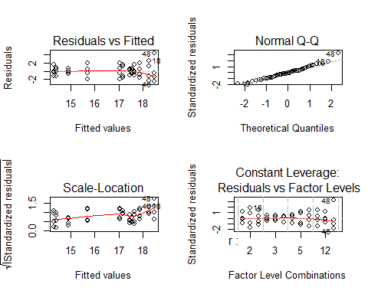

shapiro.test(lm.int$residuals)

##   
## Shapiro-Wilk normality test  
##   
## data: lm.int$residuals  
## W = 0.97423, p-value = 0.3667

par(mfrow=c(1,1))

Run the Brown-Forsythe test

library(DescTools)  
LeveneTest(cn ~ r*d , data=cratio)

## Levene's Test for Homogeneity of Variance (center = median)  
## Df F value Pr(>F)  
## group 11 1.3816 0.2235  
## 36

Apply the HSD method to the Variety means and to the nitrogen means

TukeyHSD(cn1 <- aov(cn~r+d+r*d, data=cratio), "r",   
 ordered = FALSE, conf.level = 0.95)

## Tukey multiple comparisons of means  
## 95% family-wise confidence level  
##   
## Fit: aov(formula = cn ~ r + d + r * d, data = cratio)  
##   
## $r  
## diff lwr upr p adj  
## 3-2 -0.1766638 -1.9076139 1.554286 0.9926155  
## 5-2 -0.6253283 -2.3562784 1.105622 0.7655425  
## 12-2 0.4688059 -1.2621442 2.199756 0.8846495  
## 5-3 -0.4486645 -2.1796147 1.282286 0.8971374  
## 12-3 0.6454697 -1.0854804 2.376420 0.7478975  
## 12-5 1.0941342 -0.6368159 2.825084 0.3373320

TukeyHSD(cn1 <- aov(cn~r+d+r*d, data=cratio), "d",   
 ordered = TRUE, conf.level = 0.95)

## Tukey multiple comparisons of means  
## 95% family-wise confidence level  
## factor levels have been ordered  
##   
## Fit: aov(formula = cn ~ r + d + r * d, data = cratio)  
##   
## $d  
## diff lwr upr p adj  
## 2-1 2.85753076 1.497038 4.218023 0.0000292  
## 3-1 2.91076182 1.550269 4.271254 0.0000218  
## 3-2 0.05323106 -1.307262 1.413724 0.9949709

# Apply the HSD procedure ot the C:N means for the 4x3  
 # combinations of factor levels. First create a factor  
 # to distinguish the 12=4x3 combinations.  
  
 cratio$rd <- factor(1000*cratio$date + cratio$rich)  
 TukeyHSD(cn2 <- aov(cn~rd, data=cratio), "rd",   
 ordered = TRUE, conf.level = 0.95)

## Tukey multiple comparisons of means  
## 95% family-wise confidence level  
## factor levels have been ordered  
##   
## Fit: aov(formula = cn ~ rd, data = cratio)  
##   
## $rd  
## diff lwr upr p adj  
## 1005-1002 0.08568897 -3.7997280 3.971106 1.0000000  
## 1003-1002 0.60358412 -3.2818329 4.489001 0.9999904  
## 1012-1002 1.41633768 -2.4690793 5.301755 0.9776276  
## 3005-1002 2.75221867 -1.1331983 6.637636 0.3878055  
## 2005-1002 2.88349770 -1.0019193 6.768915 0.3217730  
## 3003-1002 3.18982047 -0.6955965 7.075237 0.1964033  
## 2003-1002 3.27399433 -0.6114227 7.159411 0.1692675  
## 2012-1002 3.38619121 -0.4992258 7.271608 0.1377356  
## 3002-1002 3.60533971 -0.2800773 7.490757 0.0898848  
## 2002-1002 3.99205056 0.1066336 7.877468 0.0395715  
## 3012-1002 4.20127918 0.3158622 8.086696 0.0246372  
## 1003-1005 0.51789515 -3.3675218 4.403312 0.9999980  
## 1012-1005 1.33064871 -2.5547683 5.216066 0.9860184  
## 3005-1005 2.66652970 -1.2188873 6.551947 0.4342432  
## 2005-1005 2.79780873 -1.0876083 6.683226 0.3641201  
## 3003-1005 3.10413150 -0.7812855 6.989548 0.2272373  
## 2003-1005 3.18830536 -0.6971116 7.073722 0.1969201  
## 2012-1005 3.30050224 -0.5849148 7.185919 0.1613504  
## 3002-1005 3.51965074 -0.3657663 7.405068 0.1065945  
## 2002-1005 3.90636159 0.0209446 7.791779 0.0477754  
## 3012-1005 4.11559021 0.2301732 8.001007 0.0299815  
## 1012-1003 0.81275356 -3.0726634 4.698171 0.9998157  
## 3005-1003 2.14863455 -1.7367824 6.034052 0.7335800  
## 2005-1003 2.27991358 -1.6055034 6.165331 0.6596944  
## 3003-1003 2.58623635 -1.2991806 6.471653 0.4796565  
## 2003-1003 2.67041021 -1.2150068 6.555827 0.4320910  
## 2012-1003 2.78260709 -1.1028099 6.668024 0.3719329  
## 3002-1003 3.00175559 -0.8836614 6.887173 0.2684089  
## 2002-1003 3.38846644 -0.4969506 7.273883 0.1371486  
## 3012-1003 3.59769506 -0.2877219 7.483112 0.0912790  
## 3005-1012 1.33588099 -2.5495360 5.221298 0.9855897  
## 2005-1012 1.46716002 -2.4182570 5.352577 0.9711126  
## 3003-1012 1.77348279 -2.1119342 5.658900 0.9004628  
## 2003-1012 1.85765665 -2.0277603 5.743074 0.8703864  
## 2012-1012 1.96985353 -1.9155635 5.855271 0.8231973  
## 3002-1012 2.18900203 -1.6964150 6.074419 0.7114132  
## 2002-1012 2.57571288 -1.3097041 6.461130 0.4857186  
## 3012-1012 2.78494150 -1.1004755 6.670358 0.3707275  
## 2005-3005 0.13127903 -3.7541380 4.016696 1.0000000  
## 3003-3005 0.43760180 -3.4478152 4.323019 0.9999997  
## 2003-3005 0.52177566 -3.3636413 4.407193 0.9999979  
## 2012-3005 0.63397254 -3.2514445 4.519390 0.9999842  
## 3002-3005 0.85312104 -3.0322960 4.738538 0.9997071  
## 2002-3005 1.23983189 -2.6455851 5.125249 0.9919968  
## 3012-3005 1.44906051 -2.4363565 5.334478 0.9735762  
## 3003-2005 0.30632277 -3.5790942 4.191740 1.0000000  
## 2003-2005 0.39049663 -3.4949204 4.275914 0.9999999  
## 2012-2005 0.50269351 -3.3827235 4.388111 0.9999986  
## 3002-2005 0.72184201 -3.1635750 4.607259 0.9999421  
## 2002-2005 1.10855286 -2.7768641 4.993970 0.9968512  
## 3012-2005 1.31778148 -2.5676355 5.203198 0.9870304  
## 2003-3003 0.08417386 -3.8012431 3.969591 1.0000000  
## 2012-3003 0.19637074 -3.6890463 4.081788 1.0000000  
## 3002-3003 0.41551924 -3.4698978 4.300936 0.9999998  
## 2002-3003 0.80223009 -3.0831869 4.687647 0.9998375  
## 3012-3003 1.01145871 -2.8739583 4.896876 0.9985904  
## 2012-2003 0.11219688 -3.7732201 3.997614 1.0000000  
## 3002-2003 0.33134538 -3.5540716 4.216762 1.0000000  
## 2002-2003 0.71805623 -3.1673608 4.603473 0.9999450  
## 3012-2003 0.92728485 -2.9581321 4.812702 0.9993605  
## 3002-2012 0.21914850 -3.6662685 4.104565 1.0000000  
## 2002-2012 0.60585935 -3.2795576 4.491276 0.9999901  
## 3012-2012 0.81508797 -3.0703290 4.700505 0.9998106  
## 2002-3002 0.38671085 -3.4987061 4.272128 0.9999999  
## 3012-3002 0.59593947 -3.2894775 4.481356 0.9999916  
## 3012-2002 0.20922862 -3.6761884 4.094646 1.0000000