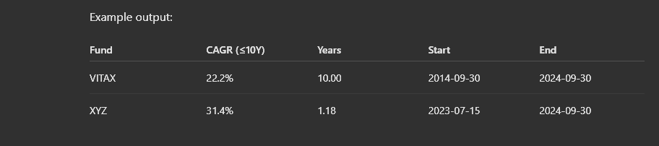

Should output to this, and then also have a column for fund name, and a column for the 10 year 10k just for funsies

Discussed with chatgpt – 10 year $10k can get weird if you don’t actually have 10 years of funds to work with. Instead, you can use a CAGR for the fund, which normalizes returns over whatever period you’re measuring by the actual time length (i.e. annual returns). Then, just to be sure we can see actual fund start and end dates, you can see the measured time length used in the table as well. Formulas for each are in the code.

