Identifying **Opel** As a positive Interest

|  |  |  |
| --- | --- | --- |
| **Classifier** | **TP** | **FP** |
| Naïve | 0.429 | 0.186 |
| IBK(KNN) | 0.344 | 0.178 |
| Logistic | 0.627 | 0.128 |
| J48 | 0.514 | 0.125 |
| LMT | 0.689 | 0.099 |

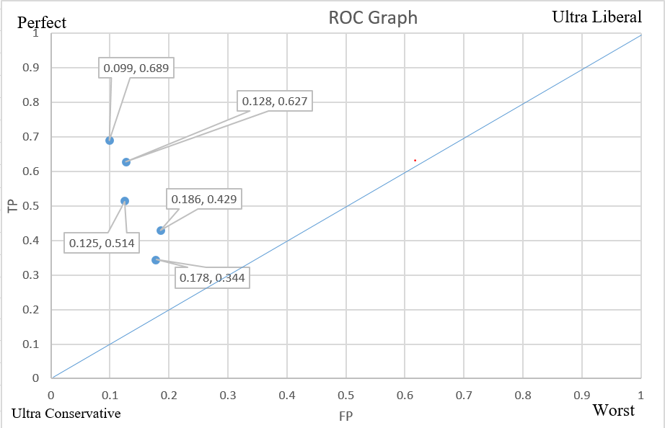

Worst

Identifying **Saab** As a positive Interest

|  |  |  |
| --- | --- | --- |
| Classifier | TP | FP |
| Naïve | 0.332 | 0.13 |
| IBK(KNN) | .198 | 0.099 |
| Logistic | 0.631 | 0.116 |
| J48 | 0.548 | 0.161 |
| LMT | 0.705 | 0.092 |

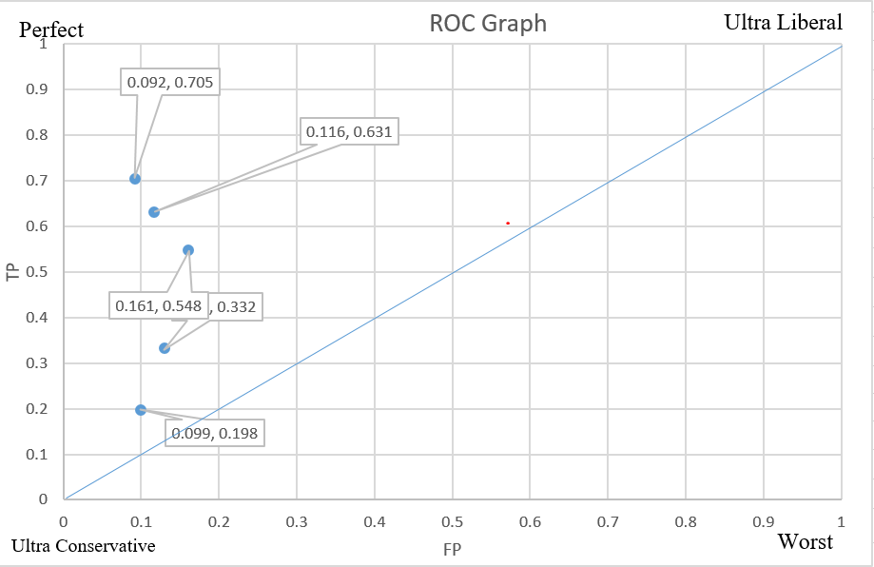

Identifying **Bus** As a positive Interest

|  |  |  |
| --- | --- | --- |
| Classifier | TP | FP |
| Naïve | 0.138 | 0.019 |
| IBK(KNN) | 0.564 | 0.291 |
| Logistic | 0.936 | 0.019 |
| J48 | 0.95 | 0.038 |
| LMT | 0.986 | 0.014 |

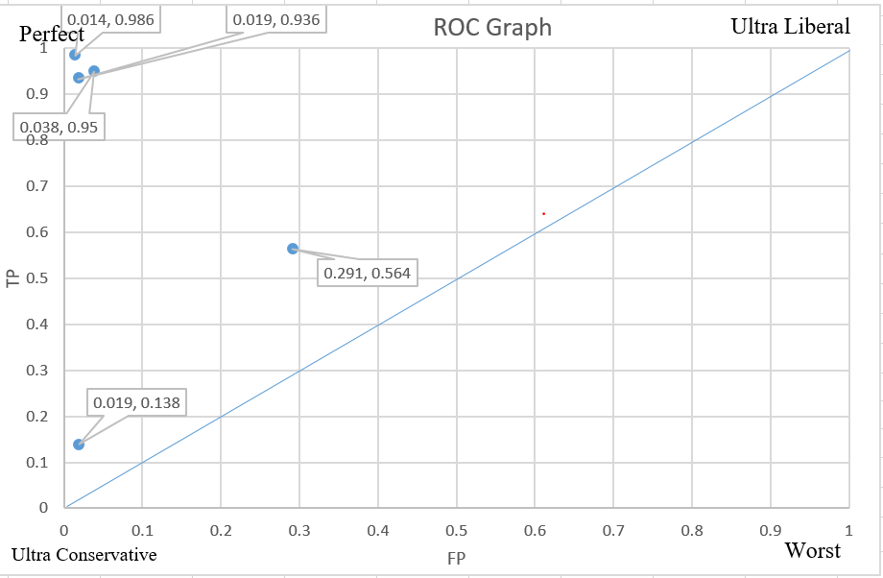

Identifying **Van** As a positive Interest

|  |  |  |
| --- | --- | --- |
| Classifier | TP | FP |
| Naïve | 0.905 | 0.403 |
| IBK(KNN) | 0.613 | 0.196 |
| Logistic | 0.955 | 0.025 |
| J48 | 0.905 | 0.042 |
| LMT | 0.955 | 0.019 |

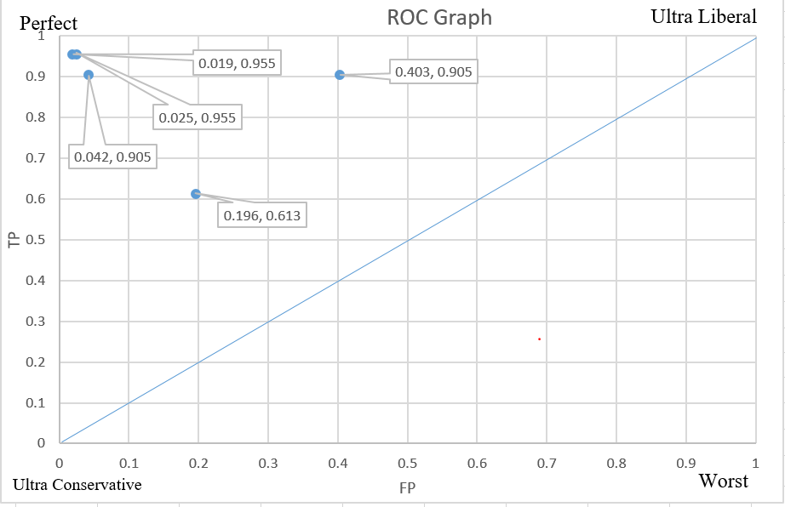

**Summary**: For classifying Opel, Saab, Bus, Van as a positive interest. I was looking for a classifier with maximum true positive rate and minimum false positive rate. Now from each of ROC graph I found that LMT is the best classifier, because it gives maximum true positive rate and minimum false positive rate for classifying Opel, Saab, Bus, and Van as a positive interest respectively. Therefore, LMT is the best classifier in this scenario.