Project Title: **Super Shop Management system**

Platform: **Desktop**

**Feature:**

By this system, one can manage super shop like selling products on online and also offline, inventory management, salary calculation, gross profit. Here three types of users, Admin, Employee and Customer. Customer can order product online with service charge and discount (admin approved). Customers can see all of their transactions. Employee use this system for offline and online manage. In online system, they can see due order and fulfilled order and in offline system, they can sell the products. The admin add employee, product with buying price. This system is automated salary calculated and admin pay salary and admin see the gross profit. Moreover, in every process system can print PDF.

**Key Points:**

1. **Online selling system.**
2. **Inventory management.**
3. **Salary management.**
4. **PDF generation for every bill.**
5. **Automatic Profit calculation.**

**System overview:**

**Admin:**

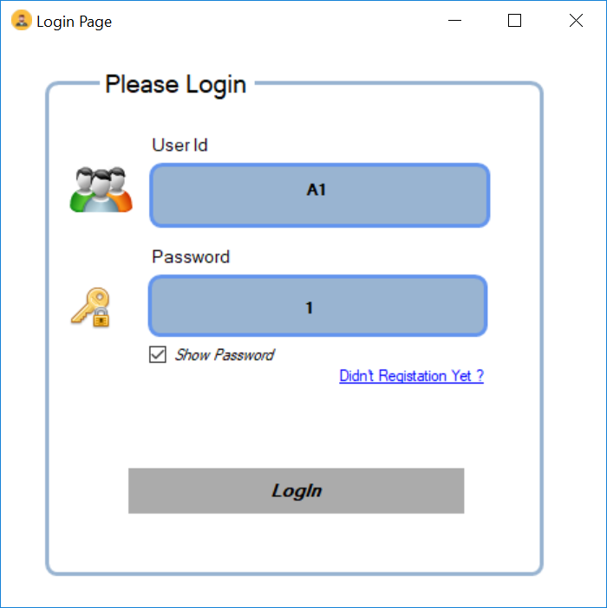

Admin login:

Admin Home page: 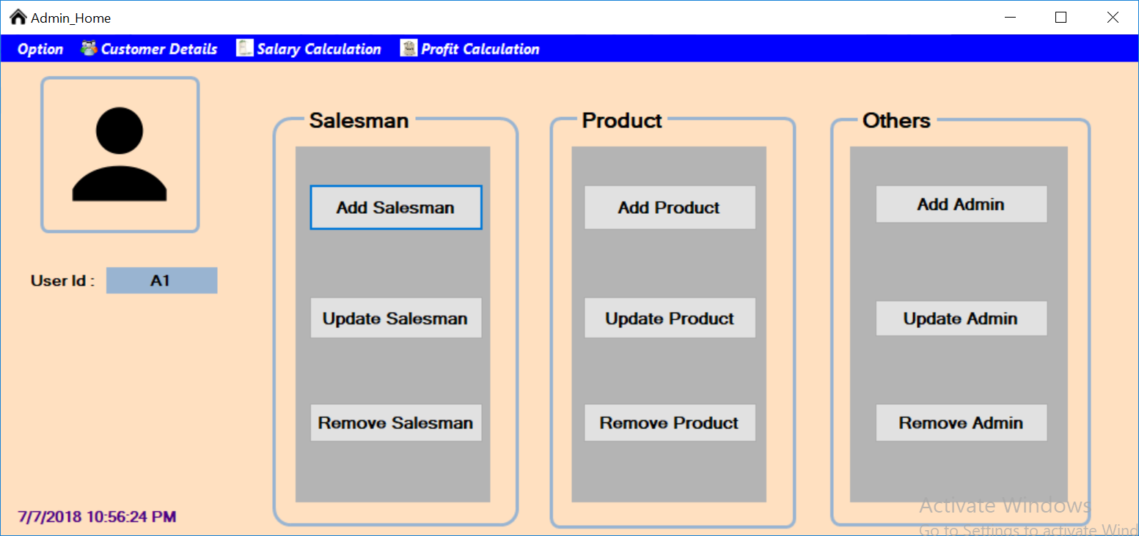

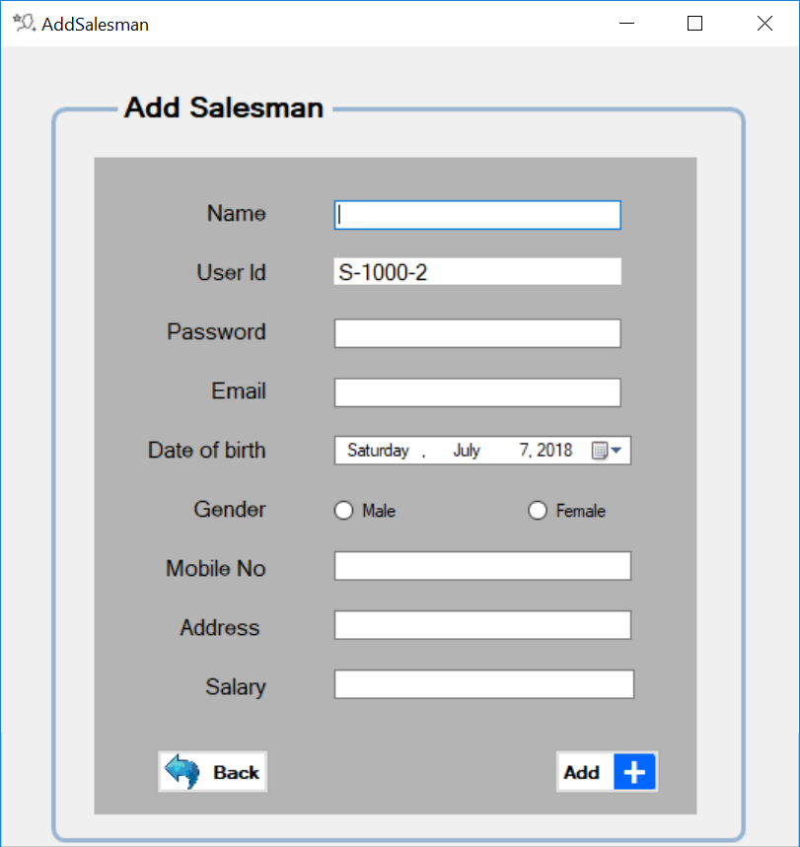Admin can add salesperson by this interface:

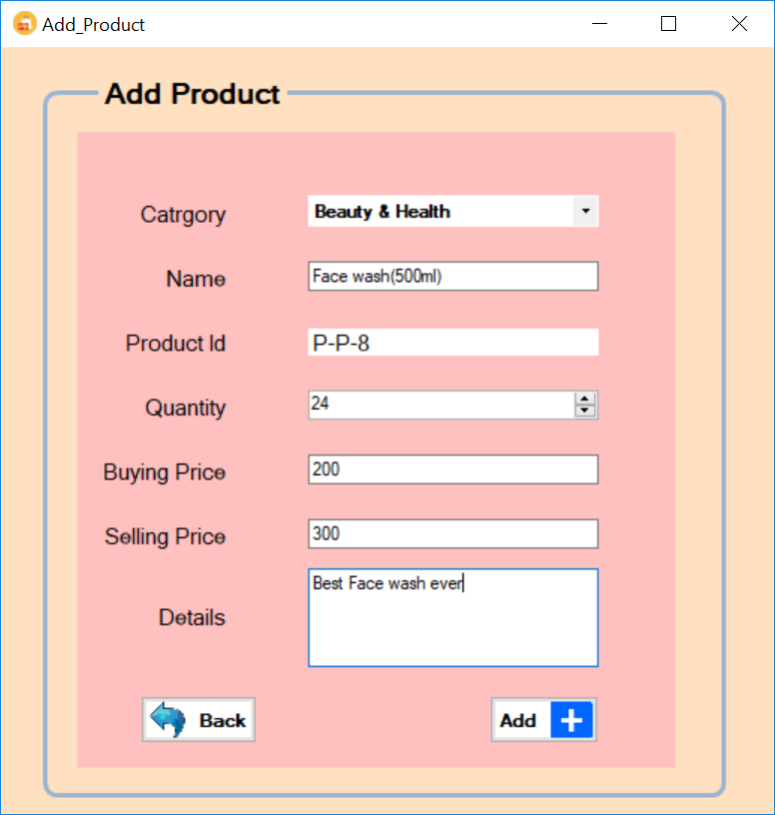Admin can add product using this interface:

Admin also add new admin:

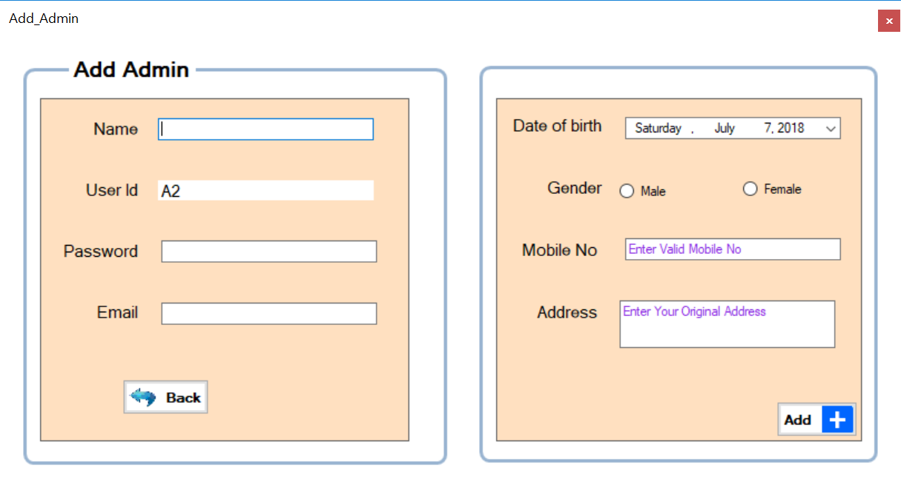

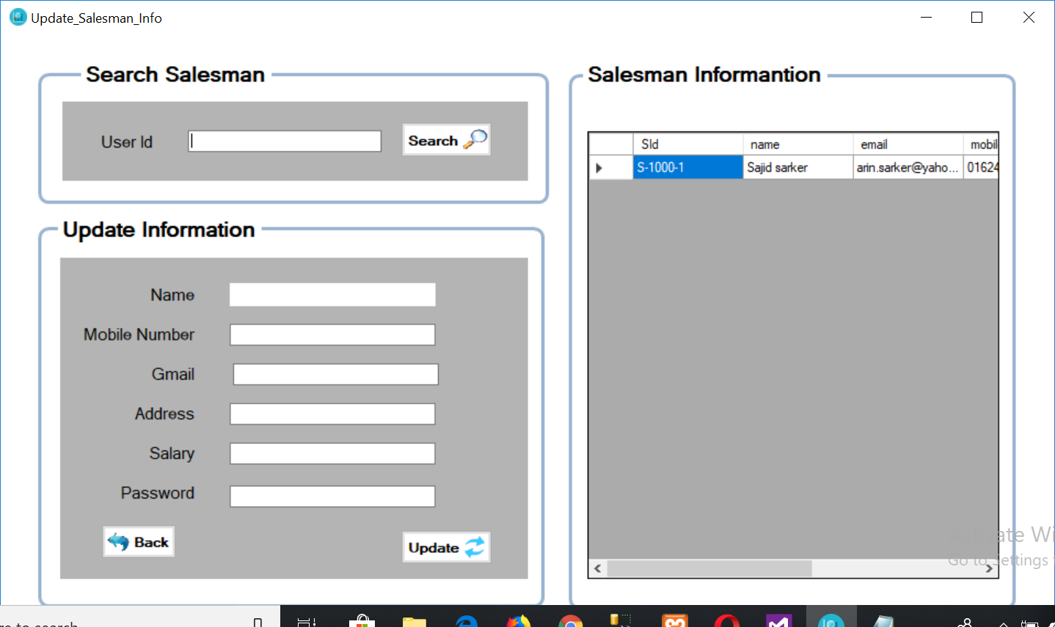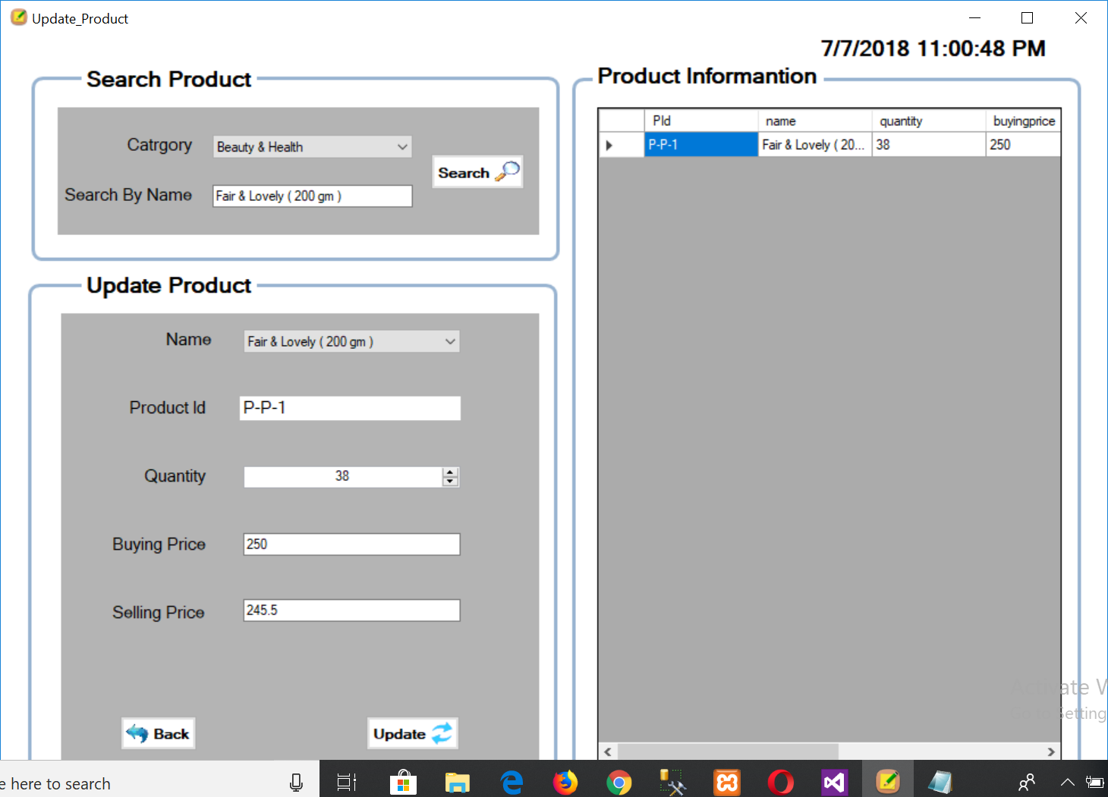Admin also update all those things using these interface:

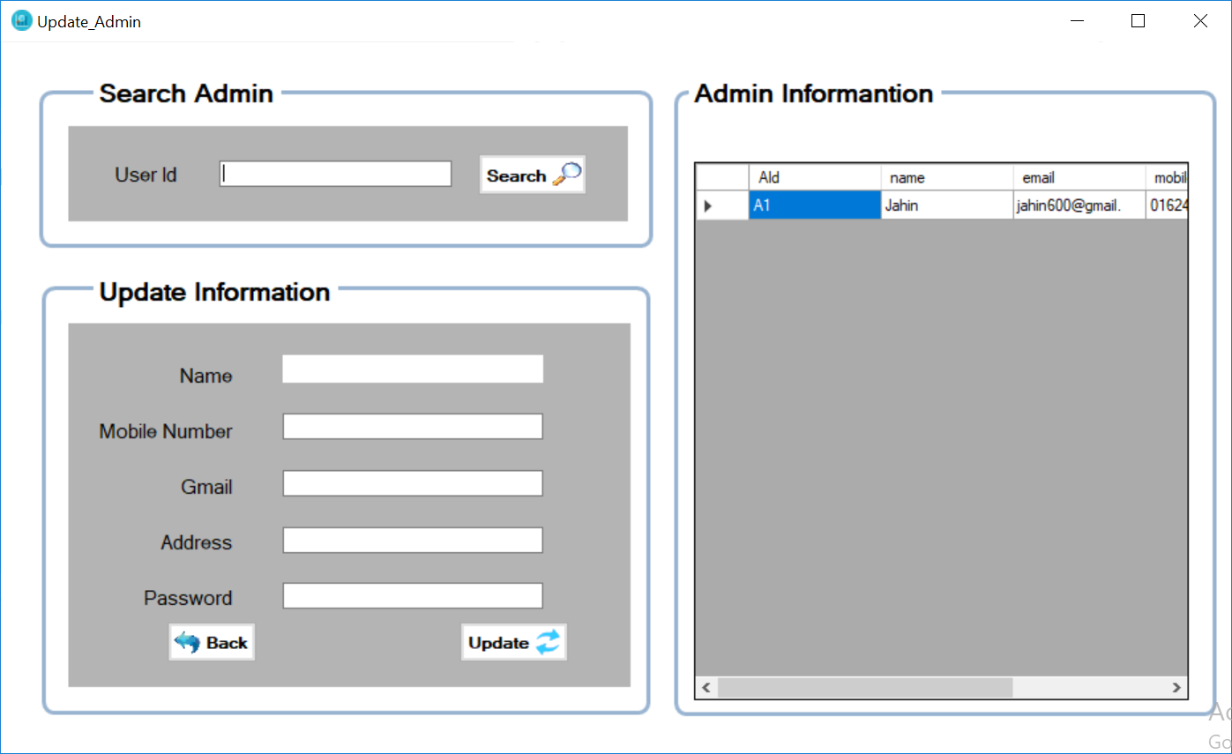

Admin can delete admin, product and salespersons:

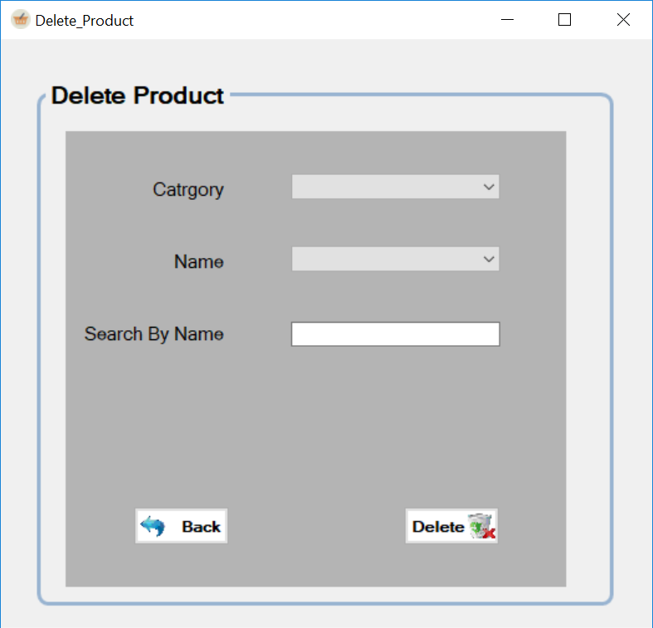

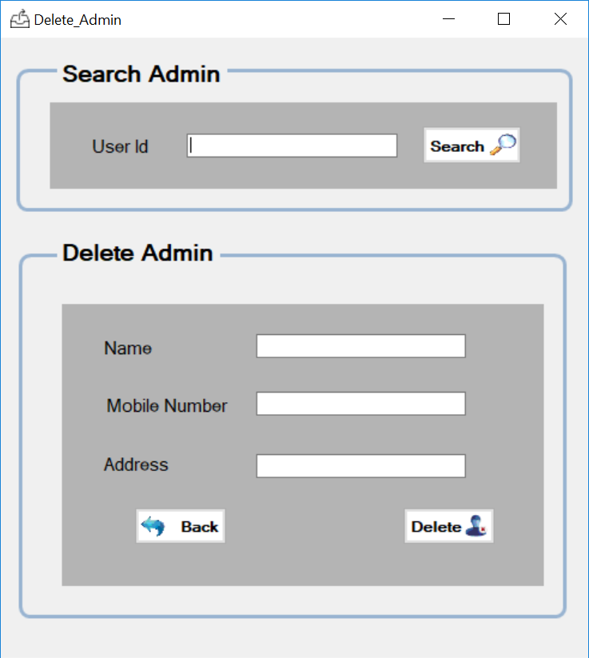

Admin can see the customer’s details and give them discount by using this interface:

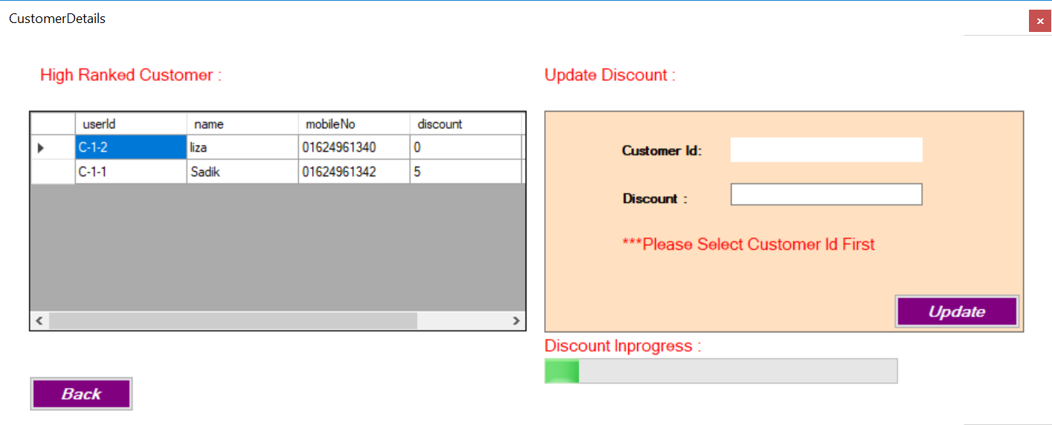

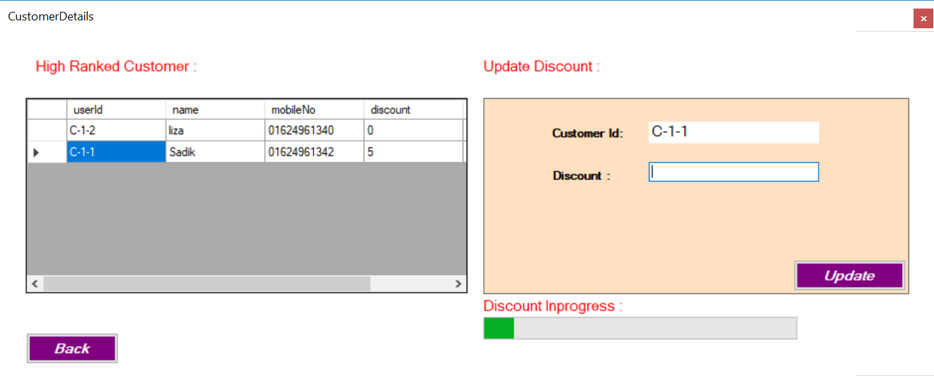

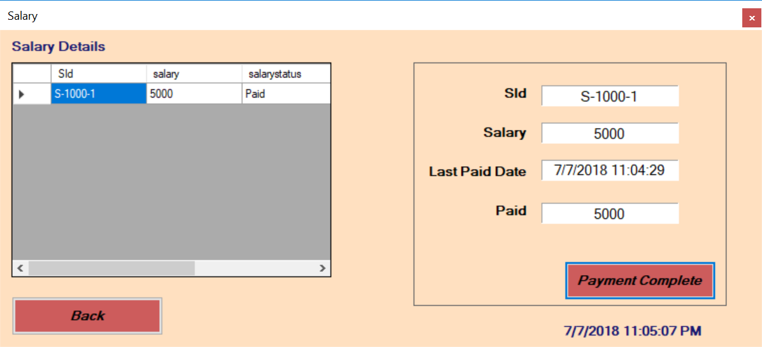Admin can give salary to employees:

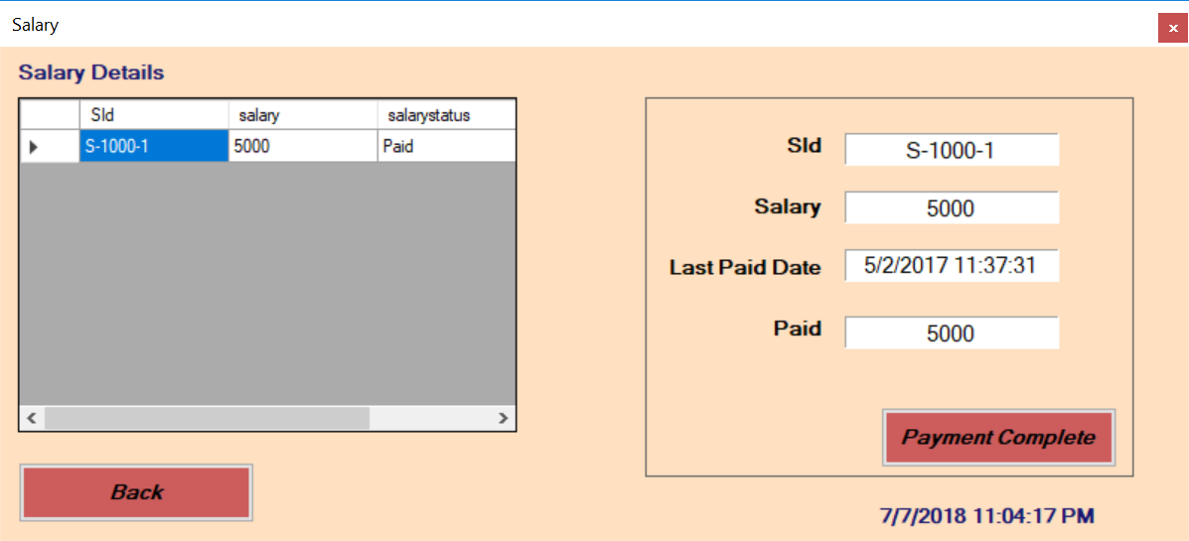

At last, admin can see gross profit of this super shop by this interface:

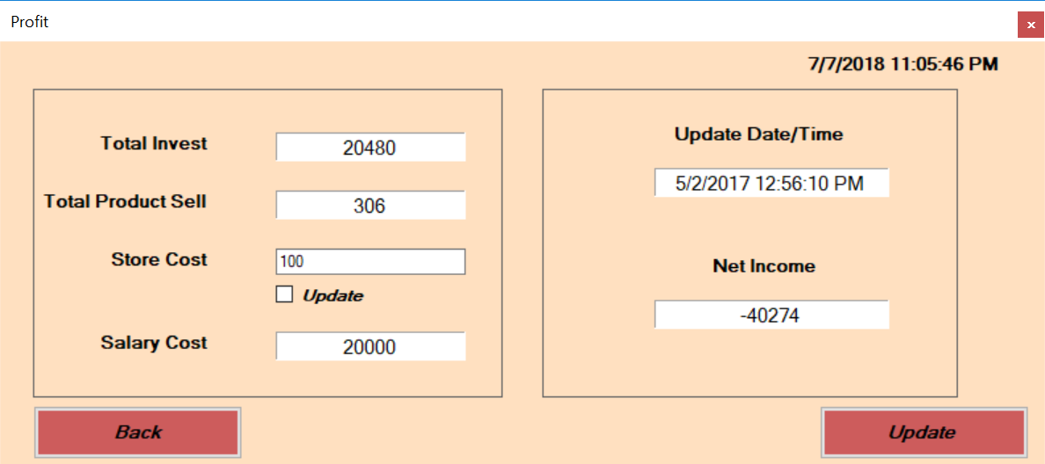

Customer:

Customer login: 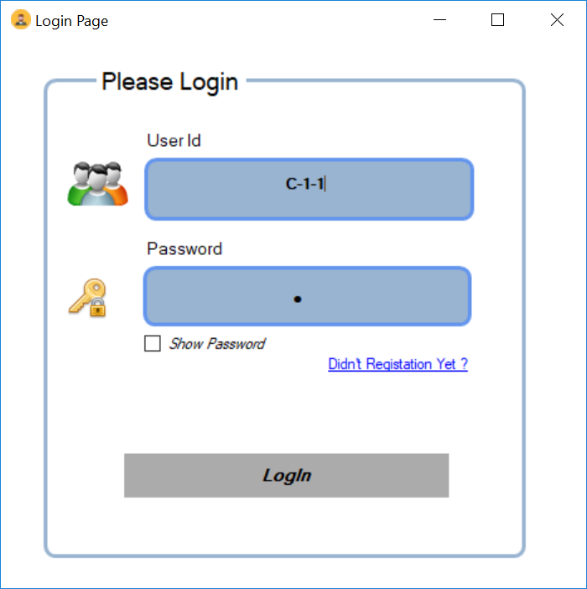

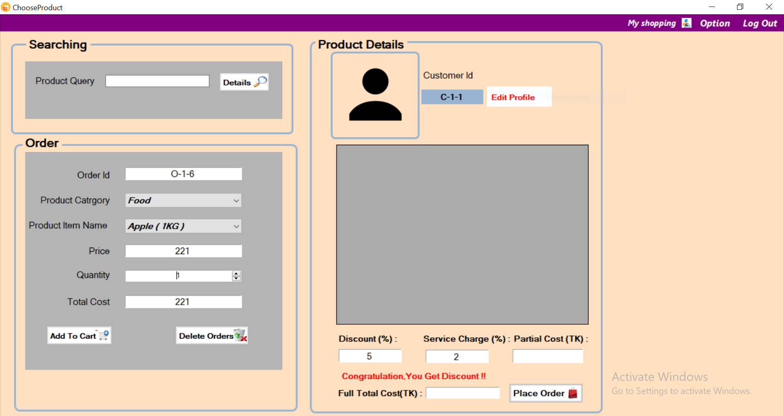Customer can order product by this page:

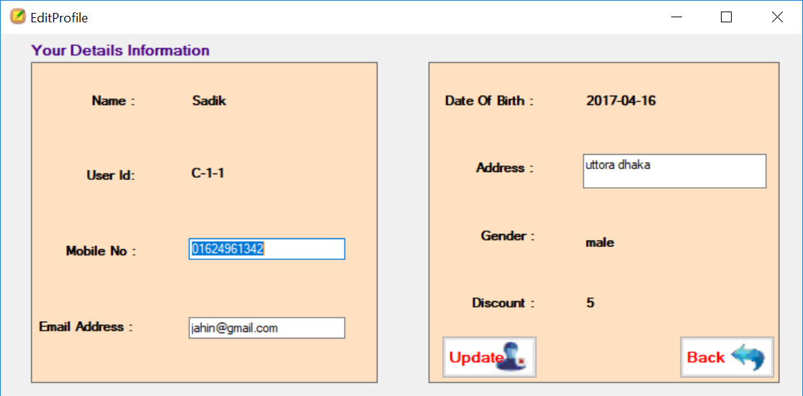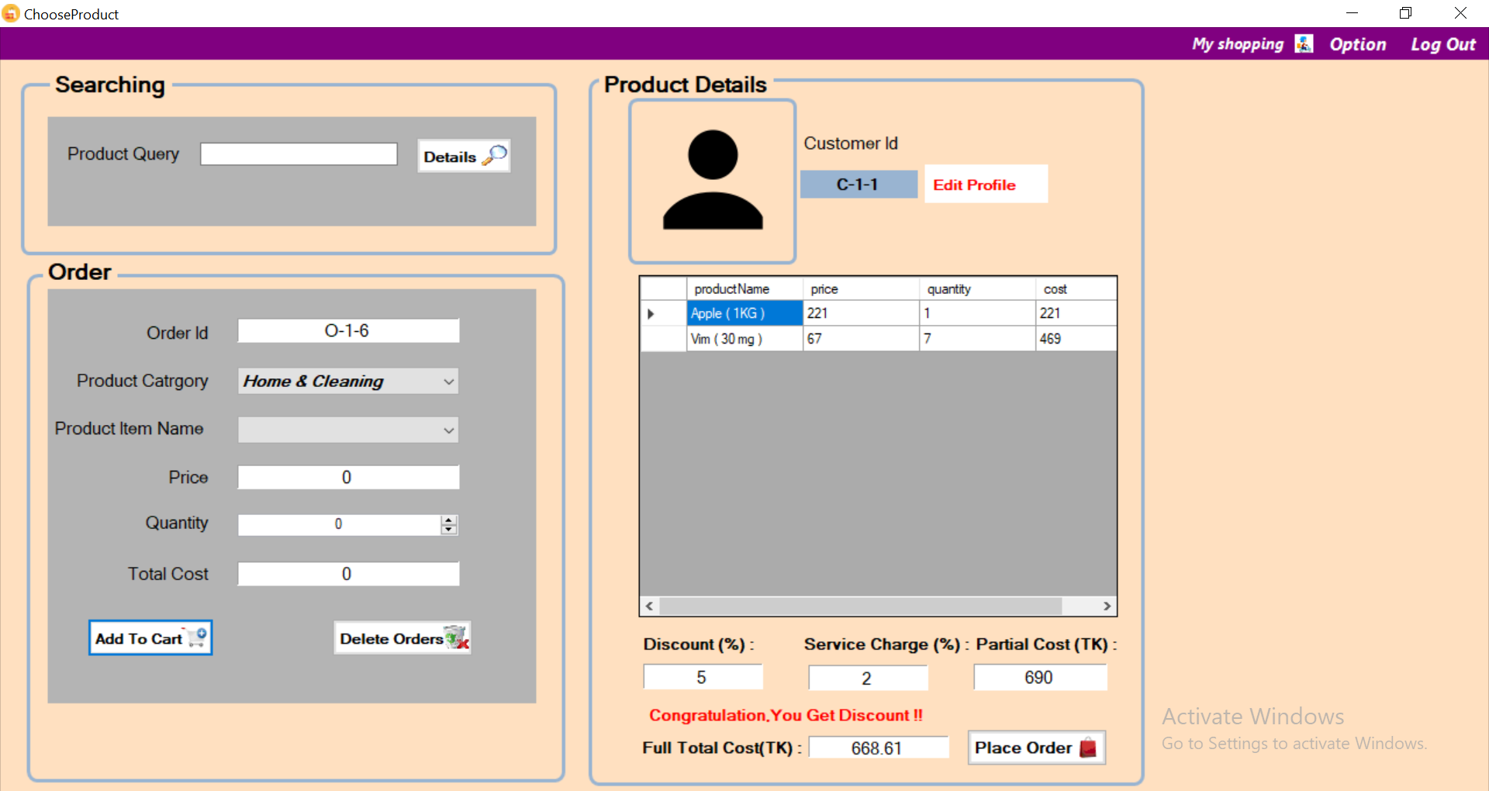Customer can edit his profile:

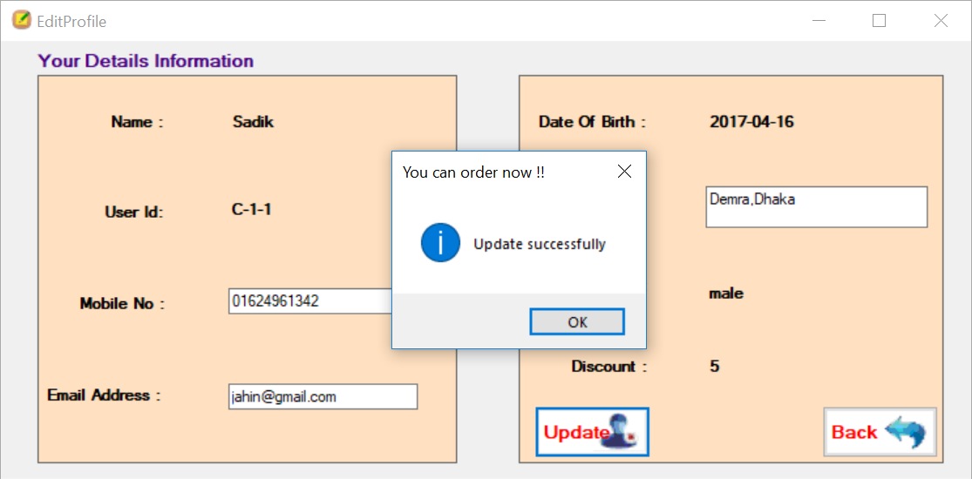

Customer can see all of their orders and in which state:

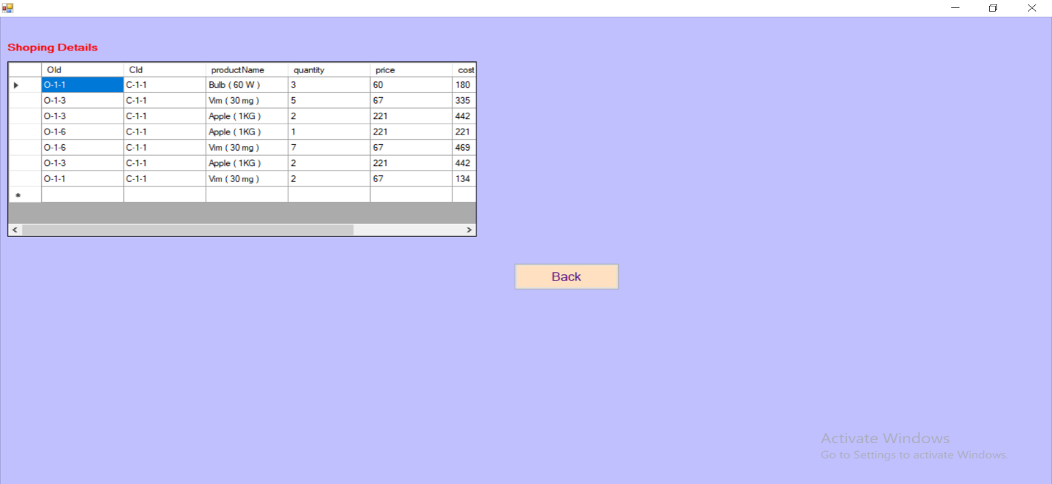

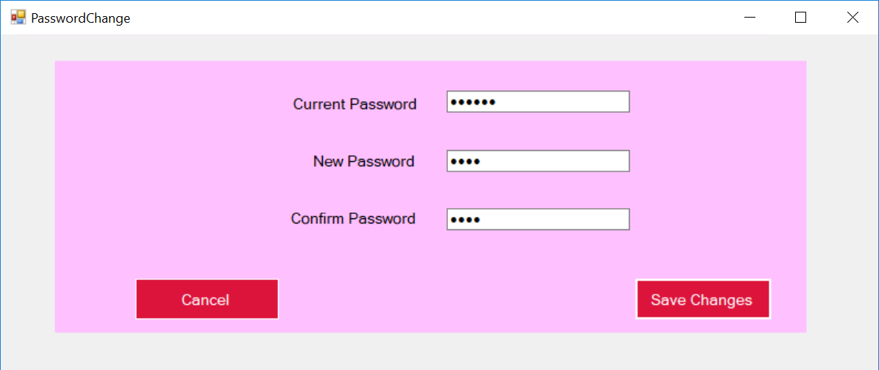Every users can change their password:

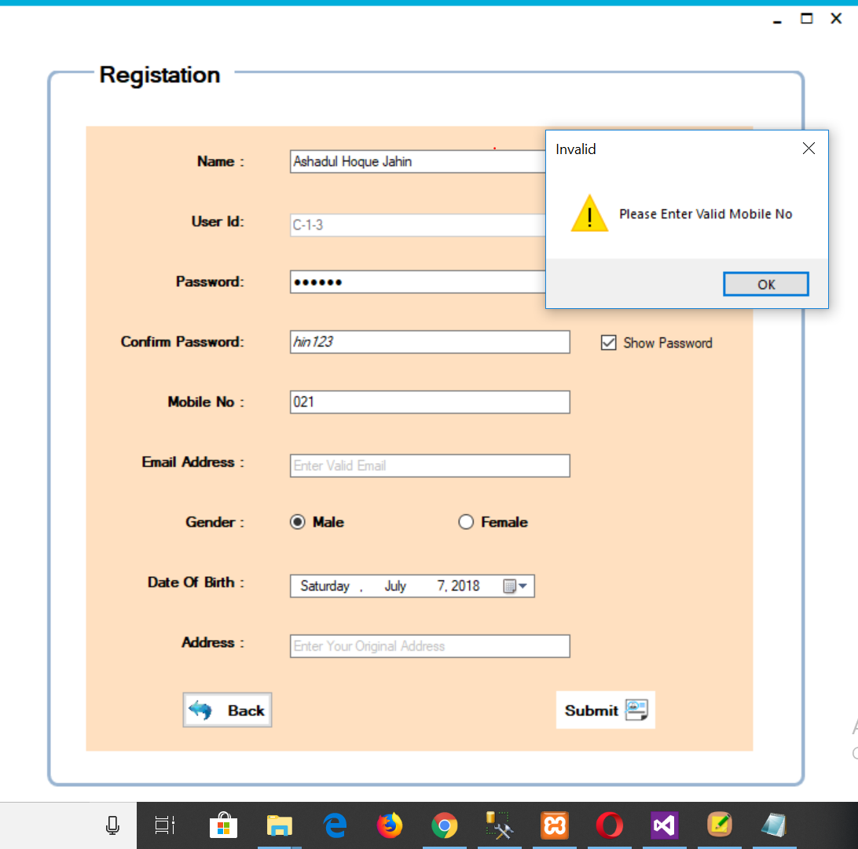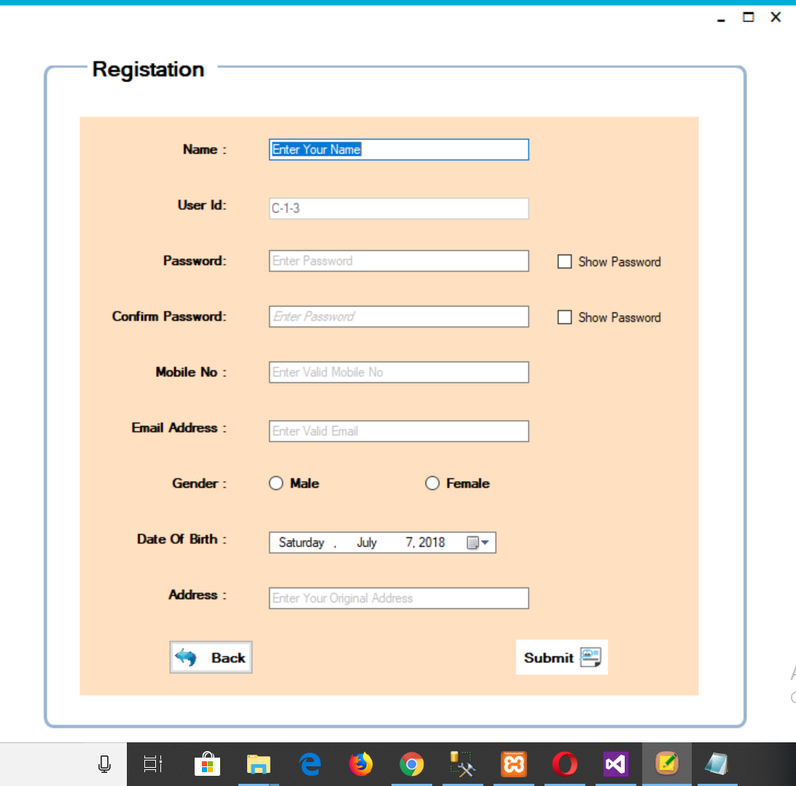New customer must do registration with valid mobile no, valid email address:

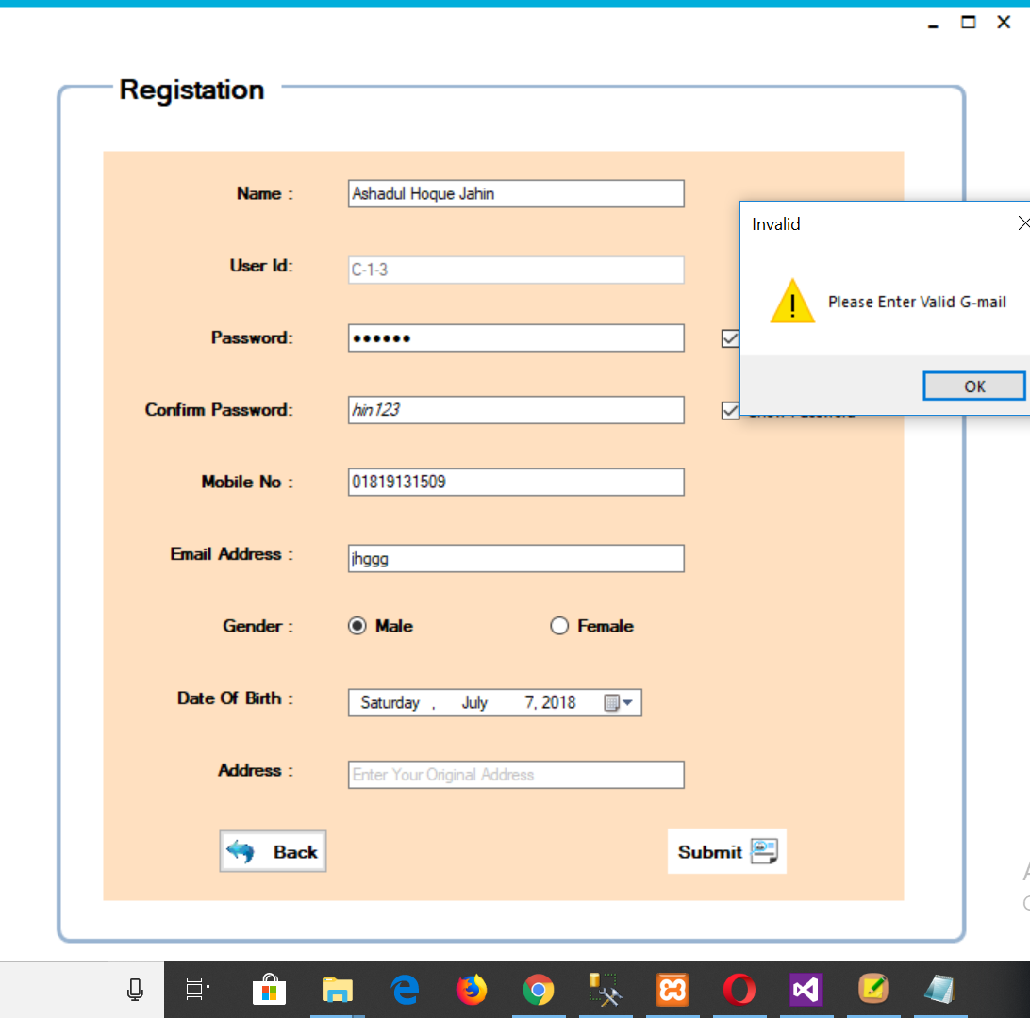

**Salespersons:**

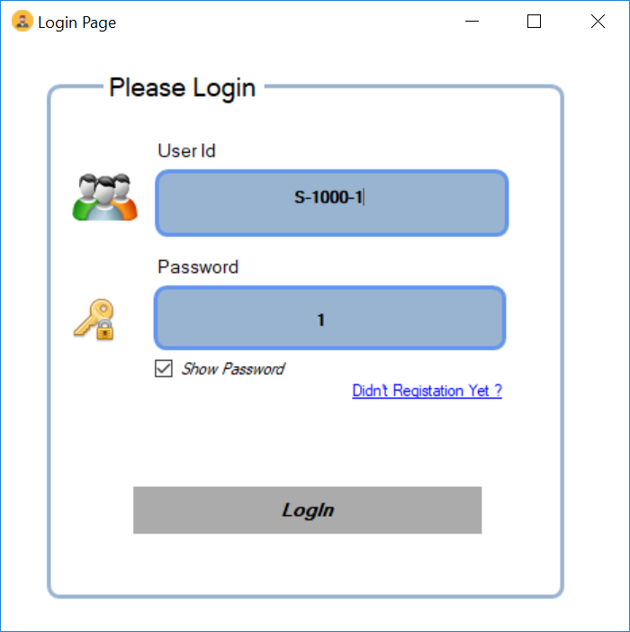**Sales login:**

Salesperson home page for create bill:

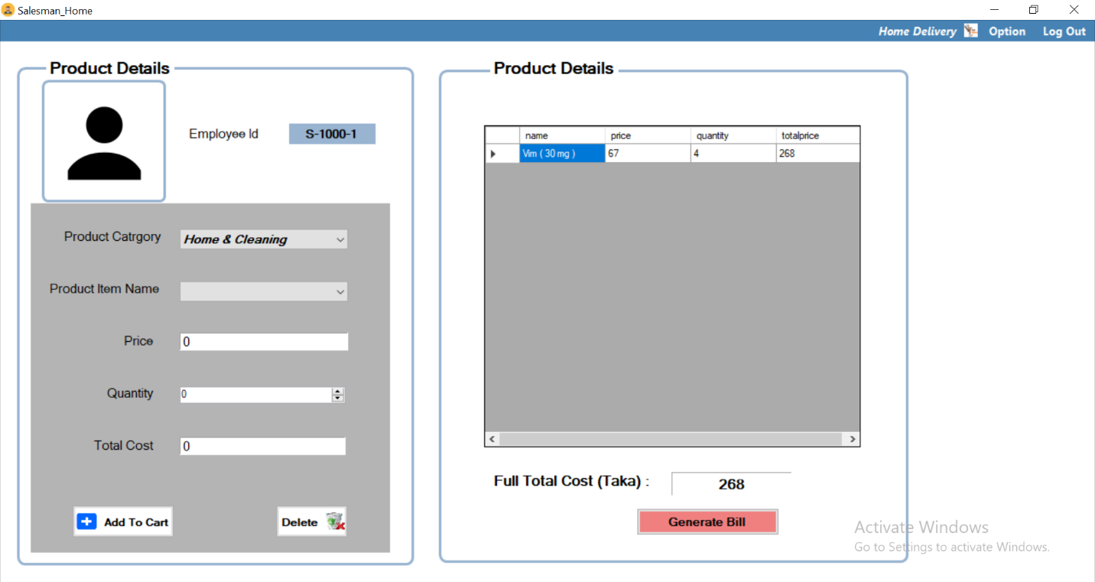

When order ready salesperson click on generate bill, which create a PDF:

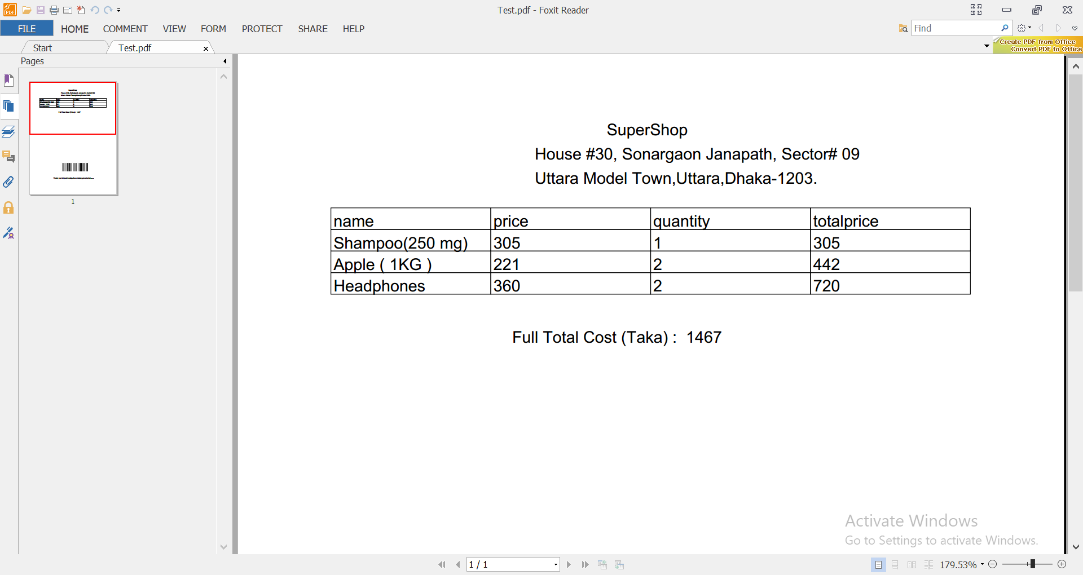

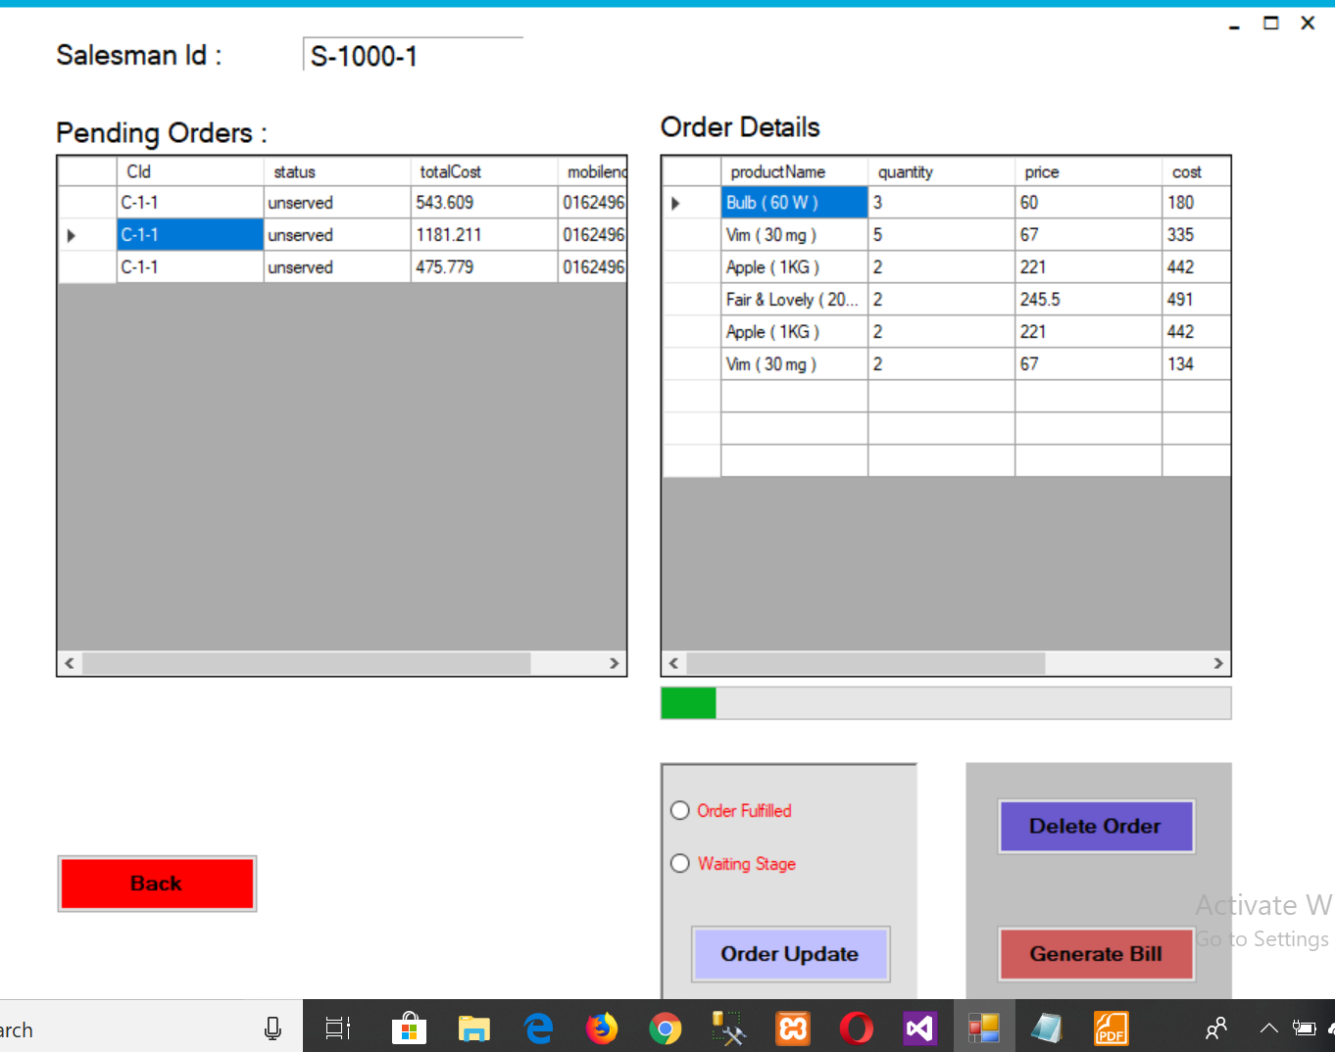By these interfaces sales representative manage online order and their status:

